SUPPLEMENTARY MATERIAL:

MIXED-CROPPING BETWEEN FIELD PEA VARIETIES ALTERS ROOT BACTERIAL AND FUNGAL COMMUNITIES
Anthony Horner, Samuel S. Browett and Rachael E. Antwis
University of Salford, UK, Rachael.Antwis@gmail.com

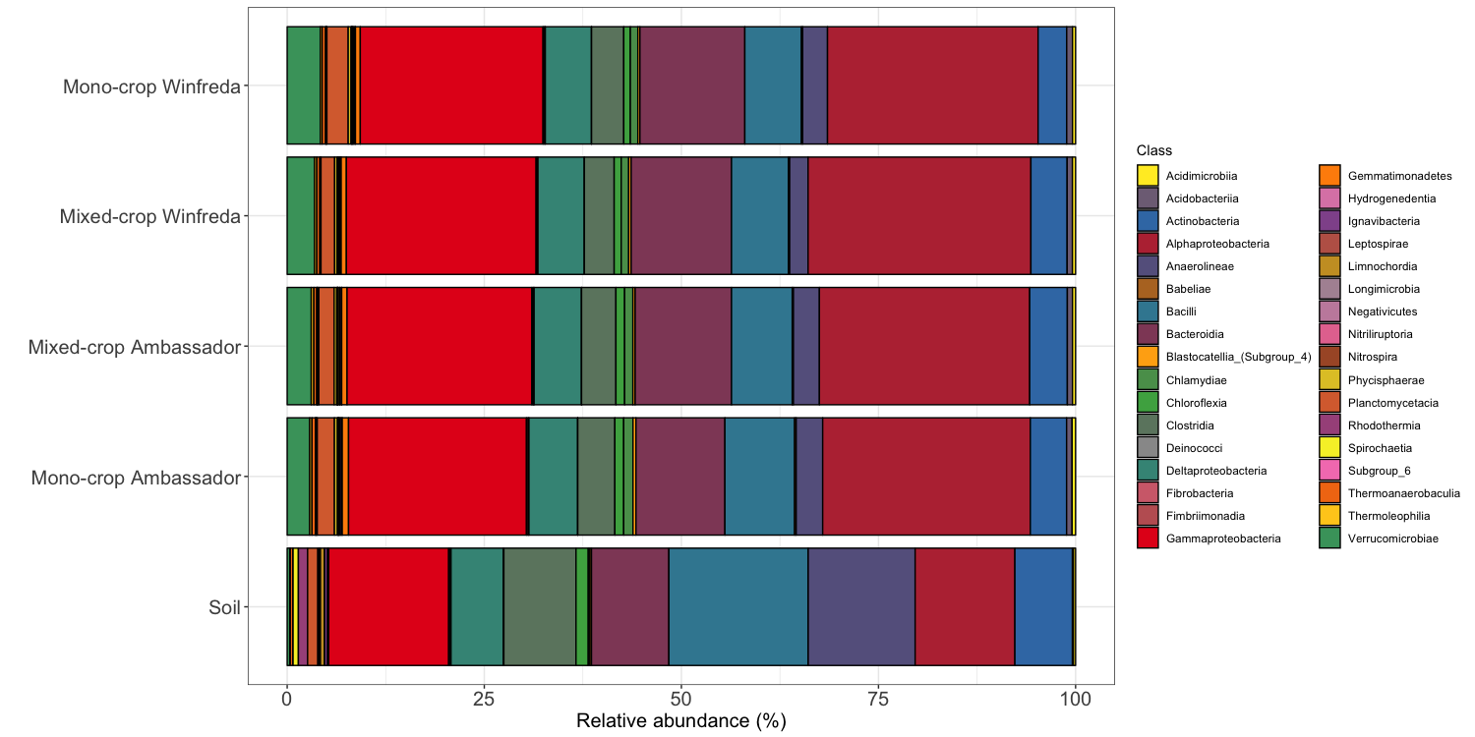
Fig. S1
Relative abundance of bacterial classes associated with the soil at the start of the experiment, and with the roots of two varieties of pea plants grown under a mono-cropping or mixed-cropping strategy at the end of the study.

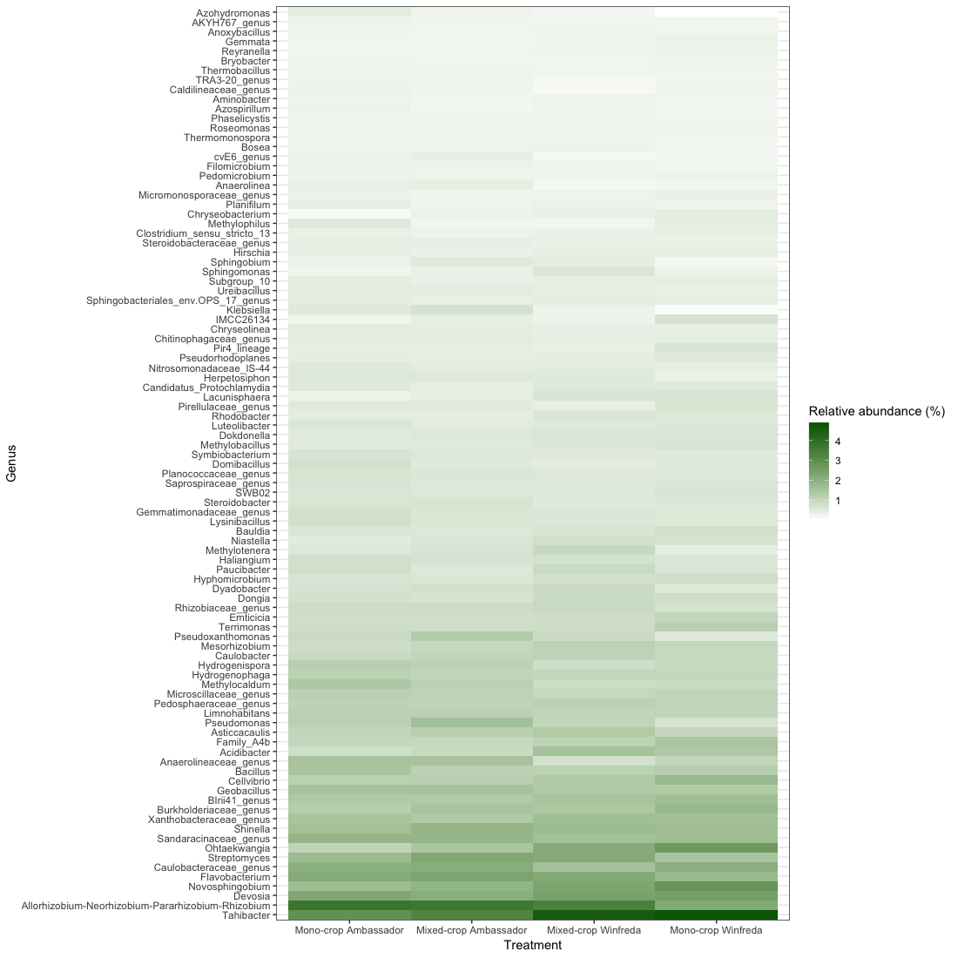

Fig. S2
Relative abundance of bacterial genera associated with the roots of two varieties of pea plants grown under a mono-cropping or mixed-cropping strategy (only those than a combined relative abundance of >1% across all treatment groups are shown).

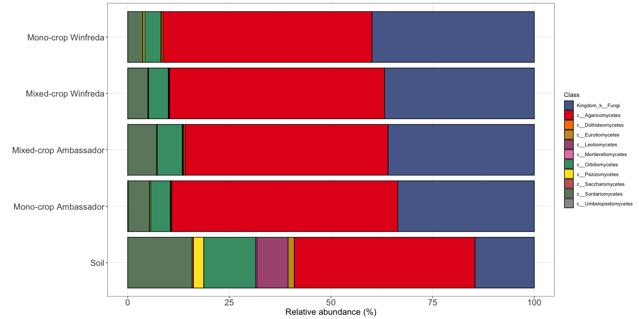
Fig. S3
Relative abundance of fungal classes associated with the soil at the start of the experiment, and with the roots of two varieties of pea plants grown under a mono-cropping or mixed-cropping strategy at the end of the study.

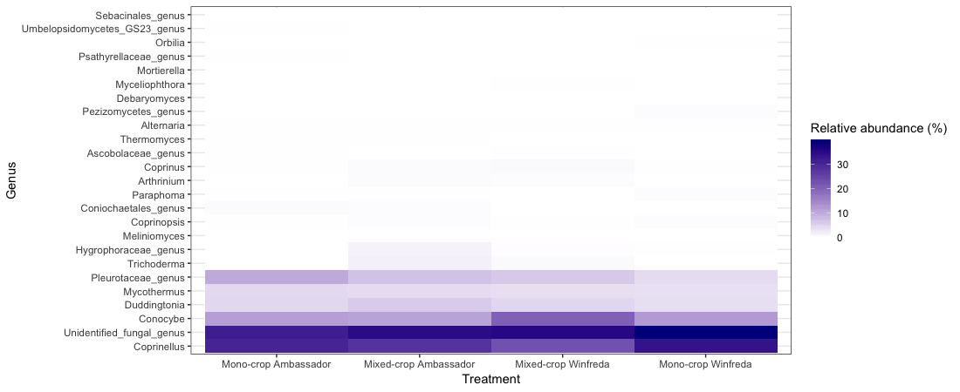
Fig. S4
Relative abundance of fungal genera associated with the roots of two varieties of pea plants grown under a mono-cropping or mixed-cropping strategy.

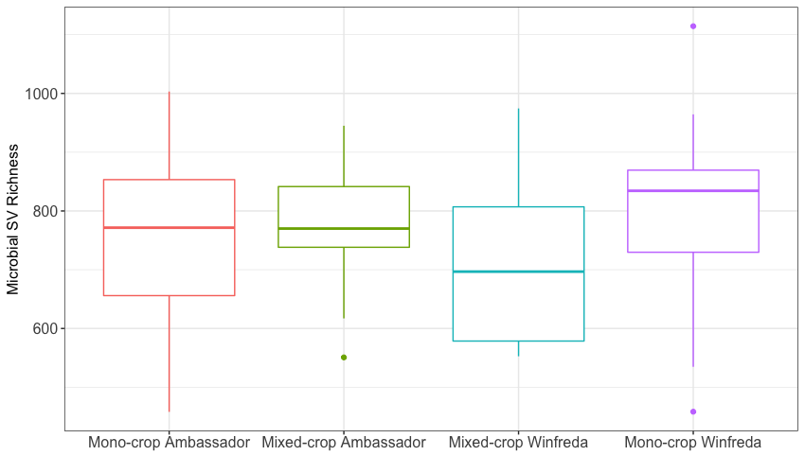
Figure S5
Microbial sequence variant richness (median average with 25% and 75% quartiles) associated with the roots of pea plants in the four different treatment groups.

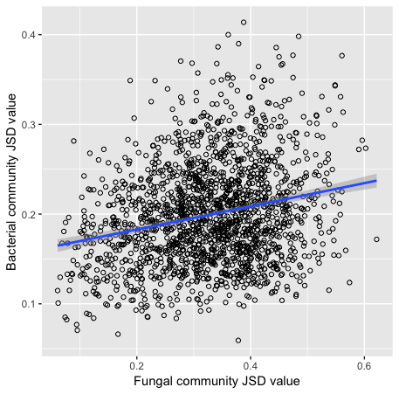
Figure S6
Relationship between Jensen-Shannon Divergence (JSD) values for fungal and bacterial communities associated with the roots of two varieties of pea plants.

