Title:
Multi-technique comparison of atherogenic and MCD NASH models highlights changes in sphingolipid metabolism.
Authors:
Sophie A. Montandon¹, Emmanuel Somm¹, Ursula Loizides-Mangold^{1,2,3,4}, Claudio de Vito⁵, Charna Dibner^{1,2,3,4} and François R. Jornayvaz^{1*}

Supplementary table S1. List of forward and reverse primers used for RT-qPCR in the liver and ileum.
Gene name | Forward | Reverse
Abcb11 (BSEP) | CTGCCAAGGATGCTAATGCA | CGATGGCTACCCTTTGCTTCT
Abcb4 (MDR2/3) | GCAGCGAGAAACGGAACAG | GGTTGCTGATGCTGCCTAGTT
Abcc4 (MRP4) | GCAGCGAGAAACGGAACAG | GGTTGCTGATGCTGCCTAGTT
Abcg5 | TGGATCCAACACCTCTATGCTAAA | GGCAGGTTTTCTCGATGAACTG
Abcg8 | CGTCGTCAGATTTCCAATGA | GGCTTCCGACCCATGAATG
Acta2 (αSMA) | TCCTCCCTGGAGAAGAGCTAC | TATAGGTGGTTTCGTGGATGC
Adgre1 (F4/80) | CTTTGGCTATGGGCTTCCAGTC | GCAAGGAGGACAGAGTTTATCGTG
Bmp6 | CCCACTCAACGCACACATG | GGATTCATAAGGTGGACCAAGGT
Bmp7 | CAAGACGCCAAAGAACCAAGAG | GGTCTCGGAAGCTGACGTACAG
Cat | CAGATGAAGCAGTGGAAGGAG | CGTCAGTGAAAACCACATCCT
Ccl2 (MCP-1) | TTAAAAACCTGGATCGGAACCAA | GCATTAGCTTCAGATTTACGGGT
Cd36 | AGATGACGTGGCAAAGAACAG | CCTTGGCTAGATAACGAACTCTG
CerS2 | TCTACTGGTCCCTGCTCTTCA | CCAGGAGAAGCAGAGGAGAAT
CerS4 | CAGTTTCCTGCATAAGGGTCA | CAGCTGTGGACCTTCAGAAAC
CerS5 | CATGCCATCTGGTCCTACCTA | CTGCCAGAGAGGTTGTTTTTG
CerS6 | AAGGGTTGAACTGCTTCTGGT | AGTGTGGTTTCTTCCCTGGAG
Col1a1 | ACGTCCTGGTGAAGTTGGTC | CAGGGAAGCCTCTTTCTCCT
Col3a1 | CCACTCTTATTTTGGCACAGC | ATGTCATCGCAAAGGACAGAT
Col4a1 | ACTGTGGATCGGCTATTCCTT | GGCGCTTCTAAACTCTTCCAG
Cpt1a | AACCCAGTGCCTTAACGATG | GAACTGGTGGCCAATGAGAT
Cyp7a1 | GCCTCTGAAGAAGTGAATGG | CTAGTACTGGCAGGTTGTTTAG
Cyp7b1 | CTGCAGTCAACAGGTCAAA | GCCTCAGAACCTCAAGAATAG
Cyp8b1 | CTGGCTTCCTGAGCTTATTC | CCCAGTAGGGAGTAGACAAA
Ddit3 (CHOP) | AGCGACAGAGCCAGAATAACA | TCAGGTGTGGTGGTGTATGAA
Degs1 (DES1) | TCACCTTCAATGTGGGCTATC | CTCACTTGCGATCTTCCTCAC
Dgat2 | AGTGGCAATGCTATCATCATCGT | AAGGAATAAGTGGGAACCAGATCA
Fabp6 | GCCTTCAGTGGCAAATATGAA | TTCAATCACGTCTCCTGGAAG
Fasn (FAS) | CATGACCTCGTGATGAACGTGT | CGGGTGAGGACGTTTACAAAG
Gck | ACTTGAGGCAGCTATGTGCAGG | GCTGTCTCCAGAATCTGTGTACTG
Gpx1 | GGACTACACCGAGATGAACGA | CAATGTAAAATTGGGCTCGAA
Gpx3 | TCTACGAGTATGGAGCCCTCA | AATGGCCCAAGTTCTTCTTGT
Gys2 | ACCAAGGCCAAAACGACAG | GGGCTCACATTGTTCTACTTGA
Hmgcr | CTTGTGGAATGCCTTGTGATTG | AGCCGAAGCAGCACATGAT
Hmgcs1 | GCCGTGAACTGGGTCGAA | GCATATATAGCAATGTCTCCTGCAA
Hspa5 (GRP78/Bip) | ACTTGGGGACCACCTATTCCT | ATCGCCAATCAGACGCTCC
IL1b | ACTGTGAAATGCCACCTTTTG | TTTGAAGCTGGATGCTCTCAT
Itgax (Cd11c) | CACTCAGTGACTGCCCAAAA | CCTCAAGACAGGACATCGCT
Ldlr | TCCAATCAATTCAGCTGTGG | GAGCCATCTAGGCAATCTCG
Mmp13 | AGGCCTTCAGAAAAGCCTTC | TCCTTGGAGTGATCCAGACC
Mmp14 | CCGCCATGCAAAAGTTCTAT | GCCCACCTTAGGGGTGTAAT
Mmp2 | GTCGCCCCTAAAACAGACAA | GGTCTCGATGGTGTTCTGGT
Mmp3 | ACGATGGACAGAGGATGTCAC | AGATGGAAACGGGACAAGTCT
Mmp9 | GCAGAGGCATACTTGTACCGCTAT | CGGCCGTAGAGACTGCTTCT
Mttp | ATGATCCTCTTGGCAGTGCTT | TGAGAGGCCAGTTGTGTGAC
Nox4 | ACCCAAGTTCCAAGCTCATTT | ATGGTGACAGGTTTGTTGCTC
Npc1l1 | GAAGCACAGCTGACAAGTTCC | CTGGATGGTAGTGCGATTGAT
Pck1 (Pepck) | CTGCATAACGGTCTGGACTTC | GCCTTCCACGAACTTCCTCAC
PDGFc | TGAGAGATTTGGGCTGGAAGA | ACTGGGCTCCTCAACTTCTACAA
Pfkl | CCATGTTGTGGGTGTCTGAG | ACAGGCTGAGTCTGGAGCAT
Pnpla2 (Atgl) | GTCCTTCACCATCCGCTTGTT | CTCTTGGCCCTCATCACCAG
PPARa | CAGGAGAGCAGGGATTTGCA | CCTACGCTCAGCCCTCTTCAT
Pygl | GAGAAGCGACGGCAGATCAG | CTTGACCAGAGTGAAGTGCAG
RPS29 | GCCAGGGTTCTCGCTCTTG | GGCACATGTTCAGCCCGTAT
Scd1 | CCTTCCCCTTCGACTACTCTG | GCCATGCAGTCGATGAAGAA
Slc10a1 (NTCP) | ATGACCACCTGCTCCAGCTT | GCCTTTGTAGGGCACCTTGT
Slc15a1 | AATGACCTCACAGACCACGAC | TCCTCCTGTACCAAGGGCTAT
Slc2a2 (Glut2) | GTCCAGAAAGCCCCAGATACC | GTGACATCCTCAGTTCCTCTTAG
Slc2a5 | CTACATGATCGGAGGCAGTGT | ATGGTGGTGAGGAAACAGATG
Slc51b (OST-β) | GTATTTTCGTGCAGAAGATGCG | TTTCTGTTTGCCAGGATGCTC
Slc5a1 | TTCTGTCCCTGCTCCTCTACA | CAGGATGAAAATGGCCAAGTA
Slco1a1 (OATP-1) | CAGTCTTACGAGTGTGCTCCAGAT | ATGAGGAATACTGCCTCTGAAGTG
Smad2 | CCGTACCACTACCAGAGAGTTGAG | GGCGGCAGTTCTGTTAGAATCT
Smad3 | CCAATGTCAACCGGAATGC | CGCACACCTCTCCCAATGT
Smad4 | GGAGCTCATCCTAGCAAGTGTGT | CCGACCAGCCACCTGAAGT
Smad5 | TGGATCTAAGCAAAAGGAAGTTTGT | CACTAATACTGGAGGTAAGACTGGACTCT
Smad6 | TATTCTCGGCTGTCTCCTCC | AGTGATGAGGGAGTTGGTGG
Smpd1 | GGCTCTTGATCAACTCCACAG | GACAATGTCCTGGAGGGATGT
Sod1 | GAGACCTGGGCAATGTGACT | GTTTACTGCGCAATCCCAAT
Sod2 | CCGAGGAGAAGTACCACGAG | GCTTGATAGCCTCCAGCAAC
Spp1 | AAAGCACCCTGTAGAAAACA | CCGTTTTATCCTCTCTACACTC
Sptl1c (SPT) | GTCCCTCCAGTCTCCAAGAAC | AGCAGCCCAAGGAAGTTAAAG
Srebf1c (Srebp-1) | GGAGCCATGGATTGCACATT | GGCCCGGGAAGTCACTGT
Srebf2 (Srebp2) | GGCGCCCCACTCAGAACACC | CAGGAACGGCGGTCACCCAC
sXBP1 | CTGAGTCCGCAGCAGGTG | TGAAAAACATGACAGGGTCCA
Tgfb1 | AACAATTCCTGGCGTTACCTT | GAATCGAAAGCCCTGTATTCC
Tgfb2 | GGATCTTGGATGGAAATGGAT | ATGGTGTTGTACAGGCTGAGG
Timp1 | ATTCAAGGCTGTGGGAAATG | CTCAGAGTACGCCAGGGAAC
Timp2 | TCCTTGCTACAGGCAGGAGT | CATTCGCTGAAGTCTGTGGA
Tnf (TNFα) | CAGCCTCTTCTCATTCCTGCT | TCTGGGCCATAGAACTGATGA
Vim (Vimentin) | GGAGGAGATGCTCCAGAGAGA | TTCCTGCAAGGATTCCACTTT
Vldlr | CTCCCAGTTTCAGTGCACAA | ATCAGAACCGTCTTCGCAAT

Supplementary figure S1. Histological sections of adipose tissues stained with hematoxylin and eosin (H&E).
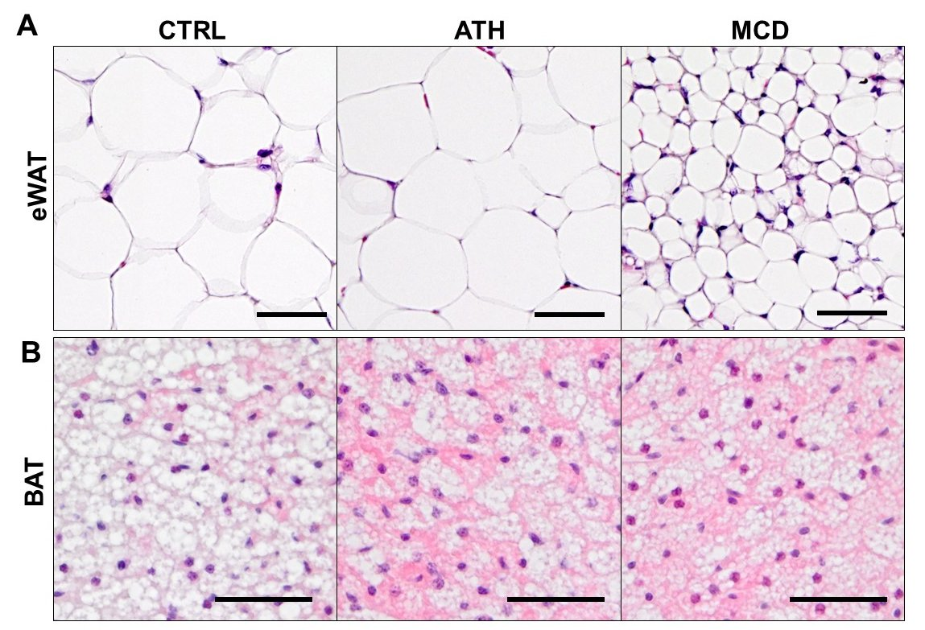
Epididymal white adipose tissue (A) and brown adipose tissue (B) sections. Scale bars 50 μm.

Supplementary figure S2. ATH and MCD diets alter nutrient absorption.
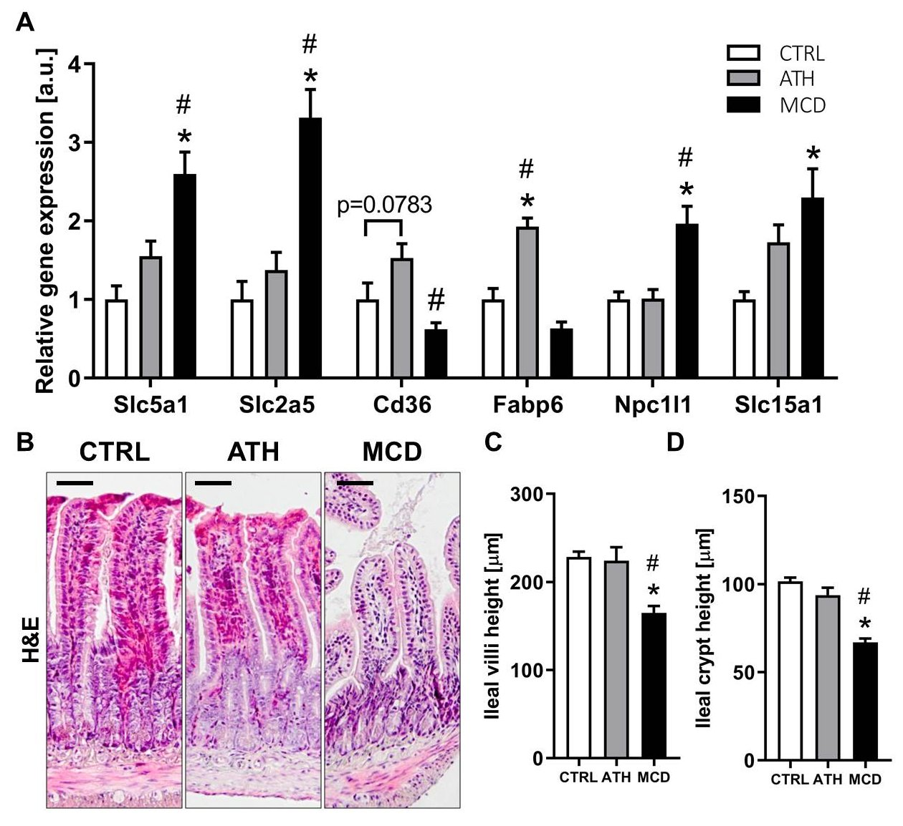
RT-qPCR of nutrient transporters (A). Histological sections of ileum stained with H&E (B). Measurements of ileal villi height (C) and crypts height (D). Scale bar 50 µm. One-way ANOVA: * p value ATH/MCD vs CTRL < 0.05, # p value MCD vs ATH < 0.05.

Supplementary figure S3. Relative abundance of diacyl-, lyso- and ether-containing phospholipids.
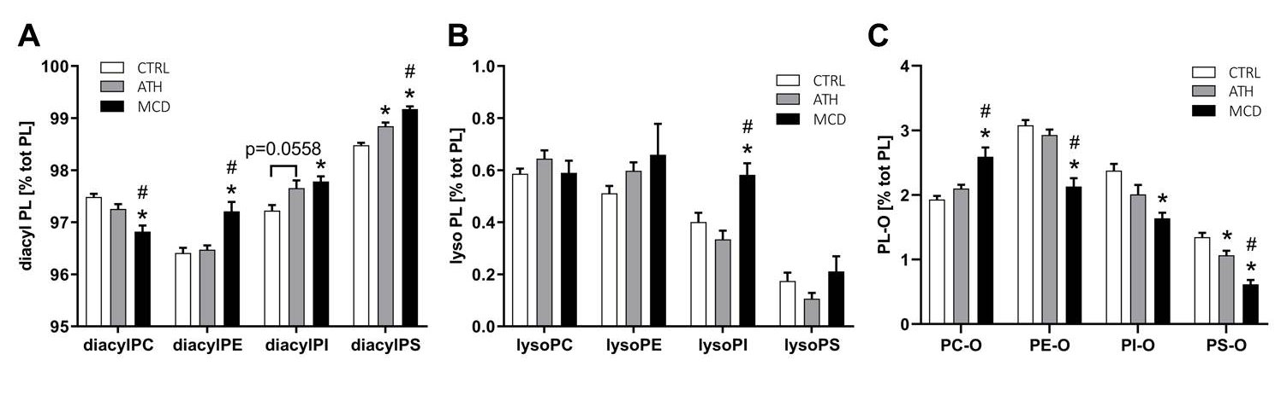Relative concentration of diacyl- (A), lyso- (B) and ether-containing phospholipids (C). PL: phospholipids, PC: phosphatidylcholine, PE: phosphatidylethanolamine, PI: phosphatidylinositol, PS: phosphatidylserine, PL-O: ether-containing phospholipids. One-way ANOVA: * p value ATH/MCD vs CTRL < 0.05, # p value MCD vs ATH < 0.05.

Supplementary figure S4. Ratios of phospholipid concentration according to their fatty acid chain length or level of unsaturation.
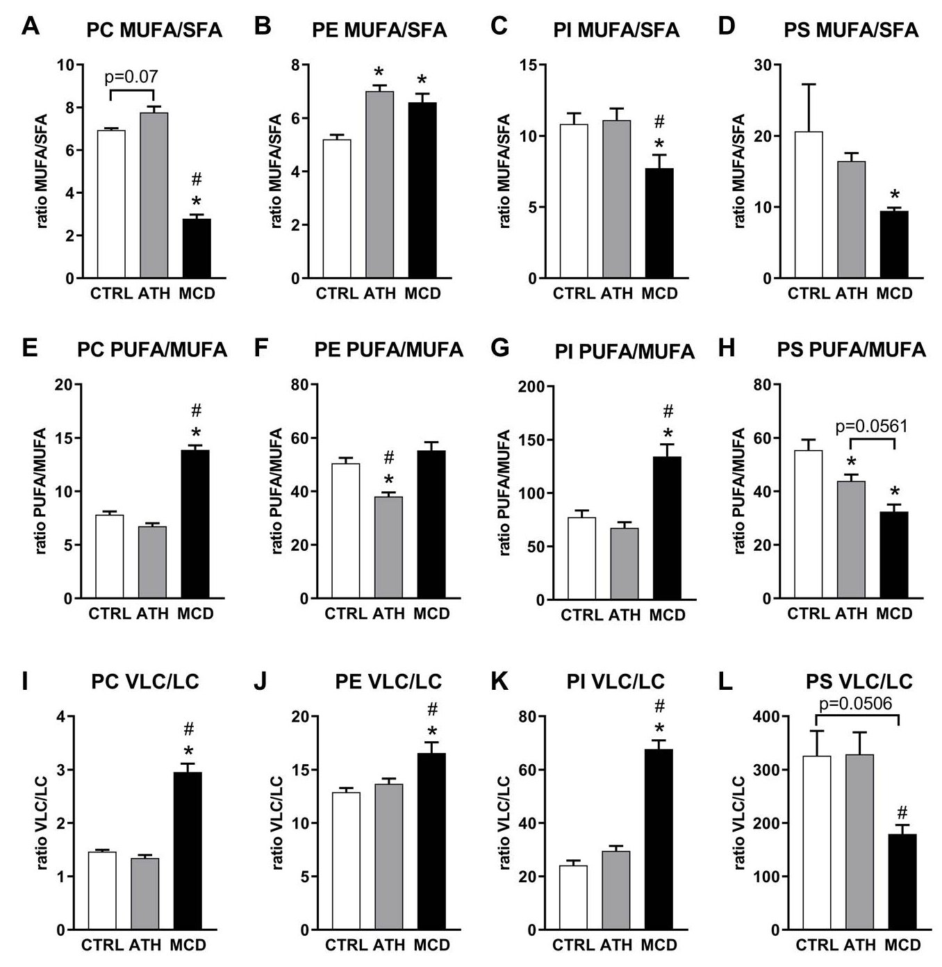
Ratios of monounsaturated fatty acids (MUFA) to saturated fatty acids (SFA) of phospholipids with choline (A), ethanolamine (B), inositol (C) or serine (D) head group. Ratios of polyunsaturated fatty acids (PUFA) to MUFA, with choline (E), ethanolamine (F), inositol (G) or serine (H) head group. Ratios of very long fatty acyl chains (VLC) to long fatty acyl chains (LC) of phospholipids with choline (I), ethanolamine (J), inositol (K) or serine (L) head group. One-way ANOVA: * p value ATH/MCD vs CTRL < 0.05, # p value MCD vs ATH < 0.05.

