Supplementary material:

The burden of submicroscopic and asymptomatic malaria in India revealed from epidemiology studies at three varied transmission sites in india
Anna Maria van Eijk, Patrick L. Sutton, Lalitha Ramanathapuram, Steven A. Sullivan, Deena Kanagaraj, G Sri Lakshmi Priya, Sangamithra Ravishankaran, Aswin Asokan, V. Sangeetha, Pavitra N. Rao, Samuel C. Wassmer, Nikunj Tandel, Ankita Patel, Nisha Desai, Sandhya Choubey, Syed Zeeshan Ali, Punam Barla, Rajashri Rani Oraon, Stuti Mohanty, Shobhna Mishra, Sonal Kale, Nabamita Bandyopadhyay, Prashant K. Mallick, Jonathan Huck, Neena Valecha, Om P. Singh, K Pradhan, Ranvir Singh, S. K. Sharma, Harish C. Srivasatava, Jane M. Carlton, Alex Eapen

Contents
Table S1. Malaria as detected by microscopy and PCR in community surveys and clinic studies at three study sites in India, 2012-2015. 2
Table S2. Factors associated with malaria, by detection method and presence of fever in multivariate analyses, community surveys at three sites in India, 2012-2014. 3
Table S3. Comparison of gametocytemia and parasite and gametocyte densities among symptomatic and asymptomatic malaria in the community surveys 6
Table S4. Factors associated with microscopic and submicroscopic malaria in clinic studies in three sites in India, 2012-2015 7
Table S5. Mixed infections reported in recent studies in Asia and Ethiopia 8
Figure S1. Age (A) and gender (B) categories in census and surveys in three sites in India, 2012-2015 9
Figure S2. Malaria prevalence diagnosed by PCR by season in surveys and clinic studies in three sites in India, 2012-2015 10
Figure S3. The association between anemia and microscopic and submicroscopic malaria in three clinic studies in India, 2012-2015 11
Figure S4. The risk of P. vivax among persons with and without P. falciparum in community surveys and clinic studies in three sites in India, 2012-2015 12
References 13

Table S1. Malaria as detected by microscopy and PCR in community surveys and clinic studies at three study sites in India, 2012-2015.
 | Community surveys  (weighted by age and gender; absolute number of infections in brackets) |  |  | Clinic studies  (number of infections in brackets)
 | Chennai (N=928)  % (95% CI) | Nadiad (N=796)  % (95% CI) | Rourkela (N=1307)  % (95% CI) | Chennai (N=1054)  % (95% CI) | Nadiad (N=685)  % (95% CI) | Rourkela (N=1875)  % (95% CI)
Microscopy: any | 0.8, 0.4-1.6* (8) | 7.9, 6.1-10.1 (58) | 8.2, 6.9-9.7 (105) | 17.6, 15.5-20.1 (186) | 10.4, 8.3-12.9 (71) | 3.4, 2.6-4.3† (63)
Pf | 0.2, 0.0-0.9 (1) | 2.1, 1.3-3.4 (16) | 6.6, 5.5-8.0 (85) | 1.5, 0.9-2.5 (16) | 1.5, 0.1-2.7 (10) | 2.1, 1.6-2.9 (40)
Pv | 0.6, 0.3-1.3 (7) | 5.5, 4.0-7.5 (40) | 1.1, 0.7-1.8 (14) | 15.8, 13.8-18.2 (167) | 8.9, 7.0-11.3 (61) | 1.1, 0.7-1.6 (20)
Pf and Pv | 0 | 0.3, 0.1-1.0 (2) | 0.5, 0.2-1.0 (6) | 0.3, 0.1-0.9 (3) | 0 | 0.1, 0.0-0.4 (2)
Pm | 0 | 0 | 0 | 0 | 0 | 0.05, 0.0-0.4 (1)
Gametocytes Pf | 0* | 1.4, 0.1-2.5 (11) | 0.6, 0.3-1.2 (7) | 0.6, 0.3-1.3 (0.6) | 1.2, 0.6-2.3 (8) | 0‡
Gametocytes Pv | 0.6, 0.3-1.3 (7) | 5.8, 4.3-7.8 (42) | 0.1, 0.0-0.4† (1) | 15.7, 13.7-18.1 (166) | 8.9, 7.0-11.3 (61) | 0.2, 0.1-0.6† (4)
Parasite density: geometric mean/µl, 95% CI (not weighted) §
P. falciparum | 7000, (1) | 2023, 774-5289, (16) | 1470, 962-2246, (86) | 921, 418-2031,  (19) †† | 1880, 528-6691, (10) | 4109, 2024-8341, (40)
P. vivax | 1179, 31-45409,  (4) | 1859, 1249-2768,  (42) | 863, 290-2567, (16) | 1592, 1260-2010, (165)* | 2540, 1862-3465, (61) | 4672, 1892-11534, (22)
Gametocytes P. falciparum | 0 | 699, 406-1204,  (11) | 174, 32-940,  (7) | 709, 78-6425,  (6) | 611, 286-1306,  (8) | 0
Gametocytes P. vivax | 198, 51-768,  (7) | 1311, 1015-1695, (42) | 320, (1) | 821, 680-992,  (166) | 1121, 802-1566,  (61) | 1056, 25-45269,  (4)
PCR: any | 2.7, 1.8-4.1* (24) | 7.6, 5.8-9.8 (56) | 8.3, 7.0-9.9 (101) | 21.1, 18.7-23.6 (222) | 9.6, 7.6-12.1 (66) | 5.0, 4.1-6.1† (94)
Pf | 0.7, 0.3-1.5 (6) | 2.1, 1.3-3.3 (16) | 6.5, 5.3-7.9 (78) | 2.8, 1.9-3.9 (29) | 1.6, 0.9-2.9 (11) | 3.4, 2.6-4.3 (63)
Pv | 1.9, 1.1-3.2 (17) | 5.2, 3.8-7.2 (38) | 1.5, 1.0-2.2 (18) | 17.9, 15.7-20.4 (189) | 8.0, 6.2-10.3 (55) | 1.2, 0.8-1.8 (22)
Pf and Pv | 0.1, 0.0-0.7 (1) | 0.2, 0.0-0.9 (2) | 0.4, 0.1-0.8 (5) | 0.4, 0.1-1.0 (4) | 0 | 0.2, 0.1-0.6 (4)
Pf and Pm | 0 | 0 | 0 | 0 | 0 | 0.3, 0.1-0.6 (5)
Pf: Pv ratio | 0.4 | 0.4 | 4.3 | 0.2 | 0.2 | 2.8
PCR vs. microscopy | N=928 | N=796 | N=1307 | N=1054 | N=685 | N=1875
Malaria by PCR & microscopy | 0.7, 0.3-1.5 (7) | 7.3, 5.6-9.5 (54) | 5.7, 4.6-7.0† (70) | 17.1, 14.9-19.5 (180) | 9.5, 7.5-11.9 (65) | 2.7, 2.1-3.6† (51)
Pf | 0.1 (1) | 2.0 (15) | 4.5 (56) | 1.5 (16) | 1.5 (10) | 1.7 (31)
Pv | 0.6 (6) | 5.1 (37) | 0.9 (10) | 15.5 (163) | 8.0 (55) | 0.9 (16)
Pf & Pv | 0 | 0.2 (2) | 0.3 (4) | 0.1 (1) | 0 | 0.2 (4)
Submicroscopic malaria | 2.0, 1.2-3.3 (17) | 0.2, 0.1-0.9 (2) | 2.6, 1.9-3.6 (31) | 4.0, 3.0-5.4 (42) | 0.1, 0.0-1.0 (1) | 2.2, 1.7-3.0 (42)
Pf | 0.5 (5) | 0.1 (1) | 1.9 (22) | 1.2 (13) | 0.1 (1) | 1.7 (32)
Pv | 1.3 (11) | 0.1 (1) | 0.6 (8) | 2.5 (26) | 0 | 0.3 (6)
Pf & Pv | 0.1 (1) | 0 | 0.1 (1) | 0.3 (3) | 0 | 0
Pf & Pm | 0 | 0 | 0 | 0 | 0 | 0.2 (4)
PCR negative | 97.3, 95.9-98.2 (904) | 92.4, 90.2-94.2 (740) | 91.7, 90.1-93.0 (1206) | 78.9, 76.4-81.3 (832) | 90.4, 87.9-92.4 (619) | 95.0, 94.0-95.9 (1781)
Malaria by fever status** | N=919 | N=794 | N=1299
Symptomatic | 0.8, 0.4-1.6 (7) | 6.1, 4.6-8.2 (44) | 2.9, 2.1-3.8† (36)
Pf | 0.2 (1) | 1.9 (14) | 2.5 (31)
Pv | 0.6 (6) | 4.3 (30) | 0.2 (3)
Pf & Pv | 0 | 0 | 0.2 (2)
Asymptomatic | 2.0, 1.2-3.3 (17) | 1.4, 0.8-2.5 (12) | 5.5, 4.4-6.8 (65)
Pf | 0.6 (5) | 0.2 (2) | 4.0 (47)
Pv | 1.3 (11) | 1.0 (8) | 1.3 (15)
Pf & Pv | 0.1 (1) | 0.2 (2) | 0.2 (3)
None | 97.2, 95.8-98.2 (895) | 92.4, 90.2-94.2 (738) | 91.6, 90.1-93.0 (1198)
Abbreviations: CI: confidence interval, PCR: polymerase chain reaction, Pf: Plasmodium falciparum, Pv: Plasmodium vivax, Pm: Plasmodium malariae
* P<0.05 comparing Chennai to Nadiad and Rourkela (Chi-square test)
† P<0.05 comparing to each other (Chi-square test or t-test for parasite densities)
‡ P<0.05 comparing Rourkela to Chennai and Nadiad (Chi-square test)
§ P. falciparum count missing for 2 participants in the community survey in Nadiad and for 5 participants in the community survey and 2 participants in the clinic study in Rourkela; P. vivax count missing for 5 participants in the clinic study in Chennai and 4 in the community survey in Rourkela. Three P. vivax infections in the community survey in Chennai only showed gametocytes
** Fever defined as a history of fever in the past 48 hours or documented fever (≥ 37.5 °C), malaria parasites detected by PCR
†† P<0.05, Chennai vs. Rourkela (t-test)

Table S2. Factors associated with malaria, by detection method and presence of fever in multivariate analyses, community surveys at three sites in India, 2012-2014.
 | Any species |  |  |  | P. falciparum |  |  |  |  | P. vivax
 | APR, 95% CI | p-value | APR, 95% CI | p-value | APR, 95% CI | p-value |  | APR, 95% CI | p-value | APR, 95% CI |  | p-value | APR, 95% CI | p-value
Chennai survey PCR | Malaria by PCR |  |  |  | Pf by PCR |  |  |  |  | Pv by PCR
Male |  |  |  |  | 10.31, 1.43-74.54 |  | 0.021
Travel last 2 weeks |  |  |  |  |  |  |  |  |  | 2.54, 0.90-7.18 |  | 0.078
Rainy season | 3.57, 1.34-9.53 | 0.011 |  |  |  |  |  |  |  | 2.88, 0.94-8.85 |  | 0.064
Chennai survey | Microscopic malaria |  | Submicroscopic malaria vs. no malaria (PCR-)* |  | Microscopic Pf |  |  | Submicroscopic Pf vs. no malaria (PCR-)* |  | Microscopic Pv |  |  | Submicroscopic Pv vs. no malaria (PCR-)*
Age (years)
<5 |  |  |  |  |  |  |  |  |  |  |  |  | 5.45, 0.84-35.41 | 0.075
5-14 |  |  |  |  |  |  |  |  |  |  |  |  | 2.47, 0.62-9.83 | 0.198
15+ |  |  |  |  |  |  |  |  |  |  |  |  | Reference
Male |  |  |  |  |  |  |  | 8.22, 1.11-61.12 | 0.039
Travel last 2 weeks |  |  | 2.52, 0.89-7.11 | 0.081 |  |  |  |  |  |  |  |  | 3.04, 0.88-10.50 | 0.078
Rainy Season | 7.40, 1.03-53.01 | 0.046 |  |  |  |  |  |  |  | 5.85, 0.80-42.78 |  | 0.082
Chennai survey | Symptomatic malaria (PCR) |  | Asymptomatic malaria vs. no malaria (PCR)* |  | Symptomatic Pf (PCR) |  |  | Asymptomatic Pf (PCR) vs. no malaria* |  | Symptomatic Pv (PCR) |  |  | Asymptomatic Pv vs. no malaria (PCR)*
Age (years)
<5 |  |  |  |  |  |  |  |  |  |  |  |  | 5.56, 0.85-36.48 | 0.074
5-14 |  |  |  |  |  |  |  |  |  |  |  |  | 2.24, 0.54-9.34 | 0.266
15+ |  |  |  |  |  |  |  |  |  |  |  |  | Reference
Male |  |  |  |  |  |  |  | 8.14, 1.10-60.45 | 0.040
Travel last 2 weeks | 6.51, 1.50-28.24 | 0.012 |  |  |  |  |  |  |  | 11.96, 2.63-54.36 | 0.001
Rainy season | 6.27, 0.83-47.3 | 0.075 | 2.98, 0.97-9.20 | 0.058
Nadiad survey PCR | Malaria by PCR |  |  |  | Pf by PCR |  |  |  |  | Pv by PCR
Male | 2.09, 1.21-3.59 | 0.008 |  |  | 2.33, 0.91-5.99 | 0.079
Antimalarial last 2 weeks | 4.66, 2.90-7.49 | <0.001
Travel last 2 weeks |  |  |  |  |  |  |  |  |  | 2.54, 0.90-7.18 | 0.078
Uses repellents | 0.47, 0.26-0.86 | 0.015
Rainy season | 2.65, 1.50-4.63 | 0.001 |  |  | 0.39, 0.14-1.05 | 0.062 |  |  |  | 2.88, 0.94-8.85 | 0.064
Nadiad survey | Symptomatic malaria (PCR) |  | Asymptomatic malaria vs. no malaria (PCR)* |  | Symptomatic Pf (PCR) |  |  | Asymptomatic Pf (PCR) vs. no malaria* |  | Symptomatic Pv (PCR) |  |  | Asymptomatic Pv vs. no malaria (PCR)*
Age (years)
<5 |  |  |  |  |  |  |  |  |  | 3.94, 1.11-13.99 |  | 0.034
5-14 |  |  |  |  |  |  |  |  |  | 1.29, 0.58-2.89 |  | 0.535
15+ |  |  |  |  |  |  |  |  |  | Reference
Male | 2.77, 1.41-5.43 | 0.003 |  |  | 4.89, 1.42-16.81 | 0.012 |  |  |  | 2.36, 1.04-5.36 |  | 0.040
Travel last 2 weeks |  |  | 3.70, 1.29-10.62 | 0.015 |  |  |  |  |  |  |  |  | 4.99, 1.66-14.97 | 0.004
Uses repellents |  |  |  |  |  |  |  |  |  | 0.35, 0.14-0.85 |  | 0.021
Antimalarial last 2 weeks | 5.77, 3.29-10.13 | <0.001 | 9.11, 3.18-26.05 | <0.001 |  |  |  | 8.42, 0.97-73.0 | 0.053 | 7.34, 3.86-13.94 |  | <0.001 | 7.48, 2.36-23.72 | 0.001
Rainy season | 2.39, 1.33-4.29 | 0.004 |  |  | 0.31, 0.09-1.07 | 0.065 |  |  |  | 10.57, 3.39-32.96 |  | <0.001
Rourkela survey PCR | Malaria by PCR |  |  |  | Pf by PCR |  |  |  |  | Pv by PCR
Age (years)
<5 | 1.42, 0.82-2.47 | 0.210 |  |  | 1.45, 0.79-2.66 | 0.229 |  |  |  | 3.08, 1.20-7.93 |  | 0.020
5-14 | 1.89, 1.32-2.70 | 0.001 |  |  | 2.03, 1.37-3.01 | <0.001 |  |  |  | 1.91, 0.81-4.47 |  | 0.137
15+ | Reference |  |  |  | Reference |  |  |  |  | Reference
Male | 1.95, 1.37-2.77 | <0.001 |  |  | 1.88, 1.27-2.77 | 0.002 |  |  |  | 2.60, 1.17-5.82 |  | 0.020
ITN use | 1.94, 1.38-2.72 | <0.001 |  |  | 2.45, 1.66-3.61 | <0.001
Use of repellents |  |  |  |  |  |  |  |  |  | 0.29, 0.10-0.86 |  | 0.026
Rainy season | 2.64, 1.80-3.85 | <0.001 |  |  | 3.31, 2.09-5.22 | <0.001
Rourkela survey | Microscopic malaria |  | Submicroscopic malaria vs. no malaria (PCR-)* |  | Microscopic Pf |  |  | Submicroscopic Pf vs. no malaria (PCR-)* |  | Microscopic Pv |  |  | Submicroscopic Pv vs. no malaria (PCR-)*
Age (years)
<5 | 2.29, 1.44-3.63 | <0.001 |  |  | 2.50, 1.52-4.09 | <0.001 |  |  |  | 3.01, 1.16-7.85 |  | 0.024 | 5.74, 1.41-23.28 | 0.015
5-14 | 2.19, 1.51-3.18 | <0.001 |  |  | 2.44, 1.64-3.63 | <0.001 |  |  |  | 1.58, 0.60-4.17 |  | 0.350 | 2.77, 0.82-9.34 | 0.100
15+ | Reference |  |  |  | Reference |  |  |  |  | Reference |  |  | Reference
Male | 1.60, 1.14-2.24 | 0.007 | 2.45, 1.25-4.82 | 0.009 | 1.39, 0.97-1.98 | 0.070 |  | 4.50, 1.85-10.95 | 0.001 | 6.93, 2.26-21.25 |  | 0.001
Past year malaria | 1.40, 1.00-1.98 | 0.053 |  |  | 1.45, 1.01-2.09 | 0.045
Antimalarial last 2 weeks |  |  | 2.85, 0.87-9.30 | 0.082 |  |  |  |  |  |  |  |  | 6.06, 0.87-42.34 | 0.069
ITN use | 1.95, 1.39-2.75 | <0.001 |  |  | 2.40, 1.64-3.49 | <0.001 |  | 3.92, 1.85-8.30 | <0.0001
Use of repellents |  |  |  |  |  |  |  |  |  |  |  |  | 0.19, 0.03-1.21 | 0.078
Rainy season | 1.51, 1.06-2.15 | 0.023 | 38.28, 6.46-227 | <0.001 | 1.76, 1.18-2.62 | 0.006 |  | 4.3% vs. 0% dry | <0.001† |  |  |  | 7.64, 1.95-29.99 | 0.004
Rourkela survey | Symptomatic malaria (PCR) |  | Asymptomatic malaria vs. no malaria (PCR)* |  | Symptomatic Pf (PCR) |  |  | Asymptomatic Pf (PCR) vs. no malaria* |  | Symptomatic Pv (PCR) |  |  | Asymptomatic Pv vs. no malaria (PCR)*
Age (years)
<5 | 1.80, 0.58-5.61 | 0.307 |  |  | 1.19, 0.31-4.57 | 0.803 |  |  |  |  |  |  | 2.84, 1.00-8.11 | 0.051
5-14 | 4.47, 2.39-8.36 | <0.001 |  |  | 5.18, 2.67-10.05 | <0.001 |  |  |  |  |  |  | 1.67, 0.62-4.45 | 0.308
15+ | Reference |  |  |  | Reference |  |  |  |  |  |  |  | Reference‡
Male |  |  | 2.27, 1.45-3.56 | <0.001 |  |  |  | 2.20, 1.33-3.65 | 0.002 |  |  |  | 2.59, 1.07-6.26 | 0.035
Antimalarial last 2 weeks | 3.63, 1.39-9.49 | 0.009 |  |  |  |  |  |  |  | 12.23, 1.38-108 |  | 0.024
Travel last 2 weeks | 3.60, 1.02-12.72 | 0.047 |  |  | 4.28, 1.23-14.90 | 0.022
ITN use | 2.36, 1.27-4.36 | 0.006 | 1.78, 1.17-2.70 | 0.008 | 2.41, 1.27-4.56 | 0.007 |  | 2.48, 1.50-4.11 | <0.001 | 7.80, 0.82-74.35 |  | 0.074
Use of repellents |  |  |  |  |  |  |  |  |  |  |  |  | 0.09, 0.02-0.56 | 0.010
Rainy season | 2.43, 1.16-5.08 | 0.018 | 2.74, 1.71-4.39 | <0.001 | 2.36, 1.17-4.76 | 0.002 |  | 4.50, 2.39-8.50 | <0.001 | 0.9% vs. 0% dry |  | 0.016†
Abbreviations: APR: adjusted prevalence ratio, CI: confidence interval, PCR: polymerase chain reaction, Pf: Plasmodium falciparum, Pv: Plasmodium vivax
Note: All models weighted for age and gender using the census information. Note that sample sizes for some outcomes were small; we presented all results with a p-value <0.08 in this table, to allow the readers to evaluate variables which had a “borderline significant” association with malaria.
*Reference group: no malaria by PCR
†Fisher’s exact test
‡ For asymptomatic P. vivax infections: Age <15 vs. 15+: prevalence ratio 2.08, 95% CI 0.90-4,82, p=0.088

Table S3. Comparison of gametocytemia and parasite and gametocyte densities among symptomatic and asymptomatic malaria in the community surveys
 | Chennai  Gametocytemia |  | Nadiad  Gametocytemia |  |  | Rourkela  Gametocytemia
(Gametocytes by microscopy) | Symptomatic malaria by microscopy (%) | Asymptomatic malaria by microscopy (%) |  | Symptomatic malaria by microscopy (%) | Asymptomatic malaria by microscopy (%) |  | Symptomatic malaria by microscopy (%) | Asymptomatic malaria by microscopy (%)
P. falciparum gametocytes | 0/1 Pf infection | 0/0 Pf infection |  | 8/13 Pf infections (61.5) | 3/5 Pf infections (60.0) |  | 2/37 Pf infections (5.4) | 5/54 Pf infections (9.3)
P. vivax gametocytes | 4/4 Pv infections (100) | 3/3 Pv infections (100) |  | 32/32 Pv infections (100) | 10/10 Pv infections (100) |  | 1/4 Pv infections (25.0) | 0/16 Pv infections (0.0)
 | Symptomatic malaria by PCR (%) | Asymptomatic malaria by PCR (%) |  | Symptomatic malaria by PCR (%) | Asymptomatic malaria by PCR (%) |  | Symptomatic malaria by PCR (%) | Asymptomatic malaria by PCR (%)
P. falciparum gametocytes | 0/1 Pf infections  (0.0) | 0/6 Pf infections  (0.0) |  | 8/14 Pf infections (57.1) | 3/4 Pf infections (75.0) |  | 2/33 Pf infections (6.1) | 4/50 Pf infections  (8.0)
P. vivax gametocytes | 4/6 Pv infections (66.7) | 2/12 Pv infections (16.7) |  | 29/30 Pv infections (96.7) | 9/10 Pv infections (90.0) |  | 1/5 Pv infections (20.0) | 0/18 Pv infections (0.0)
 |  |  |  | Density/µl,  Geometric mean, 95% CI |  |  | Density/µl,  Geometric mean, 95% CI
P. falciparum  Asexual |  |  |  | 3214, 906-11402, n=11 | 899, 119-6789,  n=4 |  | 4199, 1875-9406, n=31 | 956, 466-1962,  n=28*
P. vivax asexual |  |  |  | 2154, 1439-3224, n=30 | 1751, 438-6995,  n=9 |  | 6197  n=2 | 859, 287-2577,  n=9
P. falciparum gametocytes |  |  |  | 640, 299-1369,  n=8 | 884, 242-3231,  n=3 |  | 89  n=2 | 295, 7-11687,  n=4
P. vivax gametocytes |  |  |  | 1394, 1020-1905, n=30 | 1254, 624-2518,  n=9 |  | 320  n=1 | No data
Pv: P. vivax, Pf: P. falciparum, CI: confidence interval, µl: microliter
Note: Unweighted data. Only in Nadiad and Rourkela was a sufficient sample size present for a comparison of parasite densities.
*P=0.007 t-test log transformed values comparing parasite densities among symptomatic and asymptomatic P. falciparum infections in Rourkela

Table S4. Factors associated with microscopic and submicroscopic malaria in clinic studies in three sites in India, 2012-2015

 | Any species |  |  |  | P. falciparum |  |  |  | P. vivax
 | APR, 95% CI | p-value | APR, 95% CI | p-value | APR, 95% CI | p-value | APR, 95% CI | p-value | APR, 95% CI | p-value | APR, 95% CI | p-value
Chennai clinic study | Malaria by PCR |  |  |  | P. falciparum by PCR |  |  |  | P. vivax by PCR
Age <15 years* | 0.33, 0.14-0.79 | 0.012 |  |  |  |  |  |  | 0.30, 0.12-0.80 | 0.016
Male | 1.36, 1.04-1.78 | 0.027 |  |  |  |  |  |  | 1.37, 1.02-1.84 | 0.035
Past year malaria | 1.43, 1.10-1.86 | 0.008 |  |  | 2.18, 1.06-4.51 | 0.035 |  |  | 1.37, 1.02-1.83 | 0.039
Antimalarial last 2 weeks | 1.68, 1.00-2.83 | 0.052
Uses repellents | 0.73, 0.56-0.95 | 0.020 |  |  |  |  |  |  | 0.73, 0.55-0.97 | 0.031
Rainy season | 1.90, 1.44-2.52 | <0.001 |  |  |  |  |  |  | 2.05, 1.50-2.79 | <0.001
Chennai clinic study | Microscopic malaria |  | Submicroscopic malaria |  | Microscopic P. falciparum |  | Submicroscopic P. falciparum |  | Microscopic P. vivax |  | Submicroscopic P. vivax
Age <15 years* | 0.40, 0.17-0.95 | 0.038 |  |  |  |  |  |  | 0.37, 0.14-0.97 | 0.044
Male | 1.57, 1.14-2.17 | 0.006 |  |  |  |  |  |  | 1.64, 1.16-2.31 | 0.005
Past year malaria | 1.35, 0.99-1.84 | 0.058 | 2.06, 1.08-3.95 | 0.029 |  |  | 2.77, 1.04-7.38 | 0.042 | 1.36, 0.98-1.89 | 0.069
Antimalarial last 2 weeks |  |  | 3.02, 1.03-8.84 | 0.044
Uses repellents | 0.72, 0.054-0.97 | 0.032 |  |  |  |  |  |  | 0.73, 0.53-0.99 | 0.045
Rainy season | 2.11, 1.53-2.91 | <0.001 | 1.90, 0.99-3.65 | 0.053 |  |  |  |  | 2.26, 1.59-3.21 | <0.001
Nadiad clinic study† | Malaria by PCR |  |  |  | P. falciparum by PCR |  |  |  | P. vivax by PCR
Male | 2.34, 1.33-4.14 | 0.003 |  |  | 7.12, 0.89-56.97 | 0.064 |  |  | 2.03, 1.11-3.69 | 0.021
Past year malaria | 2.20, 1.21-4.00 | 0.009 |  |  |  |  |  |  | 2.47, 1.29-4.71 | 0.006
Antimalarial last 2 weeks |  |  |  |  | 18.41, 6.60-51.34 | <0.001
Uses repellents |  |  |  |  | 0.23, 0.05-1.06 | 0.059
Rainy season | 1.79, 1.11-2.89 | 0.016 |  |  |  |  |  |  | 1.89, 1.12-3.19 | 0.018
Rourkela clinic study | Malaria by PCR |  |  |  | P. falciparum by PCR |  |  |  | P. vivax by PCR
Male | 1.54, 1.01-2.34 | 0.046 |  |  | 1.79, 1.09-2.95 | 0.022
Past year malaria | 3.74, 2.25-6.20 | <0.001 |  |  | 2.14, 1.12-4.08 | 0.021 |  |  | 4.76, 2.05-11.06 | <0.001
Travel last 2 weeks | 1.70, 1.13-2.55 | 0.011 |  |  | 1.68, 1.04-2.69 | 0.032
Antimalarial last 2 weeks | 0.27, 0.06-1.10 | 0.067
Uses repellents |  |  |  |  |  |  |  |  | 0.49, 0.22-1.06 | 0.070
Rainy season |  |  |  |  |  |  |  |  | 0.33, 0.14-0.77 | 0.011
Rourkela clinic study | Microscopic malaria |  | Submicroscopic malaria |  | Microscopic P. falciparum |  | Submicroscopic P. falciparum |  | Microscopic P. vivax |  | Submicroscopic P. vivax
Male | 1.96, 1.08-3.57 | 0.028 |  |  | 2.82, 1.24-6.44 | 0.014
Past year malaria | 4.14, 2.27-7.56 | <0.001 |  |  | 2.73, 1.15-6.46 | 0.022 |  |  | 9.42, 3.68-24.12 | <0.001
Travel last 2 weeks | 2.22, 1.29-3.82 | 0.004 |  |  | 2.53, 1.30-4.94 | 0.007
Uses repellents | 0.51, 0.30-0.88 | 0.016
Rainy season |  |  |  |  |  |  |  |  | 0.19, 0.06-0.66 | 0.009
*Submicroscopic malaria (any species) in Chennai: 0/86 among children <15 years vs. 42/788 (5.3%) among adults, p=0.028, Fisher’s exact test
† P. falciparum by PCR in Nadiad: 0/184 among children <15 years vs. 11/501 (2.2%) among adults, p=0.042, Fisher’s exact test

Table S5. Mixed infections reported in recent studies in Asia and Ethiopia

Study | Country | Design | Study population | Test | P. falciparum  n/N (%) | P. vivax  n/N (%) | Mixed  n/N (%) | Risk ratio, 95% CI* | P (Fisher exact test)
Haji 2015¹ | Ethiopia | Clinic Study | < 16 years | Microscopy | 70/830 (8.4) | 97/830 (11.7) | 3/830 (0.4) | 0.34, 0.11-1.07 | 0.06
Baum 2015² | Thailand | Clinic study | >15 years | qPCR | 7/61 (11.5) | 13/61 (21.3) | 7/61 (11.5) | 1.81, 0.90-3.64 | 0.218
Shahzadi 2013³ | Pakistan | Clinic study | Not reported | PCR | 15/100 (15.0) | 16/100 (16.0) | 10/100 (10.0) | 1.88, 0.98-3.58 | 0.120
Golassa 2015⁴ | Ethiopia | Survey | >= 2 years | Microscopy | 25/1094 (2.3) | 22/1094 (2.0) | 8/1094 (0.7) | 11.4, 5.6-23.05 | <0.001
Tripura 2016⁵† | Cambodia | Surveys | all age groups | uPCR | 32/1447 (2.2) | 48/1447 (3.3) | 4/1447 (0.3) | 3.60, 1.37-9.44 | 0.055
Steenkeste 2010⁶ | Cambodia | Survey | All age groups | RFLP-dHPLC | 779/1319 (59.1) | 191/1319 (14.5) | 114/1319 (8.6) | 1.03, 0.79-1.34 | 0.915
Imwong 2015⁷† | Cambodia | Survey | ≥6 months | HVUSqPCR | 32/1447 (2.2) | 48/1447 (3.3) | 4/1447 (0.3) | 2.93, 1.12-7.69 | 0.104
Baum 2015² | Thailand | Survey | > 10 years | qPCR | 8/219 (3.7) | 17/219 (7.7) | 0 | 0-value in cell
Nguitragool 2017⁸ | Thailand | Survey | All age groups | qPCR | 37/4309 (0.9) | 133/4309 (3.1) | 11/4309 (0.3) | 7.34, 4.26-12.66 | <0.001
Imwong 2015⁷† | Thailand | Survey | ≥6 months | HVUSqPCR | 45/1992 (2.3) | 79/1992 (4.0) | 31/1992 (1.6) | 9.46, 6.69-13.37 | <0.001
Imwong 2015⁷† | Vietnam | Survey | ≥6 months | HVUSqPCR | 87/1536 (5.7) | 230/1536 (15.0) | 21/1536 (1.4) | 1.05, 0.71-1.57 | 0.884
Lover 2018⁹ | Laos | Survey | >18 months | PCR | 5/5802 (0.09) | 28/5802 (0.5) | 6/5802 (0.1) | 129, 67-248 | <0.001
Chaturvedi 2017¹⁰ | India | Survey | All age groups | Microscopy | 1847/6761 (27.3) | 217/6761 (3.2) | 28/6761 (0.4) | 0.34, 0.23-0.50 | <0.001
Starzengruber 2014¹¹ | Bangladesh | Survey | All age groups | PCR | 256/1418 (18.1) | 59/1418 (4.2) | 106/1418 (7.5) | 5.24, 3.90-7.04 | <0.001
Abbreviations: HVUSqPCR: high-volume ultrasensitive real-time polymerase chain reaction, PCR: polymerase chain reaction, Pf: P. falciparum, Pv: Plasmodium vivax, RFLP-dHPLC: Restriction Fragment Length Polymorphism using Denaturing High Performance Liquid Chromatography, qPCR: quantitative PCR, RR: risk ratio, uPCR: ultrasensitive qPCR
* Risk of P. vivax among persons with P. falciparum compared to persons without P. falciparum
†In the study by Tripura et al., species of 142 (9.8%) malaria infections could not be identified⁵. In the study of Imwong et al. species of 145 infections (10%) in Cambodia, 182 (12%) in Thailand and 84 (12%) in Vietnam could not be identified⁷. These infections were not included in the calculations of the risk ratio.

Figure S1. Age (A) and gender (B) categories in census and surveys in three sites in India, 2012-2015
A

B

Figure S2. Malaria prevalence diagnosed by PCR by season in surveys and clinic studies in three sites in India, 2012-2015

Figure S3. The association between anemia and microscopic and submicroscopic malaria in three clinic studies in India, 2012-2015
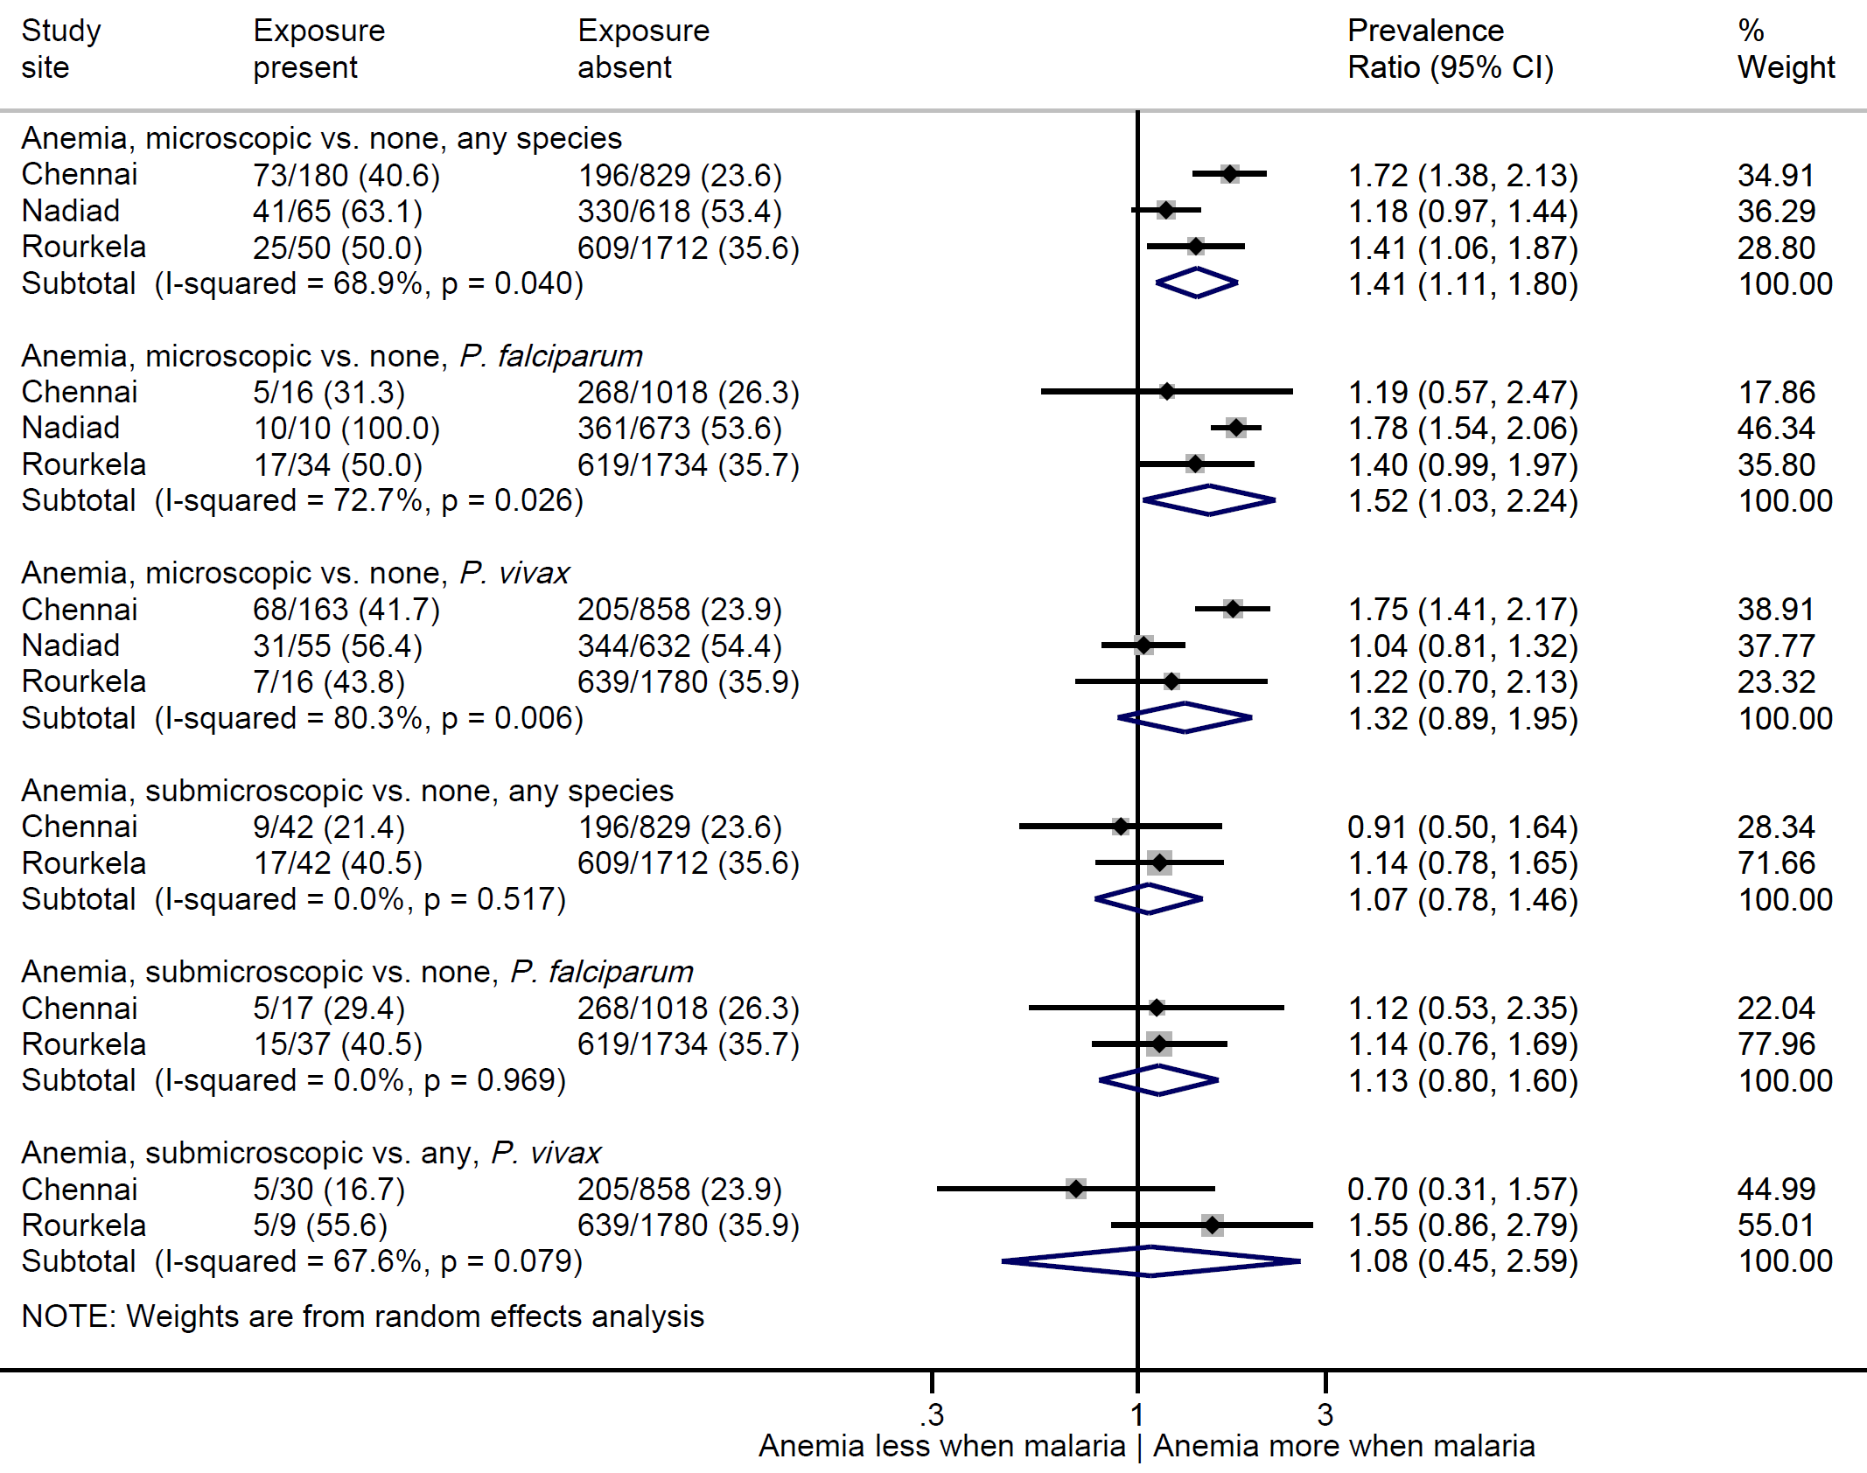
*Only 2 persons with submicroscopic malaria in Nadiad

Figure S4. The risk of P. vivax among persons with and without P. falciparum in community surveys and clinic studies in three sites in India, 2012-2015
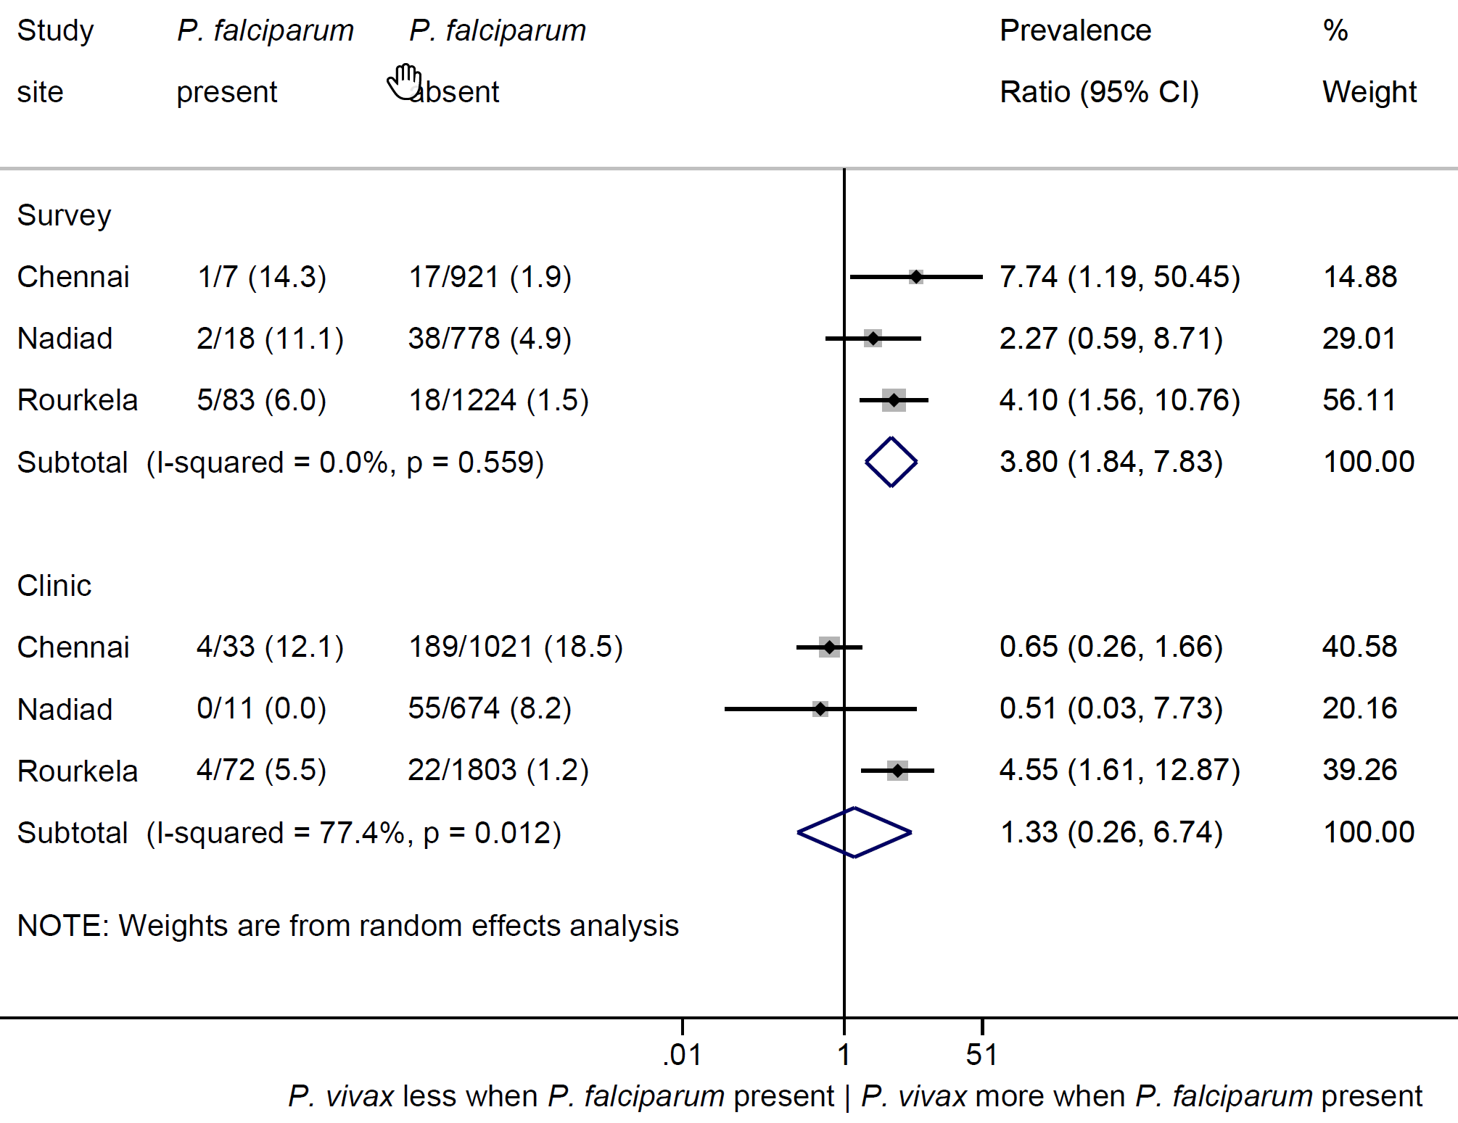

References

1 Haji, Y., Fogarty, A. W. & Deressa, W. Prevalence and associated factors of malaria among febrile children in Ethiopia: A cross-sectional health facility-based study. Acta tropica 155, 63-70, doi:10.1016/j.actatropica.2015.12.009 (2016).
2 Baum, E. et al. Submicroscopic and asymptomatic Plasmodium falciparum and Plasmodium vivax infections are common in western Thailand - molecular and serological evidence. Malar. J. 14, 95, doi:10.1186/s12936-015-0611-9 (2015).
3 Shahzadi, S. et al. Molecular detection of malaria in South Punjab with higher proportion of mixed infections. Iran. J. Parasitol. 9, 37-43 (2013).
4 Golassa, L. et al. Microscopic and molecular evidence of the presence of asymptomatic Plasmodium falciparum and Plasmodium vivax infections in an area with low, seasonal and unstable malaria transmission in Ethiopia. BMC Infect. Dis. 15, 310, doi:10.1186/s12879-015-1070-1 (2015).
5 Tripura, R. et al. Persistent Plasmodium falciparum and Plasmodium vivax infections in a western Cambodian population: implications for prevention, treatment and elimination strategies. Malar. J. 15, 181, doi:10.1186/s12936-016-1224-7 (2016).
6 Steenkeste, N. et al. Sub-microscopic malaria cases and mixed malaria infection in a remote area of high malaria endemicity in Rattanakiri province, Cambodia: implication for malaria elimination. Malar. J. 9, 108, doi:10.1186/1475-2875-9-108 (2010).
7 Imwong, M. et al. The epidemiology of subclinical malaria infections in South-East Asia: findings from cross-sectional surveys in Thailand-Myanmar border areas, Cambodia, and Vietnam. Malar. J. 14, 381, doi:10.1186/s12936-015-0906-x (2015).
8 Nguitragool, W. et al. Very high carriage of gametocytes in asymptomatic low-density Plasmodium falciparum and P. vivax infections in western Thailand. Parasit Vectors 10, 512, doi:10.1186/s13071-017-2407-y (2017).
9 Lover, A. A. et al. Prevalence and risk factors for asymptomatic malaria and genotyping of glucose 6-phosphate (G6PD) deficiencies in a vivax-predominant setting, Lao PDR: implications for sub-national elimination goals. Malar J 17, 218, doi:10.1186/s12936-018-2367-5 (2018).
10 Chaturvedi, N. et al. Prevalence of afebrile parasitaemia due to Plasmodium falciparum & P. vivax in district Balaghat (Madhya Pradesh): Implication for malaria control. Indian J Med Res 146, 260-266, doi:10.4103/ijmr.IJMR_1538_16 (2017).
11 Starzengruber, P. et al. High prevalence of asymptomatic malaria in south-eastern Bangladesh. Malar. J. 13, 16, doi:10.1186/1475-2875-13-16 (2014).

