Supplementary Information
Slitrk2 controls excitatory synapse development via PDZ-mediated protein interactions

Kyung Ah Han¹, Jinhu Kim¹, Hyeonho Kim¹, Dongwook Kim, Dongseok Lim, Jaewon Ko & Ji Won Um#

Department of Brain and Cognitive Sciences, Daegu Gyeongbuk Institute of Science and Technology (DGIST), 333 Techno Jungangdae-Ro, Hyeonpoong-eup, Dalseong-gun, Daegu 42988, Korea

¹These authors contributed equally to this study
#Correspondence and requests for materials should be addressed to J.W.U. (email: jiwonum@dgist.ac.kr)
Supplementary Figures
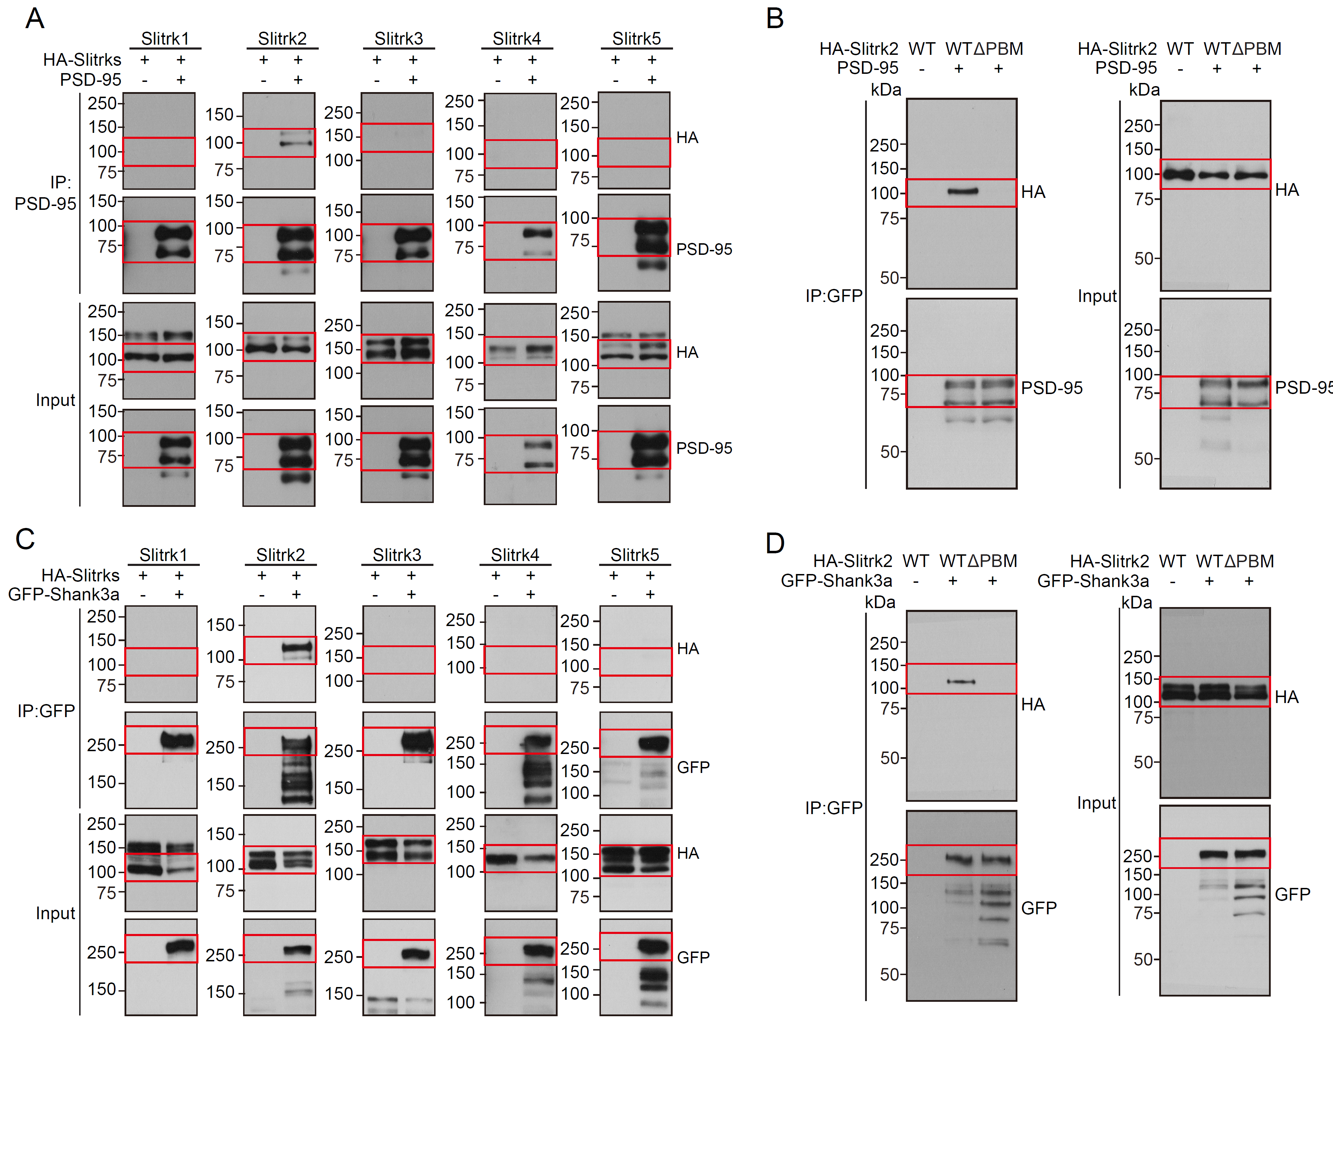
Supplementary Figure 1. Uncropped WB images
(A, B, C) The original WB images used for Figure 1C(A), 1D(B), 1F(C), and 1G(D). Red boxes indicate cropped lines.

Supplementary Figure 2. Uncropped WB images
(A, B) The original WB images used for Figure 2A(A), and 2B(B). Asterisks indicate non-specific bands. Red boxes indicate cropped lines.
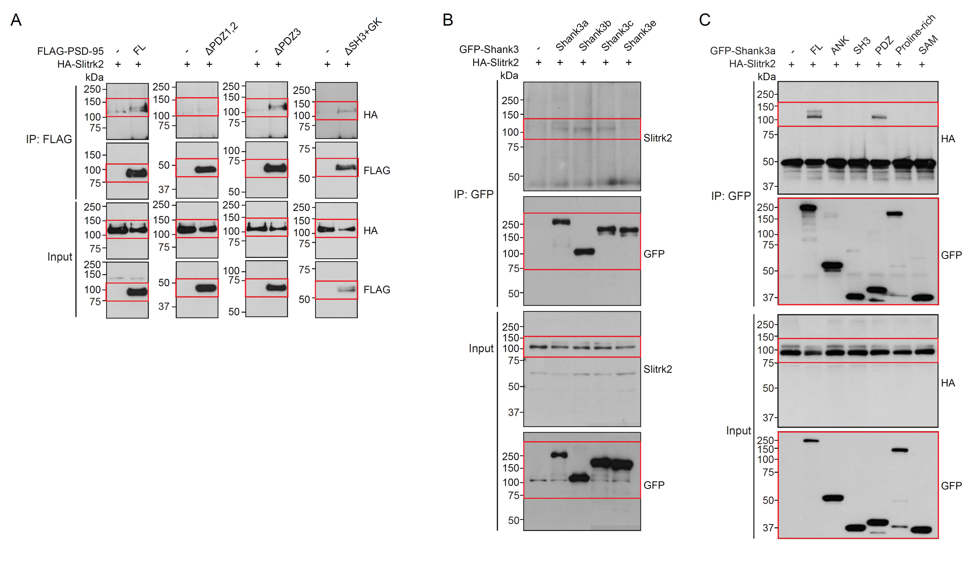
Supplementary Figure 3. Uncropped WB images
(A, B, C) The original WB images used for Figure 3B(A), 3D(B), and 3F(C). Red boxes indicate cropped lines.

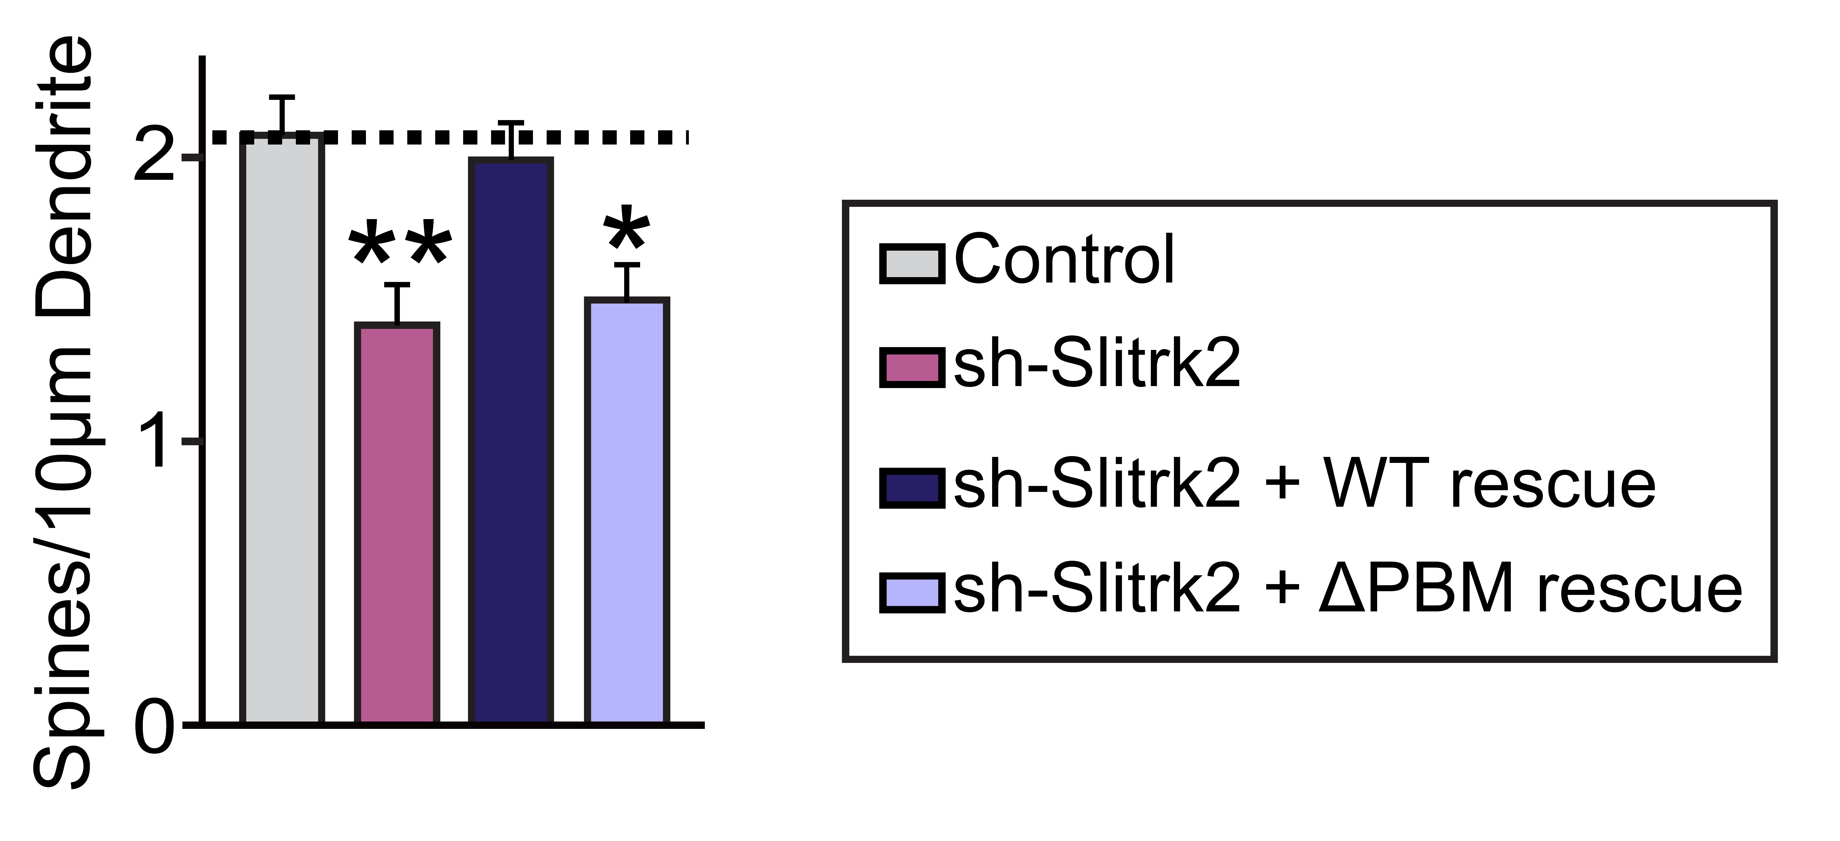

Supplementary Figure 4. The effects of Slitrk2 knockdown in neurons on dendritic spine density.
Cultured hippocampal neurons were transfected with a lentiviral vector expressing sh-Control, sh-Slitrk2, or coexpressing sh-Slitrk2 and shRNA-resistant Slitrk2 WT or Slitrk2 ΔPBM at DIV8 and analyzed at DIV14 by immunofluorescence staining for EGFP. Graph indicates the number of dendritic spines. Data are presented as means ± SEMs from three independent experiments (n = 22–30 neurons; *p < 0.05, **p < 0.01 vs. control; non-parametric ANOVA with Kruskal-Wallis test followed by post hoc Dunn’s multiple comparison test).

Supplementary Figure 5. Analysis of AAV expression in the hippocampal CA1 region.
(A) Representative images of the AAV-infected neurons in hippocampal CA1 regions of the mouse brain coronal section (-1.8 mm relative to Bregma), immunostained for EGFP (green), and counterstained with DAPI (blue). Scale bar: 1 mm.
(B) Representative images of hippocampal CA1 pyramidal cell layers 2 weeks after stereotactic injection of AAVs expressing sh-Slitrk2 or coexpressing sh-Slitrk2 and HA-tagged Slitrk2 WT (+ Slitrk2 WT) or HA-tagged Slitrk2 ΔPBM (+ Slitrk2 ΔPBM), immunostained for EGFP (green) and Slitrk2 or HA (red), and counterstained with DAPI (blue). Scale bar: 20 μm (applies to all images).
(C) Immunoblotting analyses with Slitrk2 antibodies to show the knockdown efficacy of sh-Slitrk2 in vivo. Infected mouse brain lysates were collected after stereotactic injection of AAVs expressing sh-Slitrk2 or coexpressing sh-Slitrk2 and HA-tagged shRNA-resistant Slitrk2 WT (+ S2 WT) or HA-tagged Slitrk2 ΔPBM (+ S2 ΔPBM), and immunoblotted with anti-Slitrk2 antibodies. anti-β-actin antibodies were used as normalization controls. An asterisk indicates non-specific bands.

