Dopamine and cAMP-regulated phosphoprotein 32kDa (DARPP-32) and survival in breast cancer: a retrospective analysis of protein and mRNA expression

Shreeya Kotecha, Marie N Lebot, Bhudsaban Sukkarn, Graham Ball, Paul M Moseley, Stephen Y Chan, Andrew R Green, Emad Rakha, Ian O Ellis, Stewart G Martin, Sarah J Storr

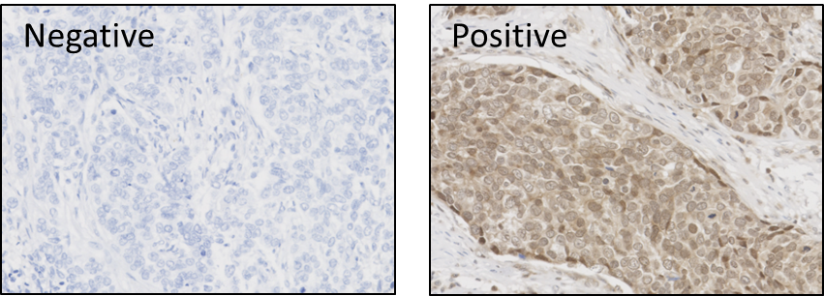

Supplementary Figure 1:
Representative photomicrographs of negative and positive control staining in breast cancer tissue (magnification at 100x).

