Differentially Expressed Genes between Carrot Petaloid Cytoplasmic Male Sterile and Maintainer during Floral Development
Bo Liu¹⁺, Chenggang Ou¹⁺, Shumin Chen¹⁺, Qiongwen Cao¹, Zhiwei Zhao¹, Zengjian Miao², Xiaoping Kong² and Feiyun Zhuang¹*
⁺ These authors contributed equally to this work and share the first authorship.
¹ Key Laboratory of Horticultural Crop Biology and Germplasm Innovation, Ministry of Agriculture; Institute of Vegetables and Flowers, Chinese Academy of Agricultural Science
No. 12 Nanda Street, Zhongguan Cun, Haidian District, Beijing 100081, China
² Xining Institute of Vegetables, Xining
No. 4 Weisan Road, Biological Industry Park, Xining 810016, Qinghai
*Corresponding author. E-mail address: zhuangfeiyun@caas.cn

Supplementary Figure
Plant hormone signal transduction

T2
T3
T4
T1

Phenylpropanoid biosynthesis

T2
T3
T4
T1

Pentatricopeptide repeat Protein

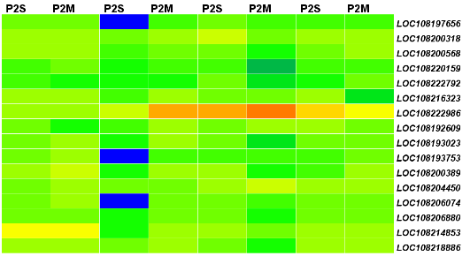

Log₂(FPKM)
T2
T3
T4
T1

Figure S1. Heatmap of DEGs involved in plant hormone signal transduction, phenylpropanoid biosynthesis and pentatricopeptide repeat protein.

