Supplementary material

Photo-ID and telemetry highlight a global whale shark hotspot in Palawan, Philippines
Gonzalo Araujo^{1,*}, Ariana Agustines¹, Brian Tracey¹, Sally Snow¹, Jessica Labaja¹, Alessandro Ponzo¹
¹Large Marine Vertebrates Research Institute Philippines, Cagulada Compound, Jagna, 6308, Bohol
*Corresponding author: g.araujo@lamave.org | +639054043833

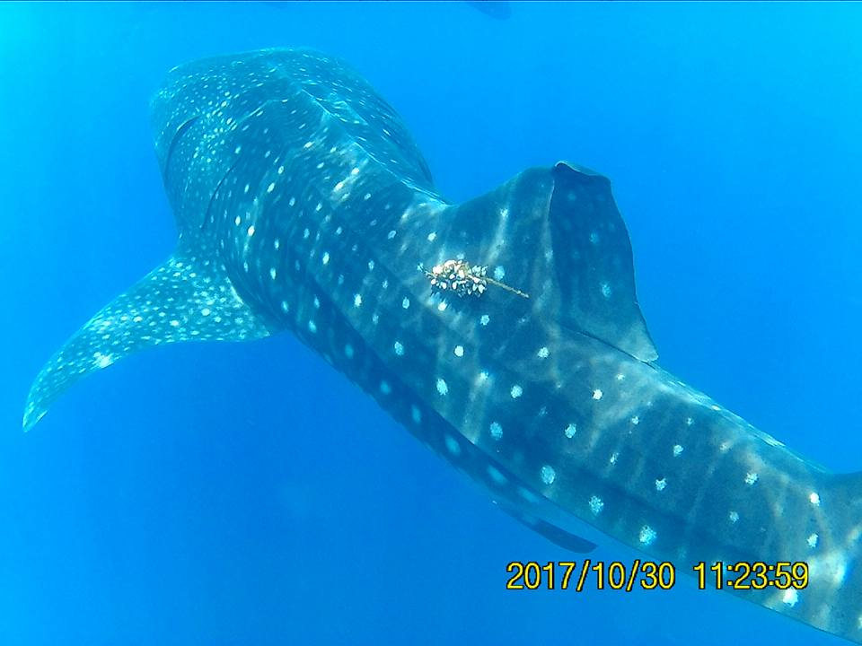
Supplementary Figure 1. Whale shark P-1122 resighted on October 30, 2017, carrying a heavily-fouled miniPAT tag in Honda Bay, Palawan. ©Andy Leonor, Dolphin and Whales Travel and Tours.

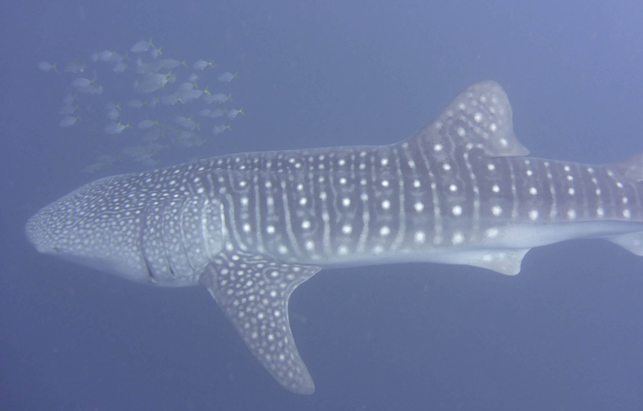
Supplementary Figure 2. Whale shark P-1396 resighted ~1 year after initial tagging showing no obvious scars or markings.

Supplementary Figure 3. Deep dives (>200 m) by individuals P-1125, P-1126 and P-1128 between July 2017 and January 2018. Note the periodicity in deep-dives over time.

Supplementary Table 1. Summary of data sourced from online searches on popular social media platforms, obtained directly from the tour operator, a local photographer and from preliminary work by the Authors in 2016 and 2017. Keywords are case sensitive. Only left flank identification images are used to determine the identity of an individual whale shark.
Source | Keyword used | Results | Honda Bay IDs Extracted
©Facebook | Butanding Honda Bay | 1 | 1
 | Butanding puerto princesa | 1 | 0
 | Honda Bay Whale Shark | 25 | 9
 | Puerto Princesa whale shark | 4 | 0
 | Whale shark Honda Bay | 1 | 0
 | Whale shark Palawan | 7 | 4
 | Whale Shark Puerto Princesa | 84 | 25
©Instagram | #hondabay | 27 | 6
 | #palawanwhaleshark | 1 | 0
 | #whalesharkpalawan | 1 | 0
 | whaleman_wanderer | 7 | 1
©YouTube | Honda Bay Whale Shark | 2 | 0
 | Palawan Whale shark | 2 | 1
 | Puerto Princesa whale shark | 16 | 8
Dolphin and Whales Travel and Tours | - | 24 | 24
Duncan Murrell | - | 27 | 27
Authors (2016) | - | - | 10
Authors (2017) | - | - | 10
 | Total | 230 | 126
 |  | Individual IDs | 86

Supplementary Video 1. Most probable track for the five tags that transmitted data, with confidence intervals in red (50%), dark orange (95%) and light orange (99%).

