Supplementary Information

Discriminative biogeochemical signatures of methanotrophs inhabiting different chemosynthetic habitats in an active mud volcano of the Canadian Beaufort Sea

Dong-Hun Lee^{1,}†, Yung Mi Lee^{2,}†, Jung-Hyun Kim^{2,*}, Young Keun Jin², Charles Paull³, Helge Niemann^{4,5}, Ji-Hoon Kim⁶, Kyung-Hoon Shin^{1,**}

¹Hanyang University ERICA campus, 15588 Ansan, South Korea
²KOPRI Korea Polar Research Institute, 21990 Incheon, South Korea
³Monterey Bay Aquarium Research Institute, Moss Landing, California, USA
⁴NIOZ Royal Netherlands Institute for Sea Research, Department of Marine Microbiology and Biogeochemistry, and Utrecht University, NL-1790 AB Den Burg, The Netherlands
⁵Department of Earth Sciences, Faculty of Geosciences, Utrecht University, Utrecht, The Netherlands
⁶Korea Institute of Geoscience and Mineral Resources, Daejeon 34132, South Korea

†These authors contributed equally to this work.

* Corresponding author:
Tel.: +82 32 760 5377
jhkim123@kopri.re.kr

** Co-corresponding author:
Tel.: +82 31 400 5536
shinkh@hanyang.ac.kr

Table S1. Lipid concentrations and carbon isotopic compositions in push core sediments of MV420.
Core depth  (cm) | Archaeal lipids |  |  |  |  |  |  |  |  |  |  |  |  | Bacterial lipids
Core depth  (cm) | Archaeol |  | sn-2-hydroxyarchaeol |  | GDGT-0 | GDGT-1 | GDGT-2 | GDGT-3 | Crenarchaeol | Biphytane-0 | Biphytane-1 | Biphytane-2 | Biphytane-3 | 4α-methyl sterols |  | C16:1ω8 |  | C16:1ω5
Core depth  (cm) | μg g⁻¹ dw | ‰ VPDB | μg g⁻¹ dw | ‰ VPDB | μg g⁻¹ dw | μg g⁻¹ dw | μg g⁻¹ dw | μg g⁻¹ dw | μg g⁻¹ dw | ‰ VPDB | ‰ VPDB | ‰ VPDB | ‰ VPDB | μg g⁻¹ dw | ‰ VPDB | μg g⁻¹ dw | ‰ VPDB | μg g⁻¹ dw | ‰ VPDB
DM site
1 | 0.01 | ND | ND | ND | 0.15 | 0.01 | 0.01 | 0.00 | 0.18 | -33.3 | ND | -39.7 | -24.5 | 0.30 | -91.1 | 0.09 | -31.7 | 0.07 | -44.1
3 | 0.04 | -38.6 | 0.02 | -83.4 | 0.07 | 0.01 | 0.01 | 0.00 | 0.08 | -31.3 | -62.1 | -39.1 | -26.9 | 0.30 | -88.7 | 0.08 | -31.1 | 0.04 | -42.3
5 | 0.04 | -43.2 | 0.03 | -91.7 | 0.13 | 0.01 | 0.01 | 0.00 | 0.11 | -40.0 | -65.6 | -42.9 | -15.6 | 0.28 | -86.0 | 0.01 | ND | 0.01 | ND
8 | 0.04 | -46.5 | 0.03 | -92.6 | 0.05 | 0.01 | 0.01 | 0.00 | 0.04 | -42.6 | -67.5 | -36.3 | -17.7 | 0.15 | -74.8 | 0.01 | ND | 0.01 | ND
12 | 0.04 | -45.9 | 0.05 | -89.1 | 0.05 | 0.01 | 0.01 | 0.00 | 0.03 | -37.5 | -70.9 | -54.7 | -20.2 | 0.01 | ND | 0.01 | ND | 0.01 | ND
16 | 0.06 | -46.3 | 0.07 | -87.4 | 0.05 | 0.01 | 0.01 | 0.00 | 0.03 | -32.2 | -71.1 | -27.5 | -21.9 | 0.01 | ND | ND | ND | 0.01 | ND
BM site
1 | 0.00 | ND | ND | ND | 0.43 | 0.02 | 0.01 | 0.01 | 0.68 | -30.1 | ND | -36.7 | -29.2 | 0.63 | -81.5 | 0.07 | -49.7 | 0.07 | -54.1
3 | 0.00 | ND | ND | ND | 0.25 | 0.02 | 0.01 | 0.01 | 0.61 | -30.5 | -73.4 | -43.9 | -18.6 | 0.70 | -84.0 | 0.05 | -53.9 | 0.02 | -50.3
5 | 0.08 | -47.5 | 0.02 | -90.8 | 0.14 | 0.02 | 0.01 | 0.01 | 0.18 | -31.4 | -69.5 | -40.5 | -20.4 | 0.31 | -61.8 | 0.02 | -46.4 | 0.02 | -48.0
8 | 0.10 | -51.6 | 0.05 | -98.3 | 0.16 | 0.02 | 0.02 | 0.02 | 0.11 | -33.3 | -62.5 | -33.4 | -22.7 | 0.12 | -49.0 | ND | ND | 0.01 | ND
12 | 0.10 | -50.7 | 0.06 | -96.9 | 0.15 | 0.02 | 0.02 | 0.01 | 0.11 | -32.7 | -67.6 | -47.6 | -23.5 | 0.13 | -38.9 | ND | ND | 0.00 | ND
16 | 0.10 | -46.5 | 0.06 | -93.1 | 0.16 | 0.02 | 0.02 | 0.01 | 0.11 | -31.9 | -60.5 | -42.5 | -24.3 | 0.01 | ND | ND | ND | 0.00 | ND
ST site
1 | 0.00 | ND | 0.00 | ND | 0.10 | 0.00 | 0.00 | 0.00 | 0.13 | -22.7 | N. D. | -37.0 | -23.4 | 0.21 | -56.1 | 0.03 | -41.2 | 0.04 | -59.0
3 | 0.04 | -48.0 | 0.02 | -85.6 | 0.07 | 0.01 | 0.01 | 0.00 | 0.16 | -26.2 | -45.5 | -19.4 | -19.2 | 0.18 | -45.6 | 0.06 | -53.7 | 0.02 | -63.8
5 | 0.06 | -49.7 | 0.05 | -102.5 | 0.04 | 0.01 | 0.01 | 0.00 | 0.05 | -37.7 | -46.7 | -30.6 | -24.2 | 0.10 | -42.7 | 0.02 | -61.5 | 0.02 | -59.0
7 | 0.05 | -50.7 | 0.08 | -105.2 | 0.04 | 0.01 | 0.01 | 0.00 | 0.03 | -30.6 | -47.5 | -35.5 | -26.8 | 0.08 | -36.1 | 0.01 | ND | 0.01 | ND
9 | 0.05 | -63.8 | 0.08 | -106.1 | 0.03 | 0.01 | 0.01 | 0.00 | 0.02 | -32.9 | -55.8 | -48.9 | -28.5 | 0.08 | -34.8 | 0.01 | ND | 0.01 | ND
12 | 0.05 | -65.5 | 0.09 | -109.6 | 0.03 | 0.01 | 0.01 | 0.00 | 0.02 | -26.1 | -59.5 | -34.6 | -27.3 | 0.01 | ND | 0.01 | ND | 0.01 | ND
Reference site
1 | ND | ND | ND | ND | 0.58 | 0.02 | 0.01 | 0.00 | 0.54 | -19.0 | -40.0 | -28.4 | -27.5 | ND | ND | ND | ND | 0.02 | ND
5 | ND | ND | ND | ND | 0.56 | 0.02 | 0.01 | 0.00 | 0.54 | -27.3 | -45.6 | -31.7 | -27.2 | ND | ND | ND | ND | 0.00 | ND
11 | ND | ND | ND | ND | 0.64 | 0.03 | 0.01 | 0.00 | 0.61 | -27.0 | -38.2 | -22.6 | -28.2 | ND | ND | ND | ND | 0.01 | ND
15 | ND | ND | ND | ND | 0.28 | 0.01 | 0.00 | 0.00 | 0.28 | -26.7 | -40.2 | ND | -30.3 | ND | ND | ND | ND | 0.00 | ND
25 | ND | ND | ND | ND | 0.51 | 0.01 | 0.01 | 0.00 | 0.51 | -23.2 | -41.3 | ND | -26.5 | ND | ND | ND | ND | 0.01 | ND
41 | ND | ND | ND | ND | 0.72 | 0.03 | 0.01 | 0.00 | 0.77 | -21.9 | -43.0 | -23.2 | -23.9 | ND | ND | ND | ND | 0.01 | ND

ND indicates ‘not determined’.

Table S2. Sequence summary and diversity indices.

Core depth (cm) | Archaea |  |  | Bacteria
Core depth (cm) | Reads No. | shannon | invsimpson | Reads No. | shannon | invsimpson
DM site
0 | 26425 | 1.30 | 1.89 | 24612 | 4.69 | 26.29
1 | 15733 | 1.94 | 3.33 | 33598 | 4.36 | 19.51
2 | 32348 | 2.75 | 8.21 | 36191 | 4.21 | 17.70
3 | 36016 | 2.40 | 5.06 | 47345 | 4.11 | 16.23
4 | 32390 | 2.60 | 6.22 | 44411 | 4.27 | 19.97
5 | 40056 | 1.82 | 2.71 | 38520 | 4.03 | 14.01
6 | 44987 | 0.92 | 1.40 | 48774 | 3.15 | 5.50
7 | 28335 | 0.36 | 1.11 | 18511 | 3.77 | 9.83
8 | 63274 | 0.26 | 1.07 | 23316 | 3.69 | 9.52
9 | 54128 | 0.37 | 1.11 | 56241 | 3.89 | 10.94
10 | 58663 | 0.47 | 1.15 | 36445 | 3.90 | 17.93
11 | 77592 | 0.41 | 1.11 | 39953 | 3.61 | 12.23
12 | 44598 | 0.87 | 1.40 | 41731 | 3.78 | 13.45
13 | 53787 | 1.45 | 2.09 | 36521 | 3.51 | 10.23
14 | 56888 | 0.95 | 1.46 | 32083 | 2.75 | 6.46
15 | 54330 | 0.79 | 1.33 | 47485 | 1.98 | 2.98
16 | 76677 | 0.47 | 1.15 | 63065 | 1.81 | 2.87
BM site
0 | N. D | N. D | N. D | 17299 | 4.95 | 39.02
1 | N. D | N. D | N. D | 16539 | 4.61 | 29.96
2 | 65506 | 0.73 | 1.35 | 28319 | 4.57 | 27.12
3 | 43241 | 0.79 | 1.41 | 42456 | 4.53 | 27.27
4 | 53350 | 0.82 | 1.42 | 20496 | 3.63 | 10.11
5 | 78511 | 0.50 | 1.18 | 36411 | 3.90 | 10.86
6 | 53731 | 0.60 | 1.24 | 50541 | 2.91 | 6.25
7 | 53720 | 0.85 | 1.45 | 30922 | 3.72 | 9.17
8 | 57837 | 0.72 | 1.34 | 42752 | 3.24 | 8.94
9 | 33333 | 1.02 | 1.61 | 8070 | 3.63 | 11.96
10 | 50309 | 0.46 | 1.16 | 15560 | 2.95 | 7.89
11 | 50744 | 0.90 | 1.53 | 37696 | 3.52 | 11.01
12 | 61229 | 0.59 | 1.23 | 16626 | 2.95 | 6.28
13 | 110192 | 0.33 | 1.09 | 48091 | 2.41 | 3.71
14 | 59775 | 0.35 | 1.12 | 46172 | 2.53 | 4.28
ST site
0 | 53595 | 1.14 | 2.27 | 31703 | 6.26 | 167.10
1 | 8711 | ND | ND | 17776 | 5.97 | 100.60
2 | 14943 | 2.61 | 7.07 | 31093 | 5.53 | 67.92
3 | 21304 | 2.63 | 6.69 | 37510 | 5.47 | 66.93
4 | 23561 | 2.70 | 7.50 | 19399 | 5.31 | 65.44
5 | 29145 | 2.05 | 3.30 | 34890 | 5.18 | 65.67
6 | 57862 | 1.39 | 1.94 | 32765 | 4.85 | 39.60
7 | 69073 | 1.05 | 1.59 | 39684 | 4.51 | 24.25
8 | 96798 | 0.52 | 1.19 | 39793 | 4.00 | 13.61
9 | 64466 | 0.61 | 1.24 | 27127 | 3.73 | 10.46
10 | 81756 | 0.42 | 1.13 | 36660 | 3.38 | 7.90
11 | 65437 | 0.50 | 1.15 | 37892 | 3.72 | 11.53
12 | 68786 | 0.29 | 1.08 | 25082 | 3.61 | 11.27
13 | 71361 | 0.29 | 1.08 | 29515 | 3.43 | 9.93
14 | 74712 | 0.35 | 1.10 | 46305 | 3.27 | 9.99
15 | 91436 | 0.27 | 1.07 | 30331 | 3.11 | 8.09
16 | 122357 | 0.26 | 1.06 | 48043 | 2.80 | 6.97
17 | 67005 | 0.28 | 1.07 | 39711 | 2.89 | 6.65
Reference site
0 | 41921 | 1.12 | 2.13 | 23459 | 6.89 | 331.66
1 | 35223 | 1.17 | 2.25 | 21928 | 6.77 | 291.09
2 | 58638 | 1.18 | 2.25 | 31106 | 6.76 | 296.45
3 | 40573 | 1.32 | 2.52 | 26927 | 6.71 | 285.31
4 | 36533 | 1.34 | 2.26 | 27294 | 6.75 | 304.76
5 | 10964 | 1.44 | 2.40 | 27567 | 6.72 | 289.96
6 | 11303 | 1.59 | 2.49 | 35995 | 6.85 | 340.26
7 | 26680 | 1.36 | 2.01 | 24851 | 6.76 | 337.02
8 | 26732 | 1.21 | 1.78 | 40093 | 6.57 | 260.00
9 | 26206 | 1.80 | 2.59 | 36969 | 6.71 | 301.31
10 | 36740 | 2.14 | 3.76 | 36404 | 6.51 | 211.19
11 | 31392 | 1.66 | 2.30 | 30134 | 6.47 | 227.08
12 | 42173 | 1.44 | 1.90 | 35205 | 6.59 | 259.25
13 | 10017 | 1.68 | 2.27 | 25018 | 6.51 | 249.97
14 | 13977 | 1.74 | 2.33 | 26409 | 6.35 | 174.80
15 | 25397 | 1.84 | 2.58 | 23206 | 6.37 | 187.55
ND indicates ‘not determined’.

Table S3. Relative abundance of OTUs of the order Methylococcales.
See the Excel file

Table S4. Heat map of major OTUs with taxonomy.
See the Excel file

Table S5. Pearson correlation coefficient between the major OTUs of ANMEs and Deltaproteobacteria.

OTU ID | DM site |  |  |  | BM site |  |  |  | ST site
OTU ID | A_OTU001 |  | A_OTU008 |  | A_OTU001 |  | A_OTU008 |  | A_OTU001 |  | A_OTU008
OTU ID | r | p | r | p | r | p | r | p | r | p | r | p
B_OTU002 | 0.41 | 0.105 | -0.26 | 0.323 | -0.16 | 0.613 | 0.21 | 0.499 | 0.92 | 0.000 | -0.34 | 0.178
B_OTU009 | 0.35 | 0.166 | -0.27 | 0.301 | 0.65 | 0.017 | -0.07 | 0.825 | 0.35 | 0.172 | 0.50 | 0.040
B_OTU011 | 0.33 | 0.200 | -0.24 | 0.353 | -0.20 | 0.522 | 0.03 | 0.926 | 0.91 | 0.000 | -0.20 | 0.442
B_OTU014 | 0.37 | 0.141 | -0.25 | 0.338 | 0.11 | 0.716 | -0.20 | 0.513 | -0.78 | 0.000 | -0.09 | 0.742
B_OTU018 | -0.47 | 0.058 | 0.27 | 0.300 | -0.21 | 0.486 | 0.09 | 0.766 | -0.46 | 0.064 | 0.71 | 0.001
B_OTU024 | 0.22 | 0.393 | -0.18 | 0.496 | -0.23 | 0.451 | -0.07 | 0.821 | 0.34 | 0.175 | 0.18 | 0.498
B_OTU029 | 0.38 | 0.128 | -0.28 | 0.275 | -0.31 | 0.305 | 0.14 | 0.645 | 0.17 | 0.514 | 0.71 | 0.001
B_OTU176 | 0.29 | 0.260 | -0.13 | 0.616 | -0.41 | 0.161 | -0.25 | 0.419 | ND | ND | ND | ND
B_OTU010 | -0.76 | 0.000 | 0.10 | 0.705 | -0.17 | 0.574 | -0.01 | 0.962 | -0.81 | 0.000 | 0.44 | 0.077
B_OTU064 | -0.36 | 0.159 | -0.18 | 0.486 | -0.60 | 0.031 | -0.49 | 0.087 | -0.90 | 0.000 | -0.15 | 0.567
B_OTU095 | 0.20 | 0.432 | -0.26 | 0.312 | ND | ND | ND | ND | -0.48 | 0.049 | -0.20 | 0.443
B_OUT119 | -0.66 | 0.004 | -0.09 | 0.725 | -0.07 | 0.823 | -0.10 | 0.756 | -0.72 | 0.001 | -0.29 | 0.262
* r indicates the Pearson correlation coefficient and p is the p value.
Bold indicates significant correlations (p < 0.01) between archaeal OTUs and deltaproteobacterial OTUs.
‘ND’ indicates ‘not determined’.

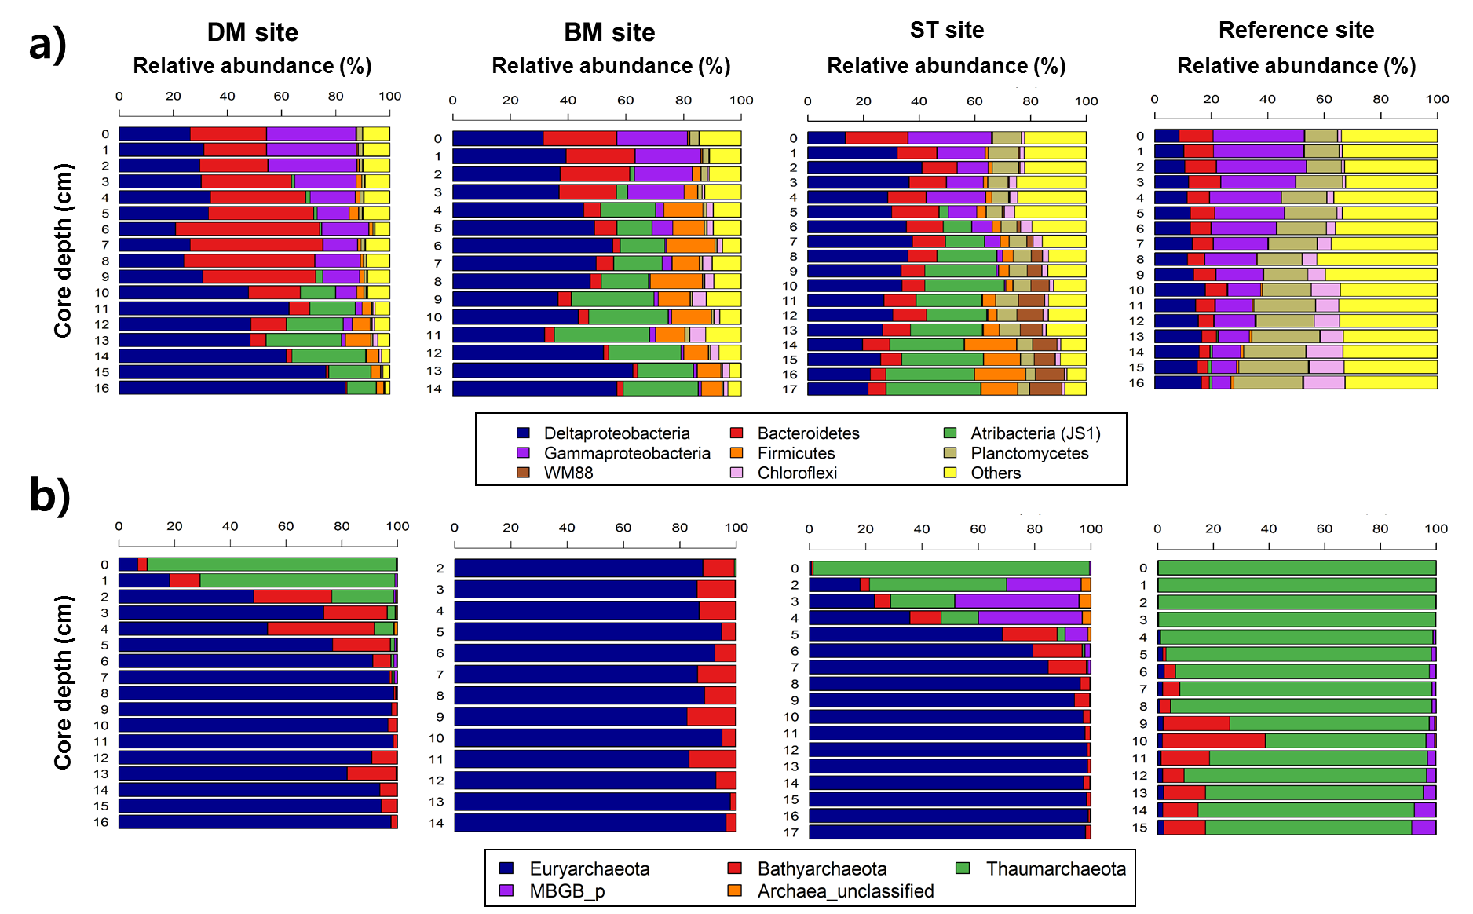

Figure S1. Relative abundance of (a) bacterial taxa at phylum level and class level of Proteobacteria) and (b) archaeal (at class level) along the core depths.
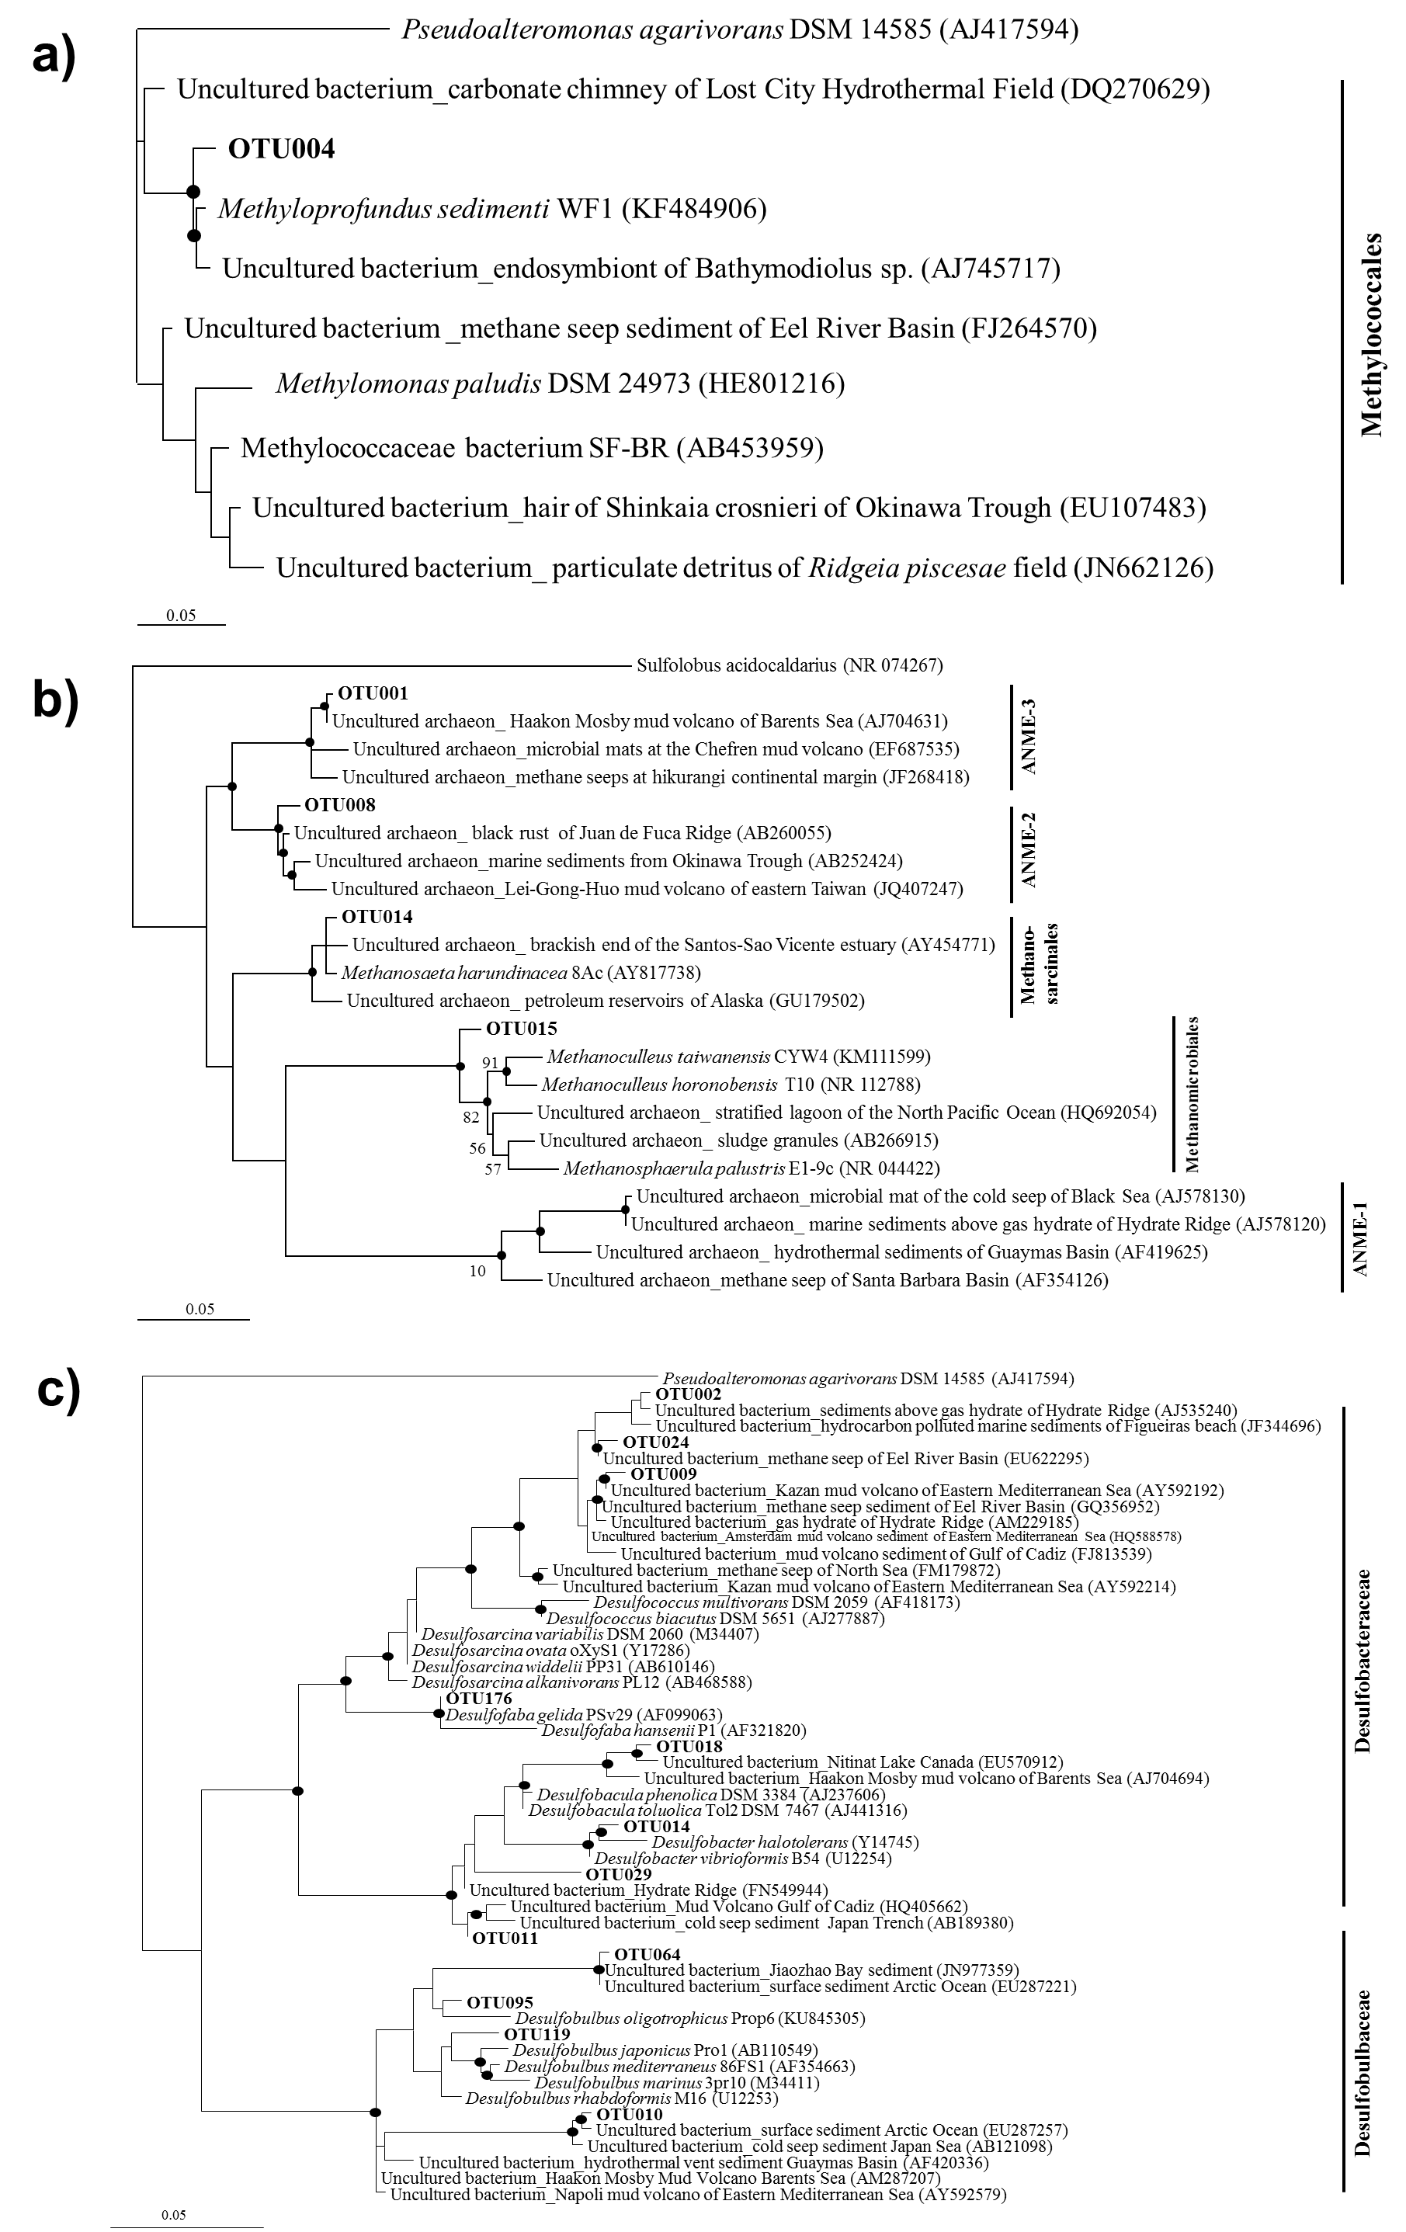

Figure S2. Phylogenetic tree of major OTUs of (a) Methylococcales, (b) Methanomicrobia, and (c) Deltaprotepbacteria. Major OTUs with more than 5 % in relative abundance at each sample were selected and phylogenetic tree was reconstructed by the heuristic search with the maximum likelihood algorithm with the GTR evolutionary model. Filled circles indicate that the corresponding nodes had >70 % bootstrap values based on 1,000 resamplings. Bars indicate 5 nucleotide substitutions per 100 nucleotides.
Sequence S1. 16S rRNA sequences of archaeal OTUs of Methanomicrobia with greater than 5 % relative abundance used for the phylogenetic analysis.

>A_OTU001
TCAATCGGAGTCAACGCCGGAAAACTCACCGGGGGCGACAGCAATATGTA
GGTCAGGCTAAAGACCTTACCCGAATCGCTGAGAGGAGGTGCATGGCCGT
CGTCAGTTCGTACTGTGAAGCATCCTGTTAAGTCAGGCAACGAGCGAGAC
CCGTGCCCACTGTTGCCAGCATGCCCTTCGGGGTGATGGGTACTCTGTGG
GGACCGCCGCTGCTAAAGCGGAGGAAGGTGCGGGCTACGGTAGGTCAGTA
TGCCCCGAATCTCCCGGGCTACACGCGGGCTACAATGATTGGGACAATGG
GTCCCTACTCCGAAAGGAGATGGTAATCTCATAAACCCAACCTTAGTTCG
AATTGAGGGCTGTAACTCGCCCTCATGAAGCTGGAATCCGTAGTAATCGC
GTTTCAACATAGCGCGGTGAATACGTCCCTGCCCCTTGCACTCACC
> A_ OTU014
TTAATCGGAGTCAACGCCGGAAATCTCACCGGGGGCGACAGCGATATGAA
GGTCAGGCTGAAGACCTTACCGGATTAGCTGAGAGGTGGTGCATGGCCGT
CGTCAGTTCGTACTGTGAAGCATCCTGTTAAGTCAGGCAACGAGCGAGAC
CCACGTCCACAGTTGCCAGCATACCCTCCGGGGTGATGGGTACACTGTGG
AGACCGCCGCTGCTAAAGCGGAGGAAGGAATGGGCAACGGTAGGTCAGTA
TGCCCCGAATCTCCCGGGCTACACGCGGGCTACAATGGTTGGTACAATGG
GCATCTACCCCGAAAGGGGAAGGAAATCTCTTAAAGCCAATCGTAGTTCG
GATTGAGGGCTGCAACTCGCCCTCATGAAGCTGGAATCCGTAGTAATCGC
GTTTCAACAGAACGCGGTGAATACGTCCCTGCCCCTTGCACACACC
> A_ OTU008
TCAATCGGAGTCAACGCCGGAAAACTCACCGGGTGCGACAGCAACATGTA
GGTCAGGCTGAAGGTCTTACCTGAATCGCTGAGAGGAGGTGCATGGCCGT
CGTCAGTTCGTACTGTGAAGCATCCTGTTAAGTCAGGCAACGAGCGAGAC
CCGCGCCCACAGTTGCCAGCATGTTCTCCGGAACGATGGGCACACTGTGG
GGACCGCCGCTGCTAAAGCGGAGGAAGGAACGGGCTACGGTAGGTCAGTA
TGCCCCGAATCTCCCGGGCTACACGCGGGCTACAATGGTTGGCACAATGG
GCACCTACCCCGAAAGGGGACGGTAATCTCCTAAATCCAACCGTAGTTCG
GATTGAGGGCTGTAACTCGCCCTCATGAAGCTGGAATCCGTAGTAATCGC
GTTTCAACATAGCGCGGTGAATACGTCCCTGCCCCTTGCACTCACC
> A_ OTU015
TTAATTGGAGTCAACGCCGGAAAACTCACCGGATAAGACAGCAGAATGAT
AGCCAGGCTGAAGACCTTGCTTGACCAGCTGAGAGGAGGTGCATGGCCGT
CGTCAGTTCGTACTGTGAAGCATCCTGTTAAGTCAGGCAACGAGCGAGAC
CCACGCCAACAGTTGCCAGCATGTCCTCCGGGATGATGGGGACACTGTTG
GGACCGCCTCTGCTAAAGAGGAGGAAGGAATGGGCAACGGTAGGTCAGCA
TGCCCCGAATTATCCGGGCTACACGCGGGCTACAATGGGCAGGACAATGG
GTATCGACACCGAAAGGTGAAGGAAATCTCCTAAACCTGTCCGTAGTTCG
GATTGTGGGCTGCAACTCGCCCACATGAAGCTGGAATCTGTAGTAATCGC
GTTTCAAAATAGCGCGGTGAATGCGTCCCTGCCCCTTGCACACACC

Sequence S2. 16S rRNA sequences of Deltaproteobacteria with greater than 5 % relative abundance used for the phylogenetic analysis.

> B_OTU002
TGTGAAAGCCCGGGGCTCAACCCCGGAAGTGCATTTGAAACTGAGAGACT
TGAGTATGGGAGAGGGAAGTGGAATTCCTGGTGTAGAGGTGAAATTCGTA
GATATCAGGAGGAACACCGGTGGCGAAGGCGACTTCCTGGACCAATACTG
ACGCTGAGGCGCGAAGGCGTGGGGAGCAAACAGGATTAGATACCCTGGTA
GTCCACGCAGTAAACGGTGAACACTAGGTGTAGCGGGTATTGACCCCTGC
TGTGCCGTAGCTAACGCATTAAGTGTTCCGCCTGGGGAGTACGACCGCAA
GGTTAAAACTCAAAGGAATTGGCGG
> B_OTU009
TGTGAAAGCCCGGGGCTTAACCCCGGAAGTGCATTTGAAACTGAAAAACT
TGAGTATGGGAGAGGGAAGTGGAATTCCTGGTGTAGAGGTGAAATTCGTA
GATATCAGGAGGAACACCGGTGGCGAAGGCGACTTCCTGGACCAATACTG
ACGCTGAGGCGCGAAGGCGTGGGGAGCAAACAGGATTAGATACCCTGGTA
GTCCACGCAGTAAACGATGAACACTAGGTGTAGCGGGTATTGACCCCTGC
TGTGCCGCAGTTAACGCATTAAGTGTTCCGCCTGGGGAGTACGACCGCAA
GGTTAAAACTCAAAGAAATTGACGG
> B_OTU010
TGTGAAAGTCCACGGCTCAACCGTGGAAGTGCATTTGAAACTGGCAAACT
TGAGTACTGGAGGGGGTAGTGGAATTCCCGGTGTAGAGGTGAAATTCGTA
GATATCGGGAGGAATACCGGTGGCGAAGGCGACTACCTGGCCAGATACTG
ACACTGAGGTGCGAAAGCGTGGGGAGCAAACAGGATTAGATACCCTGGTA
GTCCACGCCGTAAACGATGTCAACTAGGTGTTGGGATGGTTAATCGTCTC
ATTGCCGCAGCTAACGCATTAAGTTGACCGCCTGGGGAGTACGGTCGCAA
GATTAAAACTCAAAGAAATTGACGG
> B_OTU011
TGTGAAAGCCCGGGGCTCAACCCTGGAAGTGCATTTGAAACAGCAAGACT
TGAGTACGGGAGAGGAAAGCGGAATTCCTGGTGTAGAGGTGAAATTCGTA
GATATCAGGAGGAACACCGATGGCGAAGGCAGCTTTCTGGACCGATACTG
ACGCTGAGGCGCGAAGGCGTGGGTAGCGAACAGGATTAGATACCCTGGTA
GTCCACGCAGTAAACGATGTTCACTAGGTGTAGCGGGTATTAAAATCTGC
TGTGCCGGAGCTAACGCATTAAGTGAACCGCCTGGGGAGTACGGTCGCAA
GACTAAAACTCAAAGAAATTGACGG
> B_OTU014
TGTGAAAGCCCGGGGCTTAACCCCGGAAGTGCACTTGAAACAGCAAGACT
TGAATACGGGAGAGGAAAGCGGAATTCCTGGTGTAGAGGTGAAATTCGTA
GATATCAGGAGGAACACCGATGGCGAAGGCAGCTTTCTGGACCGATATTG
ACGCTGAGGCGCGAAGGCGTGGGTAGCGAACGGGATTAGATACCCCGGTA
GTCCACGCAGTAAACGTTGTACACTCGGTGTGGCGGATATTAAAATCTGC
TGTGCCTAAGCTAACGCATTAAGTGTACCGCCTGGGAAGTACGGTCGCAA
GACTAAAACTCAAAGGAATTGGCGG
> B_OTU018
TGTGAAAGCCCAGGGCTCAACCCTGGACGTGCATTTGAAACAGTAAGACT
TGAGTACTGGAGAGGAAAGCGGAATTCCTGGTGTAGAGGTGAAATTCGTA
GATATCAGGAGGAACACCGATGGCGAAGGCAGCTTTCTGGACAGAAACTG
ACGCTGATGCGCGAAGGCGTGGGTAGCGAACAGGATTAGATACCCTGGTA
GTCCACGCAGTAAACGATGTACACTAGGTGTAGGGGATATTAAAATTTTC
TGTGCCGCAGCTAACGCATTAAGTGTACCGCCTGGGGAGTACGGTCGCAA
GACTAAAACTCAAAGAAATTGACGG
> B_OTU024
TGTGAAAGCCCGGGGCTCAACCCCGGAAGTGCATTTGAAACTAATGGACT
TGAGTATGGGAGAGGGAAGTGGAATTCCTGGTGTAGAGGTGAAATTCGTA
GATATCAGGAGGAACACCGGTGGCGAAGGCGACTTCCTGGACCAATACTG
ACGCTGAGGCGCGAAGGCGTGGGGAGCAAACAGGATTAGATACCCTGGTA
GTCCACGCAGTAAACGGTGAACACTAGGTGTAGCGGGTATTGACCCCTGC
TGTGCCGCAGTTAACGCATTAAGTGTTCCGCCTGGGGAGTACGGCCGCAA
GGTTAAAACTCAAAGAAATTGACGG
> B_OTU029
TGTGAAAGCCCGGGGCTCAACCCTGGAAGTGCATTTGAAACAGCAAGACT
TGAGTACGGGAGAGGAGAGCGGAATTCCTGGTGTAGAGGTGAAATTCGTA
GATATCAGGAGGAACACCGATGGCGAAGGCAGCTCTCTGGACCGATACTG
ACGCTGAGGCGCGAAGGTGTGGGTAGCGAACAGGATTAGATACCCTGGTA
GTCCACACAGTAAACGTTGTTCACTCGGTGTAGCGGATATTAAAATCTGC
TGTGCCCAAGCTAACGTGGTAAGTGAACCGCCTGGGGAGTACGGTCGCAA
GACTAAAACTCAAATAAATTGACGG
> B_OTU095
TGTGAAAGCCCACGGCTTAACCGTGGAAGTGCATTTGAAACTGTCAGACT
TGAGTACCAGAGGGGAAAGTGGAATTCCCGGTGTAGAGGTGAAATTCGTA
GATATCGGGAGGAATACCGGTGGCGAAGGCGACTTTCTGGCTGGATACTG
ACGCTGAGGCGCGAAAGCGTGGGGAGCAAACAGGATTAGATACCCTGGTA
GTCCACGCTGTAAACGATGTGAACTAGGTGTAGGGGGTGTTGATCCCTTC
TGTGCCGCAGCTAACGCATTAAGTTCACCGCCTGGGGAGTACGGTCGCAA
GATTAAAACTCAAAGAAATTGACGG
> B_OTU119
TGTGAAAGCCCACGGCTCAACCGTGGAAGTGCATTTGAAACTGCTTGGCT
TGAGTATCAGAGGGGAAAGTGGAATTCCCGGTGTAGAGGTGAAATTCGTA
GATATCGGGAGGAATACCGGTGGCGAAGGCGACTTTCTGGCTGAATACTG
ACGCTGAGGCGCGAAAGCGTGGGGAGCAAACAGGATTAGATACCCTGGTA
GTCCACGCCGTAAACGATGTCAACTAGGTGCAGGGGGTGTTGATCCCCTC
TGTGTCGCAGCTAACGCATTAAGTTGACCGCCTGGGGAGTACGGTCGCAA
GATTAAAACTCAAAGGAATTGACGG
> B_OTU176
TGTGAAATCCCGGGGCTCAACCCCGGAAGTGCATTTGAAACCCCGAGACT
TGAGTATGGGAGAGGGAAGTGGAATTCCAGGTGTAGAGGTGAAATTCGTA
GATATCTGGAGGAACACCGGTGGCGAAGGCGACTTCCTGGACCAATACTG
ACGCTGAGGTGCGAAGGCGTGGGGAGCAAACAGGATTAGATACCCTGGTA
GTCCACGCAGTAAACGTTGTTCACTAGGTGTAGCGGGTATTGACTCCTGC
TGTGCCGCAGCTAACGCATTAAGTGAACCGCCTGGGGAGTACGATCGCAA
GATTAAAACTCAAAGAAATTGACGG

Sequence S3. 16S rRNA sequences of bacterial OTUs of Methylococcales of Gammaprotoebacteria with greater than 5 % relative abundance used for phylogenetic the analysis.

>B_OTU004
GTGCCAGCCGCCGCGGTAATACGGAGGGTGCAAGCGTTAATCGGAATTAC
TGGGCGTAAAGCGTTCGTAGGTGGTTAGTTAAGTTAGATGTGAAAGCCCC
GGGCTTAACCTGGGAACTGCATTTAAAACTGGCTAACTAGAGTTTAGGAG
AGGGAAGTGGAATTTCAGGTGTAGCAGTGAAATGCGTAGAGATCTGAAGG
AACACCAGTGGCGAAGGCGACTTCCTGGACTAAAACTGACGCTGAGGAAC
GAAAGCGTGGGTAGCAAACGGGATTAGATACCCCGGTAGTCCACGCCGTA
AACGATGTCAACTAGCCGTTGGGCCTATTTATAGGCTTAGTGGCGGAGCT
AACGTATTAAGTTGACCGCCTGGGGAGTACGGCCGCAAGGTTAAAACTCA
AAGGAATTGGCGG

