Supplementary information for

Gas-source CVD Growth of Atomic Layered WS₂ from WF₆ and H₂S Precursors with High Grain Size Uniformity

Mitsuhiro Okada*ª, Naoya Okada^{b}, Wen-Hsin Chang^{b}, Takahiko Endo^{c}, Atsushi Ando^{b}, Tetsuo Shimizuª, Toshitaka Kuboª, Yasumitsu Miyata^{c}, and Toshifumi Irisawa*^{b}

ªNanomaterials Research Institute, National Institute of Advanced Industrial Science and Technology (AIST), 1-1-1, Higashi, Tsukuba, Ibaraki 305-8565, Japan
^{b}Nanoelectronics Research Institute, National Institute of Advanced Industrial Science and Technology (AIST), 1-1-1, Umezono, Tsukuba, Ibaraki 305-8568, Japan
^{c}Department of Physics, Tokyo Metropolitan University, 1-1, Minami-Osawa, Hachioji, Tokyo 192-0397, Japan

E-mail: mi.okada@aist.go.jp, toshifumi1.irisawa@aist.go.jp

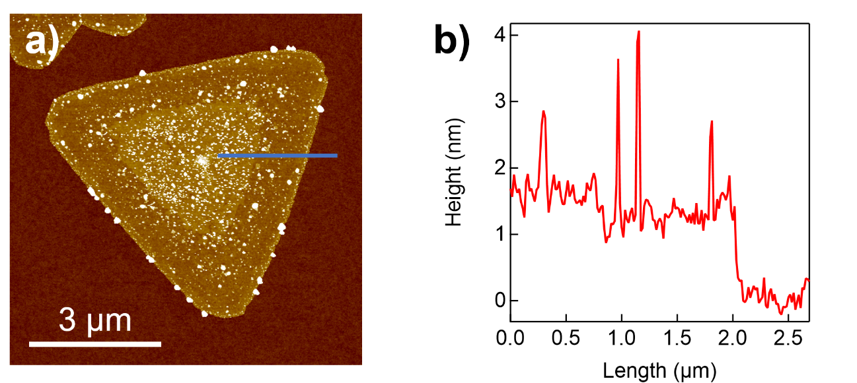
Figure S1. (a) an AFM topography and (b) corresponding height profile along the blue line of NaCl-assisted WS₂. The height of obtained WS₂ is measured as ~1 and ~1.6 nm at the inner and outer region, respectively, which clearly indicates that the WS₂ is mono- (outer region) and bilayer (inner region).

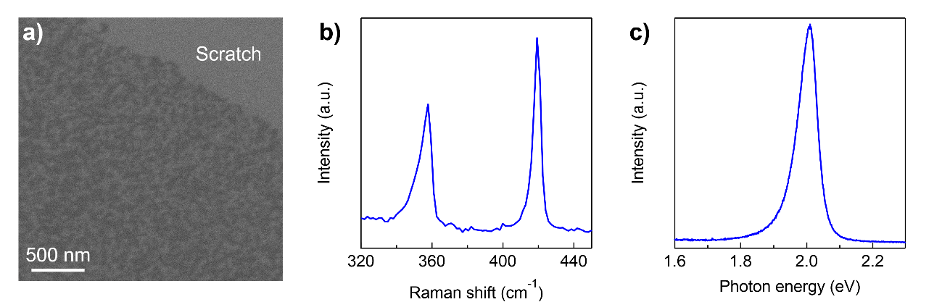
Figure S2. (a) a typical SEM image, (b) Raman and (c) PL spectrum of WS₂ without NaCl-assistance. Peak separation between E´ and A´₁ mode is measured as 61.7 cm⁻¹, which corresponds to that of the monolayer.

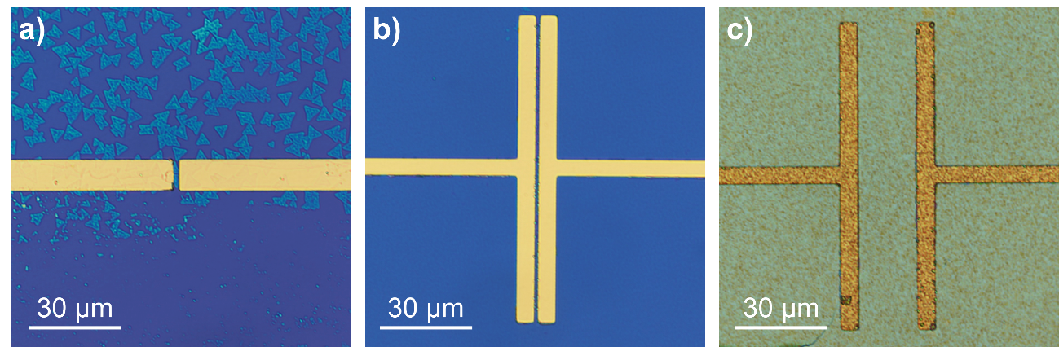

Figure S3. Optical images of fabricated FET using (a) a NaCl-assisted WS₂, (b) a thin NaCl-free WS₂ film, and (c) a thick NaCl-free WS₂ film as a channel.

Metallic behaviour of NaCl-free, thick WS₂ film.
We measured FET characteristic of other 16 devices. The results are shown in fig. S4 a): all of the devices showed metallic behaviour. The metallic behaviour on thick, NaCl-free WS₂ film would originate from effects from grain boundaries inside. The film was made of uniform, polycrystalline WS₂(Fig. S4 b) and c)) with a thickness of ~20 nm (Fig. S4 d) and e)), respectively. A grain size of WS₂ seems to be less than 100 nm (Fig. S2 a)). These results indicate that there are a lot of grain boundaries between the electrode. The grain boundaries show metallic nature and emits carriers into the crystal. The former makes the FET behaviour as a metallic directly, and the latter makes the behaviour as normally-on. And the film was deposited on a SiO₂ with a thickness of 300 nm. This SiO₂ thickness and the thick ness of the WS₂ film (~ 20 nm) makes current modulation by controlling Gate voltage difficult. This is because thick dielectric makes carrier modulation difficult and thick semiconductor with high carrier density keep high-conductive path even the gate voltage was applied.

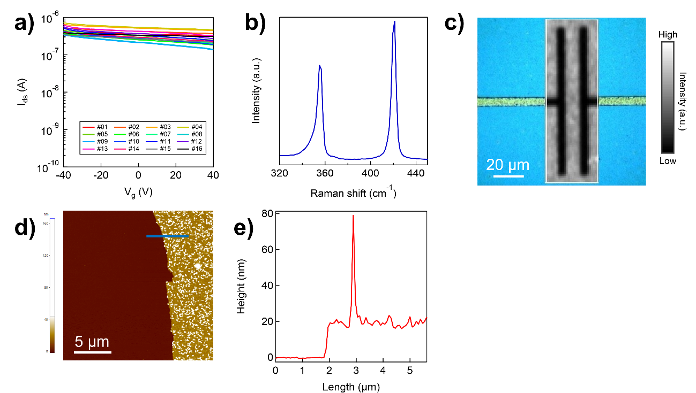
Figure S4. (a) FET characteristics of a polycrystalline WS₂ film. (b) a Raman spectrum of the film. (c) a mapping image on WS₂ A_{1g} mode intensity of a FET channel. (d) an AFM image of the film. (e) Height profile of the film along the blue line shown in (d).

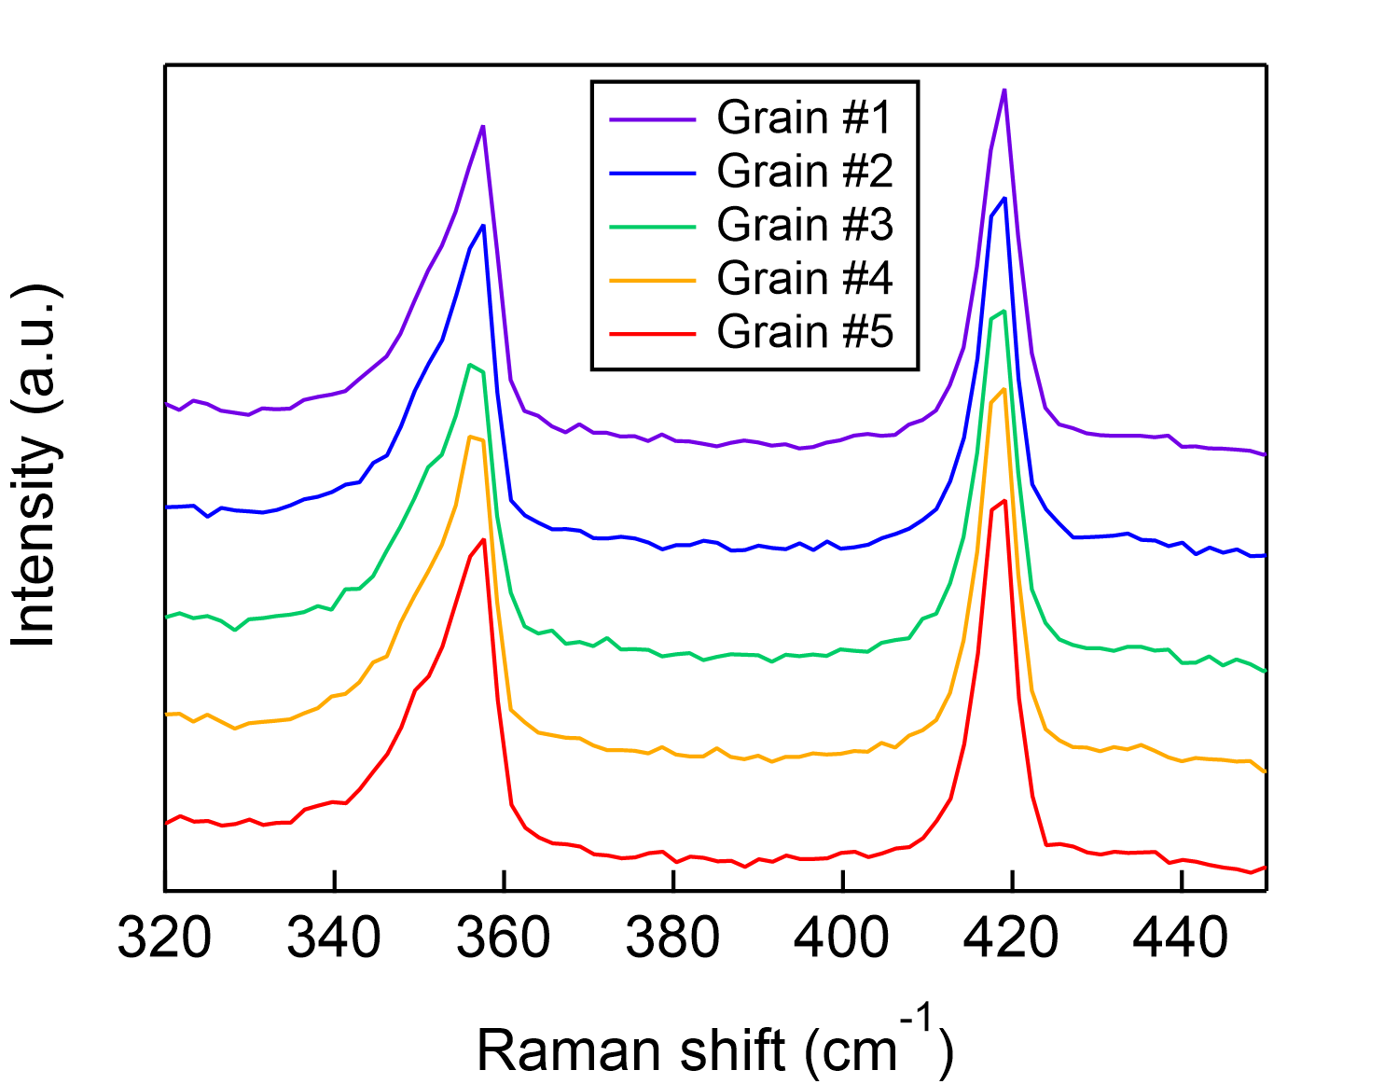

Figure S5. Grain-dependent Raman spectra of NaCl-assisted WS₂.

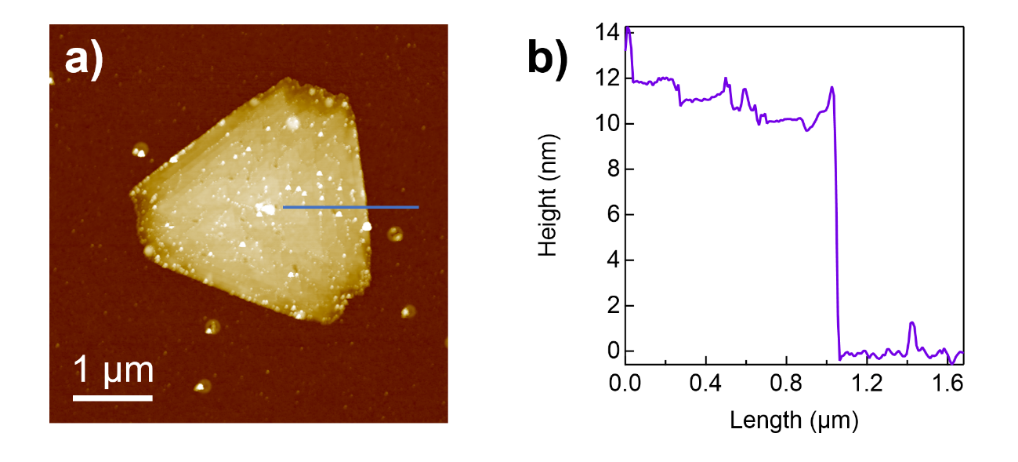
Figure S6. (a) a typical AFM image and (b) the corresponding height profile along the blue line of an NaCl-assisted WS₂ with a growth time of 60 minutes.

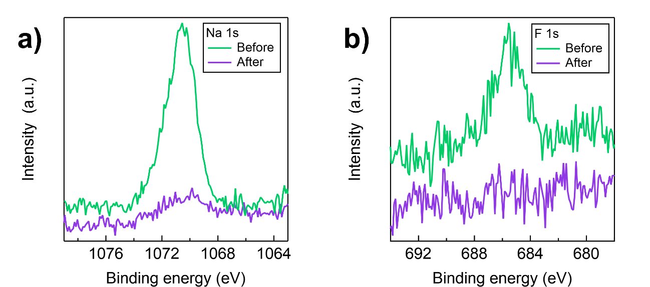

Figure S7. Typical X-ray photoelectron spectroscopy spectra of WS₂ samples before and after water washing. (a) a result of a signal from Na 1s. (b) a result of signal of F 1s.

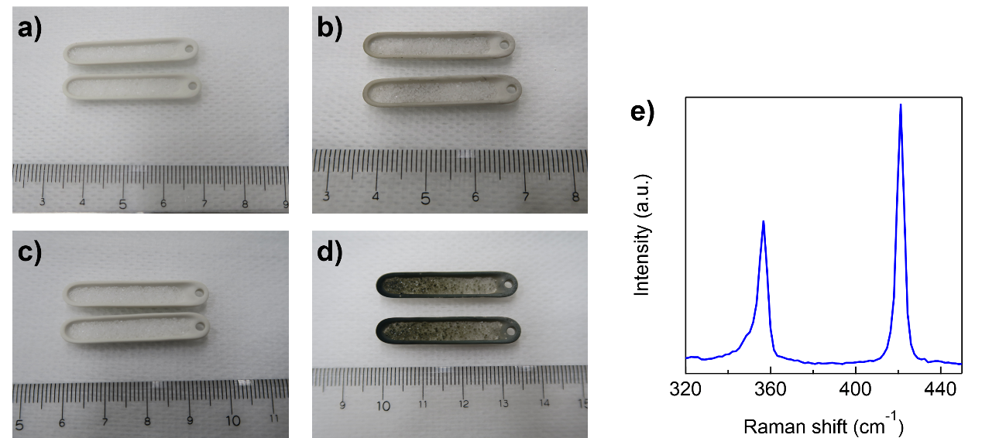

Figure S8. Optical images of boats used to contain NaCl. (a) before and (b) after 15 minutes growth. (c) before and (d) after 60 minutes growth. (e): A Raman spectrum of a NaCl powder obtained from (d).

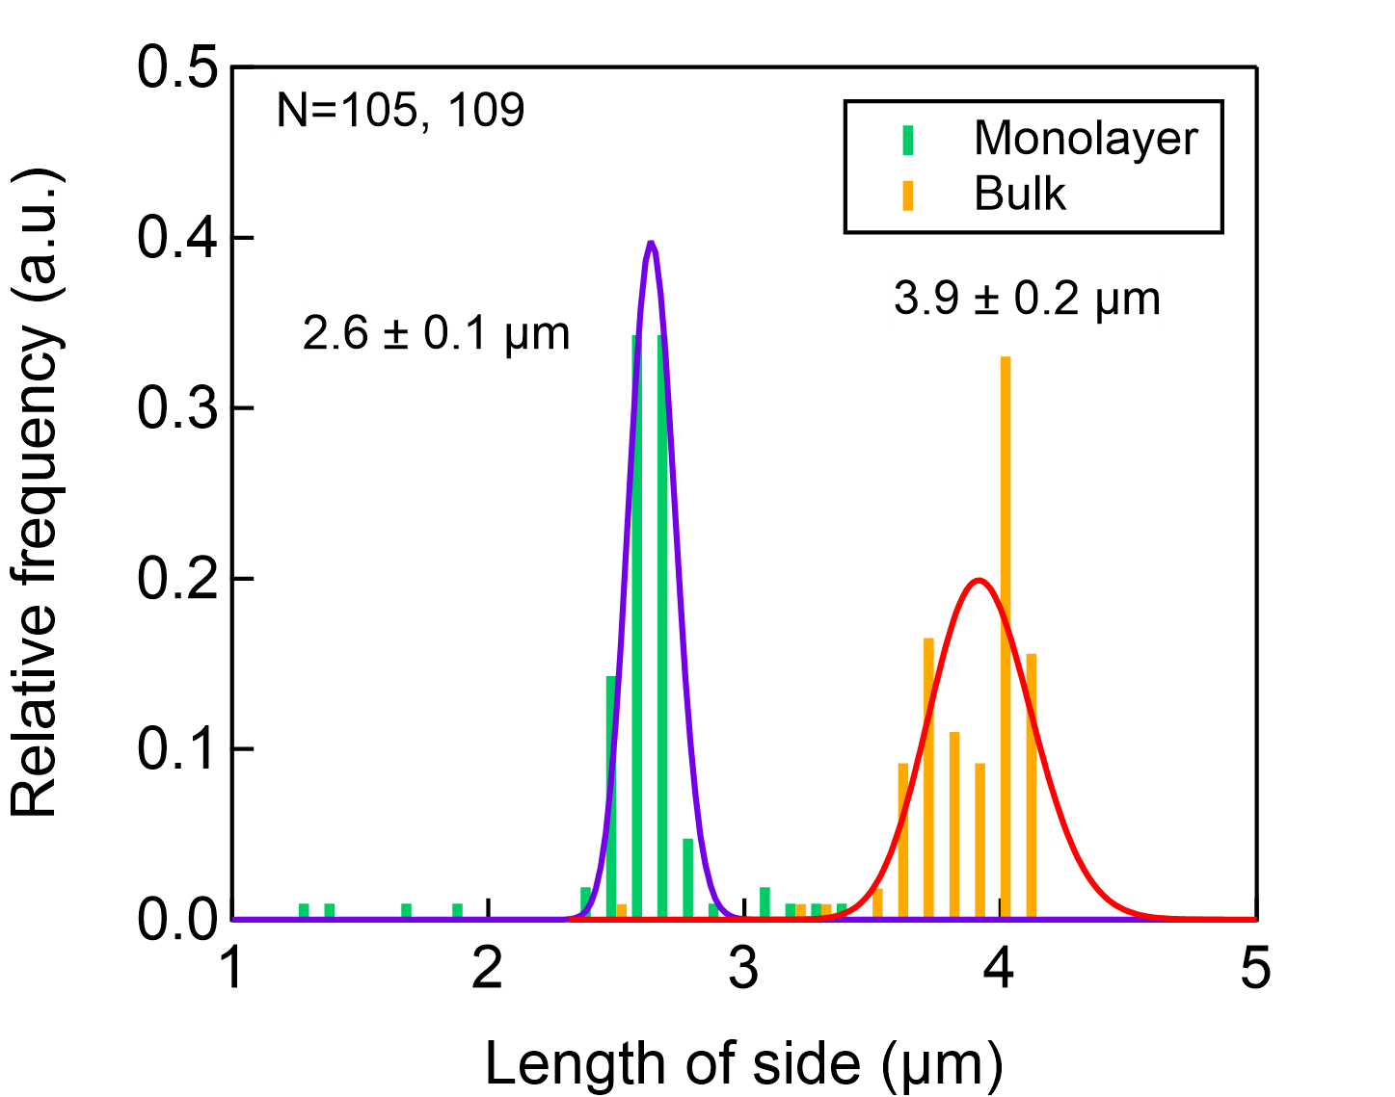
Figure S9. A grain size distribution of WS₂ made from the original image of Figure 6a and 6b. Results from irregular-shaped or merged WS₂ are not included. The length of side was calculated with an estimation of all of the WS₂ crystals show triangular shape.

Table S2. Calculated Gibbs energy change in the chemical equation.
Equation | ΔG (kJ/mol)
Equation | 900 K | 1000 K
1 | -295.4 | -322.9
2 | -79.59 | -125.4
3 | -123.9 | -115.3
4 | -692.7 | -678.1
5 | -268.9 | -277.1

We used HSC Chemistry 9 for the calculation. Calculations were done with assuming that the coefficient of W compound at left side of the equation is 1.

