Peripheral blood mononuclear cell transcriptomes reveal an over-representation of down-regulated genes associated with immunity in HIV-exposed uninfected infants.

*Zaneta D. Musimbi¹, *Martin K. Rono^{2,3}, James R. Otieno², Nelson Kibinge², Lynette Isabella Ochola-Oyier^{2,3}, Etienne Pierre de Villiers^{2,4} & Eunice W. Nduati^{2,3}

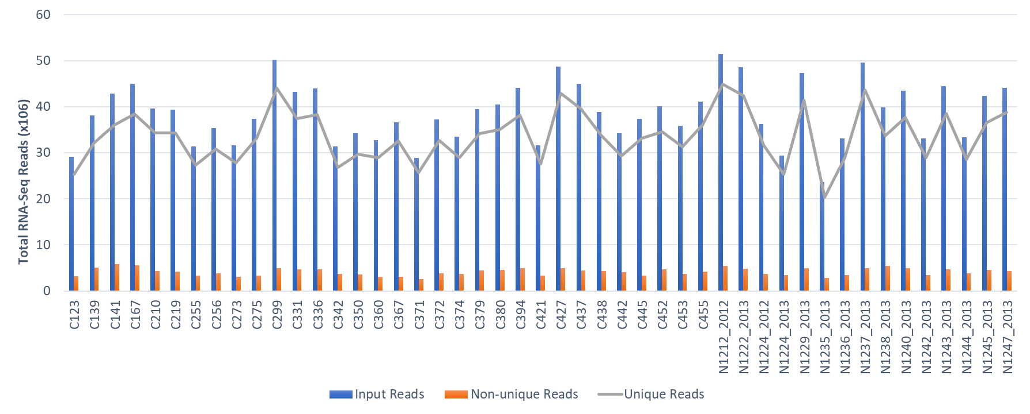
Supplementary Fig. S1 RNAseq mapping statistics. Bar graph analysis of sequenced reads from HEU and HUU PBMCs were quality checked and mapped against reference human genome predicted transcripts. Blue bars indicate total mapped reads, grey line: reads uniquely mapping to a single transcript, and red bars: reads mapping to multiple transcripts. HEU; HIV-exposed uninfected, HUU; HIV unexposed uninfected, PBMCs: Peripheral blood mononuclear cells.

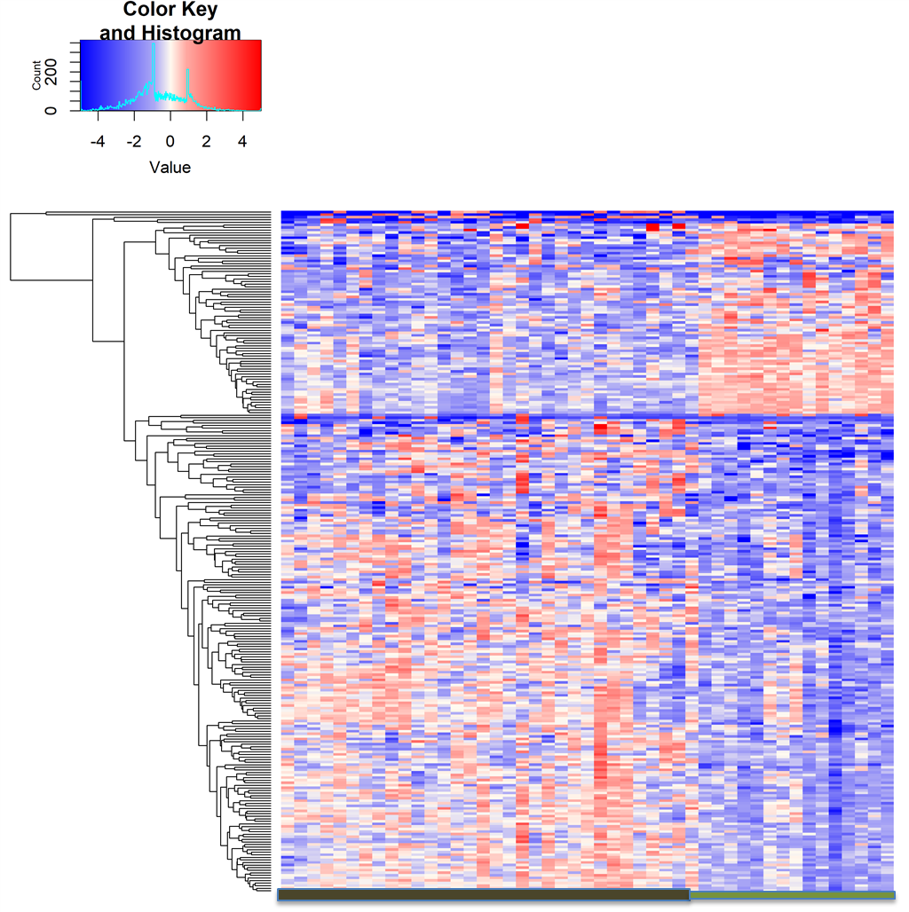

Supplementary Fig. S2 Hierarchical clustering of the 262 differentially expressed genes. Red and blue color-coding indicates relative increase or decrease in gene expression profile, respectively. Samples and DEGs are represented by the x and y axis respectively. HEU and HUU samples are represented by the colours dark brown and green respectively. DEGs: Differentially expressed genes, HEU; HIV-exposed uninfected, HUU; HIV unexposed uninfected.

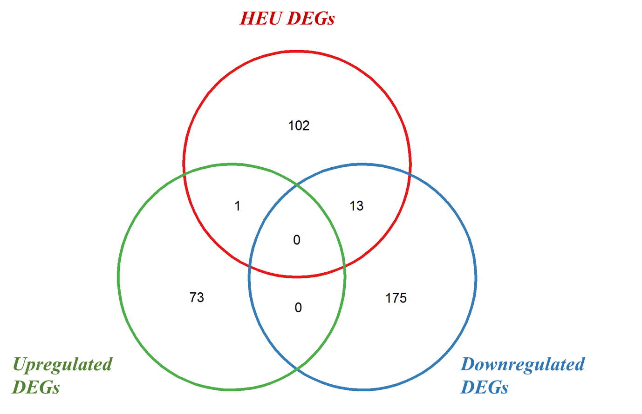

Supplementary Fig. S3 Venn plot showing an overlap between DEGs in infants of age < 12 months and up- and down-regulated genes in all the infant ages (<24 months). The red circle indicates the DEGs in infants of age <12 months, the blue indicates the downregulated genes and the green circle indicates the upregulated genes in all the infants. DEGs; Differentially expressed genes.

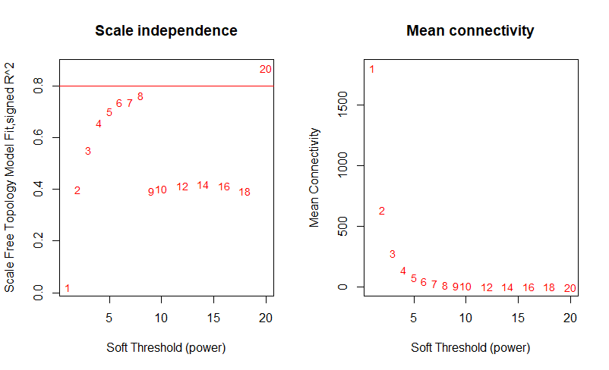
Supplementary Fig. S4 Soft-thresholding power for scale free topology model. a) Scale independence: the y-axis represents the square of the model fitting index R whose peak is 0.8.and x axis represents the soft threshold. Any power ≥ 0.8 satisfies the scale of free topology. b) Mean connectivity: the y axis represents the mean connectivity under different weighting coefficients

Supplementary Table S1: Haematological parameters for HIV unexposed uninfected community controls (HUU) and HIV exposed uninfected (HEU) infants
 | HEU infants  n = 32 | HUU infants  n = 15 | p-value
WBC count (10³/ul) | 11.3 [9-14.2] | 9.8 [9-11] | 0.2911
RBC count (10⁶/ul) | 4.7 [4.3-5] | 4.6 [4.3-4.9] | 0.4207
Hb conc (mg/dL) | 10 [9-11] | 9.7 [8.9-10.2] | 0.3344
Platelets (10³/ul) | 454 [376-605] | 418 [384-514] | 0.4896
Lymphocytes absolute (10³/ul) | 7.2 [5.5-9.5] | 6.2 [5.7-6.9] | 0.1913
Neutrophils absolute (10³/ul) | 2.8 [2.2-3.1] | 2.4 [1.8-3.3] | 0.4506
Monocytes absolute (10³/ul) | 0.64 [0.50-1.07] | 0.70 [0.58-1.05] | 0.5006
Eosinophils absolute (10³/ul) | 0.285 [0.17-0.49] | 0.38 [0.23-0.60] | 0.3784

Haematological parameters were measured at the time of sample collection in HEU and HUU infants. WBC; white blood cells, RBC; red blood cells, Hb conc; haemoglobin concentration. Values are presented as median [25th and 75th percentile], p<0.05 Mann-Whitney U tests with p<0.05 considered significant.

Supplementary Table S2: 262 Differentially expressed genes in HIV exposed uninfected (HEU) infants
Gene | baseMean | L2fc | padj | Gene.name | Gene.description
ENSG00000115758 | 3697.0 | -1.2 | 1.49E-21 | ODC1 | ornithine decarboxylase 1
ENSG00000184897 | 4148.8 | -1.5 | 2.69E-19 | H1FX | H1 histone family member X
ENSG00000213073 | 221.9 | 1.3 | 3.58E-17 | AL353625.1
ENSG00000164104 | 4751.5 | -1.1 | 3.82E-16 | HMGB2 | high mobility group box 2
ENSG00000273599 | 92.4 | 1.3 | 9.21E-16 | AL731571.1 | novel transcript, antisense to CTBP2
ENSG00000266777 | 67.6 | 1.4 | 7.26E-12 | SH3GL1P1 | SH3 domain containing GRB2 like 1, endophilin A2 pseudogene 1
ENSG00000255031 | 143.7 | 1.1 | 1.73E-11 | AP002807.1 | novel transcript, antisense to CHKA
ENSG00000231964 | 79.0 | 1.3 | 3.33E-11 | AL731567.1
ENSG00000189060 | 885.2 | -1.6 | 3.79E-10 | H1F0 | H1 histone family member 0
ENSG00000272931 | 47.5 | -1.2 | 6.38E-10 | AC099568.2 | novel transcript
ENSG00000198551 | 272.2 | -1.0 | 6.38E-10 | ZNF627 | zinc finger protein 627
ENSG00000180720 | 31.3 | -1.7 | 1.02E-09 | CHRM4 | cholinergic receptor muscarinic 4
ENSG00000223547 | 532.5 | -1.4 | 1.36E-09 | ZNF844 | zinc finger protein 844
ENSG00000183160 | 128.9 | -1.7 | 1.93E-09 | TMEM119 | transmembrane protein 119
ENSG00000173991 | 108.7 | 1.4 | 3.67E-09 | TCAP | titin-cap
ENSG00000257135 | 44.5 | -1.1 | 5.61E-09 | AC007249.2 | novel transcript
ENSG00000218809 | 157.4 | 1.4 | 6.94E-09 | AL391903.1 | triggering receptor expressed on myeloid cells 1 (TREM1) pseudogene
ENSG00000091986 | 105.0 | 1.3 | 9.63E-09 | CCDC80 | coiled-coil domain containing 80
ENSG00000113369 | 5480.5 | -1.5 | 1.06E-08 | ARRDC3 | arrestin domain containing 3
ENSG00000248323 | 258.3 | 1.5 | 1.13E-08 | LUCAT1 | lung cancer associated transcript 1
ENSG00000174611 | 71.3 | 1.9 | 1.26E-08 | KY | kyphoscoliosis peptidase
ENSG00000187837 | 598.5 | -1.0 | 1.88E-08 | HIST1H1C | histone cluster 1 H1 family member c
ENSG00000184260 | 24.0 | -1.3 | 2.35E-08 | HIST2H2AC | histone cluster 2 H2A family member c
ENSG00000125735 | 479.4 | 1.6 | 3.20E-08 | TNFSF14 | TNF superfamily member 14
ENSG00000174721 | 66.6 | -1.1 | 3.51E-08 | FGFBP3 | fibroblast growth factor binding protein 3
ENSG00000251867 | 82.6 | -1.1 | 3.61E-08 | AC009812.1 | novel transcript, antisense to ZBTB10
ENSG00000224950 | 43.0 | 1.5 | 3.66E-08 | AL390066.1 | novel transcript
ENSG00000214263 | 129.8 | 6.9 | 4.86E-08 | RPSAP53 | ribosomal protein SA pseudogene 53
ENSG00000182107 | 42.2 | -1.1 | 5.57E-08 | TMEM30B | transmembrane protein 30B
ENSG00000234290 | 759.6 | 1.1 | 8.16E-08 | AC116366.1 | novel transcript
ENSG00000126861 | 78.0 | 1.1 | 8.87E-08 | OMG | oligodendrocyte myelin glycoprotein
ENSG00000146072 | 178.0 | -1.1 | 8.87E-08 | TNFRSF21 | TNF receptor superfamily member 21
ENSG00000135116 | 471.6 | -1.1 | 9.37E-08 | HRK | harakiri, BCL2 interacting protein
ENSG00000279821 | 89.5 | 1.4 | 1.39E-07 | AC145098.2 | TEC
ENSG00000268355 | 36.9 | -1.2 | 1.45E-07 | AC243960.3 | novel transcript
ENSG00000276842 | 180.2 | 1.2 | 1.83E-07 | AC023510.2 | novel transcript, antisense to LRMP
ENSG00000169242 | 58.6 | 1.4 | 2.12E-07 | EFNA1 | ephrin A1
ENSG00000277595 | 27.9 | 1.2 | 2.25E-07 | AC007546.1 | novel transcript, sense intronic to ANKRD13A
ENSG00000260145 | 21.6 | 1.6 | 3.50E-07 | AC023825.2 | novel transcript, antisense to NLRC5
ENSG00000256249 | 11.3 | 2.4 | 5.19E-07 | AC026333.3 | novel transcript
ENSG00000235217 | 123.4 | 1.0 | 5.54E-07 | TSPY26P | testis specific protein Y-linked 26, pseudogene
ENSG00000275494 | 14.3 | -1.3 | 6.33E-07 | AC133552.5 | novel transcript
ENSG00000205786 | 21.7 | 1.2 | 7.15E-07 | LINC01531 | long intergenic non-protein coding RNA 1531
ENSG00000114737 | 851.1 | 1.6 | 8.05E-07 | CISH | cytokine inducible SH2 containing protein
ENSG00000281912 | 16.7 | -1.4 | 1.01E-06 | LINC01144 | long intergenic non-protein coding RNA 1144
ENSG00000168269 | 13.7 | 2.4 | 1.12E-06 | FOXI1 | forkhead box I1
ENSG00000238279 | 29.6 | 1.3 | 1.25E-06 | BX470102.1 | novel transcript
ENSG00000279191 | 36.2 | 1.1 | 1.42E-06 | AC068491.4 | TEC
ENSG00000279789 | 89.7 | 1.1 | 1.61E-06 | AC120114.3 | novel transcript, sense intronic to KCTD13
ENSG00000272583 | 16.4 | -1.1 | 1.71E-06 | AL592494.3 | novel transcript
ENSG00000277632 | 173.8 | -1.6 | 2.70E-06 | CCL3 | C-C motif chemokine ligand 3
ENSG00000258086 | 12.0 | 2.1 | 3.83E-06 | AC079313.1
ENSG00000250254 | 15.3 | 1.2 | 3.95E-06 | PTTG2 | pituitary tumor-transforming 2
ENSG00000229808 | 44.8 | 1.2 | 4.08E-06 | AL391825.1 | proteasome (prosome, macropain) activator subunit 3 (PA28 gamma; Ki) pseudogene
ENSG00000251194 | 40.8 | 1.0 | 4.57E-06 | AL133330.1 | novel transcript
ENSG00000218073 | 17.3 | 1.2 | 4.63E-06 | AL021407.3 | PERP, TP53 apoptosis effector (PERP) pseudogene
ENSG00000169715 | 59.1 | -1.5 | 4.79E-06 | MT1E | metallothionein 1E
ENSG00000158874 | 30.2 | 1.6 | 6.51E-06 | APOA2 | apolipoprotein A2
ENSG00000166289 | 672.3 | 1.2 | 9.74E-06 | PLEKHF1 | pleckstrin homology and FYVE domain containing 1
ENSG00000273148 | 117.2 | -1.1 | 9.89E-06 | AL035563.1
ENSG00000272523 | 26.8 | -1.0 | 1.06E-05 | LINC01023 | long intergenic non-protein coding RNA 1023
ENSG00000181126 | 128.1 | 2.4 | 1.17E-05 | HLA-V | major histocompatibility complex, class I, V (pseudogene)
ENSG00000174007 | 286.8 | 1.2 | 1.23E-05 | CEP19 | centrosomal protein 19
ENSG00000150048 | 44.6 | 1.0 | 1.28E-05 | CLEC1A | C-type lectin domain family 1 member A
ENSG00000065621 | 93.9 | 1.1 | 1.35E-05 | GSTO2 | glutathione S-transferase omega 2
ENSG00000188152 | 23.9 | 1.2 | 1.35E-05 | NUTM2G | NUT family member 2G
ENSG00000008323 | 51.0 | 1.2 | 1.73E-05 | PLEKHG6 | pleckstrin homology and RhoGEF domain containing G6
ENSG00000250182 | 1175.8 | 3.5 | 2.05E-05 | EEF1A1P13 | eukaryotic translation elongation factor 1 alpha 1 pseudogene 13
ENSG00000246451 | 112.9 | 1.1 | 2.09E-05 | AL049840.1 | novel transcript, antisense to KLC1
ENSG00000228329 | 37.6 | 1.2 | 2.13E-05 | LINC01890 | long intergenic non-protein coding RNA 1890
ENSG00000278937 | 18.5 | 1.6 | 2.20E-05 |  | lncRNA
ENSG00000260114 | 66.0 | 1.0 | 2.26E-05 | CTD2574D22.4 | lncRNA
ENSG00000135437 | 40.8 | 1.0 | 2.36E-05 | RDH5 | retinol dehydrogenase 5
ENSG00000211685 | 123.7 | -1.5 | 2.46E-05 | IGLC7 | immunoglobulin lambda constant 7
ENSG00000275022 | 19.3 | 1.3 | 2.52E-05 | MIR6753 | microRNA 6753
ENSG00000139832 | 692.2 | -1.0 | 2.60E-05 | RAB20 | RAB20, member RAS oncogene family
ENSG00000122877 | 604.6 | -2.0 | 2.62E-05 | EGR2 | early growth response 2
ENSG00000267293 | 16.4 | 1.3 | 3.19E-05 | AC012569.1 | U3 small nucleolar RNA-associated protein 18 homolog, pseudogene
ENSG00000242265 | 299.7 | -1.2 | 3.42E-05 | PEG10 | paternally expressed 10
ENSG00000255893 | 14.4 | 1.4 | 3.64E-05 | AP000786.1 | novel transcript
ENSG00000198711 | 59.6 | 1.1 | 4.56E-05 | SSBP3-AS1 | SSBP3 antisense RNA 1
ENSG00000239653 | 224.1 | 1.2 | 4.78E-05 | PSMD6-AS2 | PSMD6 antisense RNA 2
ENSG00000272037 | 20.5 | 1.2 | 5.20E-05 | AP002907.1 | novel transcript, antisense to UBR5
ENSG00000163053 | 39.6 | -1.2 | 5.31E-05 | SLC16A14 | solute carrier family 16 member 14
ENSG00000143858 | 16.6 | 1.3 | 5.52E-05 | SYT2 | synaptotagmin 2
ENSG00000267519 | 740.7 | 1.1 | 5.60E-05 | AC020916.1 | novel transcript
ENSG00000143257 | 27.2 | 1.1 | 6.08E-05 | NR1I3 | nuclear receptor subfamily 1 group I member 3
ENSG00000205426 | 14.3 | 2.7 | 6.10E-05 | KRT81 | keratin 81
ENSG00000162552 | 13.6 | 1.2 | 7.28E-05 | WNT4 | Wnt family member 4
ENSG00000279187 | 18.2 | 1.2 | 8.96E-05 | AC027601.5 | TEC
ENSG00000164707 | 43.1 | 1.1 | 8.98E-05 | SLC13A4 | solute carrier family 13 member 4
ENSG00000241157 | 10.3 | 1.9 | 9.29E-05 | AC104763.1 | ribosomal protein L32 (RPL32) pseudogene
ENSG00000257017 | 77.2 | -1.7 | 9.94E-05 | HP | haptoglobin
ENSG00000267607 | 10.1 | 2.9 | 1.02E-04 | AC011511.5 | novel transcript, antisense to ICAM4 and ICAM1
ENSG00000118523 | 35.0 | -1.9 | 1.13E-04 | CTGF | connective tissue growth factor
ENSG00000233360 | 28.1 | 1.4 | 1.17E-04 | Z83844.2
ENSG00000204882 | 10.1 | 1.8 | 1.19E-04 | GPR20 | G protein-coupled receptor 20
ENSG00000274602 | 175.8 | 1.4 | 1.19E-04 | PI4KAP1 | phosphatidylinositol 4-kinase alpha pseudogene 1
ENSG00000182782 | 1044.0 | 1.3 | 1.22E-04 | HCAR2 | hydroxycarboxylic acid receptor 2
ENSG00000278356 | 16.6 | -1.3 | 1.27E-04 | AC005911.1 | novel transcript
ENSG00000255398 | 741.9 | 1.4 | 1.27E-04 | HCAR3 | hydroxycarboxylic acid receptor 3
ENSG00000176641 | 53.0 | -1.5 | 1.29E-04 | RNF152 | ring finger protein 152
ENSG00000006118 | 45.1 | 1.4 | 1.29E-04 | TMEM132A | transmembrane protein 132A
ENSG00000244124 | 17.6 | 1.6 | 1.43E-04 | ATP1B3-AS1 | ATP1B3 antisense RNA 1
ENSG00000233668 | 14.0 | 1.3 | 1.46E-04 | AL353662.2 | ribosomal protein S8 (RPS8) pseudogene
ENSG00000152192 | 10.3 | -1.1 | 1.52E-04 | POU4F1 | POU class 4 homeobox 1
ENSG00000125968 | 116.2 | 1.8 | 1.83E-04 | ID1 | inhibitor of DNA binding 1, HLH protein
ENSG00000279412 | 27.5 | 1.1 | 2.03E-04 | AC020763.3 | novel transcript
ENSG00000253980 | 19.0 | 1.2 | 2.05E-04 | AC010609.1 | novel transcript
ENSG00000174469 | 220.7 | -1.5 | 2.06E-04 | CNTNAP2 | contactin associated protein like 2
ENSG00000223668 | 18.7 | -1.2 | 2.08E-04 | EEF1A1P24 | eukaryotic translation elongation factor 1 alpha 1 pseudogene 24
ENSG00000267501 | 15.2 | 1.5 | 2.23E-04 | AC104365.2 | novel transcript
ENSG00000276900 | 359.5 | 1.2 | 2.24E-04 | AC023157.3 | novel transcript, antisense to AMN1
ENSG00000279396 | 134.5 | 1.2 | 2.27E-04
ENSG00000197632 | 171.7 | 2.7 | 2.27E-04 | SERPINB2 | serpin family B member 2
ENSG00000259556 | 18.1 | 1.1 | 2.36E-04 | AC090971.3 | Leo1, Paf1/RNA polymerase II complex component, homolog (S. cerevisiae) (LEO1) pseudogene
ENSG00000232216 | 481.0 | -1.3 | 2.39E-04 | IGHV3-43 | immunoglobulin heavy variable 3-43
ENSG00000222009 | 319.4 | 1.3 | 2.95E-04 | BTBD19 | BTB domain containing 19
ENSG00000262874 | 13.2 | 1.4 | 3.35E-04 | C19orf84 | chromosome 19 open reading frame 84
ENSG00000213937 | 23.1 | 1.2 | 3.52E-04 | CLDN9 | claudin 9
ENSG00000126262 | 11486.3 | 1.8 | 3.53E-04 | FFAR2 | free fatty acid receptor 2
ENSG00000165181 | 18.5 | 1.3 | 3.67E-04 | C9orf84 | chromosome 9 open reading frame 84
ENSG00000170345 | 13353.5 | -1.4 | 3.81E-04 | FOS | Fos proto-oncogene, AP-1 transcription factor subunit
ENSG00000238025 | 12.1 | 1.8 | 4.12E-04 | ZDHHC4P1 | zinc finger DHHC-type containing 4 pseudogene 1
ENSG00000239503 | 12.9 | 1.6 | 4.53E-04 | MARK2P8 | microtubule affinity regulating kinase 2 pseudogene 8
ENSG00000199053 | 21.5 | 1.1 | 4.63E-04 | MIR324 | microRNA 324
ENSG00000148346 | 281.3 | -1.4 | 4.69E-04 | LCN2 | lipocalin 2
ENSG00000254554 | 11.4 | 1.3 | 4.75E-04 | AC080023.1 | novel transcript
ENSG00000281332 | 25.0 | 1.1 | 4.82E-04 | LINC00997 | long intergenic non-protein coding RNA 997
ENSG00000261349 | 30.3 | 1.1 | 4.91E-04 | AL031432.2 | novel pseudogene
ENSG00000233214 | 14.3 | 1.9 | 4.94E-04 | AC002511.2 | novel transcript
ENSG00000164047 | 214.9 | -1.4 | 5.04E-04 | CAMP | cathelicidin antimicrobial peptide
ENSG00000236567 | 31.8 | 1.3 | 5.12E-04 | TCF3P1 | transcription factor 3 pseudogene 1
ENSG00000269028 | 77.9 | -1.5 | 5.16E-04 | MTRNR2L12 | MT-RNR2 like 12
ENSG00000138131 | 17.9 | 1.0 | 5.56E-04 | LOXL4 | lysyl oxidase like 4
ENSG00000230225 | 11.0 | 1.5 | 5.57E-04 | MTND5P14 | MT-ND5 pseudogene 14
ENSG00000136244 | 53.4 | -1.3 | 5.66E-04 | IL6 | interleukin 6
ENSG00000223886 | 20.3 | -1.1 | 5.67E-04 | AC073073.1 | ring finger protein 181 (RNF181) pseudogene
ENSG00000224858 | 14.5 | 3.3 | 6.11E-04 | RPL29P11 | ribosomal protein L29 pseudogene 11
ENSG00000211966 | 1704.3 | -1.1 | 6.12E-04 | IGHV5-51 | immunoglobulin heavy variable 5-51
ENSG00000181778 | 11.8 | 1.7 | 6.19E-04 | TMEM252 | transmembrane protein 252
ENSG00000249072 | 15.4 | 6.0 | 6.37E-04 | AC114801.3 | novel pseudogene
ENSG00000267534 | 158.5 | 1.2 | 6.55E-04 | S1PR2 | sphingosine-1-phosphate receptor 2
ENSG00000267990 | 10.1 | 1.1 | 7.23E-04 | AC063977.2 | novel sialic acid binding Ig-like lectin (SIGLEC) pseudogene
ENSG00000245148 | 81.3 | 1.1 | 7.43E-04 | ARAP1-AS2 | ARAP1 antisense RNA 2
ENSG00000233030 | 14.4 | 1.6 | 7.45E-04 | AC243772.2 | novel transcript, antisense to FCGR1A
ENSG00000182327 | 23.1 | -1.0 | 7.46E-04 | GLTPD2 | glycolipid transfer protein domain containing 2
ENSG00000261655 | 19.1 | 1.5 | 8.64E-04 | AC100803.2 | novel transcript, overlapping to GPR20
ENSG00000229473 | 47.8 | 1.1 | 9.10E-04 | RGS17P1 | regulator of G protein signaling 17 pseudogene 1
ENSG00000213613 | 27.2 | 1.5 | 9.19E-04 | RPL11P3 | ribosomal protein L11 pseudogene 3
ENSG00000263624 | 12.0 | 1.3 | 9.63E-04 | AC055811.1 | novel transcript
ENSG00000168229 | 290.5 | 1.0 | 9.93E-04 | PTGDR | prostaglandin D2 receptor
ENSG00000124216 | 134.3 | 1.8 | 1.00E-03 | SNAI1 | snail family transcriptional repressor 1
ENSG00000279794 | 10.9 | 1.2 | 1.09E-03 | AC024580.1 | TEC
ENSG00000184500 | 78.0 | -1.2 | 1.18E-03 | PROS1 | protein S
ENSG00000177707 | 24.9 | 1.0 | 1.18E-03 | NECTIN3 | nectin cell adhesion molecule 3
ENSG00000272079 | 12.7 | 1.1 | 1.20E-03 | AC004233.3 | novel transcript
ENSG00000198756 | 79.8 | 1.2 | 1.33E-03 | COLGALT2 | collagen beta(1-O)galactosyltransferase 2
ENSG00000175556 | 103.1 | 1.2 | 1.63E-03 | LONRF3 | LON peptidase N-terminal domain and ring finger 3
ENSG00000237161 | 12.8 | 1.3 | 1.63E-03 | AC068446.1 | p21 protein (Cdc42/Rac)-activated kinase 2 (PAK2) pseudogene
ENSG00000261573 | 11.2 | 1.2 | 1.67E-03 | AL157402.2 | novel transcript
ENSG00000163083 | 15.4 | -1.1 | 1.69E-03 | INHBB | inhibin subunit beta B
ENSG00000261594 | 10.7 | -1.4 | 1.70E-03 | TPBGL | trophoblast glycoprotein like
ENSG00000175793 | 67.9 | 1.1 | 1.76E-03 | SFN | stratifin
ENSG00000101665 | 1881.7 | 1.3 | 1.76E-03 | SMAD7 | SMAD family member 7
ENSG00000124134 | 19.7 | 1.3 | 2.00E-03 | KCNS1 | potassium voltage-gated channel modifier subfamily S member 1
ENSG00000106328 | 11.2 | 1.0 | 2.08E-03 | FSCN3 | fascin actin-bundling protein 3
ENSG00000012223 | 1060.3 | -1.7 | 2.15E-03 | LTF | lactotransferrin
ENSG00000104918 | 190.2 | -1.5 | 2.20E-03 | RETN | resistin
ENSG00000063015 | 10.5 | 1.2 | 2.20E-03 | SEZ6 | seizure related 6 homolog
ENSG00000216809 | 16.5 | 1.1 | 2.22E-03 | AL589993.1 | DEAD/H (Asp-Glu-Ala-Asp/His) box polypeptide 24 (DDX24) pseudogene
ENSG00000180846 | 37.7 | 1.1 | 2.34E-03 | CSNK1G2-AS1 | CSNK1G2 antisense RNA 1
ENSG00000170442 | 42.2 | 1.9 | 2.38E-03 | KRT86 | keratin 86
ENSG00000271821 | 12.4 | 1.1 | 2.38E-03 | AL662844.3 | novel transcript
ENSG00000279447 | 17.2 | 1.1 | 2.46E-03 | AL118508.4 | TEC
ENSG00000259205 | 61.8 | 1.2 | 2.49E-03 | PRKXP1 | PRKX pseudogene 1
ENSG00000234292 | 11.1 | 1.2 | 2.50E-03 | AC123595.1
ENSG00000274588 | 28.8 | 1.6 | 2.51E-03 | DGKK | diacylglycerol kinase kappa
ENSG00000236278 | 23.5 | 1.0 | 2.59E-03 | PEBP1P3 | phosphatidylethanolamine binding protein 1 pseudogene 3
ENSG00000254017 | 35.6 | 1.1 | 2.64E-03 | IGHEP2 | immunoglobulin heavy constant epsilon P2 (pseudogene)
ENSG00000223825 | 10.4 | -1.6 | 2.75E-03 | DAZAP2P1 | DAZ associated protein 2 pseudogene 1
ENSG00000169439 | 83.9 | -1.2 | 2.80E-03 | SDC2 | syndecan 2
ENSG00000054598 | 10.7 | -1.0 | 2.82E-03 | FOXC1 | forkhead box C1
ENSG00000249119 | 37.5 | -2.1 | 2.85E-03 | MTND6P4 | MT-ND6 pseudogene 4
ENSG00000061656 | 65.1 | 1.1 | 2.88E-03 | SPAG4 | sperm associated antigen 4
ENSG00000229390 | 17.0 | 2.2 | 2.97E-03 | MICD | MHC class I polypeptide-related sequence D (pseudogene)
ENSG00000251441 | 13.7 | 1.1 | 3.00E-03 | RTEL1P1 | regulator of telomere elongation helicase 1 pseudogene 1
ENSG00000264304 | 21.2 | 1.1 | 3.22E-03 | AC024267.3 | novel transcript, antisense to FLOT2
ENSG00000273179 | 110.8 | 1.0 | 3.30E-03 | AC092535.4 | novel transcript, antisense to SPON2
ENSG00000235128 | 10.0 | 1.1 | 3.40E-03 | AC013474.1 | novel pseudogene
ENSG00000248905 | 345.8 | -1.2 | 3.42E-03 | FMN1 | formin 1
ENSG00000270911 | 12.6 | 1.1 | 3.44E-03 | AC114878.2 | CTAGE family, member 5 (CTAGE5) pseudogene
ENSG00000177469 | 22.0 | 1.2 | 3.56E-03 | CAVIN1 | caveolae associated protein 1
ENSG00000237927 | 19.2 | 1.2 | 3.71E-03 | AL078604.2
ENSG00000267560 | 15.1 | 1.0 | 3.88E-03 | AC027514.2 | novel transcript, antisense to KIAA1468
ENSG00000279811 | 24.9 | 1.0 | 3.93E-03 | AC093330.2 | TEC
ENSG00000231123 | 11.5 | 1.4 | 3.96E-03 | SPATA20P1 | spermatogenesis associated 20 pseudogene 1
ENSG00000259354 | 23.8 | 1.0 | 4.43E-03 | AC025580.2 | novel transcript, antisense to SLC30A4
ENSG00000259703 | 10.8 | 1.1 | 4.54E-03 | LINC00593 | long intergenic non-protein coding RNA 593
ENSG00000254030 | 29.5 | -1.1 | 4.65E-03 | IGLC5 | immunoglobulin lambda constant 5 (pseudogene)
ENSG00000204421 | 12.0 | 1.2 | 4.72E-03 | LY6G6C | lymphocyte antigen 6 family member G6C
ENSG00000269720 | 12.8 | 1.1 | 4.97E-03 | CCDC194 | coiled-coil domain containing 194
ENSG00000231940 | 11.1 | 1.1 | 5.06E-03 | RPS7P3 | ribosomal protein S7 pseudogene 3
ENSG00000251230 | 67.4 | 1.5 | 5.54E-03 | MIR3945HG | MIR3945 host gene
ENSG00000237593 | 10.7 | 1.1 | 5.58E-03 | AL445220.1 | ribosomal protein L17 (RPL17) pseudogene
ENSG00000162069 | 29.5 | 1.3 | 5.60E-03 | BICDL2 | BICD family like cargo adaptor 2
ENSG00000211665 | 53.1 | -1.1 | 6.11E-03 | IGLV3-16 | immunoglobulin lambda variable 3-16
ENSG00000214872 | 123.2 | 1.1 | 6.37E-03 | SMTNL1 | smoothelin like 1
ENSG00000275110 | 53.8 | 1.1 | 6.54E-03 | MIR6087 | microRNA 6087
ENSG00000112139 | 236.9 | 2.3 | 6.58E-03 | MDGA1 | MAM domain containing glycosylphosphatidylinositol anchor 1
ENSG00000233029 | 29.9 | 1.2 | 6.70E-03 | AC244453.2 | novel transcript
ENSG00000248923 | 67.7 | -1.4 | 6.81E-03 | MTND5P11 | MT-ND5 pseudogene 11
ENSG00000261026 | 474.6 | 1.0 | 7.21E-03 | AC105046.1 | novel transcript, overlapping to EGR3
ENSG00000205927 | 23.6 | 1.6 | 7.26E-03 | OLIG2 | oligodendrocyte transcription factor 2
ENSG00000227502 | 13.5 | 1.5 | 7.28E-03 | LINC01268 | long intergenic non-protein coding RNA 1268
ENSG00000228463 | 43.8 | -1.0 | 7.29E-03 | AP006222.1 | ribosomal protein L23a (RPL23A) pseudogene
ENSG00000168389 | 249.0 | 1.1 | 7.32E-03 | MFSD2A | major facilitator superfamily domain containing 2A
ENSG00000229512 | 10.4 | 1.1 | 7.38E-03 | AC068580.1 | novel transcript
ENSG00000176170 | 365.6 | 1.0 | 7.38E-03 | SPHK1 | sphingosine kinase 1
ENSG00000123700 | 776.3 | 1.6 | 7.87E-03 | KCNJ2 | potassium voltage-gated channel subfamily J member 2
ENSG00000279530 | 54.4 | 1.2 | 8.00E-03 | AC092881.1 | TEC
ENSG00000163661 | 595.3 | 1.5 | 8.01E-03 | PTX3 | pentraxin 3
ENSG00000260671 | 18.5 | 1.3 | 8.90E-03 | AC010536.2 | novel transcript, sense intronic to KLHDC4
ENSG00000078401 | 120.1 | 1.3 | 9.20E-03 | EDN1 | endothelin 1
ENSG00000145975 | 11.3 | 1.0 | 9.29E-03 | FAM217A | family with sequence similarity 217 member A
ENSG00000236772 | 11.3 | 1.0 | 9.67E-03 | AL034550.1 | novel transcript, antisense to NOL4L
ENSG00000250510 | 230.1 | -1.0 | 9.79E-03 | GPR162 | G protein-coupled receptor 162
ENSG00000101425 | 102.7 | -1.1 | 1.07E-02 | BPI | bactericidal permeability increasing protein
ENSG00000279554 | 19.5 | 1.2 | 1.21E-02 | AC130448.2 | novel transcript
ENSG00000242473 | 15.5 | 1.1 | 1.33E-02 | KIR2DP1 | killer cell immunoglobulin like receptor, two Ig domains pseudogene 1
ENSG00000105784 | 10.1 | 1.1 | 1.34E-02 | RUNDC3B | RUN domain containing 3B
ENSG00000120738 | 5040.8 | -1.3 | 1.36E-02 | EGR1 | early growth response 1
ENSG00000138061 | 607.2 | -1.0 | 1.36E-02 | CYP1B1 | cytochrome P450 family 1 subfamily B member 1
ENSG00000118113 | 190.8 | -1.5 | 1.38E-02 | MMP8 | matrix metallopeptidase 8
ENSG00000214975 | 13.8 | -1.4 | 1.52E-02 | PPIAP29 | peptidylprolyl isomerase A pseudogene 29
ENSG00000225690 | 12.7 | 1.1 | 1.54E-02 | TREML5P | triggering receptor expressed on myeloid cells like 5, pseudogene
ENSG00000224083 | 15.3 | 1.1 | 1.55E-02 | MTCO1P11 | MT-CO1 pseudogene 11
ENSG00000143333 | 142.4 | 1.4 | 1.55E-02 | RGS16 | regulator of G protein signaling 16
ENSG00000173262 | 54.6 | 1.5 | 1.66E-02 | SLC2A14 | solute carrier family 2 member 14
ENSG00000200814 | 11.3 | 1.0 | 1.74E-02 | RNU6-595P | RNA, U6 small nuclear 595, pseudogene
ENSG00000211642 | 429.3 | 1.3 | 1.84E-02 | IGLV10-54 | immunoglobulin lambda variable 10-54
ENSG00000167680 | 140.5 | 1.4 | 1.93E-02 | SEMA6B | semaphorin 6B
ENSG00000253239 | 175.0 | -1.6 | 1.96E-02 | IGLVI-70 | immunoglobulin lambda variable (I)-70 (pseudogene)
ENSG00000236279 | 39.1 | -1.1 | 2.03E-02 | CLEC2L | C-type lectin domain family 2 member L
ENSG00000255221 | 36.7 | 1.1 | 2.13E-02 | CARD17 | caspase recruitment domain family member 17
ENSG00000211935 | 346.0 | -1.4 | 2.39E-02 | IGHV1-3 | immunoglobulin heavy variable 1-3
ENSG00000105610 | 16.3 | -1.1 | 2.58E-02 | KLF1 | Kruppel like factor 1
ENSG00000006327 | 336.2 | 1.2 | 2.67E-02 | TNFRSF12A | TNF receptor superfamily member 12A
ENSG00000133055 | 28.1 | 1.3 | 3.17E-02 | MYBPH | myosin binding protein H
ENSG00000149256 | 14.6 | 1.0 | 3.26E-02 | TENM4 | teneurin transmembrane protein 4
ENSG00000221957 | 131.7 | 1.0 | 3.40E-02 | KIR2DS4 | killer cell immunoglobulin like receptor, two Ig domains and short cytoplasmic tail 4
ENSG00000232680 | 20.6 | 1.0 | 3.52E-02 | AC002511.1 | novel transcript
ENSG00000144130 | 27.5 | 1.0 | 3.63E-02 | NT5DC4 | 5'-nucleotidase domain containing 4
ENSG00000204001 | 59.5 | 2.2 | 3.70E-02 | LCN8 | lipocalin 8
ENSG00000256050 | 17.5 | -1.2 | 3.75E-02 | AL583722.1 | novel transcript
ENSG00000107130 | 15.4 | 1.1 | 3.89E-02 | NCS1 | neuronal calcium sensor 1
ENSG00000166450 | 11.2 | 1.3 | 4.07E-02 | PRTG | protogenin
ENSG00000137331 | 1728.5 | 1.2 | 4.31E-02 | IER3 | immediate early response 3
ENSG00000211625 | 135.2 | 1.3 | 4.41E-02 | IGKV3D-20 | immunoglobulin kappa variable 3D-20
ENSG00000148344 | 41.9 | 1.1 | 4.74E-02 | PTGES | prostaglandin E synthase
ENSG00000215030 | 1393.1 | -1.2 | 4.74E-02 | RPL13P12 | ribosomal protein L13 pseudogene 12
ENSG00000137801 | 3811.7 | -1.1 | 4.86E-02 | THBS1 | thrombospondin 1

