Germline and somatic mutations in homologous recombination associated genes in Japanese ovarian cancer patients

Kentaro Sugino^{1*}, Ryo Tamura^{1*}, Hirofumi Nakaoka^{2*}, Nozomi Yachida¹, Manako Yamaguchi¹, Yutaro Mori¹, Kaoru Yamawaki¹, Kazuaki Suda¹, Tatsuya Ishiguro¹, Sosuke Adachi¹, Masanori Isobe¹, Masayuki Yamaguchi¹, Katsunori Kashima¹, Teiichi Motoyama³, Ituro Inoue², Kosuke Yoshihara^{1†}, Takayuki Enomoto¹

- Department of Obstetrics and Gynecology, Niigata University Graduate School of Medical and Dental Sciences, Niigata 951-8510, Japan.
- Human Genetics Laboratory, National Institute of Genetics, Mishima 411-8540, Japan.
- Department of Molecular and Diagnostic Pathology, Niigata University Graduate School of Medical and Dental Sciences, Niigata 951-8510, Japan

Supplementary Table S1. A list of targeted genes
Gene Symbol | Gene Name | Gene ID | Gene Title
ATM | ATM serine/threonine kinase | 472 | HR-associated gene
BARD1 | BRCA1 associated RING domain 1 | 580 | HR-associated gene
BRCA1 | BRCA1, DNA repair associated | 672 | HR-associated gene
BRCA2 | BRCA2, DNA repair associated | 675 | HR-associated gene
BRIP1 | BRCA1 interacting protein C-terminal helicase 1 | 83990 | HR-associated gene
CHEK1 | checkpoint kinase 1 | 1111 | HR-associated gene
CHEK2 | checkpoint kinase 2 | 11200 | HR-associated gene
EMSY | EMSY, BRCA2 interacting transcriptional repressor | 56946 | HR-associated gene
FANCL | Fanconi anemia complementation group L | 55120 | HR-associated gene
NBN | nibrin | 4683 | HR-associated gene
PALB2 | partner and localizer of BRCA2 | 79728 | HR-associated gene
RAD50 | RAD50 double strand break repair protein | 10111 | HR-associated gene
RAD51B | RAD51 paralog B | 5890 | HR-associated gene

Supplementary Table S1. Continued.
Gene Symbol | Gene Name | Gene ID | Gene Title
RAD51C | RAD51 paralog C | 5889 | HR-associated gene
RAD51D | RAD51 paralog D | 5892 | HR-associated gene
RAD54L | RAD54-like (S. cerevisiae) | 8438 | HR-associated gene
TP53 | tumor protein p53 | 7157 | Ovarian cancer biomarker
PTEN | phosphatase and tensin homolog | 5728 | Ovarian cancer biomarker
ARID1A | AT-rich interaction domain 1A | 8289 | Ovarian cancer biomarker
PIK3CA | phosphatidylinositol-4,5-bisphosphate 3-kinase catalytic subunit alpha | 5290 | Ovarian cancer biomarker
KRAS | KRAS proto-oncogene, GTPase | 3845 | Ovarian cancer biomarker
MLH1 | mutL homolog 1 | 4292 | Mismatch repair gene
MSH2 | mutS homolog 2 | 4436 | Mismatch repair gene
MSH6 | mutS homolog 6 | 2956 | Mismatch repair gene
PMS2 | PMS1 homolog 2, mismatch repair system component | 5395 | Mismatch repair gene

Supplementary Table S2. A list of somatic variants
Patient ID | Age | Stage | Histological  subtype | Gene | Class | Refseq ID | Nucleotide change | Amino acid change
180 | 81 | Ⅲ | HGSC | BRCA1 | stopgain | NM_007298 | c.C1018T | p.R340X
209 | 58 | Ⅲ | HGSC | BRCA1 | frameshift deletion | NM_007300 | c.3818_3840del | p.Q1273fs
329 | 59 | Ⅱ | HGSC | BRCA1 | stopgain | NM_007294 | c.C3607T | p.R1203X
1063 | 76 | Ⅱ | HGSC | BRCA1 | frameshift deletion | NM_007300 | c.3840_3841del | p.S1280fs
635 | 48 | Ⅰ | CCC | BRCA2 | missense mutation | NM_000059 | c.T4284A | p.F1428L
646 | 46 | Ⅰ | EC | BRCA2 | stopgain | NM_000059 | c.G9946T | p.E3316X
993 | 59 | Ⅰ | CCC | BRCA2 | frameshift deletion | NM_000059 | c.965_968del | p.K322fs
1027 | 37 | Ⅱ | CCC | BRCA2 | missense mutation | NM_000059 | c.C3422T | p.T1141I
1027 | 37 | Ⅱ | CCC | BRCA2 | missense mutation | NM_000059 | c.T3641C | p.V1214A
1027 | 37 | Ⅱ | CCC | BRCA2 | missense mutation | NM_000059 | c.C9604T | p.P3202S
1075 | 56 | Ⅱ | HGSC | BRCA2 | missense mutation | NM_000059 | c.A2944T | p.I982L
1265 | 45 | Ⅰ | CCC | BRCA2 | frameshift deletion | NM_000059 | c.2665delA | p.N889fs
1266 | 72 | Ⅲ | CCC | BRCA2 | missense mutation | NM_000059 | c.C7127T | p.A2376V
1290 | 58 | Ⅰ | HGSC | BRCA2 | stopgain | NM_000059 | c.G6385T | p.E2129X
1321 | 41 | Ⅰ | EC | BRCA2 | missense mutation | NM_000059 | c.G172A | p.E58K
1321 | 41 | Ⅰ | EC | BRCA2 | missense mutation | NM_000059 | c.T7156G | p.S2386A
148 | 45 | Ⅰ | EC | ATM | missense mutation | NM_000051 | c.G5044C | p.D1682H
152 | 50 | Ⅰ | EC | ATM | missense mutation | NM_000051 | c.G4999A | p.V1667I

Supplementary Table S2. Continued.
Patient ID | Age | Stage | Histological  subtype | Gene | Class | Refseq ID | Nucleotide change | Amino acid change
173 | 45 | Ⅰ | EC | ATM | missense mutation | NM_000051 | c.C2804T | p.T935M
173 | 45 | Ⅰ | EC | ATM | stopgain | NM_000051 | c.C6889T | p.Q2297X
204 | 47 | Ⅰ | CCC | ATM | missense mutation | NM_000051 | c.T6488G | p.L2163R
215 | 56 | Ⅲ | HGSC | ATM | stopgain | NM_000051 | c.C1396T | p.Q466X
237 | 86 | Ⅲ | CCC | ATM | missense mutation | NM_000051 | c.T3454C | p.S1152P
509 | 47 | Ⅰ | EC | ATM | stopgain | NM_000051 | c.C67T | p.R23X
509 | 47 | Ⅰ | EC | ATM | missense mutation | NM_000051 | c.C9022T | p.R3008C
519 | 37 | Ⅲ | CCC | ATM | stopgain | NM_000051 | c.C7327T | p.R2443X
646 | 46 | Ⅰ | EC | ATM | missense mutation | NM_000051 | c.C3790A | p.H1264N
673 | 48 | Ⅱ | CCC | ATM | stopgain | NM_000051 | c.C5623T | p.R1875X
762 | 38 | Ⅰ | EC | ATM | frameshift insertion | NM_000051 | c.4736dupA | p.Q1579fs
902 | 56 | Ⅰ | CCC | ATM | missense mutation | NM_000051 | c.A348C | p.K116N
902 | 56 | Ⅰ | CCC | ATM | frameshift deletion | NM_000051 | c.345delA | p.L115fs
949 | 45 | Ⅰ | CCC | ATM | missense mutation | NM_000051 | c.C2280G | p.I760M
949 | 45 | Ⅰ | CCC | ATM | stopgain | NM_000051 | c.C2426G | p.S809X
994 | 68 | Ⅰ | LGSC | ATM | missense mutation | NM_000051 | c.A7343G | p.D2448G
995 | 41 | Ⅰ | CCC | ATM | missense mutation | NM_000051 | c.A967G | p.I323V
1096 | 49 | Ⅰ | HGSC | ATM | frameshift deletion | NM_000051 | c.5189delG | p.R1730fs
1146 | 50 | Ⅰ | EC | ATM | frameshift deletion | NM_000051 | c.4709delT | p.V1570fs

Supplementary Table S2. Continued.
Patient ID | Age | Stage | Histological  subtype | Gene | Class | Refseq ID | Nucleotide change | Amino acid change
1336 | 57 | Ⅰ | CCC | ATM | missense mutation | NM_000051 | c.G6490A | p.E2164K
1333 | 72 | Ⅲ | CCC | ATM | splicing | NM_000051 | c.5005+1G>T
646 | 46 | Ⅰ | EC | BARD1 | missense mutation | NM_001282543 | c.A1377C | p.E459D
840 | 60 | Ⅱ | HGSC | BRIP1 | missense mutation | NM_032043 | c.G2278A | p.V760I
1027 | 37 | Ⅱ | CCC | BRIP1 | missense mutation | NM_032043 | c.A1077G | p.I359M
1030 | 47 | Ⅰ | CCC | BRIP1 | missense mutation | NM_032043 | c.C856T | p.P286S
509 | 47 | Ⅰ | EC | CHEK1 | missense mutation | NM_001274 | c.G1175A | p.C392Y
646 | 46 | Ⅰ | EC | CHEK1 | missense mutation | NM_001114121 | c.A586C | p.I196L
1027 | 37 | Ⅱ | CCC | CHEK1 | missense mutation | NM_001114121 | c.A991G | p.S331G
646 | 46 | Ⅰ | EC | CHEK2 | missense mutation | NM_007194 | c.G542A | p.R181H
1263 | 48 | Ⅰ | CCC | CHEK2 | stopgain | NM_145862 | c.C79T | p.Q27X
1321 | 41 | Ⅰ | EC | CHEK2 | missense mutation | NM_001257387 | c.G198T | p.K66N
237 | 86 | Ⅲ | CCC | EMSY | missense mutation | NM_001300943 | c.G3880A | p.D1294N
1027 | 37 | Ⅱ | CCC | EMSY | missense mutation | NM_001300943 | c.C3334T | p.R1112C
1333 | 72 | Ⅲ | CCC | EMSY | missense mutation | NM_020193 | c.G319A | p.V107I
1500 | 63 | Ⅲ | HGSC | EMSY | missense mutation | NM_001300943 | c.G3301A | p.G1101R
756 | 74 | Ⅰ | CCC | FANCL | stopgain | NM_001114636 | c.G274T | p.E92X
1030 | 47 | Ⅰ | CCC | FANCL | missense mutation | NM_001114636 | c.C62T | p.S21L
1146 | 50 | Ⅰ | EC | FANCL | missense mutation | NM_001114636 | c.A554G | p.Q185R

Supplementary Table S2. Continued.
Patient ID | Age | Stage | Histological  subtype | Gene | Class | Refseq ID | Nucleotide change | Amino acid change
1340 | 45 | Ⅲ | CCC | FANCL | missense mutation | NM_001114636 | c.C550T | p.P184S
756 | 74 | Ⅰ | CCC | FANCL | splicing | NM_001114636 | c.274-1G>A
109 | 54 | Ⅰ | EC | NBN | missense mutation | NM_002485 | c.C1670T | p.A557V
246 | 57 | Ⅲ | HGSC | NBN | stopgain | NM_002485 | c.G2182T | p.E728X
646 | 46 | Ⅰ | EC | NBN | stopgain | NM_002485 | c.G1147T | p.E383X
1027 | 37 | Ⅱ | CCC | NBN | missense mutation | NM_002485 | c.C137T | p.A46V
358 | 38 | Ⅰ | CCC | PALB2 | missense mutation | NM_024675 | c.C757G | p.L253V
762 | 38 | Ⅰ | EC | PALB2 | missense mutation | NM_024675 | c.G458T | p.R153M
1480 | 60 | Ⅰ | CCC | PALB2 | missense mutation | NM_024675 | c.G2611C | p.D871H
646 | 46 | Ⅰ | EC | RAD50 | stopgain | NM_005732 | c.G1756T | p.E586X
765 | 51 | Ⅰ | CCC | RAD50 | missense mutation | NM_005732 | c.T3332C | p.M1111T
1321 | 41 | Ⅰ | EC | RAD51B | missense mutation | NM_133510 | c.G529T | p.V177F
1027 | 37 | Ⅱ | CCC | RAD54L | missense mutation | NM_003579 | c.C1046T | p.T349I
1027 | 37 | Ⅱ | CCC | RAD54L | missense mutation | NM_003579 | c.A2030G | p.D677G

Supplementary Table S3. Clinical characteristics stratified by HR-associated gene mutation status in HGSC, CCC and EC

Histology | HGSC |  |  |  | CCC |  |  |  | EC
Germline and/or somatic  HR-associated gene mutation | + | - |  |  | + | - |  |  | + | -
Number of patients | 21 | 29 |  |  | 27 | 72 |  |  | 9 | 30
Median Age (range) | 59 (46-81) | 61 (38-84) | p = 0.75 |  | 52 (37-86) | 55 (35-82) | p = 0.62 |  | 46 (38-54) | 53.5 (35-78) | p = 0.00061
Stage*
I | 3 (14.3) | 4 (13.8) | p = 0.53 |  | 16 (59.3) | 45 (62.5) | p = 0.31 |  | 9 (100) | 19 (63.3) | p = 0.30
II | 5 (23.8) | 4 (13.8) |  |  | 3 (11.1) | 9 (12.5) |  |  | 0 (0) | 5 (16.7)
III | 12 (57.1) | 17 (58.6) |  |  | 8 (29.6) | 12 (16.7) |  |  | 0 (0) | 4 (13.3)
IV | 1 (4.8) | 4 (13.8) |  |  | 0 (0) | 6 (8.3) |  |  | 0 (0) | 2 (6.7)
*The number of parenthesis in Stage information is percentage.

Supplementary Figure S1. The details of HR-associated gene mutations by clinical stage per histological subtype
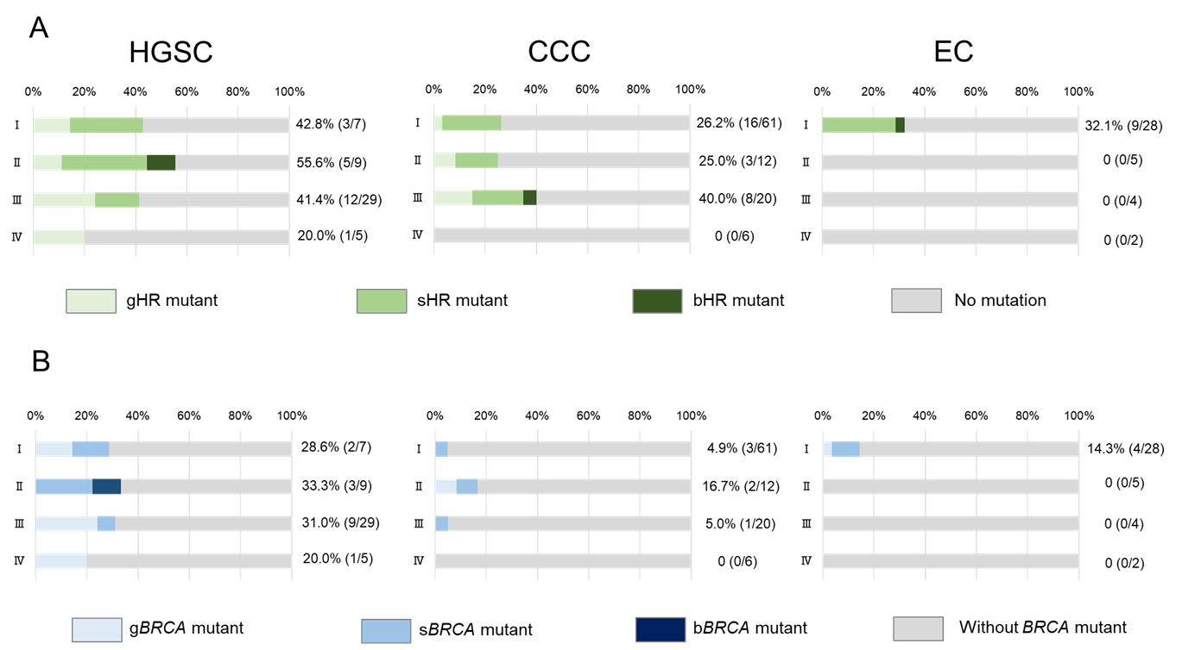

The frequency of HR-associated gene mutation and BRCA mutation by clinical stage per histological subtype is shown in 100 percent stacked bar chart. The mutation data were classified into four categories, respectively – (A) germline HR-associated gene mutation (gHR m), somatic HR-associated gene mutation (sHR m), both germline and somatic HR-associated gene mutation (bHR m) and no mutation (B) germline BRCA mutation (gBRCA m), somatic BRCA mutation (sBRCA m), both germline and somatic BRCA mutation (bBRCA m), and without BRCA mutation.
Supplementary Figure S2. Association between BRCA mutations and clinical outcome per histological subtype
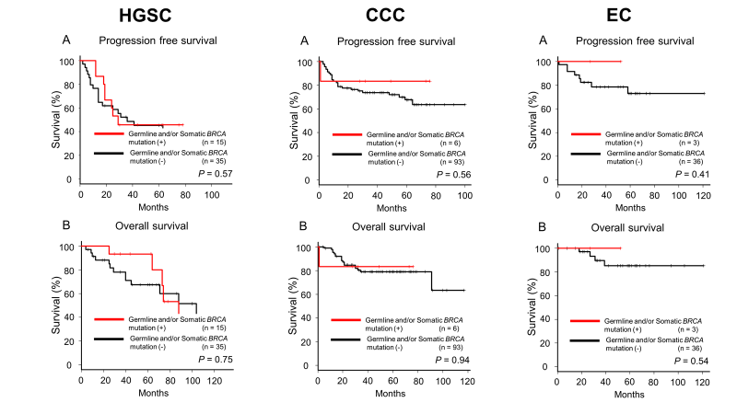

Kaplan–Meier estimates of progression-free survival (A) and overall survival (B) in HGSC, CCC, and EC.
Supplementary Figure S3. Association between MMR gene mutations and HR-associated gene mutations
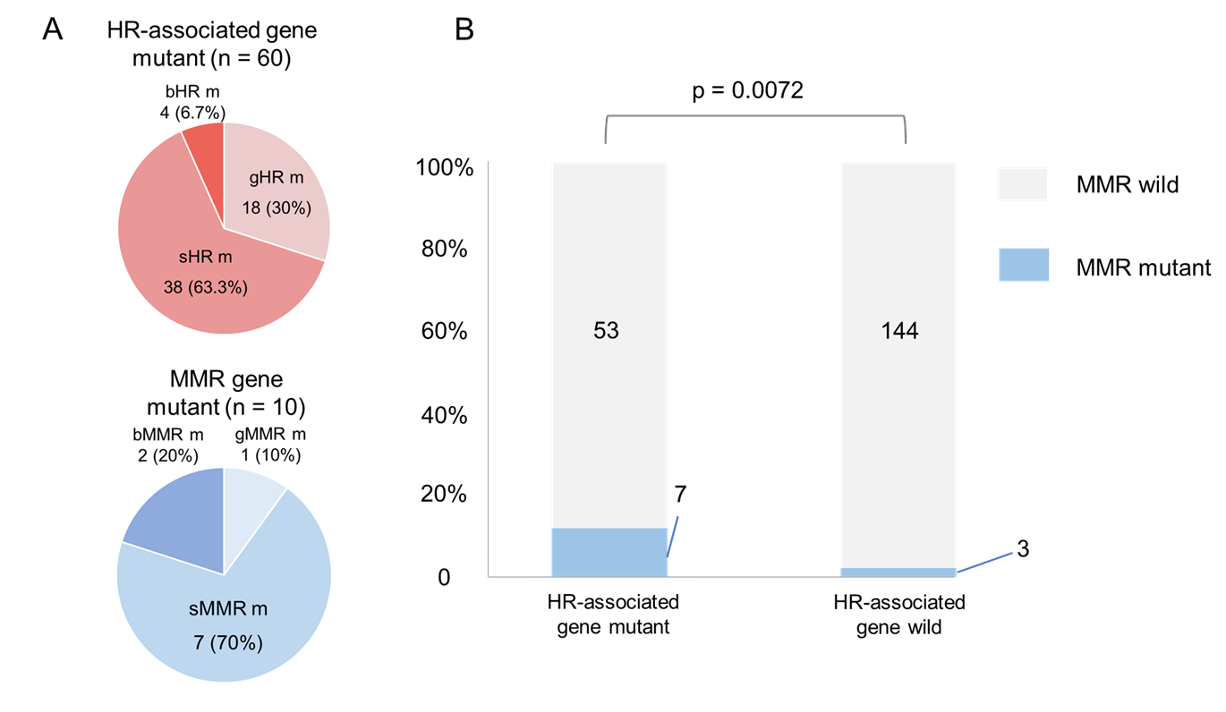
(A) The details of HR-associated gene mutation and MMR mutation are shown in pie chart. The mutation data were
classified into six categories –germline HR-associated gene mutation (gHR m), somatic HR-associated gene mutation (sHR m), both germline and somatic HR-associated gene mutation (bHR m), germline MMR mutation (gMMR m), somatic MMR mutation (sMMR m), and both germline and somatic MMR mutation (bMMR m). (B) Association between MMR gene mutations and HR-associated gene mutations is shown in 100% stacked column chart.

