S5: Funnel plot

Omega-3 Fatty Acids Effects on Inflammatory Biomarkers and Lipid Profiles among Diabetic and Cardiovascular Disease Patients: A Systematic Review and Meta-Analysis

Zuhair S. Natto BDS, MPH, MSc, DrPH, Wael Yaghmoor BDS, MSc , Heba K. Alshaeri PharmD, MPH, PhD & Thomas E. Van Dyke DDS, MS, PhD.

Risk of publication bias summary:
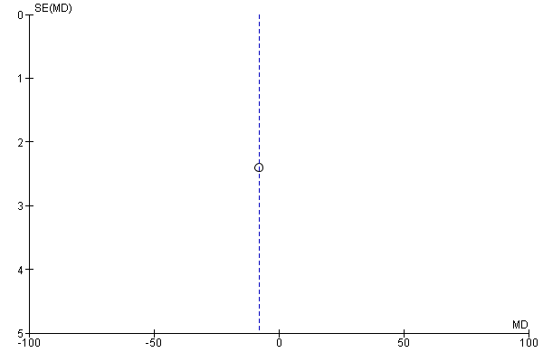Caption
Funnel plot of comparison: DM, outcome: Apo A II.

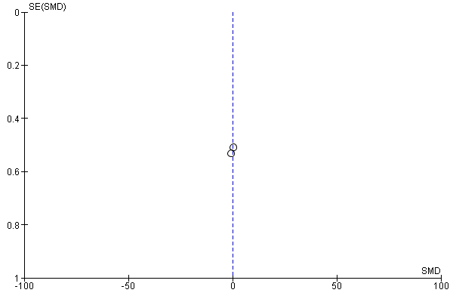
Funnel plot of comparison: DM, outcome: Apo A I.

Forest plot of comparison: 7 DM, outcome: 7.3 Apo B.
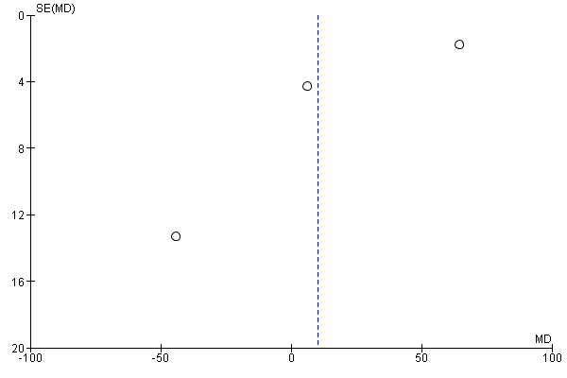
Funnel plot of comparison: DM, outcome: Apo B.

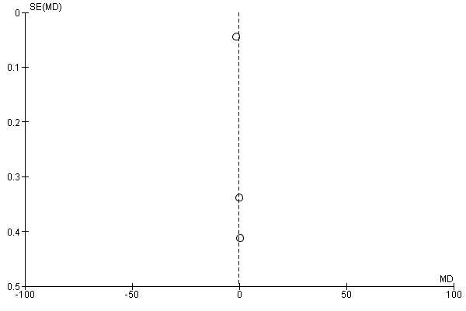
Funnel plot of comparison: DM, outcome: CRP.
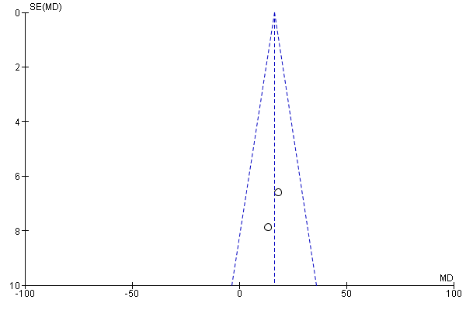
Funnel plot of comparison: DM, outcome: Fasting blood glucose.
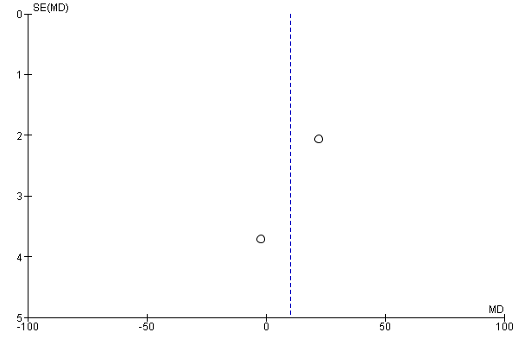
Funnel plot of comparison: DM, outcome: Glucose.

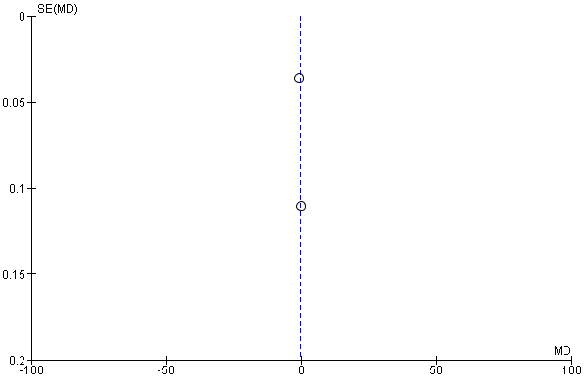
Funnel plot of comparison: DM, outcome: HbAIc.
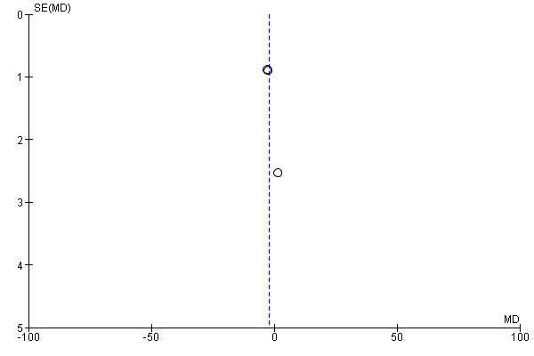
Funnel plot of comparison: DM, outcome: HDL.

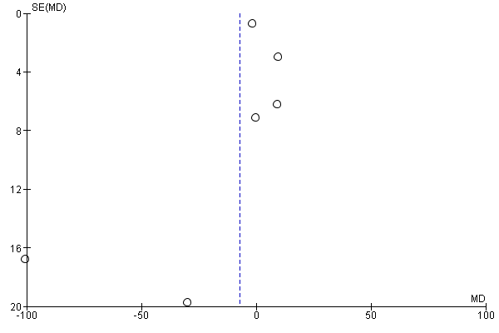
Funnel plot of comparison: DM, outcome: 7. LDL.
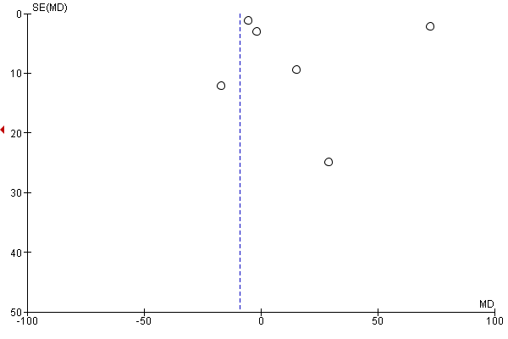
Funnel plot of comparison: DM, outcome: Total cholestrol.

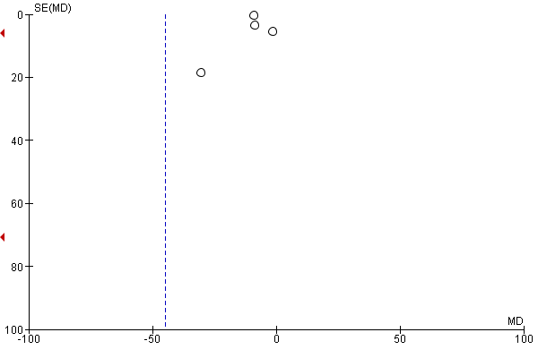
Funnel plot of comparison: DM, outcome: TG.
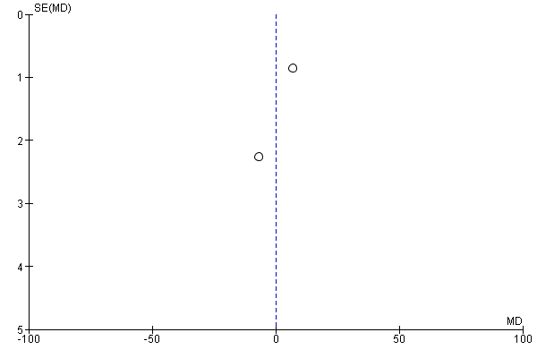
Funnel plot of comparison: CVD, outcome: Apo A.
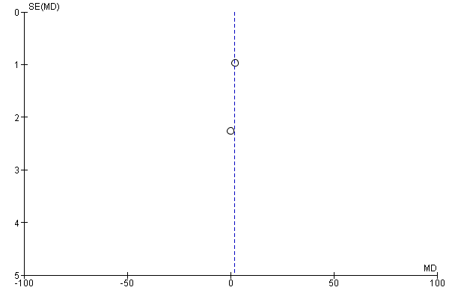
Funnel plot of comparison: CVD, outcome: Apo B.
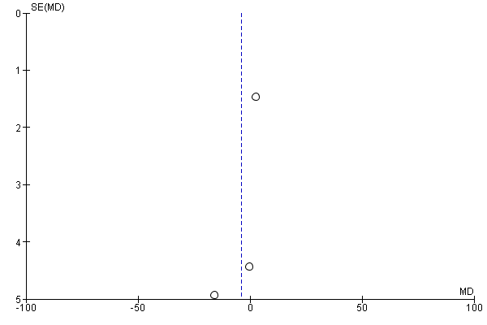
Funnel plot of comparison: CVD, outcome: Glucose.

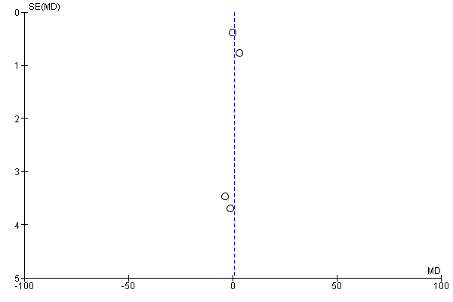
Funnel plot of comparison: CVD, outcome: HDL.
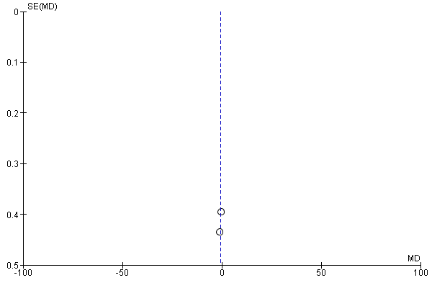
Funnel plot of comparison: CVD, outcome: Hemoglobin.

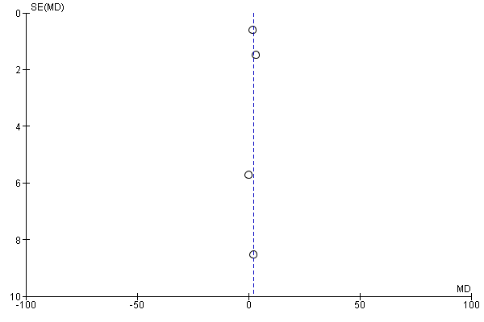
Funnel plot of comparison: CVD, outcome: LDL.

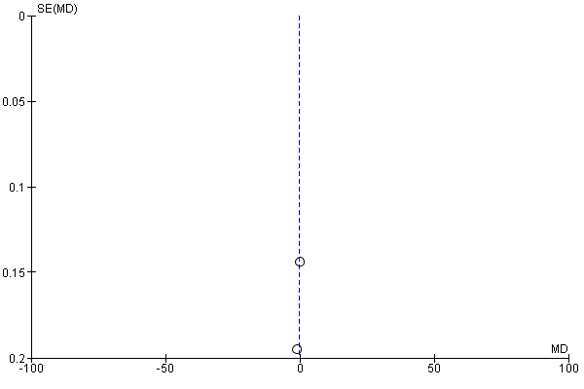
Funnel plot of comparison: CVD, outcome: TNF-a.

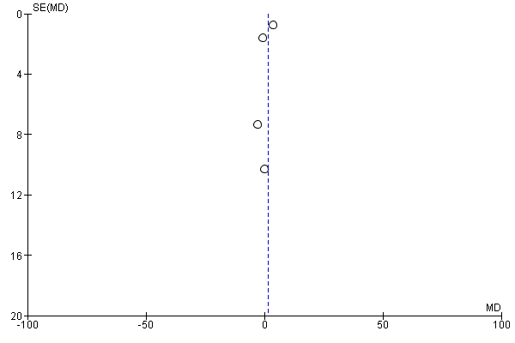
Funnel plot of comparison: CVD, outcome: Total Cholesterol.
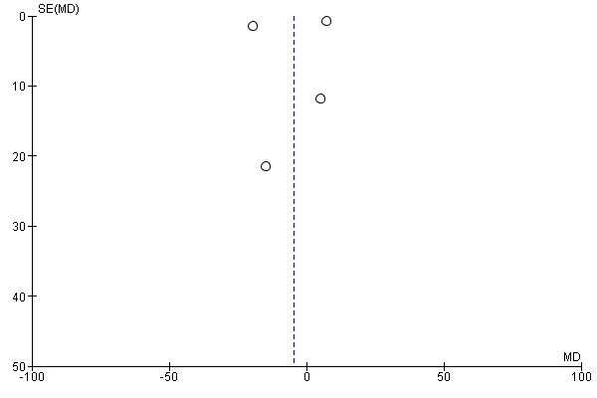
Funnel plot of comparison: CVD, outcome: TG.

