Effect of ultrapure lipopolysaccharides derived from diverse bacterial species on the modulation of platelet activation

Thomas M. Vallance¹, Divyashree Ravishankar¹, Dina A. I. Albadawi¹, Harry Layfield¹, Jonathan Sheard^{2,3}, Rajendran Vaiyapuri⁴, Philip Dash⁵, Ketan Patel⁵, Darius Widera² and Sakthivel Vaiyapuri¹*
¹School of Pharmacy, University of Reading, Reading, RG6 6UB, United Kingdom
²Stem Cell Biology and Regenerative Medicine Group, School of Pharmacy, University of Reading, Reading, RG6 6UB, United Kingdom
³Sheard BioTech Ltd, 20-22, Wenlock Road, London N1 7GU, United Kingdom

⁴School of Pharmacy, University of Reading Malaysia, Johor, Malaysia
⁵School of Biological Sciences, University of Reading, Reading, RG6 6UB, United Kingdom

*Corresponding author: Dr Sakthivel Vaiyapuri, School of Pharmacy, University of Reading, Reading, RG6 6UB, United Kingdom. Email: s.vaiyapuri@reading.ac.uk

Supplementary Information

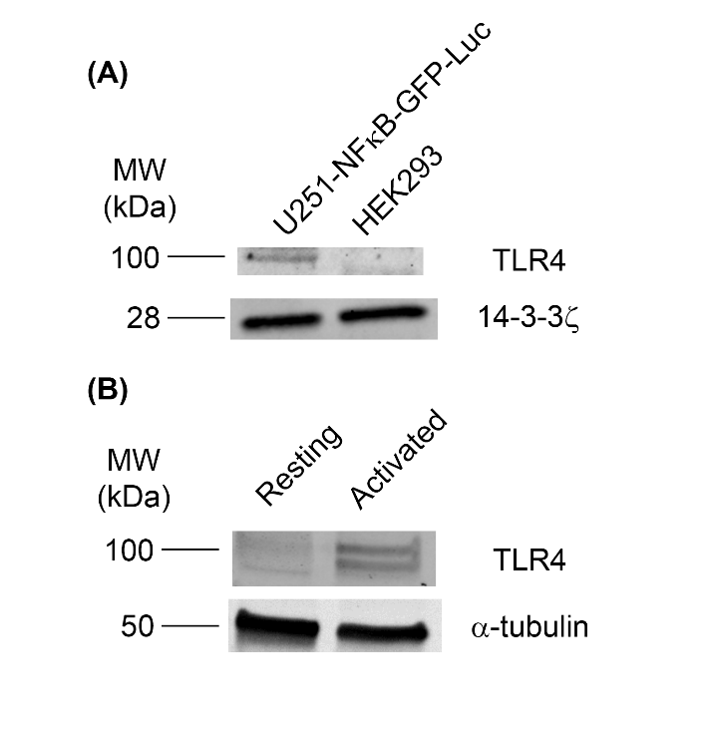

Figure S1: TLR4 expression in platelets and control cells. (A) U251-NF-κB-GFP-Luc cell lysates (left) and HEK293 cell lysates (right) were used as positive and negative controls respectively to validate the anti-TLR4 antibody used. (B) Platelet lysates stimulated with 1μg/mL collagen and their resting equivalents were also probed for their TLR4 expression using the anti-TLR4 antibody. The blot shown is representative of three separate experiments.

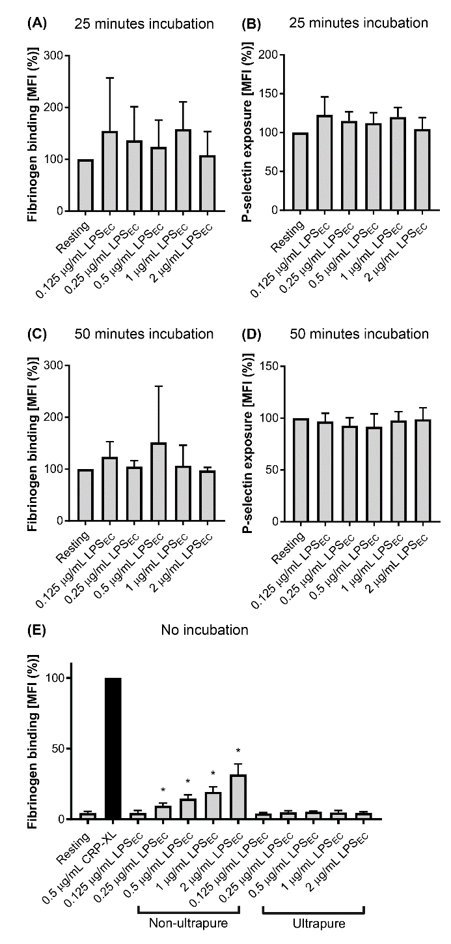
Figure S2: Effect of LPS_{EC} on platelet activation. The level of fibrinogen binding and P-selectin exposure in PRP was measured upon incubation with ultrapure LPS_{EC} for 25 minutes at room temperature (A, B) or 50 minutes at 37°C (n=5) (C, D). Furthermore, the level of fibrinogen binding to platelets treated with a non-ultrapure version of LPS_{EC} following 20 minutes of incubation was determined (n=3) (E). All data were normalised to their resting control and analysed using one-way ANOVA and Dunnett’s post-hoc test (*p<0.05). Data represent mean ± S.D.
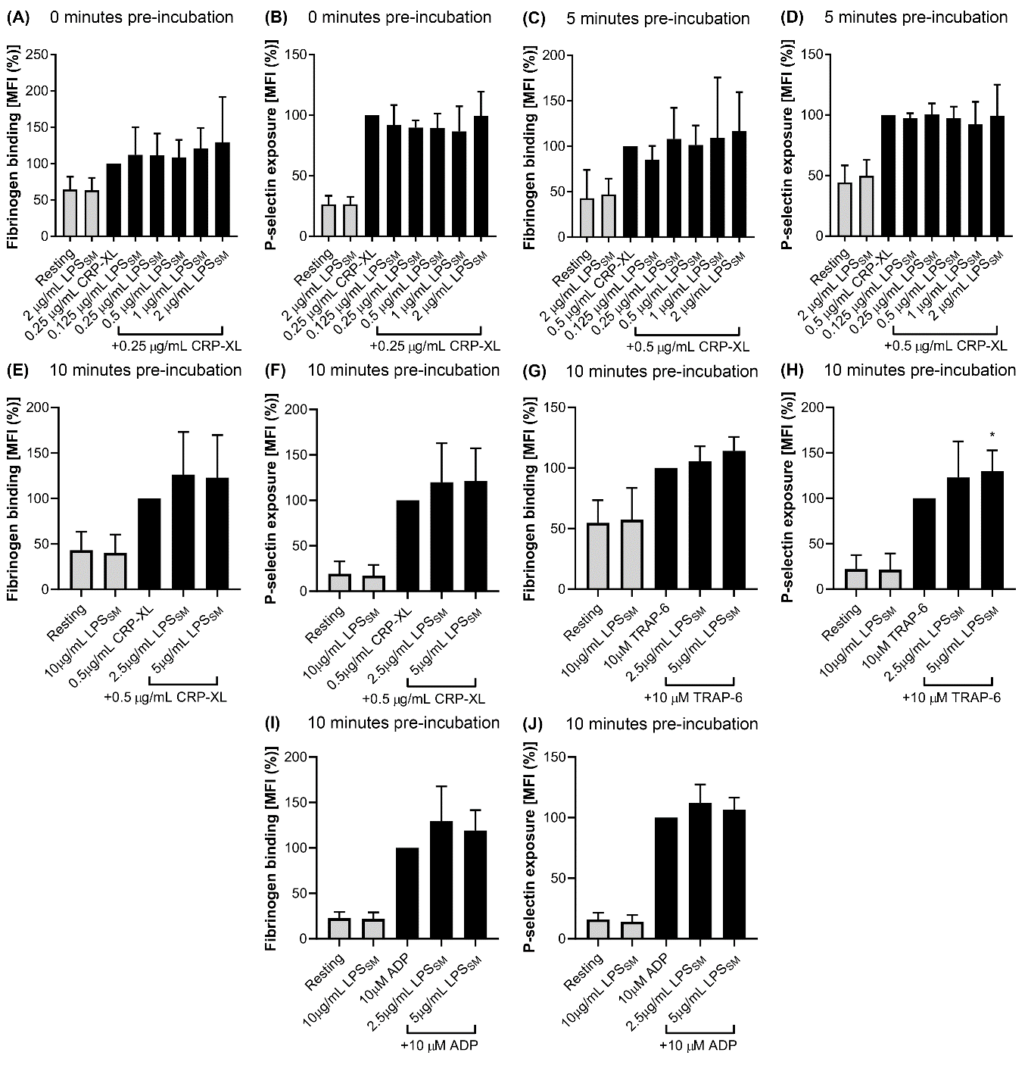
Figure S3: Effect of LPS_{SM} on platelet activation. The level of fibrinogen binding and P-selectin exposure was measured in PRP in the presence of different concentrations of LPS_{SM} and 0.25μg/mL CRP-XL after simultaneous incubation for 20 minutes at room temperature (A, B) (n=3) or preincubation with LPS_{SM} for 5 minutes followed by stimulation with 0.5μg/mL CRP-XL for 20 minutes at room temperature (n=5) (C, D). Similarly, higher LPS_{SM} concentrations were tested with 0.5μg/mL CRP-XL following 10 minutes of pre-incubation and the level of fibrinogen binding (E) and P-selectin exposure (F) was measured (n=7). This experimental set-up was repeated with 10μM TRAP-6 (G and H; n=7) and 10μM ADP as platelet agonists (I and J; n=7). The data were normalised to their 0.5μg/mL CRP-XL, 10μM TRAP-6, or 10μM ADP controls and analysed using one-way ANOVA and Dunnett’s post-hoc test (*p<0.05). Data represent mean ± S.D.

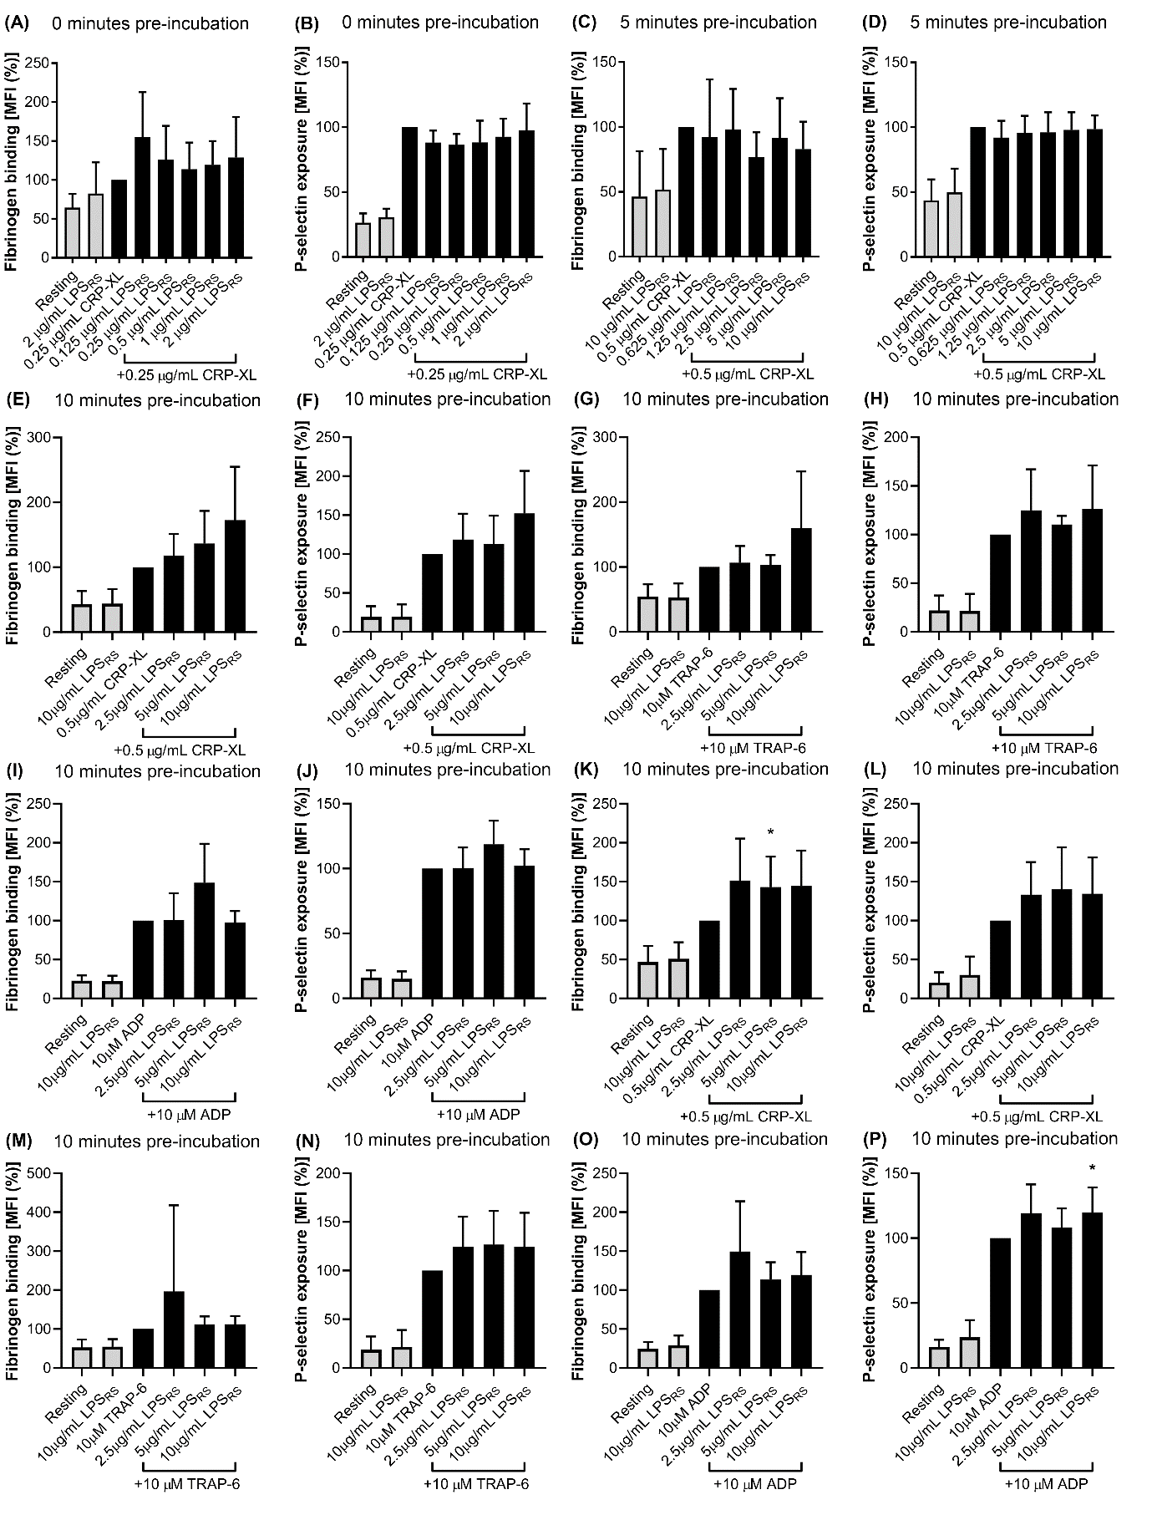
Figure S4: Effect of LPS_{RS} on platelet activation. The level of fibrinogen binding and P-selectin exposure was measured in PRP in the presence of different concentrations of LPS_{RS} and 0.25μg/mL CRP-XL after incubation for 20 minutes at room temperature (A, B) (n=4) or preincubation with LPS_{RS} for 5 minutes followed by stimulation with 0.5μg/mL CRP-XL for 20 minutes at room temperature (n=4) (C, D). Similarly, ultrapure LPS_{RS} concentrations were tested with 0.5μg/mL CRP-XL following 10 minutes of pre-incubation and the level of fibrinogen binding (E) and P-selectin exposure (F) was measured (n=7). This experimental set-up was repeated with 10μM TRAP-6 (G and H; n=7) and 10μM ADP as platelet agonists (I and J; n=7). Furthermore, non-ultrapure LPS_{SM} was also tested for its effect on fibrinogen binding and P-selectin exposure in response to 0.5μg/mL CRP-XL (K and L; n=9), 10μM TRAP-6 (M and N; n=10), and 10μM ADP (O and P; n=10) following 10 minutes of pre-incubation. The data were normalised to their 0.5μg/mL CRP-XL, 10μM TRAP-6, or 10μM ADP controls and were analysed using a one-way ANOVA and Dunnett’s post-hoc test (*p<0.05). Data represent mean ± S.D. The samples treated in the absence of 0.5μg/mL CRP-XL are represented with empty bars.

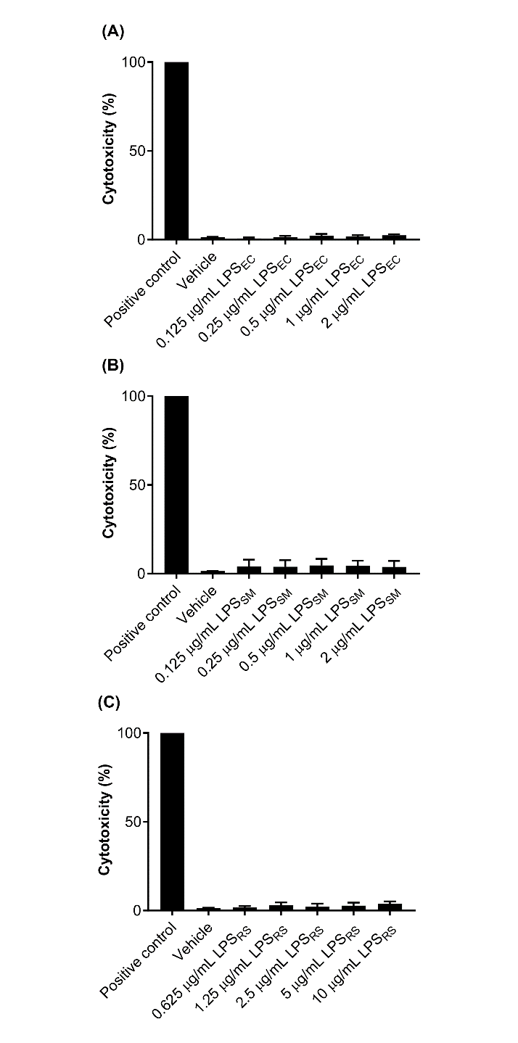
Figure S5: Cytotoxic effects of LPS chemotypes in platelets. The cytotoxic effects of LPS_{EC} (A), LPS_{SM} (B), and LPS_{RS} (C) in platelets were investigated using a lactate dehydrogenase (LDH) cytotoxicity assay. All the results were normalised to the positive control. Data represent mean ± S.D. (n=3) and analysed with one-way ANOVA with Dunnett’s post-hoc test.

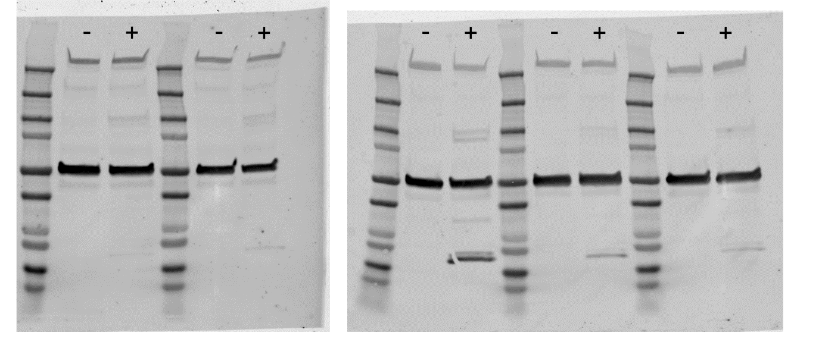
Figure S6: Full length immunoblots of TLR4 and α-tubulin in whole platelet lysates shown in Figure 2. Resting (-) and CRP-XL (0.5μg/mL) activated (+) platelets were examined for the presence of TLR4 via immunoblotting. The level of α-tubulin was detected as a loading control.

