Deciphering the metabolic capabilities of Bifidobacteria using genome-scale metabolic models
- N. T. Devika^{1, 2} and Karthik Raman^{1, 2, 3*}
¹Department of Biotechnology, Bhupat Jyoti Mehta School of Biosciences, Indian Institute of Technology (IIT) Madras, Chennai – 600 036, India
²Initiative for Biological Systems Engineering (IBSE), IIT Madras
³Robert Bosch Centre for Data Science and Artificial Intelligence (RBCDSAI), IIT Madras

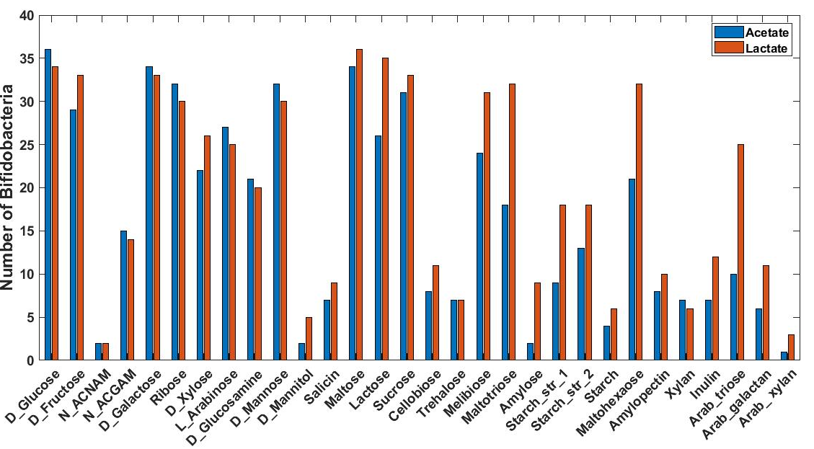
Supplementary Information

Supplementary Fig 1: Environment dependent production of acetate and lactate across strains of bifidobacteria. Comparison of acetate and lactate production across strains of bifidobacteria under 30 different nutrient environments.

