  - Supplementary Material

  - Host phylogeny, diet, and habitat differentiate the gut microbiomes of Darwin’s finches
Wesley T. Loo¹, Jefferson García-Loor², Rachael Y. Dudaniec³, Sonia Kleindorfer^{4,5*}, Colleen M. Cavanaugh^{1*}
  - ¹Department of Organismic and Evolutionary Biology, Harvard University, Cambridge, MA, USA
  - ² Laboratory of Evolutionary Biology, San Francisco University, Quito, Ecuador
  - ³Department of Biological Sciences, Macquarie University, Sydney, NSW, Australia
  - ⁴College of Science and Engineering, Flinders University, Adelaide, SA, Australia
  - ⁵Konrad Lorenz Research Center for Behaviour and Cognition and Department of Behavioural Biology, University of Vienna, Vienna, Austria

  - * Address correspondence to sonia.kleindorfer@flinders.edu.au or cavanaug@fas.harvard.edu
  - Supplementary Figures
Figure S1. Mean relative abundance of bacterial taxa grouped at varying taxonomic levels.
Relative abundance was calculated for each bacterial ribosomal sequence variant (ASV) according to the total number of sequences per sample. Only taxa with mean relative abundance above 5% were included. Mean relative abundance for ASVs grouped for bacterial order (A) and genera (B). Note that taxa labeled as ‘Unclassified’ at these taxonomic levels may be classified at larger taxonomic levels.

Figure S2. Double principal coordinate analysis with all samples showing the outlier warbler finch sample.
This sample was excluded from further analysis.

Figure S3. Beta dispersion of weighted UniFrac distances of gut microbiome samples categorized by habitat and finch species.
Weighted UniFrac distances were plotted on the first two principal coordinate axes and colored by category. Habitat displayed a significant difference in dispersion while species did not.

Figure S4 First foraging observations of Darwin’s finch species across both habitats.
Two species, the small ground finch (SGF) and medium ground finch (MGF) occur in both habitats.

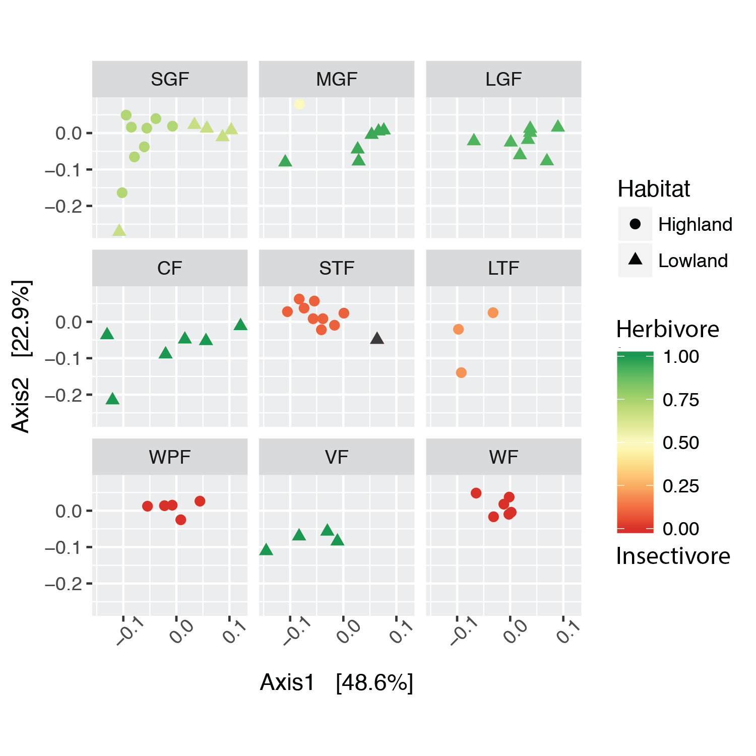
Figure S5. Double principal coordinate analysis (DPCoA) of Darwin’s finch gut microbiome samples overlaid with foraging data.
Darwin’s finch gut microbiome samples are plotted with DPCoA ordination and facetted by finch species. The color of each point corresponds to the proportion of the diet coming from plants vs invertebrates as estimated by foraging observations. The lowland small tree finch is colored gray as no foraging observations were collected for that species and habitat combination.

Figure S6. Beta Diversity Through Time with full bacterial timescale.
Lines show pairwise Sorensen dissimilarities of Darwin’s finch gut microbiome samples determined by time slices every 10 Mya correlated to pairwise dietary distances calculated with first foraging observations (red), pairwise dietary distances using 𝛿¹³C and 𝛿¹⁵N stable isotope measurements (green), and pairwise host phylogenetic distances (blue).

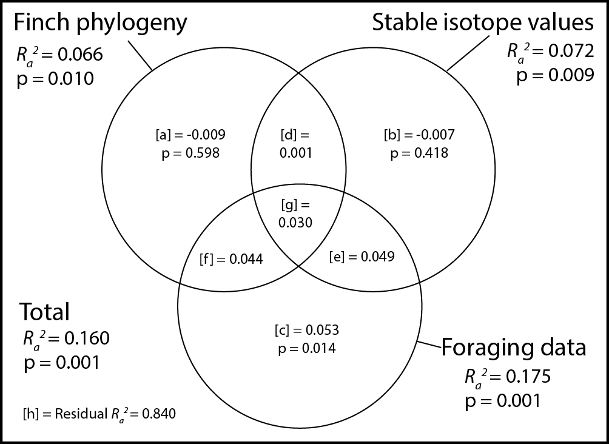
Figure S7. Variation partitioning of Darwin’s finch gut microbiome samples by finch phylogeny, stable isotope values, and foraging data.
Results of variation partitioning using weighted UniFrac distances between gut microbiome samples against Darwin’s finch phylogeny (first two principal coordinate axes), stable isotope values (𝛿¹³C and 𝛿¹⁵N values), and foraging data (first two principal component axes) visualized with a Venn diagram. Adjusted R² values for each component are plotted inside the circles. All testable components include the p-value calculated using distance based redundancy analysis. Adjusted R² values in [a], [b], and [c] are the amount of variation explained uniquely by the corresponding explanatory table. Parts [d], [e], and [f] are amounts of variation that can be explained by either table in the overlap and part [g] is shared by all three tables. Foraging data is the only table with a positive adjusted R² value after controlling for overlapping variance.

A |  | Predicted Class
 |  | CF |  | LGF |  | LTF |  | MGF |  | SGF |  | STF |  | VF |  | WF |  | WPF |  | Accuracy
Actual class | CF |  | 0 |  | 1 |  | 0 |  | 2 |  | 3 |  | 0 |  | 0 |  | 0 |  | 0 |  | 0.00
Actual class | LGF |  | 2 |  | 0 |  | 0 |  | 4 |  | 1 |  | 0 |  | 0 |  | 0 |  | 0 |  | 0.00
Actual class | LTF |  | 1 |  | 0 |  | 0 |  | 0 |  | 0 |  | 1 |  | 0 |  | 1 |  | 0 |  | 0.00
Actual class | MGF |  | 0 |  | 3 |  | 0 |  | 0 |  | 2 |  | 0 |  | 1 |  | 0 |  | 0 |  | 0.00
Actual class | SGF |  | 2 |  | 2 |  | 0 |  | 0 |  | 8 |  | 1 |  | 0 |  | 0 |  | 0 |  | 0.62
Actual class | STF |  | 0 |  | 0 |  | 0 |  | 0 |  | 2 |  | 3 |  | 0 |  | 1 |  | 1 |  | 0.43
Actual class | VF |  | 2 |  | 0 |  | 0 |  | 0 |  | 2 |  | 0 |  | 0 |  | 0 |  | 0 |  | 0.00
Actual class | WF |  | 0 |  | 0 |  | 0 |  | 0 |  | 3 |  | 1 |  | 0 |  | 1 |  | 1 |  | 0.17
Actual class | WPF |  | 0 |  | 0 |  | 0 |  | 0 |  | 0 |  | 1 |  | 0 |  | 3 |  | 1 |  | 0.20

B |  | Predicted class
 |  | Highland | Lowland | Accuracy
Actual class | Highland | 27 | 2 | 0.93
Actual class | Lowland | 0 | 28 | 1.00

Figure S8. Confusion matrices for the random forest classifier using Darwin’s finch gut microbiome communities with leave-one-out cross-validation.
A) Prediction of finch species. Overall accuracy of the predictions was 0.23 and was equal to the no information rate. B) Prediction of habitat. Overall accuracy was 0.96 with a 95% confidence interval of 0.88 to 1.00. This was significantly higher than the no information rate (0.51, p<0.0001).

Figure S9. Abundance of the actual sequence variant with the most importance for classification by habitat, Tetrasphaera.
This ASV is present in almost all of the lowland samples but absent from almost all highland samples. This strong pattern of presence/absence explains why this ASV was so useful in classifying gut microbiome samples as coming from the highland or lowland habitats.

  - Supplementary Tables

Table S1. Statistical tests on amplicon library size mean and distribution across categorical variables of interest
Variable | Kruskal-Wallis test  for library size mean |  | Levene’s test for  library size distribution
Variable | 𝜲² | p-value | F value | p-value
Species | 13.17 | 0.11 | 0.58 | 0.79
Habitat | 0.11 | 0.74 | 0.05 | 0.82
Sex | 0.51 | 0.48 | 2.23 | 0.14
PCRPlate | 6.75 | 0.24 | 1.52 | 0.20

Table S2. Relative abundance of bacterial phyla across all samples
Phylum | meanRA | sdRA | minRA | maxRA
Firmicutes | 35.4% | 32.3% | 0.2% | 98.3%
Actinobacteria | 31.3% | 24.2% | 0.2% | 89.9%
Proteobacteria | 27.5% | 22.7% | 0.7% | 93.9%
Unclassified | 3.6% | 7.2% | 0.1% | 38.2%
Chloroflexi | 0.9% | 1.6% | 0.0% | 8.9%
Tenericutes | 0.4% | 2.3% | 0.0% | 17.2%
Acidobacteria | 0.3% | 0.4% | 0.0% | 1.6%
Planctomycetes | 0.3% | 0.3% | 0.0% | 1.5%
Bacteroidetes | 0.2% | 0.9% | 0.0% | 7.0%
Cyanobacteria | 0.1% | 0.2% | 0.0% | 1.1%
Spirochaetes | 0.1% | 0.4% | 0.0% | 2.8%
Deinococcus-Thermus | 0.0% | 0.1% | 0.0% | 0.7%
Verrucomicrobia | 0.0% | 0.0% | 0.0% | 0.2%
Chlamydiae | 0.0% | 0.0% | 0.0% | 0.0%
Gemmatimonadetes | 0.0% | 0.0% | 0.0% | 0.1%

Phylum | CF | LGF | SGF | MGF | STF | LTF | WPF | VF | WF
Firmicutes | 81.0% | 12.6% | 53.1% | 34.6% | 34.2% | 35.2% | 15.9% | 12.4% | 18.9%
Actinobacteria | 9.8% | 53.2% | 24.5% | 40.6% | 38.6% | 35.3% | 28.5% | 13.9% | 27.9%
Proteobacteria | 7.4% | 27.2% | 19.6% | 15.9% | 24.4% | 28.8% | 48.1% | 54.9% | 43.7%
Unclassified | 1.1% | 4.0% | 1.5% | 6.1% | 0.7% | 0.3% | 1.3% | 17.3% | 6.0%
Chloroflexi | 0.3% | 2.2% | 0.5% | 2.0% | 1.3% | 0.3% | 0.4% | 0.1% | 1.1%
Tenericutes | 0.1% | 0.0% | 0.0% | 0.0% | 0.0% | 0.0% | 3.7% | 0.0% | 0.9%
Acidobacteria | 0.1% | 0.3% | 0.3% | 0.5% | 0.4% | 0.0% | 0.2% | 0.3% | 0.2%
Planctomycetes | 0.1% | 0.2% | 0.3% | 0.3% | 0.4% | 0.1% | 0.3% | 0.1% | 0.4%
Bacteroidetes | 0.1% | 0.0% | 0.0% | 0.0% | 0.1% | 0.0% | 1.5% | 0.2% | 0.0%
Cyanobacteria | 0.0% | 0.1% | 0.1% | 0.0% | 0.1% | 0.0% | 0.1% | 0.5% | 0.1%
Spirochaetes | 0.0% | 0.0% | 0.0% | 0.0% | 0.0% | 0.0% | 0.0% | 0.0% | 0.7%
Deinococcus-Thermus | 0.0% | 0.0% | 0.0% | 0.0% | 0.0% | 0.0% | 0.0% | 0.3% | 0.0%

Table S3. Relative abundance of bacterial phyla across Darwin’s finch species

Table S4. Most abundant bacterial genera across all Darwin finch gut microbiome samples above 1 percent mean relative abundance.
Phylum | Genus | meanRA | sdRA | minRA | maxRA
Firmicutes | Lactobacillus | 26.2% | 32.8% | 0.0% | 98.2%
Proteobacteria | Acinetobacter | 6.4% | 16.0% | 0.0% | 86.0%
Actinobacteria | Kocuria | 4.5% | 12.2% | 0.0% | 69.7%
Proteobacteria | Methylobacterium | 3.8% | 4.9% | 0.0% | 25.6%
Actinobacteria | Mycobacterium | 2.6% | 6.6% | 0.0% | 51.3%
Actinobacteria | Nocardioides | 1.8% | 1.9% | 0.0% | 9.0%
Actinobacteria | Geodermatophilus | 1.8% | 3.2% | 0.0% | 16.3%
Proteobacteria | Diplorickettsia | 1.7% | 11.3% | 0.0% | 89.5%
Actinobacteria | Solirubrobacter | 1.7% | 2.1% | 0.0% | 9.1%
Firmicutes | Enterococcus | 1.7% | 4.6% | 0.0% | 22.6%
Actinobacteria | Cellulomonas | 1.4% | 3.1% | 0.0% | 21.3%
Proteobacteria | Enterobacter | 1.3% | 4.8% | 0.0% | 29.8%
Actinobacteria | Curtobacterium | 1.3% | 2.6% | 0.0% | 13.5%
Proteobacteria | Rhodospirillum | 1.3% | 9.9% | 0.0% | 78.9%
Proteobacteria | Rhizobium | 1.2% | 1.6% | 0.0% | 7.7%
Firmicutes | Clostridium_XVIII | 1.1% | 8.4% | 0.0% | 67.0%
Actinobacteria | Corynebacterium | 1.0% | 5.0% | 0.0% | 39.6%

Table S5. Most abundant classified bacterial genus for each Darwin finch species
Darwin finch species | Bacterial genus | meanRA | sdRA | minRA | maxRA
SGF | Lactobacillus | 49.7% | 34.3% | 0.2% | 95.7%
MGF | Lactobacillus | 27.3% | 34.8% | 0.1% | 84.5%
LGF | Kocuria | 22.5% | 26.5% | 2.0% | 69.7%
CF | Lactobacillus | 77.8% | 16.3% | 56.5% | 98.2%
STF | Lactobacillus | 11.7% | 20.3% | 0.1% | 61.8%
LTF | Lactobacillus | 26.1% | 13.2% | 14.0% | 40.2%
WPF | Rhodospirillum | 15.8% | 35.3% | 0.0% | 78.9%
VF | Acinetobacter | 16.5% | 29.9% | 1.3% | 61.4%
WF | Diplorickettsia | 14.0% | 33.4% | 0.1% | 89.5%

Table S6. Alpha diversity estimates by Darwin’s finch species
Species | Observed ASVs mean | Observed ASVs SE | Chao1 mean | Chao1 SE | PD mean | PD SE
CF | 522.17 | 151.25 | 701.04 | 188.83 | 52.09 | 10.04
LGF | 796.63 | 112.25 | 1023.84 | 110.62 | 66.04 | 6.54
SGF | 622.46 | 113.56 | 853.22 | 131.87 | 53.60 | 6.08
WF | 575.00 | 70.67 | 729.71 | 74.16 | 59.64 | 4.99
STF | 777.50 | 88.13 | 962.39 | 101.93 | 68.51 | 6.56
MGF | 732.43 | 141.23 | 928.88 | 151.93 | 59.02 | 7.29
VF | 471.25 | 73.26 | 623.35 | 84.95 | 58.62 | 4.80
LTF | 475.67 | 151.15 | 684.07 | 170.49 | 44.06 | 8.20
WPF | 997.20 | 99.30 | 1228.33 | 127.62 | 80.87 | 5.58

Table S7. Anova on alpha diversity metrics across species (N = 9, sample size ranging from 3 to 13)
Diversity metric | F value | p value
Observed ASVs | 1.58 | 0.15
Chao 1 | 1.50 | 0.18
Phylogenetic diversity | 1.67 | 0.13

Table S8. Permanova tests of weighted UniFrac distances with categorical variables of interest (N = 62)

- Variable | - F | - R² | - p
- Habitat* | - 12.1 | - 0.15 | - 0.03
- Habitat:Species* | - 1.6 | - 0.21 | - 0.03
- Sex | - 0.97 | - 0.02 | - 0.41
- PCRPlate | - 0.78 | - 0.01 | - 0.56

* Species is nested within habitat because only the small ground finch is present in both habitats

Table S9. Post hoc pairwise anova with weighted UniFrac distances between Darwin’s finch species
Pairwise comparison | F.Model | R2 | p.value | p.adjusted
WF vs VF | 6.46 | 0.45 | 0.005 | 0.180
WF vs STF | 1.95 | 0.12 | 0.020 | 0.720
WF vs SGF | 1.75 | 0.09 | 0.130 | 1.000
WF vs LGF | 4.66 | 0.28 | 0.001 | *0.036
WF vs LTF | 2.49 | 0.26 | 0.052 | 1.000
WF vs MGF | 2.79 | 0.20 | 0.013 | 0.468
WF vs WPF | 1.75 | 0.16 | 0.025 | 0.900
WF vs CF | 3.49 | 0.26 | 0.005 | 0.180
VF vs STF | 5.28 | 0.31 | 0.001 | *0.036
VF vs SGF | 2.43 | 0.14 | 0.047 | 1.000
VF vs LGF | 4.28 | 0.30 | 0.006 | 0.216
VF vs LTF | 1.88 | 0.27 | 0.046 | 1.000
VF vs MGF | 3.07 | 0.25 | 0.044 | 1.000
VF vs WPF | 6.37 | 0.48 | 0.007 | 0.252
VF vs CF | 1.12 | 0.12 | 0.306 | 1.000
STF vs SGF | 1.78 | 0.08 | 0.096 | 1.000
STF vs LGF | 4.64 | 0.22 | 0.001 | *0.036
STF vs LTF | 2.23 | 0.17 | 0.048 | 1.000
STF vs MGF | 2.71 | 0.15 | 0.017 | 0.612
STF vs WPF | 1.65 | 0.11 | 0.083 | 1.000
STF vs CF | 3.76 | 0.21 | 0.002 | 0.072
SGF vs LGF | 2.04 | 0.10 | 0.075 | 1.000
SGF vs LTF | 0.90 | 0.06 | 0.398 | 1.000
SGF vs MGF | 1.22 | 0.06 | 0.298 | 1.000
SGF vs WPF | 1.85 | 0.10 | 0.088 | 1.000
SGF vs CF | 1.40 | 0.08 | 0.212 | 1.000
LGF vs LTF | 3.37 | 0.27 | 0.023 | 0.828
LGF vs MGF | 0.67 | 0.05 | 0.727 | 1.000
LGF vs WPF | 3.73 | 0.25 | 0.004 | 0.144
LGF vs CF | 1.88 | 0.14 | 0.107 | 1.000
LTF vs MGF | 1.72 | 0.18 | 0.155 | 1.000
LTF vs WPF | 2.97 | 0.33 | 0.049 | 1.000
LTF vs CF | 1.13 | 0.14 | 0.271 | 1.000
MGF vs WPF | 2.27 | 0.19 | 0.039 | 1.000
MGF vs CF | 1.22 | 0.10 | 0.261 | 1.000
WPF vs CF | 3.20 | 0.26 | 0.008 | 0.288

Table S10. Stable isotope (𝛿 ¹³C and 𝛿 ¹⁵N) ratios by Darwin’s finch species

Species | Habitat | 𝛿 ¹³C mean (‰) | 𝛿 ¹³C SD (‰) | 𝛿 ¹⁵N mean (‰) | 𝛿 ¹⁵N SD (‰)
SGF | H | -20.9 | 5.3 | 6.9 | 1.5
SGF | L | -23.6 | 0.7 | 10.1 | 1.8
MGF | H | -24.6 | -* | 8.7 | -*
MGF | L | -23.0 | 2.0 | 10.1 | 1.1
LGF | L | -23.3 | 1.0 | 9.3 | 0.7
CF | L | -16.2 | 1.6 | 11.4 | 1.2
STF | H | -25.2 | 1.4 | 7.7 | 1.0
STF | L | -23.7 | -* | 12.9 | -*
LTF | H | -25.7 | 0.2 | 8.9 | 0.5
WPF | H | -25.6 | 0.8 | 9.2 | 0.8
VF | L | -24.5 | 0.2 | 10.5 | 1.0
WF | H | -26.7 | 0.7 | 9.3 | 0.3

* Single sample for this species/habitat so standard deviation was not calculated

Table S11 Kruskal-Wallis tests of stable isotope ratios
- Stable isotope | - Variable | - Kruskal-Wallis chi-squared | - p
- 𝛿 ¹³C | - Habitat | - 16.3 | - 5.5e-05
- 𝛿 ¹³C | - Species | - 34.8 | - 2.9e-05
- 𝛿 ¹⁵N | - Habitat | - 23.0 | - 1.6e-05
- 𝛿 ¹⁵N | - Species | - 22.5 | - 0.004

  - Table S12 Dunn Test on 𝛿 ¹³C by species.
Comparison | Z | P.unadj | P.adj*
CF - LGF | 1.747 | 0.081 | 1.000
CF - LTF | 3.211 | 0.001 | 0.048
LGF - LTF | 1.882 | 0.060 | 1.000
CF - MGF | 2.016 | 0.044 | 1.000
LGF - MGF | 0.280 | 0.779 | 1.000
LTF - MGF | -1.665 | 0.096 | 1.000
CF - SGF | 2.185 | 0.029 | 1.000
LGF - SGF | 0.228 | 0.820 | 1.000
LTF - SGF | -1.861 | 0.063 | 1.000
MGF - SGF | -0.091 | 0.927 | 1.000
CF - STF | 3.506 | 0.000 | 0.016
LGF - STF | 1.781 | 0.075 | 1.000
LTF - STF | -0.557 | 0.577 | 1.000
MGF - STF | 1.492 | 0.136 | 1.000
SGF - STF | 1.813 | 0.070 | 1.000
CF - VF | 2.533 | 0.011 | 0.407
LGF - VF | 1.058 | 0.290 | 1.000
LTF - VF | -0.832 | 0.405 | 1.000
MGF - VF | 0.819 | 0.413 | 1.000
SGF - VF | 0.973 | 0.330 | 1.000
STF - VF | -0.422 | 0.673 | 1.000
CF - WF | 4.857 | 0.000 | 4.2e-05b
LGF - WF | 3.294 | 0.001 | 0.036
LTF - WF | 0.755 | 0.450 | 1.000
MGF - WF | 3.025 | 0.002 | 0.090
SGF - WF | 3.497 | 0.000 | 0.017
STF - WF | 1.687 | 0.092 | 1.000
VF - WF | 1.811 | 0.070 | 1.000
CF - WPF | 3.734 | 0.000 | 0.007
LGF - WPF | 2.202 | 0.028 | 0.997
LTF - WPF | -0.013 | 0.989 | 1.000
MGF - WPF | 1.946 | 0.052 | 1.000
SGF - WPF | 2.247 | 0.025 | 0.887
STF - WPF | 0.645 | 0.519 | 1.000
VF - WPF | 0.933 | 0.351 | 1.000
WF - WPF | -0.897 | 0.369 | 1.000

*p-values adjusted by Bonferroni correction

  - Table S13 Dunn Test on 𝛿 ¹⁵N by species.
Comparison | Z | P.unadj | P.adj*
CF - LGF | 2.088 | 0.037 | 1.000
CF - LTF | 2.209 | 0.027 | 0.977
LGF - LTF | 0.581 | 0.562 | 1.000
CF - MGF | 1.483 | 0.138 | 1.000
LGF - MGF | -0.630 | 0.529 | 1.000
LTF - MGF | -1.069 | 0.285 | 1.000
CF - SGF | 3.708 | 0.000 | 0.008
LGF - SGF | 1.426 | 0.154 | 1.000
LTF - SGF | 0.418 | 0.676 | 1.000
MGF - SGF | 2.145 | 0.032 | 1.000
CF - STF | 3.616 | 0.000 | 0.011
LGF - STF | 1.529 | 0.126 | 1.000
LTF - STF | 0.577 | 0.564 | 1.000
MGF - STF | 2.180 | 0.029 | 1.000
SGF - STF | 0.273 | 0.785 | 1.000
CF - VF | 0.556 | 0.578 | 1.000
LGF - VF | -1.281 | 0.200 | 1.000
LTF - VF | -1.575 | 0.115 | 1.000
MGF - VF | -0.743 | 0.457 | 1.000
SGF - VF | -2.573 | 0.010 | 0.363
STF - VF | -2.603 | 0.009 | 0.333
CF - WF | 1.983 | 0.047 | 1.000
LGF - WF | -0.030 | 0.976 | 1.000
LTF - WF | -0.590 | 0.555 | 1.000
MGF - WF | 0.576 | 0.565 | 1.000
SGF - WF | -1.388 | 0.165 | 1.000
STF - WF | -1.496 | 0.135 | 1.000
VF - WF | 1.218 | 0.223 | 1.000
CF - WPF | 2.112 | 0.035 | 1.000
LGF - WPF | 0.200 | 0.841 | 1.000
LTF - WPF | -0.388 | 0.698 | 1.000
MGF - WPF | 0.776 | 0.438 | 1.000
SGF - WPF | -1.048 | 0.295 | 1.000
STF - WPF | -1.182 | 0.237 | 1.000
VF - WPF | 1.371 | 0.170 | 1.000
WF - WPF | 0.221 | 0.825 | 1.000

*p-values adjusted by Bonferroni correction

Table S14. First foraging observations across all Darwin’s finch species and both habitats

Sp. | Hab | Total (n) | Counts (n) |  |  |  |  | Proportion of counts (%) |  |  |  |  | Summary (%)
Sp. | Hab | Total (n) | Flower | Fruit | Leaf | Seed | Insect | Flower | Fruit | Leaf | Seed | Insect | Plant* | Insect
SGF | L | 12 | 2 | - | - | 6 | 4 | 17 | - | - | 50 | 33 | 67 | 33
SGF | H | 25 | - | 3 | - | 15 | 7 | - | 12 | - | 60 | 28 | 72 | 28
MGF | L | 20 | 5 | - | 2 | 12 | 1 | 25 | - | 10 | 60 | 5 | 95 | 5
MGF | H | 12 | - | - | - | 6 | 6 | - | - | - | 50 | 50 | 50 | 50
LGF | L | 11 | - | - | 1 | 9 | 1 | - | - | 9 | 82 | 9 | 91 | 9
CF | L | 6 | 3 | - | 3 | - | - | 50 | - | 50 | - | - | 100 | 0
STF | H | 41 | - | - | - | 4 | 37 | - | - | - | 10 | 90 | 10 | 90
LTF | H | 15 | - | 3 | - | - | 12 | - | 20 | - | - | 80 | 20 | 80
WPF | H | 19 | - | - | - | - | 19 | - | - | - | - | 100 | 0 | 100
VF | L | 6 | 2 | - | 4 | - | - | 33 | - | 67 | - | - | 100 | 0
WF | H | 34 | - | - | - | - | 34 | - | - | - | - | 100 | 0 | 100

* The category ‘Plant’ is the sum of all plant derived food items (flower, fruit, leaf, and seed).

Table S15. Procrustes Analysis of Co-Phylogeny.
 | Host phylogeny | Stable isotope* | Diet**
R² | 0.178 | 0.064 | 0.175
p-value | <0.0001 | 0.013 | <0.0001
* Euclidean distances were calculated between δ¹³C and δ¹⁵N values for all microbiome samples
** Euclidean distances were calculated based on proportion of food items in first foraging observations

Table S16. Top actual sequence variants (ASVs) for classifying gut microbiome samples by habitat of origin using the random forest algorithm

Phylum | Family | Genus | meanMDA*
Actinobacteria | Intrasporangiaceae | Tetrasphaera | 0.009
Actinobacteria | Mycobacteriaceae | Mycobacterium | 0.008
Actinobacteria | Nocardiaceae | Williamsia | 0.008
Actinobacteria | Micromonosporaceae | Unclassified | 0.008
Actinobacteria | Patulibacteraceae | Patulibacter | 0.007
Proteobacteria | Methylobacteriaceae | Methylobacterium | 0.006
Actinobacteria | Mycobacteriaceae | Mycobacterium | 0.005
Actinobacteria | Mycobacteriaceae | Mycobacterium | 0.005
Actinobacteria | Mycobacteriaceae | Mycobacterium | 0.005
Actinobacteria | Nocardioidaceae | Nocardioides | 0.005
* Mean decrease in accuracy averaged across all 62 random forest classifiers

