Supplementary Material

Diversity of P1 phage-like elements in multidrug resistant Escherichia coli
Carola Venturini^{1,*,†}, Tiziana Zingali^{2,*}, Ethan R. Wyrsch², Bethany Bowring¹, Jonathan Iredell¹, Sally R. Partridge^{1,*}, Steven P. Djordjevic^{2,*,†}

¹Centre for Infectious Diseases and Microbiology, The Westmead Institute for Medical Research, The University of Sydney and Westmead Hospital, Sydney, NSW, Australia
²The ithree Institute, University of Technology Sydney, Sydney, NSW, Australia

*These authors contributed equally to this work.

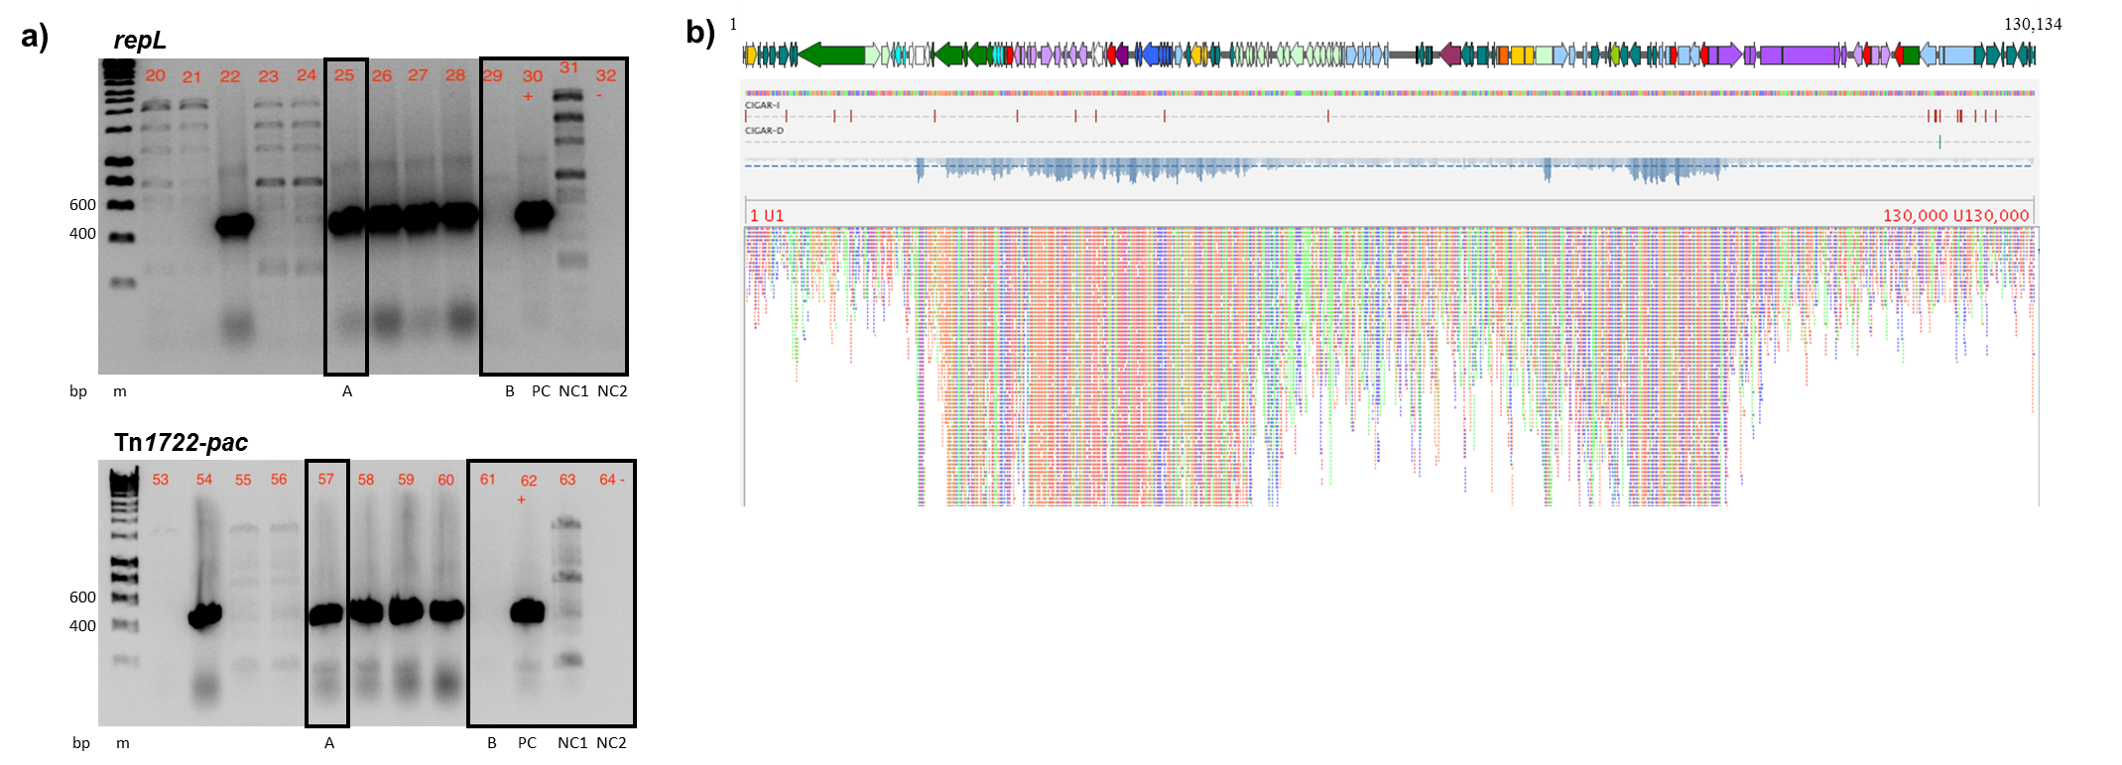
Supplementary Figure 1. Detection of pTZ20_1P in lysogenized commensal E. coli WH17. a) Confirmatory PCRs after lysogenization. repL, lytic replication gene, expected amplicon size 489 bp; Tn1722/pac, region spanning Tn1722 (plasmid insertion) and pacA (phage P1), expected amplicon size 428 bp. Lanes highlighted by black boxes show: A (lanes 25, 57), lysogenized E. coli WH17 after co-incubation on solid medium with filtrate from E. coli TZ20_1P induced with mitomycin C (0.2 μg/mL); B (lanes 29, 61), E. coli WH17 co-incubated with filtrate from uninduced E. coli TZ20_1P; PC (lanes 30, 62), positive control E. coli TZ20_1P donor; NC1 (lanes 31, 63), negative control, E. coli WH17 recipient; NC2 (lanes 32, 64), negative control, molecular grade DNAse-free water. Additional lanes are from lysogenization of WH17 with: 20-21, mitomycin C in liquid medium; 22-25, mitomycin C on solid medium; 26-28, UV light (26-28) on solid medium; 53, UV light in liquid medium; 54-57, mitomycin C on solid medium; 58-60, UV light on solid medium. bp, base pairs; m, Hyperladder™ 1 kb Bioline (Meridian Bioscience). b) Short-read mapping of E. coli WH17 lysogenized with pTZ20_1P (lane A in gels). Illumina raw reads aligned to the full length of the pTZ20_1P genome without gaps. Alignment mapped using Bowtie2⁵⁶ v2.3.0 and visualized using Tablet⁵⁸ v1.19.05.28.

