Near ideal synaptic functionalities in Li ion synaptic transistor using Li₃PO_{x}Se_{x} electrolyte with high ionic conductivity
Revannath Dnyandeo Nikam^{1,2}, Myonghoon Kwak^{1,2}, Jongwon Lee^{1,2}, Krishn Gopal Rajput^{1,2},
Writam Banerjee, Hyunsang Hwang^{1,2,*}
¹Center for Single Atom-based Semiconductor Device, ²Department of Material Science and Engineering, Pohang University of Science and Technology (POSTECH), Pohang 790-784, Republic of Korea
* Authors to whom correspondence should be addressed
Email: hwanghs@postech.ac.kr

Section S1: Simulation for time-dependent calculation of Li ion distribution

To know the amount of Li⁺ transported from LiCoO₂ channel to Si reservoir via electrolyte (Li₃PO₄ OR Li₃PO_{x}Se_{x}), we have constructed the one dimensional (1D) simulation model. The model geometry used in this simulation is as shown below.
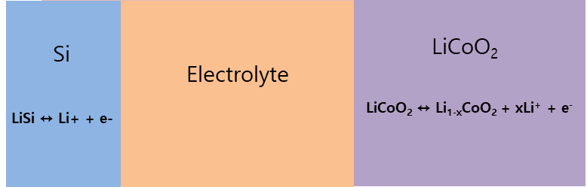
The model geometry consisted 3 domains (channel, electrolyte and Si reservoir).
On the channel side under the electric field the LiCoO₂ is dissociating as,
LiCoO₂ ↔ Li_{1-x}CoO₂ + xLi⁺ + e⁻
On the Si reservoir side Li⁺ associate as,
Si + Li⁺ ↔ SiLi
The hysteresis behavior (volatility or nonvolatility) in lithium ion transistor is determined by the dissociation reaction rate in LiCoO₂ (k_{LCO}), association rate in Si reservoir (k_{Si}) and ionic mobility (µ_{ion}) in electrolyte defined by ionic conductivity of electrolyte.
The reaction kinetics in LiCoO₂ channel and in Si reservoir are described using the Butler-Volmer equation as,
i_{0, LiCoO2} =Fk_{LiCoO2} ${\left(\frac{CLi,max-CLi)CLi}{CLi,max-CLi,min⁡)CLi}\right)}^{LiCoO2} {\left(\frac{CLi,-CLi,min)}{CLi,max-CLi,min⁡)}\right)}^{1-LiCoO2}$
Where C_{Li,max} and C_{Li,min} are the maximum and minimum amount of Li⁺ ion in LiCoO₂ channel.
And --------------(1)
i_{0, Si} =Fk_{Si} ${\left(\frac{CLi,max-CLi)CLi}{CLi,max-CLi,min⁡)CLi}\right)}^{Si} {\left(\frac{CLi,-CLi,min)}{CLi,max-CLi,min⁡)}\right)}^{1-Si}$
During the potentiation, a negative gate pulses initiate the oxidation reaction at the surface of LiCoO₂ and produces the Li⁺ ions. Under the electric field this Li⁺ migrate toward Si reservoir via electrolyte.
The chemical reaction in electrolyte is as,
Li⁺ ↔ Li⁰ + n⁻
The transport Li⁺ kinetic in electrolyte are described by the Nernst-Plank equation as,
N_{i =} -D_{i} 𝐷𝑖∇𝑐 +$\frac{ZiF}{RT}$ DiCi ∇𝜙_{l} ----------------(2)
The hysteresis behavior (volatility or nonvolatility) of Li₃PO₄ and Li₃PO_{x}Se_{x} electrolytes consisted synaptic transistor devices can have explained by knowing the Li⁺ ion concertation with time in LiCoO₂ after the potentiation. To know the Li⁺ ion concertation with time in LiCoO₂, we solve the Equation (1) and (2) using COMSOL multiphysic simulation platform with experimentally know parameters such as thickness of LiCoO₂ channel, electrolyte and Si reservoir.
We first experimentally obtained the voltage decay curve with time for device with constant current. Then we simulate the device by tuning the various parameter to know which parameters were the most important in governing the time decay behavior. We finally concluded that the diffusion rate and reaction rates are the important parameter. Then we tuned the parameters during simulation until we obtain better fit to our experimental result.
Figure S1: Experimental and simulation voltage decay curves for Li₃PO₄ and Li₃PO_{x}Se_{x} electrolytes.
Figure S2: Li⁺ ion concentration in LiCoO₂ after removal of current bias in Li₃PO₄ and Li₃PO_{x}Se_{x} consisted devices.

Table S1: The parameter used in simulation is given in below table.
L | Thickness of electrolyte | 200 [nm]
M | Thickness of electrode | 100 [nm]
c0_Li_ion | Total concentration of Li ions in Li₃PO₄ or Li₃PO_{x}Se_{x} | 6.01×10⁴ [mol/mm³]
kr | Li ion recombination reaction rate | 0.9×10⁻⁸ -[m^3/(mol*s)]
delta | Fraction of free Li ions in equilibrium | 0.18
D_Li_ion | Diffusion coefficient for Li ions in electrolyte | 0.9e-15[m^2/s]
D_n | Diffusion coefficient for n in electrolyte | 5.1e-15[m^2/s]
c_Li_max | Selected maximal activity of Li, positive electrode | 2.33e4[mol/m^3]
D_Li | Diffusion coefficient for Li, positive electrode | 1.76e-15[m^2/s]
alpha_pos | Charge transfer coefficient | 0.6
k_LCO | Rate constant charge transfer reaction, positive electrode | 5.1e-4[mol/m^2/s]
T | Temperature | 298.15[K]
kd | Dissociation rate constant in electrolyte | kr*c0_Li_ion*delta^2/(1-delta)
c_Li_ion_init | Initial Li ion electrolyte concentration | c0_Li_ion*delta
i_1C | 1C current | 10e-6[A/cm^2]
c_Li_init | Initial Li concentration, positive electrode | c_Li_max/2*1.01
C_rate | C rate parameter in parametric sweep | 1
c_Li_min | Minimum Li concentration, positive electrode | c_Li_max/2
alpha_neg | Charge transfer coefficient, negative electrode | 0.5
k_neg | Rate constant charge transfer reaction, negative electrode | 1e-2[mol/m^2/s]

Section S3: XPS analysis of Li₃PO₄ and Li₃PO_{x}Se_{x}
Figure S3. Survey XPS spectra of Li₃PO₄ deposited at 30⁰C.

Figure S4. Survey XPS spectra of Li₃PO_{x}Se_{x} deposited at 30⁰C.

Table S2. Fractional % elemental analysis in Li₃PO₄ electrolyte from the XPS spectra
Element | B.E. | Height CPS | FWHM | Area CPS | Atomic % | Structure
Li (1s) | 56.48 | 1969.19 | 1.97 | 4532.53 | 53.06 | Li₃PO₄
C (1S) | 290.83 | 3498.82 | 1.37 | 7218.24 | 5.05 | Li₃PO₄
P (2p) | 134.31 | 5061.2 | 1.91 | 10262.37 | 5.83 | Li₃PO₄
O (1s) | 532.41 | 68024.47 | 1.78 | 141568.23 | 36.06 | Li₃PO₄
# Fractional % element calculated from % = (the peak area under (XPS elemental peak)/the sensitivity factor of element ) × 100.

Table S3. Fractional % elemental analysis in Li₃PO_{x}Se_{x} electrolyte from the XPS spectra
Element | B.E. | Height CPS | FWHM | Area CPS | Atomic % | Structure
Li1s | 56.22 | 4143.09 | 1.71 | 7725.61 | 53.74 | Li₃PO_{x}Se_{x}
P2p | 134.11 | 1476.59 | 1.77 | 2835.43 | 0.96 | Li₃PO_{x}Se_{x}
C1s | 291 | 16956.21 | 1.24 | 27941.82 | 11.61 | Li₃PO_{x}Se_{x}
Se3p | 161.87 | 1112.28 | 2.37 | 2957.83 | 0.26 | Li₃PO_{x}Se_{x}
O1s | 532.81 | 125313.05 | 1.59 | 220876.01 | 33.44 | Li₃PO_{x}Se_{x}
# Fractional % element calculated from % = (the peak area under (XPS elemental peak)/the sensitivity factor of element) × 100

Section S5: Surface and thickness analysis of Li₃PO₄ and Li₃PO_{x}Se_{x} using AFM
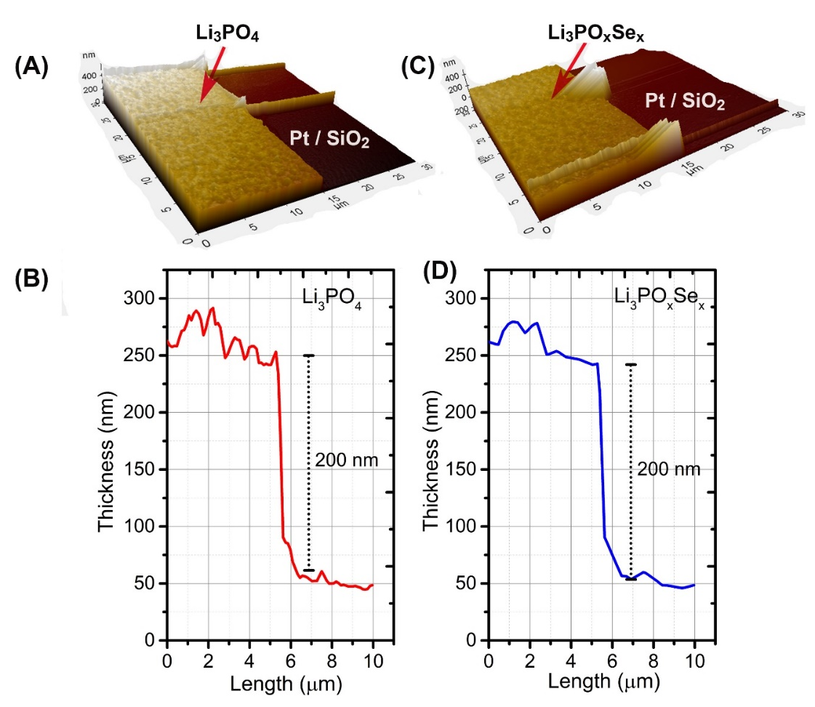
Figure S5: (A-B) Surface analysis of as grown electrolytes film by atomic force microscopy (AFM). (B-D) Depth profile to demine the exact thickness of as deposited electrolyte.

Section S6: EIS circuit model

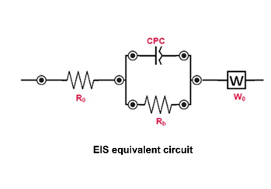
Figure S6: EIS circuit model used to fit the raw data.

Section S7: Se content dependnt swtching behavior of Li₃PO_{x}Se_{x} consisted LIST device.

Figure S7: LTP and LTD characteristics Li₃PO_{x}Se_{x} with varying Se content

The obtained synaptic property with varying Se content in Li₃PO_{x}Se_{x} is summarized in below table.
% Se content | Initial conductance (nS) | On/off ratio | Asymmetric ratio
0.13 | 2.7 | 11 | 1.5
0.26 | 2.6 | 13 | 0.15
0.52 | 4.1 | 1.8 | 0.95
Note: In ideal symmetric switching the asymmetric ratio is zero.
To change the Se content Li₃PO_{x}Se_{x} electrolyte, we have change the RF power of Se target during deposition. To correlate the RF power and Se content in Li₃PO_{x}Se_{x} we use high resolution XPS analysis. First we fabricated a reference sample of Li₃PO_{x}Se_{x} by giving 10 W RF power to Se target and analyzed with XPS. The obtained XPS result on Li₃PO_{x}Se_{x} reference samples is as below.
Section S8: Individual pulse scheme for endurance test

Figure S8. Schematic of individual pulse scheme used for potentiation and depression during endurance test. During each potentiation and depression cycle 90 pulses with (±1.5 V, 1 s) with 1 s space were used.

Table S4: Comaparision of ionic conductiviyt of various electrolytes with present study.
Solid-State electrolyte | Thickness | Li+ conductivity (S cm−1) | Composition | Method | References
Li₃PO₄ | 1000 nm | 7 × 10−8 (25°C) | Li_{2.7}PO_{3.9} | RF sputtering | [1]
Li₃PO₄ | 130 ± 10 nm | 3.3 × 10−8 (25°C) | Li_{2.8}PO₂ | ALD | [2]
Li₃PO₄ | 1000 nm | 6.6 × 10−8 (25°C) | Li_{2.7}PO_{3.9} | RF sputtering | [3]
Li₃PO₄ | 2000 nm | 4 × 10−7 (25°C) | Li₃PO₄ | PLD | [4]
Li₃PO₄ | 1500 nm | 3.3 × 10−7 (25°C) | Li₃PO₄ | PLD | [5]
Li₃PO₄  (polycrystalline) | 0.2 cm | 4.2 × 10−18 (25°C) | Li₃PO₄ | Solid state reaction | [6]
Li₃PO₄  (N₂ doping) | 2000 nm | 2.1 × 10−6 (25°C) | Li_{2.9} PO_{2.6} N_{0.91} | RF sputtering | [7]
Li₃PO₄  (N₂ doping) | 2000 nm | 1.7 × 10−6 (25°C) | Li_{1.8} PO_{1.2} N_{1.5} | RF sputtering | [7]
Li₃PO₄  (N₂ doping) | 2000 nm | 3.1 × 10−6 (25°C) | Li_{3.3} PO_{2.9} N_{0.83} | RF sputtering | [7]
Li₃PO₄  (N₂ doping) | 12 nm | 2.71 × 10−10 (25°C) | 0% N content | ALD | [8]
Li₃PO₄  (N₂ doping) | 10 nm | 3.36 × 10−7 (25°C) | 10 % N content | ALD | [8]
Li₃PO₄  (Si doping) | 1000 nm | 1.49 × 10−6 (25°C) | Li_{2.40} Si_{0.88}P_{0.12}O_{2.28} | RF sputtering | [9]
Li₃PO₄  (Si and N₂ doping) | 1000 nm | 2.06 × 10−5 (25°C) | Li_{1.35} Si_{0.79}P_{0.21}O_{1.98}N_{0.98} | RF sputtering | [9]
Li₃PO₄ | 200 nm | 1.2 × 10⁻⁷ (25°C) |  | RF sputtering | This study
Li₃PO₄  (Se doping) | 200 nm | 2.0 × 10⁻⁶ (25°C) |  | RF sputtering | This study
[1] J. Electrochem. Soc., 144 (1997), pp. 524-532; [2] Nanotechnology 25 (2014) 504007; [3] J. Power Sources 44 103–10; [4] Journal of The Electrochemical Society, 157 (4) A521-A527 (2010); [5] ECS Transactions, 16 (26) 53-60 (2009); [6] J. Solid State Chem. 115 313–23; [7] Solid State Ionics 191 (2011) 49–54; [8] Chemistry of Materials 2015 27 (15), 5324-5331; [9] ACS Appl. Energy Mater. 2019, 2, 4782−4791

