Appendix A

Mental rotation of sequentially presented 3D figures: sex and sex hormones related differences in behavioural and ERP measures.
Ramune Griksiene^{a*}, Aurina Arnatkeviciuteª, Rasa Monciunskaiteª, Thomas Koenig^{b}, Osvaldas Ruksenasª
ª Department of Neurobiology and Biophysics, Vilnius University, Vilnius, Lithuania.
^{b} Translational Research Center, University Hospital of Psychiatry, Bern, Switzerland.

* Corresponding author. Ramune Griksiene: Department of Neurobiology and Biophysics, Vilnius University, Sauletekio ave. 7, 10257 Vilnius, Lithuania. E-mail: ramune.griksiene@gf.vu.lt

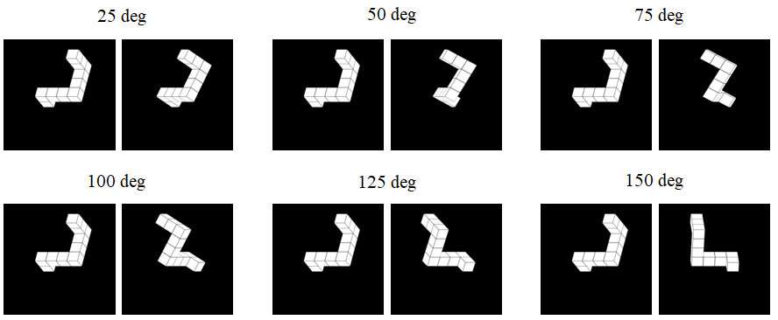
Fig1 The examples of six angular disparity conditions.

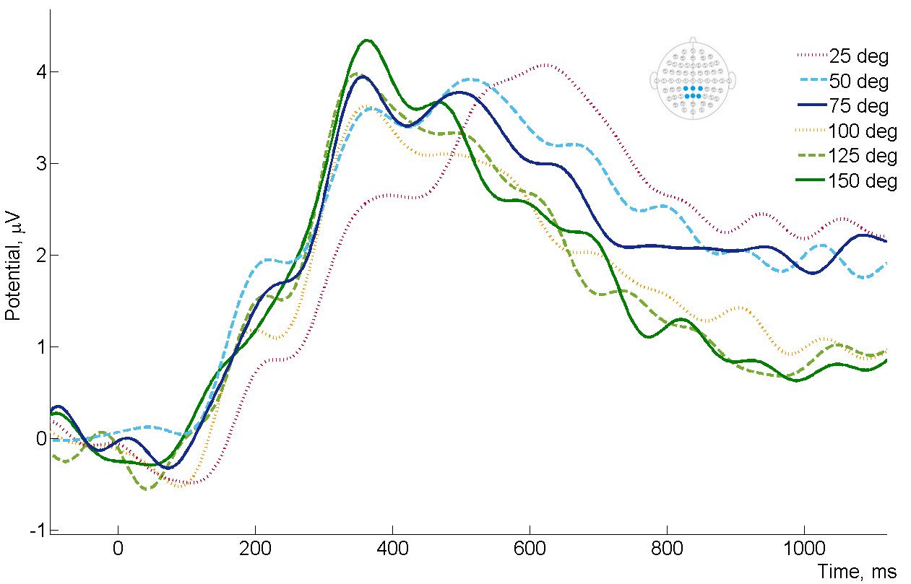
Fig2 Averaged ERP waveforms from the parietal scalp area electrodes (CP1, CPz, CP2, P1, Pz, P2) of all subjects in six angular disparity conditions.

