Supplementary information

Title: Multiple incursion pathways for Helicoverpa armigera in Brazil show its genetic diversity spreading in a connected world

Authors: Jonas A. Arnemann, Stephen H. Roxburgh, Thomas K. Walsh, Jerson V.C. Guedes, Karl H.J. Gordon, Guy Smagghe, Wee Tek Tay

Suppl. Table 1: South American and global Helicoverpa armigera sequences and iBoL/GenBank accession numbers for the mtDNA COI 5’ region. Numbers of individuals (n) from each location are indicated in parentheses. Haplotypes identified in this study are indicated by †
Countries | Locations (n) | iBoL/GenBank accession numbers
China | Kunming (8) | GQ892840.1, GQ892842.1, GQ892854.1, GQ995232.1, GQ995234.1, GQ995235.1, GQ995244.1, GQ995239.1
 | Tibet (2) | JX392497.1, JX392415.1
 | Miaofengshan (4) | JX509766.1, JX509765.1, JX509764.1, JX509739.1
 | Not specified (1) | HQ132369.1
 | Dali (15) | GQ892846.1, GQ892847.1, GQ892848.1, GQ892849.1, GQ892850.1, GQ892851.1, GQ892852.1, GQ892853.1, GQ995233.1, GQ995236.1, GQ995237.1, GQ995240.1, GQ995241.1, GQ995242.1, GQ995243.1
 | Henan (2) | GQ995238.1, GQ892855.1
 | Lijiang (1) | GQ892845.1
 | Yuxi (2) | GQ892843.1, GQ892844.1
Thailand | Not specified (1) | EU768935.1
India | Not specified (6) | HM854928.1, HM854929.1, HM854930.1, HM854931.1, HM854932.1, JX532104.1
Pakistan | Not specified (2) | JN988529.1, JN988530.1
Europe | Not specified (24) | FN907979.1, FN907980.1, FN907988.1, FN907989.1, FN907995.1, FN907996.1, FN907997.1, FN907998.1, FN907999.1, FN908000.1, FN908001.1, FN908002.1, FN908003.1, FN908005.1, FN908006.1, FN908011.1, FN908013.1, FN908014.1, FN908015.1, FN908016.1, FN908017.1, FN908018.1, FN908023.1, FN908026.1
 | Germany (4) | GU654969.1, GU686757.1, GU686955.1, JF415782.1
Australia | Queensland (10) | ANICL283-10, ANICL284-10, GBGL12943-14, GBGL12944-14, GBGL12945-14, GBGL12946-14, GBGL12947-14, GBGL12948-14, GBGL12949-14, GBGL12950-14
 | New South Wales (8) | GBGL12935-14, GBGL12936-14, GBGL12937-14, GBGL12938-14, GBGL12939-14, GBGL12940-14, GBGL12941-14, GBGL12942-14
Brazil | Bahia (112) | KM274936-KM274938, KM27513-KM275140 KM274939-KM274941, KM274943-KM274950, KM274951-KM274953, KM274957-KM274975, KM274979-KM274986, KM275038-KM275052, KM275078-KM275082, KM275070-KM275077, KM275127-KM275136, KF624850-KF624861
 | Maranhão (20) | KM27498-KM274996, KM275103-KM275112
 | Mato Grosso (19) | KM275083-KM275092, KM275156-KM275158, KM275097-KM275102
 | Piaui (39) | KF624811- KF624849
 | Roraima (14) | KF624862-KF624875
 | Parana (3) | † (MG230503 - MG230505)
 | Santa Catarina (7) | † (MG230518 - MG230524)
 | Rio Grande do Sul (12) | † (MG230506 - MG230517)
Argentina | Santa Fé (3) | † (MG230495 - MG230497)
Uruguay | Maldonado (2) | † (MG230525 - MG230526 (and sequences from Arnemann et al [7])
Paraguay | Alto Paraná (10) | † (MG230499 - MG230502  (and sequences from Arnemann et al [7])

Suppl. Table 2: Detected mtDNA COI haplotypes within South America locations with the number of Helicoverpa armigera individuals carrying specific haplotypes at particular sites indicated.
Haplotypes | ARG | URY | PRY | Brazilian states
 |  |  |  | BA | MA | MT | PI | RR | PR | SC | RS |  | n
Harm_BC01 | 0 | 0 | 3 | 24 | 8 | 6 | 11 | 6 | 1 | 4 | 3 |  | 66
Harm_BC02 | 0 | 1 | 0 | 36 | 9 | 6 | 18 | 5 | 1 | 2 | 3 |  | 81
Harm_BC03 | 1 | 0 | 0 | 13 | 1 | 6 | 3 | 1 | 0 | 0 | 0 |  | 25
Harm_BC04 | 1 | 0 | 0 | 10 | 0 | 0 | 1 | 0 | 0 | 0 | 4 |  | 16
Harm_BC05 | 0 | 0 | 0 | 5 | 0 | 0 | 2 | 1 | 1 | 0 | 0 |  | 9
Harm_BC06 | 0 | 0 | 0 | 0 | 1 | 0 | 0 | 0 | 0 | 0 | 0 |  | 1
Harm_BC07 | 0 | 0 | 0 | 2 | 0 | 0 | 3 | 0 | 0 | 0 | 0 |  | 5
Harm_BC13 | 0 | 0 | 2 | 0 | 0 | 0 | 0 | 0 | 0 | 1 | 0 |  | 3
Harm_BC14 | 0 | 0 | 0 | 2 | 0 | 0 | 0 | 0 | 0 | 0 | 0 |  | 2
Harm_BC16 | 1 | 0 | 1 | 0 | 0 | 0 | 0 | 0 | 0 | 0 | 0 |  | 2
Harm_BC17 | 0 | 0 | 2 | 0 | 0 | 0 | 0 | 0 | 0 | 0 | 0 |  | 2
Harm_BC23 | 0 | 0 | 0 | 0 | 0 | 0 | 1 | 0 | 0 | 0 | 0 |  | 1
Harm_BC24 | 0 | 0 | 0 | 0 | 0 | 0 | 0 | 1 | 0 | 0 | 0 |  | 1
Harm_BC34 | 0 | 0 | 0 | 1 | 0 | 0 | 0 | 0 | 0 | 0 | 0 |  | 1
Harm_BC35 | 0 | 0 | 0 | 1 | 0 | 0 | 0 | 0 | 0 | 0 | 0 |  | 1
Harm_BC36 | 0 | 0 | 0 | 1 | 0 | 0 | 0 | 0 | 0 | 0 | 0 |  | 1
Harm_BC37 | 0 | 0 | 0 | 0 | 1 | 0 | 0 | 0 | 0 | 0 | 0 |  | 1
Harm_BC38 | 0 | 0 | 0 | 0 | 0 | 1 | 0 | 0 | 0 | 0 | 0 |  | 1
Harm_BC39 | 0 | 0 | 0 | 1 | 0 | 0 | 0 | 0 | 0 | 0 | 0 |  | 1
Harm_BC42 | 0 | 0 | 0 | 0 | 0 | 0 | 0 | 0 | 0 | 0 | 1 |  | 1
Harm_BC43 | 0 | 0 | 1 | 0 | 0 | 0 | 0 | 0 | 0 | 0 | 0 |  | 1
Harm_BC44 | 0 | 1 | 0 | 0 | 0 | 0 | 0 | 0 | 0 | 0 | 0 |  | 1
Harm_BC45 | 0 | 0 | 0 | 0 | 0 | 0 | 0 | 0 | 0 | 0 | 1 |  | 1
Harm_BC46 | 0 | 0 | 1 | 0 | 0 | 0 | 0 | 0 | 0 | 0 | 0 |  | 1
Harm_BC47 | 1 | 0 | 0 | 0 | 0 | 0 | 0 | 0 | 0 | 0 | 0 |  | 1
n | 4 | 2 | 10 | 96 | 20 | 19 | 39 | 14 | 3 | 7 | 12 |  | 226

Suppl. Table 3: Haplotypes distribution within individuals from Australia (AUS, n = 18), Asia (Asia, n = 44), Europe (EUR, n = 28), Argentina (ARG, n = 4), Uruguay (URY, n = 2), Paraguay (PRY, n = 10) and Brazilian states (Bahia BA, n = 96; Maranhão MA, n = 20; Mato Grosso MT, n = 19; Piauí PI, n = 39; Roraima RR, n = 14; Paraná PR, n = 3; Santa Catarina SC, n = 7; Rio Grande do Sul RS, n = 12).
Haplotypes | AUS | ASIA | EUR | ARG | URY | PRY | BRAZILIAN STATES
 |  |  |  |  |  |  | BA | MA | MT | PI | RR | PR | SC | RS
Harm_BC01 | 2 | 10 | 14 |  |  | 3 | 24 | 8 | 6 | 11 | 6 | 1 | 4 | 3
Harm_BC02 |  | 4 | 2 |  | 1 |  | 36 | 9 | 6 | 18 | 5 | 1 | 2 | 3
Harm_BC03 | 1 |  | 3 | 1 |  |  | 13 | 1 | 6 | 3 | 1
Harm_BC04 |  | 3 | 3 | 1 |  |  | 10 |  |  | 1 |  |  |  | 4
Harm_BC05 |  |  |  |  |  |  | 5 |  |  | 2 | 1 | 1
Harm_BC06 |  | 6 | 2 |  |  |  |  | 1
Harm_BC07 |  | 1 |  |  |  |  | 2 |  |  | 3
Harm_BC08 | 5
Harm_BC09 |  | 5
Harm_BC10 |  | 3 | 1
Harm_BC11 | 3
Harm_BC12 | 3
Harm_BC13 |  |  |  |  |  | 2 |  |  |  |  |  |  | 1
Harm_BC14 |  |  |  |  |  |  | 2
Harm_BC15 |  | 2
Harm_BC16 |  |  |  | 1 |  | 1
Harm_BC17 |  |  |  |  |  | 2
Harm_BC18 | 2
Harm_BC19 |  | 1
Harm_BC20 |  |  | 1
Harm_BC21 |  |  | 1
Harm_BC22 |  |  | 1
Harm_BC23 |  |  |  |  |  |  |  |  |  | 1
Harm_BC24 |  |  |  |  |  |  |  |  |  |  | 1
Harm_BC25 |  | 1
Harm_BC26 |  | 1
Harm_BC27 |  | 1
Harm_BC28 |  | 1
Harm_BC29 |  | 1
Harm_BC30 |  | 1
Harm_BC31 |  | 1
Harm_BC32 |  | 1
Harm_BC33 |  | 1
Harm_BC34 |  |  |  |  |  |  | 1
Harm_BC35 |  |  |  |  |  |  | 1
Harm_BC36 |  |  |  |  |  |  | 1
Harm_BC37 |  |  |  |  |  |  |  | 1
Harm_BC38 |  |  |  |  |  |  |  |  | 1
Harm_BC39 |  |  |  |  |  |  | 1
Harm_BC40 | 1
Harm_BC41 | 1
Harm_BC42 |  |  |  |  |  |  |  |  |  |  |  |  |  | 1
Harm_BC43 |  |  |  |  |  | 1
Harm_BC44 |  |  |  |  | 1
Harm_BC45 |  |  |  |  |  |  |  |  |  |  |  |  |  | 1
Harm_BC46 |  |  |  |  |  | 1
Harm_BC47 |  |  |  | 1

Suppl. Table 4: Observations of haplotypes within South American locations summed into two broad categories.
Haplotypes | Non-Brazil | Brazil | n
Harm_BC01 | 3 | 63 | 66
Harm_BC02 | 1 | 80 | 81
Harm_BC03 | 1 | 24 | 25
Harm_BC04 | 1 | 15 | 16
Harm_BC05 | 0 | 9 | 9
Harm_BC06 | 0 | 1 | 1
Harm_BC07 | 0 | 5 | 5
Harm_BC13 | 2 | 1 | 3
Harm_BC14 | 0 | 2 | 2
Harm_BC16 | 2 | 0 | 2
Harm_BC17 | 2 | 0 | 2
Harm_BC23 | 0 | 1 | 1
Harm_BC24 | 0 | 1 | 1
Harm_BC34 | 0 | 1 | 1
Harm_BC35 | 0 | 1 | 1
Harm_BC36 | 0 | 1 | 1
Harm_BC37 | 0 | 1 | 1
Harm_BC38 | 0 | 1 | 1
Harm_BC39 | 0 | 1 | 1
Harm_BC42 | 0 | 1 | 1
Harm_BC43 | 1 | 0 | 1
Harm_BC44 | 1 | 0 | 1
Harm_BC45 | 0 | 1 | 1
Harm_BC46 | 1 | 0 | 1
Harm_BC47 | 1 | 0 | 1
n | 16 | 210 | 226

Suppl. Table 5: Pairwise F_{ST} estimates of 11 populations of Helicoverpa armigera from Brazilian states, Argentina, Uruguay and Paraguay.
 | Roraima | Maranhão | Piauí | Bahia | Mato Grosso | Santa Catarina | Rio Grande do Sul | Paraná | Argentina |  |  | Uruguai | Paraguay
Roraima | -
Maranhão | -0.0503 | -
Piauí | -0.0313 | -0.0046 | -
Bahia | -0.0199 | -0.0088 | -0.0001 | -
Mato Grosso | 0.0121 | 0.0111 | 0.0378 | 0.0179 | -
Santa Catarina | 0.0160 | 0.0312 | 0.0977 | 0.0506 | 0.1181 | -
Rio Grande do Sul | 0.0615 | 0.0862 | 0.1203 | 0.0630 | 0.1327 | -0.0096 | -
Paraná | -0.0800 | 0.0395 | -0.0643 | -0.0316 | 0.0669 | 0.1102 | 0.0314
Argentina | 0.1917 | 0.2520 | 0.2661 | 0.1838 | 0.1324 | 0.1433 | 0.0518 | 0.0429 | -
Uruguai | 0.1152 | 0.2261 | 0.1009 | 0.0836 | 0.1310 | 0.3243 | 0.0400 | -0.0714 | -0.1429 |  |  | -
Paraguay | 0.3470 | 0.3947 | 0.4266 | 0.3759 | 0.3813 | 0.1832 | 0.1922 | 0.3010 | 0.1033 |  |  | 0.2214 | -
Note: Uruguay sample size of H. armigera is n=2, of which one is the most common Harm_BC02 mtDNA COI haplotype detected in Brazil in this study, and the other being a rare mtDNA COI haplotype Harm_BC44 (see Suppl. Fig. 2). Sample size for Argentina is n=4, of which two haplotypes (i.e., Harm_BC03, Harm_BC04) representing the 3rd and 4th most commonly detected haplotypes were shared with Brazilian populations, one haplotype shared with Paraguay (i.e., Harm_BC16) and one unique haplotype (Harm_BC47). Of the n=10 H. armigera sampled in Paraguay, non-Brazilian haplotypes were detected in n=6, one rare haplotype (Harm_BC13) was shared with H. armigera from the state of Santa Catarina, and the remaining n=3 have a common Harm_BC01 haplotype found widely in Brazil. Of the n=12 H. armigera sampled from the State of Rio Grande do Sul, two unique haplotypes were detected (i.e., Harm_BC42, Harm_BC45).

Suppl. Table 6: Pairwise F_{st} estimates between Brazilian, Old World, and non-Brazilian (Argentina/Paraguay/Uruguay) Helicoverpa armigera populations.
Population | Non-Brazilian | Brazilian
Brazilian | 0.2879 | -
Old World | 0.2022 | 0.0742

Suppl. Table 7: Summary of AMOVA of different hierarchical population structures of Helicoverpa armigera from the South American continent. p < 0.05 indicated by ‘*’.

Source of variation | d.f. | Sum of squares | Variance components | Percentage of variation | F-Statistic
Among groups | 3 | 10.219 | 0.04905 va | 7.10 | 0.07102*
Among populations within groups | 7 | 6.219 | 0.01919 vb | 2.78 | 0.02992
Within populations | 215 | 133.814 | 0.62239 vc | 90.12 | 0.09881*
Total | 225 | 150.252 | 0.69063

Suppl. Fig. 1: Distribution of P-values from 10,000 significance tests using pseudo-observed data conforming to the null hypothesis. (a) Model validation results for matrices of size 25 rows x 11 columns, corresponding to the dimensions of the full dataset (Suppl. Table 3). (b) Model validation results for matrices of size 25 rows x 2 columns, corresponding to the dimensions of the aggregated dataset for examining patterns between Brazil and non-Brazilian locations (see above).

(a) (b)

Suppl. Fig. 2: Haplotype distribution patterns and diversity of Helicoverpa armigera in South America based on the partial mtDNA COI gene (548bp). Pie charts (i), (ii) and (iii) are from Mato Grosso, Piaui and Bahia States, respectively.

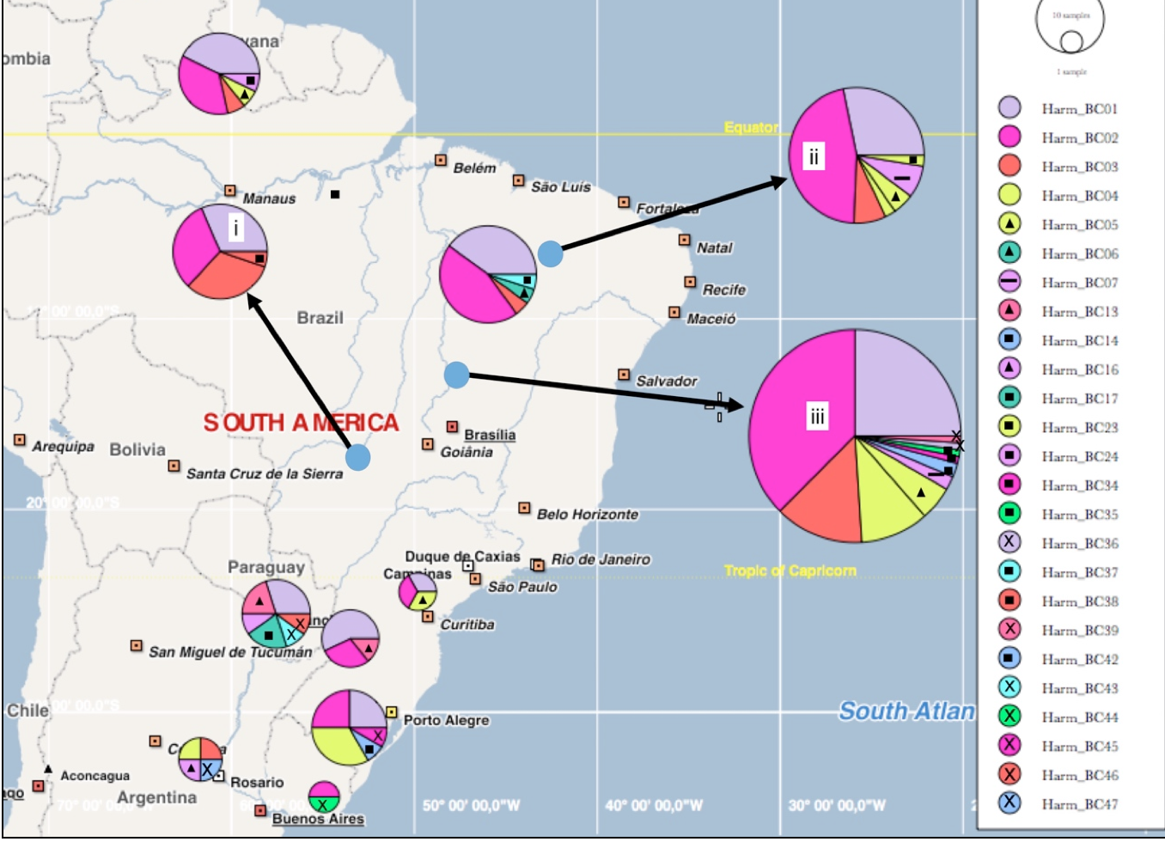
Generated using PopART <http://popart.otago.ac.nz>. Leigh, JW, Bryant D (2015). PopART: Full-feature software for haplotype network construction. Methods Ecol Evol 6(9):1110–1116.

