Supplementary Material
Distribution, Interaction and Functional Profiles of Epiphytic Bacterial Communities from the Rocky Intertidal Seaweeds, South Africa
Selvarajan Ramganesh¹, Sibanda Timothy², Siddarthan Venkatachalam³, Henry JO Ogola^{1,4}, Chinedu Christopher Obieze ⁵, Titus A Msagati⁶
¹Department of Environmental Sciences, College of Agricultural and Environmental Sciences, UNISA, South Africa.
²Department of Biological Sciences, University of Namibia, Mandume Ndemufayo Ave, Pionierspark, Windhoek, Namibia.
³Arctic Division, National Centre for Polar and Ocean Research, Vasco-da-gama, Goa, India
⁴Centre for Research, Innovation and Technology, Jaramogi Oginga Odinga University of Science and Technology, Bondo, Kenya.
⁵Department of Microbiology, University of Port Harcourt, Nigeria
⁶Nanotechnology and Water Sustainability Research Unit, College of Science, Engineering and Technology, University of South Africa-Science Campus, Florida, South Africa

Corresponding Author
Dr Selvarajan Ramganesh
Dept. of Environmental Sciences
College of Agricultural and Environmental Sciences
University of South Africa – Science Campus
South Africa
Telephone: +27-011-471-2068
Email: ramganesh.presidency@gmail.com

S. Table 1: Percentage of elemental compositions of the collected seaweed surface determined using energy-dispersive X-ray (EDX) analysis

Elements | SW1 | SW2 | SW3 | SW4 | SW5 | SW6 | SW7 | SW8
C | 40.49 | 64.14 | 71.01 | 45.04 | 31.3 | 47.5 | 48.04 | 51.94
O | 33.2 | 19.94 | 9.87 | 21.12 | 13.03 | 24.08 | 33.5 | 23.88
Cl | 8.66 | 5.88 | 9.93 | 16.06 | 27.05 | 8.16 | 3.45 | 8.92
Na | 8.39 | 4.36 | 7.85 | 13.5 | 9.42 | 5.45 | 2.05 | 4.25
S | 4.45 | 0.88 | 1.02 | 0.36 | 2.53 | 1.15 | 0.89 | 1.44
Ca | 2.69 | 1.9 | 0.12 | 1.05 | 1.5 | 12.42 | 11 | 1.45
Mg | 1.6 | 0.74 | 0.02 | 0.01 | 0.5 | 1.17 | 1.01 | 1.53
Si | 0.44 | 0 | 0.05 | 0.02 | 0.3 | 0.04 | 0.01 | 6.17
Al | 0.06 | 0.28 | 0.06 | 0.01 | 0.1 | 0.02 | 0.04 | 0.32
K | 0.02 | 1.88 | 0.07 | 2.83 | 14.27 | 0.01 | 0.01 | 0.1
Total | 100 | 100 | 100 | 100 | 100 | 100 | 100 | 100

S. Table 2: Relative abundance of minor epiphytic bacterial phyla observed in the collected seaweed samples

Minor Phyla | SW1 | SW2 | SW3 | SW4 | SW5 | SW6 | SW7 | SW8
Parcubacteria | 0.359 | 0.018 | 0.078 | 0.084 | 2.048 | 0.090 | 0.000 | 2.093
Chloroflexi | 0.294 | 0.166 | 0.489 | 3.693 | 0.405 | 0.008 | 0.020 | 0.734
Bacteria_unclassified | 0.212 | 0.300 | 0.419 | 5.177 | 0.996 | 0.553 | 1.097 | 0.438
Acidobacteria | 0.147 | 0.000 | 0.000 | 0.000 | 0.043 | 0.000 | 0.000 | 0.012
SBR1093 | 0.082 | 0.000 | 0.000 | 0.000 | 0.057 | 0.000 | 0.000 | 0.005
SR1_(Absconditabacteria) | 0.049 | 0.000 | 0.000 | 0.000 | 0.000 | 0.008 | 0.000 | 0.022
Gemmatimonadetes | 0.033 | 0.000 | 0.000 | 0.000 | 0.000 | 0.000 | 0.000 | 0.000
Gracilibacteria | 0.016 | 0.013 | 0.295 | 0.000 | 0.220 | 0.000 | 0.000 | 0.267
Lentisphaerae | 0.000 | 0.000 | 0.039 | 0.000 | 0.185 | 0.000 | 0.431 | 0.010
Omnitrophica | 0.000 | 0.000 | 0.000 | 0.000 | 0.000 | 0.000 | 0.000 | 0.005
Peregrinibacteria | 0.000 | 0.000 | 0.031 | 0.000 | 0.128 | 0.000 | 0.000 | 0.090
Saccharibacteria | 0.000 | 0.002 | 0.054 | 0.000 | 0.085 | 0.376 | 0.000 | 0.159
Spirochaetae | 0.000 | 0.006 | 0.031 | 0.034 | 0.156 | 0.609 | 0.000 | 0.005
Tenericutes | 0.000 | 0.000 | 0.000 | 0.000 | 0.014 | 0.000 | 0.000 | 0.000
WWE3 | 0.000 | 0.000 | 0.000 | 0.000 | 0.000 | 0.000 | 0.000 | 0.049

S. Table 3: Number of predicted metagenomes, counts, number of KEGG pathways and NSTI scores for collected seaweed samples

Samples | KEGG pathways | Predicted metagenomes | Metagenome counts | NSTI score
SW7 | 248 | 3476 | 157151 | 0.115
SW4 | 260 | 4066 | 167246 | 0.117
SW1 | 262 | 4429 | 1221706 | 0.114
SW8 | 264 | 4488 | 4022194 | 0.091
SW6 | 266 | 4618 | 3955217 | 0.088
SW2 | 268 | 4754 | 14553314 | 0.180
SW5 | 274 | 4774 | 2642801 | 0.109
SW3 | 279 | 4809 | 1268965 | 0.100

S. Figure 1: Scanning electron microscopy micrographs showed the variations in surface morphology of the collected seaweeds

SW1: Codium extricatum. SW2: Sargassum incisifolium SW3: Hypnea rosea SW4: Sargassum obovatum, SW5: Valonia utricularis, SW6: Gracilaria corticata
SW7: Arthrocardia flabellata and SW8: Codium lucasii

S. Figure 2 : Cluster analysis of epiphytic bacterial community patterns between the collected seaweeds

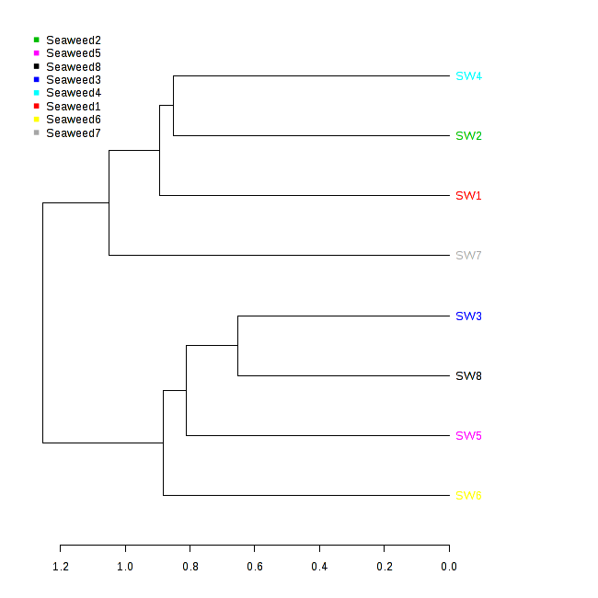

S. Figure 3 : Principal coordinates analysis (PCoA) plot of Bray–Curtis distances for bacterial communities associated with surface of collected seaweeds

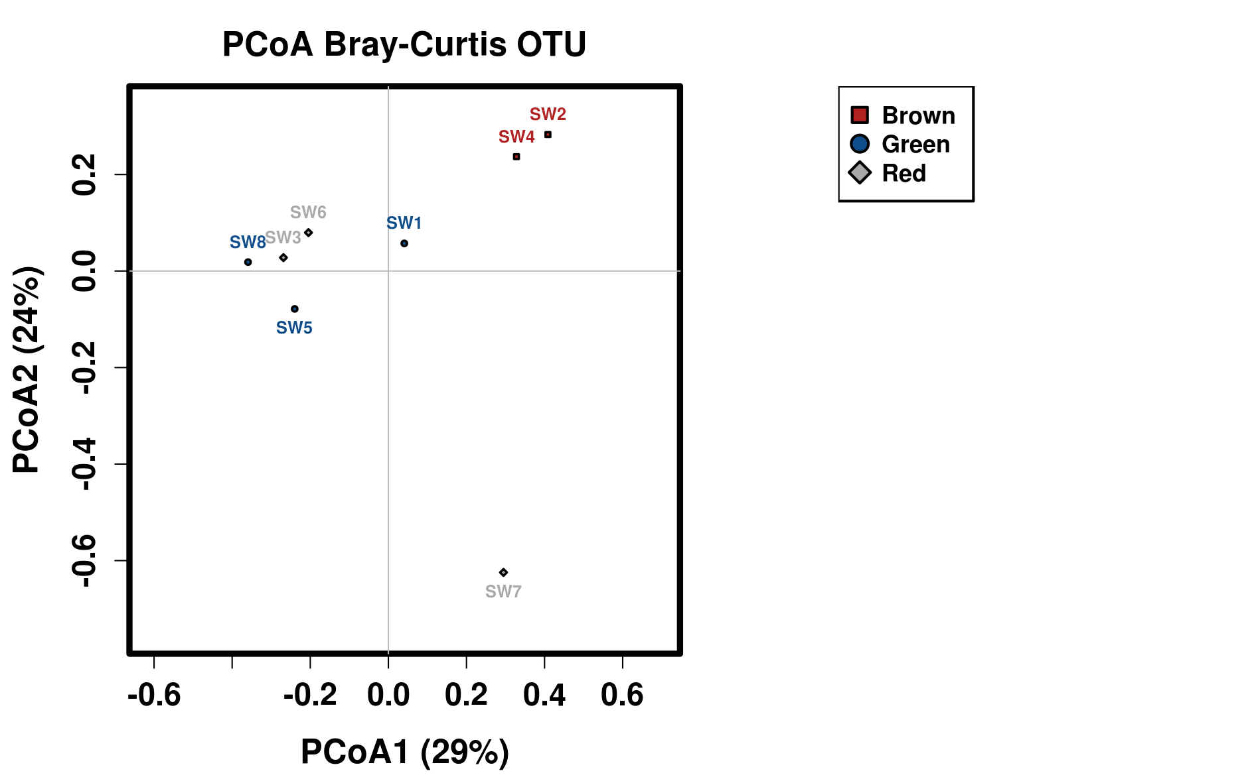

S. Figure 4 : Elemental sulphur interaction with bacterial communities observed on the surface of the seaweeds.

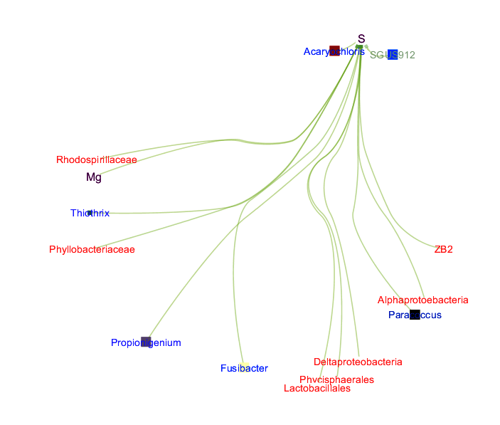

S. Figure 5 : Carbon interaction with bacterial communities observed on the surface of the seaweeds.

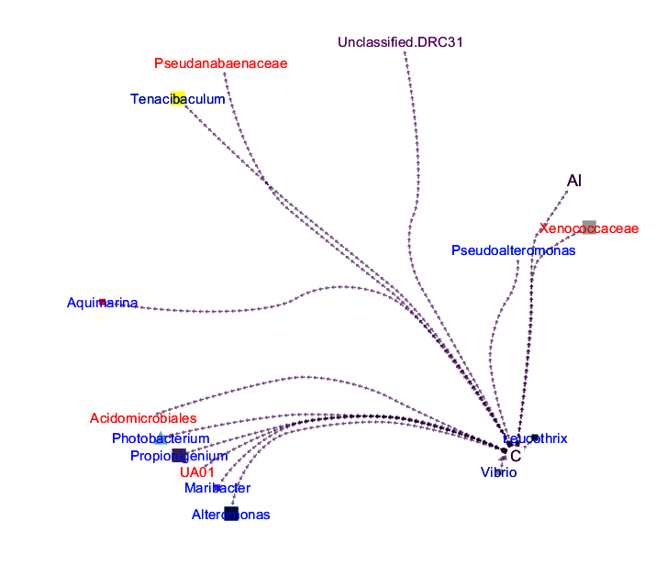

S. Figure 6 : Calcium interaction with bacterial communities observed on the surface of the seaweeds.

