Supplementary information
Reduced TRPM8 expression underpins reduced migraine risk and attenuated cold pain sensation in humans

Narender R Gavva^{1,} *, Robert Sandrock¹, Gregory E Arnold¹, Michael Davis¹, Edwin Lamas¹, Chris Lindvay¹, Chi-Ming Li¹, Brian Smith¹, Miroslav Backonja², Kristin Gabriel¹ & Gabriel Vargas¹

1 Amgen Inc., Thousand Oaks, California, USA
2 Worldwide Clinical Trials, Morrisville, North Carolina, USA.

SUPPLEMENTARY MATERIALS

Supplementary Figure 1 Changes in systolic (a) and diastolic (b) blood pressures for the different rs10166942 genotype groups (T/T, T/C, C/C) during the cold pressor test.
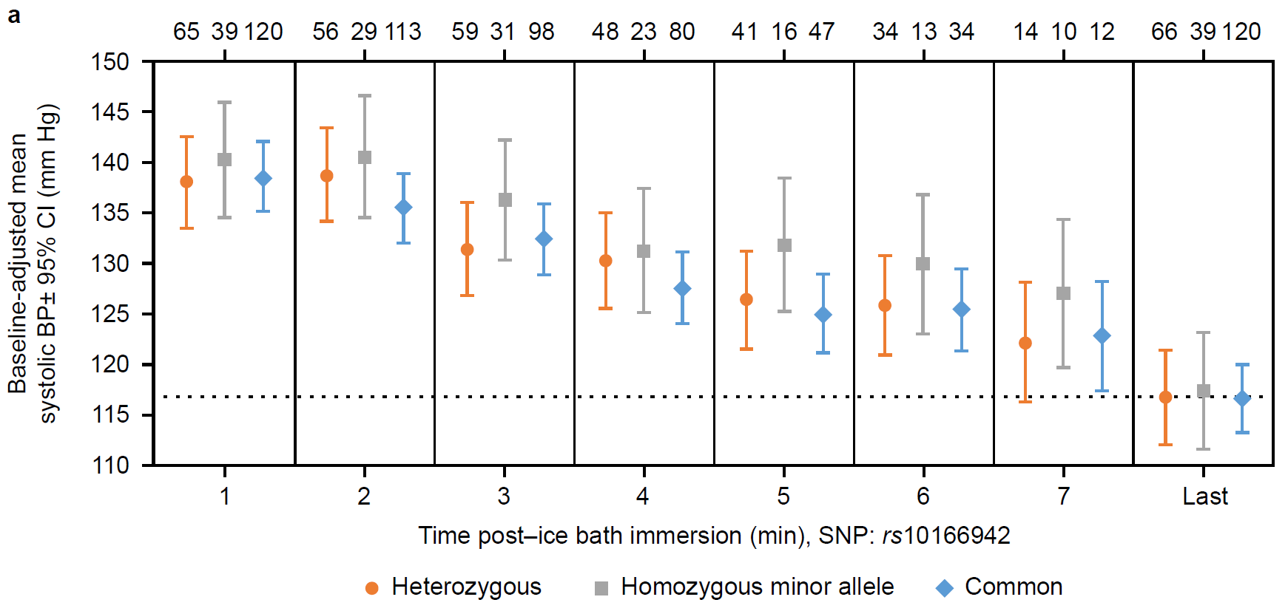
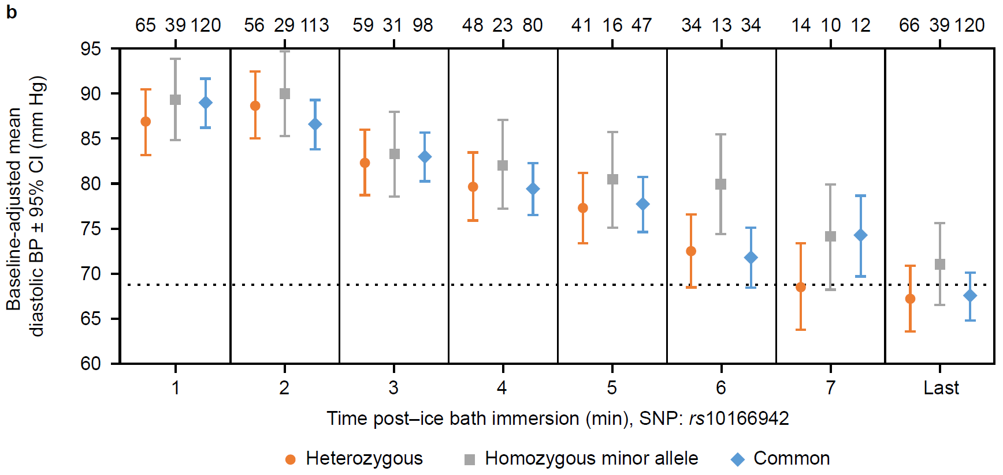

Baseline-adjusted mean blood pressure (BP) levels and their 95% confidence intervals (CI) are plotted by time post-immersion into an ice bath. The number of observations per single-nucleotide polymorphism (SNP) group (common, T/T; heterozygote, T/C; minor allele homozygote, C/C) is indicated at the top of the plots. The dotted line designates the mean baseline BP. A mixed-effects linear least squares model was used to fit the data with time and genotype as nominal factors, baseline as a covariate, a genotype*time interaction term and subject as a random factor.
Supplementary Figure 2 Changes in systolic (a) or diastolic (b) blood pressures for the different rs17862920 genotype groups (C/C, C/T, T/T) during the cold pressor test.

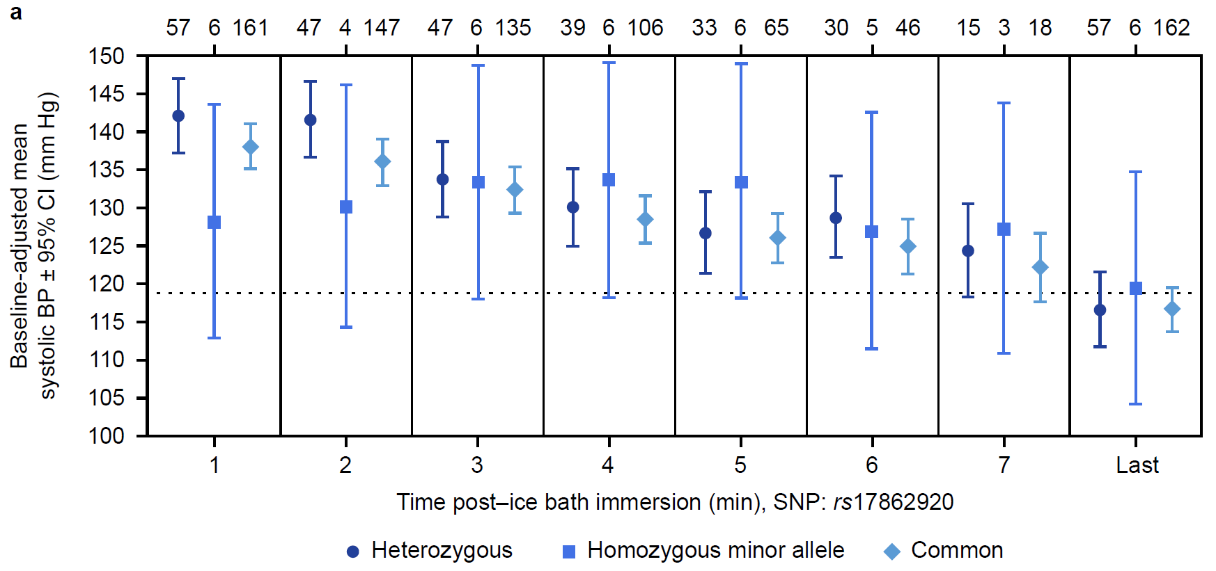
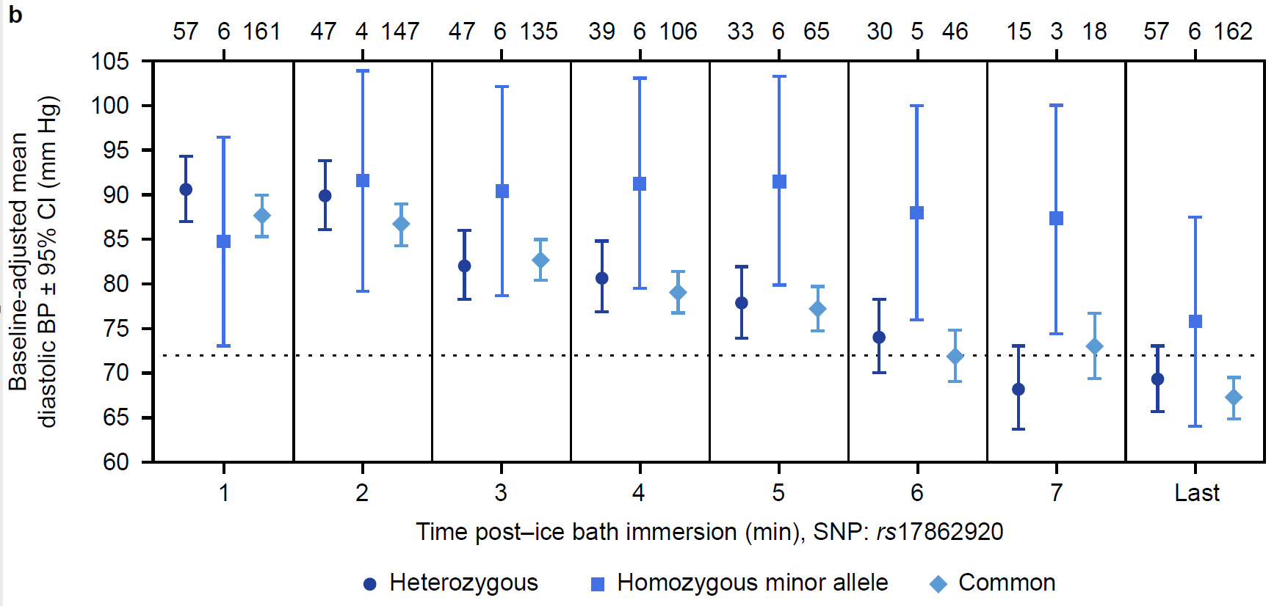

Baseline-adjusted mean blood pressure (BP) levels and their 95% confidence intervals (CI) are plotted by time post-immersion into an ice bath. The number of observations per single-nucleotide polymorphism (SNP) group (common, C/C; heterozygote, C/T; minor allele homozygote, T/T) is indicated at the top of the plots. The dotted line designates the mean baseline BP. A mixed-effects linear least squares model was used to fit the data with time and genotype as nominal factors, baseline as a covariate, a genotype*time interaction term and subject as a random factor.

Supplementary Figure 3: Linkage analysis for SNPs studied here and other studies are shown.

Supplementary Table 1. Description of reduced migraine risk–associated SNP alleles and mSNP alleles, allelic frequency, primers used to amplify genomic and cDNA regions, and length of PCR product.

dbSNP ID: alleles | Het^{b} | Forward primer (5' to 3') | Reverse primer (5' to 3') | Length of PCR product (bp)
rs10166942: T>Cª | 0.31 | CTTTATGACCTGTCTGAGCC | GGAAGGATAGGGTTGTAGTG | 139
rs17862920: C>T | 0.20 | AATAGTACCACGGCCAAC | GAGACCCAATCTTAAACATTAAGC | 163
rs11562975: G>C | 0.18 | GCCCAGTACCTTATGGATGA | GCTCAGAGATATACTTCTCTAGCTG | 151
rs13004520: G>C | 0.12 | GCCCAGTACCTTATGGATGA | GCTCAGAGATATACTTCTCTAGCTG | 151
rs28901637: A>T | 0.02 | GCCCAGTACCTTATGGATGA | GCTCAGAGATATACTTCTCTAGCTG | 151
ªAllele with higher population frequency. ^{b}Frequency of heterozygosity (het) in the CEU population. PCR, polymerase chain reaction; SNP, single-nucleotide polymorphism.

Supplementary Table 2. Genotypes of six DRG samples used in this study.
Sample ID | rs10166942 | rs17862920 | rs11562975 | rs28901637 | rs13004520
379630 | 1 | 0 | 1 | 0 | 0
385164 | 1 | 0 | 1 | 0 | 0
390387 | 1 | 0 | 1 | 0 | 0
390388 | 1 | 0 | 0 | 1 | 0
397628 | 1 | 1 | 0 | 0 | 1
397629 | 1 | 0 | 1 | 0 | 0
Value of “1” denotes heterozygosity; value of “0” denotes homozygosity for the common allele. No samples were homozygous for the minor allele.

Supplementary Table 3. Phasing of alleles rs10166942 and rs17862920 associated with reduced migraine risk and marker alleles showing allelic expression imbalance

DRG sample | Chromatid | rs10166942 | rs17862920 | mSNP rs11562975 | mSNP rs28901637 | mSNP rs13004520 | Number of clones sequencedª
385164 | 1 | C^{b} | C | C^{c} | A | G | 6
385164 | 2 | T | C | G | A | G | 8
390387 | 1 | C | C | C | A | G | 16
390387 | 2 | T | C | G | A | G | 17
390388 | 1 | C | C | G | T | G | 24
390388 | 2 | T | C | G | A | G | 17
397628 | 1 | C | T^{d} | G | A | C | 9
397628 | 2 | T | C | G | A | G | 8
397629 | 1 | C | C | C | A | G | 21
397629 | 2 | T | C | G | A | G | 16
ªNumber of phagemid clones sequenced that show a particular linkage pattern. ^{b}rs10166942 allele (C) associated with reduced migraine risk is shown in green. ^{c}mSNP alleles associated with reduced allelic expression are shown in red. ^{d}rs17862920 allele (T) associated with reduced migraine risk is shown in blue. DRG, dorsal root ganglia; mSNP, marker single-nucleotide polymorphism.

Supplementary Table 4. Screen summary of male volunteer genotypes for SNP rs10166942 and rs17862920
 |  |  | Screen status
 |  |  | Pass |  |  |  |  | Fail
SNP | Genotype | SNP status | Count (n=70) | Presence (%) | Group | Presence (%) |  | Count  (n=95) | Presence (%) | Group | Presence (%)
rs10166942 | C/C | +SNP | 7 | 10 | A | 41 |  | 7 | 7 | A | 40
rs10166942 | C/T | +SNP | 22 | 31 | A | 41 |  | 31 | 33 | A | 40
rs10166942 | T/T | –SNP | 41 | 59 | B | 59 |  | 57 | 60 | B | 60
rs17862920 | T/T | +SNP | 1 | 1 | A | 26 |  | 0 | 0 | A | 24
rs17862920 | T/C | +SNP | 17 | 24 | A | 26 |  | 23 | 24 | A | 24
rs17862920 | C/C | –SNP | 52 | 74 | B | 74 |  | 72 | 76 | B | 76
SNP, single-nucleotide polymorphism.

Supplementary Table 5. Analyses of time to temperature of threshold for SNP groups (rs10166942) during the CPT
 | Carriers  +SNP  N=18 | Non-carriers  –SNP  N=20
Threshold (CPT)
LS geometric mean (seconds) | 18.03 | 15.78
Ratio between SNP groups (95% CI) | 1.14 (0.61–1.68) | ―
P valueª | 0.5918 | ―
The carrier group includes volunteers with either rs10166942(C) or both rs10166942(C) and rs17862920(T). ªP value is associated with +SNP group versus –SNP group.
Time to pain intolerance could not be adequately estimated as 35.4% (n/N=93/263) of observations were censored because subjects did not reach intolerance. CI, confidence interval; CPT, cold pressor test; LS, least squares; SNP, single-nucleotide polymorphism.
Supplementary Table 6. Comparison of CPT measurements between genotypes for the rs10166942 and rs17862920 loci
rs10166942 | SNP groups |  |  |  |  |  |  | Comparisons between SNP groups
 | T/T |  | T/C |  | C/C |  | Difference tested | T/T–T/C |  | T/T–C/C |  | T/C–C/C
 | Median | n (obs) | Median | n (obs) | Median | n (obs) | Difference tested | Value  (95% CI) | P value | Value  (95% CI) | P value | Value  (95% CI) | P value
CPT time to threshold (seconds) | 12 | 20 (119) | 15 | 11 (66) | 43 | 7 (39) | Hazard ratio | 1.23  (0.58–2.64) | 0.59 | 0.41  (0.16–1.04) | 0.06 | 0.34  (0.11–1.03) | 0.06
CPT time to tolerance (seconds) | 207 | 20 (120) | 300ª | 11 (66) | 209 | 7 (39) | Hazard ratio | 0.53  (0.19–1.47) | 0.23 | 0.93  (0.34–2.56) | 0.88 | 1.65  (0.48–5.72) | 0.43
Likert score threshold | 3.0 | 20 (120) | 3.0 | 11 (66) | 2.0 | 7 (39) | Mean ranks^{b} | ― |  | ― |  | ―
Likert score tolerance | 7.5 | 20 (119) | 7.7 | 11 (66) | 6.0 | 7 (39) | Mean ranks^{b} | ― |  | ― |  | ―

rs17862920 | SNP groups |  |  |  |  |  |  | Comparisons between SNP groups
 | C/C |  | C/T |  | T/T |  | Difference tested | C/C–C/T |  | C/C–T/T |  | C/T–T/T
 | Median | n (obs) | Median | n (obs) | Median | n (obs) | Difference tested | Value  (95% CI) | P value | Value  (95% CI) | P value | Value  (95% CI) | P value
CPT time to threshold (seconds) | 15 | 27 (162) | 14 | 10 (57) | 43 | 1 (6) | Hazard ratio | 0.97  (0.45–2.08) | 0.93 | N/A |  | N/A
CPT time to tolerance (seconds) | 207 | 27 (162) | 209 | 10 (57) | 300ª | 1 (6) | Hazard ratio | 0.63  (0.24–1.68) | 0.59 | N/A |  | N/A
Likert score threshold | 2.00 | 27 (162) | 1.67 | 10 (57) | 1.33 | 1 (6) | Mean ranks^{b} | ― |  | ― |  | ―
Likert score tolerance | 4.92 | 27 (162) | 3.83 | 10 (57) | 1.83 | 1 (6) | Mean ranks^{b} | ― |  | ― |  | ―
N/A indicates that no comparisons were made because n=1 in the T/T SNP group. ªMedian was a censored event. ^{b}Statistical significance was not achieved, therefore no comparisons between groups were made. CI, confidence interval; CPT, cold pressor test; SNP, single-nucleotide polymorphism.

Supplementary Table 7. Analysis of Likert Pain Scale data for SNP groups (rs10166942) during QST
 | Carriers  +SNP  N=18 | Non-carriers  –SNP  N=20
Threshold (QST)
LS mean | 1.93 | 2.19
Difference between SNP groups (95% CI) | –0.26 (–1.10, 0.57) | ―
P valueª | 0.54 | ―
Intolerance (QST)
LS mean | 3.59 | 4.78
Difference between SNP groups (95% CI) | –1.19 (–2.59, 0.21) | ―
P valueª | 0.095 | ―
The carrier group includes volunteers with either rs10166942(C) or both rs10166942(C) and rs17862920(T). ªP value is associated with +SNP group versus –SNP group. CI, confidence interval; LS, least squares; QST, quantitative sensory testing; SNP, single-nucleotide polymorphism.
Supplementary Table 8. Analysis of Likert Pain Scale data for SNP groups (rs10166942) during the CPT
 | Carriers  +SNP  N=18 | Non-carriers  –SNP  N=20
Threshold (CPT)
LS mean | 3.13 | 3.20
Difference between SNP groups (95% CI) | –0.07 (–1.02, 0.88) | ―
P valueª | 0.89 | ―
Intolerance (CPT)
LS mean | 6.40 | 6.90
Difference between SNP groups (95% CI) | –0.50 (–1.85, 0.85) | ―
P valueª | 0.46 | ―
The carrier group includes volunteers with either rs10166942(C) or both rs10166942(C) and rs17862920(T). ªP value is associated with +SNP group versus –SNP group. CI, confidence interval; CPT, cold pressor test; LS, least squares; SNP, single-nucleotide polymorphism.

