Mycobacterium tuberculosis clinical isolates of the Beijing and East-African Indian lineage induce fundamentally different host responses in mice compared to H37Rv.

B.C. Mourik, J.E.M. de Steenwinkel, G.J. de Knegt, R. Huizinga, A. Verbon, T.H.M Ottenhoff, D. van Soolingen, P.J.M. Leenen
Supplementary Table 1: Fluorescent antibody panels
 | Panel 1 |  |  | Panel 2
Marker | Ab | Clone | Source | Ab | Clone | Source
FITC | CD4 | L3T4 | BD biosciences | CD45R | RA3-6B2 | BD biosciences
PE | FoxP3 | FJK-16s | E-Bioscience | Siglec-F | E50-2440 | BD biosciences
PerCP Cy5.5 | Ly-6C | ER-MP20 | E-Bioscience | Ly-6C | ER-MP20 | E-Bioscience
APC | CD3 | 145-2CN | BD biosciences | CD11b | M1/70 | BD biosciences
Pe Cy7 | CD11b | M1/70 | E-Bioscience | CD11c | N418 | E-Bioscience
APC Cy7 | CD25 | PC61 | Biolegend | MHC-II | M5/114.15.2 | E-Bioscience
PB | CD8 | 53-6.7 | E-Bioscience | CD45 | 30-F11 | Biolegend
 | Panel 3 |  |  | Panel 4
Marker | Ab | Clone | Source | Ab | Clone | Source
FITC | CD68 | FA-11 | Biolegend | iNOS | 6/iNOS | BD biosciences
PE | PDL1 | MIH5 | E-Bioscience | CD200R | OX110 | E-Bioscience
PerCP Cy5.5 | Ly-6C | ER-MP20 | E-Bioscience | F4/80 | BM8 | E-Bioscience
APC | CD117 | ACK2 | E-Bioscience | CD86 | B7-2,GL-1 | E-Bioscience
Pe Cy7 | CD11c | N418 | E-Bioscience | CD11c | N418 | E-Bioscience
APC Cy7 | CD11b | M1/70 | E-Bioscience | MHC-II | M5/114.15.2 | E-Bioscience
PB | Ly-6G | 1A8 | Biolegend | CD11b | M1/70 | E-Bioscience

Supplementary Table 2: Primer sequences and probe numbers used for real-time quantitative PCR
 | Forward primer | Reverse primer |  | Probe* | Ref
GAPDH | AGCTTGTCATCAACGGGAAG | TTTGATGTTAGTGGGGTCTCG |  | 9 | ¹
IFN-γ | GCAAAAGGATGGTGACATGA | TTCAAGACTTCAAAGAGTCTGAGG |  | 21 | ¹
TNF-α | CCACGTCGTAGCAAACCAC | TTTGAGATCCATGCCGTTG |  | 25 | ¹
IL-17a | TTTTCAGCAAGGAATGTGGA | TTCATTGTGGAGGGCAGAC |  | 34 | ¹
IL-12p35 | GAGACTTCTTCCACAACAAGAGG | CAGGGTCATCATCAAAGACG |  | 27 | ¹
IL-12p40 | TGGACTGGACTCCCGATG | CATCTTCTTCAGGCGTGTCA |  | 80 | ¹
IL-10 | GCTCCTAGAGCTGCGGACT | TGTTGTCCAGCTGGTCCTTT |  | 41 | ¹
Mx1 | TTCAAGGATCACTCATACTTCAGC | GGGAGGTGAGCTCCTCAGT |  | 53 | ²
IFN-α1,6,5 | Mm03030145_gH** |  | ThermoFisher Scientific
IFN-α2 | Mm00833961_s1 |  | ThermoFisher Scientific
IFN-α7 | Mm02525960_s1 |  | ThermoFisher Scientific
IFN-β1 | Mm00439552_s1 |  | ThermoFisher Scientific
IFI44 | Mm00505670_m1 |  | ThermoFisher Scientific
CCL2 | Mm00441242_m1 |  | ThermoFisher Scientific
* Universal probe library (Roche), ** ThermoFisher scientific Assay ID

Supplementary figure 1: IL-6 protein levels in lung homogenate of Mtb-infected mice
IL-6 protein levels were determined in lung tissue homogenates of mice infected with Beijing-1585 (black dots), EAI-1627 (open circles) or H37Rv (grey squares). Kinetics were similar to those observed for TNF-α as shown in Fig. 3D. * p < 0.05, ** p < 0.01, **** p < 0.0001 after Bonferroni correction.

Supplementary figure 2: mRNA expression of relevant cytokines in the lungs of Mtb-infected mice
mRNA expression levels relative to Gapdh in the lungs of mice infected with Beijing-1585 (black dots), EAI-1627 (open circles) or H37Rv (grey squares). N=6 mice per group per time point, * p < 0.05, ** p < 0.01, **** p < 0.0001 after Bonferroni correction.

Supplementary figure 3: Eosinophils in the lungs of Mtb-infected mice
Eosinophils in the lungs of mice infected with Beijing-1585 (black bars), EAI-1627 (open bars) or H37Rv (grey bars). ** p < 0.01 after Bonferroni correction. Gating strategies were similar as described previously and Eosinophils were identified based on their high expression of CD11b, Siglec-F and autofluorescence in the APC channel ³.

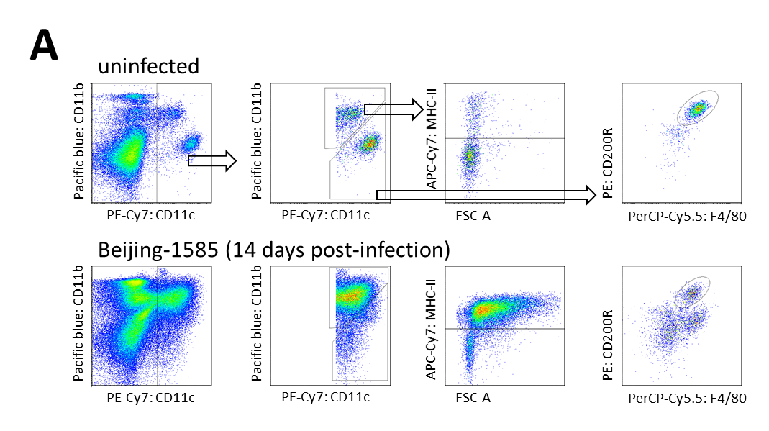

Supplementary figure 4: Gating strategies to identify different myeloid cell types and assess iNOS expression in each
A) Gating strategies to identify iM/DC (I) and AM (II) in lung homogenate. iM/DC were separated from other cell populations based on their expression of CD11c, CD11b and MHC-II, while AM were separated based on their high CD11c expression and additional expression of CD200R and F4/80.
B) Population size determination of AM and iM/DC through this alternative fluorescent antibody marker panel yielded highly similar results as shown in Figure 4B/D in the manuscript, indicating that the same cell populations are identified.
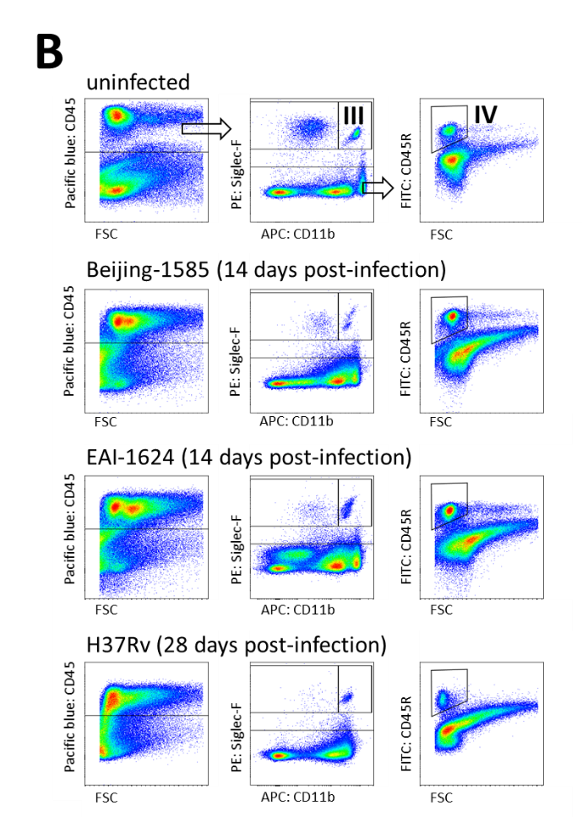
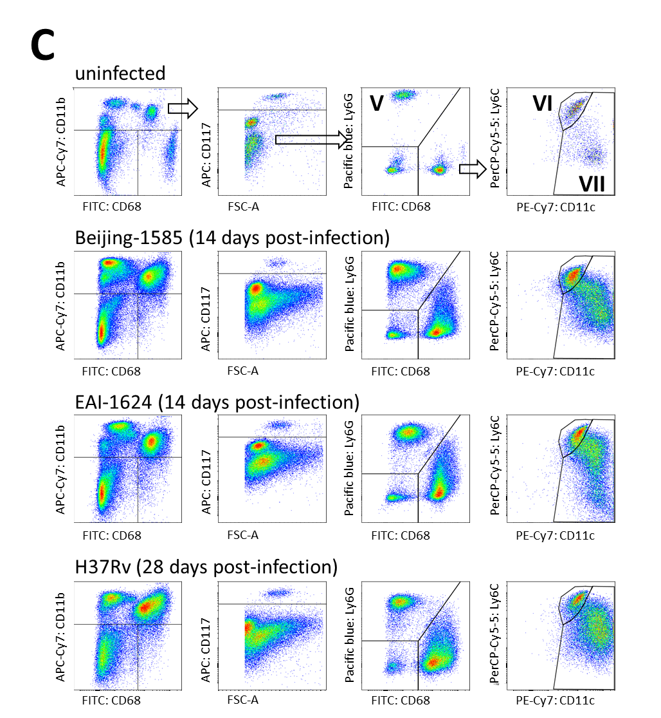
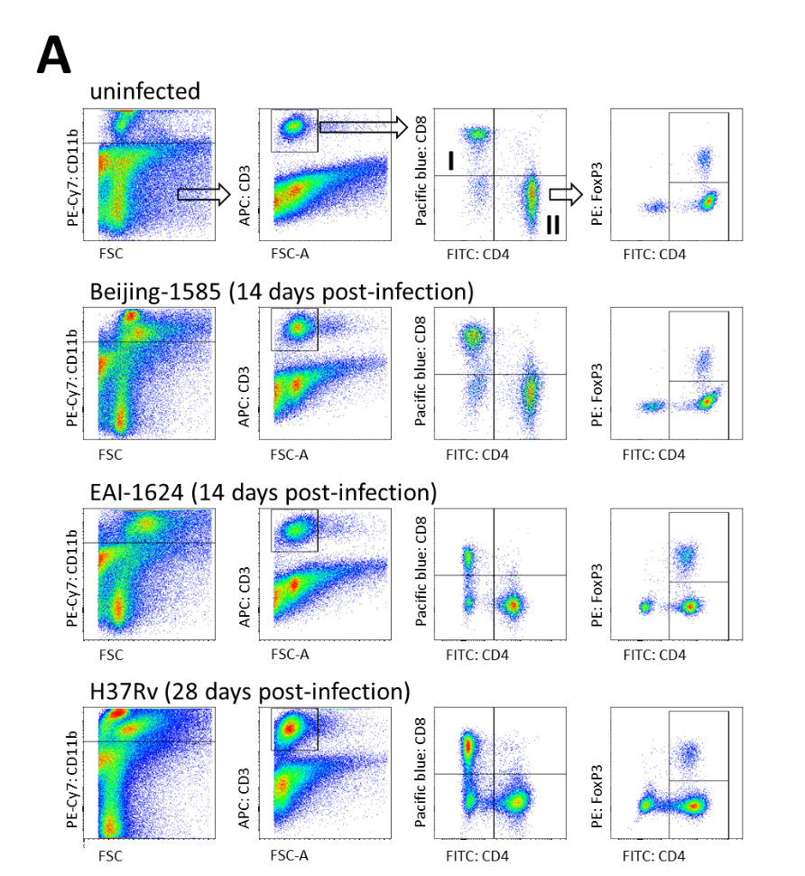
Supplementary figure 5: Gating strategies
A) Gating strategies for the CD8⁺ (I) and CD4⁺ (II) T-cell populations shown in Fig. 2. in the manuscript B) Gating strategies for the B-cell population (IV) shown in Fig. 2. and alveolar macrophages (III) shown in Fig. 4. C) Gating strategies for the PMN (CD11b⁺Ly6G^{high}, V), monocyte-like cells (Mo-like) (CD11b⁺Ly6C^{high}CD11c^{low}, VI) and iM/DC (CD11b⁺Ly6C^{int}CD11c^{high}, VII) populations in the lungs.
Supplementary figure 6: mRNA expression levels of type 1 interferon-inducible genes in the lungs of Mtb-infected mice
mRNA expression levels relative to Gapdh in the lungs of mice infected with Beijing-1585 (black dots), EAI-1627 (open circles) or H37Rv (grey squares). The combined expression of MX1, IFI44 and CCL2 into a Type 1 interferon signature in shown in Figure 7C of the manuscript. N=6 mice per group per time point, * p < 0.05, ** p < 0.01, *** p < 0.001, **** p < 0.0001 after Bonferroni correction

Supplementary data references:
1 Huizinga, R. et al. Sialylation of Campylobacter jejuni lipo-oligosaccharides: impact on phagocytosis and cytokine production in mice. PLoS One 7, e34416, doi:10.1371/journal.pone.0034416 (2012).
2 Rubio, D. et al. Crosstalk between the type 1 interferon and nuclear factor kappa B pathways confers resistance to a lethal virus infection. Cell Host Microbe 13, 701-710 (2013).
3 Mourik, B. C. et al. Immunotherapy Added to Antibiotic Treatment Reduces Relapse of Disease in a Mouse Model of Tuberculosis. Am J Respir Cell Mol Biol 56, 233-241 (2017).

