SUPPLEMENTARY DATA

PulmonDB: a curated lung disease gene expression database

Villaseñor-Altamirano, Ana B.¹; Moretto, Marco²; Maldonado, Mariel³; Zayas-Del Moral, Alejandra⁴; Munguía-Reyes, Adrián³; Romero, Yair⁵; García-Sotelo, Jair. S.¹; Aguilar, Luis A⁶; Aldana-Assad, Oscar¹; Engelen, Kristof²; Selman, Moisés³; Collado-Vides, Julio^{4,7*}; Balderas-Martínez, Yalbi I.^{3,8*}; Medina-Rivera, Alejandra^{1*}

¹ Laboratorio Internacional de Investigación sobre el Genoma Humano, UNAM, Juriquilla, Mexico.
² Unit of Computational Biology, Research and Innovation Centre, Fondazione Edmund Mach, 38010 San Michele all’Adige, Italy.
³ Instituto Nacional de Enfermedades Respiratorias Ismael Cosío Villegas, Mexico City, Mexico
⁴ Center for Genomic Sciences, UNAM, Cuernavaca, Mexico.
⁵ Facultad de Ciencias, UNAM, Mexico City, Mexico.
⁶ Laboratorio Nacional de Visualización Científica Avanzada, LAVIS, UNAM, Juriquilla, Mexico.
⁷ Department of Biomedical Engineering, Boston University, Boston, Massachusetts, USA
⁸ CONACYT-Instituto Nacional de Enfermedades Respiratorias Ismael Cosío Villegas, Mexico City, Mexico

* To whom correspondence should be addressed to Alejandra Medina-Rivera. Phone: +525556234331, email: amedina@liigh.unam.mx
Correspondence should also be addressed to Yalbi I. Balderas-Martínez. Phone:+525554871771, email: yalbibalderas@gmail.c
Correspondence should also be addressed to Julio Collado-Vides. Phone: +527773132063, fax: +527773175581, email: collado@ccg.unam.mx

Supplementary Figure 1. Database schema of the MySQL created for PulmonDB. This schema contains the tables with probes, genes, samples, experiments, normalized values, raw values, etc. of PulmonDB, and each line represents the relationship with other tables; they are colored by topic. Experimental information is shown in khaki, homogenized data in purple, condition annotation in lemon green, central ontology structure in pink, probe gene mapping in green, raw data in white, gene information in yellow, ongoing experiment in wheat.

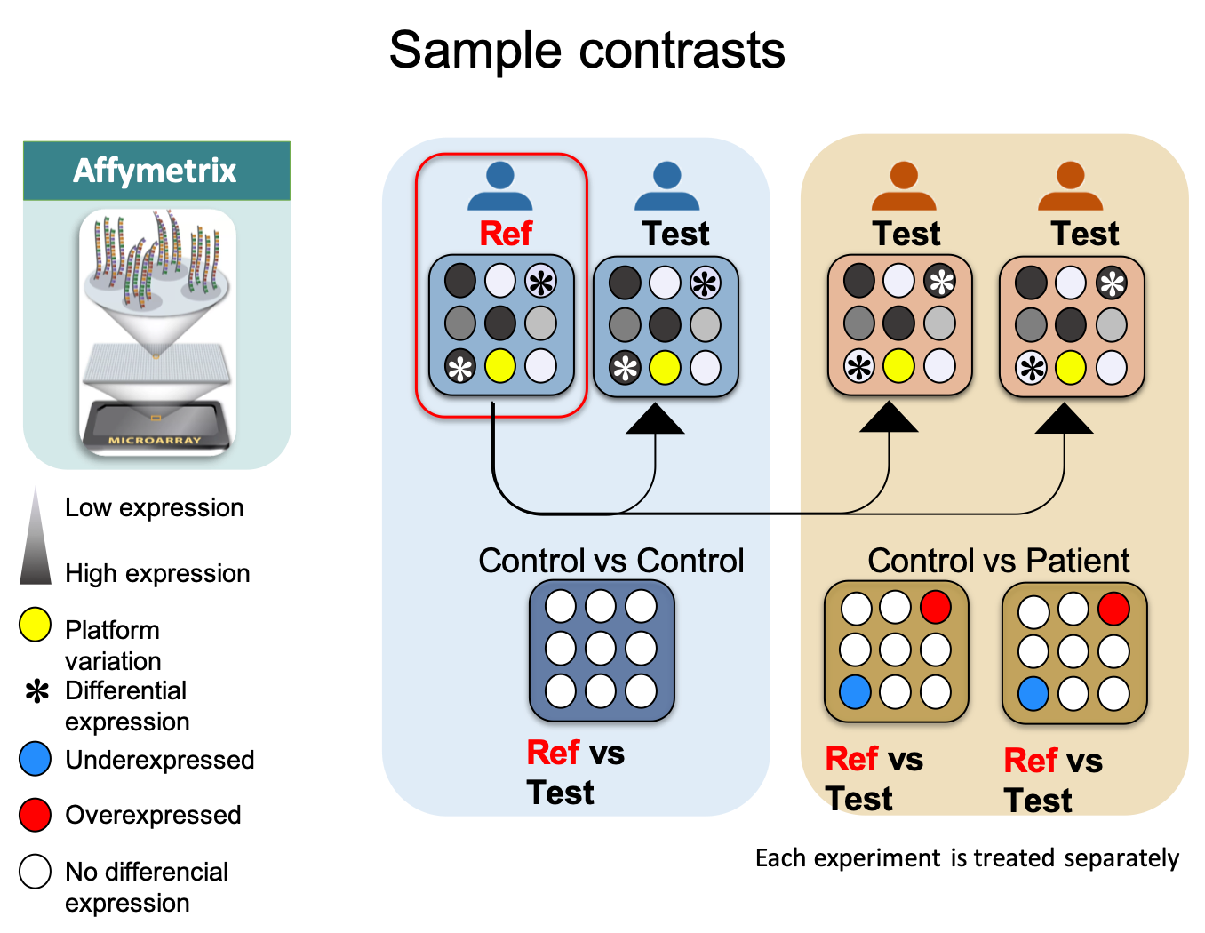

Supplementary Figure 2. Sample contrasts, created based on the original hypothesis of each experiment. We used a sample as a reference to make individual contrasts. The contrasts can be between control and control, control vs disease, etc. In this figure, a microarray is represented, with low expression in white and high expression in black, platform variation in yellow, differential gene expression by an asterisk, underexpressed genes in blue, overexpressed genes in red, and genes with no differential expression in white.

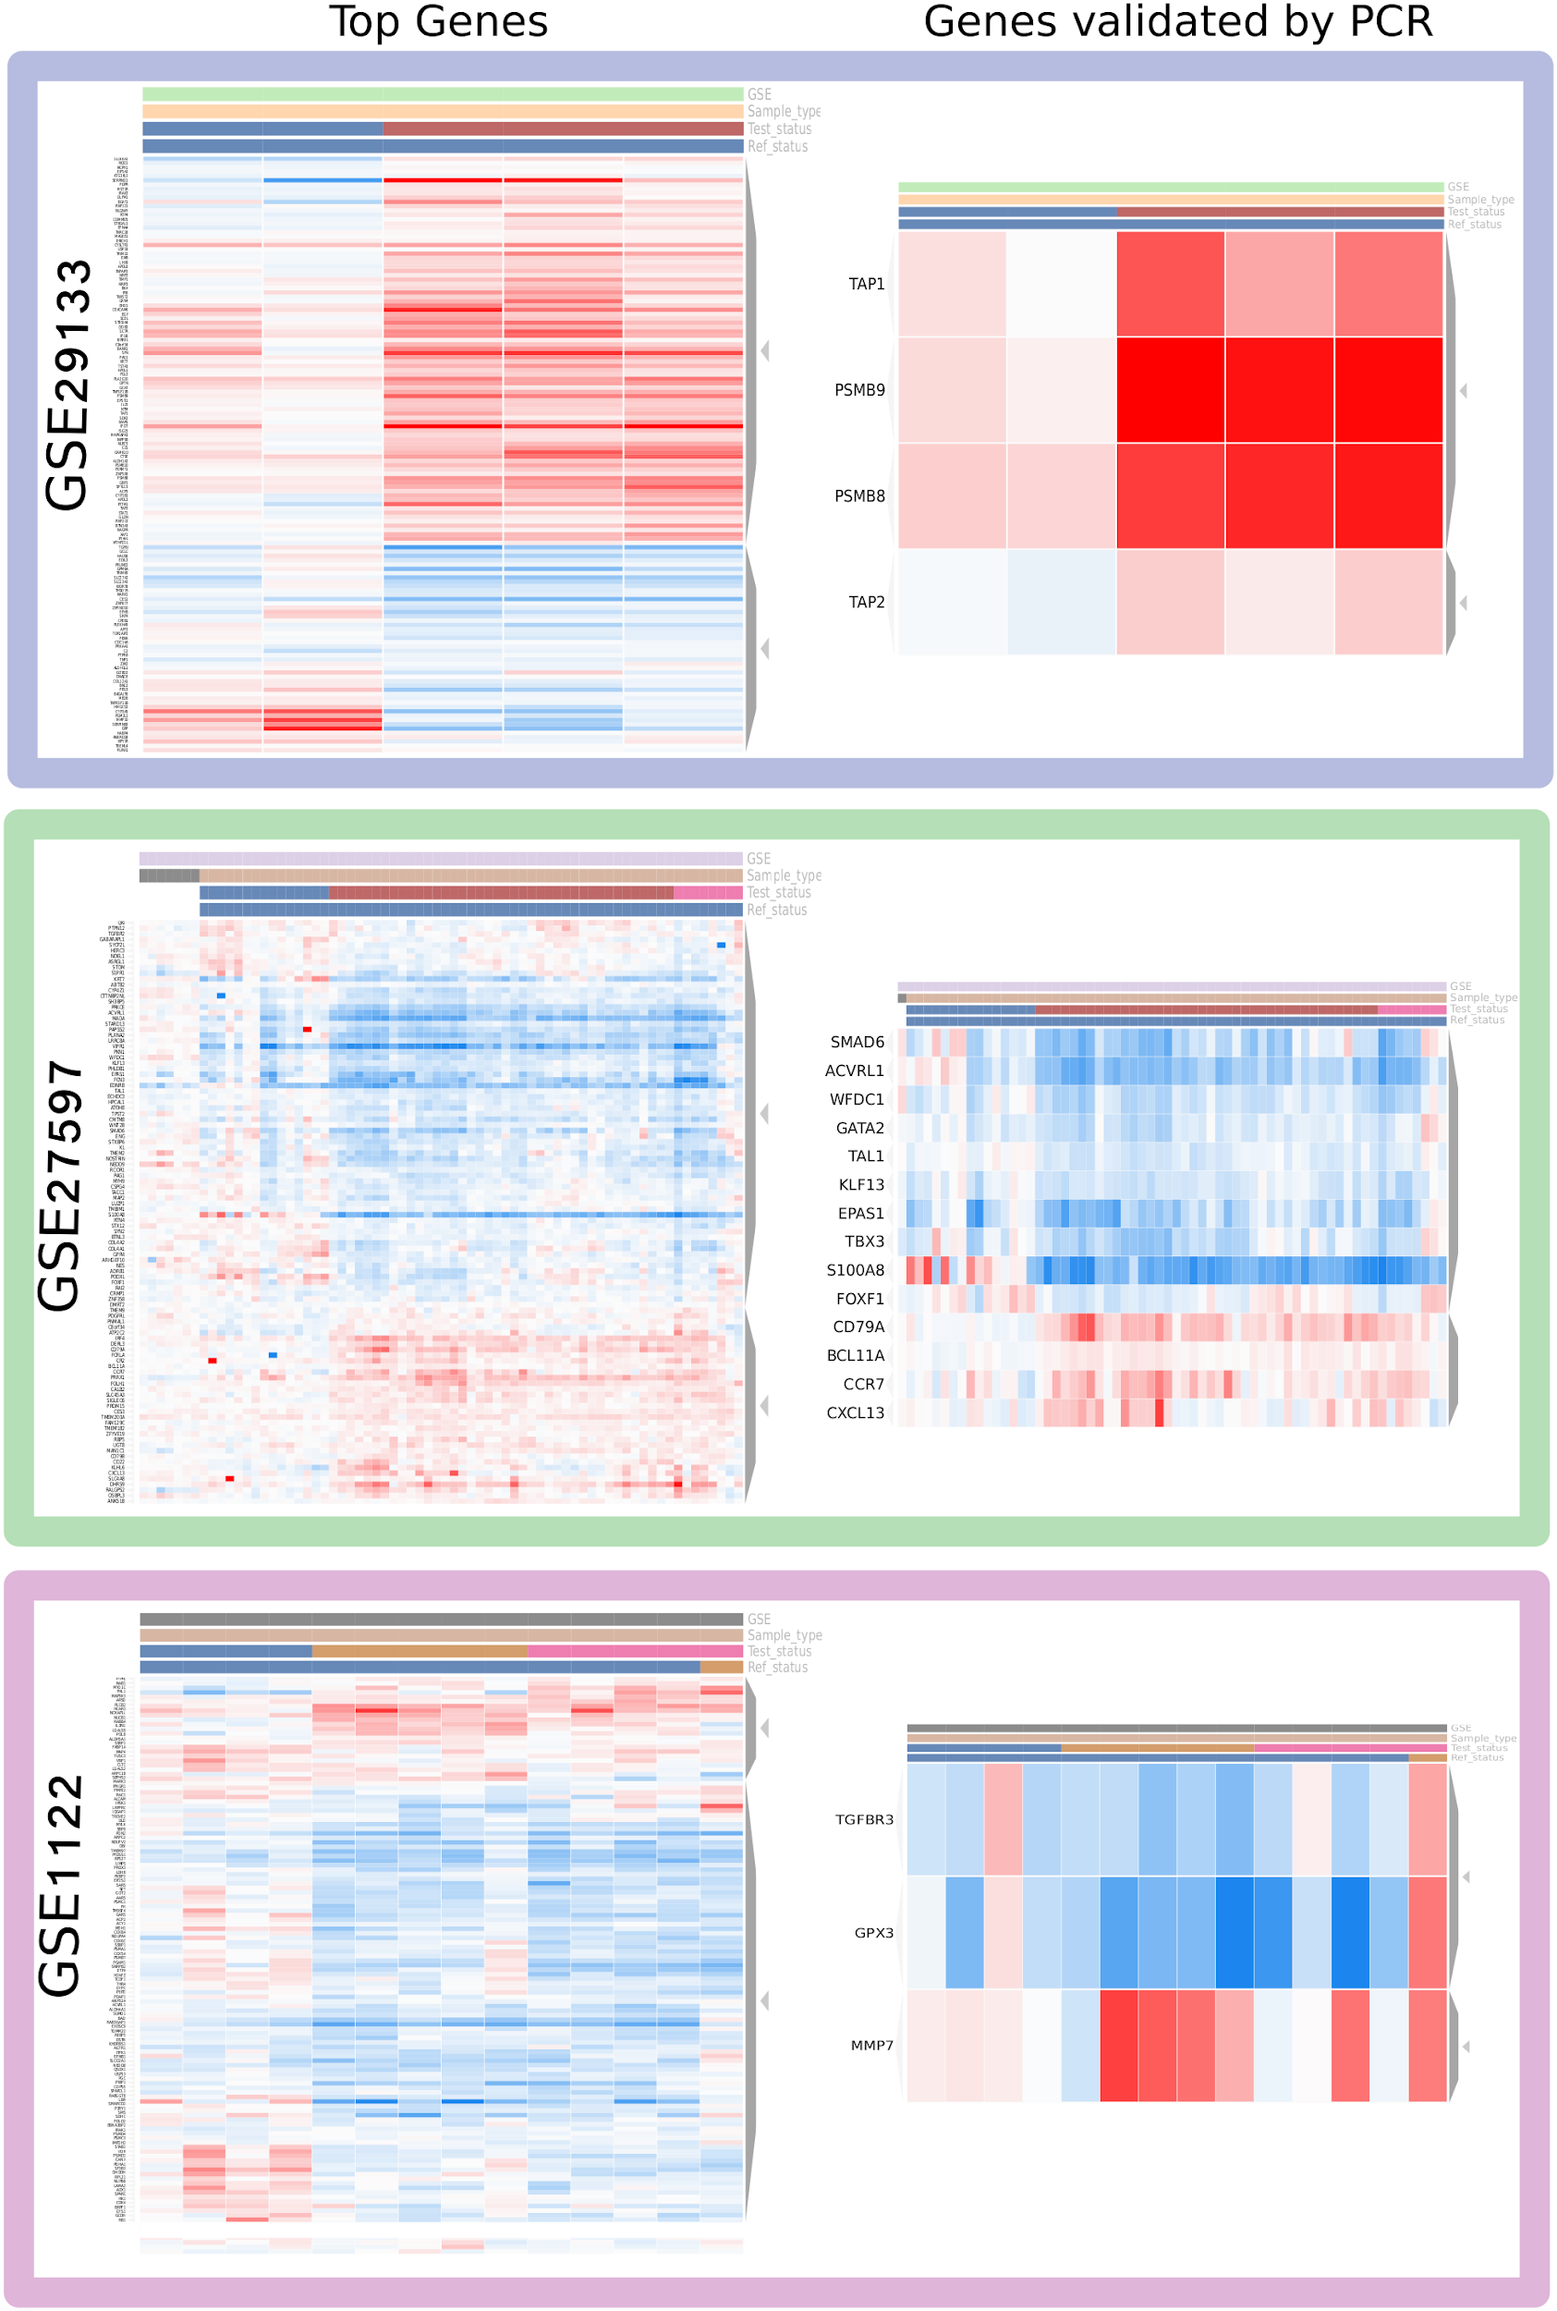
Supplementary Figure 3. Top differentially expressed genes in COPD published in three separate papers that also have a related GSE. Purple, genes of Fujino N, et al.⁵² using GSE29133; green, genes of Campbell JD, et al.³¹ using GSE27597; pink, genes of Golpon HA, et al.⁵³ using GSE1122. The top genes and the genes validated by PCR reported in each article were used as input in PulmonDB website to check reproducibility per experiment in our homogenized contrast values.

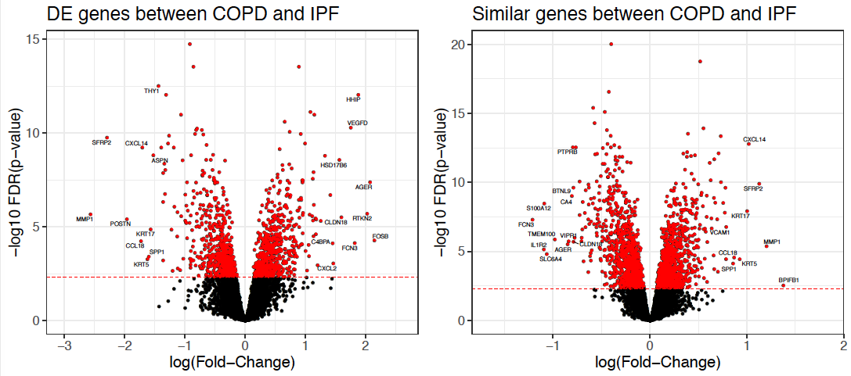
Supplementary Figure 4. Volcano plots of differentially expressed genes analyzed for COPD versus IPF and for COPD and IPF compared to a control group. The x axis is the log₂ fold change, the y axis is the adjusted p -value using FDR in −log₁₀, red dots are genes with an adjusted p-value of <0.001.

Supplementary Table 1. Names and descriptions of the controlled vocabulary used to annotate samples in PulmonDB.

Name | Description | Units
1. CLINIC_DETAIL
PACK_PER_YEAR | No. of cigarette packs smoked per year | Number of packs per year
1.1. SMOKING_STATUS
CURRENT | Current smoker | Boolean
FORMER | Former smoker is an ex-smoker individual | Boolean
NON_SMOKER | Nonsmoker | Boolean
1.2. STAGE
1.2.1. COPD
AE | Acute exacerbation | Boolean
GOLD_I | GOLD stage I, mild; FEV1 / FVC < 0.70;FEV1 80% predicted | Boolean
GOLD_II | GOLD stage II, moderate; FEV1 / FVC < 0.7050% FEV1 < 80% predicted | Boolean
GOLD_III | GOLD stage III, severe;FEV1 / FVC < 0.7030% FEV1 < 50% predicted | Boolean
GOLD_IV | GOLD stage IV, very severe;FEV1 / FVC < 0.70FEV1 < 30% predicted or FEV1 < 50% predicted plus chronic respiratory failure | Boolean
STABLE | Stable patients | Boolean
1.2.2. IPF
ADVANCED | IPF advanced stage | Boolean
EARLY | IPF early stage | Boolean
FAMILIAL_IPF | Familial IPF sample | Boolean
SPONTANEOUS_IPF | Spontaneous IPF | Boolean
1.2.2.1 ACUTE_EXACERBATION
RAPID | Acute exacerbation – rapid | Boolean
SLOW | Acute exacerbation - slow | Boolean
1.3. DONOR
1.3.1. AGE
AGE_PER_INDIVIDUAL | Age of the donor | Years
1.3.1.1. AGE_IN_GROUP
SD+/-_AGE | Standard deviation for the group age | Boolean
MEAN_AGE | Average age of the group | years
RANGE | Group age range | Years
1.3.2. ANCESTRY
AFRICAN | Ancestry of the donor: African | Boolean
ASIAN | Ancestry of the donor: Asian | Boolean
CAUCASIAN | Ancestry of donor: Caucasian | Boolean
HISPANIC | Ancestry of the donor: Hispanic | Boolean
LATINAMERICAN | Ancestry of the donor: Latin American | Boolean
NATIVE_AMERICAN | Ancestry of the donor: Native American | Boolean
NOT_CAUCASIAN | Ancestry: Not Caucasian | Boolean
1.3.3. BODY_MASS_INDEX
LOW_BODY_MASS | Low body mass | Boolean
NORMAL_BODY_MASS | Normal body mass | Boolean
1.4. DISEASE_STATUS
AAD | Alpha-1 antitrypsin deficiency-related emphysema | Boolean
ASTHMATIC | Asthmatic | Boolean
COP | Cryptogenic organizing pneumonia | Boolean
COPD | Chronic obstructive pulmonary disease | Boolean
CPFE | Combined pulmonary fibrosis and emphysema | Boolean
DIP | Desquamative interstitial pneumonia | Boolean
EMPHYSEMA | Emphysema | Boolean
HEALTHY/CONTROL | Normal status | Boolean
IPF | Idiopathic pulmonary fibrosis | Boolean
LUNG_CANCER | Donor with lung cancer | Boolean
MATCH_TISSUE_CONTROL | Non-cancerous sample from a cancer patient | Boolean
NON_IPF_ILD | Interstitial lung disease (ILD) | Boolean
NORMAL_RELATIVE | Non affected relative | Boolean
NSIP | Nonspecific interstitial pneumonia | Boolean
PAH | Pulmonary arterial hypertension | Boolean
PH | Pulmonary hypertension | Boolean
RB-ILD | Respiratory bronchiolitis | Boolean
SARCOIDOSIS | Nodular | self-limiting (N-SL)
SS | Systemic sclerosis | Boolean
UNCLASSIFIED | Sample with unclassified disease | Boolean
1.5. GENDER
FEMALE | Female sample | Boolean
MALE | Male | Boolean
MALE/FEMALE_RATIO | Male/female ratio | Boolean
1.6. PHARMACOLOGICAL_TREATMENT
STATIN_USER | Statin user | Boolean
PHYSICAL_STATUS | NA | NA
SEDENTARY | Sedentary | Boolean
TRAINED | Trained | Boolean
2. FUNCTIONAL_TESTS
DLCO (%) | DLCO % | %
FEV1/FVC (%) | FEV1/FVC (%) | %
FVC (%) | FVC percentage | %
3. PROPERTIES
PASSAGE (RANGE) | Range of the number of times a cell culture has been subcultured | Boolean
PASSAGE (SPECIFIC) | Number of times a cell culture has been subcultured | Boolean
3.1. ANATOMIC_LOCALIZATION
LOW_LOBE | Lower lobe | Boolean
MIDDLE_LOBE | Middle lobe | Boolean
UPPER_LOBE | Upper lobe | Boolean
4. SAMPLE
4.1. DIFFERENTIAL_CELL_COUNTS
LYMPHOCYTES | Lymphocytes | Boolean
MACROPHAGES | Macrophages | Boolean
NEUTROPHILS | Neutrophils | Boolean
4.3. PROFILE_TYPE
MRNA | mRNA | Boolean
POLYSOME_ASSOCIATED_RNA | Polysome associated RNA | Boolean
SMALL_RNAS | Small RNAs | Boolean
TOTAL_RNA | Total RNA | Boolean
4.4. SAMPLE_TYPE
4.3.1. CELLS
4.3.1.1. CELL_LINE
4.3.1.1.1. BRONCHIAL_EPITHELIAL_CELLS
BEAS-2B | Bronchial epithelial cell line | Boolean
4.3.1.1.2. FIBROBLASTS
CCD25Lu | Commercial fibroblast cell line | Boolean
HFL1 | HFL1 | Boolean
MRC5 | Commercial fibroblast-like cell line MRC5 | Boolean
NHLF | Fibroblast commercial cell line | Boolean
TIG1 | Fibroblast cell line TIG1 (Tokyo Institute of Gerontology-1) | Boolean
TIG7 | Embryonic pulmonary fibroblast cell line TIG7 | Boolean
4.3.1.1.3. MONOCYTES
CD14+ | Monocytes CD14+ | Boolean
THP-1 | THP-1 cell line | Boolean
U937 | Immortalized monocyte cell line | Boolean
A549 | Lung carcinoma cell line | Boolean
4.3.1.2. PRIMARY_CULTURE
AIRWAY_SMOOTH_MUSCLE_CELLS | Airway smooth muscle cells | Boolean
ALVEOLAR_EPITHELIAL_CELLS | Alveolar epithelial cells | Boolean
ALVEOLAR_MACROPHAGE | Alveolar macrophage | Boolean
BRONCHIAL_EPITHELIAL_CELLS | Bronchial epithelial cells | Boolean
CD34+ | CD34+ hematopoietic stem cells | 0,1
ENDOTHELIAL_CELLS | Endothelial cells | Boolean
FIBROBLASTS | Fibroblasts | Boolean
LARGE_AIRWAY_EPITHELIAL CELLS | Large airway epithelial cells | Boolean
LEUKOCYTES | Leukocytes | Boolean
MAMMARY EPITHELIAL CELLS | Mammary epithelial cells | Boolean
MESENCHYMAL_PROGENITOR_CELL | Mesenchymal progenitor cell | Boolean
MONOCYTE | Monocyte | Boolean
MYELOID DENDRITIC CELLS | Myeloid dendritic cells | Boolean
PBMC | Peripheral blood mononuclear cell | Boolean
SMALL_AIRWAYS_EPITHELIAL_CELLS | Small airways epithelial cells | Boolean
TRACHEAL EPITHELIAL CELLS | Tracheal epithelial cells | Boolean
4.3.1.2.1. T-CELLS
CD4-T-CELLS | CD4 T cells | Boolean
CD8-T-CELLS | CD8 T cells | Boolean
IL-6R_CD8 | IL-6R CD8 T cells | Boolean
IL-7R_CD8 | IL-7R CD8 T cells | Boolean
4.3.1.2.1.1. DIFFERENTIATION_STATUS
EFFECTOR | Differential status of T cells | 0,1
MEMORY | Differentiation status of T cells | 0,1
NAIVE | Differentiation status of T cells | 0,1
4.4.1. FLUID
BAL | Bronchoalveolar lavage (BAL) | Boolean
BLOOD | Blood (sample type) | Boolean
SALIVA | Saliva | Boolean
SERUM | Serum | Boolean
SPUTUM | Sputum | Boolean
4.4.2. TISSUE
BONE_MARROW | Hematopoietic stem cells | Boolean
BONE_MARROW | Hematopoietic stem cells | Boolean
DIAPHRAGM_MUSCLE | Diaphragm muscle | Boolean
LUNG_BIOPSY | Lung biopsy | Boolean
LUNG_EXPLANT | Sample taken from a lung explant | Boolean
VASTUS_LATERALIS_MUSCLE | Vastus lateralis muscle | Boolean
REFERENCE RNA | Stratagene Universal Human Reference RNA (catalog number 740000) | Boolean
4.5. TREATMENT
ADENOVIRUS_TREATMENT | Cell culture treated with adenovirus to activate green fluorescent protein (GFP) | Boolean
AIR_TREATMENT | Air treatment | Boolean
ALI_CULTURE | Air-liquid interface culture | Days
ANTI_CD3_AND_ANTI_CD28 | Anti-CD3/CD28 cell activator | Boolean
ATRA | All-trans retinoic acid concentration | mM
AZA | 5'-Azacytidine | uM
CD3/28 | Anti-CD3/CD28 beads | Boolean
CIGARETTES | Number of cigarettes per year | Number_of_Cigarettes
CONTRACTILE_ECM | Contractile extracellular matrix | Boolean
CONTROL_ECM | Control extracellular matrix | Boolean
CULTURED | Cultured samples | Boolean
CURCUMIN | Curcumin | uM
EBV | Epstein-Barr virus infection
FLUTICASONE | Corticosteroid treatment for COPD | Boolean
FLUTICASONE/SALMETEROL | Corticosteroid treatment for COPD | Boolean
FLUTICASONE_6MONTHS/PLACEBO_24MONTHS | Treatment for COPD | Boolean
GHK | Glycyl-L-histidyl-L-lysine peptide (nano molar concentration) | nM
HOMOZYGOUS_NULL | Homozygous null gene | null_gene
IFN_GAMMA | Interferon gamma concentration | U/mL
IL-13 | IL-13 | ng/mL
IPF_ECM | Fibrotic extracellular matrix | Boolean
LIA | Leukocyte-induced angiogenesis assay | Boolean
NON_CONTRACTILE_ECM | Non contractile extracellular matrix | Boolean
NON_CULTURED | Noncultured | Boolean
NTHi375 | H. influenzae strain NTHi375 | CFU/mL
OXIDATIVE_STRESS | H2O2 concentration (micromolar) | μM
OXYGEN_TREATMENT | Oxygen treatment | Boolean
P3C | Pam3Cys | μg/mL
PGE2 | Prostaglandin E2 | μg /mL
PLACEBO | Placebo | Boolean
SLPS | Standard lipopolysaccharide (LPS) | ug/mL
SMOKE_EXPOSURE | Treatment with smoke exposure | Boolean
TGF_BETA | Exogenous TGF-beta levels | ng/mL
TNF_ALFA | TNF-alpha concentration | ng/mL
TRAINING_EXERCISE | Training exercise (in weeks) | Number of weeks
TRANSFECTED | Transfection with the gene (fill in the blank with the gene name) | Gene
UNTREATED | No treated cells/tissue | Boolean
UPLPS | Ultrapure Escherichia coli O111:B4 LPS | μg/mL
4.4.1. TIME_OF_STIMULI
HOURS | HOURS | HOURS
MONTHS | MONTHS | MONTHS
WEEKS | WEEKS | WEEKS
4.6. TYPE
GROUP | Number of individuals that comprise the pool or group | individuals
INDIVIDUAL | If the donor is an individual | Boolean
5. STUDIED_DISEASE
COPD_EXPERIMENT | Used to classify the disease studied in the experiment. NOTE: It does not describe whether donor is healthy or diseased. | Boolean
CPFE_EXPERIMENT | Combined pulmonary fibrosis and emphysema; used to classify the disease studied in the experiment. | Boolean
IPF_EXPERIMENT | Used to classify the disease studied in the experiment. NOTE: It does not describe whether donor is healthy or diseased. | Boolean

Supplementary Table 2. GEO Series available in PulmonDB with the number of sample contrasts created per experiment.

GEO Series ID | Lung disease | Experiment original name (as published) | Pubmed ID related | Platform(s) | Sample contrasts
GSE10038 | COPD | Upregulation of expression of matrix metalloproteinases in alveolar macrophages of HIV-1+ smokers with early emphysema | 19605697 | HG-U133_Plus_2 | 10
GSE107426 | COPD | Results of differentially expressed lncRNAs in COPD and healthy smokers using the Arraystar Human LncRNA microarray | NA | GPL16956 | 1
GSE10896 | COPD | Impact of curcumin on human monocytes (U937 cells) exposed to oxidative stress | 18421014 | HG-U133_Plus_2 | 22
GSE1122 | COPD | Emphysema lung tissue gene expression profiling | 15284076 | GPL80 | 14
GSE12815 | COPD | PI3K pathway activity in the normal airway of smokers with lung cancer, and in smokers with airway dysplasia | 20375364 | GPL5175,GPL96, HG-U133_Plus_2 | 67
GSE13896 | COPD | Smoking-dependent reprogramming of alveolar macrophage polarization: implication for pathogenesis of COPD | 19635926 | HG-U133_Plus_2 | 69
GSE1650 | COPD | COPD study | 15374838 | GPL96 | 29
GSE16972 | COPD | COPD-specific gene expression signatures of alveolar macrophages as well as peripheral blood monocytes overlap and correlate with lung function | 21430361 | GPL96 | 11
GSE2125 | COPD | Isolated alveolar macrophages | 16166618 | HG-U133_Plus_2 | 44
GSE23704 | COPD | Gene expression profiling on bronchoalveolar lavage (BAL) cells treated with all-trans-retinoic acid (ATRA) | 22204820 | HG-U133_Plus_2 | 1
GSE26296 | COPD | Genome-wide analysis of lung myeloid dendritic cells gene expression from healthy or emphysema subjects | 22261033 | GPL6884 | 5
GSE27536 | COPD | Vastus lateralis biopsies from healthy and COPD patients before and after 8 weeks of exercise training | 21909251 | HG-U133_Plus_2 | 53
GSE27543 | COPD | Vastus lateralis biopsies from healthy and COPD patients before and after 3 weeks of endurance training | 21909251 | GPL201 | 15
GSE27597 | COPD | A gene expression signature of emphysema-related lung destruction and its reversal by the tripeptide GHK | 22937864, 24380442, 24380443, 24089408 | GPL13243 | 70
GSE29133 | COPD | Transcriptome in alveolar epithelial type II cells isolated from normal and COPD lungs of adult human | 23117565 | HG-U133_Plus_2 | 5
GSE30027 | COPD | Human lung CD8+ T cells compared with paired non-naive peripheral blood CD8+ T cells | NA | GPL6947 | 11
GSE33337 | COPD | miRNA changes in mild and moderate emphysema correlate with target gene expression in vivo and in vitro [target gene expression data] | 24479666 | GPL6947 | 6
GSE34562 | COPD | IL-6R identifies early differentiated human effector memory CD8+ T cells that potently expand and produce IL-2 and IL-13 | 25390970 | GPL10558 | 5
GSE37147 | COPD | Bronchial airway gene expression reflects a COPD-associated field of injury that changes with disease severity and is reversible with therapy | 23471465 | GPL13243 | 269
GSE37693 | COPD | Gene expression effects of IL-13 on primary human airway epithelial cells | 23187130 | GPL6947 | 7
GSE37768 | COPD | Expression data in lung tissue from moderate COPD patients, healthy smokers and nonsmokers | NA | HG-U133_Plus_2 | 37
GSE40885 | COPD | Data expression in alveolar macrophages induced by lipopolysaccharide in humans | 22952057 | HG-U133_Plus_2 | 13
GSE45251 | COPD | The inflammatory response of human airway smooth muscle cells | 23590298 | GPL6480 | 15
GSE46903 | COPD | Transcriptome-based network analysis reveals a spectrum model of human macrophage activation [Expression] | 24530056 | GPL6947 | 383
GSE47460 | COPD | Gene expression profiling of chronic lung disease for the Lung Genomics Research Consortium | 29988126, 27609773, 27609774 | GPL5175, GPL13607,GPL4133 | 581
GSE475 | COPD | Chronic obstructive pulmonary disease | NA | GPL96 | 6
GSE47718 | COPD | Smoking dysregulates the human airway basal cell transcriptome at COPD-linked risk locus 19q13.2 | 24498427 | GPL11154 | 16
GSE47929 | COPD | Gene expression profiles of Siglec-14/THP-1 and Siglec-5/THP cell lines, with or without NTHi stimulation | 24994897 | HG-U133_Plus_2 | 3
GSE55962 | COPD | Systemic inflammatory response to smoking in chronic obstructive pulmonary disease: evidence of a gender effect | 24830457 | GPL13667 | 105
GSE56341 | COPD | Gene expression profiles of COPD and nonCOPD small airway epithelia | 24298892 | GPL6244 | 21
GSE56768 | COPD | Whole blood and isolated blood cell transcriptomics in COPD | NA | HG-U133_Plus_2 | 431
GSE56768 | COPD | Whole blood and isolated blood cell transcriptomics in COPD | NA | HG-U133_Plus_2
GSE57148 | COPD | Characterizing gene expression in lung tissue of COPD subjects using RNA-seq | 25834810, 29871630 | GPL11154 | 186
GSE60399 | COPD | Expression analysis of stable chronic obstructive pulmonary disease and acute exacerbation of chronic obstructive pulmonary disease | 25407108 | GPL18451 | 4
GSE62974 | COPD | RNA sequencing (RNA-SEQ) of EPAS1 knockdown by siRNA in endothelial cells | 25569234 | GPL16791 | 5
GSE63073 | COPD | Genes related to emphysema are enriched for ubiquitination pathways | 25432663 | GPL3991 | 42
GSE69134 | COPD | Genome expression profiling identifies host-directed antimicrobial drugs against respiratory infection by nontypable Haemophilus influenzae | 26416856 | GPL887 | 7
GSE69557 | COPD | CD34⁺ DNAM^{bright} CXCR4⁺ CLP mobilized in chronic inflammation | 26436997 | GPL6244 | 3
GSE69818 | COPD | COPD lung tissue expression | 26735770 | GPL13667 | 69
GSE7557 | COPD | Human bronchial epithelial cells_Passage 3 vs. passage 0 | 17965775 | GPL5102 | 3
GSE76705 | COPD | Complex disease subtypes identified by network-based clustering of gene expression data: application to COPD | 26773458 | HG-U133_Plus_2 | 228
GSE77344 | COPD | Gene expression in chronic obstructive pulmonary disease (COPD) patients | http://dx.doi.org/10.1101/038794 | GPL11532 | 171
GSE81614 | COPD | Novel RNA-binding activity of NQO1 promotes SERPINA1 mRNA translation | 27515817 | GPL10558 | 14
GSE8581 | COPD | Human chronic obstructive pulmonary disorder (COPD) biomarker | 18849563 | HG-U133_Plus_2 | 58
GSE8608 | COPD | MDM from COPD patients and healthy subjects after treatment with LPS or fine and ultrafine particles | 18084737 | HG-U133_Plus_2 | 5
GSE87098 | COPD | Expression data of mucociliated human airway epithelia on-chip with or without exposure to whole cigarette smoke under physiological breathing | 27894999 | GPL16686 | 14
GSE994 | COPD | Effects of cigarette smoke on the human airway epithelial cell transcriptome | 15210990 | GPL96 | 74
GSE1786 | Lung function in elderly | Vastus lateralis biopsies from healthy trained and sedentary males | 16260967 | GPL96 | 22
GSE101286 | IPF | Gene expression profiling of idiopathic interstitial pneumonias (IIPs): identification of potential diagnostic markers and therapeutic targets | 28821283 | GPL6947 | 14
GSE11196 | IPF | Fibrotic myofibroblasts manifest genome-wide derangements of translational control | 18795102 | HG-U133_Plus_2 | 44
GSE15197 | IPF | RNA expression profiling of lung tissue identifies mutually distinct molecular signatures in PAH and PH secondary to IPF | 20081107 | GPL6480 | 38
GSE19976 | IPF | Gene expression analysis of lung biopsies from patients with two different forms of pulmonary sarcoidosis | 20194811 | GPL6244 | 14
GSE21369 | IPF | Gene expression profiles of interstitial lung disease (ILD) patients | 21241464 | HG-U133_Plus_2 | 28
GSE24206 | IPF | Validated gene expression signatures of idiopathic pulmonary fibrosis | 21974901 | HG-U133_Plus_2 | 22
GSE26594 | IPF | Increased cell surface Fas expression is necessary to sensitize lung fibroblasts to Fas ligation-induced apoptosis: implications for fibroblast accumulation in idiopathic pulmonary fibrosis | 21632719 | HG-U133_Plus_2 | 5
GSE28221 | IPF | Peripheral blood mononuclear cell gene expression profiles may predict poor outcome in idiopathic pulmonary fibrosis | 24089408 | GPL4133,GPL5175 | 136
GSE31934 | IPF | To examine the expression of Sulf1 and Sulf2, as well as other glycan-related genes, in human Idiopathic pulmonary fibrosis (IPF) lungs compared to normal lung samples | NA | GPL11097 | 5
GSE32537 | IPF | Molecular phenotyping of the idiopathic interstitial pneumonias [mRNA] | 23783374 | GPL6244 | 216
GSE33566 | IPF | The peripheral blood transcriptome predicts the presence and extent of disease in idiopathic pulmonary fibrosis | 22761659 | GPL4133 | 122
GSE35145 | IPF | Gene expression changes in IPF | 22700861 | GPL10558 | 7
GSE38958 | IPF | Profiling of gene expression in idiopathic pulmonary fibrosis | 26286721 | GPL5175 | 114
GSE44723 | IPF | Bleomycin induces molecular changes directly relevant to idiopathic pulmonary fibrosis: A model for “active” disease | 23565148 | HG-U133_Plus_2 | 12
GSE45686 | IPF | An extracellular matrix-driven positive feedback loop regulates translation in idiopathic pulmonary fibrosis | 24590289 | GPL10558 | 38
GSE48149 | IPF | Lung tissues in systemic sclerosis have gene expression patterns unique to pulmonary fibrosis and pulmonary hypertension | 21360508 | GPL16221 | 52
GSE49072 | IPF | Alveolar macrophage gene expression in human pulmonary fibrosis | 23924348 | GPL96 | 83
GSE52463 | IPF | Transcriptome analysis reveals differential splicing events in IPF lung tissue | 24647608 | GPL11154 | 14
GSE52612 | IPF | Forkhead Box F1 (FOXF1) represses fibroblast functions relevant to fibrogenesis | 25260753 | GPL13607 | 7
GSE53845 | IPF | 40 IPF patients and 8 healthy controls | 25217476 | GPL4133 | 94
GSE5457 | IPF | Retinoic acids exposure alters TGF-beta1-induced epithelial mesenchymal transition via Wnt5b expression | 18621908 | GPL96 | 7
GSE6804 | IPF | Expression data of myofibroblast isolated from patients with idiopathic pulmonary fibrosis | 17986007 | GPL201 | 2
GSE69764 | IPF | Identification of the gene expression in IPF lung fibroblasts after demethylation | 26442443 | HG-U133_Plus_2 | 5
GSE71351 | IPF | Global gene expression profiles of fibroblasts from the lungs of patients with idiopathic pulmonary fibrosis: The role of CCL8 | 28057004 | GPL10558 | 11
GSE72073 | IPF | Expression data from lung tissues of IPF patients and normal controls | 26453058 | GPL17586 | 7
GSE73854 | IPF | Developmental programming in idiopathic pulmonary fibrosis (IPF) | 27869174 | HG-U133_Plus_2 | 7
GSE94060 | IPF | Human lung MPC | 28463231 | GPL6244 | 8
GSE38934 | IPF/COPD | Gene expression profiling of lung tissues from patients with combined pulmonary fibrosis and emphysema | 23025845 | HG-U133_Plus_2 | 5

Supplementary Table 3. A full extended table with number of contrasts per disease type.

Disease type | Number of contrasts
ASTHMATIC | 15
COPD | 1383
EMPHYSEMA | 26
HEALTHY/CONTROL | 1566
IPF | 770
MATCH_TISSUE_CONTROL | 265
NON_IPF_ILD | 66
NORMAL_RELATIVE | 24
PAH | 26
SARCOIDOSIS | 7
UNCLASSIFIED | 30

Supplementary Table 4. A full extended table with number of contrasts per sample type previously described in Supplementary Table1.

Sample type | Number of contrasts
A549 | 14
AIRWAY_SMOOTH_MUSCLE_CELLS | 15
ALVEOLAR_EPITHELIAL_CELLS | 8
BAL | 237
BLOOD | 1487
BONE_MARROW | 3
BRONCHIAL_EPITHELIAL_CELLS | 438
CD4-T-CELLS | 78
CD8-T-CELLS | 79
DIAPHRAGM_MUSCLE | 6
ENDOTHELIAL_CELLS | 5
FIBROBLASTS | 134
LUNG_BIOPSY | 1696
LUNG_EXPLANT | 55
MAMMARY_EPITHELIAL_CELLS | 26
MONOCYTE | 74
MYELOID_DENDRITIC_CELLS | 5
THP-1 | 3
TRACHEAL_EPITHELIAL_CELLS | 7
U937 | 22
VASTUS_LATERALIS_MUSCLE | 90

Supplementary Table 5. Number of contrasts per platform version, a platform type is also presented in an additional column.

Platform version | Number of contrasts | Platform type
[Glyco_v4_Hs] Custom Affymetrix Glyco v4 GeneChip | 5 | Affymetrix
[HG-Focus] Affymetrix Human HG-Focus Target Array | 17 | Affymetrix
[HG-U133_Plus_2] Affymetrix Human Genome U133 Plus 2.0 Array | 1110 | Affymetrix
[HG-U133A] Affymetrix Human Genome U133A Array | 260 | Affymetrix
[HG-U219] Affymetrix Human Genome U219 Array | 174 | Affymetrix
[HTA-2_0] Affymetrix Human Transcriptome Array 2.0 [transcript (gene) version] | 7 | Affymetrix
[Hu6800] Affymetrix Human Full Length HuGeneFL Array | 14 | Affymetrix
[HuEx-1_0-st] Affymetrix Human Exon 1.0 ST Array [transcript (gene) version] | 257 | Affymetrix
[HuGene-1_0-st] Affymetrix Human Gene 1.0 ST Array [transcript (gene) version] | 262 | Affymetrix
[HuGene-1_1-st] Affymetrix Human Gene 1.1 ST Array [transcript (gene) version] | 171 | Affymetrix
[HuGene-2_0-st] Affymetrix Human Gene 2.0 ST Array [transcript (gene) version] | 14 | Affymetrix
[HuGene10stv1_Hs_ENSG] Affymetrix GeneChip Human Gene 1.0 ST Array [Brainarray Version 11.0.1] | 276 | Affymetrix
Agilent-012097 Human 1A Microarray (V2) G4110B (Feature Number version) | 7 | Agilent
Agilent-014850 Whole Human Genome Microarray 4x44K G4112F (Feature Number version) | 457 | Agilent
Agilent-014850 Whole Human Genome Microarray 4x44K G4112F (Probe Name version) | 53 | Agilent
Agilent-028004 SurePrint G3 Human GE 8x60K Microarray (Feature Number version) | 436 | Agilent
Agilent-045997 Arraystar human lncRNA microarray V3 (Probe Name Version) | 1 | Agilent
Human 3.0 A1 | 42 | NA
Illumina HiSeq 2000 (Homo sapiens) | 216 | Illumina
Illumina HiSeq 2500 (Homo sapiens) | 5 | Illumina
Illumina HumanHT-12 V3.0 expression beadchip | 422 | Illumina
Illumina HumanHT-12 V4.0 expression beadchip | 211 | Illumina
Illumina HumanRef-8 v3.0 expression beadchip (Search Key version) | 52 | Illumina
Illumina HumanWG-6 v3.0 expression beadchip | 5 | Illumina
NimbleGen Homo sapiens HG18 expression array [100718_HG18_opt_expr_HX12] SEQ_ID condensed version | 4 | NA
Operon Homo sapiens 21K (Hs Operon Vw) | 3 | NA

