Soybean yield, biological N₂ fixation and seed composition responses to additional inoculation in the United States

Walter D. Carciochi, Luiz H. Moro Rosso, Mario A. Secchi, Adalgisa R. Torres, Seth Naeve, Shaun N. Casteel, Péter Kovács, Dan Davidson, Larry C. Purcell, Sotirios Archontoulis, and Ignacio A. Ciampitti.

Supplementary Table 1: Seed yield and protein and oil concentrations in soybean seeds averaged across inoculation strategies (control without inoculation, seed inoculation, seed inoculation + soil inoculation at V4, and seed inoculation + soil inoculation at R1) and environment (Env.).

Env. | Treatment | Seed yield  (kg ha⁻¹) | Protein  (g kg⁻¹) | Oil  (g kg⁻¹)
IN1 | Control | 4339 | 414.8 | 223.8
 | Seed | 4328 | 412.0 | 223.4
 | Seed + V4 | 4162 | 410.7 | 223.3
 | Seed + R1 | 4108 | 410.6 | 222.6
IN2 | Control | 4627 | 403.5 | 220.0
 | Seed | 4411 | 401.3 | 219.8
 | Seed + V4 | 4353 | 400.1 | 219.6
 | Seed + R1 | 4157 | 399.1 | 219.6
IN3 | Control | 3976 | 398.7 | 233.6
 | Seed | 3925 | 397.1 | 231.6
 | Seed + V4 | 3924 | 396.9 | 230.8
 | Seed + R1 | 3813 | 396.1 | 228.5
IN4 | Control | 4118 | 386.5 | 229.4
 | Seed | 4117 | 385.0 | 228.0
 | Seed + V4 | 4049 | 384.4 | 226.8
 | Seed + R1 | 4042 | 383.7 | 226.2
KS1 | Control | 1927 | 441.2 | 202.0
 | Seed | 1868 | 437.5 | 201.3
 | Seed + V4 | 1841 | 436.3 | 201.1
 | Seed + R1 | 1779 | 435.2 | 197.0
KS2 | Control | 3017 | 434.1 | 203.1
 | Seed | 2907 | 432.2 | 202.6
 | Seed + V4 | 2522 | 430.2 | 202.1
 | Seed + R1 | 2363 | 427.9 | 200.2
KS3 | Control | 2608 | 451.3 | 220.3
 | Seed | 2577 | 442.9 | 220.1
 | Seed + V4 | 2549 | 441.3 | 217.3
 | Seed + R1 | 2520 | 438.6 | 215.2
KS4 | Control | 3750 | 452.7 | 203.8
 | Seed | 3722 | 452.0 | 202.8
 | Seed + V4 | 3666 | 448.9 | 201.6
 | Seed + R1 | 3577 | 448.5 | 199.8
MN | Control | 3582 | 431.8 | 210.1
 | Seed | 3572 | 429.6 | 207.2
 | Seed + V4 | nd ^{φ} | nd | nd
 | Seed + R1 | 3490 | 422.4 | 202.6
SD1 | Control | 3765 | 406.7 | 213.5
 | Seed | 3527 | 406.3 | 211.7
 | Seed + V4 | 3377 | 403.7 | 210.5
 | Seed + R1 | 3344 | 399.7 | 209.1
SD2 | Control | 3493 | 419.0 | 202.5
 | Seed | 3365 | 418.2 | 201.6
 | Seed + V4 | 3314 | 417.5 | 200.5
 | Seed + R1 | 3272 | 416.5 | 200.2
^{φ} nd, not determined.

Supplementary Table 2: Concentration of 18 amino acids in soybean seed in 11 environments (Env.) evaluating different soybean inoculation strategies (control without inoculation, seed inoculation, seed inoculation + soil inoculation at V4, and seed inoculation + soil inoculation at R1).
Env. | Treatment | Ala§ | Arg | Asp | Cys | Glu | Gly | His | Ile | Leu | Lys | Met | Phe | Pro | Ser | Thr | Trp | Tyr | Val
Env. | Treatment | - - - - - - - - - - - - - - - - - - - - (g kg⁻¹)- - - - - - - - - - - - - - - - - - - -
IN1 | Control | 17.4 | 29.3 | 46.9 | 6.60 | 71.8 | 17.9 | 10.5 | 20.0 a¥ | 31.5 | 27.2 | 5.70 | 21.7 a | 19.8 | 18.4 | 16.0 | 4.80 | 15.5 | 19.8
 | Seed | 17.3 | 29.0 | 46.2 | 6.60 | 70.6 | 17.7 | 10.3 | 19.8 ab | 31.1 | 27.0 | 5.60 | 21.5 ab | 19.7 | 18.2 | 15.8 | 4.80 | 15.3 | 19.5
 | Seed + V4 | 17.3 | 28.8 | 46.0 | 6.60 | 70.5 | 17.7 | 10.3 | 19.7 b | 30.9 | 27.0 | 5.70 | 21.3 b | 19.6 | 18.2 | 15.8 | 4.80 | 15.3 | 19.4
 | Seed + R1 | 17.3 | 29.1 | 46.4 | 6.50 | 70.9 | 17.8 | 10.4 | 19.9 ab | 31.1 | 26.9 | 5.60 | 21.6 ab | 19.6 | 18.3 | 15.8 | 4.90 | 15.4 | 19.6
IN2 | Control | 17.0 | 28.4 | 45.1 | 6.50 | 68.4 | 17.4 | 10.2 | 19.4 | 30.5 | 26.5 | 5.50 | 21.1 | 19.4 a | 18.0 | 15.6 | 4.90 a | 15.1 | 19.2
 | Seed | 16.9 | 28.3 | 44.8 | 6.40 | 68.4 | 17.3 | 10.1 | 19.3 | 30.2 | 26.3 | 5.40 | 20.9 | 19.1 b | 17.9 | 15.5 | 4.80 ab | 15.0 | 19.0
 | Seed + V4 | 16.9 | 28.2 | 44.7 | 6.40 | 68.1 | 17.2 | 10.1 | 19.2 | 30.3 | 26.4 | 5.50 | 20.9 | 19.2 ab | 17.9 | 15.5 | 4.80 b | 14.9 | 19.0
 | Seed + R1 | 16.9 | 28.3 | 44.8 | 6.40 | 68.1 | 17.2 | 10.0 | 19.3 | 30.3 | 26.4 | 5.40 | 20.9 | 19.1 ab | 17.9 | 15.5 | 4.80 ab | 15.0 | 19.0
IN3 | Control | 16.8 | 27.6 | 44.8 | 6.40 | 67.6 | 17.1 | 10.0 | 19.2 | 30.2 | 26.2 | 5.40 | 20.9 | 19.0 | 17.8 | 15.4 | 4.70 | 15.0 | 18.9
 | Seed | 16.8 | 27.7 | 44.7 | 6.30 | 67.5 | 17.1 | 10.0 | 19.3 | 30.2 | 26.2 | 5.40 | 20.8 | 19.0 | 17.7 | 15.3 | 4.60 | 14.9 | 19.0
 | Seed + V4 | 16.8 | 27.5 | 44.6 | 6.30 | 67.0 | 17.1 | 10.0 | 19.2 | 30.1 | 26.2 | 5.40 | 20.8 | 19.0 | 17.7 | 15.2 | 4.70 | 14.9 | 18.9
 | Seed + R1 | 16.8 | 27.5 | 44.7 | 6.30 | 67.1 | 17.2 | 10.0 | 19.2 | 30.1 | 26.2 | 5.40 | 20.9 | 19.1 | 17.7 | 15.3 | 4.70 | 15.0 | 18.9
IN4 | Control | 16.4 | 26.7 | 43.3 | 6.20 | 65.0 | 16.6 | 9.70 | 18.7 | 29.5 | 25.8 | 5.30 | 20.2 | 18.4 | 17.4 | 15.1 | 4.60 | 14.6 | 18.5
 | Seed | 16.4 | 26.8 | 43.3 | 6.20 | 65.1 | 16.6 | 9.70 | 18.7 | 29.5 | 25.8 | 5.30 | 20.2 | 18.6 | 17.3 | 15.0 | 4.60 | 14.6 | 18.5
 | Seed + V4 | 16.4 | 26.7 | 43.2 | 6.20 | 64.7 | 16.6 | 9.70 | 18.6 | 29.3 | 25.7 | 5.30 | 20.3 | 18.5 | 17.3 | 15.0 | 4.70 | 14.5 | 18.3
 | Seed + R1 | 16.4 | 26.8 | 43.4 | 6.10 | 65.3 | 16.6 | 9.70 | 18.7 | 29.4 | 25.8 | 5.30 | 20.3 | 18.4 | 17.3 | 15.0 | 4.60 | 14.6 | 18.5
KS1 | Control | 18.4 | 30.6 | 48.7 | 7.30 | 74.0 | 18.9 | 10.9 | 20.2 | 32.6 | 27.8 | 5.80 | 22.4 | 21.0 | 19.5 | 16.9 | 4.50 | 16.1 | 20.6
 | Seed | 18.3 | 31.0 | 48.6 | 7.40 | 74.1 | 18.9 | 11.0 | 20.4 | 32.5 | 27.7 | 5.80 | 22.3 | 20.8 | 19.2 | 16.7 | 4.60 | 16.0 | 20.9
 | Seed + V4 | 18.4 | 31.1 | 49.0 | 7.40 | 75.2 | 19.0 | 11.0 | 20.4 | 32.6 | 27.8 | 5.90 | 22.3 | 20.7 | 19.4 | 16.9 | 4.40 | 16.1 | 20.9
 | Seed + R1 | 18.5 | 31.5 | 49.5 | 7.40 | 75.7 | 19.1 | 11.1 | 20.4 | 32.7 | 27.8 | 5.80 | 22.4 | 20.9 | 19.4 | 16.9 | 4.40 | 16.1 | 21.0
KS2 | Control | 18.1 | 30.7 | 48.4 | 7.20 | 73.3 | 18.5 | 10.9 | 20.3 | 32.3 | 28.0 | 5.90 | 22.1 | 20.5 | 19.1 | 16.5 | 4.60 | 16.0 | 20.5
 | Seed | 18.0 | 31.0 | 48.5 | 7.20 | 74.0 | 18.5 | 10.9 | 20.4 | 32.2 | 27.9 | 5.80 | 22.2 | 20.4 | 19.0 | 16.5 | 4.70 | 15.9 | 20.5
 | Seed + V4 | 17.9 | 30.4 | 47.9 | 7.10 | 72.9 | 18.4 | 10.7 | 20.3 | 32.0 | 27.8 | 5.80 | 22.0 | 20.4 | 19.0 | 16.4 | 4.60 | 15.8 | 20.3
 | Seed + R1 | 17.9 | 30.5 | 47.6 | 7.10 | 72.8 | 18.3 | 10.8 | 20.1 | 31.9 | 27.6 | 5.80 | 21.8 | 20.4 | 18.9 | 16.4 | 4.90 | 15.7 | 20.2
KS3 | Control | 18.5 | 30.2 | 49.5 | 8.00 | 75.9 | 19.1 | 11.0 ab | 20.2 | 33.0 | 28.2 | 6.20 | 22.2 | 20.7 | 20.1 | 17.4 | 4.80 | 16.7 ab | 20.6
 | Seed | 18.4 | 30.1 | 49.4 | 7.90 | 75.6 | 19.0 | 10.9 ab | 20.2 | 32.9 | 28.2 | 6.10 | 22.1 | 20.6 | 20.3 | 17.4 | 4.80 | 16.7 ab | 20.4
 | Seed + V4 | 18.7 | 30.9 | 50.4 | 8.10 | 77.6 | 19.4 | 11.2 a | 20.5 | 33.6 | 28.6 | 6.20 | 22.5 | 20.9 | 20.5 | 17.7 | 4.90 | 17.0 a | 20.9
 | Seed + R1 | 18.3 | 29.7 | 48.9 | 7.90 | 74.7 | 18.8 | 10.8 b | 19.9 | 32.7 | 28.1 | 6.10 | 21.9 | 20.4 | 20.1 | 17.3 | 4.80 | 16.6 b | 20.3
KS4 | Control | 18.7 | 32.0 | 50.7 | 7.80 | 78.2 | 19.3 | 11.4 | 20.6 | 33.8 | 28.9 | 6.20 | 22.6 | 21.2 | 20.7 | 17.7 | 4.80 | 16.9 | 20.9
 | Seed | 18.7 | 31.8 | 50.6 | 8.00 | 77.7 | 19.2 | 11.4 | 20.5 | 33.5 | 28.9 | 6.30 | 22.6 | 21.2 | 20.6 | 17.7 | 4.80 | 16.8 | 21.0
 | Seed + V4 | 18.6 | 31.6 | 50.4 | 8.00 | 77.7 | 19.1 | 11.4 | 20.4 | 33.6 | 28.9 | 6.20 | 22.5 | 21.1 | 20.6 | 17.7 | 4.90 | 16.8 | 20.9
 | Seed + R1 | 18.6 | 31.4 | 50.1 | 7.90 | 76.8 | 19.1 | 11.3 | 20.5 | 33.4 | 28.8 | 6.20 | 22.5 | 21.0 | 20.4 | 17.5 | 4.70 | 16.8 | 20.9
MN | Control | 17.7 | 29.7 | 47.0 | 7.10 | 71.6 | 18.1 | 10.6 | 19.9 | 31.5 | 27.4 | 5.90 b | 21.4 | 20.4 | 18.8 | 16.3 b | 4.60 | 15.4 b | 20.0
 | Seed | 17.9 | 30.5 | 47.9 | 7.20 | 73.3 | 18.4 | 10.7 | 20.1 | 32.1 | 27.9 | 6.00 ab | 21.7 | 20.7 | 19.0 | 16.6 a | 4.50 | 15.6 a | 20.4
 | Seed + V4 | nd^{φ} | nd | nd | nd | nd | nd | nd | nd | nd | nd | nd | nd | nd | nd | nd | nd | nd | nd
 | Seed + R1 | 17.9 | 30.3 | 47.8 | 7.20 | 73.2 | 18.4 | 10.7 | 19.9 | 32.0 | 27.7 | 6.10 a | 21.6 | 20.7 | 19.1 | 16.6 a | 4.60 | 15.7 a | 20.2
SD1 | Control | 17.0 | 28.7 | 45.8 | 6.80 | 69.9 | 17.5 | 10.3 | 19.2 | 30.5 | 26.6 | 5.70 | 20.9 | 19.3 | 18.3 | 15.8 | 4.70 | 15.1 | 19.2
 | Seed | 16.9 | 27.8 | 45.1 | 6.80 | 68.3 | 17.4 | 10.0 | 18.9 | 30.0 | 26.4 | 5.70 | 20.5 | 18.8 | 18.1 | 15.8 | 4.70 | 14.9 | 18.8
 | Seed + V4 | 17.0 | 28.2 | 45.5 | 6.80 | 69.4 | 17.5 | 10.3 | 19.2 | 30.5 | 26.5 | 5.70 | 20.7 | 19.3 | 18.2 | 15.8 | 4.80 | 15.1 | 19.2
 | Seed + R1 | 17.1 | 28.4 | 45.6 | 6.80 | 69.5 | 17.5 | 10.2 | 19.1 | 30.6 | 26.7 | 5.80 | 20.7 | 19.2 | 18.3 | 16.0 | 4.80 | 15.1 | 19.3
SD2 | Control | 17.4 | 29.8 | 46.7 | 6.80 | 71.4 | 17.8 | 10.6 | 19.5 | 31.2 | 27.1 | 5.70 | 21.2 | 19.8 | 18.7 | 16.2 | 4.90 | 15.4 | 19.5
 | Seed | 17.5 | 30.0 | 46.9 | 6.80 | 71.8 | 17.9 | 10.6 | 19.7 | 31.5 | 27.3 | 5.80 | 21.5 | 19.8 | 18.7 | 16.3 | 4.90 | 15.5 | 19.9
 | Seed + V4 | 17.4 | 30.0 | 46.6 | 6.70 | 71.4 | 17.8 | 10.5 | 19.6 | 31.2 | 27.1 | 5.70 | 21.3 | 19.8 | 18.7 | 16.2 | 4.80 | 15.3 | 19.8
 | Seed + R1 | 17.4 | 30.1 | 46.7 | 6.80 | 71.6 | 17.9 | 10.6 | 19.7 | 31.3 | 27.1 | 5.70 | 21.5 | 20.1 | 18.7 | 16.1 | 4.90 | 15.4 | 19.8
§ Ala, alanine; Arg, arginine; Asp, aspartic acid; Cys, cysteine; Glu, glutamic acid; Gly, glycine; His, histidine; Ile, isoleucine; Leu, leucine; Lys, lysine; Met, methionine; Phe, phenylalanine; Pro, proline; Ser, serine; Thr, threonine; Trp, tryptophan; Tyr, tyrosine; Val, valine.
¥ Different letters in the same amino acid and environment indicate differences between inoculation treatments at P < 0.05 using Tukey test.
^{φ} nd, not determined

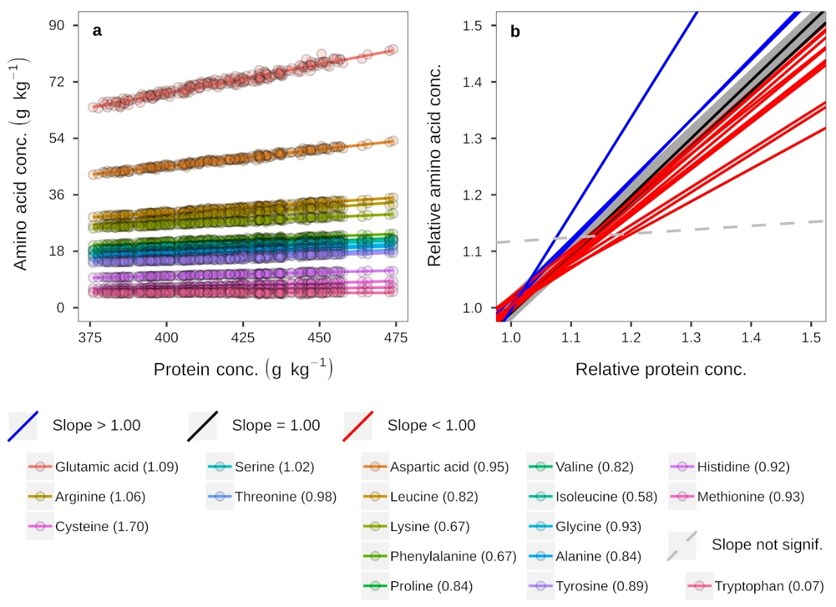
Supplementary Figure 1. Relationship between amino acids and protein concentrations (a), and relative amino acids and relative protein concentrations (b) in 11 environments evaluating different soybean inoculation strategies. Values between brackets indicate the slope of the relationship showed in panel B.

