Supplementary Information
Supplemental Information includes one figure and four tables and can be found with this article online.

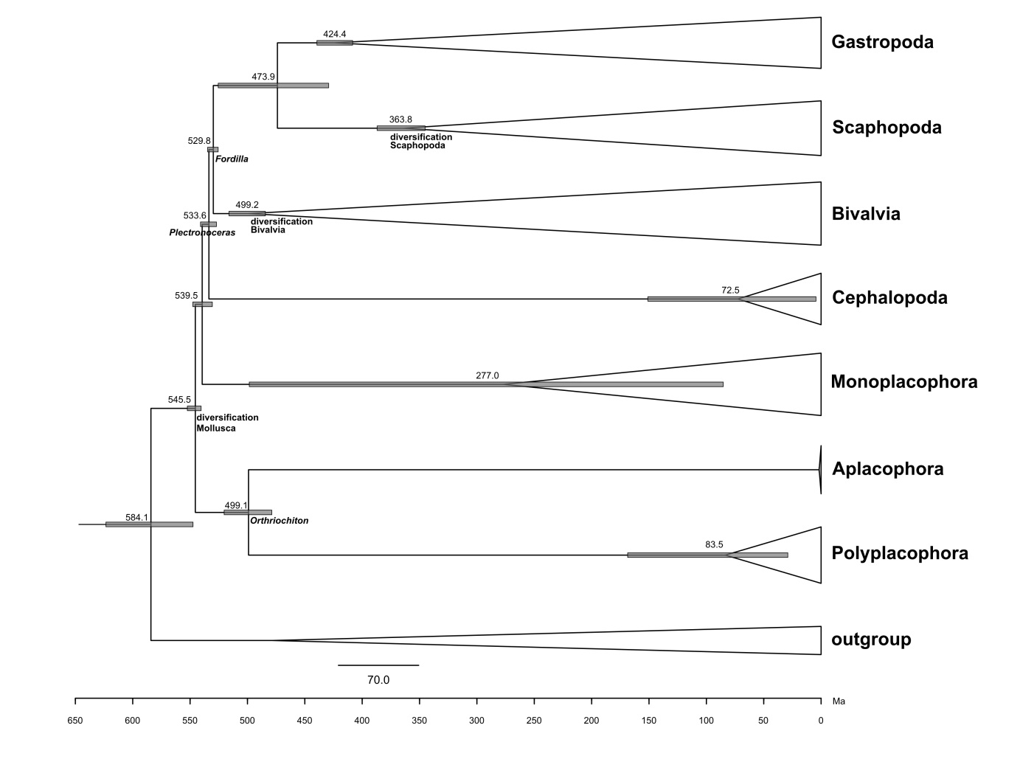
Supplementary Figure 1. Detailed presentation of results of relaxed molecular clock analysis (Figure 2). Numbers along x-axis are millions of years before present (Ma). Numbers at nodes represent the average age of the split; Error bars at nodes represent the 95% HPD (highest posterior density). The raw data and uncollapsed tree are available via FigShare (see Data Availability section).
Tables
Supplementary Table 1. Taxon sampling.
Taxon | Species | Abbrev. | Type | Reads | HaMStR genes | Source | Accession Number(s) / Version  / URL / Citation
Solenogastres | Alexandromenia crassa | ACRA | Illumina | 45,059,456 | 2,084 | NCBI SRA | SRR2052564
 | Macellomenia schanderi | MSCH | Illumina | 49,904,154 | 2,130 | NCBI SRA | SRR2057023
 | Neomenia carinata | NCAR | Illumina | 36,612,396 | 1,547 | NCBI SRA | SRR2057026
Caudofoveata | Prochaetoderma californicum | PCAL | Illumina | 90,561,352 | 2,116 | NCBI SRA | SRR6926326
 | Spathoderma clenchi | SCLE | Illumina | 52,062,402 | 1,172 | NCBI SRA | SRR8258011
Polyplacophora | Leptochiton rugatus | LRUG | Illumina | 49,670,054 | 2,096 | NCBI SRA | SRR1611558
 | Rhyssoplax olivaceus | ROLI | Illumina | 23,189,291 | 2,149 | NCBI SRA | SRR618506
Gastropoda | Aplysia californica | ACAL | Sanger | 216,556 | 931 | NCBI UniGene | January 27, 2010 Version
 | Crepidula fornicata | CFOR | Illumina | 39,362,017 | 1,883 | NCBI SRA | SRR1324873-SRR1324880
 | Haliotis rufescens | HRUF | Illumina | 355,678,562 | 2,177 | Dryad | http://datadryad.org/resource/  doi:10.5061/dryad.85p80
 | Lottia gigantea | LGIG | Genome | - | 2,259 | JGI | JGI filtered models v. 1.0
 | Lymnaea stagnalis | LSTA | Illumina | 81,851,004 | 936 | NCBI SRA | DRR002012
 | Patella vulgata | PVUL | Illumina | 47,237,104 | 1,931 | From authors | https://doi.org/10.1007/s10126-012-9481-0
Bivalvia | Crassostrea gigas | CGIG | Genome | - | 2,199 | V9 protein models | http://gigadb.org/Pacific_oyster/
 | Enucula tenius | ETEN | Illumina | 77,448,350 | 1,760 | Dryad – exemplars/isotigs only | dryad.34644
 | Mytilus edulis | MEDU | Illumina | 72,220,824 | 2,238 | NCBI SRA | SRX565221-SRX565224
 | Nuculana pernula | NPER | Illumina | 35,983,152 | 591 | NCBI SRA | SRR2057025
 | Pinctada fucata | PFUC | Genome | - | 2,073 | From authors | http://marinegenomics.oist.jp/  genomes/download?project_id=20
 | Ruditapes philippinarum | RPHI | Illumina | 41,031,443 | 1,911 | NCBI Nucleotide Database | JO101212-JO124029
 | Solemya velum | SVEL | Illumina | 66,597,054 | 2,068 | Dryad – exemplars/isotigs only | dryad.34644
 | Villosa lienosa | VLIE | Illumina | 162,000,000 | 2,118 | NCBI BioProject | PRJNA75063, ID #75063
Scaphopoda | Entalina tetragona | ETET | Illumina | 39,609,424 | 1,575 | NCBI SRA | SRR2057018
 | Gadila tolmiei | GTOL | Illumina | 75,942,132 | 1,815 | Dryad – exemplars/isotigs only | dryad.34644
 | Graptacme eborea | GEBO | Illumina | 61,523,742 | 2,156 | NCBI SRA | SRR2057020
Monoplacophora | Laevipilina antarctica | LANT | Genome | - | 2,233 | NCBI SRA | SRR6506080
 | Laevipilina hyalina | LHYA | 454, Sanger | 75,485 | 430 | Dryad – transcripts | dryad.34644
Cephalopoda | Dosidicus gigas | DGIG | Illumina | 37,094,323 | 1,663 | NCBI SRA | SRR1386212
 | Euprymna scolopes | ESCO | Sanger | 35,420 | 1,179 | NCBI Trace Archive | DW251302-DW286722
 | Nautilus pompilius | NPOM | 454 | 549,720 | 406 | NCBI SRA | SRR108979
 |  |  | 454 | 112,375 | 464 | Dryad – exemplars/isotigs only | dryad.34644
 | Octopus vulgaris | OVUL | Illumina | 16,501,336 | 1,742 | Dryad – exemplars/isotigs only | dryad.34644
 | Sepia esculenta | SESC | Illumina | 80,947,907 | 1,705 | NCBI SRA | SRR1386223
 | Sepioteuthis lessoniana | SLES | Illumina | 67,170,966 | 1,482 | NCBI SRA | SRR1386192
Annelida | Boccardia proboscidea | BPRO | Illumina | 63,634,426 | 1,722 | NCBI SRA | SRR2057014
 | Capitella teleta | CTEL | Genome | - | 2,215 | JGI | JGI v1.0
 | Clymenella torquata | CTOR | Illumina | 85,285,816 | 2,129 | NCBI SRA | SRR2057016
 | Glycera dibranchiata | GDIB | Illumina | 82,775,880 | 1,299 | NCBI SRA | SRR2057019
 | Helobdella robusta | HROB | Genome | - | 2,049 | JGI | JGI filtered models v. 3
 | Pectinaria gouldii | PGOU | Illumina | 145,853,782 | 1,506 | NCBI SRA | SRR2057036
 | Phascolosoma agassizii | PAGA | Illumina | 63,918,870 | 1,876 | Dryad – transcripts | dryad.30k4v
Brachiopoda | Hemithiris psittacea | HPSI | Illumina | 60,731,022 | 2,224 | NCBI SRA | SRR1611556
 | Glottidia pyramidata | GPYR | Illumina | 67,613,510 | 2,101 | NCBI SRA | SRR1611555
 | Laqueus californicus | LCAL | Illumina | 67,414,776 | 2,113 | NCBI SRA | SRR1611557
 | Novocrania anomala | NANO | Illumina | 52,243,928 | 1,531 | NCBI SRA | SRR1611564
Phoronida | Phoronis psammophila | PPSA | Illumina | 58,372,182 | 2,223 | NCBI SRA | SRR1611565
 | Phoronis vancouverensis | PVAN | Illumina | 69,531,036 | 2,211 | NCBI SRA | SRR1611566
Entoprocta | Barentsia gracilis | BGRA | Illumina | 67,947,336 | 1,283 | NCBI SRA | SRR1611554
 | Loxosoma pectinaricola | LPEC | Illumina | 75,025,552 | 1,675 | NCBI SRA | SRR1611559
Nemertea | Malacobdella grossa | MGRO | Illumina | 30,538,858 | 1,878 | NCBI SRA | SRR1611560
 | Paranemertes peregrina | PPER | Illumina | 59,441,992 | 1,986 | NCBI SRA | SRR1611562

Supplementary Table 2. Hypothesis test results.
Constraint | Log-likelihood | AU test  (p-value) | SH test  (p-value)
Unconstrained | -1,481,197.46
Monoplacophora sister to all other conchiferans | -1,481,202.46 | 0.001 | 0.190
Gastropoda + Bivalvia | -1,481,209.21 | 3.00E-78 | 3.00E-04
Diasoma | -1,481,227.52 | 0.198 | 0.814
Patellogastropoda sister to clade of all other gastropods | -1,481,298.44 | 0.210 | 0.744
Cyrtosoma (as Gastropoda + Cephalopoda) | -1,481,535.61 | 0.448 | 0.827
Serialia | -1,481,747.97 | 0.001 | 0.000
Testaria | -1,482,088.01 | 4.00E-56 | 0.000

Supplementary Table 3. BEAST2 molecular clock results. HPD = highest posterior density.
Node | Divergence time (Ma) | 95% HPD (Ma)
Mollusca | 545.449 | 540.386 - 552.405
Aculifera | 499.060 | 478.787 - 520.313
Aplacophora | 1.677 | 1.527 - 1.912
Solenogastres | 0.777 | 0.703 - 0.887
Caudofoveata (Prochaetodermatidae) | 0.127 | 0.070 - 0.183
Polyplacophora | 83.455 | 29.001 - 168.611
Conchifera | 539.449 | 530.604 - 547.625
Monoplacophora (Laevipilina) | 276.956 | 85.269 - 498.414
Ganglionata | 533.595 | 527.025 - 540.918
Cephalopoda | 72.505 | 4.478 - 150.959
Bivalvia + Gastropoda + Scaphopoda | 529.765 | 525.529 - 534.738
Bivalvia | 499.182 | 484.407 - 516.073
Gastropoda + Scaphopoda | 473.888 | 429.253 - 525.494
Scaphopoda | 363.764 | 345.457 - 386.955
Gastropoda | 424.426 | 408.354 - 439.456
Mollusc stem/Trochozoa | 584.137 | 547.438 - 623.354

Supplementary Table 4. Constraints used in molecular clock analysis.
Calibration node | Fossil calibration | Date range (Ma) | Reference | Prior settings in BEAST v.2.4.6 (distribution; gamma shape, gamma scale, zero offset)
Diversification of Mollusca | first shell record | ~ 545 | ⁶³ | Gamma; 2.5, 2.0, 540.0
Split of Bivalvia/Scaphopoda/Gastropoda | Fordilla | ~ 530 | ⁶³ | Gamma; 3.3, 2.2, 525.0
Split of Cephalopoda/Bivalvia/Scaphopoda/  Gastropoda | Plectronoceras | ~ 505 | ⁸⁶ | Gamma; 2.4, 7.0, 495.0
Split of Polyplacophora/  Aplacophora | Orthriochiton | ~ 490 | ⁸⁷ | Gamma; 5.0, 5.0, 470.0
Diversification of Bivalvia |  | ~ 490 | ⁴⁸ | Gamma; 5.0, 5.0, 470.0
Origin of Caenogastropoda | Sublitoidea | ~ 418 | ⁸⁸ | Gamma; 2.3, 9.0, 405.0
Diversification of Scaphopoda | Dentalium | ~ 353 | ⁸⁹ | Gamma; 2.2, 6.7, 345.0

