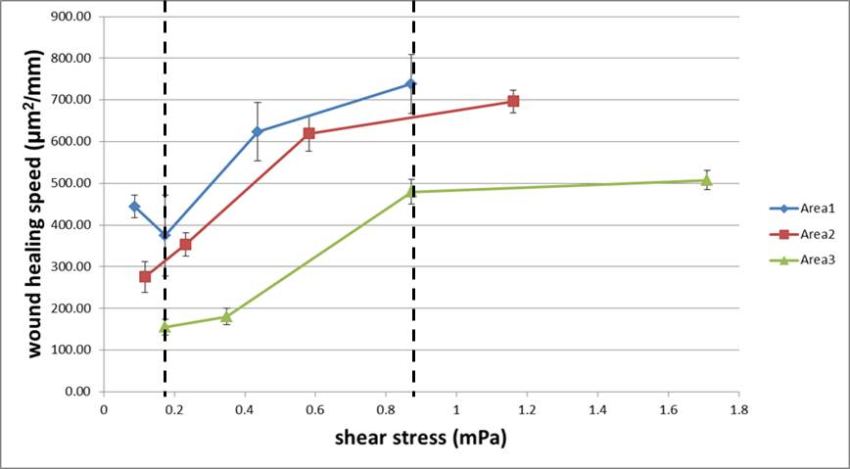
Figure S1. Wound-healing speeds under different wound widths and shear stresses.

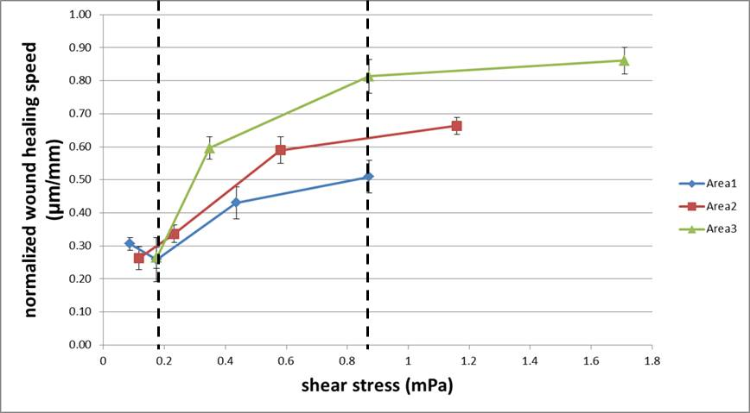
Figure S2. Normalized wound-healing speeds under different wound widths and shear stresses.

