25-vitamin D reduces inflammation in uremic environment

Authors: Rodrigo Barbosa de Oliveira Brito¹; Jacqueline Ferritto Rebello¹; Caren Cristina Grabulosa¹, Walter Pinto¹; Armando Morales Jr¹; Rosilene Motta Elias^{1,2}; Rosa Maria Affonso Moyses^{1,2}; Maria Aparecida Dalboni*¹

Institutions:
1. Universidade Nove de Julho, UNINOVE, Sao Paulo, Brazil; 2. Hospital das Clinicas HCFMUSP, Universidade de Sao Paulo, Sao Paulo, Brazil

Supplementary Table 1. ELISA kits

Protein | KIT
IL-6 | KIT human IL-6 High Sensitivity cat: HS600B R&D SYSTEMS
TNF-α | KIT human TNF-α High Sensitivity cat: HSTA00D R&D SYSTEMS
IL-10 | KIT human Il-10 cat: 550613 BD
LL37 (Cathelicidin) | KIT human LL37(Cathelicidin) cat: HK321-02 Hycult biotech
CCL2 (MCP-1) | KIT human CCL2 (MCP-1) affymetrix eBioscience ref:88-7399-22
NF-kB | Kit human NF-κB p50/p65 Transcription Factor Assay Kit eBioscience

Supplementary Table 2. Description of Monoclonal antibodies used by flow cytometry

Tube | Monoclonal antibodies | Quantity | Fluorophore | Clone | Manufacturer | Catalog
1 blank | - | - | - | - | - | -
2 | CD14 | 5µL | FITC | 61D3 | eBioscience | 11014942
2 | TLR-4 | 5µL | PE | HTA125 | eBioscience | 12991742
2 | VDR | 1µL (VDR)  3µL (antibody secondary) | APC | H1512  MOUSE | Santa Cruz/  Invitrogem | SC13133  Z25151
3 | CYP24 | 1µL (CYP24)  3µL (antibody secondary) | Alexa Fluor 488 | D0811  RABBIT | Santa Cruz/  Invitrogem | SC66851  Z5302
3 | CYP27 | 1µL (CYP27)  3µL (antibody secondary) | Alexa Fluor 647 | K2911  GOAT | Santa Cruz/  Invitrogem | SC49642  Z25608

Supplementary Figure 1. Demonstration of expression of CD14, TLR-4 and VDR in U937 cells by flow cytometry.
Suppl. Fig 1A: U937 cells were selected in the P1 gate according to the characteristics of size (Foward Scatter - FSC) and complexity (Side Scatter - SSC). Suppl. Fig 1B, 1C, and 1D: Autofluorescence adjustment of U937 cells in the detection channels for the respective antibodies labeled with respective fluorochromes FITC, PE and APC. Suppl. Fig1E (P3) = CD14 FITC expression; Suppl. Fig 1F (Q2-2) = Expression of TLR4 PE and CD14 FITC. Suppl. Fig 1G (Q2-6) = Expression of VDR APC and CD14 FITC
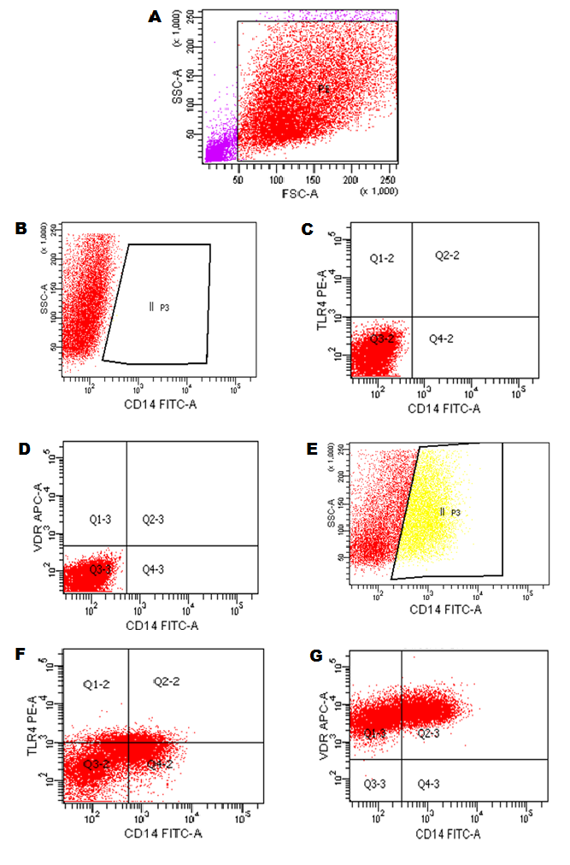
Supplementary Figure 2. Demonstration of high fluorescence adjustment of U937 cells for analysis of the CYP27 and CYP24.
Suppl. Fig. 2A: Gate P1 = U937 cells were selected from their Foward Scatter (FSC) and internal complexity (Side Scatter - SSC) characteristics. Histogram-type graphs (number of cells in relation to detected fluorescence intensity) were created from the gate. Suppl. Fig. 2B, 2C: Autofluorescence adjustment of the cells for the detection channels of monoclonal antibodies conjugated to the respective fluorochromes: Alexa fluor 647 (AF 647) and Alexa Fluor 488 (AF 488). Suppl. Fig. 2D, 2E: U937 positive for monoclonal antibodies: CYP27 and CYP24 as shown in the quadrants P3 and P2.

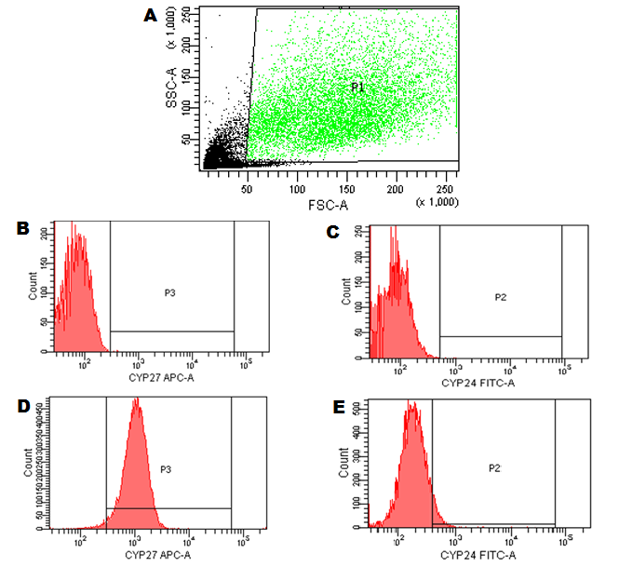

Supplementary Figure 3. Demonstration of the high fluorescence adjustment of U937 cells for the analysis of Reactive Oxygen Species (ROS).
Suppl. Fig. 3A: Gate P2 = U937 cells were selected from their Foward Scatter (FSC) and internal complexity (Side Scatter - SSC) characteristics. The histogram type graph (number of cells in relation to the detected fluorescence intensity) was created from the gate. Suppl. Fig. 3B: Autofluorescence adjustment of the cells for the DCFH-(FITC) detection channel. Suppl. Fig. 3C: C: U937 positive for DCFH (FITC) demonstrated in the P2 quadrant.

