Supplementary Information

Epigenetic reprogramming underlies efficacy of DNA demethylation therapy in osteosarcomas

Naofumi Asano^{1,2}, Hideyuki Takeshima³, Satoshi Yamashita³, Hironori Takamatsu^{2, 3}, Naoko Hattori³, Takashi Kubo⁴, Akihiko Yoshida⁵, Eisuke Kobayashi⁶, Robert Nakayama², Morio Matsumoto², Masaya Nakamura², Hitoshi Ichikawa⁴, Akira Kawai⁶, Tadashi Kondo¹, and Toshikazu Ushijima³

¹Division of Rare Cancer Research, National Cancer Center Research Institute, 5-1-1 Tsukiji, Chuo-ku, Tokyo 104-0045, Japan; ²Department of Orthopaedic Surgery, Keio University School of Medicine, 35 Shinanomachi, Shinjuku-ku, Tokyo 160-8582, Japan; ³Division of Epigenomics, National Cancer Center Research Institute, 5-1-1 Tsukiji, Chuo-ku, Tokyo 104-0045, Japan; ⁴Department of Clinical Genomics, National Cancer Center Research Institute, 5-1-1 Tsukiji, Chuo-ku, Tokyo 104-0045, Japan; ⁵Department of Pathology and Clinical Laboratory, National Cancer Center Hospital, 5-1-1 Tsukiji, Chuo-ku, Tokyo 104-0045, Japan; ⁶Department of Musculoskeletal Oncology, National Cancer Center Hospital, 5-1-1 Tsukiji, Chuo-ku, Tokyo 104-0045, Japan

Supplementary Information

Supplementary Figure 1. The in vivo effect of the DNA methylation treatment on 143B cells.
Supplementary Table 1. Clinical characteristics of 31 OS and 11 EWS patients
Supplementary Table 2. Genes analyzed for mutations (NCC Oncopanel v4)
Supplementary Table 3. Univariate analysis of factors influencing progression-free survival (PFS) in the 24 patients with primary localized OS
Supplementary Table 4. Re-expression of 31 genes by demethylation of MG63 cell
Supplementary Table 5. Re-expression of 13 genes by demethylation of U2OS cell
Supplementary Table 6. Primer sets used for quantitative Methylation-Specific PCR (qMSP)

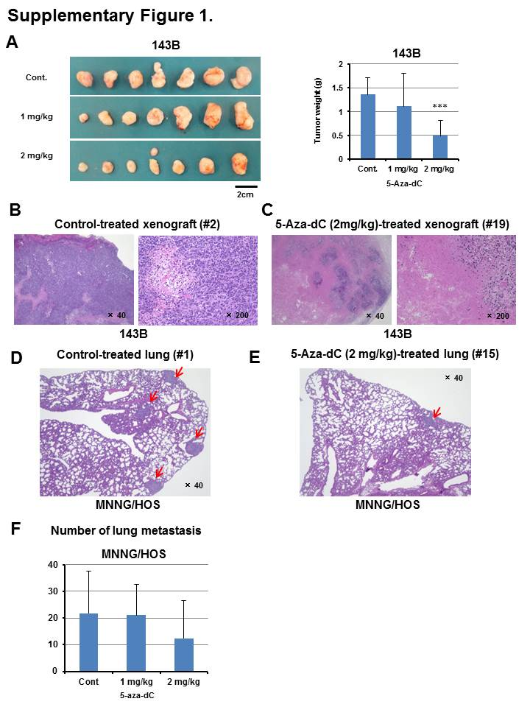

Supplementary Figure 1. The in vivo effect of the DNA methylation treatment on 143B cells. (A) The treatment of 143B cells with 5-aza-dC reduced the tumor volume and weight of 143B xenograft tumors. (B - F) Pathological analysis of the hematoxylin-stained specimens. In the 5-aza-dC-treated tumors, marked tumor cell necrosis of 143B tumor xenograft (C) and reduction of lung metastasis of MNNG/HOS xenograft (F, and G) was observed as compared with the non-administration tumor (B, and D).

Supplementary Table 1. Clinical characteristics of 31 OS and 11 EWS patient

 | Number of patients
Variable | Total (N=42) | OS (N=31) | EWS (N=11)
Age (years)
Median (range) | 15 (7-68) | 13 (7-68) | 19 (9-65)
Sex
Male | 24 | 16 | 8
Female | 18 | 15 | 3
Primary tumor site
Extremity | 33 | 27 | 5
Trunk | 9 | 4 | 6
Primary tumor origin
Bone | 37 | 31 | 6
Soft tissue | 5 | 0 | 5
Primary tumor size (cm)
Median (range) | 9.5 (4.0 - 20.5) | 10.0 (4.0 - 20.5) | 9.0 (4.3 - 20.0)
M0/M1
M0 | 38 | 28 | 10
M1 | 4 | 3 | 1
TNM Stage (UICC 7th ed.)
IA/IB | 0 | 0 | 0
IIA/IIB | 33 | 26 | 7
III | 5 | 2 | 3
IV | 4 | 3 | 1
Treatment
Surgery + chemo | 33 | 27 | 6
Surgery + chemo + RT | 2 | 0 | 2
RT or CIRT + chemo | 5 | 3 | 2
Palliative chemo therapy | 2 | 1 | 1
Local recurrence
no | 35 | 26 | 9
yes | 3 | 2 | 1
NE | 4 | 3 | 1
Distant metastasis
no | 22 | 17 | 5
yes | 16 | 11 | 5
NE | 4 | 3 | 1
Recurrence
no | 20 | 15 | 5
yes | 18 | 13 | 5
NE | 4 | 3 | 1
Follow up (months)
Median (range) | 63.3 (3.8 – 240.1) | 68.9 (3.8 - 240.1) | 37.6 (17.8 - 145.6)
Oncological outcome
No evidence of disease | 22 | 18 | 4
Alive with disease | 6 | 4 | 1
Dead of disease | 13 | 9 | 5
Dead of others | 1 | 0 | 1
chemo, chemotherapy; RT, radiation therapy; CIRT, carbon ion radiation therapy; NE, not evaluable

Supplementary Table 2. Genes analyzed for mutations (NCC Oncopanel v4)

For somatic mutations and copy number alterations |  |  |  |  |  | For fusions
ABL1 | CRKL | IDH2 | NF1 | RAC2 |  | ALK
ACTN4 | CREBBP | IGF1R | NFE2L2 | RAD51C |  | AKT2
AKT1 | CTNNB1 | IGF2 | NOTCH1 | RAF1 |  | BRAF
AKT2 | CUL3 | IL7R | NOTCH2 | RB1 |  | ERBB4
AKT3 | DDR2 | JAK1 | NOTCH3 | RET |  | FGFR2
ALK | EGFR | JAK2 | NRAS | RHOA |  | FGFR3
APC | ENO1 | JAK3 | NRG1 | ROS1 |  | NRG1
ARAF | EP300 | KDM6A | NTRK1 | SETBP1 |  | NTRK1
ARID1A | ERBB2 | KEAP1 | NTRK2 | SETD2 |  | NTRK2
ARID2 | ERBB3 | KIT | NTRK3 | SMAD4 |  | PDGFRA
ATM | ERBB4 | KRAS | NT5C2 | SMARCA4 |  | RET
AXIN1 | ESR1 | MAP2K1 | PALB2 | SMARCB1 |  | ROS1
AXL | EZH2 | MAP2K2 | PBRM1 | SMO
BAP1 | FBXW7 | MAP2K4 | PDGFRA | STAT3
BARD1 | FGFR1 | MAP3K1 | PDGFRB | STK11
BCL2L11 | FGFR2 | MAP3K4 | PIK3CA | TP53
BRAF | FGFR3 | MDM2 | PIK3R1 | TSC1
BRCA1 | FGFR4 | MDM4 | PIK3R2 | VHL
BRCA2 | FLT3 | MET | POLD1
CCND1 | GNA11 | MLH1 | POLE
CD274 | GNAQ | MTOR | PRKCI
CDK4 | GNAS | MSH2 | PTCH1
CDKN2A | HRAS | MYC | PTEN
CHEK2 | IDH1 | MYCN | RAC1

Variable | Number of cases | Univariate
Variable | Number of cases | 5y-PFS rate (%) | P value
Methylation cluster
cluster III-a | 14 | 75.0 | 0.361
cluster IV-a | 10 | 50.0
TP53 gene alteration
Yes | 9 | 88.9 | 0.064
No | 15 | 53.3
Age
< 18 years | 19 | 78.9 | 0.008
≥ 18 years | 5 | 20.0
Sex
Male | 13 | 61.5 | 0.437
Female | 11 | 72.7
Tumor site
Extremity | 21 | 71.4 | 0.007
Trunk | 3 | 33.3
Tumor size
≤ 8cm | 3 | 66.7 | 0.707
> 8cm | 21 | 66.7
Histological response to chemotherapy
Good (< 10% viable cells) | 11 | 90.9 | 0.045
Poor (≥ 10% viable cells) | 10 | 50.0
Supplementary Table 3. Univariate analysis of factors influencing progression-free survival (PFS) in the 24 patients with primary localized OS*
*We excluded from survival analysis one patient whose follow up term was only 3.8 months. OS, osteosarcoma; HR, hazard ratios; 95% CI, 95% confidence interval; NS, not significant

Supplementary Table 4. Re-expression of 31 genes by demethylation of MG63 cells

Gene symbol | Gene Name | Gene function
HSPA2 | heat shock 70kDa protein | expression in cancer cells
NETO2 | neuropilin (NRP) and tolloid (TLL)-like 2 | endocytosis
GREM1^{a, b} | gremlin 1, DNA family BMP antagonist | methylation in cancers (tumor suppressor), bone formation
QPCTª | glutaminyl-peptide cyclotransferase | methylation in melanoma (tumor suppressor)
IGFBP2^{b} | insulin-like growth factor | cancer cell proliferation, bone formation, osteoblast function
PRSS23 | protease, serine, 23 | NA
LOC93622 | Morf4 family associated protein 1-like 1 | NA
IRS2 | insulin receptor substrate 2 | tumorigenesis, metastasis
FNDC1 | fibronectin type III domain containing 1 | tumor growth, metastasis
ULBP1ª | UL16 binding protein 1 | activate human natural killer (NK) cells
PPL | periplakin | tumor progression
TESª | testis derived transcript (3 LIM domains) | methylation in ovarian carcinoma (tumor suppressor)
PTGER4^{b} | prostaglandin E receptor 4 (subtype EP4) | bone formation
FOXQ1^{b} | forkhead box Q1 | overexpression in colorectal and lung adenocarcinoma, embryogenesis
DSP | desmoplakin | cancer cell proliferation, cell adhesion
TLE4 | transducin-like enhancer of split 4 | B cell differentiation,
SH2D4A | SH2 domain containing 4A | NA
GCHFR | GTP cyclohydrolase I feedback regulator | expression in prostate cancer, oxidant-induced cell death
EFNB2 | ephrin-B2 | expression in cancers
DLX5^{b} | distal-less homeobox 5 | bone morphogenesis, chondrogenesis, embryonic development, tooth morphogenesis
STC2^{b} | stanniocalcin 2 | bone development
PLTP | phospholipid transfer protein | DM, HL
FBXO6 | F-box protein 6 | differentiation hepatocytes
MBP | myelin basic protein | demyelination, T cell-mediated autoimmunity, regulation of CXCL12 expression in astrocytes by soluble MBP
KLF4ª | Kruppel-like factor 4 (gut) | suppressing the tumorigenicity of colon cancer cells, p53-dependent cell cycle arrest
CLDN11 | claudin 11 | oligodendrocyte morphogenesis, cell differentiation
FMN2 | formin 2 | expression in cancers
CYBA | cytochrome b-245, alpha polypeptide | chronic granulomatous disease, NADPH oxidase
EPSTI1 | epithelial stromal interaction 1 | epithelial-stromal interaction in breast cancer
CXCL12ª | chemokine (C-X-C motif) ligand 12 | hematopoiesis, T cell activation
GMPR | guanosine monophosphate | neoplastic or normal cell proliferation
a, osteo/chondrogenesis related genes; b, tumor-suppressor genes

Supplementary Table 5. Re-expression of 13 genes by demethylation of U2OS cells
Gene symbol | Gene Name | Gene function
QPCTª | glutaminyl-peptide cyclotransferase | methylation in melanoma (tumor suppressor)
TNFRSF10Dª | tumor necrosis factor receptor superfamily 10D | OS cells Apo2L/TRAIL-induced apoptosis, promoter hypermethylation in neuroblastoma
FNDC1 | fibronectin type III domain containing 1 | tumor growth, metastasis
SPINT2ª | serine peptidase inhibitor, Kunitz type 2 | tumor suppressor gene, promoter region methylation
PPL | periplakin | tumor progression
CST6ª | cystatin E/M | tumor suppressor gene, epigenetic inactivation
CTHRC1 | collagen triple helix repeat containing 1 | cancer cell migration
MBP | myelin basic protein | demyelination, T cell-mediated autoimmunity, regulation of CXCL12 expression in astrocytes by soluble MBP
CPT1C | carnitine palmitoyltransferase 1C | NA
GPR68^{a, b} | G protein-coupled receptor 68 | termed ovarian cancer G protein-coupled receptor 1 (OGR1), RANKL-induced osteoclast differentiation, IFN-alpha-activated NK cells
ALPL^{a, b} | alkaline phosphatase, liver/bone/kidney | tumor suppressor gene, bone mineralization
COMP^{b} | cartilage oligomeric matrix protein | differentiated chondrocyte
COL15A1 | collagen, type XV, alpha 1 | dermal fibroblast
a, osteo/chondrogenesis related genes; b, tumor-suppressor genes

Supplementary Table 6. Primer sets used for qMSP

TSPYL5 forward
GATTTTGAGAGTACGATGAGTTC
TSPYL5 reverse
CGAACTCGCTTTAAATCTCGACG
TNFRSF10D forward
GTCGGAAAGAGTTAGTTTTTGTTC
TNFRSF10D reverse
AATAAAACGTACTCCTCCG
Alu N forward
GGTTAGGTATAGTGGTTTATATTTGTAATTTTAGTA
Alu N reverse
ATTAACTAAACTAATCTTAAACTCCTAACCTCA

