Supplementary information for Husso et al. 2019:
The composition of the perinatal intestinal microbiota in horse
Husso A¹, Jalanka J², Alipour MJ¹, Huhti P³, Kareskoski M⁴, Pessa-Morikawa T¹, Iivanainen A¹*, Niku M¹*
¹ Veterinary Biosciences, Faculty of Veterinary Medicine, University of Helsinki, Finland
² Human Microbiome Research Program, Faculty of Medicine, University of Helsinki, Helsinki, Finland
³ Saharan ravitalli (Sahara stud), Haapamäki, Finland
⁴ Production Animal Medicine, Faculty of Veterinary Medicine, University of Helsinki, Finland

Antti Iivanainen and Mikael Niku jointly supervised this work.
* Correspondence to: MN (mikael.niku@helsinki.fi) and AI (antti.iivanainen@helsinki.fi)
Contents
Supplementary results and discussion 2
Quantification of 16S rRNA gene copy numbers in mares 2
Observed composition of the commercial microbiota community standard 3
Effect of data decontamination on phylum-level microbiota compositions and read counts 4
Core bacterial taxa in foals 5
Core bacterial taxa in mares 9
Comparison of foal and mare microbiotas 14
Supplementary methods 15
Quantitative PCR 15
MiSeq amplicon sequencing of 16S rRNA genes 16
Detailed description of the bioinformatics pipeline 18
Obtaining the data 18
Quality check 18
Trimming 18
Mapping file 18
QIIME2 18
Data decontamination 19
Supplementary references 19

Supplementary results and discussion

Quantification of 16S rRNA gene copy numbers in mares
Bacterial loads in mare fecal, oral and vaginal samples were analysed by 16S rRNA gene qPCR (Supplementary Figure 1). The average copy number in mare feces was 1.3 × 10¹⁰ per a 125 mg sample (SD = 7.6 × 10⁹), in mare mouth 5.9 × 10⁸ per swab (SD = 4.7 × 10⁸) and in mare vaginal vestibulum 1.9 × 10⁷ per swab (SD = 1.8 × 10⁷).
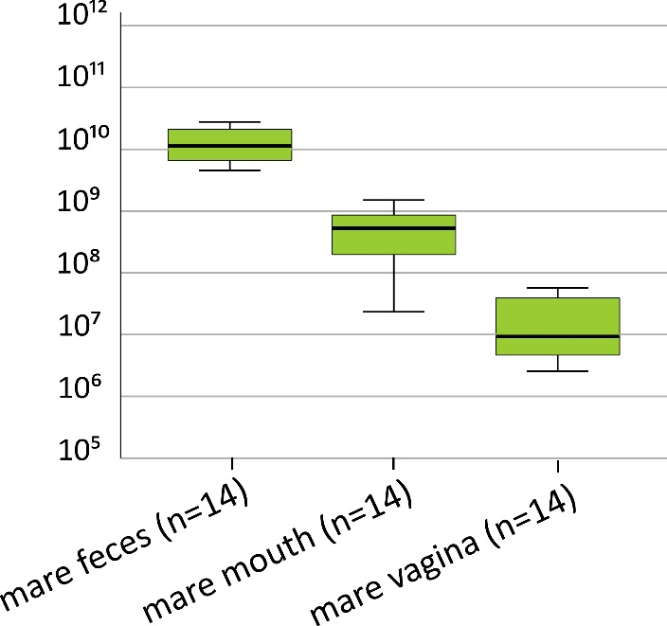
SUPPLEMENTARY FIGURE 1. 16S rRNA gene copy numbers in mares, per sample. Boxes represent the interquartile ranges (IQR) containing 50% of samples. The horizontal line in a box indicates the median. Whiskers show maxima and minima within 1.5 × IQR. Copy numbers were calculated per a whole original sample (125 mg mare feces or one oral or vaginal swab).

Observed composition of the commercial microbiota community standard
The ZymoBIOMICS Microbial Community Standard (Zymo Research, Irvine, CA, USA) was used to assay the reliability of the entire analytical pipeline from DNA extraction in representing the actual microbiota community composition. A comparison of the observed and expected compositions and taxonomic classifications are shown in Supplementary Figure 2. The expected 16S rRNA gene composition is based on the data provided by the manufacturer.
The observed composition closely matched the expected composition. The relative abundances of Pseudomonas aeruginosa, E. coli and Bacillus subtilis were slightly overestimated, while those of Listeria monocytogenes and Lactobacillus fermentum were slightly underestimated. Listeria monocytogenes, Lactobacillus fermentum and Staphylococcus aureus were correctly classified to the species level. A minority of S. aureus sequences and all the other bacteria were correctly classified to the genus level.
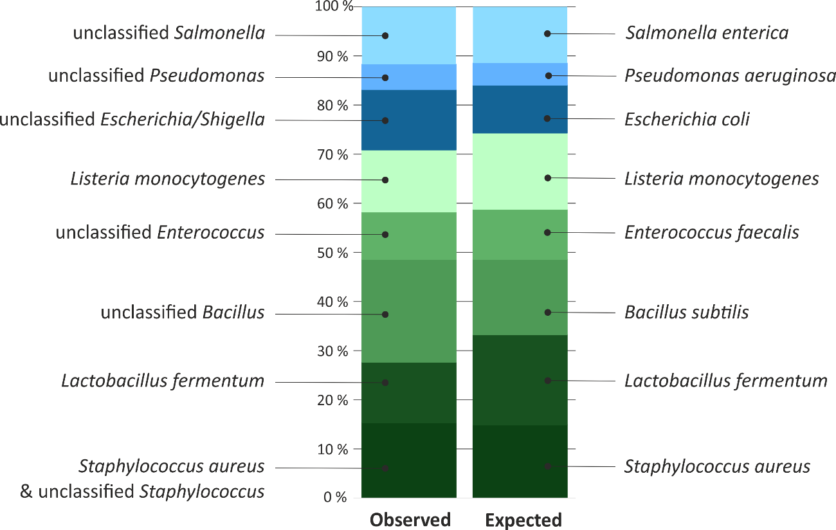

SUPPLEMENTARY FIGURE 2. Observed (left) and expected (right) relative abundances of the bacteria included in the commercial community standard. Blue = Proteobacteria, green = Firmicutes.

Effect of data decontamination on phylum-level microbiota compositions and read counts
Average phylum-level compositions and read counts in unfiltered raw data and in decontaminated data are shown in Supplementary Fig. 3. Almost all ASVs detected in negative controls were removed. In samples collected immediately after birth, majority of data was also removed as potential contaminants, but in 11 out of 18 animals, a 16 rRNA gene profile could be observed and characterised. In samples from older animals, the filtering had minor effects on average microbiota compositions and read counts.
The filtering effectively removed obvious reagent contaminants such as Ralstonia (see Results). To estimate the rate of false negatives, we calculated the proportion of reads deleted from several typical intestinal taxa. These included ASVs classified as Akkermansia, Bacteroides, Christensenellaceae, Clostridium sensu stricto 1, Enterococcus, Faecalibacterium, Fibrobacter, Lachnospiraceae, Lactobacillus, Prevotella, Ruminiclostridium and Ruminococcaceae, as well as ASVs labelled as “gut group” or “gut metagenome”. As described in Results, only 0.18% of these were purged.

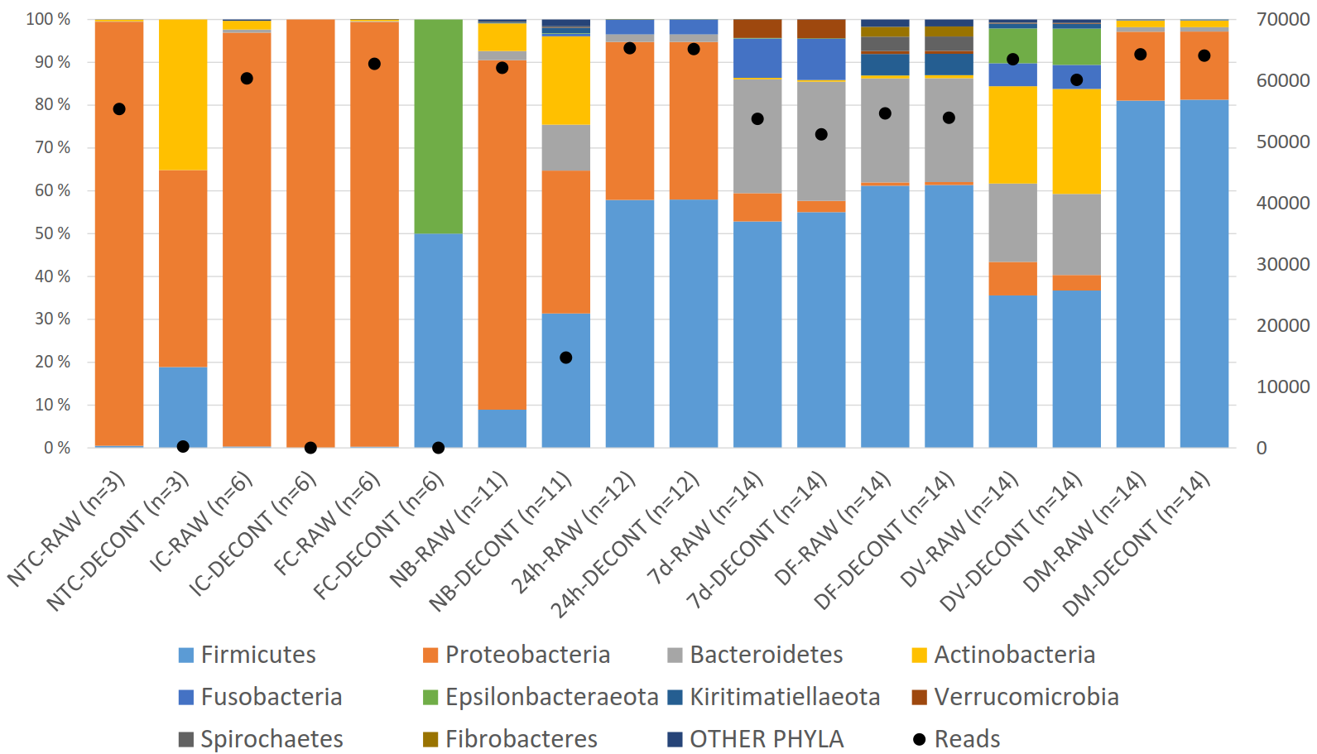
SUPPLEMENTARY FIGURE 3. Effect of data decontamination on average phylum-level compositions and read counts. NTC = PCR no-template control; IC = instrument control; FC = field control; NB = newborns (0 h); 24h = 24h old foals; 7d = 7d old foals; DF = dam feces; DV = dam vagina; DM = dam mouth; RAW = unfiltered raw data; DECONT = decontaminated data. 0 h foal samples with less than 1500 accepted ASVs and two low-quality 24h samples were excluded from the analysis.

Core bacterial taxa in foals
Most prevalent genus-level bacterial taxa (present in >50% of animals) in foals sampled immediately after birth (0 h) and later (24 h and 7 d) are shown in Supplementary Tables 1 – 3.
SUPPLEMENTARY TABLE 1: Genus-level bacterial taxa observed in 0 h foal rectum in >50% of animals.
Prevalences, mean relative abundances and standard deviations in 0 h foals (n=11), and sharing of taxa with the other samples (FE = mare feces, VA = mare vagina, MO = mare mouth).

Taxon | Prevalence | Mean | SD | 24h |  | 7d | FE | VA | MO
Actinobacteria | 91 % | 20.65 % | 14.61 %
Corynebacterium 1 | 82 % | 3.43 % | 3.58 % | - |  | - | - | + | -
Brachybacterium | 64 % | 2.77 % | 4.30 % | - |  | - | - | - | -
unclassified Microbacteriaceae | 64 % | 2.04 % | 4.02 % | - |  | - | - | - | -
Nocardioides | 64 % | 0.47 % | 0.68 % | - |  | - | - | - | -
Kocuria | 55 % | 0.90 % | 1.92 % | - |  | - | - | - | -
Glutamicibacter | 55 % | 0.43 % | 0.91 % | - |  | - | - | - | -
Streptomyces | 55 % | 0.40 % | 0.75 % | - |  | - | - | - | -
Bacteroidetes | 100 % | 10.70 % | 12.43 %
Chryseobacterium | 73 % | 0.77 % | 1.08 % | - |  | - | - | - | -
Pedobacter | 64 % | 1.56 % | 2.50 % | - |  | - | - | - | -
Rikenellaceae RC9 gut group | 64 % | 0.75 % | 1.23 % | - |  | - | + | + | -
Sphingobacterium | 55 % | 0.58 % | 1.13 % | - |  | - | - | - | -
Hymenobacter | 55 % | 0.31 % | 0.72 % | - |  | - | - | - | -
Bacteroides | 55 % | 0.21 % | 0.37 % | + |  | + | - | + | -
Firmicutes | 100 % | 31.38 % | 20.90 %
Staphylococcus | 91 % | 8.77 % | 12.61 % | - |  | - | - | + | -
Bacillus | 82 % | 2.20 % | 2.78 % | - |  | - | - | + | -
Streptococcus | 82 % | 1.51 % | 1.28 % | + |  | + | + | + | +
unclassified Lachnospiraceae | 73 % | 0.71 % | 0.91 % | + |  | + | + | + | -
Lactobacillus | 64 % | 3.23 % | 9.87 % | - |  | + | + | + | -
Clostridium sensu stricto 1 | 64 % | 0.50 % | 0.74 % | + |  | + | + | + | -
[Eubacterium] coprostanoligenes group | 55 % | 0.92 % | 2.15 % | - |  | + | + | - | -
Ruminococcaceae UCG-010 | 55 % | 0.79 % | 1.60 % | - |  | - | + | + | -
Anaerovorax | 55 % | 0.40 % | 0.76 % | - |  | - | + | - | -
Ruminococcaceae UCG-005 | 55 % | 0.37 % | 0.67 % | - |  | - | + | - | -
Paenibacillus | 55 % | 0.20 % | 0.28 % | - |  | - | - | - | -
Phascolarctobacterium | 55 % | 0.15 % | 0.28 % | - |  | + | + | - | -
Kiritimatiellaeota | 55 % | 1.17 % | 2.18 %
uncultured WCHB1-41 | 55 % | 0.84 % | 1.49 % | - |  | - | + | - | -
Proteobacteria | 100 % | 33.35 % | 30.48 %
Ralstonia | 100 % | 1.42 % | 1.43 % | - |  | - | - | - | -
Sphingomonas | 91 % | 1.74 % | 1.78 % | - |  | - | - | + | -
Pseudomonas | 82 % | 1.13 % | 1.79 % | - |  | - | - | - | -
Methylobacterium | 64 % | 5.25 % | 10.66 % | - |  | - | - | - | -
Acinetobacter | 64 % | 1.65 % | 2.16 % | - |  | - | - | - | -
Paracoccus | 64 % | 0.68 % | 0.78 % | - |  | - | - | - | -
Allorhizobium-Neorhizobium-Pararhizobium-Rhizobium | 55 % | 2.00 % | 3.36 % | - |  | - | - | - | -
Bradyrhizobium | 55 % | 1.62 % | 2.21 % | - |  | - | - | - | -

SUPPLEMENTARY TABLE 2: Genus-level bacterial taxa observed in 24 h old foal rectum in >50% of animals.
Prevalences, mean relative abundances and standard deviations in 24 h old foals (n=12), and sharing of taxa with the other samples (0 h = newborn, FE = mare feces, VA = mare vagina, MO = mare mouth).

Taxon | Prevalence | Mean | SD | 0h | 7d | FE | VA | MO
Bacteroidetes | 75 % | 1.73 % | 3.86 %
Bacteroides | 75 % | 1.67 % | 3.73 % | - | - | - | - | -
Firmicutes | 100 % | 57.96 % | 26.20 %
Streptococcus | 92 % | 9.42 % | 28.57 % | + | + | - | + | -
Epulopiscium | 92 % | 4.24 % | 4.69 %
Clostridium sensu stricto 1 | 83 % | 24.04 % | 18.68 %
Terrisporobacter | 83 % | 5.66 % | 4.52 % | + | + | + | + | +
Romboutsia | 83 % | 3.73 % | 5.03 % | - | - | - | - | -
Enterococcus | 83 % | 0.66 % | 0.72 % | + | + | + | + | -
Tyzzerella 4 | 75 % | 1.57 % | 4.30 % | - | + | - | - | -
Faecalitalea | 75 % | 0.90 % | 1.42 % | - | - | - | - | -
[Ruminococcus] gnavus group | 75 % | 0.50 % | 0.52 % | - | - | - | - | +
Erysipelatoclostridium | 75 % | 0.15 % | 0.17 % | - | + | - | - | -
unclassified Lachnospiraceae | 67 % | 1.94 % | 2.97 % | - | + | - | - | -
Turicibacter | 67 % | 1.40 % | 2.48 % | - | + | - | - | -
Butyricicoccus | 67 % | 0.67 % | 0.93 % | - | + | + | - | -
Fournierella | 58 % | 0.94 % | 1.56 % | + | + | + | + | -
unclassified Ruminococcaceae | 58 % | 0.12 % | 0.17 % | - | - | - | - | -
Ruminiclostridium 9 | 58 % | 0.08 % | 0.10 % | - | + | - | - | -
[Clostridium] innocuum group | 58 % | 0.04 % | 0.05 % | - | + | - | - | -
Ruminiclostridium 5 | 58 % | 0.03 % | 0.04 % | - | + | + | + | -
 |  |  |  | - | + | + | - | -
Fusobacteria | 67 % | 3.50 % | 5.67 % | - | + | - | - | -
Fusobacterium | 67 % | 3.50 % | 5.66 % | - | + | + | - | -
Proteobacteria | 100 % | 36.78 % | 27.90 %
Escherichia-Shigella | 92 % | 35.19 % | 28.86 % | - | + | - | + | +
Klebsiella | 58 % | 1.54 % | 3.24 %

SUPPLEMENTARY TABLE 3: Genus-level bacterial taxa observed in 7 d old foal rectum in >50% of animals.
Prevalences, mean relative abundances and standard deviations in 7 d old foals (n=14), and sharing of taxa with the other samples (0 h = newborn, FE = mare feces, VA = mare vagina, MO = mare mouth).

Taxon | Prevalence | Mean | SD | 0h | 24h | FE | VA | MO
Actinobacteria | 100 % | 0.37 % | 0.31 %
Eggerthella | 79 % | 0.11 % | 0.13 % | - | - | - | - | -
Bacteroidetes | 100 % | 27.86 % | 9.46 %
Bacteroides | 100 % | 17.96 % | 9.52 % | + | + | - | + | -
Parabacteroides | 100 % | 4.43 % | 5.06 % | - | - | - | - | -
Alistipes | 100 % | 2.51 % | 3.30 % | - | - | - | - | -
Butyricimonas | 64 % | 0.70 % | 1.45 % | - | - | - | - | -
Odoribacter | 57 % | 1.08 % | 1.56 % | - | - | - | - | -
Firmicutes | 100 % | 55.03 % | 12.88 %
Tyzzerella 4 | 100 % | 6.16 % | 5.02 % | - | + | - | - | -
Streptococcus | 100 % | 5.96 % | 3.76 % | + | + | + | + | +
Lactobacillus | 100 % | 5.46 % | 5.21 % | + | - | + | + | -
Faecalitalea | 100 % | 3.90 % | 3.36 % | - | + | - | - | -
[Ruminococcus] torques group | 100 % | 2.55 % | 1.69 % | - | - | - | - | -
Blautia | 100 % | 2.30 % | 5.71 % | - | - | + | - | -
Flavonifractor | 100 % | 1.66 % | 1.58 % | - | - | - | - | -
[Eubacterium] coprostanoligenes group | 100 % | 1.41 % | 0.83 % | + | - | + | - | -
Ruminiclostridium 9 | 100 % | 1.34 % | 0.99 % | - | + | + | - | -
Lachnoclostridium | 100 % | 1.25 % | 1.12 % | - | - | - | - | -
Erysipelatoclostridium | 100 % | 1.15 % | 0.75 % | - | + | + | - | -
unclassified Ruminococcaceae | 100 % | 1.07 % | 1.06 % | - | + | + | + | -
Butyricicoccus | 100 % | 1.04 % | 0.75 % | - | + | - | - | -
Oscillibacter | 100 % | 0.67 % | 0.88 % | - | - | + | - | -
Ruminococcaceae UCG-004 | 100 % | 0.56 % | 0.27 % | - | - | + | + | -
uncultured Ruminococcaceae | 100 % | 0.25 % | 0.58 % | - | - | + | - | -
UBA1819 | 100 % | 0.23 % | 0.16 % | - | - | - | - | -
Ruminiclostridium 5 | 100 % | 0.20 % | 0.20 % | - | + | + | - | -
Fournierella | 93 % | 4.57 % | 4.05 % | - | + | - | - | -
unclassified Lachnospiraceae | 93 % | 3.71 % | 3.19 % | + | + | + | + | -
Sellimonas | 93 % | 1.34 % | 1.45 % | - | - | - | - | -
Tyzzerella | 93 % | 0.96 % | 0.69 % | - | - | - | - | -
Negativibacillus | 93 % | 0.54 % | 0.75 % | - | - | - | - | -
Eubacterium | 93 % | 0.18 % | 0.20 % | - | - | + | - | -
Candidatus Soleaferrea | 93 % | 0.05 % | 0.04 % | - | - | + | - | -
Phascolarctobacterium | 86 % | 0.50 % | 0.36 % | + | - | + | - | -
Clostridium sensu stricto 1 | 86 % | 0.27 % | 0.43 % | + | + | + | + | -
Anaerotruncus | 86 % | 0.21 % | 0.32 % | - | - | - | - | -
Family XIII AD3011 group | 86 % | 0.07 % | 0.06 % | - | - | + | - | -
[Ruminococcus] gnavus group | 79 % | 0.44 % | 0.57 % | - | + | - | - | -
[Clostridium] innocuum group | 79 % | 0.28 % | 0.87 % | - | + | - | - | -
[Eubacterium] nodatum group | 79 % | 0.21 % | 0.22 % | - | - | + | - | -
Pseudoflavonifractor | 71 % | 0.27 % | 0.34 % | - | - | - | - | -
Eisenbergiella | 71 % | 0.20 % | 0.33 % | - | - | - | - | -
Intestinimonas | 71 % | 0.06 % | 0.07 % | - | - | - | - | -
Dielma | 71 % | 0.04 % | 0.05 % | - | - | - | - | -
[Eubacterium] fissicatena group | 71 % | 0.03 % | 0.03 % | - | - | - | - | -
Ruminococcaceae UCG-014 | 64 % | 0.61 % | 0.88 % | - | - | + | + | -
Veillonella | 57 % | 0.26 % | 0.46 % | - | - | - | - | -
Terrisporobacter | 57 % | 0.21 % | 0.32 % | - | + | - | - | -
Holdemania | 57 % | 0.03 % | 0.04 % | - | - | - | - | -
Fusobacteria | 100 % | 9.60 % | 8.77 %
Fusobacterium | 100 % | 9.60 % | 8.77 % | - | + | - | + | +
Proteobacteria | 100 % | 2.62 % | 2.15 %
Sutterella | 93 % | 0.63 % | 0.84 % | - | - | + | - | -
Bilophila | 79 % | 0.29 % | 0.27 % | - | - | - | - | -
Escherichia-Shigella | 71 % | 0.81 % | 1.21 % | - | + | - | - | -
Desulfovibrio | 57 % | 0.41 % | 0.44 % | - | - | + | - | -
Verrucomicrobia | 71 % | 4.36 % | 9.45 %
Akkermansia | 71 % | 4.36 % | 9.45 % | - | - | + | - | -

Core bacterial taxa in mares
Most prevalent bacterial taxa in mare feces, vaginal vestibulum and mouth (present in >50% of animals) are shown in Supplementary Tables 4 – 6.
SUPPLEMENTARY TABLE 4: Genus-level bacterial taxa observed in mare feces in >50% of animals.
Prevalences, mean relative abundances and standard deviations in mare feces (n=14), and sharing of taxa with the other samples (0 h = newborn, VA = mare vagina, MO = mare mouth).

Taxon | Prevalence |  | Mean | SD | 0h | 24h | 7d | VA | MO
Actinobacteria | 100 % |  | 0.69 % | 0.27 %
uncultured Eggerthellaceae | 100 % |  | 0.37 % | 0.16 % | - | - | - | - | -
uncultured Coriobacteriales Incertae Sedis | 100 % |  | 0.05 % | 0.04 % | - | - | - | - | -
unclassified Eggerthellaceae | 93 % |  | 0.05 % | 0.04 % | - | - | - | - | -
uncultured Coriobacteriales | 86 % |  | 0.07 % | 0.05 % | - | - | - | + | -
Phoenicibacter | 71 % |  | 0.11 % | 0.10 % | - | - | - | - | -
Armatimonadetes | 86 % |  | 0.05 % | 0.03 %
uncultured Armatimonadetes | 86 % |  | 0.04 % | 0.03 % | - | - | - | - | -
Bacteroidetes | 100 % |  | 24.26 % | 3.85 %
Rikenellaceae RC9 gut group | 100 % |  | 7.12 % | 3.25 % | + | - | - | + | -
uncultured Bacteroidales p-251-o5 | 100 % |  | 3.61 % | 2.38 % | - | - | - | - | -
uncultured Bacteroidales F082 | 100 % |  | 3.51 % | 2.10 % | - | - | - | - | -
uncultured Bacteroidales RF16 group | 100 % |  | 1.85 % | 0.64 % | - | - | - | + | -
uncultured Bacteroidales UCG-001 | 100 % |  | 1.18 % | 0.90 % | - | - | - | - | -
Prevotellaceae UCG-001 | 100 % |  | 0.97 % | 0.49 % | - | - | - | - | -
Prevotella 1 | 100 % |  | 0.95 % | 0.50 % | - | - | - | - | -
Prevotellaceae UCG-003 | 100 % |  | 0.75 % | 0.38 % | - | - | - | - | -
Prevotellaceae UCG-004 | 100 % |  | 0.44 % | 0.23 % | - | - | - | - | -
hoa5-07d05 gut group | 100 % |  | 0.41 % | 0.32 % | - | - | - | - | -
unclassified Bacteroidales | 100 % |  | 0.37 % | 0.49 % | - | - | - | - | -
uncultured Muribaculaceae | 100 % |  | 0.12 % | 0.06 % | - | - | - | - | -
uncultured Paludibacteraceae | 93 % |  | 0.74 % | 0.95 % | - | - | - | - | -
uncultured Prevotellaceae | 93 % |  | 0.53 % | 1.37 % | - | - | - | - | -
uncultured Bacteroidales BS11 gut group | 93 % |  | 0.34 % | 0.24 % | - | - | - | - | -
uncultured Marinifilaceae | 93 % |  | 0.29 % | 0.20 % | - | - | - | - | -
unclassified Prevotellaceae | 93 % |  | 0.21 % | 0.16 % | - | - | - | - | -
Alloprevotella | 93 % |  | 0.17 % | 0.11 % | - | - | - | + | -
uncultured Bacteroidales | 93 % |  | 0.13 % | 0.23 % | - | - | - | - | -
dgA-11 gut group | 86 % |  | 0.08 % | 0.06 % | - | - | - | - | -
unclassified Rikenellaceae | 86 % |  | 0.05 % | 0.07 % | - | - | - | - | -
Prevotellaceae Ga6A1 group | 64 % |  | 0.04 % | 0.05 % | - | - | - | - | -
Bacteroidetes bacterium GWF2_40_13 | 57 % |  | 0.06 % | 0.07 % | - | - | - | - | -
uncultured M2PB4-65 termite group | 57 % |  | 0.03 % | 0.05 % | - | - | - | - | -
Cyanobacteria | 93 % |  | 0.30 % | 0.17 %
uncultured Gastranaerophilales | 93 % |  | 0.17 % | 0.10 % | - | - | - | - | -
unclassified Gastranaerophilales | 93 % |  | 0.06 % | 0.06 % | - | - | - | - | -
rumen bacterium YS2 | 79 % |  | 0.04 % | 0.03 % | - | - | - | - | -
Elusimicrobia | 79 % |  | 0.02 % | 0.03 %
Elusimicrobium | 71 % |  | 0.02 % | 0.02 % | - | - | - | - | -
Epsilonbacteraeota | 64 % |  | 0.01 % | 0.01 %
Campylobacter | 64 % |  | 0.01 % | 0.01 % | - | - | - | + | -
Euryarchaeota | 100 % |  | 0.24 % | 0.22 %
Methanocorpusculum | 86 % |  | 0.19 % | 0.21 % | - | - | - | - | -
Methanobrevibacter | 79 % |  | 0.05 % | 0.05 % | - | - | - | - | -
Fibrobacteres | 100 % |  | 2.32 % | 1.58 %
Fibrobacter | 100 % |  | 2.32 % | 1.58 % | - | - | - | - | -
Firmicutes | 100 % |  | 61.38 % | 3.97 %
unclassified Lachnospiraceae | 100 % |  | 8.47 % | 2.77 % | + | + | + | + | -
Ruminococcaceae NK4A214 group | 100 % |  | 4.46 % | 1.66 % | - | - | - | - | -
Ruminococcus 1 | 100 % |  | 4.16 % | 1.70 % | - | - | - | - | -
Ruminococcaceae UCG-010 | 100 % |  | 3.95 % | 1.99 % | + | - | - | + | -
Christensenellaceae R-7 group | 100 % |  | 3.48 % | 1.59 % | - | - | - | + | -
Lachnospiraceae XPB1014 group | 100 % |  | 3.16 % | 1.40 % | - | - | - | - | -
Lachnospiraceae AC2044 group | 100 % |  | 2.64 % | 1.00 % | - | - | - | - | -
Ruminococcaceae UCG-005 | 100 % |  | 2.62 % | 1.11 % | + | - | - | - | -
[Eubacterium] coprostanoligenes group | 100 % |  | 2.36 % | 1.16 % | + | - | + | - | -
Marvinbryantia | 100 % |  | 1.99 % | 1.00 % | - | - | - | - | -
Ruminococcaceae UCG-002 | 100 % |  | 1.72 % | 1.10 % | - | - | - | + | -
Lachnospiraceae UCG-009 | 100 % |  | 1.31 % | 0.62 % | - | - | - | - | -
Ruminiclostridium 9 | 100 % |  | 1.14 % | 1.09 % | - | + | + | - | -
[Eubacterium] hallii group | 100 % |  | 1.13 % | 0.63 % | - | - | - | - | -
Blautia | 100 % |  | 1.09 % | 0.63 % | - | - | + | - | -
Family XIII AD3011 group | 100 % |  | 1.07 % | 0.37 % | - | - | + | - | -
Anaerovorax | 100 % |  | 0.92 % | 0.64 % | + | - | - | - | -
Phascolarctobacterium | 100 % |  | 0.89 % | 0.28 % | + | - | + | - | -
unclassified Ruminococcaceae | 100 % |  | 0.86 % | 0.43 % | - | + | + | + | -
Saccharofermentans | 100 % |  | 0.74 % | 0.32 % | - | - | - | - | -
uncultured Lachnospiraceae | 100 % |  | 0.57 % | 0.34 % | - | - | - | - | -
uncultured Ruminococcaceae | 100 % |  | 0.57 % | 0.25 % | - | - | + | - | -
Erysipelotrichaceae UCG-004 | 100 % |  | 0.55 % | 0.38 % | - | - | - | - | -
Lachnospiraceae NK4A136 group | 100 % |  | 0.53 % | 0.23 % | - | - | - | - | -
Candidatus Soleaferrea | 100 % |  | 0.52 % | 0.45 % | - | - | + | - | -
Papillibacter | 100 % |  | 0.50 % | 0.47 % | - | - | - | - | -
Ruminococcaceae UCG-014 | 100 % |  | 0.50 % | 0.23 % | - | - | + | + | -
Oribacterium | 100 % |  | 0.41 % | 0.21 % | - | - | - | - | -
Agathobacter | 100 % |  | 0.37 % | 0.21 % | - | - | - | - | -
[Eubacterium] ruminantium group | 100 % |  | 0.35 % | 0.18 % | - | - | - | - | -
Catenisphaera | 100 % |  | 0.35 % | 0.28 % | - | - | - | - | -
Ruminococcaceae UCG-004 | 100 % |  | 0.33 % | 0.16 % | - | - | + | + | -
Ruminococcaceae UCG-013 | 100 % |  | 0.31 % | 0.19 % | - | - | - | - | -
uncultured Clostridiales vadinBB60 group | 100 % |  | 0.31 % | 0.16 % | - | - | - | - | -
Lactobacillus | 100 % |  | 0.30 % | 0.20 % | + | - | + | + | -
unclassified Family XIII | 100 % |  | 0.28 % | 0.20 % | - | - | - | - | -
Sarcina | 100 % |  | 0.27 % | 0.23 % | - | - | - | - | -
Family XIII UCG-001 | 100 % |  | 0.27 % | 0.09 % | - | - | - | - | -
Pseudobutyrivibrio | 100 % |  | 0.27 % | 0.17 % | - | - | - | - | -
Anaerovibrio | 100 % |  | 0.20 % | 0.15 % | - | - | - | - | -
Mogibacterium | 100 % |  | 0.19 % | 0.14 % | - | - | - | + | -
Defluviitaleaceae UCG-011 | 100 % |  | 0.18 % | 0.07 % | - | - | - | - | -
uncultured Peptococcaceae | 100 % |  | 0.18 % | 0.07 % | - | - | - | - | -
uncultured Family XIII | 100 % |  | 0.16 % | 0.08 % | - | - | - | - | -
Lachnoclostridium 10 | 100 % |  | 0.16 % | 0.08 % | - | - | - | - | -
Ruminococcaceae UCG-007 | 100 % |  | 0.15 % | 0.08 % | - | - | - | - | -
Acetitomaculum | 100 % |  | 0.15 % | 0.14 % | - | - | - | - | -
uncultured Erysipelotrichaceae | 100 % |  | 0.13 % | 0.05 % | - | - | - | - | -
Quinella | 100 % |  | 0.12 % | 0.09 % | - | - | - | - | -
Lachnospiraceae UCG-008 | 100 % |  | 0.12 % | 0.08 % | - | - | - | - | -
Lachnospiraceae NK4B4 group | 100 % |  | 0.10 % | 0.04 % | - | - | - | - | -
unclassified Erysipelotrichaceae | 100 % |  | 0.10 % | 0.08 % | - | - | - | - | -
uncultured Christensenellaceae | 100 % |  | 0.06 % | 0.04 % | - | - | - | - | -
Eubacterium | 93 % |  | 0.40 % | 0.35 % | - | - | + | - | -
unclassified Clostridiales | 93 % |  | 0.15 % | 0.22 % | - | - | - | - | -
Oscillibacter | 93 % |  | 0.13 % | 0.13 % | - | - | + | - | -
Oscillospira | 93 % |  | 0.09 % | 0.07 % | - | - | - | - | -
Lachnospiraceae FCS020 group | 93 % |  | 0.09 % | 0.06 % | - | - | - | - | -
[Eubacterium] nodatum group | 93 % |  | 0.08 % | 0.06 % | - | - | + | - | -
Erysipelatoclostridium | 93 % |  | 0.07 % | 0.06 % | - | + | + | - | -
Shuttleworthia | 93 % |  | 0.06 % | 0.04 % | - | - | - | - | -
Clostridium sensu stricto 1 | 86 % |  | 0.24 % | 0.29 % | + | + | + | + | -
Lachnospiraceae ND3007 group | 86 % |  | 0.11 % | 0.07 % | - | - | - | - | -
Hydrogenoanaerobacterium | 86 % |  | 0.11 % | 0.13 % | - | - | - | - | -
uncultured Veillonellaceae | 86 % |  | 0.09 % | 0.15 % | - | - | - | - | -
Coprococcus 2 | 86 % |  | 0.09 % | 0.07 % | - | - | - | - | -
Lachnospiraceae UCG-006 | 86 % |  | 0.07 % | 0.04 % | - | - | - | - | -
Clostridiales vadinBB60 group rumen bacterium | 86 % |  | 0.06 % | 0.06 % | - | - | - | - | -
Ruminococcaceae UCG-009 | 86 % |  | 0.06 % | 0.05 % | - | - | - | - | -
Coprococcus 1 | 86 % |  | 0.04 % | 0.04 % | - | - | - | - | -
Faecalibacterium | 86 % |  | 0.04 % | 0.02 % | - | - | - | - | -
Pygmaiobacter | 79 % |  | 0.07 % | 0.10 % | - | - | - | - | -
Lachnospiraceae UCG-002 | 79 % |  | 0.06 % | 0.06 % | - | - | - | - | -
Ruminococcaceae V9D2013 group | 79 % |  | 0.06 % | 0.07 % | - | - | - | - | -
unclassified Clostridiales vadinBB60 group | 79 % |  | 0.06 % | 0.05 % | - | - | - | - | -
Lachnospiraceae FE2018 group | 79 % |  | 0.04 % | 0.03 % | - | - | - | - | -
Ruminiclostridium 5 | 79 % |  | 0.04 % | 0.03 % | - | + | + | - | -
Clostridiales vadinBB60 group metagenome | 79 % |  | 0.04 % | 0.03 % | - | - | - | - | -
Streptococcus | 71 % |  | 0.48 % | 1.17 % | + | + | + | + | +
FD2005 | 71 % |  | 0.06 % | 0.05 % | - | - | - | - | -
Ruminiclostridium 1 | 71 % |  | 0.05 % | 0.05 % | - | - | - | - | -
Subdoligranulum | 71 % |  | 0.04 % | 0.04 % | - | - | - | - | -
Johnsonella | 71 % |  | 0.03 % | 0.03 % | - | - | - | - | -
Ruminococcus 2 | 64 % |  | 0.08 % | 0.16 % | - | - | - | - | -
Cellulosilyticum | 64 % |  | 0.06 % | 0.07 % | - | - | - | - | -
[Eubacterium] saphenum group | 64 % |  | 0.03 % | 0.05 % | - | - | - | - | -
Moryella | 64 % |  | 0.03 % | 0.02 % | - | - | - | - | -
Erysipelotrichaceae UCG-003 | 64 % |  | 0.02 % | 0.02 % | - | - | - | - | -
Kiritimatiellaeota | 100 % |  | 5.00 % | 1.83 %
uncultured WCHB1-41 | 100 % |  | 3.63 % | 1.52 % | + | - | - | - | -
unclassified WCHB1-41 | 100 % |  | 0.75 % | 0.28 % | - | - | - | - | -
uncultured WCHB1-41 rumen bacterium | 100 % |  | 0.62 % | 0.41 % | - | - | - | - | -
Lentisphaerae | 100 % |  | 0.32 % | 0.39 %
uncultured Victivallales vadinBE97 | 93 % |  | 0.18 % | 0.31 % | - | - | - | - | -
horsej-a03 | 86 % |  | 0.06 % | 0.08 % | - | - | - | - | -
uncultured Victivallaceae | 86 % |  | 0.04 % | 0.03 % | - | - | - | - | -
Z20 | 64 % |  | 0.03 % | 0.04 % | - | - | - | - | -
Patescibacteria | 100 % |  | 0.12 % | 0.10 %
Candidatus Saccharimonas | 100 % |  | 0.12 % | 0.10 % | - | - | - | - | -
Planctomycetes | 100 % |  | 0.06 % | 0.03 %
p-1088-a5 gut group | 100 % |  | 0.05 % | 0.03 % | - | - | - | - | -
Proteobacteria | 100 % |  | 0.66 % | 0.26 %
uncultured Rhodospirillales rumen bacterium | 100 % |  | 0.11 % | 0.07 % | - | - | - | - | -
Sutterella | 93 % |  | 0.03 % | 0.02 % | - | - | + | - | -
uncultured Rhodospirillales bacterium | 86 % |  | 0.16 % | 0.19 % | - | - | - | - | -
Desulfovibrio | 86 % |  | 0.11 % | 0.11 % | - | - | + | - | -
Mailhella | 79 % |  | 0.06 % | 0.06 % | - | - | - | - | -
Rhodospirillales gut metagenome | 64 % |  | 0.02 % | 0.02 % | - | - | - | - | -
Spirochaetes | 100 % |  | 3.37 % | 2.67 %
Treponema 2 | 100 % |  | 3.07 % | 2.67 % | - | - | - | - | -
uncultured MVP-15 | 71 % |  | 0.07 % | 0.16 % | - | - | - | - | -
Sediminispirochaeta | 71 % |  | 0.02 % | 0.03 % | - | - | - | - | -
Synergistetes | 93 % |  | 0.24 % | 0.33 %
uncultured Synergistaceae | 79 % |  | 0.09 % | 0.17 % | - | - | - | - | -
Cloacibacillus | 71 % |  | 0.09 % | 0.14 % | - | - | - | - | -
Pyramidobacter | 64 % |  | 0.03 % | 0.04 % | - | - | - | - | -
Tenericutes | 100 % |  | 0.20 % | 0.13 %
Anaeroplasma | 93 % |  | 0.07 % | 0.06 % | - | - | - | - | -
unclassified Mollicutes RF39 | 64 % |  | 0.05 % | 0.05 % | - | - | - | - | -
uncultured Mollicutes F39 | 57 % |  | 0.03 % | 0.03 % | - | - | - | - | -
Verrucomicrobia | 100 % |  | 0.66 % | 0.88 %
Akkermansia | 100 % |  | 0.61 % | 0.85 % | - | - | + | - | -

SUPPLEMENTARY TABLE 5: Genus-level bacterial taxa observed in mare vagina in >50% of animals.
Prevalences, mean relative abundances and standard deviations in mare vaginal vestibulum (n=14), and sharing of taxa with the other samples (0 h = newborn, FE = mare feces, MO = mare mouth).

Taxon | Prevalence | Mean | SD | 0h | 24h | 7d | FE | MO
Actinobacteria | 100 % | 24.48 % | 15.88 % | - | - | - | - | -
Corynebacterium | 100 % | 17.60 % | 14.96 % | - | - | - | - | -
Arcanobacterium | 100 % | 1.87 % | 2.80 % | - | - | - | - | -
uncultured Propionibacteriaceae | 93 % | 0.14 % | 0.15 % | - | - | - | - | -
Corynebacterium 1 | 86 % | 2.44 % | 5.98 % | + | - | - | - | -
unclassified Corynebacteriaceae | 71 % | 0.57 % | 1.04 % | - | - | - | - | -
Mobiluncus | 64 % | 0.36 % | 0.70 % | - | - | - | - | -
uncultured Coriobacteriales | 64 % | 0.11 % | 0.17 % | - | - | - | + | -
Bacteroidetes | 100 % | 18.97 % | 11.44 %
Porphyromonas | 100 % | 14.25 % | 11.08 % | - | - | - | - | +
Bacteroides | 64 % | 0.16 % | 0.48 % | + | + | + | - | -
Alloprevotella | 64 % | 0.15 % | 0.43 % | - | - | - | + | -
Rikenellaceae RC9 gut group | 57 % | 0.93 % | 2.58 % | + | - | - | + | -
uncultured Bacteroidales RF16 group | 57 % | 0.27 % | 0.70 % | - | - | - | + | -
Epsilonbacteraeota | 100 % | 8.45 % | 4.89 %
Campylobacter | 100 % | 8.45 % | 4.89 % | - | - | - | + | -
Firmicutes | 100 % | 36.73 % | 11.88 %
Helcococcus | 100 % | 8.97 % | 8.77 % | - | - | - | - | -
Streptococcus | 100 % | 6.18 % | 9.28 % | + | + | + | + | +
Peptoniphilus | 100 % | 3.96 % | 2.99 % | - | - | - | - | -
Globicatella | 100 % | 3.16 % | 2.46 % | - | - | - | - | -
unclassified Ruminococcaceae | 93 % | 0.35 % | 0.74 % | - | + | + | + | -
Peptococcus | 93 % | 0.33 % | 0.43 % | - | - | - | - | -
Anaerococcus | 86 % | 2.97 % | 6.10 % | - | - | - | - | -
Peptostreptococcus | 86 % | 1.87 % | 1.96 % | - | - | - | - | -
unclassified Peptostreptococcaceae | 86 % | 0.76 % | 1.53 % | - | - | - | - | -
Murdochiella | 79 % | 1.39 % | 1.42 % | - | - | - | - | -
unclassified Lachnospiraceae | 71 % | 0.27 % | 0.38 % | + | + | + | + | -
Christensenellaceae R-7 group | 71 % | 0.27 % | 0.51 % | - | - | - | + | -
Clostridium sensu stricto 1 | 71 % | 0.06 % | 0.07 % | + | + | + | + | -
Ruminococcaceae UCG-002 | 64 % | 0.35 % | 0.81 % | - | - | - | + | -
Staphylococcus | 64 % | 0.31 % | 0.69 % | + | - | - | - | -
Ignavigranum | 64 % | 0.18 % | 0.33 % | - | - | - | - | -
Bacillus | 64 % | 0.17 % | 0.38 % | + | - | - | - | -
Mogibacterium | 64 % | 0.10 % | 0.21 % | - | - | - | + | -
Ruminococcaceae UCG-004 | 64 % | 0.06 % | 0.12 % | - | - | + | + | -
Ruminococcaceae UCG-010 | 57 % | 0.58 % | 1.64 % | + | - | - | + | -
Ruminococcaceae UCG-014 | 57 % | 0.12 % | 0.21 % | - | - | + | + | -
Lactobacillus | 57 % | 0.02 % | 0.03 % | + | - | + | + | -
Fusobacteria | 100 % | 5.64 % | 5.68 %
Oceanivirga | 86 % | 4.41 % | 5.90 % | - | - | - | - | -
Fusobacterium | 71 % | 1.17 % | 2.73 % | - | + | + | - | +
Proteobacteria | 93 % | 3.61 % | 8.91 %
Sphingomonas | 57 % | 0.42 % | 0.94 % | + | - | - | - | -

SUPPLEMENTARY TABLE 6: Genus-level bacterial taxa observed in mare mouth in >50% of animals.
Prevalences, mean relative abundances and standard deviations in mare vestibulum oris (n=14), and sharing of taxa with the other samples (0 h = newborn, FE = mare feces, VA = mare vagina).

Taxon | Prevalence | Mean | SD | 0h | 24h | 7d | FE | VA
Bacteroidetes | 100 % | 1.03 % | 1.86 %
Porphyromonas | 86 % | 0.43 % | 0.90 % | - | - | - | - | +
Bergeyella | 79 % | 0.13 % | 0.17 % | - | - | - | - | -
Firmicutes | 100 % | 81.28 % | 15.12 %
Gemella | 100 % | 74.13 % | 16.23 % | - | - | - | - | -
Streptococcus | 100 % | 4.71 % | 5.11 % | + | + | + | + | +
Enterococcus | 100 % | 1.66 % | 3.33 % | - | + | - | - | -
Fusobacteria | 93 % | 0.16 % | 0.16 %
Leptotrichia | 79 % | 0.12 % | 0.13 % | - | - | - | - | -
Fusobacterium | 79 % | 0.04 % | 0.05 % | - | + | + | - | +
Proteobacteria | 100 % | 15.89 % | 13.09 %
unclassified Pasteurellaceae | 100 % | 5.74 % | 8.68 % | - | - | - | - | -
Moraxella | 100 % | 2.81 % | 5.91 % | - | - | - | - | -
Actinobacillus | 93 % | 1.99 % | 4.57 % | - | - | - | - | -
Neisseria | 93 % | 0.30 % | 0.45 % | - | - | - | - | -
Alysiella | 86 % | 3.88 % | 8.03 % | - | - | - | - | -
Lautropia | 86 % | 0.17 % | 0.18 % | - | - | - | - | -

Comparison of foal and mare microbiotas
A  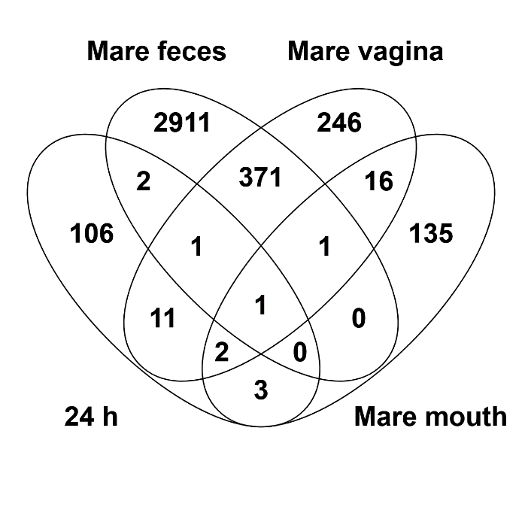 | B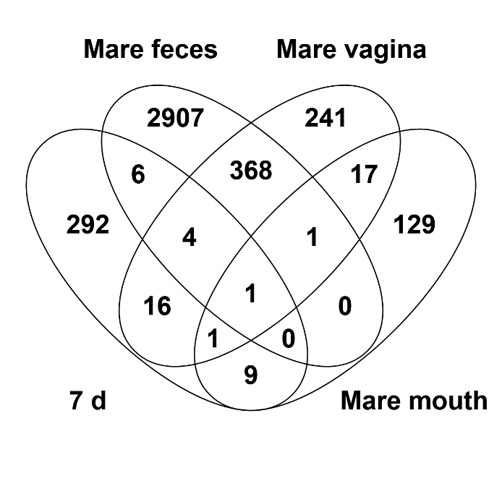
SUPPLEMENTARY FIGURE 4. ASVs shared between rectal microbiota samples of 24 h foals (A) and 7 d foals (B) and various mare microbiota samples. All ASVs detected in at least 2 animals per sample group are included.

The 7-day rectal microbiota clustered closer to the adult fecal microbiota at the family level than at the ASV level (Supplementary Fig. 5).
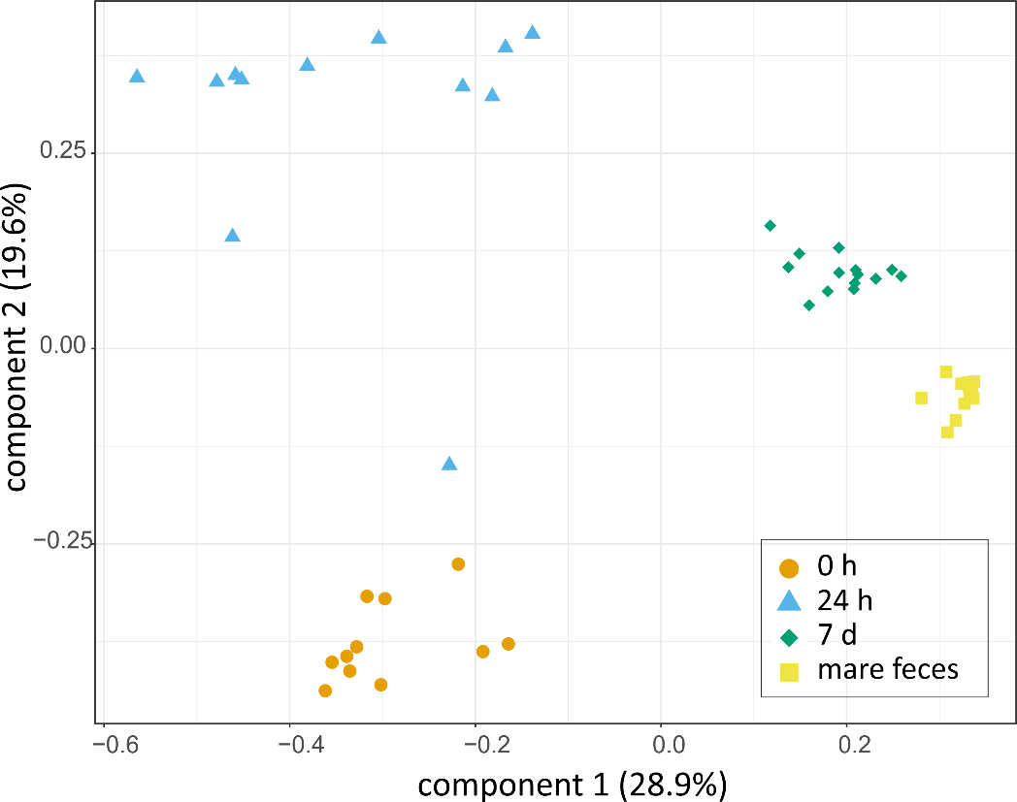

SUPPLEMENTARY FIGURE 5. PCoA on Bray-Curtis distances of rectal microbiota in the 0 h, 24 h old and 7 d old foals and adult mares at the family level. Colours and shapes indicate the sample types.

Supplementary methods

Quantitative PCR
A universal probe and primer set targeting the bacterial 16S rRNA gene was used for the quantification of 16S rRNA gene copy numbers in the DNA extracted from the foal rectal samples (0 h, 24 h and 7 d) and negative controls (no-template, instrument and field controls) [forward primer: 5ʹ-TCCTACGGGAGGCAGCAGT-3ʹ; reverse primer: 5ʹ-GGACTACCAGGGTATCTAATCCTGTT-3ʹ; probe: (6-FAM)-5ʹ-CGTATTACCGCGGCTGCTGGCAC-3ʹ-(BHQ1)]¹. To prepare a standard curve for absolute quantification, the complete 16S rRNA gene from Lactobacillus amylovorus (strain GRL1112) was amplified using primers 5ʹ-AGAGTTTGATCCTGGCTCAG-3ʹ and 5ʹ-ACGGCTACCTTGTTACGACTT-3ʹ². A standard series consisting of seven ten-fold dilutions from 1x10² to 1x10⁸ copies was used.
The qPCR was performed with an Mx3005P instrument (Agilent Technologies, Santa Clara, CA, USA) using DNA free 96 well plates (Eppendorf, Germany). The PCR reaction (25 µl total volume) containing 200 nM of probe and 300 nM of each primer was performed utilizing the ROX-containing 5× HOT FIREPol Probe qPCR Mix Plus (Solis BioDyne, Estonia). All samples were amplified in triplicate by the following thermal cycling conditions: 95°C for 15 min (polymerase activation and initial template denaturation), followed by 40 cycles of 95°C for 15 s (denaturation) and 60°C for 60 s (annealing/elongation).
To fit all samples within the dynamic range of qPCR, 2.5 µl of control and 0 h foal DNA extract and 0.05 µl of 1 d and 7 d DNA extracts were used per reaction. Fecal and especially the meconium samples contain high concentrations of PCR inhibitors, which are not completely removed by DNA extraction kits. Smaller PCR inhibitor concentrations in the more diluted samples may allow more efficient PCR amplification, resulting in values proportionally up to ~50% higher in the 24 h and 7 d samples, based on dilution series tests. The MxPro – Mx3000P software version 4.10 (Agilent Technologies) was used for data analysis.
Mare samples were quantified using the same primers and standard series and the HOT FIREPol EvaGreen qPCR mix (Solis Biodyne, Estonia). Per reaction, 0.05 µl of mare fecal DNA extract and 2.5 µl of mare vaginal and oral DNA extract were used as template.

MiSeq amplicon sequencing of 16S rRNA genes
The hypervariable regions V3-V4 of the 16S rRNA genes were sequenced using the Illumina MiSeq platform in the DNA core facility of the University of Helsinki, as described previously³.
Each sample was first amplified in triplicate in 25 µl total volume, using 1× Phusion Hot Start II High-Fidelity PCR Master Mix (Thermo Scientific), 2.5% DMSO (Thermo Scientific), 500 nM of a mixture of 4 forward and 4 reverse universal bacterial primers (Metabion, Supplementary Table 7), and 2.5 µl of DNA extracted from each sample, diluted with Nuclease-free Water 1:1 (Ambion™, Thermo Fisher Scientific, USA). DNA and PCR inhibitor free tubes (STARLAB International, Germany) were used. The 0 h foal samples were ran in the same batch as the negative controls and a no-template control was added to every batch. Otherwise every sample type was ran as its own batch, with the added no-template controls.
The thermal cycling conditions included an initial denaturation step at 98 °C for 30 seconds, followed by an optimised amount of cycles dependent on the sample type of denaturing at 98 °C for 10 seconds, annealing at 56 °C for 30 seconds and extension at 72 °C for 20 seconds. The final extension step was at 72 °C for 5 minutes. T100™ Thermal Cycler (Bio-Rad Laboratories) was used. The 0 h foal meconium samples, instrument controls and field controls were amplified with 21 PCR cycles, mare mouth and vaginal samples with 18 cycles, 24 h foal rectal samples with 16 cycles and 7 d old foal rectal samples and mare fecal samples with 14 cycles. ZymoBIOMICS Microbial Community Standard (Zymo Research, U.S.A.) was amplified with 12 cycles.
After the 1st round PCR, the triplicates were combined to a same tube (STARLAB International, Germany), checked on agarose gel and used as templates for the 2nd round PCR.
The 2nd round PCR amplifications were performed using an Illumina forward and reverse primer set (Supplementary Table 7), Phusion Hot-Start II polymerase (Finnzymes/Thermo Scientific), High Fidelity buffer and 2.5 % DMSO. The following thermal cycling conditions were applied with an Arktik thermal cycler (Finnzymes/Thermo Scientific): initial denaturation at 98 °C for 30 s, 17 cycles at 98 °C for 10s, 65°C for 30s, 72 °C for 10s, and a final extension at 72 °C for 5 min.
The second round PCR products were pooled in equal amounts, purified with Agencourt AMPure XP magnetic beads (Beckman Coulter) and size selected (500-700 bp) using BluePippin™ (Sage Science, USA). The quantity and quality of the amplicons were assessed with Qubit (Invitrogen, Thermo Scientific) and Bioanalyzer 2100 (Agilent Technologies), respectively. The final 16S rRNA gene amplicons obtained from samples, negative controls and PCR blanks were sequenced on an Illumina MiSeq sequencer using the v2 600 cycle kit paired-end (325 bp + 285 bp).
SUPPLEMENTARY TABLE 7. Sequencing primers
1st round | FW 5ʹ-3ʹ  (341F) | ACACTCTTTCCCTACACGACGCTCTTCCGATCTCCTACGGGNGGCWGCAG
1st round | FW 5ʹ-3ʹ  (341F) | ACACTCTTTCCCTACACGACGCTCTTCCGATCTgtCCTACGGGNGGCWGCAG
1st round | FW 5ʹ-3ʹ  (341F) | ACACTCTTTCCCTACACGACGCTCTTCCGATCTagagCCTACGGGNGGCWGCAG
1st round | FW 5ʹ-3ʹ  (341F) | ACACTCTTTCCCTACACGACGCTCTTCCGATCTtagtgtCCTACGGGNGGCWGCAG
1st round | REV 5ʹ-3ʹ  (785R) | GTGACTGGAGTTCAGACGTGTGCTCTTCCGATCTGACTACHVGGGTATCTAATCC
1st round | REV 5ʹ-3ʹ  (785R) | GTGACTGGAGTTCAGACGTGTGCTCTTCCGATCTaGACTACHVGGGTATCTAATCC
1st round | REV 5ʹ-3ʹ  (785R) | GTGACTGGAGTTCAGACGTGTGCTCTTCCGATCTtctGACTACHVGGGTATCTAATCC
1st round | REV 5ʹ-3ʹ  (785R) | GTGACTGGAGTTCAGACGTGTGCTCTTCCGATCTctgagtgGACTACHVGGGTATCTAATCC
2nd round | FW 5ʹ-3ʹ | AATGATACGGCGACCACCGAGATCTACACTCTTTCCCTACACGAC
2nd round | REV 5ʹ-3ʹ | CAAGCAGAAGACGGCATACGAGATXXXXXXXXGTGACTGGAGTTCAGACGTGT
►Sequencing primer ►16S specific primer ►Spacer nucleotide ►Illumina adapter ►IndeX

Detailed description of the bioinformatics pipeline

Obtaining the data
The sequencing data for 108 samples was obtained from the sequencing lab in demultiplexed FASTQ format. The compressed .tar.gz-package was uploaded to supercluster Taito of Finnish Center for Scientific Computing (CSC). Package md5sum was validated before further decompression and analyses.

Quality check
FastQC 0.11.8 was ran for all the files and the resulting reports were checked manually⁴. FastQC reports were also compiled and assessed with MultiQC 1.7⁵.

Trimming
All leftover primers and spacers were removed with Cutadapt v.1.10⁶.
find -name "*R1_001.fastq.gz" -exec cutadapt -g CCTACGGGNGGCWGCAG -o '{}.TRIMMED_CUTADAPT_FW.gz' '{}' ';'
find -name "*R2_001.fastq.gz" -exec cutadapt -g GACTACHVGGGTATCTAATCC -o '{}.TRIMMED_CUTADAPT_REV.gz' '{}' ';'
The trimmed sequences were again checked with FastQC 0.11.8 and MultiQC 1.7⁵.

Mapping file
A QIIME 2 compatible mapping containing the sample metadata file was created with Google Sheets and validated with Keemei⁷ ⁸.

QIIME2
Fastq.gz files were first imported to QIIME2 v2018.8 with command qiime tools import⁷. The sequences were checked again using qiime demux summarize. The total number of raw sequences was 15242693 (mean per sample: 141136) with read quality starting to drop forward at 302 and reverse at 257. DADA2⁹ was ran using the command dada2 denoise-paired with truncating option F302 and R257. DADA2 pipeline plugin in QIIME2 goes through 1000000 reads to estimate the error model, filters and trims the data, dereplicates, learns error rates, infers sample composition, merges paired reads, makes a sequence table and removes chimaeras^{7,9}. This results in an amplicon sequence variant (ASV) table. After DADA2 the total number of sequences was 6393231 (mean per sample: 59197). Approximately 42% of raw reads were preserved.
Stats from the denoising and merging steps were checked with qiime metadata tabulate. Resulting data was explored with visual summaries created with qiime feature-table summarize and qiime feature-table tabulate-seqs. The whole dataset contained 13756 ASVs with a total frequency of 6393231. Median and mean frequency per sample were respectively 60272 and 59196. Median and mean frequency per ASV were 27 and 465.
The phylogenetic tree was created using qiime alignment mafft¹⁰. Highly variable positions adding noise were masked with qiime alignment mask. FastTree was used to create a phylogenetic tree from the masked alignment: qiime phylogeny fasttree and qiime phylogeny midpoint-root¹¹.
Preliminary diversity analysis was created with qiime diversity core-metrics-phylogenetic using sampling depth 37149.
The taxonomy was assigned according to the SILVA v132 QIIME release 97 %¹². Representative set of sequences and taxonomy were imported to QIIME2 with qiime tools import. Reference reads were first extracted from the sequence directory with qiime feature-classifier extract-reads¹³. Then a Naïve Bayes classifier was trained to the curated taxonomy with qiime feature-classifier fit-classifier-naïve-bayes¹⁴. Finally the actual classification was called with qiime feature-classifier classify-sklearn¹⁵.
The taxonomy was visualised again with qiime metadata tabulate and qiime taxa barplot. After this the ASV table was exported from QIIME2 for handling in spreadsheet programs. First the table and taxonomy data was exported in biom-format with qiime tools export¹⁶. The two were combined with biom package: biom add-metadata. Finally the ASV table and table with taxonomy were converted to .tsv format with biom convert.

Data decontamination
We first removed unassigned ASVs, unclassified bacteria (mostly mitochondrial sequences), chloroplasts and the ASVs which were detected less than 10 times in the entire dataset. The data was then filtered to remove ASVs which represented probable contaminants. An ASV was removed if its prevalence in actual samples was ≤ 2× its prevalence in instrument controls or its prevalence in field controls, and if its mean relative abundance in actual samples was ≤ 10× its mean abundance in instrument controls or its mean abundance in field controls. The filtering was performed for each sample group separately.

Supplementary references
1 Nadkarni, M. A., Martin, F. E., Jacques, N. A. & Hunter, N. Determination of bacterial load by real-time PCR using a broad-range (universal) probe and primers set. Microbiology (Reading, England) 148, 257-266 (2002).
2 Weisburg, W. G., Barns, S. M., Pelletier, D. A. & Lane, D. J. 16S ribosomal DNA amplification for phylogenetic study. J. Bacteriol. 173, 697-703 (1991).
3 Pereira, P. A. B. et al. Oral and nasal microbiota in Parkinson's disease. Parkinsonism Relat. Disord. 38, 61-67, doi:10.1016/j.parkreldis.2017.02.026 (2017).
4 Andrews, S. FastQC: a quality control tool for high throughput sequence data v. 0.11.8. https://www.bioinformatics.babraham.ac.uk/projects/fastqc/ (2018).
5 Ewels, P., Magnusson, M., Lundin, S. & Kaller, M. MultiQC: summarize analysis results for multiple tools and samples in a single report. Bioinformatics 32, 3047-3048, doi:10.1093/bioinformatics/btw354 (2016).
6 Martin, M. Cutadapt removes adapter sequences from high-throughput sequencing reads. EMBnet.journal; Vol 17, No 1: Next Generation Sequencing Data Analysis (2011).
7 Bolyen, E. et al. QIIME 2: Reproducible, interactive, scalable, and extensible microbiome data science. PeerJ Preprints 6, e27295v27292, doi:10.7287/peerj.preprints.27295v2 (2018).
8 Rideout, J. R. et al. Keemei: cloud-based validation of tabular bioinformatics file formats in Google Sheets. Gigascience 5, 27, doi:10.1186/s13742-016-0133-6 (2016).
9 Callahan, B. J. et al. DADA2: High-resolution sample inference from Illumina amplicon data. Nat. Methods 13, 581-583, doi:10.1038/nmeth.3869 (2016).
10 Katoh, K. MAFFT: a novel method for rapid multiple sequence alignment based on fast Fourier transform. Nucleic Acids Research 30, 3059-3066, doi:10.1093/nar/gkf436 (2002).
11 Price, M. N., Dehal, P. S. & Arkin, A. P. FastTree: computing large minimum evolution trees with profiles instead of a distance matrix. Mol. Biol. Evol. 26, 1641-1650, doi:10.1093/molbev/msp077 (2009).
12 Quast, C. et al. The SILVA ribosomal RNA gene database project: improved data processing and web-based tools. Nucleic Acids Res. 41, D590-596, doi:10.1093/nar/gks1219 (2013).
13 Bokulich, N. A. et al. Optimizing taxonomic classification of marker-gene amplicon sequences with QIIME 2's q2-feature-classifier plugin. Microbiome 6, 90, doi:10.1186/s40168-018-0470-z (2018).
14 Rennie, J. D., Shih, L., Teevan, J. & Karger, D. R. in Proceedings of the 20th international conference on machine learning (icml-03). 616-623.
15 Pedregosa, F. et al. Scikit-learn: Machine Learning in Python. J. Mach. Learn. Res 12, 2825-2830 (2011).
16 McDonald, D. et al. The Biological Observation Matrix (BIOM) format or: how I learned to stop worrying and love the ome-ome. Gigascience 1, 7, doi:10.1186/2047-217X-1-7 (2012).

