Metabolomic networks and pathways associated with feed efficiency and related-traits in Duroc and Landrace pigs
Victor Adriano Okstoft Carmelo¹, Priyanka Banerjee¹, Wellison Jarles da Silva Diniz^{1, 2} and
Haja N. Kadarmideen^{1*}

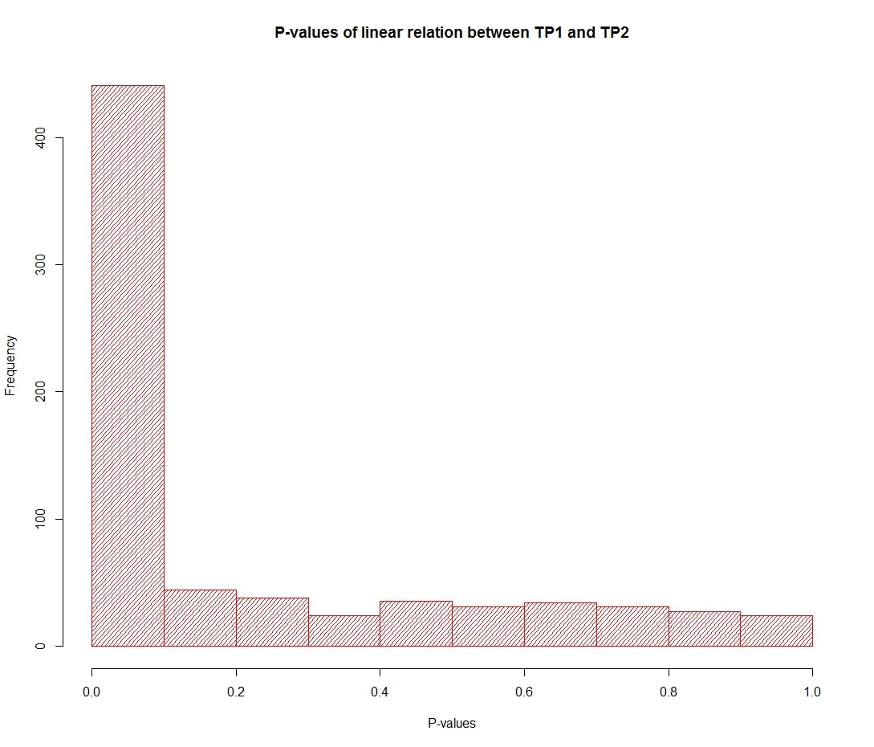 Supplementary Fig. S1: P-value for the linear relationship between TP1 and TP2 (Duroc and Landrace combined) for each metabolite. The metabolites were log-transformed. The model fit is a simple linear regression only including an intercept, the metabolite values from the first sampling and the metabolite from the second sampling as a responsive value. No other covariates are needed since each metabolite is paired between each pig.
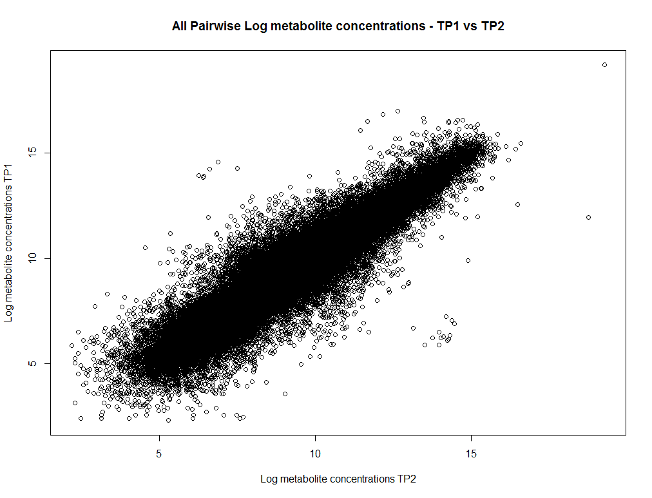
Supplementary Fig. S2: All pairwise metabolite concentrations between TP1 and TP2 for all metabolites and all pigs. We see that there is a strong linear relationship between the metabolite concentrations in the two timepoints, with a Pearson correlation of 0.935. 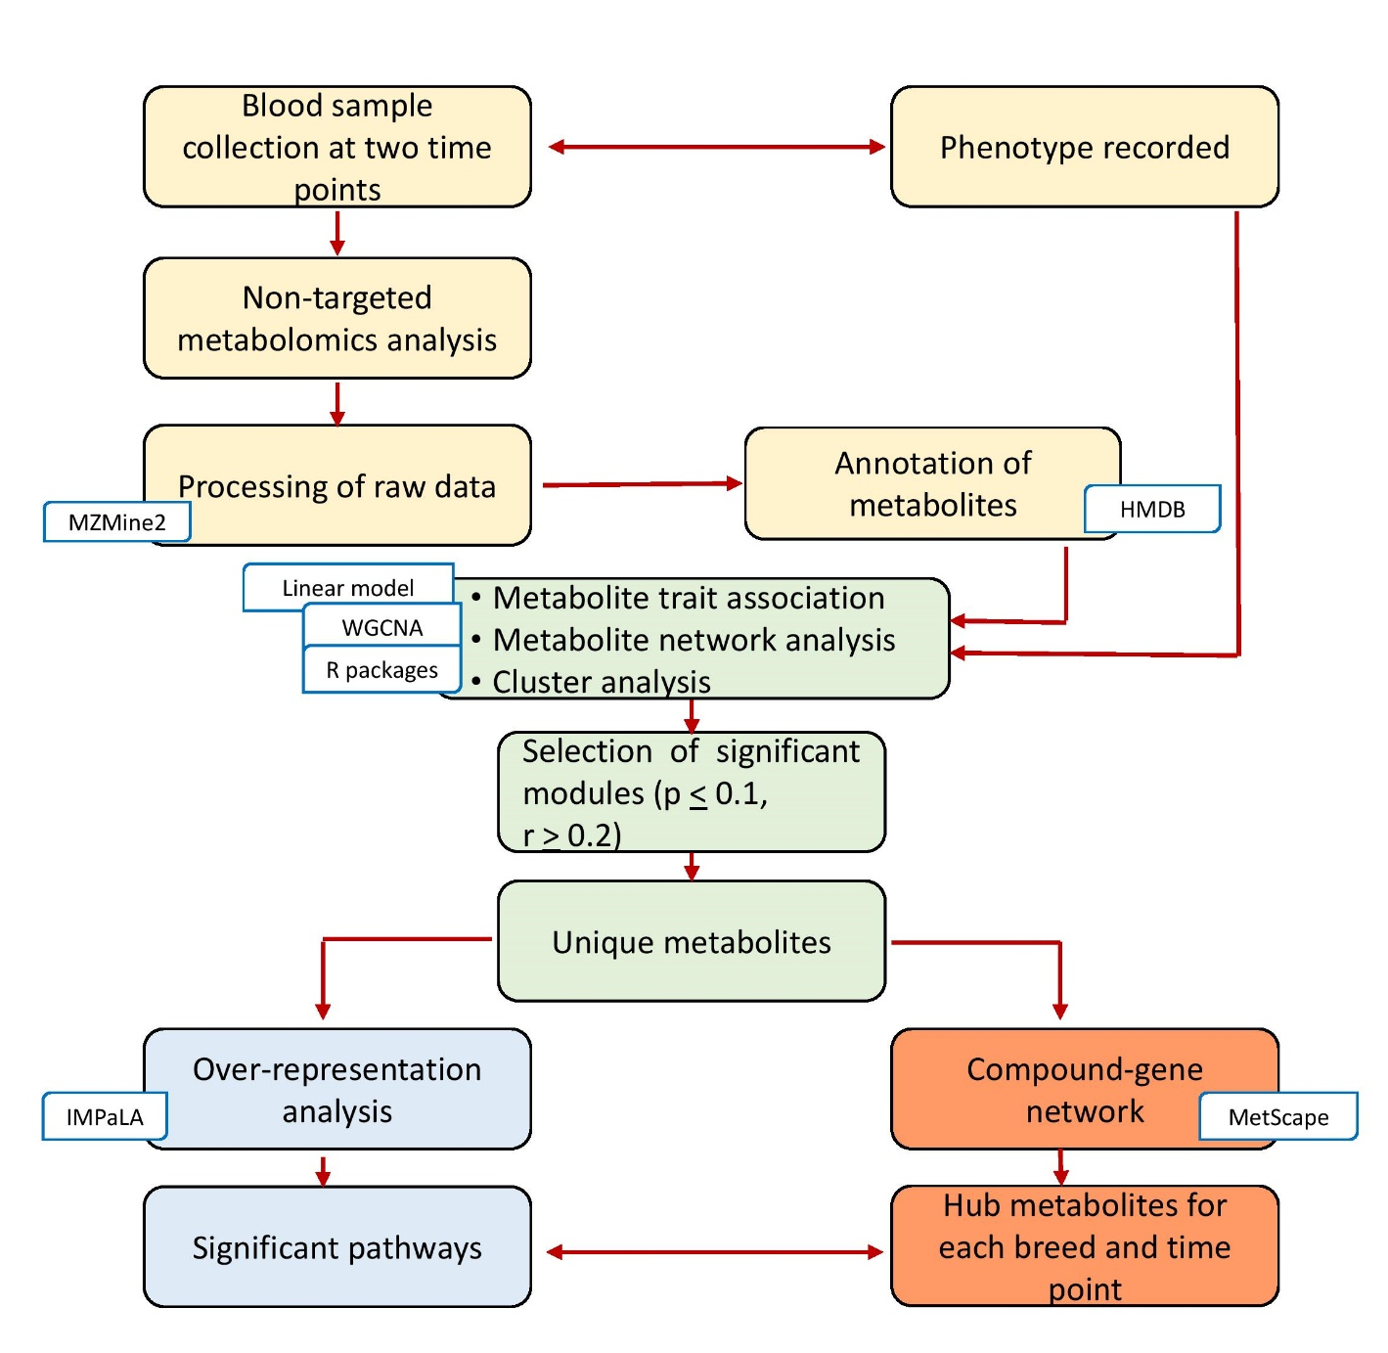
Supplementary Fig. S3: Schematic workflow for identification of hub metabolites for each time point in Duroc and Landrace.

