Immune gene signatures for predicting durable clinical benefit of anti-PD-1 immunotherapy in patients with non-small cell lung cancer

Sohyun Hwang^{1*}, Ah-Young Kwon^{1*}, Ju-Yeon Jeong², Sewha Kim¹, Haeyoun Kang¹, Joonsuk Park³, Joo-Hang Kim⁴, Ok Jin Han², Sun Min Lim^{4§}, Hee Jung An^{1§}

¹Department of Pathology, CHA University, CHA Bundang Medical Center, Seongnam-si, Kyeonggi-do, Republic of Korea
²CHA Advanced Research Institute, CHA Bundang Medical Center, Seongnam-si, Kyeonggi-do, Republic of Korea
³Department of Thoracic Surgery, CHA University, CHA Bundang Medical Center, Seongnam-si, Kyeonggi-do, Republic of Korea
⁴Hematology- Oncology, Department of Internal Medicine, CHA University, CHA Bundang Medical Center, Seongnam-si, Kyeonggi-do, Republic of Korea

*These authors contributed equally as co-first authors
§These authors contributed equally as co-corresponding authors

Supplementary figures
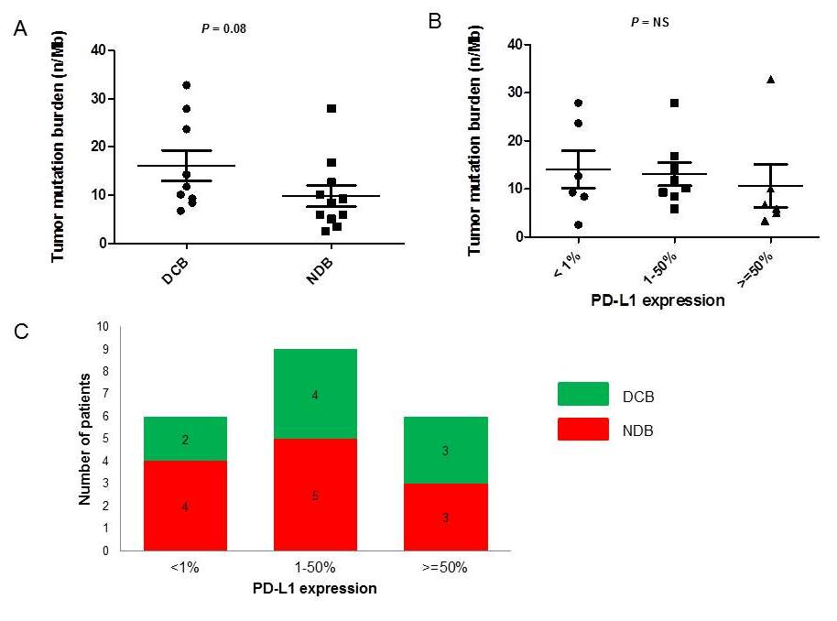
Supplementary figure S1. (A) Tumor mutation burden (TMB) in patients with durable clinical benefit (DCB) versus non-durable benefit (NDB). Median TMB was 11.76 versus 8.4 mutations per Mb, Mann-Whitney P=0.08). (B) TMB according to PD-L1 expression. Median TMB was 10.94, 10.93, 6.29/Mb, respectively for the PD-L1 expression of <1%, 1-50%, ≥50%. (C) Distribution of PD-L1 expression (<1%, 1-50%, >=50%) according to clinical outcome. DCB in green and NDB in red.

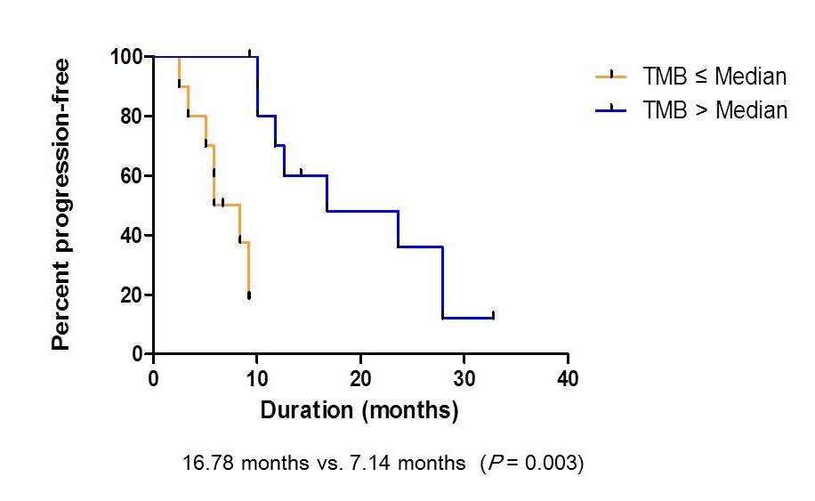
Supplementary figure S2. Progression-free survival (PFS) in patients according to the median TMB value of 9.27. Patients with higher TMB showed a prolonged PFS as compared to patients with lower TMB (16.78 months vs. 7.14 months, P=0.003).
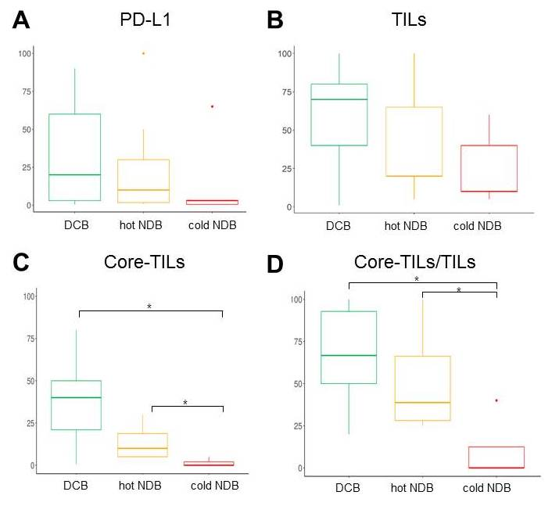
Supplementary figure S3. PD-L1 expression, tumor-infiltrating lymphocytes (TILs), and core TILs in patients with durable clinical benefit (DCB), non-durable benefit (NDB) with high gene-expression (hot NDB), and NDB with low gene-expression (cold NDB). (A) PD-L1 expression shows no significant difference among three groups, although there is a slight tendency to decrease from DCB to “hot” NDB to “cold” NDB groups. (B) There is no significant difference of TIL among three groups. (C) For core TIL, DCB group shows significant higher value than two NDB groups (P=0.02). There is a significant difference between core TILs of hot and cold NDB groups (P=0.04) (D) The ratio of core TIL to total TIL was significantly different between the DCB and NDB groups (P = 0.03), the “hot” NDB group showed no difference from the DCB group, and the “cold” NDB group showed a lower core TIL ratio than the DCB (P = 0.002) and “hot” NDB groups (P = 0.03).
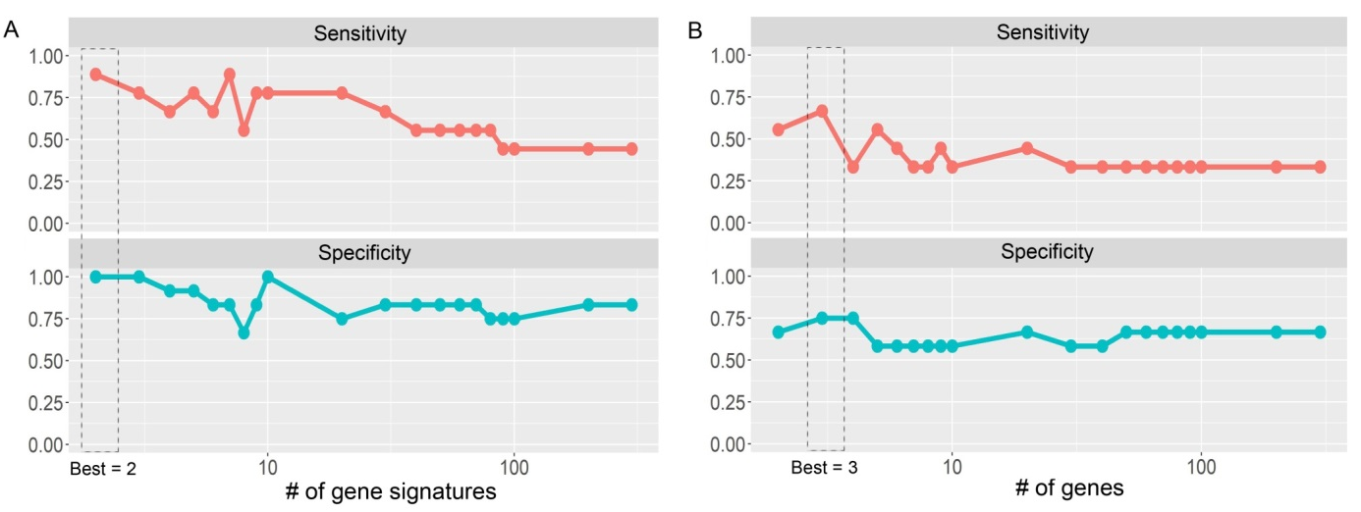
Supplementary figure S4. The performance of random forest classification models. (A) Among random forest models of gene signatures, the model of two gene signatures showed the best performance; sensitivity = 0.89 and specificity = 1.0. (B) Among random forest models consisted of genes (from two genes to all 393 genes), the model of three genes showed the best performance; sensitivity = 0.67 and specificity = 0.75.

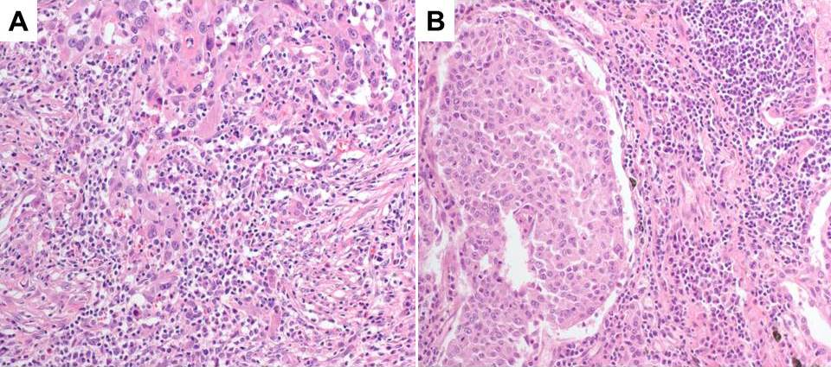
Supplementary figure S5. A representative picture of tumor immune microenvironment in patients. (A) Tumor of patient D2 (durable clinical benefit group) shows highly infiltrated lymphocytes within tumor core (Hematoxylin-eosin stain [H-E], x200). (B) Tumor of patient N9 (non-durable benefit group with low gene-expression) contains many tumor-infiltrating lymphocytes, but mainly localized along the tumor margin or in fibrotic nests (H-E, x200).

Supplementary tables

Supplementary table S1. The predictability of gene signatures of functional annotation in discriminating between DCB and NDB
ID | AUC | t-test  p-value (adjusted) | PFS  p-value  (adjusted) | OS  p-value  (adjusted)
Type II interferon signaling | 0.77 | 0.0529  (1.0) | 0.917  (1.0) | 0.34  (1.0)
TCR coexpression | 0.81 | 0.0186  (0.71) | 1.38e-2  (0.57) | 0.76  (1.0)
Neutrophil | 0.85 | 6.08e-3  (0.24) | 2.26e-2  (0.88) | 0.23  (1.0)
Tumor marker | 0.85 | 4.83e-3  (0.20) | 0.154  (1.0) | 0.81  (1.0)
Apoptosis | 0.74 | 0.0279  (1.0) | 0.154  (1.0) | 0.81  (1.0)

Supplementary table S2. Description of signatures
Id | Description | Genes
M1 signature | Up-regulated genes in classical macrophage 1 compared with alternative macrophage 2 in developmental process (GSE5099, GSE5099 CLASSICAL M1 VS ALTERNATIVE M2 MACROPHAGE UP) | CBLB, CCR7, CD27, CD48, FOXO1, FYB, HLA-B, HLA-G, IFIH1, IKZF4, LAMP3, NFKBIA, SAMHD1
Peripheral T cell signature | Down-regulated genes in lymph node T cells compared with fat tissue T cells. (GSE7852, GSE7852 LN VS FAT TCONV UP) | GPR18, HLA-DOA, STAT1

Supplementary table S3. The predictability of selected gene signatures and genes in discriminating DCB and NDB
ID | AUC | t-test  p-value | edgeR  p-value | PFS  p-value | OS  p-value
M1 signature | 1 | 4.95e-4* | 8.54e-11* | 7.84e-5* | 0.348
Peripheral T cell signature | 0.944 | 1.08e-4* | 1.45e-10* | 8.29e-3* | 0.695
BCL2 | 0.87 | 0.122 | 0.558 | 2.68e-3* | 0.408
TNFRSF9 (CD137) | 0.93 | 2.78e-3* | 1.23e-3* | 0.0822 | 0.179
PSMB9 | 0.87 | 6.66e-3* | 0.193 | 4.13e-3* | 0.530
*Statistically significant

Supplementary table S4. The entire list of 395 genes used in the panel
Gene | Target | NCBI name | NCBI  ACCESSION | GENE  FUNCTION
ABCF1 | ABCF1_11741283 | ATP_binding_cassette_subfamily_F_member_1 | NM_001025091 | Housekeeping
ADGRE5 | ADGRE5_26552764 | adhesion_G_protein-coupled_receptor_E5 | NM_078481 | Adhesion,migration
ADORA2A | ADORA2A_771873 | adenosine_A2a_receptor | NM_000675 | Checkpoint_pathway
AIF1 | AIF1_385491 | allograft_inflammatory_factor_1 | NM_001623 | Macrophage
AKT1 | AKT1_358467 | AKT_serine_threonine_kinase_1 | NM_001014431 | Tumor_marker
ALOX15B | ALOX15B_13391445 | arachidonate_15-lipoxygenase_type_B | NM_001141 | Macrophage
ARG1 | ARG1_174278 | arginase_1 | NM_000045 | Myeloid_marker
AXL | AXL_24872596 | AXL_receptor_tyrosine_kinase | NM_021913 | Innate_immune_response
B3GAT1 | B3GAT1_170280 | beta-13-glucuronyltransferase_1 | NM_018644 | NK_activation
BAGE | BAGE_153290 | B_melanoma_antigen | NM_182482 | Tumor_antigen
BATF | BATF_237345 | basic_leucine_zipper_ATF-like_transcription_factor | NM_006399 | Helper_T_cells
BCL2 | BCL2_10401144 | B-cell_CLL_lymphoma_2 | NM_000633 | Apoptosis
BCL2L11 | BCL2L11_620729 | BCL2_like_11 | NM_138621 | Apoptosis
BCL6 | BCL6_21502257 | B-cell_CLL_lymphoma_6 | NM_001706 | Type_II_interferon_signaling
BRCA1 | BRCA1_42344338 | BRCA1_DNA_repair_associated | NM_007300 | Tumor_marker
BRCA2 | BRCA2_98179922 | BRCA2_DNA_repair_associated | NM_000059 | Tumor_marker
BST2 | BST2_218322 | bone_marrow_stromal_cell_antigen_2 | NM_004335 | Type_I_interferon_signaling
BTLA | BTLA_227334 | B_and_T_lymphocyte_associated | NM_181780 | Checkpoint_pathway
BUB1 | BUB1_701803 | BUB1_mitotic_checkpoint_serine_threonine_kinase | NM_004336 | Proliferation
C10orf54 | C10orf54_562672 | chromosome_10_open_reading_frame_54 | NM_022153 | Checkpoint_pathway
C1QA | C1QA_67171 | complement_component_1_q_subcomponent_A_chain | NM_015991 | Innate_immune_response
C1QB | C1QB_111199 | complement_component_1_q_subcomponent_B_chain | NM_000491 | Innate_immune_response
CA4 | CA4_420530 | carbonic_anhydrase_4 | NM_000717 | Neutrophil
CBLB | CBLB_296407 | Cbl_proto-oncogene_B | NM_170662 | T_cell_receptor_signaling
CCL17 | CCL17_288394 | C-C_motif_chemokine_ligand_17 | NM_002987 | Chemokine_signaling
CCL18 | CCL18_198296 | C-C_motif_chemokine_ligand_18 | NM_002988 | Lymphocyte_infiltrate
CCL2 | CCL2_242346 | C-C_motif_chemokine_ligand_2 | NM_002982 | Lymphocyte_infiltrate
CCL20 | CCL20_297403 | C-C_motif_chemokine_ligand_20 | NM_004591 | Chemokine_signaling
CCL21 | CCL21_432539 | C-C_motif_chemokine_ligand_21 | NM_002989 | Lymphocyte_infiltrate
CCL22 | CCL22_79185 | C-C_motif_chemokine_ligand_22 | NM_002990 | Chemokine_signaling
CCL3 | CCL3_238343 | C-C_motif_chemokine_ligand_3 | NM_002983 | Lymphocyte_infiltrate
CCL4 | CCL4_121220 | C-C_motif_chemokine_ligand_4 | NM_002984 | Lymphocyte_infiltrate
CCL5 | CCL5_110219 | C-C_motif_chemokine_ligand_5 | NM_002985 | Lymphocyte_infiltrate
CCNB2 | CCNB2_9861095 | cyclin_B2 | NM_004701 | Proliferation
CCR1 | CCR1_54149 | C-C_motif_chemokine_receptor_1 | NM_001295 | Cytokine_signaling
CCR2 | CCR2_385483 | C-C_motif_chemokine_receptor_2 | NM_001123396 | Helper_T_cells
CCR4 | CCR4_76182 | C-C_motif_chemokine_receptor_4 | NM_005508 | Chemokine_signaling
CCR5 | CCR5_85193 | C-C_motif_chemokine_receptor_5_gene_pseudogene | NM_001100168 | Lymphocyte_infiltrate
CCR6 | CCR6_271363 | C-C_motif_chemokine_receptor_6 | NM_004367 | Chemokine_signaling
CCR7 | CCR7_133237 | C-C_motif_chemokine_receptor_7 | NM_001838 | TCR_coexpression
CD14 | CD14_329435 | CD14_molecule | NM_000591 | Dendridic_cell,macrophage
CD160 | CD160_194300 | CD160_molecule | NM_007053 | Checkpoint_pathway
CD163 | CD163_21422245 | CD163_molecule | NM_004244 | Macrophage
CD19 | CD19_12011317 | CD19_molecule | NM_001178098 | B_cell_marker
CD1C | CD1C_12531357 | CD1c_molecule | NM_001765 | Antigen_presentation
CD1D | CD1D_10661173 | CD1d_molecule | NM_001766 | Antigen_presentation
CD2 | CD2_350452 | CD2_molecule | NM_001767 | Lymphocyte_infiltrate
CD209 | CD209_9921101 | CD209_molecule | NM_021155 | Dendridic_cell,macrophage
CD22 | CD22_10251132 | CD22_molecule | NM_001771 | B_cell_marker
CD226 | CD226_9021006 | CD226_molecule | NM_006566 | Adhesion,migration
CD244 | CD244_868973 | CD244_molecule | NM_001166663 | Checkpoint_pathway
CD247 | CD247_152252 | CD247_molecule | NM_198053 | TCR_coexpression
CD27 | CD27_409517 | CD27_molecule | NM_001242 | Drug_target
CD274 | CD274_461569 | CD274_molecule | NM_014143 | Checkpoint_pathway
CD276 | CD276_12011310 | CD276_molecule | NM_001024736 | Checkpoint_pathway
CD28 | CD28_601704 | CD28_molecule | NM_006139 | Checkpoint_pathway
CD33 | CD33_387493 | CD33_molecule | NM_001772 | Myeloid_marker
CD37 | CD37_496605 | CD37_molecule | NM_001774 | Lymphocyte_infiltrate
CD38 | CD38_519628 | CD38_molecule | NM_001775 | Adhesion,migration
CD3D | CD3D_400503 | CD3d_molecule | NM_000732 | TCR_coexpression
CD3E | CD3E_677780 | CD3e_molecule | NM_000733 | TCR_coexpression
CD3G | CD3G_616717 | CD3g_molecule | NM_000073 | TCR_coexpression
CD4 | CD4_147255 | CD4_molecule | NM_000616 | Helper_T_cells
CD40 | CD40_300407 | CD40_molecule | NM_001250 | Drug_target
CD40LG | CD40LG_479579 | CD40_ligand | NM_000074 | T_cell_receptor_signaling
CD44 | CD44_10151123 | CD44_molecule_Indian_blood_group | NM_000610 | Adhesion,migration
CD47 | CD47_826931 | CD47_molecule | NM_001777 | Adhesion,migration
CD48 | CD48_695798 | CD48_molecule | NM_001778 | Checkpoint_pathway
CD52 | CD52_70175 | CD52_molecule | NM_001803 | Lymphocyte_infiltrate
CD53 | CD53_28133 | CD53_molecule | NM_001040033 | Adhesion,migration
CD6 | CD6_17771886 | CD6_molecule | NM_006725 | TCR_coexpression
CD63 | CD63_692800 | CD63_molecule | NM_001780 | Lymphocyte_infiltrate
CD68 | CD68_172280 | CD68_molecule | NM_001251 | Macrophage
CD69 | CD69_195303 | CD69_molecule | NM_001781 | Checkpoint_pathway
CD70 | CD70_259363 | CD70_molecule | NM_001252 | Drug_target
CD74 | CD74_787896 | CD74_molecule | NM_001025159 | Antigen_processing
CD79A | CD79A_184290 | CD79a_molecule | NM_001783 | B_cell_receptor_signaling
CD79B | CD79B_484590 | CD79b_molecule | NM_001039933 | B_cell_receptor_signaling
CD80 | CD80_457557 | CD80_molecule | NM_005191 | Checkpoint_pathway
CD83 | CD83_480580 | CD83_molecule | NM_004233 | Antigen_presentation
CD86 | CD86_169267 | CD86_molecule | NM_175862 | Checkpoint_pathway
CD8A | CD8A_14271531 | CD8a_molecule | NM_171827 | TCR_coexpression
CD8B | CD8B_403510 | CD8b_molecule | NM_172213 | TCR_coexpression
CDK1 | CDK1_837939 | cyclin-dependent_kinase_1 | NM_001786 | Proliferation
CDKN2A | CDKN2A_696829 | cyclin-dependent_kinase_inhibitor_2A | NM_000077 | Tumor_marker
CDKN3 | CDKN3_434534 | cyclin-dependent_kinase_inhibitor_3 | NM_005192 | Proliferation
CEACAM1 | CEACAM1_10471155 | carcinoembryonic_antigen_related_cell_adhesion_molecule_1 | NM_001712 | Checkpoint_pathway
CEACAM8 | CEACAM8_745847 | carcinoembryonic_antigen_related_cell_adhesion_molecule_8 | NM_001816 | Myeloid_marker
CIITA | CIITA_294397 | class_II_major_histocompatibility_complex_transactivator | NM_000246 | Type_II_interferon_signaling
CLEC4C | CLEC4C_322429 | C-type_lectin_domain_family_4_member_C | NM_130441 | Dendridic_cell
CMKLR1 | CMKLR1_36143 | chemerin_chemokine-like_receptor_1 | NM_001142345 | Dendridic_cell,macrophage
CORO1A | CORO1A_457563 | coronin_1A | NM_007074 | Lymphocyte_infiltrate
CRTAM | CRTAM_312417 | cytotoxic_and_regulatory_T-cell_molecule | NM_019604 | TCR_coexpression
CSF1R | CSF1R_19612067 | colony_stimulating_factor_1_receptor | NM_005211 | Cytokine_signaling
CSF2RB | CSF2RB_11971301 | colony_stimulating_factor_2_receptor_beta_common_subunit | NM_000395 | Cytokine_signaling
CTAG1B | CTAG1B_276373 | cancer_testis_antigen_1B | NM_001327 | Tumor_antigen
CTAG2 | CTAG2_407763 | cancer_testis_antigen_2 | ENST00000369585 | Tumor_antigen
CTLA4 | CTLA4_584689 | cytotoxic_T-lymphocyte_associated_protein_4 | NM_005214 | Drug_target
CTSS | CTSS_356460 | cathepsin_S | NM_004079 | Lymphocyte_infiltrate
CX3CL1 | CX3CL1_190298 | C-X3-C_motif_chemokine_ligand_1 | NM_002996 | Type_II_interferon_signaling
CX3CR1 | CX3CR1_35133 | C-X3-C_motif_chemokine_receptor_1 | NM_001337 | Lymphocyte_infiltrate
CX3CR1 | CX3CR1_147243 | C-X3-C_motif_chemokine_receptor_1 | NM_001171172 | Lymphocyte_infiltrate
CX3CR1 | CX3CR1_207292 | C-X3-C_motif_chemokine_receptor_1 | NM_001171171 | Lymphocyte_infiltrate
CX3CR1 | CX3CR1_58187 | C-X3-C_motif_chemokine_receptor_1 | NM_001171174 | Lymphocyte_infiltrate
CXCL1 | CXCL1_357459 | C-X-C_motif_chemokine_ligand_1 | NM_001511 | Chemokine_signaling
CXCL10 | CXCL10_354459 | C-X-C_motif_chemokine_ligand_10 | NM_001565 | Type_II_interferon_signaling
CXCL11 | CXCL11_261361 | C-X-C_motif_chemokine_ligand_11 | NM_005409 | Type_II_interferon_signaling
CXCL13 | CXCL13_202307 | C-X-C_motif_chemokine_ligand_13 | NM_006419 | Type_II_interferon_signaling
CXCL8 | CXCL8_197302 | C-X-C_motif_chemokine_ligand_8 | NM_000584 | Cytokine_signaling
CXCL9 | CXCL9_149250 | C-X-C_motif_chemokine_ligand_9 | NM_002416 | Type_II_interferon_signaling
CXCR2 | CXCR2_379486 | C-X-C_motif_chemokine_receptor_2 | NM_001557 | Chemokine_signaling
CXCR3 | CXCR3_11138 | C-X-C_motif_chemokine_receptor_3 | NM_001504 | Chemokine_signaling
CXCR4 | CXCR4_100208 | C-X-C_motif_chemokine_receptor_4 | NM_003467 | Lymphocyte_infiltrate
CXCR5 | CXCR5_153252 | C-X-C_motif_chemokine_receptor_5 | NM_001716 | Type_II_interferon_signaling
CXCR6 | CXCR6_48153 | C-X-C_motif_chemokine_receptor_6 | NM_006564 | Lymphocyte_infiltrate
CYBB | CYBB_14221529 | cytochrome_b-245_beta_chain | NM_000397 | Type_II_interferon_signaling
DDX58 | DDX58_540643 | DEXD_H-box_helicase_58 | NM_014314 | Interferon_signaling
DGAT2 | DGAT2_439548 | diacylglycerol_O-acyltransferase_2 | NM_032564 | Neutrophil
DMBT1 | DMBT1_64696575 | deleted_in_malignant_brain_tumors_1 | NM_007329 | Innate_immune_response
EBI3 | EBI3_527636 | Epstein-Barr_virus_induced_3 | NM_005755 | T_cell_regulation
EFNA4 | EFNA4_548649 | ephrin_A4 | NM_005227 | Tumor_marker
EGFR | EGFR_31583261 | epidermal_growth_factor_receptor | NM_005228 | Tumor_marker
EGR2 | EGR2_454559 | early_growth_response_2 | NM_000399 | T_cell_differentiation
EGR3 | EGR3_411516 | early_growth_response_3 | NM_004430 | Tumor_marker
EIF2AK2 | EIF2AK2_257357 | eukaryotic_translation_initiation_factor_2_alpha_kinase_2 | NM_001135651 | Type_II_interferon_signaling
ENTPD1 | ENTPD1_708815 | ectonucleoside_triphosphate_diphosphohydrolase_1 | NM_001098175 | Checkpoint_pathway
EOMES | EOMES_9391044 | eomesodermin | NM_005442 | Checkpoint_pathway
FAS | FAS_473575 | Fas_cell_surface_death_receptor | NM_000043 | B_cell_receptor_signaling
FASLG | FASLG_417521 | Fas_ligand | NM_000639 | Type_II_interferon_signaling
FCER1G | FCER1G_31138 | Fc_fragment_of_IgE_receptor_Ig | NM_004106 | Lymphocyte_infiltrate
FCGR1A | FCGR1A_547652 | Fc_fragment_of_IgG_receptor_Ia | NM_000566 | B_cell_marker
FCGR2B | FCGR2B_792903 | Fc_fragment_of_IgG_receptor_IIb | NM_004001 | B_cell_marker
FCGR3A | FCGR3A_575682 | Fc_fragment_of_IgG_receptor_IIIa | NM_000569 | Macrophage
FCGR3B | FCGR3B_620722 | Fc_fragment_of_IgG_receptor_IIIb | NM_000570 | NK_activation
FCRLA | FCRLA_710815 | Fc_receptor_like_A | NM_001184866 | B_cell_marker
FOXM1 | FOXM1_10551166 | forkhead_box_M1 | NM_021953 | Proliferation
FOXO1 | FOXO1_9761081 | forkhead_box_O1 | NM_002015 | PD-1_signaling,tumor_marker
FOXP3 | FOXP3_865975 | forkhead_box_P3 | NM_014009 | T_cell_regulation
FUT4 | FUT4_31443252 | fucosyltransferase_4 | NM_002033 | Myeloid_marker,stem_cell
FYB | FYB_12891393 | FYN_binding_protein | NM_001465 | Lymphocyte_infiltrate
G6PD | G6PD_10841194 | glucose-6-phosphate_dehydrogenase | NM_000402 | Housekeeping
GADD45GIP1 | GADD45GIP1_329429 | GADD45G_interacting_protein_1 | NM_052850 | Apoptosis
GAGE1,GAGE12I,GAGE12F | GAGE1_144260 | G_antigen_1 | NM_001468,NM_001477,NM_001098405 | Tumor_antigen
GAGE10 | GAGE10_137250 | G_antigen_10 | NM_001098413 | Tumor_antigen
GAGE12J | GAGE12J_144260 | G_antigen_12J | NM_001098406 | Tumor_antigen
GAGE13 | GAGE13_116232 | G_antigen_13 | NM_001098412 | Tumor_antigen
GAGE2C,GAGE2A,GAGE2E | GAGE2C_104217 | G_antigen_2C | NM_001472,NM_001127212,NM_001127200 | Tumor_antigen
GATA3 | GATA3_14061514 | GATA_binding_protein_3 | NM_001002295 | Helper_T_cells
GBP1 | GBP1_771872 | guanylate_binding_protein_1 | NM_002053 | Type_II_interferon_signaling
GNLY | GNLY_251357 | granulysin | NM_006433 | NK_activation
GPR18 | GPR18_238340 | G_protein-coupled_receptor_18 | NM_001098200 | TCR_coexpression
GRAP2 | GRAP2_283387 | GRB2-related_adaptor_protein_2 | NM_004810 | TCR_coexpression
GUSB | GUSB_17671872 | glucuronidase_beta | NM_000181 | Housekeeping
GZMA | GZMA_165265 | granzyme_A | NM_006144 | Lymphocyte_infiltrate
GZMB | GZMB_581688 | granzyme_B | NM_004131 | Lymphocyte_infiltrate
GZMH | GZMH_233339 | granzyme_H | NM_033423 | Lymphocyte_infiltrate
GZMK | GZMK_178286 | granzyme_K | NM_002104 | Lymphocyte_infiltrate
HAVCR2 | HAVCR2_594705 | hepatitis_A_virus_cellular_receptor_2 | NM_032782 | Checkpoint_pathway
HERC6 | HERC6_17021806 | HECT_and_RLD_domain_containing_E3_ubiquitin_protein_ligase_family_member_6 | NM_017912 | Dendridic_cell
HGF | HGF_14151518 | hepatocyte_growth_factor | NM_000601 | Cytokine_signaling
HIF1A | HIF1A_13371439 | hypoxia_inducible_factor_1_alpha_subunit | NM_001530 | PD-1_signaling,tumor_marker
HLA-A | HLA-A_345445 | major_histocompatibility_complex_class_I_A | NM_002116 | Antigen_processing
HLA-B | HLA-B_639746 | major_histocompatibility_complex_class_I_B | NM_005514 | Antigen_processing
HLA-C | HLA-C_9191023 | major_histocompatibility_complex_class_I_C | NM_002117 | Antigen_processing
HLA-DMA | HLA-DMA_764869 | major_histocompatibility_complex_class_II_DM_alpha | NM_006120 | Antigen_processing
HLA-DMB | HLA-DMB_854962 | major_histocompatibility_complex_class_II_DM_beta | NM_002118 | Antigen_processing
HLA-DOA | HLA-DOA_55163 | major_histocompatibility_complex_class_II_DO_alpha | NM_002119 | Antigen_processing
HLA-DOB | HLA-DOB_182290 | major_histocompatibility_complex_class_II_DO_beta | NM_002120 | Antigen_processing
HLA-DPA1 | HLA-DPA1_129237 | major_histocompatibility_complex_class_II_DP_alpha_1 | NM_033554 | Antigen_processing
HLA-DPB1 | HLA-DPB1_175280 | major_histocompatibility_complex_class_II_DP_beta_1 | NM_002121 | Antigen_processing
HLA-DQA1 | HLA-DQA1_587686 | major_histocompatibility_complex_class_II_DQ_alpha_1 | NM_002122 | Antigen_processing
HLA-DQA2 | HLA-DQA2_840937 | major_histocompatibility_complex_class_II_DQ_alpha_2 | NM_020056 | Antigen_processing
HLA-DQB2 | HLA-DQB2_142243 | major_histocompatibility_complex_class_II_DQ_beta_2 | NM_001198858 | Antigen_processing
HLA-DRA | HLA-DRA_186294 | major_histocompatibility_complex_class_II_DR_alpha | NM_019111 | Antigen_processing
HLA-DRB1 | HLA-DRB1_877982 | major_histocompatibility_complex_class_II_DR_beta_1 | NM_002124 | Antigen_processing
HLA-E | HLA-E_639747 | major_histocompatibility_complex_class_I_E | NM_005516 | Antigen_processing
HLA-F | HLA-F_101204 | major_histocompatibility_complex_class_I_F | NM_001098479 | Antigen_processing
HLA-F-AS1 | HLA-F-AS1_726834 | HLA-F_antisense_RNA_1 | NR_026972 | Antigen_processing
HLA-G | HLA-G_483585 | major_histocompatibility_complex_class_I_G | NM_002127 | Antigen_processing
HMBS | HMBS_796904 | hydroxymethylbilane_synthase | NM_000190 | Housekeeping
ICAM1 | ICAM1_605711 | intercellular_adhesion_molecule_1 | NM_000201 | Type_II_interferon_signaling
ICOS | ICOS_382487 | inducible_T-cell_costimulator | NM_012092 | Checkpoint_pathway
ICOSLG | ICOSLG_483588 | inducible_T-cell_costimulator_ligand | NM_015259 | Checkpoint_pathway
ID2 | ID2_579679 | inhibitor_of_DNA_binding_2_HLH_protein | NM_002166 | T_cell_regulation
ID3 | ID3_572678 | inhibitor_of_DNA_binding_3_HLH_protein | NM_002167 | T_cell_regulation
IDO1 | IDO1_268369 | indoleamine_23-dioxygenase_1 | NM_002164 | Drug_target
IDO2 | IDO2_458562 | indoleamine_23-dioxygenase_2 | NM_194294 | Checkpoint_pathway
IFI27 | IFI27_37143 | interferon_alpha_inducible_protein_27 | NM_005532 | Type_I_interferon_signaling
IFI35 | IFI35_419526 | interferon_induced_protein_35 | NM_005533 | Interferon_signaling
IFI44L | IFI44L_12771376 | interferon_induced_protein_44_like | NM_006820 | Interferon_signaling
IFI6 | IFI6_47156 | interferon_alpha_inducible_protein_6 | NM_022873 | Interferon_signaling
IFIH1 | IFIH1_20172123 | interferon_induced_with_helicase_C_domain_1 | NM_022168 | Innate_immune_response
IFIT1 | IFIT1_158259 | interferon_induced_protein_with_tetratricopeptide_repeats_1 | NM_001548 | Type_I_interferon_signaling
IFIT2 | IFIT2_124224 | interferon_induced_protein_with_tetratricopeptide_repeats_2 | NM_001547 | Cytokine_signaling
IFIT3 | IFIT3_72174 | interferon_induced_protein_with_tetratricopeptide_repeats_3 | NM_001031683 | Type_I_interferon_signaling
IFITM1 | IFITM1_359459 | interferon_induced_transmembrane_protein_1 | NM_003641 | Type_I_interferon_signaling
IFITM2 | IFITM2_316422 | interferon_induced_transmembrane_protein_2 | NM_006435 | Type_I_interferon_signaling
IFNA17 | IFNA17_691788 | interferon_alpha_17 | NM_021268 | T_cell_receptor_signaling
IFNB1 | IFNB1_579686 | interferon_beta_1 | NM_002176 | Type_II_interferon_signaling
IFNG | IFNG_400500 | interferon_gamma | NM_000619 | Type_II_interferon_signaling
IGF1R | IGF1R_12291338 | insulin_like_growth_factor_1_receptor | NM_000875 | Adhesion,migration
IGSF6 | IGSF6_411515 | immunoglobulin_superfamily_member_6 | NM_005849 | Lymphocyte_infiltrate
IKZF1 | IKZF1_189301 | IKAROS_family_zinc_finger_1 | NM_006060 | Lymphocyte_development
IKZF2 | IKZF2_537639 | IKAROS_family_zinc_finger_2 | NM_016260 | Lymphocyte_development
IKZF3 | IKZF3_427534 | IKAROS_family_zinc_finger_3 | NM_012481 | TCR_coexpression
IKZF4 | IKZF4_746852 | IKAROS_family_zinc_finger_4 | NM_022465 | Lymphocyte_development
IL10 | IL10_491598 | interleukin_10 | NM_000572 | Drug_target
IL10RA | IL10RA_192296 | interleukin_10_receptor_subunit_alpha | NM_001558 | Lymphocyte_infiltrate
IL12A | IL12A_739842 | interleukin_12A | NM_000882 | Drug_target
IL12B | IL12B_314422 | interleukin_12B | NM_002187 | Drug_target
IL13 | IL13_268378 | interleukin_13 | NM_002188 | Cytokine_signaling
IL15 | IL15_49155 | interleukin_15 | NM_000585 | T_cell_regulation
IL17A | IL17A_233320 | interleukin_17A | NM_002190 | Helper_T_cells
IL17F | IL17F_35139 | interleukin_17F | NM_052872 | Dendridic_cell,macrophage
IL18 | IL18_140246 | interleukin_18 | NM_001562 | T_cell_regulation
IL1A | IL1A_14431546 | interleukin_1_alpha | NM_000575 | Cytokine_signaling
IL1B | IL1B_659766 | interleukin_1_beta | NM_000576 | Type_II_interferon_signaling
IL2 | IL2_366451 | interleukin_2 | NM_000586 | Drug_target
IL21 | IL21_368450 | interleukin_21 | NM_021803 | Cytokine_signaling
IL22 | IL22_263349 | interleukin_22 | NM_020525 | T_cell_regulation
IL23A | IL23A_386491 | interleukin_23_subunit_alpha | NM_016584 | Dendridic_cell,macrophage
IL2RA | IL2RA_240338 | interleukin_2_receptor_subunit_alpha | NM_000417 | Cytokine_signaling
IL2RB | IL2RB_9991107 | interleukin_2_receptor_subunit_beta | NM_000878 | TCR_coexpression
IL2RG | IL2RG_884988 | interleukin_2_receptor_subunit_gamma | NM_000206 | Lymphocyte_infiltrate
IL3RA | IL3RA_465565 | interleukin_3_receptor_subunit_alpha | NM_002183 | Dendridic_cell
IL4 | IL4_380477 | interleukin_4 | NM_000589 | Cytokine_signaling
IL6 | IL6_521626 | interleukin_6 | NM_000600 | Cytokine_signaling
IL7 | IL7_545652 | interleukin_7 | NM_000880 | Cytokine_signaling
IL7R | IL7R_551658 | interleukin_7_receptor | NM_002185 | TCR_coexpression
IRF1 | IRF1_752861 | interferon_regulatory_factor_1 | NM_002198 | Type_II_interferon_signaling
IRF4 | IRF4_786895 | interferon_regulatory_factor_4 | NM_002460 | Interferon_signaling
IRF9 | IRF9_12191322 | interferon_regulatory_factor_9 | NM_006084 | Type_II_interferon_signaling
IRS1 | IRS1_37283828 | insulin_receptor_substrate_1 | NM_005544 | Tumor_marker
ISG15 | ISG15_66173 | ISG15_ubiquitin-like_modifier | NM_005101 | Type_I_interferon_signaling
ISG20 | ISG20_642750 | interferon_stimulated_exonuclease_gene_20 | NM_002201 | Type_I_interferon_signaling
ITGA1 | ITGA1_814914 | integrin_subunit_alpha_1 | NM_181501 | Adhesion,migration
ITGAE | ITGAE_33753481 | integrin_subunit_alpha_E | NM_002208 | Adhesion,migration
ITGAL | ITGAL_535638 | integrin_subunit_alpha_L | NM_002209 | Leukocyte_migration
ITGAM | ITGAM_31033209 | integrin_subunit_alpha_M | NM_001145808 | Leukocyte_migration
ITGAX | ITGAX_20482151 | integrin_subunit_alpha_X | NM_000887 | Dendridic_cell
ITGB1 | ITGB1_679777 | integrin_subunit_beta_1 | NM_002211 | Adhesion,migration
ITGB2 | ITGB2_15421648 | integrin_subunit_beta_2 | NM_000211 | Lymphocyte_infiltrate
ITGB7 | ITGB7_24342544 | integrin_subunit_beta_7 | NM_000889 | Leukocyte_migration
ITK | ITK_563669 | IL2_inducible_T-cell_kinase | NM_005546 | TCR_coexpression
JAML | JAML_78188 | junction_adhesion_molecule_like | NM_001098526 | Lymphocyte_infiltrate
JCHAIN | JCHAIN_134238 | joining_chain_of_multimeric_IgA_and_IgM | NM_144646 | B_cell_marker
KIAA0101 | KIAA0101_319426 | KIAA0101 | NM_014736 | Proliferation
KIR2DL1 | KIR2DL1_9142 | killer_cell_immunoglobulin_like_receptor_two_Ig_domains_and_long_cytoplasmic_tail_1 | NM_014218 | Drug_target
KIR2DL2 | KIR2DL2_27126 | killer_cell_immunoglobulin_like_receptor_two_Ig_domains_and_long_cytoplasmic_tail_2 | NM_014218 | NK_cell_marker
KIR2DL3 | KIR2DL3_654757 | killer_cell_immunoglobulin_like_receptor_two_Ig_domains_and_long_cytoplasmic_tail_3 | NM_015868 | NK_cell_marker
KLF2 | KLF2_9111017 | Kruppel_like_factor_2 | NM_016270 | T_cell_regulation,trafficking
KLRB1 | KLRB1_177284 | killer_cell_lectin_like_receptor_B1 | NM_002258 | NK_activation
KLRD1 | KLRD1_515619 | killer_cell_lectin_like_receptor_D1 | NM_002262 | Drug_target
KLRF1 | KLRF1_188285 | killer_cell_lectin_like_receptor_F1 | NM_016523 | NK_activation
KLRG1 | KLRG1_410518 | killer_cell_lectin_like_receptor_G1 | NM_005810 | NK_activation
KLRK1 | KLRK1_698804 | killer_cell_lectin_like_receptor_K1 | NM_007360 | NK_activation
KREMEN1 | KREMEN1_12861389 | kringle_containing_transmembrane_protein_1 | NM_032045 | Neutrophil
KRT5 | KRT5_10631165 | keratin_5 | NM_000424 | Tumor_marker
KRT7 | KRT7_440543 | keratin_7 | NM_005556 | Tumor_marker
LAG3 | LAG3_13111419 | lymphocyte_activating_3 | NM_002286 | Drug_target
LAMP1 | LAMP1_374485 | lysosomal_associated_membrane_protein_1 | NM_005561 | Lymphocyte_infiltrate
LAMP3 | LAMP3_12361344 | lysosomal_associated_membrane_protein_3 | NM_014398 | TCR_coexpression
LAPTM5 | LAPTM5_555664 | lysosomal_protein_transmembrane_5 | NM_006762 | Lymphocyte_infiltrate
LCK | LCK_89192 | LCK_proto-oncogene_Src_family_tyrosine_kinase | NM_001042771 | TCR_coexpression
LCN2 | LCN2_153259 | lipocalin_2 | NM_005564 | Innate_immune_response
LEXM | LEXM_10551156 | lymphocyte_expansion_molecule | NM_001110533 | T_cell_differentiation
LILRB1 | LILRB1_15681666 | leukocyte_immunoglobulin_like_receptor_B1 | NM_001081637 | Leukocyte_inhibition
LILRB2 | LILRB2_891994 | leukocyte_immunoglobulin_like_receptor_B2 | NM_001080978 | Lymphocyte_infiltrate
LMNA | LMNA_588696 | lamin_A_C | NM_170707 | Housekeeping
LRG1 | LRG1_24131 | leucine_rich_alpha-2-glycoprotein_1 | NM_052972 | Neutrophil
LRP1 | LRP1_25642670 | LDL_receptor_related_protein_1 | NM_002332 | Housekeeping
LST1 | LST1_22120 | leukocyte_specific_transcript_1 | NM_007161 | Leukocyte_inhibition
LY9 | LY9_13751476 | lymphocyte_antigen_9 | NM_002348 | Lymphocyte_infiltrate
LYZ | LYZ_120222 | lysozyme | NM_000239 | Innate_immune_response
M6PR | M6PR_229336 | mannose-6-phosphate_receptor_cation_dependent | NM_002355 | T_cell_regulation
MAD2L1 | MAD2L1_115221 | MAD2_mitotic_arrest_deficient-like_1_yeast | NM_002358 | Proliferation
MADCAM1 | MADCAM1_9291024 | mucosal_vascular_addressin_cell_adhesion_molecule_1 | NM_130760 | Adhesion,migration
MAGEA1 | MAGEA1_22129 | MAGE_family_member_A1 | NM_004988 | Tumor_antigen
MAGEA10 | MAGEA10_241320 | MAGE_family_member_A10 | NM_021048 | Tumor_antigen
MAGEA12 | MAGEA12_30130 | MAGE_family_member_A12 | NM_005367 | Tumor_antigen
MAGEA3 | MAGEA3_20121 | MAGE_family_member_A3 | NM_005362,NM_005363 | Tumor_antigen
MAGEA4 | MAGEA4_28131 | MAGE_family_member_A4 | NM_001011548 | Tumor_antigen
MAGEC2 | MAGEC2_249358 | MAGE_family_member_C2 | NM_016249 | Tumor_antigen
MAPK1 | MAPK1_13241425 | mitogen-activated_protein_kinase_1 | NM_002745 | Tumor_marker
MAPK14 | MAPK14_14031511 | mitogen-activated_protein_kinase_14 | NM_139012 | Innate_immune_response
MELK | MELK_300401 | maternal_embryonic_leucine_zipper_kinase | NM_014791 | Proliferation
MIF | MIF_157270 | macrophage_migration_inhibitory_factor_glycosylation-inhibiting_factor | NM_002415 | Innate_immune_response
MKI67 | MKI67_581686 | marker_of_proliferation_Ki-67 | NM_002417 | Proliferation
MLANA | MLANA_159265 | melan-A | NM_005511 | Tumor_antigen
MMP2 | MMP2_11051213 | matrix_metallopeptidase_2 | NM_004530 | Tumor_marker
MMP9 | MMP9_11741283 | matrix_metallopeptidase_9 | NM_004994 | Tumor_marker
MPO | MPO_15121620 | myeloperoxidase | NM_000250 | Myeloid_marker
MRC1 | MRC1_529634 | mannose_receptor_C_type_1 | NM_002438 | Dendridic_cell,macrophage
MS4A1 | MS4A1_127232 | membrane_spanning_4-domains_A1 | NM_021950 | Drug_target
MTOR | MTOR_62366338 | mechanistic_target_of_rapamycin | NM_004958 | PD-1_signaling,tumor_marker
MX1 | MX1_232336 | MX_dynamin_like_GTPase_1 | NM_001178046 | Interferon_signaling
MYC | MYC_510619 | v-myc_avian_myelocytomatosis_viral_oncogene_homolog | NM_002467 | Tumor_marker
NCAM1 | NCAM1_26012709 | neural_cell_adhesion_molecule_1 | NM_181351 | Adhesion,migration
NCF1 | NCF1_509617 | neutrophil_cytosolic_factor_1 | NM_000265 | Chemokine_signaling
NCR1 | NCR1_754861 | natural_cytotoxicity_triggering_receptor_1 | NM_004829 | NK_cell_marker
NCR3 | NCR3_234342 | natural_cytotoxicity_triggering_receptor_3 | NM_147130 | NK_cell_marker
NECTIN2 | NECTIN2_13881496 | nectin_cell_adhesion_molecule_2 | NM_001042724 | Adhesion,migration
NFATC1 | NFATC1_27682875 | nuclear_factor_of_activated_T-cells_1 | NM_172387 | PD-1_signaling
NFKBIA | NFKBIA_734840 | NFKB_inhibitor_alpha | NM_020529 | T_cell_receptor_signaling
NKG7 | NKG7_557664 | natural_killer_cell_granule_protein_7 | NM_005601 | Lymphocyte_infiltrate
NOS2 | NOS2_91195 | nitric_oxide_synthase_2 | NM_000625 | Innate_immune_response
NOTCH3 | NOTCH3_738847 | notch_3 | NM_000435 | Tumor_marker
NRP1 | NRP1_14831588 | neuropilin_1 | NM_003873 | Dendridic_cell
NT5E | NT5E_12531355 | 5-nucleotidase_ecto | NM_002526 | Checkpoint_pathway
NTN3 | NTN3_12821377 | netrin_3 | NM_006181 | B_cell_marker
OAS1 | OAS1_757865 | 2-5-oligoadenylate_synthetase_1 | NM_016816 | Type_II_interferon_signaling
OAS2 | OAS2_15981707 | 2-5-oligoadenylate_synthetase_2 | NM_016817 | Interferon_signaling
OAS3 | OAS3_667776 | 2-5-oligoadenylate_synthetase_3 | NM_006187 | Interferon_signaling
PDCD1 | PDCD1_143244 | programmed_cell_death_1 | NM_005018 | Drug_target
PDCD1LG2 | PDCD1LG2_315423 | programmed_cell_death_1_ligand_2 | NM_025239 | Checkpoint_pathway
PECAM1 | PECAM1_22132 | platelet_and_endothelial_cell_adhesion_molecule_1 | NM_000442 | Adhesion,migration
PGF | PGF_742842 | placental_growth_factor | NM_002632 | Tumor_marker
PIK3CA | PIK3CA_12781384 | phosphatidylinositol-45-bisphosphate_3-kinase_catalytic_subunit_alpha | NM_006218 | PD-1_signaling,tumor_marker
PIK3CD | PIK3CD_19842095 | phosphatidylinositol-45-bisphosphate_3-kinase_catalytic_subunit_delta | NM_005026 | PD-1_signaling,tumor_marker
PMEL | PMEL_233339 | premelanosome_protein | NM_006928 | Drug_target
POLR2A | POLR2A_42334334 | polymerase_RNA_II_subunit_A | NM_000937 | Housekeeping
POU2AF1 | POU2AF1_230337 | POU_class_2_associating_factor_1 | NM_006235 | B_cell_marker
PRDM1 | PRDM1_484588 | PR_domain_1 | NM_001198 | PD-1_signaling
PRF1 | PRF1_672778 | perforin_1 | NM_005041 | NK_activation
PSMB9 | PSMB9_384491 | proteasome_subunit_beta_9 | NM_002800 | Type_II_interferon_signaling
PTEN | PTEN_19732078 | phosphatase_and_tensin_homolog | NM_000314 | PD-1_signaling,tumor_marker
PTGS2 | PTGS2_14761583 | prostaglandin-endoperoxide_synthase_2 | NM_000963 | Tumor_marker
PTK7 | PTK7_15161625 | protein_tyrosine_kinase_7_inactive | NM_002821 | Tumor_marker
PTPN11 | PTPN11_14261533 | protein_tyrosine_phosphatase_non-receptor_type_11 | NM_002834 | PD-1_signaling,tumor_marker
PTPN6 | PTPN6_17741884 | protein_tyrosine_phosphatase_non-receptor_type_6 | NM_080548 | T_cell_receptor_signaling
PTPN7 | PTPN7_471581 | protein_tyrosine_phosphatase_non-receptor_type_7 | NM_001199797 | Lymphocyte_infiltrate
PTPRC | PTPRC_710817 | protein_tyrosine_phosphatase_receptor_type_C | NM_002838 | Lymphocyte_infiltrate
PTPRCAP | PTPRCAP_383516 | protein_tyrosine_phosphatase_receptor_type_C_associated_protein | NM_005608 | TCR_coexpression
PVR | PVR_9571064 | poliovirus_receptor | NM_006505 | Checkpoint_pathway
PYGL | PYGL_586697 | phosphorylase_glycogen_liver | NM_002863 | Neutrophil
RB1 | RB1_24592560 | RB_transcriptional_corepressor_1 | NM_000321 | Tumor_marker
RORC | RORC_12011307 | RAR_related_orphan_receptor_C | NM_005060 | Helper_T_cells
RPS6 | RPS6_124229 | ribosomal_protein_S6 | NM_001010 | Tumor_marker
S100A8 | S100A8_239334 | S100_calcium_binding_protein_A8 | NM_002964 | Myeloid_marker,MDSC
S100A9 | S100A9_174280 | S100_calcium_binding_protein_A9 | NM_002965 | Myeloid_marker,MDSC
SAMHD1 | SAMHD1_19002006 | SAM_and_HD_domain_containing_deoxynucleoside_triphosphate_triphosphohydrolase_1 | NM_015474 | Lymphocyte_infiltrate
SDHA | SDHA_16361735 | succinate_dehydrogenase_complex_flavoprotein_subunit_A | NM_004168 | Housekeeping
SELL | SELL_139245 | selectin_L | NM_000655 | Leukocyte_migration
SH2D1A | SH2D1A_540642 | SH2_domain_containing_1A | NM_002351 | Lymphocyte_activation
SH2D1B | SH2D1B_173275 | SH2_domain_containing_1B | NM_053282 | Lymphocyte_activation
SIT1 | SIT1_148254 | signaling_threshold_regulating_transmembrane_adaptor_1 | NM_014450 | Lymphocyte_infiltrate
SKAP2 | SKAP2_809912 | src_kinase_associated_phosphoprotein_2 | NM_003930 | B_cell_marker
SLAMF7 | SLAMF7_9161020 | SLAM_family_member_7 | NM_021181 | Drug_target
SLAMF8 | SLAMF8_9071016 | SLAM_family_member_8 | NM_020125 | Lymphocyte_infiltrate
SNAI1 | SNAI1_138246 | snail_family_transcriptional_repressor_1 | NM_005985 | Tumor_marker,stemness
SNAI2 | SNAI2_722828 | snail_family_transcriptional_repressor_2 | NM_003068 | Tumor_marker,stemness
SRGN | SRGN_230328 | serglycin | NM_002727 | Lymphocyte_infiltrate
SSX2 | SSX2_233349 | SSX_family_member_2 | NM_003147 | Tumor_antigen
STAT1 | STAT1_18871996 | signal_transducer_and_activator_of_transcription_1 | NM_007315 | Type_II_interferon_signaling
STAT3 | STAT3_17511856 | signal_transducer_and_activator_of_transcription_3 | NM_139276 | Drug_target
STAT4 | STAT4_245352 | signal_transducer_and_activator_of_transcription_4 | NM_003151 | Helper_T_cells
STAT5A | STAT5A_18501954 | signal_transducer_and_activator_of_transcription_5A | NM_003152 | Cytokine_signaling
STAT6 | STAT6_231339 | signal_transducer_and_activator_of_transcription_6 | NM_003153 | Helper_T_cells
TAGAP | TAGAP_10531160 | T-cell_activation_RhoGTPase_activating_protein | NM_054114 | Lymphocyte_infiltrate
TAP1 | TAP1_15701675 | transporter_1_ATP-binding_cassette_sub-family_B_MDR_TAP | NM_000593 | Type_II_interferon_signaling
TARP | TARP_416517 | TCR_gamma_alternate_reading_frame_protein | NM_001003806 | Lymphocyte_infiltrate
TBP | TBP_259367 | TATA-box_binding_protein | NM_003194 | Housekeeping
TBX21 | TBX21_9251036 | T-box_21 | NM_013351 | Type_II_interferon_signaling
TCF7 | TCF7_677799 | transcription_factor_7_T-cell_specific_HMG-box | NM_003202 | Tumor_marker
TDO2 | TDO2_55162 | tryptophan_23-dioxygenase | NM_005651 | Checkpoint_pathway
TFRC | TFRC_10891196 | transferrin_receptor | NM_001128148 | Housekeeping
TGFB1 | TGFB1_13681474 | transforming_growth_factor_beta_1 | NM_000660 | Checkpoint_pathway
TIGIT | TIGIT_383491 | T-cell_immunoreceptor_with_Ig_and_ITIM_domains | NM_173799 | TCR_coexpression
TLR3 | TLR3_24932595 | toll_like_receptor_3 | NM_003265 | Dendridic_cell
TLR7 | TLR7_99206 | toll_like_receptor_7 | NM_016562 | Innate_immune_response
TLR8 | TLR8_36137 | toll_like_receptor_8 | NM_138636 | Lymphocyte_infiltrate
TLR9 | TLR9_619727 | toll_like_receptor_9 | NM_017442 | Drug_target
TNF | TNF_450555 | tumor_necrosis_factor | NM_000594 | Checkpoint_pathway
TNFAIP8 | TNFAIP8_188295 | TNF_alpha_induced_protein_8 | NM_014350 | Lymphocyte_infiltrate
TNFRSF14 | TNFRSF14_846950 | tumor_necrosis_factor_receptor_superfamily_member_14 | NM_003820 | Checkpoint_pathway
TNFRSF17 | TNFRSF17_254359 | tumor_necrosis_factor_receptor_superfamily_member_17 | NM_001192 | B_cell_marker
TNFRSF18 | TNFRSF18_348456 | tumor_necrosis_factor_receptor_superfamily_member_18 | NM_004195 | Drug_target
TNFRSF4 | TNFRSF4_304389 | tumor_necrosis_factor_receptor_superfamily_member_4 | NM_003327 | Drug_target
TNFRSF9 | TNFRSF9_894998 | tumor_necrosis_factor_receptor_superfamily_member_9 | NM_001561 | Drug_target
TNFSF10 | TNFSF10_251357 | tumor_necrosis_factor_superfamily_member_10 | NM_003810 | Apoptosis
TNFSF13B | TNFSF13B_774879 | tumor_necrosis_factor_superfamily_member_13b | NM_006573 | B_cell_marker
TNFSF14 | TNFSF14_224334 | tumor_necrosis_factor_superfamily_member_14 | NM_003807 | Checkpoint_pathway
TNFSF18 | TNFSF18_128228 | tumor_necrosis_factor_superfamily_member_18 | NM_005092 | Checkpoint_pathway
TNFSF4 | TNFSF4_347439 | tumor_necrosis_factor_superfamily_member_4 | NM_003326 | Checkpoint_pathway
TNFSF9 | TNFSF9_325412 | tumor_necrosis_factor_superfamily_member_9 | NM_003811 | Cytokine_signaling
TOP2A | TOP2A_27522855 | topoisomerase_DNA_II_alpha | NM_001067 | Proliferation
TP63 | TP63_143246 | tumor_protein_p63 | NM_003722 | Tumor_marker
TRIM29 | TRIM29_882990 | tripartite_motif_containing_29 | NM_012101 | Tumor_marker
TUBB | TUBB_369479 | tubulin_beta_class_I | NM_178014 | Housekeeping
TWIST1 | TWIST1_9291033 | twist_family_bHLH_transcription_factor_1 | NM_000474 | Tumor_marker,stemness
TYROBP | TYROBP_350455 | TYRO_protein_tyrosine_kinase_binding_protein | NM_198125 | Lymphocyte_infiltrate
VCAM1 | VCAM1_829933 | vascular_cell_adhesion_molecule_1 | NM_001078 | Leukocyte_migration
VEGFA | VEGFA_17121817 | vascular_endothelial_growth_factor_A | NM_001171623 | Chemokine_signaling
VTCN1 | VTCN1_49157 | V-set_domain_containing_T_cell_activation_inhibitor_1 | NM_024626 | Checkpoint_pathway
XAGE1B | XAGE1B_469547 | X_antigen_family_member_1B | NM_001097594 | Tumor_antigen
ZAP70 | ZAP70_673781 | zeta_chain_of_T_cell_receptor_associated_protein_kinase_70kDa | NM_001079 | T_cell_receptor_signaling
ZBTB46 | ZBTB46_13361440 | zinc_finger_and_BTB_domain_containing_46 | NM_025224 | Dendridic_cell
ZEB1 | ZEB1_74175 | zinc_finger_E-box_binding_homeobox_1 | NM_001174093 | Tumor_marker,stemness

