Syntaxin-3 is dispensable for basal neurotransmission and synaptic plasticity in postsynaptic hippocampal CA1 neurons

Shan Shi^{1,2}, Ke Ma^{1,2,*}, Na-Ryum Bin^{2,3}, Hidekiyo Harada⁴, Xiaoyu Xie^{2,5}, Mengjia Huang^{2,3}, Haiyu Liu^{2,6}, Soomin Lee^{2,3}, Xue Fan Wang³,^{4,}, Roberto Adachi⁷, Philippe P. Monnier^{3,4,8}, Liang Zhang^{2,9}, and Shuzo Sugita^{2,3,*}
Affiliations: ¹Department of Pediatrics, The First Hospital of Jilin University School of Medicine, Changchun 130021, China; ²Division of Fundamental Neurobiology, Krembil Research Institute, University Health Network, Toronto, Ontario, M5T 2S8, Canada; ³Department of Physiology, University of Toronto, Toronto, Ontario, M5S 1A8, Canada; ⁴Division of Genetics and Development, Krembil Research Institute, University Health Network, Ontario, M5T 2S8, Canada; ⁵Department of Anesthesiology, Dalian Medical University, Dalian, Liaoning 116044, China; ⁶Department of Neurosurgery, The First Hospital of Jilin University School of Medicine, Changchun 130021, ⁷Department of Pulmonary Medicine, The University of Texas MD Anderson Cancer Center, Houston, Texas 77030; ⁸Department of Ophthalmology & Vision Sciences, ⁹Department of Medicine, Faculty of Medicine, University of Toronto, Toronto, Ontario, M5S 1A8, Canada
*Correspondence: Ke Ma, M.D., Department of Pediatrics, The First Hospital of Jilin University School of Medicine, Changchun 130021, China;
Shuzo Sugita, Ph.D., Krembil Discovery Tower, 7KD-419, University Health Network, 60 Leonard Avenue, Toronto, Ontario, M5T 2S8, Canada
Shuzo.Sugita@uhnresearch.ca
Supplementary Fig. 1. X-Gal staining to examine the expression of β-galactosidase/neomycin fusion protein in syntaxin-3 cKO mice at three different ages. (a) X-Gal staining at 8 weeks in syntaxin-3 cKO mice. (b) X-Gal staining at 10 weeks in syntaxin-3 cKO mice. (c) X-Gal staining at 12 weeks in syntaxin-3 cKO mice. Scale bar: 0.5 mm.

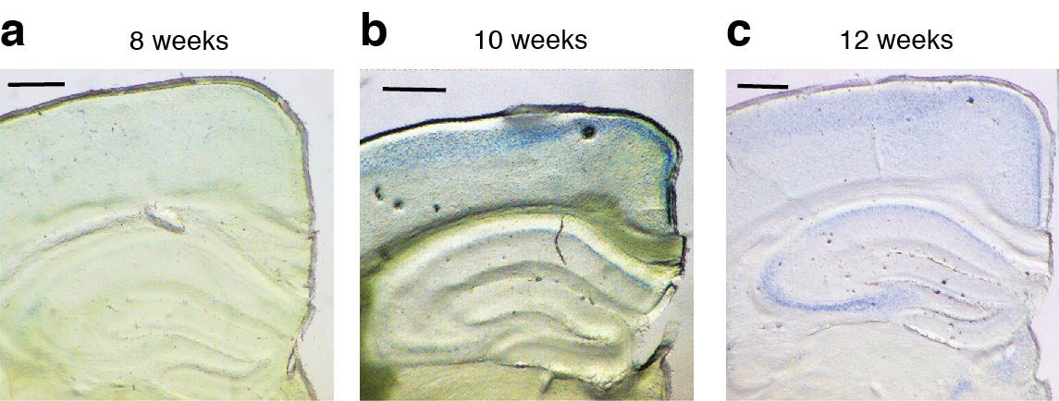

Supplementary Fig. 2. Syntaxin-3 protein is under the detection level by Immunohistochemistry. Immunohistochemical staining of Syntaxin-3 on the hippocampus (red). (a) Syntaixn-3 signal is not able to detect on the hippocampus. (b) DAPI staining of hippocampus section (Blue). (c) Merged picture of Syntaxin-3 staining and DAPI. Scale bar: 200 µm
