Supplementary information
Long-term Proton Pump Inhibitor Administration Caused Physiological and Microbiota Changes in Rats
Yu-Chen SH Yang^{1#}, Hsuen-Wen Chang^{2#}, I-Hsuan Lin³, Li-Nien Chien⁴, Min-Ju Wu⁵, Yun-Ru Liu¹, Peiguo G. Chu⁶, Guoxiang Xie⁷, Fangcong Dong⁷, Wei Jia⁷, Vincent HS Chang^{5*}, Yun Yen^{3, 8, 9, 10, 11*}
¹Joint Biobank, Office of Human Research, Taipei Medical University, Taipei, Taiwan
²Laboratory Animal Center, Office of Research and Development, Taipei Medical University, Taipei, Taiwan
³TMU Research Center of Cancer Translational Medicine, Taipei Medical University, Taipei, Taiwan
⁴School of Health Care Administration, College of Management, Taipei Medical University, Taipei, Taiwan
⁵The PhD Program for Translational Medicine, College of Medical Science and Technology, Taipei Medical University, Taiwan
⁶Department of Pathology, City of Hope National Medical Center, Duarte, CA 91010, USA
⁷University of Hawaii Cancer Center, Honolulu, Hawaii 96815, USA
⁸The PhD Program for Cancer Biology and Drug Discovery, College of Medical Science and Technology, Taipei Medical University, Taipei, Taiwan.
⁹Division of Chemistry and Chemical Engineering, California Institute of Technology, Pasadena, CA, 91125, USA
¹⁰Graduate Institute of Cancer Biology and Drug Discovery, TMU
¹¹Cancer Center, Taipei Municipal WanFang Hospital
#These authors contributed equally to this work
*corresponding authors
Dr. Yun Yen.
The PhD Program for Cancer Biology and Drug Discovery, College of Medical Science and Technology, Taipei Medical University, Taipei, Taiwan; Phone: 886-2-27361661 ext.2008; Fax: 886-2-23787795; E-mail: [yyen@tmu.edu.tw] and [yunyen@caltech.edu].
Dr. Vincent HS Chang.
Departmentof Physiology, School of Medicine, College of Medicine, Taipei Medical University, Taipei, Taiwan; Phone: 886-2-27361661 ext. 7503; E-mail: [vinhschang@tmu.edu.tw].

Supplementary Figure 1
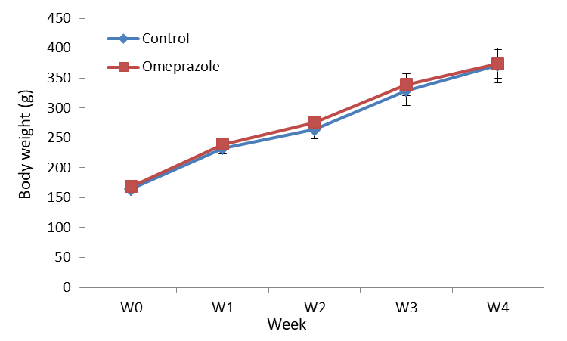
Supplementary Figure 1 : The body weights of rat treated with omeprazole. The body weights of rats in treatment and control groups were measured before and during treatment each week for 30 days. Long-term omeprazole treatment did not change body weights.

