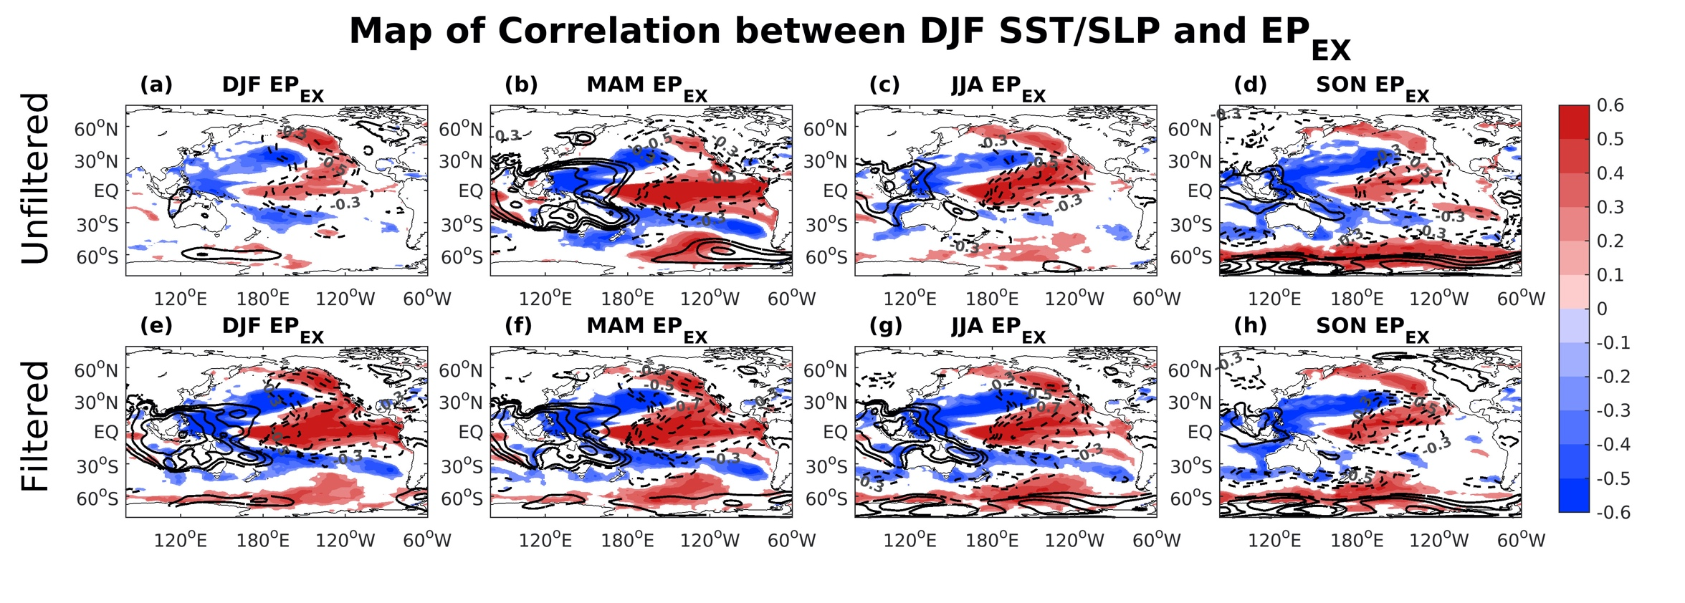
Figure S1. Correlation between the (a-d) unfiltered and (e-h) EEMD filtered EP_{EX} during the DJF, MAM, JJA, and SON and the following DJF SST (shading) and SLP (contours) anomalies.

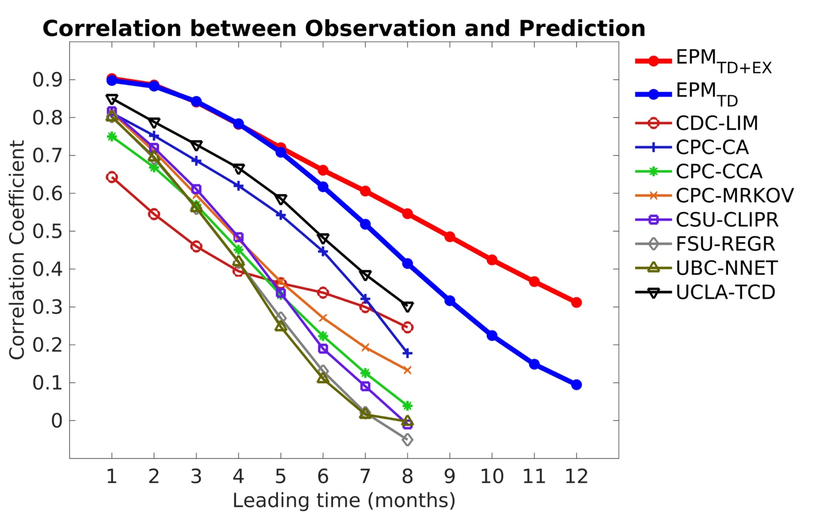
Figure S2. Correlation between 3-month running mean observed and predicted Niño34 index based on the tropical dynamics only (${EPM}_{TD}$; blue curve), tropical and extratropical precursors together (${EPM}_{TD+EX}$; red curve) during 2002-2018. The correlation between observations and statistical model forecasts presented in IRI ENSO plume are shown with thin curves and different markers.

