Supplementary information
Spatio-temporal genetic tagging of a cosmopolitan planktivorous shark provides insight to gene flow, temporal variation and site-specific re-encounters
Lilian Lieber, Graham Hall, Jackie Hall, Simon Berrow, Emmett Johnston, Chrysoula Gubili, Jane Sarginson, Malcom Francis, Clinton Duffy, Sabine P. Wintner, Phil D. Doherty, Brendan J. Godley, Lucy A. Hawkes, Matthew J. Witt, Suzanne M. Henderson, Eleonora de Sabata, Mahmood S. Shivji, Deborah A. Dawson, David W. Sims, Catherine S. Jones, Leslie R. Noble

Supplementary Table S1: Initial basking shark sample sizes per site and final sample sizes shown following matching analyses (pairs of samples were regarded as matches when genotypes mismatched at three or fewer loci).
Site | Initial sample sizes | N taken out after matching analysis | Sample sizes* after matching analysis
IoM09 | 9 | 1 | 8
IoM10 | 35 | 8 | 27
IoM11 | 12 | 1 | 11
IoM12 | 38 | 9 | 29
IoM13 | 24 | 2 | 22
IRE09 | 15 | 4 | 11
IRE10 | 34 | 2 | 32
IRE11 | 23 | 5 | 18
IRE12 | 21 | 3 | 18
IRE14 | 31 | 3 | 28
MF13 | 22 | 2 | 20
SCO12 | 62 | 9 | 53
SCO13 | 57 | 2 | 55
SCO14 | 5 | 0 | 5
S_ENG | 6 | 0 | 6
MED | 11 | 0 | 11
SA | 5 | 1 | 4
PAC | 38 | 0 | 38
NWA | 12 | 1 | 11
TOTAL | 460 | 53 | 407
Sampling locations include: IoM= Isle of Man, IRE= Ireland, MF= Moray Firth, Scotland, SCO= West Scotland, with year indicated accordingly and S_ENG= South England, MED= Mediterranean; SA= South Africa; PAC= New Zealand, NWA= Northwest Atlantic N, number of individuals, *, Samples sizes used for measures of genetic differentiation, probability of identity and microsatellite characterisation.

Supplementary Table S2: Final sample sizes of the nine global, putative populations following matching and relatedness analyses and the total removal of 53 individuals. These samples were taken for all measures of differentiation and genetic diversity estimates.
Sample sizes for 9 putative populations | Site
97 | IoM
89 | IRE
18 | IRE_12
133 | SCO
6 | S_ENG
11 | MED
4 | SA
38 | PAC
11 | NWA
Global sampling locations include: IoM= Isle of Man, IRE= Ireland, IRE_12= Ireland (from 2012 only) SCO= West Scotland and the Moray Firth, S_ENG= South England, MED= Mediterranean; SA= South Africa; PAC= New Zealand, NWA= Northwest Atlantic.

Supplementary Table S3: Characterisation of 19 microsatellite loci in 407 basking sharks
Locus | N | k | error rate | H_{O} | H_{E} | PIC | HWE | F(Null)
1HA5 | 399 | 11 | 0.0115 | 0.591 | 0.632 | 0.602 | NS | 0.036
1HC2 | 353 | 6 | 0.0115 | 0.470 | 0.483 | 0.403 | NS | 0.007
1HF4 | 404 | 6 | 0.0115 | 0.636 | 0.632 | 0.571 | NS | -0.010
Cmax01 | 405 | 3 | 0.0115 | 0.506 | 0.502 | 0.377 | NS | -0.005
Cmax02 | 406 | 3 | 0.0115 | 0.224 | 0.240 | 0.212 | NS | 0.034
Cmax03 | 405 | 5 | 0 | 0.652 | 0.650 | 0.578 | NS | 0.001
Cmax04 | 407 | 7 | 0.0115 | 0.742 | 0.711 | 0.662 | NS | -0.026
Cmax05 | 407 | 5 | 0.0115 | 0.538 | 0.517 | 0.400 | NS | -0.022
Cmax06 | 391 | 15 | 0.0115 | 0.754 | 0.779 | 0.749 | NS | 0.017
Cmax07 | 394 | 18 | 0 | 0.802 | 0.879 | 0.867 | NS | 0.044
Cmax08 | 365 | 9 | 0 | 0.795 | 0.767 | 0.736 | NS | -0.021
Cmax09 | 407 | 4 | 0.0115 | 0.570 | 0.555 | 0.492 | NS | -0.018
Cmax10 | 406 | 5 | 0.0115 | 0.761 | 0.706 | 0.654 | NS | -0.040
Cmax11 | 407 | 7 | 0.0115 | 0.796 | 0.745 | 0.700 | NS | -0.035
Cmax15 | 401 | 13 | 0.023 | 0.738 | 0.790 | 0.762 | NS | 0.033
Cmax16 | 405 | 6 | 0.0115 | 0.669 | 0.692 | 0.641 | NS | 0.017
Cmax17 | 407 | 10 | 0.0115 | 0.828 | 0.815 | 0.792 | NS | -0.008
Cmax18 | 406 | 15 | 0 | 0.865 | 0.873 | 0.859 | NS | 0.006
Cmax19 | 405 | 6 | 0.0115 | 0.560 | 0.594 | 0.544 | NS | 0.024
Mean | 399 | 8 | 0.0097 | 0.658 | 0.661 | 0.611 | NS | 0.002
Characteristics per locus calculated in CERVUS v. 3.0.3*, where N, number of individuals genotyped; k, number of alleles; error rate, based on re-genotyping of 87 individuals where mean error rate per locus was calculated as the ratio between the number of single-locus genotypes including at least one allelic mismatch and the number of replicated single-locus genotypes ; H_{O}, observed heterozygosity; H_{E}, expected heterozygosity; PIC, Polymorphic Information Content, HWE, significance testing for Hardy-Weinberg equilibrium (HWE) where NS=not significantly different from HWE; F(Null), estimated frequency of null alleles. *Kalinowski, ST, Taper, ML & Marshall, TC (2007) Revising how the computer program CERVUS accommodates genotyping error increases success in paternity assignment. Molecular Ecology 16: 1099-1106.

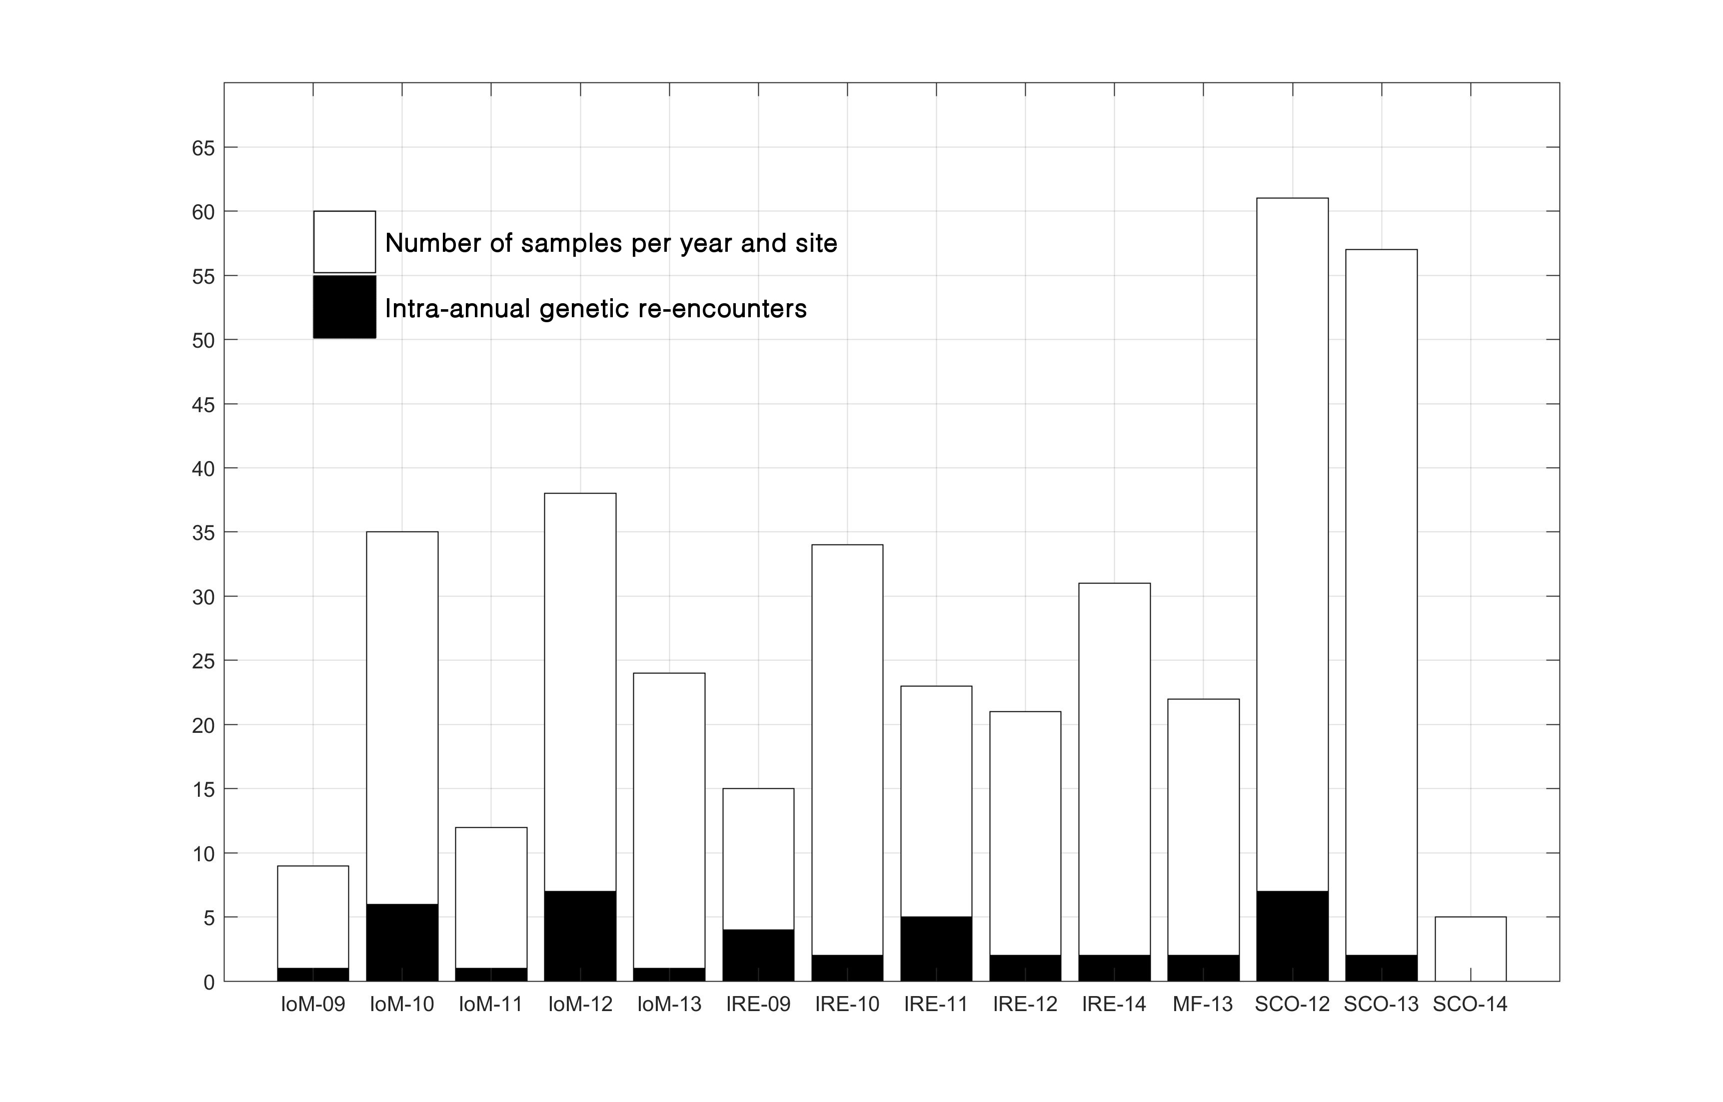
Supplementary Figure S1: Number of individuals sampled and intra-annual genetically confirmed re-encounters (individuals sampled repeatedly within a site and year) on the y-axis, and sites (where IoM =Isle of Man, IRE= Ireland, MF= Moray Firth, SCO= Scotland; and numbers represent sampling years post 2000) on the x-axis.

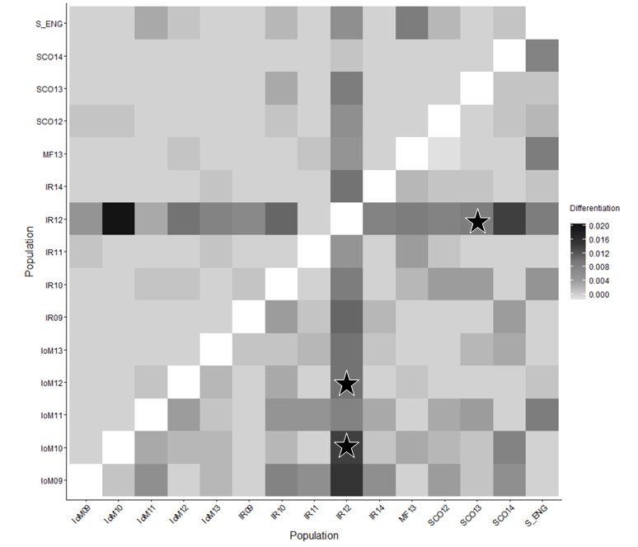
Supplementary Figure S2: Pairwise DST (above diagonal) and GST (below diagonal) genetic differentiation among Northeast Atlantic (NEA) samples (IoM =Isle of Man; SCO= Scotland; MF= Moray Firth; IR= Ireland; S_ENG= South England; where the numbers represent sampling years post 2000). Stars () indicate significant comparisons at 95% confidence intervals using 1,000 bootstraps.

Supplementary Table S4: Wright’s pairwise FST comparisons between 15 Northeast Atlantic temporal samples below the diagonal, with annotated significance level at the 5 % level (bold) above. None were significant using the Bonferroni-corrected level (α = 0.000476). IoM =Isle of Man; SCO= Scotland; MF= Moray Firth; IR= Ireland; S_ENG= South England; where the numbers represent sampling years post 2000.
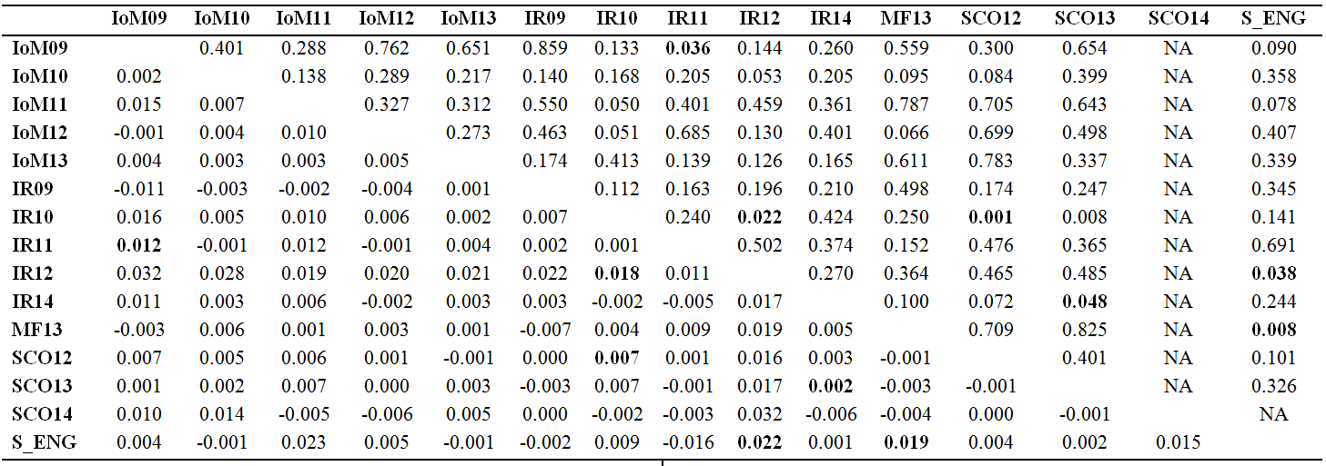

Supplementary Figure S3: Principal Coordinates Analysis (PCoA) of Nei’s pairwise genetic distances in the Northeast Atlantic sample (IoM = Isle of Man; SCO= Scotland; MF= Moray Firth; IR= Ireland; where the numbers represent sampling years post 2000). SCO_14 and S_ENG have been excluded due to very low sample sizes.

Supplementary Table S5: Means of the posterior distributions of m (along with their standard deviations), the migration rate into each population, are shown. The source ‘populations’ from which individuals migrated are listed in the columns, while the ‘populations’ from which individuals were sampled are listed in the rows. Values along the diagonal (italic & bold) are the proportions of individuals derived from the source populations each generation, while migration rates >0.10 are shown in bold. F, given in the columns, denotes the population-specific inbreeding coefficient as estimated in BayesAss. Sampling locations include: IoM= Isle of Man, IRE= Ireland, IRE_12= Ireland (from 2012 only), SCO= West Scotland.
 | IoM (F=0.0174 ± 0.0080) | IRE (F=0.2652 ± 0.2087) | IRE_12 (F=0.3589 ± 0.2512) | SCO (F=0.1614 ± 0.1153)
IoM | 0.9529 (± 0.0254) | 0.3115 (± 0.0118) | 0.2632 (± 0.0369) | 0.3205 (± 0.0073)
IRE | 0.0135 (± 0.0111) | 0.6726 (± 0.0061) | 0.0210 (± 0.0205) | 0.0043 (± 0.0043)
IRE_12 | 0.0033 (± 0.0034) | 0.0037 (± 0.0037) | 0.6844 (± 0.0171) | 0.0024 (± 0.0024)
SCO | 0.0303 (± 0.0235) | 0.0122 (± 0.0101) | 0.0314 (± 0.0270) | 0.6729 (± 0.0054)

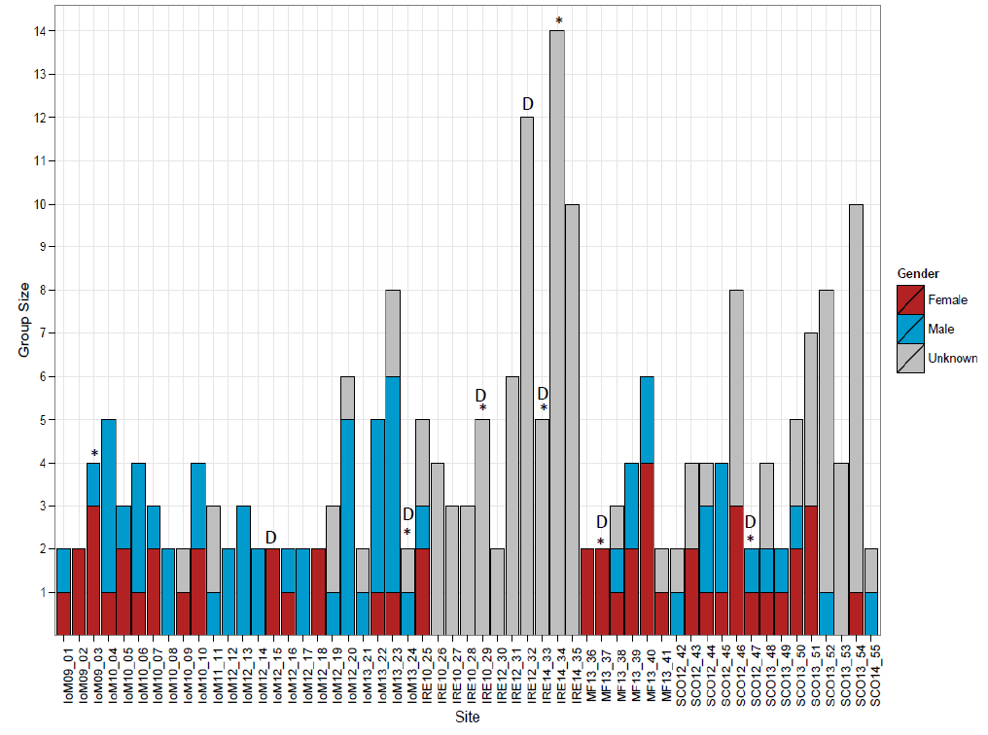
Supplementary Figure S5: Number of individuals and gender composition (where available) of basking shark groups (n=55) sampled around the Isle of Man (IoM, 2009-2013), Ireland (IRE, 2010-2012, 2014), the Moray Firth, Scotland (MF, 2013) and the West Coast of Scotland (SCO, 2012-2014). Groups that are significantly (p<0.05) more related than expected by chance based on a 1000 MCMC iterations using the relatedness estimators LynchRD and Dydad_F (accounting for inbreeding) are marked with an asterisk ‘*’, or with a ‘D’, respectively.

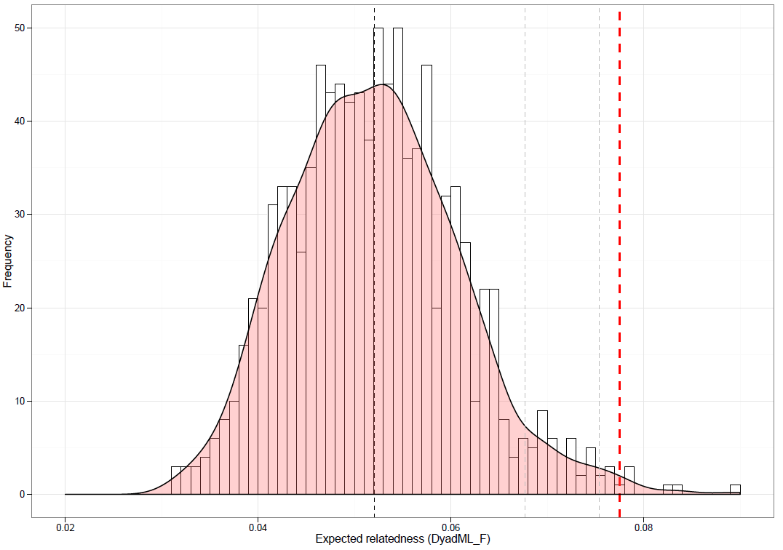

Supplementary Figure S6: Histogram with kernel density curve of observed, average within-group relatedness based on the likelihood method ‘DyadML’⁷⁴ with inbreeding taken into account. Average within group relatedness examined across all 55 groups (red dashed line= 0.0775, p<0.008) and expected pattern of relatedness using a 1000 iterations. The iteration’s mean (=0.0521) is shown as a dark grey dashed line and the 95% (0.0677) and 99% (0.0754) quantiles shown as a light grey dashed line, respectively.

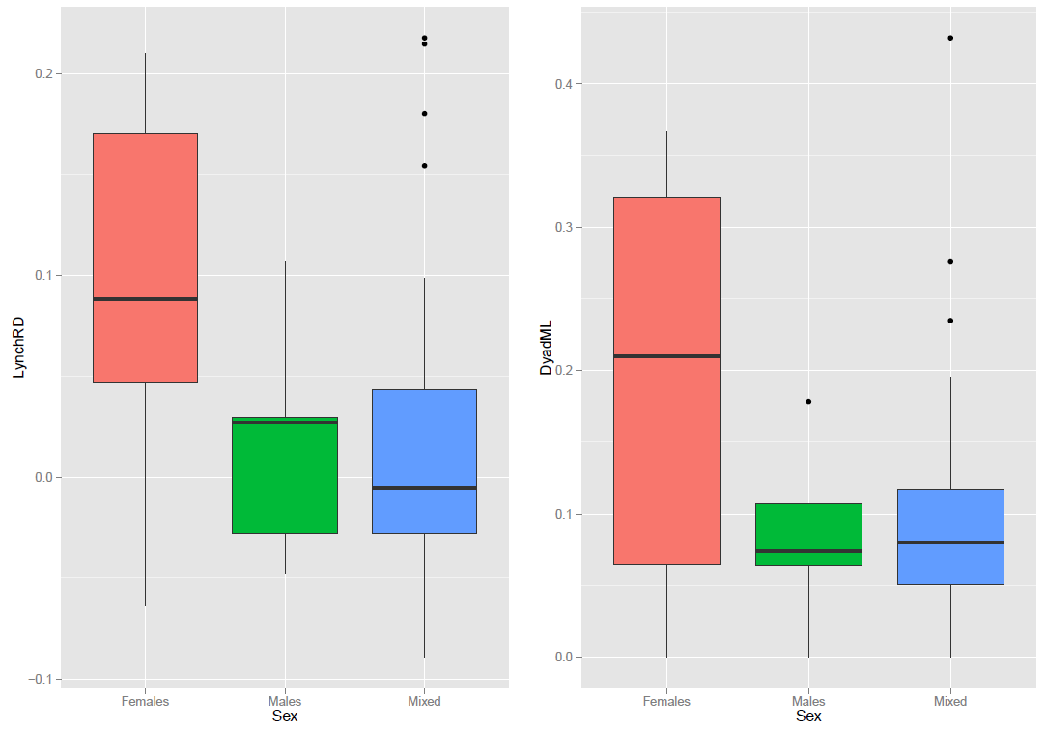
Supplementary Figure S7: Boxplots showing the variance in within-group relatedness of basking shark groups (n=55) by sex based on LynchRD (left) and DyadML (right). There were only five all-female groups (‘Females’), five all-male groups (‘Males’) and 45 mixed-sex groups (‘Mixed’; also applied to groups of unknown sexes). Sampling sites include the Isle of Man (IoM, 2009-2013), Ireland (IRE, 2010-2012, 2014), the Moray Firth, Scotland (MF, 2013) and the West Coast of Scotland (SCO, 2012-2014).

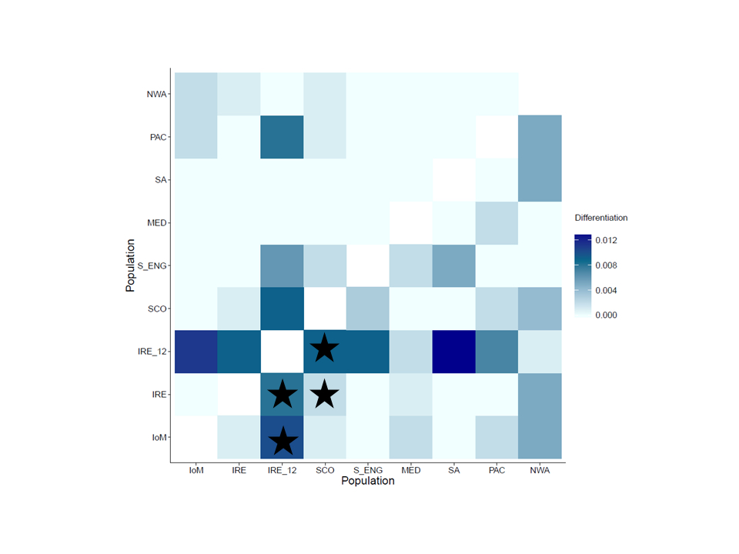Supplementary Figure S8: Pairwise D_{ST} (above diagonal) and G_{ST} (below diagonal) genetic differentiation among global samples with annotated () significant comparisons (when 95% confidence limits were not bounded by zero after a 1,000 bootstraps). IoM=Isle of Man (n=97); IRE= Ireland (n=89); IRE_12= Irish samples from 2012 (18); SCO= Scotland (n=133); S_ENG= South England (n=6); MED= Mediterranean (n=11); SA= South Africa (n=4); PAC= New Zealand (n=38); NWA= Northwest Atlantic (n=11).

Supplementary Table S7: Wright’s pairwise FST comparisons between nine global samples below the diagonal, with annotated significance level at the 5 % level (bold) above. None were significant using the Bonferroni-corrected level (α = 0.001389). Where IoM= Isle of Man; IRE= Ireland; IRE_12= Irish samples from 2012; SCO= Scotland; S_ENG= South England; MED= Mediterranean; SA= South Africa; PAC= New Zealand; NWA= Northwest Atlantic.
 | IoM | IRE | IRE_12 | SCO | S_ENG | MED | SA | PAC | NWA
IoM |  | 0.046 | 0.122 | 0.296 | 0.167 | 0.093 | 0.946 | 0.043 | 0.313
IRE | 0.002 |  | 0.235 | 0.003 | 0.299 | 0.685 | 0.956 | 0.129 | 0.429
IRE_12 | 0.020 | 0.016 |  | 0.461 | 0.035 | 0.324 | 0.690 | 0.283 | 0.586
SCO | 0.001 | 0.003 | 0.017 |  | 0.107 | 0.307 | 0.982 | 0.072 | 0.429
S_ENG | 0.001 | -0.001 | 0.022 | 0.005 |  | 0.076 | 0.289 | 0.474 | 0.139
MED | 0.005 | 0.001 | 0.004 | 0.000 | 0.001 |  | 0.975 | 0.536 | 0.388
SA | -0.007 | -0.007 | 0.033 | -0.011 | 0.021 | -0.028 |  | 0.878 | 0.260
PAC | 0.005 | 0.001 | 0.013 | 0.004 | -0.008 | 0.002 | -0.004 |  | 0.414
NWA | 0.010 | 0.009 | 0.005 | 0.008 | 0.007 | -0.004 | 0.022 | 0.009

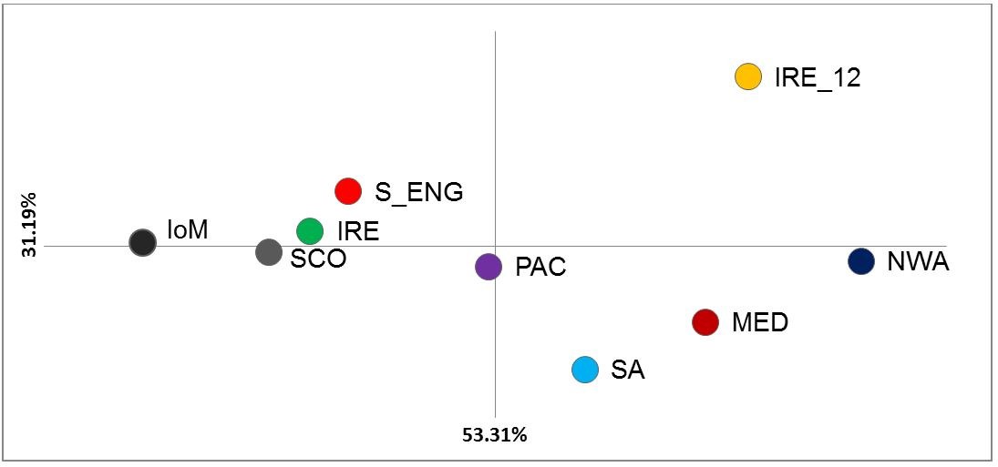
Supplementary Figure S9: Principal Coordinates (PCoA) analysis on Nei’s pairwise genetic distance matrix between global samples. Axis 1 explains 53.31% and axis 2, 31.19% of the variation in the data; where IoM= Isle of Man (n=97); IRE= Ireland (n=89); IRE_12= Irish samples from 2012 (18); SCO= Scotland (n=133); S_ENG= South England (n=6); MED= Mediterranean (n=11); SA= South Africa (n=4); PAC= New Zealand (n=38); NWA= Northwest Atlantic (n=11).

 | Lowest Allele  Frequency | Estimated  N_{e} | 95% CIs  (Parametric) | 95% CIs  (Jack–knife)
IoM | 0.05 | 529.1 | 272.8 – 3861.7 | 253.3 – 43784.8
IoM | 0.02 | 381.6 | 241.4 – 830.2 | 237.6 – 871.7
IRE | 0.05 | 386 | 212 – 1549.8 | 188.6 – 6016.3
IRE | 0.02 | 623.1 | 297.1 – Infinite | 274.2 – Infinite
IRE_12 | 0.05 | 342.3 | 55.4 – Infinite | 53.8 – Infinite
IRE_12 | 0.02 | 111.3 | 44.4 – Infinite | 44.6 – Infinite
SCO | 0.05 | Infinite | 2678.2 – Infinite | 1398.9 – Infinite
SCO | 0.02 | Infinite | 2344.7 – Infinite | 1505.7 – Infinite
S_ENG | 0.05  0.02 | Infinite  Infinite | 81.8 – Infinite  81.8 – Infinite | Infinite – Infinite  Infinite – Infinite
MED | 0.05 | Infinite | 41.6 – Infinite | 48.7 – Infinite
MED | 0.02 | Infinite | 35.1 – Infinite | 41.5 – Infinite
SA | 0.05 | 2.9 | 1.5 – 25.4 | 1.9 – 9.4
SA | 0.02 | 2.9 | 1.5 – 25.4 | 1.9 – 9.4
PAC | 0.05 | 208 | 91.1 – Infinite | 79.1 – Infinite
PAC | 0.02 | 522.9 | 154.4 – Infinite | 132 – Infinite
NWA | 0.05 | 8 | 4.4 – 14.4 | 4.8 – 13.1
NWA | 0.02 | 8.7 | 4.9 – 15.9 | 5.5 – 14.2
Supplementary Table S8: N_{e} estimator outputs per sampling site with P_{crit}=0.05 and 0.02 denoted as lowest allele frequency used.
Sampling locations include: IoM= Isle of Man, IRE= Ireland, IRE_12= Ireland (from 2012 only), SCO= West Scotland, S_ENG= South England, MED= Mediterranean; SA= South Africa; PAC= New Zealand, NWA= Northwest Atlantic.

Supplementary Table S9: Genetic diversity statistics derived from 19 microsatellite loci across all unique Northeast Atlantic, temporally collected basking shark samples.

Sampling site & year sampled | N | N_{dA} | N_{A} | P_{A} | A_{R} | N_{E} | H_{O} | H_{E} | HWE | F | r
IoM_2009 | 8 | 80 | 4 | 0.000 | NA | 3.022 | 0.658 | 0.604 | 0.803 | -0.067 | 0.020
IoM_2010 | 27 | 108 | 6 | 0.000 | 4.091 | 3.775 | 0.702 | 0.677 | 0.446 | -0.039 | -0.044
IoM_2011 | 11 | 90 | 5 | 0.105 | 3.967 | 3.177 | 0.684 | 0.617 | 0.878 | -0.113 | 0.039
IoM_2012 | 29 | 109 | 6 | 0.000 | 3.879 | 3.344 | 0.675 | 0.637 | 0.411 | -0.069 | 0.022
IoM_2013 | 22 | 106 | 6 | 0.000 | 3.965 | 3.341 | 0.651 | 0.639 | 0.132 | -0.015 | 0.012
IRE_2009 | 11 | 95 | 5 | 0.105 | 4.201 | 3.405 | 0.637 | 0.638 | 0.699 | -0.007 | -0.037
IRE_2010 | 32 | 111 | 6 | 0.053 | 4.047 | 3.551 | 0.661 | 0.663 | 0.181 | 0.010 | -0.024
IRE_2011 | 18 | 98 | 5 | 0.053 | 3.974 | 3.424 | 0.678 | 0.649 | 0.716 | -0.051 | -0.017
IRE_2012 | 18 | 98 | 5 | 0.105 | 3.842 | 3.117 | 0.658 | 0.609 | 0.115 | -0.064 | 0.101
IRE_2014 | 28 | 106 | 6 | 0.158 | 3.873 | 3.339 | 0.656 | 0.646 | 0.541 | -0.018 | -0.002
MF_2013 | 20 | 105 | 6 | 0.000 | 4.072 | 3.504 | 0.671 | 0.644 | 0.959 | -0.040 | -0.003
SCO_2012 | 53 | 122 | 6 | 0.105 | 3.977 | 3.529 | 0.642 | 0.648 | 0.218 | 0.003 | 0.007
SCO_2013 | 55 | 122 | 6 | 0.000 | 3.990 | 3.597 | 0.645 | 0.648 | 0.452 | 0.452 | 0.007
SCO_2014 | 6 | 70 | 4 | 0.000 | NA | 2.778 | 0.618 | 0.572 | 0.975 | -0.053 | 0.073
S_ENG | 5 | 67 | 4 | 0.000 | NA | 2.704 | 0.695 | 0.580 | 0.998 | -0.203 | 0.047
Sampling locations include: IoM= Isle of Man, IRE= Ireland, MF= Moray Firth, Scotland, SCO= West Scotland, S_ENG= South England, with year indicated accordingly; N, sample size; N_{dA}, number of different alleles; N_{A}, mean number of alleles across 19 loci; PA, number of private alleles; A_{R}, allelic richness based on 6 diploid individuals; N_{E}, number of effective alleles; H_{O}, observed heterozygosity; H_{E}, expected heterozygosity; HWE, p-value for Hardy-Weinberg equilibrium probability test; F, Fixation index (average inbreeding coefficient of subpopulations relative to the total population), r= mean group relatedness determined by 999 bootstraps where * indicates if different across putative populations determined by 999 permutations. NA= Non-applicable (samples excluded from allelic richness estimate due to low sample size).

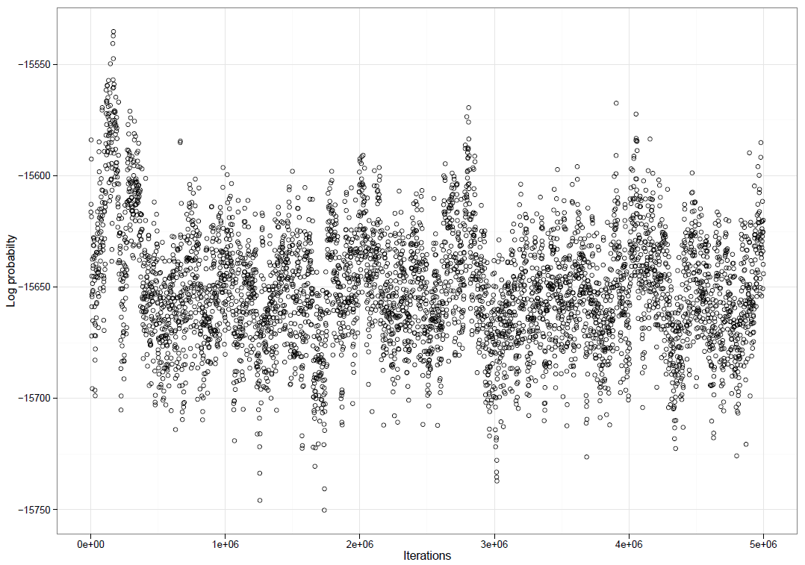

Supplementary Figure S9: Scatterplot of the trace file for log-probability analysis in BayesAss after 5,000,000 sample iterations, 50,000 burn-in iterations and a thinning interval of 1000 iterations, used for convergence diagnosis. The log-probability initially increases during the burn-in, but then oscillates regularly around a plateau, indicating that the MCMC chain has converged, sampling the whole parameter space.

