Syngeneic Mesenchymal Stem Cells Reduce Immune Rejection After Induced Pluripotent Stem Cell-Derived Allogeneic Cardiomyocyte Transplantation
Shohei Yoshida M.D., Ph.D., Shigeru Miyagawa M.D., Ph.D., Toshihiko Toyofuku M.D., Ph.D., Satsuki Fukushima M.D., Ph.D., Takuji Kawamura M.D., Ph.D., Ai Kawamura M.D., Ph.D., Noriyuki Kashiyama M.D., Ph.D., Yuki Nakamura M.D., Ph.D., Koichi Toda M.D., Ph.D., Yoshiki Sawa M.D., Ph.D.

SUPPLEMENTAL INFORMATION

Table SI. Lists of primary antibodies used in this study.
Table SII. Lists of primers used in this study.
Figure SI. Survival rate of transplanted induced pluripotent stem cell-derived cardiomyocytes (iPSC-CMs) with tacrolimus.
Figure SII. T cell receptor repertoire analysis.
Movie SI. Beating of murine induced pluripotent stem cell-derived cardiomyocyte (iPSC-CMs) on day 16.

SUPPLEMENTAL TABLE
Table SI. List of primary antibodies used in this study.
 | Antibodies | Source
For immunocytochemistry and immunohistochemistry
 | ms CD4 | Abcam, ab25475
 | ms CD8 | Abcam, ab22378
 | ms CD25 | R&D, AF2438
 | ms FOXP3 | Abcam, ab54501
 | ms Annexin V | Abcam, ab14196
 | TnT | Thermo scientific, MS-295-P1
 | α-actinin | Sigma-Aldrich, A7732
For flow cytometry
 | ms CD4 | BD Bioscience, 563729
 | ms CD8 | BD Bioscience, 553033
 | IL-4 | BD Bioscience, 554435
 | IFN-g | eBioscience
For T cell proliferation assay
 | ms CD3 | BD Bioscience, 553057
 | ms CD28 | Affymetrix, 16-0281-85
For Treg depletion model
 | ms CD25 | BioLegend, 102014

Table SII. Lists of primers used in this study.
Gene Name | Primers
GAPDH | taqman | Mm99999915_g1
FOXP3 | taqman | Mm00475162_m1
ITGAE | taqman | Mm00434443_m1
TGFB1 | taqman | Mm01178820_m1
MYH7B | taqman | Mm01249941_m1
IL2 | taqman | Mm00434256_m1
IL10 | taqman | Mm00439614_m1
TNNT2 | taqman | Mm01290256_m1
GAPDH | SYBR | F: 3′-CCAGTATGACTCCACTCACG-5′  R: 5′-GACTCCACGACATACTCAGC-3′
LIN28 | SYBR | F: 3′-CTGCTGTAGCGTGATGGTTGA-5′  R: 5′-CCACCCAATGTGTTCTATTGCA-3′
NANOG | SYBR | F: 3′-TCGCCATCACACTGACATGA-5′  R: 5′-TGTGCAGAGCATCTCAGTAGCA-3′
OCT4 | SYBR | F: 3′-TTTAACCCCAAAGCTCCAGG-5′  R: 5′-GGCTCTCCCATGCATTCAA-3′
ANP-1 | SYBR | F: 3′-AAAGAAACCAGAGTGGGCAGAG-5′  R: 5′-CCAGGGTGATGGAGAAGGAG-3′
NKX2.5 | SYBR | F: 3′-CAAGTGCTCTCCTGCTTTCC-5′  R: 5′-GGCTTTGTCCAGCTCCACT-3′
ISTL1 | SYBR | F: 3′-TTTCCCTGTGTGTTGGTTGC -5′  R: 5′-TGATTACACTCCGCACATTTCA-3′
MYH6 | SYBR | F: 3′-GAGATTTCTCCAACCCAG-5′  R: 5′-CCAGGGTGATGGAGAAGGAG-3′

SUPPLEMENTAL FIGURE
Figure SI. Survival rate of transplanted induced pluripotent stem cell-derived cardiomyocytes (iPSC-CMs) with tacrolimus.
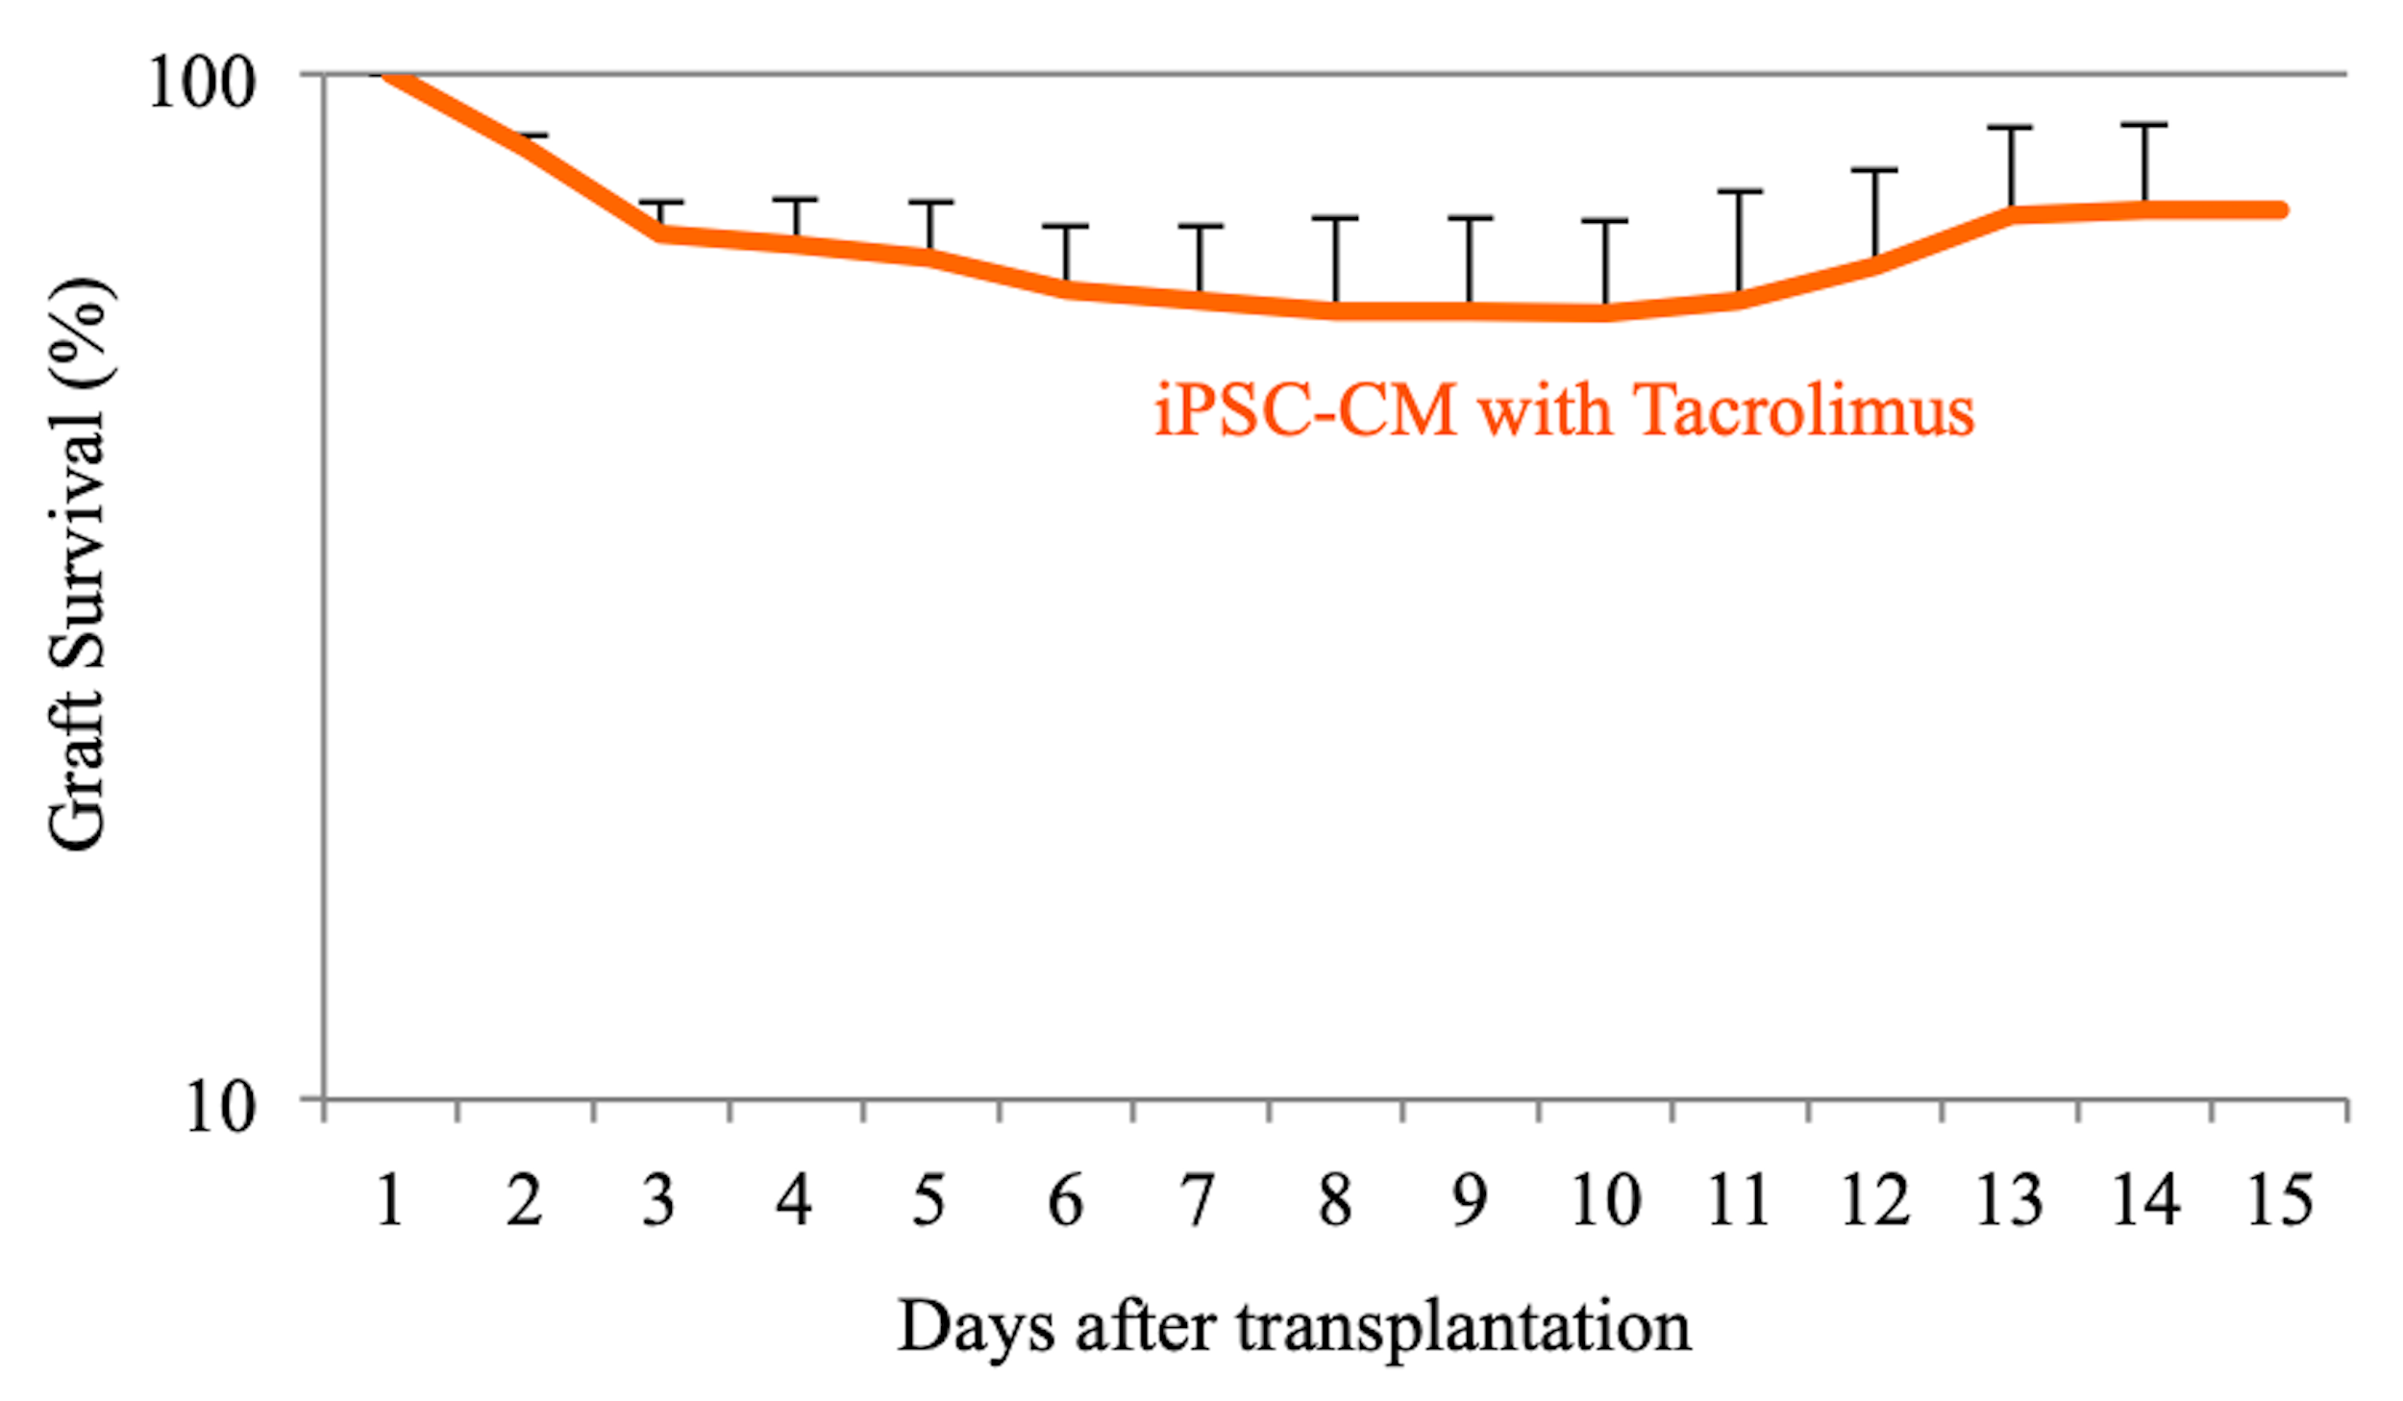Survival rate of allogeneic iPSC-CM sheets, which were transplanted with tacrolimus, using an in vivo imaging system (n = 15).

Figure SII. T cell receptor repertoire analysis.
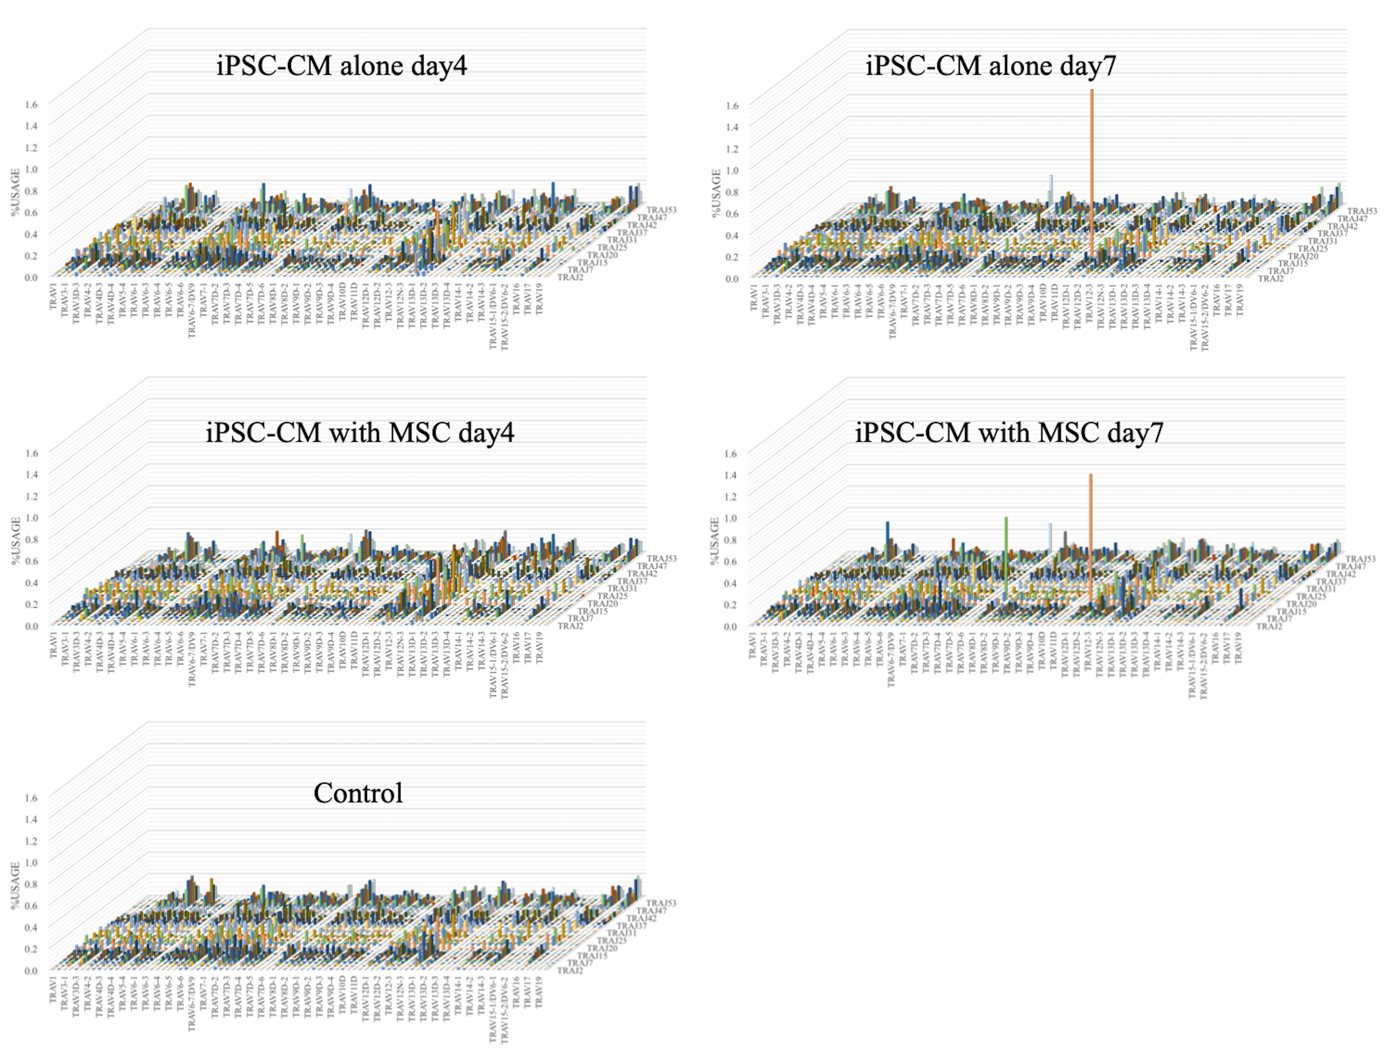The T cell receptor repertoire was analyzed using the spleens of induced pluripotent stem cell-derived cardiomyocyte (iPSC-CM) alone and iPSC-CM with mesenchymal stem cell (MSC) groups on day 4 and 7 after iPSC-CM sheet implantation and in a normal BALB/c mouse subjected to a sham operation as a control. Control and iPSC-CM alone and iPSC-CM with MSC groups on day 4 did not exhibit specific proliferated T cells, whereas specific T cells were identified in both iPSC-CM alone and iPSC-CM with MSC groups on day 7.
SUPPLEMENTAL MOVIE
Movie SI. Beating of murine induced pluripotent stem cell-derived cardiomyocyte (iPSC-CMs) on day 16.

