Supplementary information

A Cyclic-di-GMP signalling network regulates biofilm formation and surface associated motility of Acinetobacter baumannii 17978

^{1,2} Irfan Ahmad, ¹Evelina Nygren, ²Fizza Khalid, ¹Si Lhyam Myint and ¹Bernt Eric Uhlin

¹The Laboratory for Molecular Infection Medicine Sweden (MIMS) and the Department of Molecular Biology, Umea University, Umea, Sweden

²Institute of Biomedical and Allied Health Sciences, University of Health Sciences, Lahore, Pakistan

Figure S1
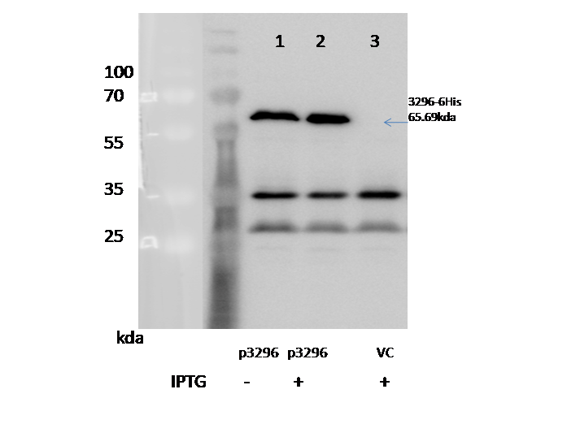

Figure S2: Immunoblot illustrating the expression of A1S_3296-6His through plasmid pMBB67EH in the presence and absence of inducer IPTG. 1&2: A. baumannii 17978 containing pMBB67:A1S_3296, 3: A. baumannii 17978 containing pMBB67 as a vector control (VC)

Table S1. Bacterial strains used in the study
Strain | Genotype | Reference
Escherichia coliDH5α | wild type | ATCC
Salmonella typhimurium SR11 | wild type | ATCC
Vibrio choleraeC6706luxO^{C} |  | (Vance et al., 2003)
Acinetobacter baumanniiATCC 17978 | wild type | ATCC
Δ3296:Km | Acinetobacter baumanniiATCC 17978where A1S_3296 is replaced by Km resistance gene | This study
Δ2986:Km | Acinetobacter baumanniiATCC 17978where A1S_2986 is replaced by Km resistance gene | This study
ΔpilA:Km | Acinetobacter baumanniiATCC 17978where pilA is replaced by Km resistance gene | This study
ΔcsuA:Km | Acinetobacter baumanniiATCC 17978where csuA is replaced by Km resistance gene | This study

Table S2. Plasmids used in the study
Plasmid | Genotype | Reference
pMMB67EH | Broad host range | (Fürste et al., 1986)
p0751 | pMMB67EH clone with locus A1S_0751 | This study
p1067 | pMMB67EH clone with locus A1S_1067 | This study
p2986 | pMMB67EH clone with locus A1S_2986 | This study
p3296 | pMMB67EH clone with locus A1S_3296 | This study
p1695 | pMMB67EH clone with locus A1S_1695 | This study
p2506 | pMMB67EH clone with locus A1S_2506 | This study
p0546 | pMMB67EH clone with locus A1S_0546 | This study
p1949 | pMMB67EH clone with locus A1S_1949 | This study
p2337 | pMMB67EH clone with locus A1S_2337 | This study
p1254 | pMMB67EH clone with locus A1S_1254 | This study
p2422 | pMMB67EH clone with locus A1S_2422 | This study
pPilA | pMMB67EH clone with locus pilA | This study

Table S3.Primers used in the study
Primer | 5`-3` Squence
Cloning Primers
0751_F | TCGCGAGCTCTGTAGGAACAAATTTATGATTGGTAGTTTTTGG
0751_R | AAAGTCTAGATTAGTGATGGTGATGGTGATGCAAAGAAATAAAAACTCTATTACGC
1067_F | GAAGGATCCTGTAGGAATCGACTAGTGGCGAATAGG
1067_R | TTCGTCGACTTAGTGATGGTGATGGTGATGGGCAATTTCAGCGACTTGTA
1695_F | TCGCGGTACCGAGAGCATTAATTATGAAGTTGCAAGG
1695_R | AAAGTCTAGATTAGTGATGGTGATGGTGATGAGTTAGATCTACAATTTGTTCTTC
2506_F | CCTGGAATTCTGTAGGAAGAAACGCATGGAAACTTTAGATTCTTC
2506_R | CGCAGGATCCTTAGTGATGGTGATGGTGATGTGGTAGAAGTAATTTCTTG
2986_F | TCGCGAGCTCTGTAGGAATTTTACGATGGAAACTTATGCAAAAC
2986_R | AAAGTCTAGATTAGTGATGGTGATGGTGATGATTCTCTGGTTTATAAATAAACC
3296_F | TCGCGAGCTCTGTAGGAAGCTAGAAATGTCAGGATTACGTTCA
3296_R | AAAGTCTAGATTAGTGATGGTGATGGTGATGTCCCTCTACTACATTTCGTCC
1949_F | CCTGGAATTCTGTAGGAAGCATGTTATGACTTCAATGT
1949_R | TTCGTCGACTTAGTGATGGTGATGGTGATGATTCATAGAATAGTGACTTTCTAGATA
2337_F | GAAGGATCCAGGATAGAAAAATCTTATGTCTGG
2337 – Rev | TTCGTCGACTTAGTGATGGTGATGGTGATGAATATGCGTATTTGTTTGTAGATATTG
1254_F | GAAGGTACCTGTAGGAATCTTTATATGGATATCTGTTTC
1254_R | TTCGTCGACTTAGTGATGGTGATGGTGATGTTCTTTATCGATCTTGATGGGCAAT
2422_F | TCGCGAGCTCTGTAGGAAAAGATTTATGGGAAGCATTAAAGTGAG
2422_R | AAAGTCTAGATTAGTGATGGTGATGGTGATGTTGGTCTTGTACGTCTGTTAAGC
0546_F | CCTGGAGCTCTGTAGGAAGTCCAATATGGGTCATGTTGATTACGA
0546_Rev | CGCAGGATCCTTAGTGATGGTGATGGTGATGAACAAAATGAGCACCTTGCGACTGAAT
pilA_F | CGTATCTAGAGGGAAAAAGGCTATGAATGCAC
pilA_R | CGTCGAAGCTTTTAATGGTGATGGTGATGGTGAATTATTGTACAGCCTTTTGGAGC
Sequencing Primers
pMMB67EH - forward | CACTGCATAATTCGTGTCGCTC
pMMB67EH – reverse | CTGTATCAGGCTGAAAATCTTCTC
0546_Seq | CCAATATCAGGCTGAACATGAC
2337_1 | CAAATGCCTTGTAGCACTAA
2337_2 | ACCTTCCTAACCGCTTTTACT
2337_3 | CACATATCATCTTGATGGTTC
Gene deletion Primers
pilA-ko-1f | ATGAATGCACAAAAAGGTTTTACATTAATTGAACTCATGATCGTGGTTGCCATTATCGGTATTTTGGCAGCAATTGCGATTCCGCAATATCAGAAGATTGTGTAGGCTGGAGCTGCTTCC
pilA-ko-1r | TTAAATTATTGTACAGCCTTTTGGAGCAATTACTGAAGAAATATCTGTTGTTCCTTTAGTAATAGAACATGTCCAGCCACCCACATTTGCATATGAATATCCTCCTTAGTTCCTATTCCG
pilA-control-f | GCAATACCAGAAAGCTGTAGTTAC
pilA-control-rev | CTTAACCCTGCTGCAAAGGCA
A1S_2986_Ko_F | ATGGAAACTTATGCAAAACAAAATTTGCAATTACTTAGCCATACTCTTCTTGAGCGTATTCAACCTGCCGTTGTGTTTAACGATAAGATCACGATCCCGGAATTGCCAGCTGGG
A1S_2986_Ko_R | TTAATTCTCTGGTTTATAAATAAACCAATGTTGCTCAGAAGTCTTAGCCTTATACATCGCTTGATCTGCTTGCATAATAAAATCTTCTGGATTCAGAAGAACTCGTCAAG
A1S_2986_Control_F | TTGGCTAAGAACGCGGAGTAA
A1S_2986_Control_R | GCACAGCAATGCAATAAAGG
A1S_3296_ko_F | ATGTCAGGATTACGTTCAGAACATATCAGTAATCGACTGTTTTTCTTCATGTTGGTCATTATTTTGTCCTTACTGTTTATGGCGGTTCCGCTTATTCCGGAATTGCCAGCTGGG
A1S_3296_ko_R | TTATCCCTCTACTACATTTCGTCCCCGAGCTTTAGCTCTTAAGAGTGAACGATCAGCGTTCTCTAATAACTCCATCCAGCTTGTCGCTCCATTCAGAAGAACTCGTCAAG
A1S_3296_control_F | ACAGCAGTGGCTAAACCAAG
A1S_3296_control_R | GCTTCTTGAAACCGATGTTGA
csuA_ko_F | ATGATATTCAATCGTGGTTCGGCATTTATAATTTCTTATTTTTTAATTTCTTTAGTAAATGCGGGTGAAATTGGAGCTAAATTAACTAGTCAAATTGAATCCGGAATTGCCAGCTGGG
CsuA_ko_R | TTAAAACTCAATCGTAATTGGTACTATATCTTTATATTCACCCTTAGATATACGACTACCATCATGGGTTGCTTGACCAAAAATATCGATATTCTTTTTATTCAGAAGAACTCGTCAAG
CsuA_Control_F | GGCGATTATAAAGATACTC
CsuA_Control_R | GAATTGAGCTGAGGATCT

