Supplementary Information
Performance comparison of next generation sequencing analysis pipelines for HIV-1 drug resistance testing

Emma R. Lee¹, Neil Parkin², Cheryl Jennings³, Chanson J. Brumme^{4,5}, Eric Enns⁶, Maria Casadellà⁷, Mark Howison⁹, Mia Coetzer¹⁴, Santiago Avila Rios¹⁰, Rupert Capina¹, Eric Marinier⁶, Gary Van Domselaar^{6,11}, Marc Noguera-Julian⁷, Don Kirby^{4,5}, Jeff Knaggs^{4,5}, Richard Harrigan¹², Miguel Quiñones-Mateu¹³, Roger Paredes^{7,8} , Rami Kantor¹⁴, Paul Sandstrom^{1,11}, Hezhao Ji^{1,11 §}

¹ National HIV and Retrovirology Laboratories, National Microbiology Laboratory at JC Wilt Infectious Diseases Research Centre, Public Health Agency of Canada, Winnipeg, Manitoba, Canada
² Data First Consulting Inc., Belmont, California, USA
³ Virology Quality Assurance Program, Rush Medical College, Chicago, USA
⁴ British Columbia Center for Excellence in HIV/AIDS, University of British Columbia, Vancouver, British Columbia, Canada
⁵ Division of Infectious Diseases, Faculty of Medicine, University of British Columbia, Vancouver, Canada
⁶ Bioinformatics Core at the National Microbiology Laboratory, Public Health Agency of Canada, Winnipeg, Manitoba, Canada
⁷ IrsiCaixa AIDS Research Institute, Badalona, Catalonia, Spain
⁸ Infectious Diseases Service, Hospital Germans Trias, Badalona, Catalonia, Spain
⁹ Research Improving People’s Lives, Providence, Rhode Island, USA
¹⁰ Centre for Research in Infectious Diseases, National Institute of Respiratory Diseases, Mexico City, Mexico
¹¹ Department of Medical Microbiology and Infectious Diseases, University of Manitoba, Winnipeg, Manitoba, Canada
¹² Division of AIDS, Department of Medicine, University of British Columbia, Vancouver, Canada
¹³ Department of Microbiology and Immunology, University of Otago, Dunedin, New Zealand
¹⁴ Division of Infectious Diseases, Brown University Alpert Medical School, Providence, Rhode Island, USA.

§ Corresponding author at:
National HIV & Retrovirology Laboratories
National Microbiology Laboratory at JC Wilt Infectious Diseases Research Centre,
Public Health Agency of Canada,
Winnipeg, Canada
Tel: 1-204-789-6521
Fax: 1-204-318-2221
Email: hezhao.ji@canada.ca

Supplemental Data
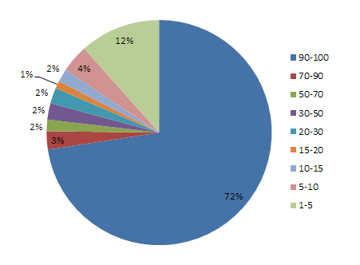
Supplementary Figure S1. Distribution of AAV frequencies.

 | HyDRA | MiCall | DEEPGEN | PASeq | hivmmer
Slope | 0.9984 ± 0.0014 | 1.001 ± 0.0007 | 0.9892 ± 0.0035 | 1.003 ± 0.0023 | 0.9958 ± 0.0024
r² | 0.9928 | 0.9981 | 0.9567 | 0.9822 | 0.9917
Supplementary Table S1. Linear aggression analysis between observed and expected AAV frequencies for each pipeline.

 |  | Pipeline
Source of FASTQ data | % threshold | HyDRA | Micall | DEEPGEN | PASeq | Hivmmer
Brown University | ≥1% | 99.83 | 100 | 99.83 | 99.83 | 99.48
Providence, USA | ≥2% | 99.79 | 100 | 100 | 99.79 | 99.57
 | ≥5% | 99.82 | 100 | 99.82 | 99.82 | 99.46
 | ≥10% | 99.81 | 100 | 99.81 | 99.81 | 99.81
 | ≥15% | 99.8 | 100 | 99.8 | 99.8 | 99.8
 | ≥20% | 99.8 | 100 | 99.8 | 99.8 | 99.8
National Microbiology | ≥1% | 99.85 | 99.09 | 99.39 | 99.39 | 98.78
Laboratory, PHAC | ≥2% | 99.84 | 100 | 99.34 | 99.67 | 99.18
Winnipeg, Canada | ≥5% | 99.81 | 100 | 99.63 | 99.63 | 100
 | ≥10% | 99.8 | 100 | 100 | 99.6 | 100
 | ≥15% | 99.79 | 100 | 100 | 99.59 | 100
 | ≥20% | 99.79 | 100 | 100 | 99.58 | 100
British Columbia | ≥1% | 99.83 | 100 | 99.5 | 99.83 | 99.5
Center for Excellence | ≥2% | 99.83 | 100 | 100 | 99.83 | 99.66
in HIV/AIDS | ≥5% | 100 | 100 | 99.46 | 99.82 | 100
Vancouver, Canada | ≥10% | 100 | 100 | 99.61 | 99.8 | 100
 | ≥15% | 100 | 100 | 99.6 | 99.8 | 100
 | ≥20% | 100 | 100 | 99.6 | 99.8 | 100
Case Western | ≥1% | 99.63 | 99.81 | 98.88 | 99.25 | n/a
Reserve University | ≥2% | 99.77 | 99.77 | 98.87 | 100 | n/a
Cleveland, USA | ≥5% | 99.81 | 99.81 | 99.04 | 100 | n/a
 | ≥10% | 99.81 | 99.81 | 99.04 | 100 | n/a
 | ≥15% | 99.81 | 99.81 | 99.42 | 100 | n/a
 | ≥20% | 99.8 | 99.8 | 99.41 | 100 | n/a
IrisCaxia AIDS | ≥1% | 100 | 100 | 99.78 | 99.33 | 99.33
Research Institute | ≥2% | 100 | 100 | 99.77 | 99.77 | 99.77
Badalona, Spain | ≥5% | 100 | 100 | 99.76 | 99.76 | 99.76
 | ≥10% | 100 | 100 | 99.76 | 99.76 | 99.76
 | ≥15% | 100 | 100 | 99.76 | 99.76 | 99.76
 | ≥20% | 100 | 100 | 99.76 | 99.76 | 99.76
Center for Research | ≥1% | 99.4 | 99.85 | 96.54 | 96.24 | 99.7
in Infectious Diseases | ≥2% | 99.82 | 100 | 97.05 | 99.63 | 99.82
(CIENI) | ≥5% | 99.79 | 100 | 97.32 | 100 | 100
Mexico City, Mexico | ≥10% | 99.78 | 100 | 97.83 | 100 | 100
 | ≥15% | 99.78 | 100 | 99.78 | 100 | 100
 | ≥20% | 99.78 | 100 | 99.78 | 100 | 100
 | mean ± SD ≥1% | 99.76 ± 0.21 | 99.79 ± 0.35 | 98.99 ± 1.25 | 98.98 ± 1.37 | 99.36 ± 0.35
 | mean ± SD ≥2% | 99.84 ± 0.08 | 99.96 ± 0.09 | 99.17 ± 1.13 | 99.78 ± 0.13 | 99.60 ± 0.25
 | mean ± SD ≥5% | 99.87 ± 0.10 | 99.97 ± 0.08 | 99.17 ± 0.95 | 99.84 ± 0.14 | 99.84 ± 0.24
 | mean ± SD ≥10% | 99.87 ± 0.10 | 99.97 ± 0.08 | 99.34 ± 0.81 | 99.83 ± 0.15 | 99.91 ± 0.12
 | mean ± SD ≥15% | 99.86 ± 0.11 | 99.97 ± 0.08 | 99.73 ± 0.20 | 99.83 ± 0.16 | 99.91 ± 0.12
 | mean ± SD ≥20% | 99.86 ± 0.11 | 99.97 ± 0.08 | 99.73 ± 0.20 | 99.82 ± 0.16 | 99.91 ± 0.12
Supplementary Table S2. The sensitivity of NGS HIVDR data analysis pipelines at various AAV frequency thresholds.

 |  | Pipeline
Source of FASTQ data | % threshold | HyDRA | Micall | DEEPGEN | PASeq | Hivmmer
Brown University | ≥1% | 94.81 | 98.96 | 85.3 | 99.14 | 97.23
Providence, USA | ≥2% | 99.36 | 100 | 95.73 | 99.79 | 99.79
 | ≥5% | 99.64 | 99.64 | 96.93 | 99.46 | 99.64
 | ≥10% | 99.81 | 99.62 | 97.34 | 99.43 | 99.81
 | ≥15% | 99.8 | 99.8 | 97.83 | 99.41 | 99.8
 | ≥20% | 99.8 | 99.8 | 98.6 | 99.4 | 99.8
National Microbiology | ≥1% | 95.89 | 98.33 | 85.69 | 99.7 | 82.5
Laboratory, PHAC | ≥2% | 100 | 100 | 97.05 | 100 | 99.02
Winnipeg, Canada | ≥5% | 100 | 100 | 97.41 | 100 | 100
 | ≥10% | 100 | 100 | 98.81 | 100 | 100
 | ≥15% | 100 | 100 | 99.38 | 100 | 100
 | ≥20% | 100 | 100 | 99.58 | 100 | 100
British Columbia Center | ≥1% | 94.83 | 99 | 88.82 | 98 | 94.16
Center for Excellence | ≥2% | 97.98 | 99.32 | 94.44 | 98.48 | 97.64
In HIV/AIDS | ≥5% | 99.46 | 99.64 | 97.11 | 98.73 | 98.92
Vancouver, Canada | ≥10% | 99.61 | 99.61 | 98.03 | 99.41 | 99.01
 | ≥15% | 99.6 | 99.6 | 98.4 | 99.6 | 99
 | ≥20% | 99.6 | 99.6 | 99 | 99.6 | 99.2
Case Western | ≥1% | 96.08 | 96.26 | 91.59 | 98.51 | n/a
Reserve University | ≥2% | 97.51 | 99.1 | 93.88 | 99.1 | n/a
Cleveland, USA | ≥5% | 99.43 | 99.23 | 95.4 | 99.62 | n/a
 | ≥10% | 100 | 99.62 | 96.34 | 99.81 | n/a
 | ≥15% | 100 | 99.61 | 96.51 | 99.81 | n/a
 | ≥20% | 100 | 99.61 | 96.85 | 99.8 | n/a
IrisCaxia AIDS | ≥1% | 18.43 | 99.33 | 17.98 | 98.2 | 87.87
Research Institute | ≥2% | 88.4 | 99.77 | 87.24 | 98.61 | 97.91
Badalona, Spain | ≥5% | 99.05 | 99.77 | 97.87 | 99.05 | 99.29
 | ≥10% | 99.52 | 99.76 | 98.1 | 99.76 | 99.52
 | ≥15% | 99.52 | 99.76 | 98.31 | 99.76 | 99.52
 | ≥20% | 99.51 | 99.76 | 99.03 | 99.76 | 99.51
Center for Research | ≥1% | 40.6 | 86.32 | 0 | 97.9 | 58.05
In Infectious Diseases | ≥2% | 93.91 | 99.82 | 82.47 | 99.08 | 97.97
(CIENI) | ≥5% | 99.59 | 99.79 | 91.75 | 99.18 | 99.79
Mexico City, Mexico | ≥10% | 99.78 | 99.78 | 92.41 | 99.35 | 99.78
 | ≥15% | 99.78 | 99.78 | 92.91 | 99.56 | 99.78
 | ≥20% | 99.78 | 99.78 | 93.48 | 99.55 | 99.78
 | mean ± SD ≥1% | 73.44 ± 34.74 | 96.37 ± 5.05 | 61.56 ± 41.18 | 98.58 ± 0.71 | 83.96 ± 15.56
 | mean ± SD ≥2% | 96.19 ± 4.37 | 99.67 ± 0.37 | 91.80 ± 5.70 | 99.18 ± 0.61 | 98.47 ± 0.91
 | mean ± SD ≥5% | 99.53 ± 0.31 | 99.68 ± 0.26 | 96.11 ± 2.30 | 99.37 ± 0.40 | 99.53 ± 0.43
 | mean ± SD ≥10% | 99.79 ± 0.20 | 99.73 ± 0.15 | 96.87 ± 2.36 | 99.63 ± 0.27 | 99.62 ± 0.38
 | mean ± SD ≥15% | 99.78 ± 0.20 | 99.76 ± 0.15 | 97.22 ± 2.31 | 99.69 ± 0.21 | 99.62 ± 0.39
 | mean ± SD ≥20% | 99.78 ± 0.20 | 99.76 ± 0.15 | 97.76 ± 2.29 | 99.69 ± 0.21 | 99.66 ± 0.31
Supplementary Table S3. The specificity of NGS HIVDR data analysis pipelines at various AAV frequency thresholds.

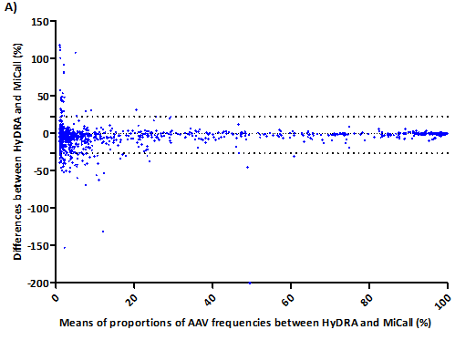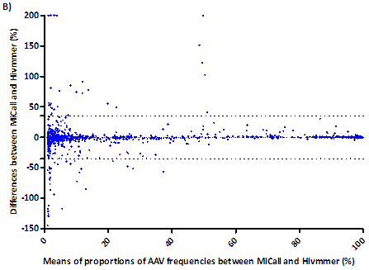
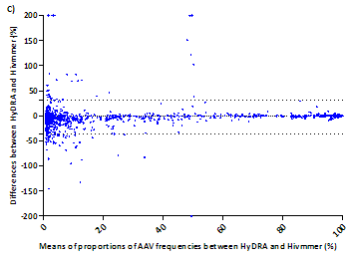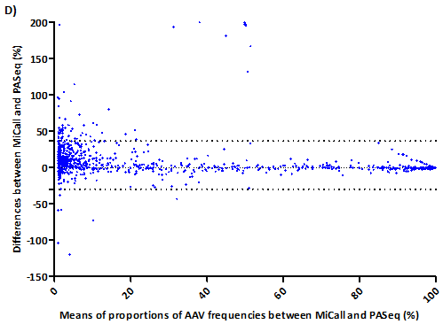

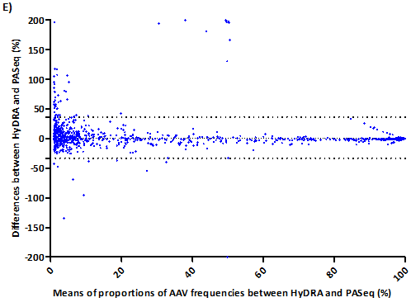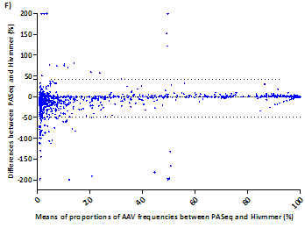

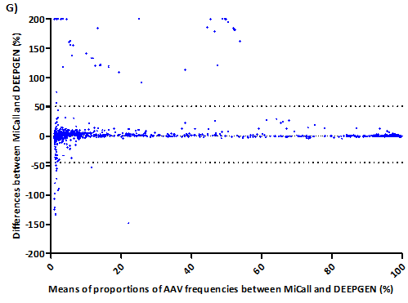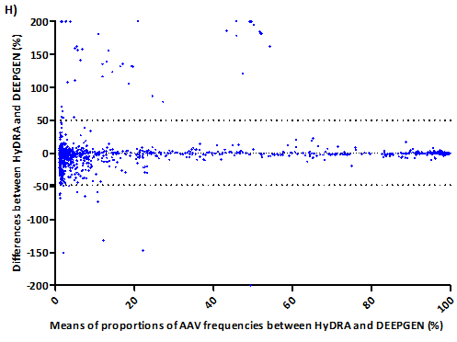

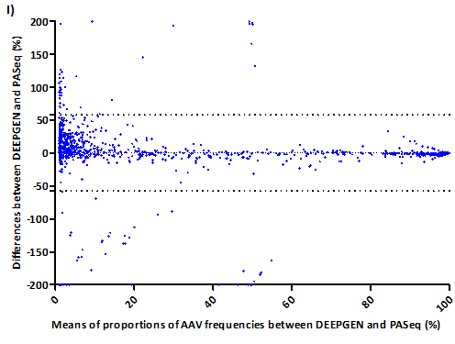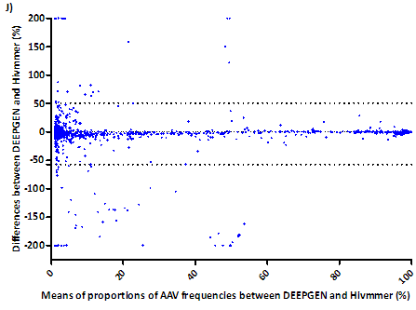
Supplementary Figure S2. Comparison of NGS HIVDR data analysis pipelines. The agreement between two different NGS-based HIVDR pipelines was assessed using the Bland-Altman plot which plotted the percentage of difference in AAV frequency measurements (y-axis) between A) HyDRA and MiCall, B) MiCall and Hivmmer, C) HyDRA and Hivmmer, D) MiCall and PASeq, E) HyDRA and PASeq, F) PASeq and Hivmmer, G) MiCall and DEEPGEN, H) HyDRA and DEEPGEN, I) DEEPGEN and PASeq, J) DEEPGEN and Hivmmer and x-axis indicates the mean between the two measurements. The 95% confidence intervals limits of agreement were calculated and upper and lower limits of agreement are depicted by the dotted lines.

Analysis pipelines | Number of discordances, n (%), 95% confidence intervals
Analysis pipelines | ≥ 20% threshold | ≥ 15% threshold | ≥ 10% threshold | ≥ 5% threshold | ≥ 2% threshold | ≥ 1% threshold
HyDRA versus MiCall | 22 (0.95%) (-13.55-11.78) | 28 (1.19%) (-13.83-11.91) | 32 (1.33%) (-16.67-14.21) | 56 (2.22%) (-18.22-15.09) | 78 (2.86%) (-21.99-18.04) | 102 (3.43%) (-26.49-22.73)
MiCall versus Hivmmer | 24 (1.03%) (-15.36-16.50) | 25 (1.06%) (-15.51-16.64) | 37 (1.54%) (-17.67-18.65) | 52 (2.06%) (-18.96-19.72) | 67 (2.46%) (-24.72-26.22) | 83 (2.78%) (-35.46-34.95)
HyDRA versus Hivmmer | 24 (1.03%) (-20.42-19.78) | 28 (1.20%) (-20.69-19.91) | 44 (1.83%) (-23.94-22.45) | 58 (2.30%) (-25.63-23.42) | 77 (2.84%) (-30.23-27.77) | 101 (3.37%) (-35.92-31.71)
MiCall versus PASeq | 21 (0.90%) (-25.21-27.19) | 26 (1.11%) (-25.27-27.40) | 36 (1.50%) (-25.78-28.34) | 51 (2.03%) (-26.17-29.78) | 69 (2.54%) (-27.10-32.53) | 85 (2.89%) (-29.68-36.73)
HyDRA versus PASeq | 17 (0.73%) (-28.45-28.57) | 21 (0.90%) (-28.50-28.70) | 23 (0.96%) (-28.35-28.61) | 35 (1.40%) (-28.92-29.39) | 48 (1.77%) (-29.89-31.16) | 72 (2.44%) (-33.00-36.42)
PASeq versus Hivmmer | 27 (1.16%) (-29.35-28.63) | 32 (1.37%) (-29.58-28.65) | 43 (1.79%) (-32.53-30.80) | 61 (2.43%) (-34.27-31.49) | 79 (2.92%) (-39.51-35.54) | 108 (3.62%) (-49.21-41.41)
MiCall versus DEEPGEN | 25 (1.08%) (-34.46-40.23) | 28 (1.19%) (-34.95-41.03) | 37 (1.54%) (-37.07-44.02) | 43 (1.71%) (-38.44-46.05) | 50 (1.84%) (-40.52-48.61) | 74 (2.51%) (-44.77-51.14)
HyDRA versus DEEPGEN | 27 (1.17%) (-37.16-41.01) | 32 (1.37%) (-38.46-42.82) | 43 (1.80%) (-41.17-45.70) | 49 (1.95%) (-42.59-46.83) | 61 (2.42%) (-45.74-49.73) | 76 (2.53%) (-48.14-50.37)
DEEPGEN versus Hivmmer | 34 (1.46%) (-43.41-38.67) | 39 (1.66%) (-45.05-39.83) | 51 (2.12%) (-47.39-41.58) | 61 (2.42%) (-50.17-43.65) | 71 (2.61%) (-54.16-47.83) | 91 (3.01%) (-57.17-50.87)
DEEPGEN versus PASeq | 33 (1.43%) (-44.66-40.79) | 38 (1.63%) (-46.82-42.58) | 47 (1.97%) (-48.53-44.19) | 59 (2.35%) (-51.66-47.76) | 70 (2.59%) (-52.70-50.15) | 102 (3.43%) (-57.13-58.01)
Supplementary Table S4. The number of discordances between the analysis pipelines according to the variant detection threshold. Data from one of the six participating labs were removed from outlier analysis because the results from one pipeline were missing. In this case, there were 47 data sets as opposed to 57 (see methods). For each agreement analysis between two different pipelines, the number of discordances was calculated by counting the number of discordances outside the 95% confidence intervals, n (%) is the percentage of discordances out of the total number AAVs between two pipelines, and 95% confidence intervals were calculated using Bland-Altman analysis.

%frequency threshold | Mean ± SEM | P<0.05
≥ 20% | 25.4 ± 1.64
≥ 15% | 29.7 ± 1.78 | 0.0929ª
≥ 10% | 39.3 ± 2.55 | 0.0064^{b}
≥ 5% | 52.5 ± 2.67 | 0.0022^{c}
≥ 2% | 67.0 ± 3.46 | 0.0038^{d}
≥ 1% | 89.4 ± 4.19 | 0.0006e
Supplementary Table S5. Comparison of the average number of discordances amongst the pipelines between different thresholds. Results from an unpaired 2-tailed t-test. Comparison of the number of discordances between ª20% and 15% threshold; ^{b}15% and 10% threshold; ^{c}10% and 5% threshold; ^{d}5% and 2% threshold and ^{e}2% and 1 % threshold.

A)
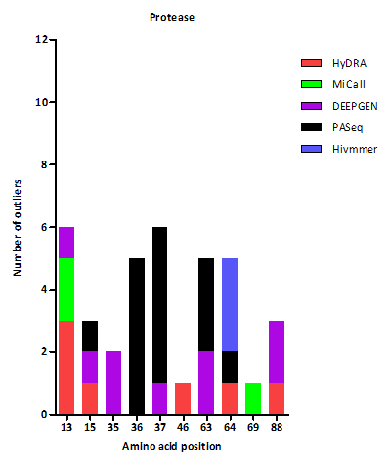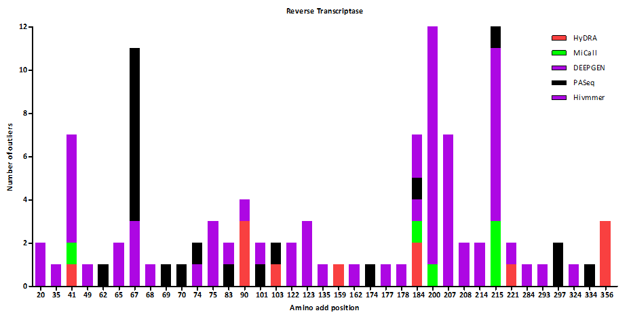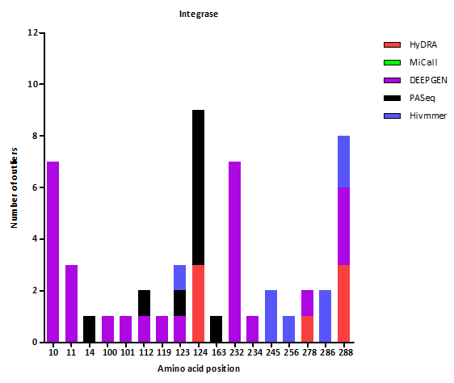
B)
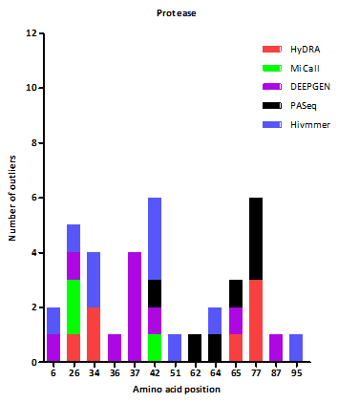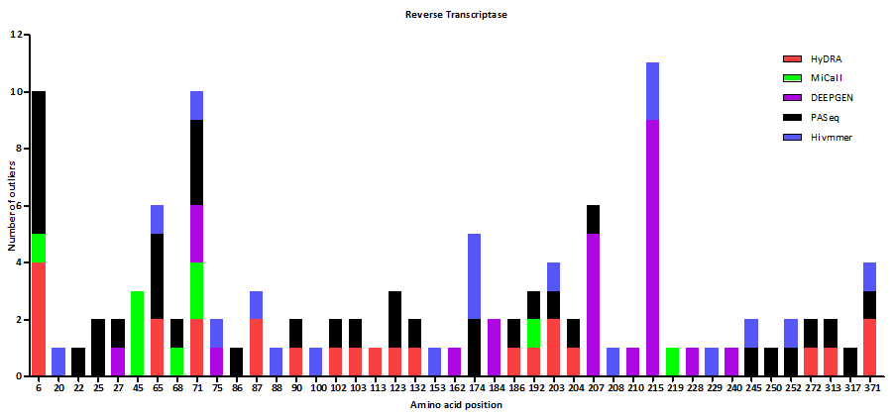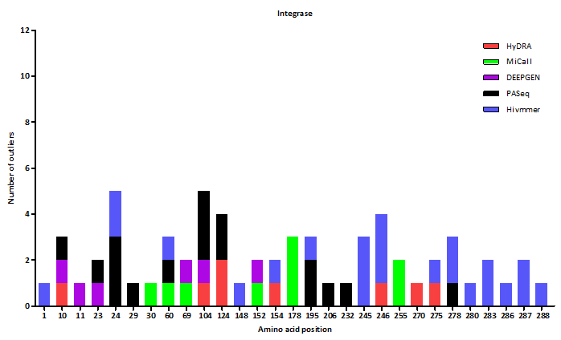
Supplementary Figure S3. Number of AAV outliers found in each pipeline at AAV frequencies >20% and at <20%. Thresholds for outliers were arbitrarily determined to be twice the %CV median for each defined %AAV frequency range and were calculated to be %CV ≤1%, ≤ 3%, ≤ 5%, ≤7%, ≤ 10%, ≤ 12%, ≤ 20%, ≤ 24% for AAV frequencies at ≥90%, 70%-90%, 50%-70%, 30%-50%, 20%-30%, 10%-20%, 2%-10% and 1%-2% respectively (see materials and methods). The total number of outliers found at A) >20% and B) <20% were then plotted at each amino acid position for HIV protease, reverse transcriptase and integrase genes.

 |  |  | % Detectedª
Mutation | Number of data sets present | % AAV frequency range | Hydra | Micall | DEEPGEN | PASeq.org | Hivmmer
IN D10E | 42 | > 88.54 | 100 | 100 | 83.33 | 100 | 100
IN D288N | 4 | >98 | 50 | 100 | 100 | 100 | 50
 | 1 | 6.56-7.8 | 100 | 100 | 100 | 100 | 0
PR S37A | 4 | 15.75-9.79 | 100 | 100 | 75^{b} | 100 | 100
PR S37D | 6 | >98 | 100 | 100 | 100 | 33^{c} | 100
 | 1 | 3.03-3.43 | 100 | 100 | 100 | 100 | 100
RT D67N | 13 | 99.72-83.72 | 100 | 100 | 100^{d} | 92.31e | 100
 | 2 | 40.65-76.14 | 100 | 100 | 100^{f} | 0 | 100
RT T200A | 4 | 17.29-34.08 | 100 | 100 | 100^{g} | 100 | 100
RT Q207N | 4 | 19.9-32.24 | 100 | 100 | 100^{h} | 100 | 100
Supplementary Table S6. Summary of AAV positions that are favored for outliers.
ªConsidered not detected if AAV frequency <1%
^{b}DEEPGEN AAV frequency range is 1.02%–1.40% and had 8 extra mutations at frequency >5% (range 5.00%-24.65%)
^{c}PASeq AAV frequency range is 1.065–4.98%
^{d}DEEPGEN had one AAV frequency detected at 3.03%
^{e}PASeq had 3 AAV frequencies detected at 1.01%, 4.12% and 8.48% respectively
^{f}DEEPGEN had one AAV frequency detected at 18.63%
^{g}DEEPGEN detected all 4 AAVs at 2.97%-6.71% and had 5 extra AAVs at frequencies at 14.14%-19.17%
^{h}DEEPGEN frequency range is 2.97%–5.56% and has 10 extra AAVs at frequencies at 5.54%–21.64%

