Co-production of DHA and squalene by thraustochytrid from forest biomass
Alok Patel, Stephan Liefeldt, Ulrika Rova, Paul Christakopoulos, Leonidas Matsakas*

Biochemical Process Engineering, Division of Chemical Engineering, Department of Civil, Environmental, and Natural Resources Engineering, Luleå University of Technology, SE-971 87 Luleå, Sweden

Alok Patel, email: alok.kumar.patel@ltu.se
Stephan Liefeldt: stephan.liefeldt@ltu.se
Ulrika Rova, email: ulrika.rova@ltu.se, Tel: +46 92 049 13 15
Paul Christakopoulos, email: paul.christakopoulos@ltu.se, Tel: +46 92 049 25 10
*Corresponding author: Leonidas Matsakas, Department of Civil, Environmental and Natural Resources Engineering, SE-971 87 Luleå Sweden, leonidas.matsakas@ltu.se, tel.: +46 (0) 920 493043

Supplementary Fig. S1. Representative microscopic image of S. limacinum SR21 cultivated on 60 g/L of glucose with two different C/N ratio (C/N 10 and C/N 50), where it showed the formation of zoosporangia (green arrow) as a result of sexual reproduction at high C/N ratio (C/N 50) and the emptied cells (red arrow) are clearly visualized after releasing of zoospores from the cells.

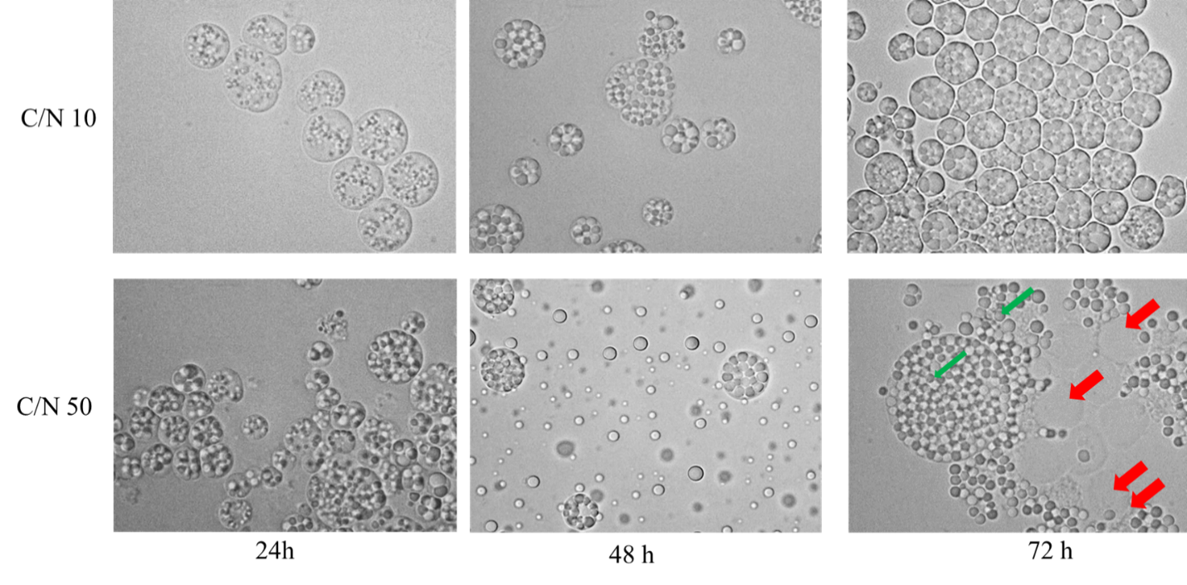

Supplementary Fig. S2. Time-course determination of cell dry weight (g/L), total lipid concentration (g/L), lipid content (%, w/w), and residual glucose (g/L) of S. limacinum SR21cultivated in Erlenmeyer (A-D): (A) 30 g/L glucose; (B) 60 g/L glucose; (C) 90 g/L glucose; (D) 120 g/L glucose flasks. Time-course determination of cell dry weight (g/L), total lipid concentration (g/L), lipid content (%, w/w), and residual glucose (g/L) of S. limacinum SR21cultivated in a bioreactor (E-H): (E) 30 g/L glucose; (F) 60 g/L glucose; (G) 90 g/L glucose; (H) 120 g/L glucose.

