Supporting information

Assembly and Folding Properties of Cytosolic IgG Intrabodies

Youngsil Seo^{1,2} *, Yeonjin Lee¹ *, Minjae Kim¹, Hyunjoon Park¹, and Myung-Hee Kwon^{1,2 †}

¹Dept. of Biomedical Sciences, Graduate School, Ajou University, 206 World cup-ro, Yeongtong-gu, Suwon 16499, Gyeonggi-do, South Korea.

²Dept. of Microbiology, Ajou University School of Medicine, 206 World cup-ro, Yeongtong-gu, Suwon 16499, Gyeonggi-do, South Korea.

*These authors contributed equally to this work.

†Correspondence: Department of Microbiology, Ajou University School of Medicine, 206 World Cup-ro, Yeongtong-gu, Suwon 16499, South Korea. Tel: +82-31-219-5074; Fax: +82-31-219-5079; E-mail: kwonmh@ajou.ac.kr

Supporting information contains:
Supplementary Figure 1 (Fig. S1) and legend
Supplementary Figure 2 (Fig. S2) and legend
Supplementary Figure 3 (Fig. S3): Raw western blot of Figure 1d
Supplementary Figure 4 (Fig. S4): Raw western blot of Figure 3b
Supplementary Figure 5 (Fig. S5): Raw western blot of Figure 4f
Supplementary Figure 6 (Fig. S6): Raw western blot of Figure 5f
Supplementary Figure 7 (Fig. S7): Raw western blot of Figure 5g

Fig. S1
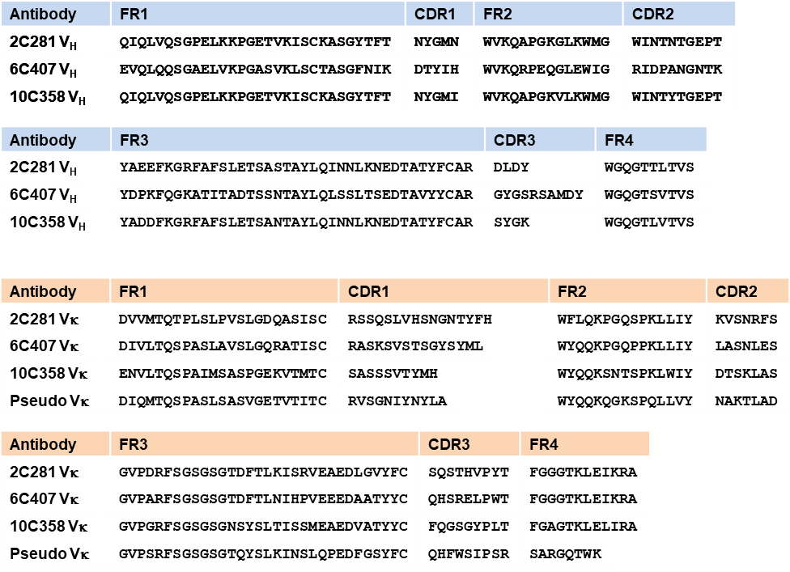
Supplementary Fig. S1. Amino acid sequence alignments of variable domains (V_{H} and V_{L}). Amino acid sequences of variable regions for three mouse anti-KIFC1 antibodies (2C281, 6C407, and 10C358) and a pseudo mouse sequence are aligned. The positions of complementarity determining regions (CDRs) and framework regions (FRs) are indicated according to the ImMunoGeneTics (IMGT) numbering system.

Fig. S2

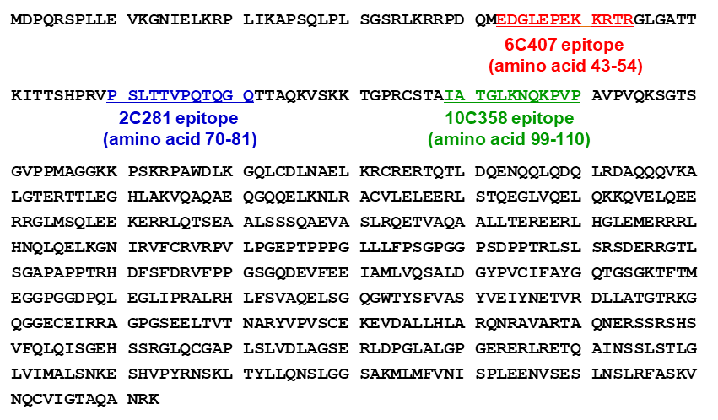
Fig. S2. Amino acid sequences of the KIFC1 protein and epitopes recognized by antibodies. The epitope sequences recognized by 6C407, 2C281, and 10C358 antibodies are indicated by red, blue, and green amino acids, respectively.

Fig. S3. Raw western blot of Figure 1d

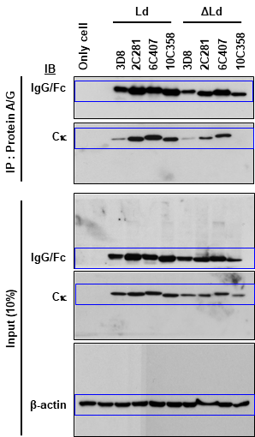

Fig. S4. Raw western blot of Figure 3b

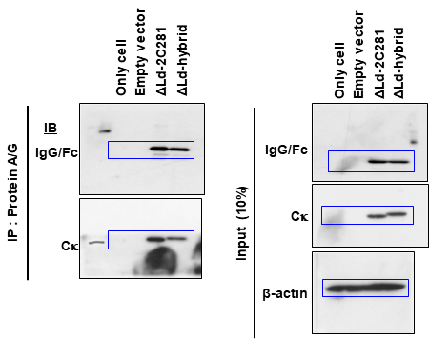

Fig. S5. Raw western blot of Figure 4f

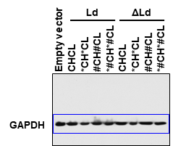
Fig. S6. Raw western blot of Figure 5f

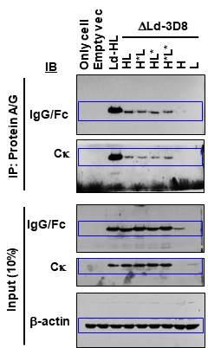

Fig. S7. Raw western blot of Figure 5g

