Suppementary Information
Perceptual effects of fast and automatic visual ensemble statistics from faces in individuals with typical development and autism spectrum conditions
Mrinmoy Chakrabarty ¹, Makoto Wada ¹.
¹ Developmental Disorders Section, Department of Rehabilitation for Brain Functions, Research Institute of National Rehabilitation Center for Persons with Disabilities, Saitama 359-8555, Japan

Corresponding Author: Makoto Wada M.D., Ph.D.
Chief, Developmental Disorders Section, Department of Rehabilitation for Brain Functions, Research Institute of National Rehabilitation Center for Persons with Disabilities, 4-1, Namiki, Tokorozawa, Saitama, 359-8555, JAPAN.
TEL: +81-4-2995-3100 (ex. 2578); FAX: +81-4-2995-3132; E-mail: wada-makoto@rehab.go.jp

Supplementary Figure 1

Supplementary Figure 2
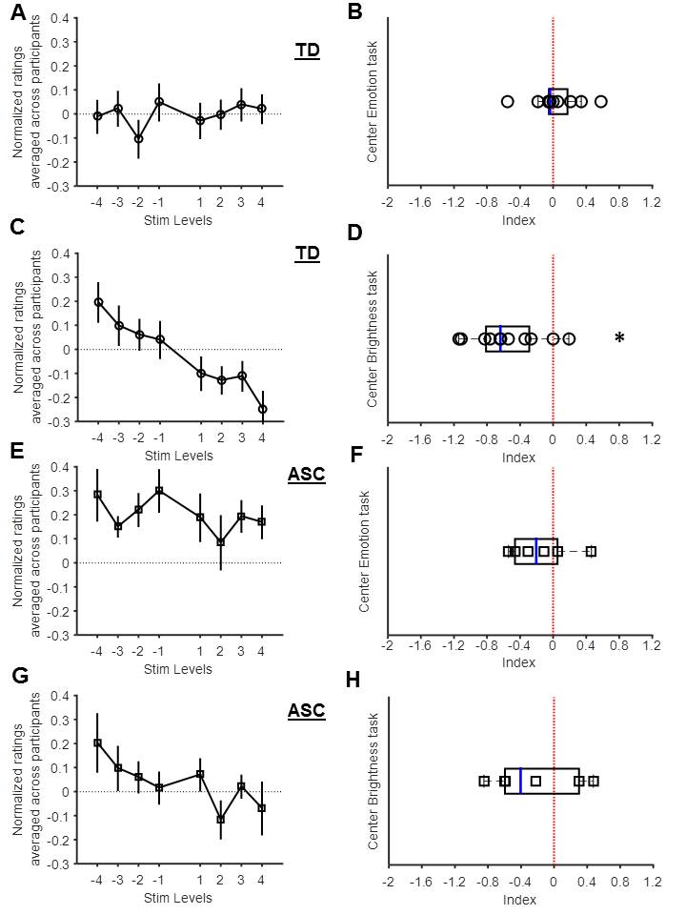

Supplementary Figure 3
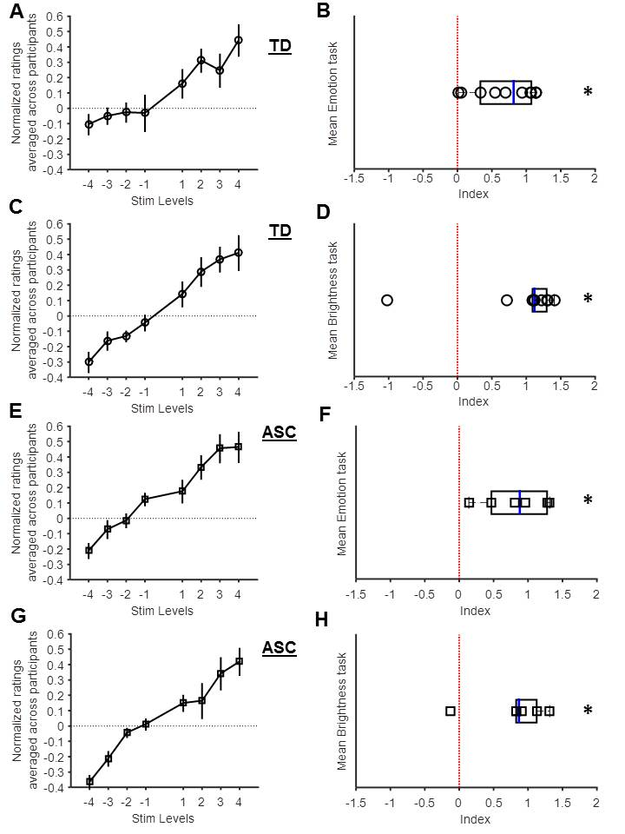

Supplementary Figure Legends

Supplementary Figure 1. Experimental procedure A typical emotion-judgment trial. Each trial commenced with the presentation of a fixation cross in the centre of the screen (white fixation) that appeared for a random time duration (1,500–2,000 ms). The face image-set was then presented for 200 ms which was followed without delay by a high-contrast visual mask (perlin noise) with a central black fixation cross for 1,000 ms. This was followed by a key-pad response instruction. Participants were asked to accurately indicate a mentally computed representation without any time restriction. The trial ended with the key-press, and the next trial began after a blank screen of 500 ms. All other aspects were same as described in Figure 1B and Apparatus and general task procedures. The face images were sourced from the Karolinska Directed Emotional Faces database (KDEF) ¹. KDEF image IDs:Periphery (clockwise)- Periphery (clockwise)- four Happy images (HA 1-4); Centre- neutral image (NE). Original images replaced by illustration for copyright reasons.

Supplementary Figure 2. Effects of covert ensembles with backward visual masking. (A - D) Data from TD (n=11) are shown. Means ± SEMs of the raw judgment ratings across participants are shown for the positive (+1 to +4) and negative (-1 to -4) levels of stimulus manipulations relative to the zero level (black horizontal broken line) in the emotion (A) and brightness task-sessions (C), along with the distribution of their respective indices (black open circles; B, D). (E - H) Data from ASC (n=6) are shown with the same conventions as TD: raw judgment ratings (emotion: E, brightness: G) and distribution of respective indices (black open squares; F, H). All statistical tests were conducted on the indices (B,D,F,G). * p < 0.05, Stim Levels (levels of experimental stimulus manipulation).

Supplementary Figure 3. Effects of overt ensembles with backward visual masking. (A - D) Data from TD (n=10) are shown. Means ± SEMs of the raw judgment ratings across participants are shown for the positive (+1 to +4) and negative (-1 to -4) levels of stimulus manipulations relative to the zero level (black horizontal broken line) in the emotion (A) and brightness task-sessions (C), along with the distribution of their respective indices (black open circles; B, D). (E - H) Data from ASC (n=6) are shown with the same conventions as TD: raw judgment ratings (emotion: E, brightness: G) and distribution of respective indices (black open squares; F, H). All statistical tests were conducted on the indices (B,D,F,G). * p < 0.05, Stim Levels (levels of experimental stimulus manipulation).

References
- Flykt, A., Lundqvist, D., Flykt, A. & Öhman, A. The Karolinska directed emotional faces (KDEF). CD ROM from Dep. Clin. Neurosci. Psychol. Sect. Karolinska Institutet (1998). doi:10.1017/S0048577299971664

