Elevated HbA1c is not associated with recurrent venous thromboembolism in the elderly, but with all-cause mortality– the SWEETCO 65+ study

Alexandra Mathis*, Lukas Villiger, MD¹, Martin F. Reiner, MD, PhD^{2,3}, MD¹, Michael Egloff, MD², Hans Ruedi Schmid⁴, Simona Stivala, MD³, Andreas Limacher, PhD⁵, Marie Mean, MD^{6,7}, Drahomir Aujesky MD, MSc⁶, Nicolas Rodondi, MD, MAS^{6,8}, Anna Angelillo-Scherrer, MD^{9,10}, Marc Righini, MD¹¹, Daniel Staub, MD¹², Markus Aschwanden, MD¹², Beat Frauchiger, MD¹³, Joseph Osterwalder, MD¹⁴, Nils Kucher, MD¹⁵, Christian M. Matter, MD^{3,16}, Martin Banyai, MD¹⁷, Oliver Hugli, MD, MPH¹⁸, Juerg H. Beer, MD^{2,3}

¹DiaMon Institute, Baden-Dättwil, Switzerland ²Department of Internal Medicine, Cantonal Hospital of Baden, Baden, Switzerland ³Center for Molecular Cardiology, University of Zurich, Schlieren, Switzerland ⁴Central Laboratory, Cantonal Hospital of Baden, Baden, Switzerland ⁵CTU Bern, and Institute of Social and Preventive Medicine (ISPM), University of Bern, Bern, Switzerland ⁶Division of General Internal Medicine, Bern University Hospital, Inselspital, University of Bern, Bern, Switzerland ⁷Division of Internal Medicine, Lausanne University Hospital, Lausanne, Switzerland ⁸Institute of Primary Health Care (BIHAM), University of Bern, Bern, Switzerland ⁹Department of Hematology and Central Hematology Laboratory, Bern University Hospital, Inselspital, University of Bern, Bern, Switzerland ¹⁰Department of Bio Medical Research, University of Bern, Bern, Switzerland ¹¹Division of Angiology and Hemostasis, Geneva University Hospital, Geneva, Switzerland ¹²Division of Angiology, Basel University Hospital, Basel, Switzerland ¹³Department of Internal Medicine, Cantonal Hospital of Frauenfeld, Frauenfeld, Switzerland ¹⁴Cantonal Hospital of St. Gallen, St. Gallen, Switzerland ¹⁵Division of Angiology, Zurich University Hospital, Zurich, Switzerland ¹⁶Department for Cardiology, University Heart Center, Zurich University Hospital, Zurich, Switzerland ¹⁷Division of Angiology, Cantonal Hospital of Lucerne, Lucerne, Switzerland ¹⁸Emergency Department, Lausanne University Hospital, Lausanne, Switzerland

Supplementary Figures

Suppl. Figure 1. Flow chart summarizing the enrollment of subjects for the Sweetco 65+ study

Suppl. Figure 2. Kaplan-Meier estimates of cumulative mortality by HbA1c-categories in patients with history of diabetes
The cumulative mortality was comparable in all three patient groups (log-rank p=0.389). Notably, in patients with HbA1c<5.7%, all deaths occurred during the first year.

Suppl. Figure 3. Kaplan-Meier estimates of cumulative mortality by HbA1c-categories in patients without history of diabetes
The cumulative mortality was higher in patients with HbA1c ≥6.5% than in patients with lower HbA1c levels (log-rank p=0.177).

Suppl. Figure 4. Kaplan-Meier estimates of cumulative major bleeding by HbA1c-categories
The cumulative incidence of major bleeding did not differ between groups (log-rank p=0.527).

Supplemental Figure 1. Enrollment of subjects for the Sweetco 65+ study

Patients not eligible (n=462)
Thrombosis at a different site than lower limb (n=21)
Catheter-related thrombosis (n=7)
Insufficient spoken ability in German or French (n=51)
Inability to provide informed consent (n=285)
Follow-up not possible (n=192)
Screened (n=1863)
Patients who did not consent (n=398)
Enrolled (n=1003)
Patients excluded from analysis (n=115)
Denying use of data (n=8)
Early withdrawal (n=4)
No biosample taken (n=89)
No HbA1c result (n=14)
Evaluation of baseline HbA1c in 888 patients
Association with recurrent venous thromboembolism, mortality and major bleeding
History of diabetes
(n= 139)
no History of diabetes (n=749)
3 HbA1c-groups
<5.7%
5.7 to <6.5%
≥6.5%
3 HbA1c-groups
<5.7%
5.7 to <6.5%
≥6.5%
3 HbA1c-groups
<5.7%
5.7 to <6.5%
≥6.5%
Supplemental Figure 2. Mortality by HbA1c-categories in patients with history of diabetes

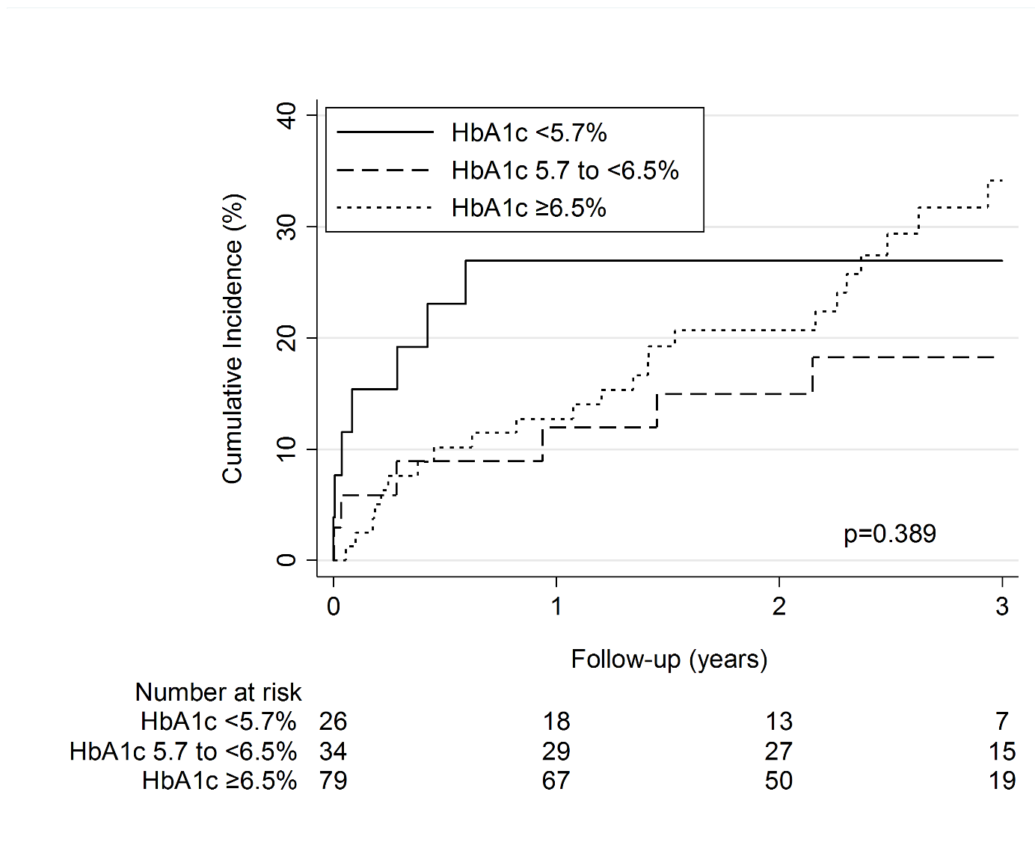
Supplemental Figure 3. Mortality by HbA1c-categories in patients without history of diabetes

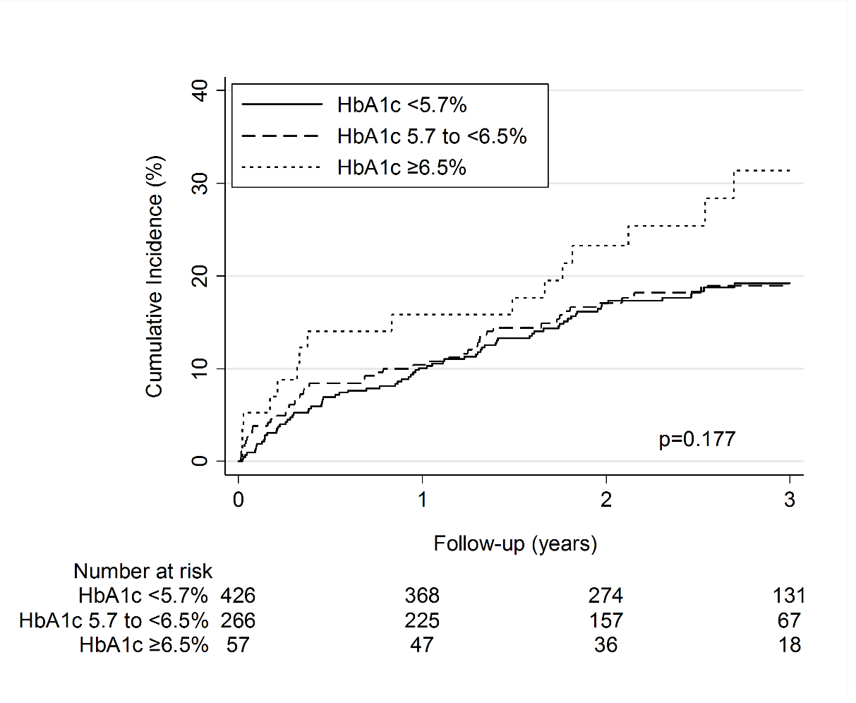

Supplemental Figure 4. Major bleeding by HbA1c-categories

Supplemental Table 4. Causes of death by diabetes status known at baseline
 | All deaths | History of Diabetes | No History of Diabetes
 | N = 186 | N = 39 | N = 147
Death cause
PE-related | 7 (3.8%) | 3 (7.7%) | 4 (2.7%)
Possibly PE-related | 28 (15.1%) | 4 (10.3%) | 24 (16.3%)
Bleeding | 12 (6.5%) | 2 (5.1%) | 10 (6.8%)
Acute coronary syndrom | 3 (1.6%) | 1 (2.6%) | 2 (1.4%)
Stroke | 2 (1.1%) | 0 (0.0%) | 2 (1.4%)
Left ventricular failure | 11 (5.9%) | 3 (7.7%) | 8 (5.4%)
Cancer | 61 (32.8%) | 7 (17.9%) | 54 (36.7%)
Infection | 14 (7.5%) | 3 (7.7%) | 11 (7.5%)
Sepsis | 16 (8.6%) | 5 (12.8%) | 11 (7.5%)
Pulmonary causes other than PE | 6 (3.2%) | 2 (5.1%) | 4 (2.7%)
Suicide | 3 (1.6%) | 1 (2.6%) | 2 (1.4%)
Other | 4 (2.2%) | 2 (5.1%) | 2 (1.4%)
Unknown | 19 (10.2%) | 6 (15.4%) | 13 (8.8%)
PE = pulmonary embolism.

