Species-specific genetic variation in response to deep-sea environmental variation amongst Vulnerable Marine Ecosystem indicator taxa

Cong Zeng^{1,2,3,4}, Ashley A. Rowden^{2,3}, Malcolm R. Clark³, Jonathan P. A. Gardner²

1 - College of Animal Science and Technology, Hunan Agricultural University, Changsha, China
2 - School of Biological Sciences, Victoria University of Wellington, Wellington 6140, New Zealand
3 - Coasts and Oceans National Centre, National Institute for Water and Atmospheric Research, Private Bag 14901, Kilbirnie, Wellington, New Zealand
4 – School of Oceanography, Shanghai Jiao Tong University, Shanghai 200030, China

Table S1. Correlation analyses between pairs of environmental variables
 | bpi.broad | bpi.fine | sigma.theta | slope.percent | stdev.slope | diso2 | pocc | slopec | woanitc | woaphosc | woasalc | woasilc | woatempc | omega.ara | omega.cal | botspd | cdom | disorg | dynoc | sstgrd | sst | tempbot | tempres | tidcurr | vgpm | seamount
bpi.broad
bpi.fine | 0.753
sigma.theta | 0.172 | 0.132
slope.percent | 0.650 | 0.571 | 0.294
stdev.slope | 0.777 | 0.804 | 0.240 | 0.760
diso2 | -0.253 | -0.434 | -0.596 | -0.380 | -0.436
pocc | -0.537 | -0.475 | -0.623 | -0.479 | -0.550 | 0.584
slopec | 0.576 | 0.627 | 0.232 | 0.695 | 0.639 | -0.377 | -0.432
woanitc | 0.280 | 0.316 | 0.838 | 0.327 | 0.376 | -0.797 | -0.729 | 0.305
woaphosc | 0.272 | 0.339 | 0.849 | 0.309 | 0.377 | -0.801 | -0.716 | 0.285 | 0.986
woasalc | -0.007 | 0.112 | -0.538 | 0.084 | 0.070 | 0.026 | 0.253 | 0.104 | -0.539 | -0.540
woasilc | 0.328 | 0.473 | 0.789 | 0.391 | 0.451 | -0.790 | -0.649 | 0.391 | 0.848 | 0.861 | -0.212
woatempc | -0.241 | -0.266 | -0.883 | -0.265 | -0.320 | 0.610 | 0.663 | -0.232 | -0.937 | -0.942 | 0.677 | -0.841
omega.ara | -0.233 | -0.304 | -0.872 | -0.292 | -0.350 | 0.772 | 0.691 | -0.265 | -0.960 | -0.967 | 0.548 | -0.846 | 0.937
omega.cal | -0.234 | -0.306 | -0.871 | -0.295 | -0.353 | 0.776 | 0.692 | -0.267 | -0.960 | -0.967 | 0.541 | -0.849 | 0.936 | 1.000
botspd | -0.061 | -0.238 | 0.294 | -0.040 | -0.171 | -0.106 | -0.156 | 0.015 | 0.205 | 0.173 | -0.182 | 0.072 | -0.181 | -0.232 | -0.231
cdom | -0.396 | -0.288 | -0.335 | -0.234 | -0.307 | 0.011 | 0.634 | -0.173 | -0.324 | -0.314 | 0.249 | -0.340 | 0.431 | 0.287 | 0.285 | 0.040
disorg | -0.470 | -0.440 | -0.311 | -0.308 | -0.399 | 0.350 | 0.795 | -0.271 | -0.445 | -0.438 | 0.083 | -0.429 | 0.403 | 0.388 | 0.390 | 0.006 | 0.678
dynoc | 0.446 | 0.513 | -0.070 | 0.361 | 0.427 | -0.441 | -0.139 | 0.317 | 0.089 | 0.116 | 0.256 | 0.156 | 0.084 | -0.096 | -0.100 | -0.251 | 0.260 | -0.123
sstgrd | -0.477 | -0.456 | -0.398 | -0.418 | -0.496 | 0.520 | 0.774 | -0.408 | -0.574 | -0.545 | 0.107 | -0.536 | 0.481 | 0.499 | 0.502 | 0.078 | 0.433 | 0.731 | -0.234
sst | -0.547 | -0.472 | -0.463 | -0.410 | -0.518 | 0.477 | 0.749 | -0.405 | -0.605 | -0.579 | 0.242 | -0.548 | 0.548 | 0.542 | 0.544 | 0.062 | 0.461 | 0.664 | -0.212 | 0.942
tempbot | 0.087 | 0.227 | -0.332 | 0.184 | 0.202 | -0.353 | 0.068 | 0.151 | -0.150 | -0.163 | 0.711 | 0.001 | 0.387 | 0.193 | 0.184 | -0.244 | 0.394 | 0.027 | 0.641 | -0.152 | -0.032
tempres | 0.090 | 0.227 | -0.332 | 0.192 | 0.206 | -0.352 | 0.066 | 0.153 | -0.152 | -0.165 | 0.714 | -0.002 | 0.389 | 0.193 | 0.185 | -0.238 | 0.392 | 0.026 | 0.639 | -0.152 | -0.029 | 0.999
tidcurr | -0.391 | -0.347 | -0.441 | -0.496 | -0.488 | 0.589 | 0.786 | -0.418 | -0.583 | -0.549 | 0.057 | -0.440 | 0.423 | 0.520 | 0.522 | -0.261 | 0.343 | 0.537 | -0.157 | 0.659 | 0.573 | -0.131 | -0.138
vgpm | -0.376 | -0.243 | -0.368 | -0.157 | -0.257 | 0.025 | 0.659 | -0.092 | -0.400 | -0.388 | 0.373 | -0.366 | 0.517 | 0.365 | 0.363 | 0.007 | 0.901 | 0.781 | 0.300 | 0.521 | 0.553 | 0.438 | 0.437 | 0.309
seamount | 0.632 | 0.651 | 0.112 | 0.485 | 0.597 | -0.349 | -0.389 | 0.419 | 0.277 | 0.279 | 0.021 | 0.299 | -0.199 | -0.248 | -0.249 | -0.026 | -0.140 | -0.304 | 0.382 | -0.376 | -0.389 | 0.177 | 0.179 | -0.407 | -0.123
Note: numbers in bold indicate significant correlation coefficients (p < 0.05).

Table S2. Sequential test results of the DistLM analysis for regional-level genetic variation amongst four deep-sea VME indicator taxa
Species | Marker | Loci | Variable | Adj R² | SS(trace) | Proportion
Poecillastra laminaris | COI |  | botspd | 0.090 | 4810.0 | 54.511
Poecillastra laminaris | Cytb |  | tempbot | 0.246 | 5036.4 | 62.314
Poecillastra laminaris | Microsatellites | All | woasilc | 0.177 | 1868.1 | 58.828
Poecillastra laminaris | Microsatellites | Neutral | botspd | 0.248 | 1514.3 | 62.401
Goniocorella dumosa | Microsatellites | All | vgpm | 0.669 | 2430.0 | 83.447
Goniocorella dumosa | Microsatellites | Neutral | vgpm | 0.740 | 2410.1 | 86.988
Madrepora oculata | ITS |  | woasalc | 0.282 | 4340.6 | 64.090
Madrepora oculata | Microsatellites | All | dynoc | 0.342 | 1406.6 | 67.123
Madrepora oculata | Microsatellites | Neutral | tempbot | 0.320 | 1315.1 | 65.976
Solenosmilia variabilis | Microsatellites | All | diso2 | 0.289 | 354.4 | 64.456
Solenosmilia variabilis | Microsatellites | Neutral | dynoc | 0.398 | 361.3 | 69.890

Table S3. Sequential test results of the DistLM analysis for microsatellite data amongst geomorphic features for all species
Species | Loci | Variable | Adj R² | SS (trace) | p | Proportion
Goniocorella dumosa | all microsatellites | botspd | 0.040 | 1332.200 | 0.392 | 35.980
Goniocorella dumosa | all microsatellites | seamount | 0.306 | 1513.900 | 0.280 | 40.888
Goniocorella dumosa | all microsatellites | botspd | 0.174 | 1657.800 | 0.199 | 44.936
Goniocorella dumosa | all microsatellites | seamount | 0.360 | 1244.000 | 0.334 | 33.721
Solenosmilia variabilis | all microsatellites | stdev.slope | 0.066 | 1229.600 | 0.104 | 19.992
Solenosmilia variabilis | all microsatellites | seamount | 0.182 | 1327.100 | 0.026 | 21.577
Solenosmilia variabilis | all microsatellites | tempbot | 0.276 | 1047.600 | 0.850 | 17.033
Solenosmilia variabilis | all microsatellites | slope.percent | 0.345 | 819.710 | 0.266 | 13.327
Solenosmilia variabilis | all microsatellites | dynoc | 0.368 | 615.680 | 0.431 | 10.010
Solenosmilia variabilis | all microsatellites | tidcurr | 0.446 | 624.430 | 0.439 | 10.152
Solenosmilia variabilis | neutral microsatellites | stdev.slope | 0.136 | 1332.800 | 0.027 | 25.925
Solenosmilia variabilis | neutral microsatellites | seamount | 0.234 | 994.690 | 0.048 | 19.348
Solenosmilia variabilis | neutral microsatellites | tempbot | 0.297 | 749.610 | 0.161 | 14.581
Solenosmilia variabilis | neutral microsatellites | sst | 0.329 | 585.540 | 0.372 | 11.389
Solenosmilia variabilis | neutral microsatellites | slope.percent | 0.388 | 578.930 | 0.367 | 11.261
Solenosmilia variabilis | neutral microsatellites | vgpm | 0.454 | 498.290 | 0.459 | 9.692
Poecillastra laminaris | all microsatellites | seamount | 0.190 | 3330.700 | 0.166 | 46.010
Poecillastra laminaris | all microsatellites | sigma.theta | 0.397 | 2452.200 | 0.360 | 33.874
Poecillastra laminaris | neutral microsatellites | seamount | 0.250 | 0.483 | 0.174 | 49.985
Poecillastra laminaris | neutral microsatellites | botspd | 0.508 | 2342.200 | 0.363 | 33.613
Poecillastra laminaris | COI | sst | 0.099 | 5192.300 | 0.093 | 39.913
Poecillastra laminaris | COI | omega.ara | 0.269 | 4647.000 | 0.340 | 35.722
Poecillastra laminaris | CytB | sigma.theta | 0.125 | 5390.000 | 0.088 | 41.641
Poecillastra laminaris | CytB | dynoc | 0.146 | 3867.900 | 0.583 | 29.878

Table S4. Geomorphic feature (site), collection date and sample size collection information for the three deep-sea corals and one sponge species.

Geomorphic feature | Date of collection | Poecillastra laminaris | Goniocorella dumosa | Madrepora oculata | Solenosmilia variabilis
Bollons Seamount | 2003 |  |  | 1 | 2
Bounty Plateau | 1979-2008 |  |  | 4 | 4
Bounty Trough | 2006-2008 |  |  | 2 | 5
Campbell Plateau | 1978-2010 | 4 | 1 | 8 | 8
Challenger Plateau | 1961-2013 | 3 | 3 | 5 | 1
Chatham Rise | 1963-2015 | 19 | 48 | 42 | 71
Hikurangi Margin | 2002-2010 | 2 | 1 | 1 | 4
Kermadec Ridge | 1989-2012 | 11 | 3 | 6 | 33
Louisville Seamount | 2014 |  |  |  | 14
Macquarie Ridge | 1998-2008 | 14 | 2 |  | 13
NE Continental Slope | 2000 |  | 3
Tasman Basin | 1988-2009 |  |  |  | 3
Note: Only the geomorphic features (total sample size ≤ 3) were listed in the table.

Table S5. Pairwise estimates of Φ_{ST} and F_{ST} derived from DNA sequence and microsatellite analyses of genetic variation of one sponge and three coral species.

Table S5a. Pairwise Φ_{ST} values for COI (below diagonal) and Cytb (above diagonal) between populations of the sponge, Poecillastra laminaris.
Populations | Kermadec Ridge | Three Kings Ridge | Challenger Plateau | NW Slope | Hikurangi Margin | Chatham Rise | Campbell Plateau | Bounty Trough | Macquarie Ridge | Antarctica
Kermadec Ridge |  | - | 0.891** | -1.000 | 0.410 | 0.371** | 0.937** | 0.700* | 0.400** | 0.891
Three Kings Ridge | -0.875 |  | - | - | - | - | - | - | - | -
Challenger Plateau | 0.780* | 1.000 |  | 1.000 | 0.500 | -0.058 | 1.000* | 0.421 | 0.432** | 1.000
NW Slope | -0.875 | 0 | 1.000 |  | -1.000 | -0.063 | 1.000 | -0.467 | -0.039 | 1.000
Hikurangi Margin | 0.264 | -1.000 | 0 | -1.000 |  | -0.012 | 0.848 | 0.063 | 0.154 | 0.429
Chatham Rise | 0.329** | -0.101 | -0.104 | -0.101 | -0.072 |  | 0.474** | 0.144 | 0.226** | 0.309
Campbell Plateau | 0.95** | 1.000 | 1.000 | 1.000 | 0.919 | 0.469 |  | 0.250 | 0.434* | 1.000
Bounty Trough | 0.652* | -0.727 | 0.136 | -0.727 | 0 | 0.148* | 0.250 |  | 0.058 | -0.294
Macquarie Ridge | 0.650** | 0.444 | 0.502* | 0.444 | 0.462* | 0.210** | 0.467** | 0.238 |  | 0.064
Antarctica | 0.899 | 1.000 | 1.000 | 1.000 | 0.600 | -0.092 | 1.000 | -1.000 | -0.583
Significant values of p<0.05 are marked as *, and p<0.01 are marked as **.
- data are unavailable.

Table S5b. Pairwise F_{ST} values for microsatellite variation between populations of the sponge, Poecillastra laminaris.
 | Campbell Plateau | Chatham Rise | Kermadec Ridge | Macquarie Ridge
Campbell Plateau
Chatham Rise | -0.005
Kermadec Ridge | 0.156* | 0.061*
Macquarie Ridge | 0.023 | -0.015 | 0.035

Table S5c. Pairwise Φ_{ST} values for ITS of Madrepora oculata (above diagonal) and Solenosmilia variabilis (below diagonal) between coral populations.
 | Bounty Plateau | Campbell Plateau | Chatham Rise | Kermadec Ridge | Louisville Seamount Chain | Macquarie Ridge
Bounty Plateau |  | 0.063 | 0.148 | 0.447 | - | -
Campbell Plateau | - |  | 0.175 | 0.5 | - | -
Chatham Rise | - | -0.087 |  | 0.457** | - | -
Kermadec Ridge | - | -0.094 | 0.019 |  | - | -
Louisville Seamount Chain | - | 0 | -0.014 | -0.018 |  | -
Macquarie Ridge | - | -0.018 | 0.032 | 0.223* | 0.100*
Significant values of p < 0.05 are marked as *, and p < 0.01 are marked as **.
Data for G. dumosa not included because all Φ_{ST} values are NS.

Table S5d. Pairwise F_{ST} values for all (below diagonal) and neutral (above diagonal) loci between populations of the coral, Goniocorella dumosa.
 | NE continental slope | Challenger Plateau | Chatham Rise | Kermadec Ridge
NE continental slope |  | -0.018 | 0.033 | 0.009
Challenger Plateau | -0.047 |  | -0.006 | 0.015
Chatham Rise | 0.001 | -0.014 |  | 0.044*
Kermadec Ridge | -0.012 | 0.003 | 0.024*

Table S5e. Pairwise F_{ST} values for all (below diagonal) and neutral (above diagonal) loci between populations of the coral, Solenosmilia variabilis.
 | Bounty Plateau | Bounty Trough | Campbell Plateau | Chatham Rise | Hikurangi Margin | Kermadec Ridge | Louisville Seamount Chain | Macquarie Ridge
Bounty Plateau |  | -0.022 | -0.002 | 0.031* | 0.053 | 0.048* | 0.053 | 0.019
Bounty Trough | -0.037 |  | -0.001 | 0.008 | -0.038 | -0.018 | 0.034 | 0.02
Campbell Plateau | 0.02 | -0.003 |  | 0.061** | 0.034 | 0.086** | 0.115** | 0.061**
Chatham Rise | 0.025 | 0.003 | 0.048** |  | 0.033* | 0.022** | 0.043** | -0.009
Hikurangi Margin | 0.094 | 0.02 | 0.052 | 0.048** |  | -0.008 | 0.068* | 0.038*
Kermadec Ridge | 0.035 | -0.014 | 0.061** | 0.014** | 0.008 |  | 0.032** | 0.031**
Louisville Seamount Chain | 0.06 | 0.029 | 0.085** | 0.035** | 0.081** | 0.027** |  | 0.045**
Macquarie Ridge | 0.027 | 0.013 | 0.041** | -0.008 | 0.030* | 0.018** | 0.036**

Significant values of p < 0.05 are marked as *, and p < 0.01 are marked as **.
Data for M. oculata not shown because all F_{ST} values were not statistically significant.

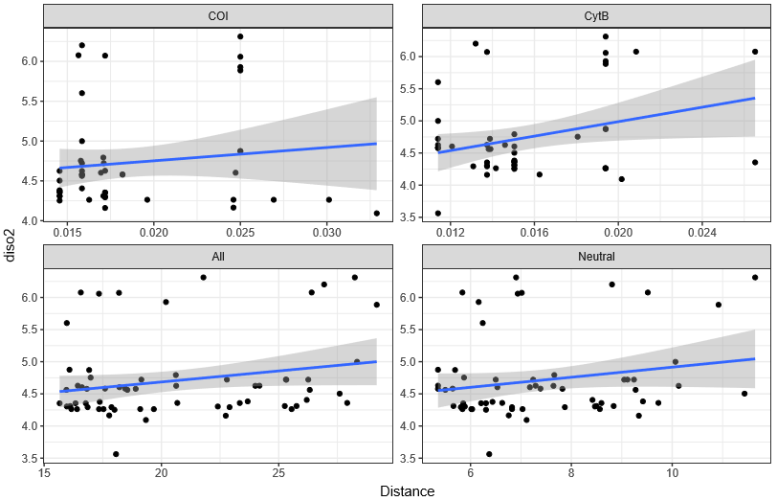
Figure S1. Scatterplot of genetic distance (Distance) as a function of dissolved oxygen (diso2) for the deep-sea sponge Poecillastra laminaris across four genetic marker types.
Note: The blue line is the fitted linear regression line and the grey area is the 95% confidence interval.

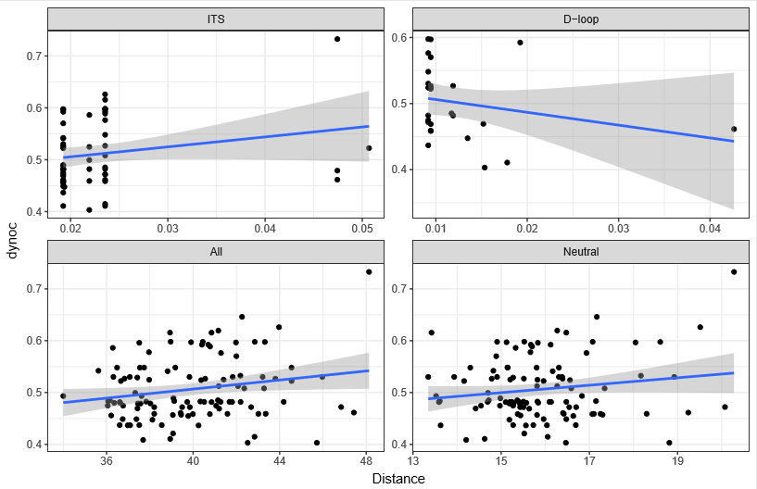
Figure S2. Scatterplot of genetic distance (Distance) as a function of dynamic topography (dynoc) for the deep-sea coral Goniocorella dumosa across four genetic marker types.
Note: The blue line is the fitted linear regression line and the grey area is the 95% confidence interval.

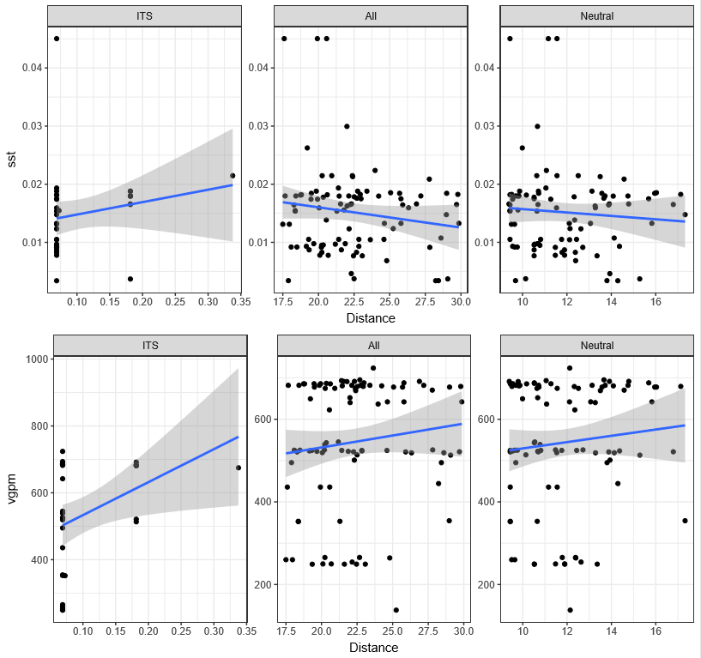
Figure S3. Scatterplot of genetic distance (Distance) as a function of sea surface temperature (sst) and surface water primary productivity (vgpm) for the deep-sea coral Madrepora oculata across three genetic marker types.
Note: The blue line is the fitted linear regression line and the grey area is the 95% confidence interval.

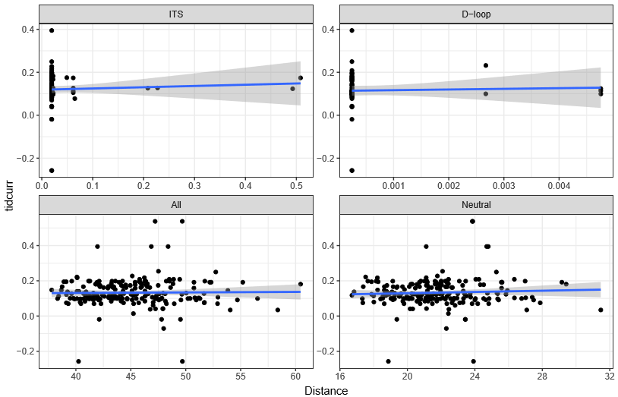
Figure S4. Scatterplot of genetic distance (Distance) as a function of tidal current speed (tidcurr) for the deep-sea coral Solenosmilia variabilis across four genetic markers.
Note: The blue line is the fitted linear regression line and the grey area is the 95% confidence interval.
Figure S5. Comparison across north-central-south regional populations of their distribution range along the environmental variables that effected the genetic structures in DistLM analyses amongst Poecillastra laminaris (A, B, C, D), Goniocorella dumosa (E), Madrepora oculata (F, G, H) and Solenosmilia variabilis (I, J) and different markers (COI (A), Cytb (B), ITS (F), all microsatellite loci (D, E, H, J) and neutral microsatellite loci (C, E, G, I)). Individual observations are shown as small horizontal white lines within the estimated density trace. Dotted lines represent the median over all subpopulations.

