Gene expression in immortalized versus primary isolated cardiac endothelial cells

SUPPLEMENTARY MATERIAL

Lisa Deng¹, Luisa Pollmeier¹, Qian Zhou², Stella Bergemann¹, Christoph Bode², Lutz Hein^{1,3}, Achim Lother^{1,2}

¹ Institute of Experimental and Clinical Pharmacology and Toxicology, Faculty of Medicine, University of Freiburg, Germany
² Heart Center Freiburg University, Department of Cardiology and Angiology I, Faculty of Medicine, University of Freiburg, Germany
³ BIOSS Centre for Biological Signaling Studies, University of Freiburg, Germany

Supplementary Methods
Total RNA was extracted from MCEC using RNeasy Mini Kit (Qiagen) according to manufacturer’s instruction and used for the synthesis of cDNA using the QuantiTect Reverse Transcription Kit (Qiagen). Quantitative real-time polymerase chain reaction was carried out using a CFX96 Touch Real-Time PCR Detection System (Bio-Rad) and the SsoAdvanced Universal SYBR Green Supermix (Bio-Rad). Gene expression analyses were normalized to expression of Rps29 (Ribosomal Protein S29). Primer sequences are given in Supplementary Table 1.

Supplementary Table 1: Primer sequences
Gene | Forward primer | Reverse primer
Rps29 | ATGGGTCACCAGCAGCTCTA | AGCCTATGTCCTTCGCGT ACT
Cdh5 | TATAGGGACCTCTGTCATCCG TG | CGATTTGGTACAAGACAG TGGC
Pecam1 | AACAGAGCCAGCAGTATGAG | ATGACCACTCCAATGACA ACCA
Kdr | TTTGGCAAATACAACCCTTCAGA | GCAGAAGATACTGTCACCACC

Supplementary Figure 1

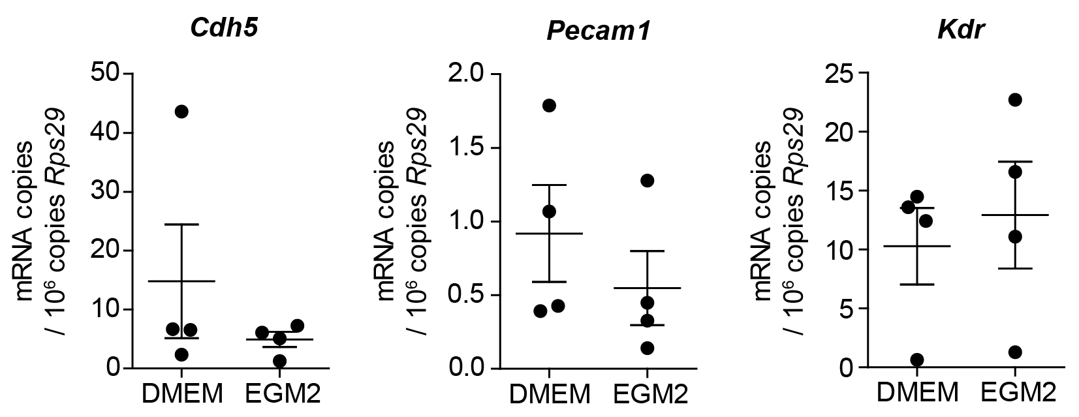

Supplementary Figure 1: Culture medium-dependent expression of endothelial cell marker genes. Immortalized mouse cardiac endothelial cells were cultured in either Dulbecco's Modified Eagle Medium with 5% FCS (DMEM) or in Microvascular Endothelial Cell Growth Medium-2 with 5% FCS and growth factor supplement (EGM2, Lonza) for 3 days. Expression of the typical endothelial cell marker genes cadherin 5 (Cdh5), platelet endothelial cell adhesion molecule 1 (Pecam1) or vascular endothelial cell growth factor receptor 2 (Kdr) was determined by qRT-PCR. Mean ± SEM. n = 4 per group. Rps29, Ribosomal protein S29.

