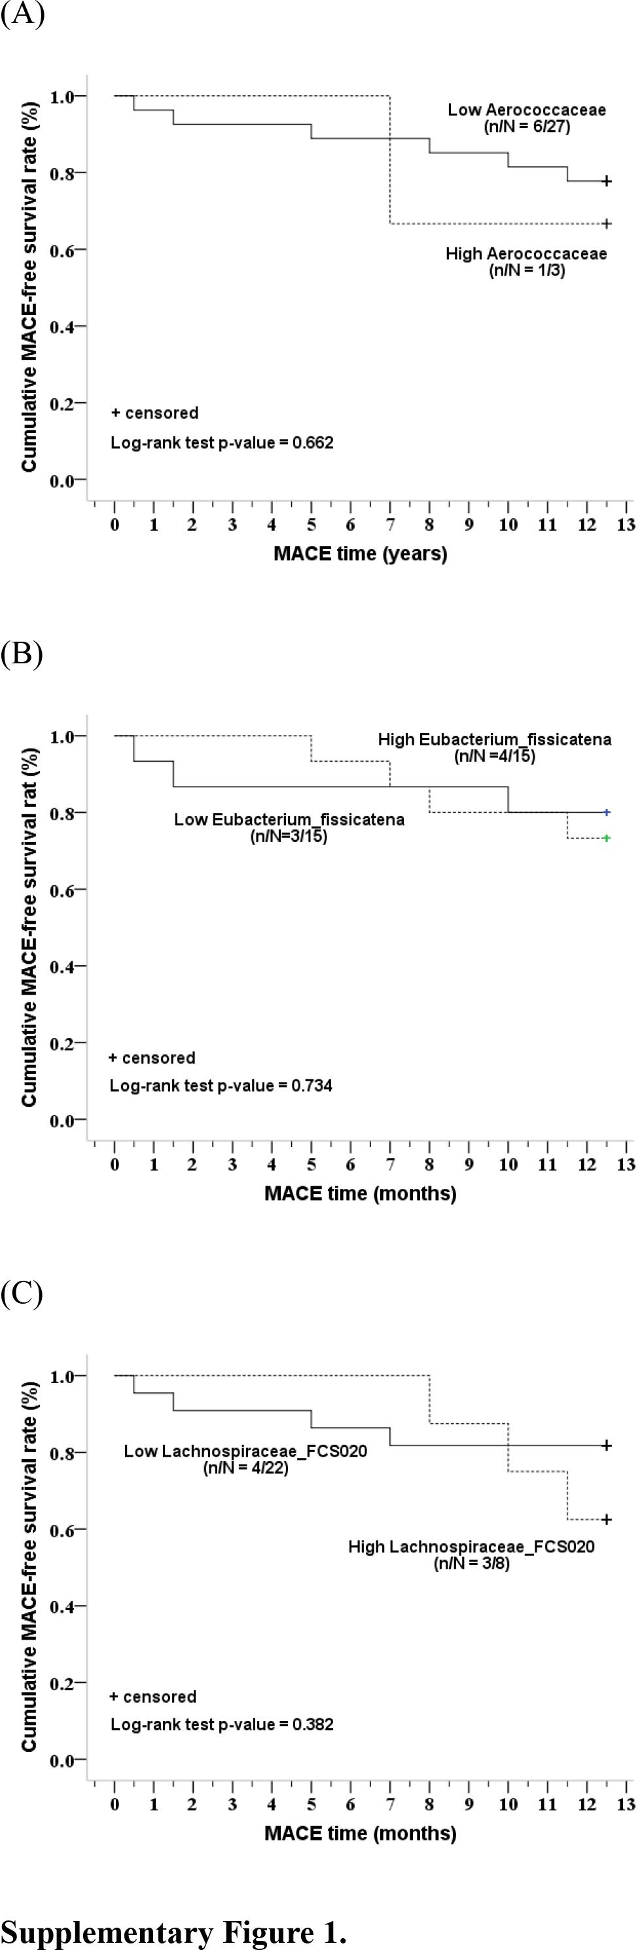
Supplementary Figure 1. Comparison of 1-year MACE-free or total event-free survival rates between patients with low and high abundance of (A) Aerococcaceae, (B) Eubacterium_fissicatena, and (C) Lachnospiraceae_FCS020. Patients were stratified according to the mean abundance of microbes = 0.29×10⁻⁵ for Aerococcaceae, mean value = 1.86×10⁻⁵ for Eubacterium_fissicatena, and median abundance of microbes = 0.12×10⁻³ for Lachnospiraceae_FCS020 in controls. n indicates MACE, N indicates total number of patients. No significant differences were found between microbes.

