Surveillance of Enterococcus spp. reveals their distinct species and antimicrobial resistance diversity across the One-Health continuum
Rahat Zaheer¹, Shaun R Cook², Ruth Barbieri¹, Noriko Goji³, Andrew Cameron¹, Aaron Petkau⁴, Rodrigo Ortega Polo¹, Lisa Tymensen², Courtney Stamm⁵, Jiming Song⁵, Sherry Hannon⁵, Tineke Jones⁶, Deirdre Church⁷⁸, Calvin W Booker⁵, Kingsley Amoako³, Gary Van Domselaar⁴, Ron R Read⁷, Tim A McAllister^{1*}
¹Lethbridge Research and Development Centre, Agriculture and Agri-Food Canada, 5403 1st Avenue South, Lethbridge, AB, T1J 4P4, Canada
²Alberta Agriculture and Forestry, 100, 5401 1st Avenue South, Lethbridge, AB, T1J 4V6, Canada
³Canadian Food Inspection Agency, National Center for Animal Disease, Lethbridge Laboratory, Township Rd 9-1, Lethbridge, AB, T1J3Z4, Canada
⁴National Microbiology Laboratory, Public Health Agency of Canada, 1015 Arlington Street, Winnipeg, MB, R3E 3R2, Canada
⁵Feedlot Health Management Services, Okotoks, AB, Canada
⁶Lacombe Research and Development Centre, Agriculture and Agri-Food Canada, 6000 C and E Trail
Lacombe, AB, T4L 1W1, Canada
⁷Cumming School of Medicine, University of Calgary, 3280 Hospital Drive NW, Calgary, Alberta
⁸Calgary Laboratory Services (CLS), Alberta Health Services, 3535 Research Rd NW, Calgary, AB T2L 2K8 Canada.
* Correspondence to: tim.mcallister@canada.ca

Supplementary Table S1: Sampling details.

Location/Site |  | Number of samples collected over 2 years
Beef Cattle Feedlots (n=4)
 | Composite Pen Fecal | 866
 | Catch Basins | 72
 | Manure stockpile | 5
Environment
 | Surface water (constructed wetland, creek, drain, clean storage) | 57
 | Soil | 25
Urban wastewater
 | Influent | 22
 | Effluent | 21
Beef Processing
 | Carcass gauze swab after Hide Removal (abattoir) | 150
 | Carcass gauze swab after Final Wash (abattoir) | 150
 | Gauze swab Conveyor Belts (abattoir) | 150
 | Ground Beef (abattoir) | 150
 | Retail Meat | 60
 | Total number of samples | 1728

Supplementary Table S2: Percentage of samples positive for enterococci per sampling site.
 | Enterococci
 | antibiotic-free media | Selective media (with erythromycin)
Feedlot – Pen Composite
A | 99.56% | 98.25%
B | 98.66% | 81.25%
C | 98.60% | 92.52%
D | 99.50% | 91.50%
Feedlot – Catch Basin
A | 87.50% | 75.00%
B | 100.00% | 83.33%
C | 70.59% | 61.76%
D | 58.33% | 54.17%
Surface Water
C – Constructed Wetland | 100.00% | 68.42%
C – Clean storage | 100.00% | 71.43%
C – Drain | 100.00% | 12.50%
A – creek upstream feedlot | 81.82% | 27.27%
A – creek downstream feedlot | 100.00% | 45.45%
Soil
C – East Field | 0.00% | 0.00%
C – West Field | 0.00% | 0.00%
C – Manure stockpile | 100.00% | 100.00%
Urban wastewater
Medicine Hat – Influent | 100.00% | 100.00%
Medicine Hat – Effluent | 72.73% | 9.09%
Calgary – Influent | 100.00% | 100.00%
Calgary – Effluent | 90.00% | 20.00%
Beef Processing
Hide Removal | 59.33% | 32.67%
Final Wash | 15.33% | 8.00%
Conveyor Belts | 12.67% | 0.67%
Ground Beef | 82.67% | 35.33%
Retail Meat | 78.33% | 36.67%

Supplementary Table S3: Proportion of Enterococcus species isolated from various sample types
[number(%)]
 | Fecal | Manure stockpile | Catch Basin | Surface Water | Abattoir - retail meat | Urban wastewater | Clinical
E. avium | 4(0.09) | 0(0) | 0(0) | 0(0) | 1(0.13) | 0(0) | 0(0)
E. casseliflavus | 5(0.11) | 10(29.41) | 85(16.47) | 119(22.67) | 5(0.65) | 1(0.43) | 3(0.16)
E. columbae | 2(0.04) | 0(0) | 0(0) | 0(0) | 0(0) | 0(0) | 0(0)
E. durans | 91(2.02) | 0(0) | 35(6.78) | 89(16.95) | 14(1.81) | 9(3.86) | 0(0)
E. faecalis | 35(0.78) | 0(0) | 26(5.04) | 42(8.00) | 572(73.90) | 121(51.93) | 1541(83.34)
E. faecium | 73(1.62) | 0(0) | 45(8.72) | 52(9.90) | 34(4.39) | 89(38.20) | 249(13.47)
E. gallinarum | 1(0.02) | 0(0) | 18(3.49) | 4(0.76) | 7(0.90) | 4(1.72) | 1(0.05)
E. hirae | 4117(91.51) | 24(70.59) | 306(59.30) | 145(27.62) | 112(14.47) | 9(3.86) | 3(0.16)
E. malodoratus | 47(1.04) | 0(0) | 0(0) | 0(0) | 9(1.16) | 0(0) | 0(0)
E. mundtii | 5(0.11) | 0(0) | 1(0.19) | 74(14.10) | 3(0.39) | 0(0) | 0(0)
E. raffinosus | 0(0) | 0(0) | 0(0) | 0(0) | 17(2.20) | 0(0) | 0(0)
E. villorum | 119(2.65) | 0(0) | 0(0) | 0(0) | 0(0) | 0(0) | 0(0)
Enterococcus spp. | 0(0) | 0(0) | 0(0) | 0(0) | 0(0) | 0(0) | *52(2.81)
TOTAL isolates: | 4499 | 34 | 516 | 525 | 774 | 233 | 1849

*Fifty of these isolates were later characterized as E. faecalis (42), E. faecium (5), E. casseliflavus (1), E. hirae (1), and E. raffinosis (1).

Supplementary Table S4: Antimicrobial resistance genes identified in E. faecalis, and E. faecium genomes
Resistance type | No. of genes | Gene name(s)
aminoglycoside | 13 | aac(6')-Ie/aph(2'')-Ia, aac(6'), aadE, aac(6')-Ii, aac(6')-Iid, aadD1, ant(6)-Ia, ant(9)-Ia, ant(9)-Ib, aph(2'')-IIIa, aph(3')-IIIa, str, spw
quaternary ammonium compound small multidrug resistance (SMR) family of drug efflux pumps | 2 | bcrB, bcrC
linezolid | 1 | cfr
phenicol | 4 | cat-TC, catA, catP, fexA
oxazolidinone phenicol transferable resistance | 1 | optrA
macrolide | 4 | erm(A), erm(B), erm(T), msr(C)
lincosamide & streptogramin A | 5 | lnu(A), lnu(B), lnu(G), lsa(A), lsa(E)
lincosamides, streptogramins A, and pleuromutilins | 1 | eat(A)
streptothricin | 1 | sat4
tetracycline | 5 | tet(L), tet(M), tet(O), tet(S), tet(W)
trimethoprim | 4 | dfrC, dfrE, dfrF, dfrG
vancomycin gene cluster | 15 | vanA, vanB, vanC, vanH-A, vanH-B, vanR, vanS, vanT/Tc, vanW, vanX-A, vanX-B, vanXY-C, vanY-A, vanY-B, vanZ-A

Genes in bold were detected in isolates from both species.

Supplementary Table S5: Virulence factors and their associated genes identified in E. faecalis, and E. faecium genomes
Virulence factors | No. of genes | Gene name(s)
adhesins | 2 | EF0149, sgrA
aggregation substances | 3 | EF0485, asa1, prgB/asc10
hyaluronidases | 2 | hylA/EF0818, hylB/EF3023
biofilm-associated proteins | 8 | ace, bopD, gelE, ebpA, ebpB, ebpC, esp, srtC
lipopolysaccharide biosynthesis proteins | 2 | bplB, bplC
bile salt hydrolase | 1 | bsh
caseinolytic protease | 1 | clpP
capsular polysaccharide biosynthesis | 11 | cpsA, cpsB, cpsC, cpsD, cpsE, cpsF, cpsG, cpsH, cpsI, cpsJ, cpsK
cytolysin production | 8 | cylA, cylB, cylI, cylL, cylM, cylR1, cylR2, cylS
collagen binding protein | 3 | ecbA, acm, scm
endocarditis specific antigen | 1 | efaA
virulence regulator/signal transduction system | 3 | fsrA, fsrB, fsrC
fibrinogen adhesins | 3 | fss1, fss2, fss3
fimbrial biogenesis | 2 | pilT, pilU
metal binding lipoprotein | 1 | psaA
serine protease | 1 | sprE

Genes in bold were detected in isolates from both species.

Supplementary Table S6: Description of antimicrobials used in the feedlots
Antimicrobial family | Antimicrobial | Route
Tetracycline | Chlortetracycline | In Feed
 | Oxytetracycline | Parenteral
Ionophore | Monensin | In Feed
 | Lasalocid | In Feed
Macrolide | Tylosin | In Feed/parenteral
 | Tulathromycin | Parenteral
 | Tilmicosin | Parenteral
Phenicol | Florfenicol | Parenteral
Cephalosporin | Ceftiofur | Parenteral
Fluoroquinolone | Enrofloxacin | Parenteral
Potentiated sulfonamide | Sulfadoxine | Parenteral
Sulfonamide combination | Sulfanilamide, sulfathiozole, sulfamethazine | Oral Administration

The in-feed antimicrobials (ionophores, chlortetracycline or tylosin) were administered to all cattle in the conventional feedlot throughout the feeding period, while the therapeutic parenteral drugs were administered to only clinically ill cattle as required. Tylosin was used in-feed at 11 mg/kg dry matter (DM) basis. In feed Chlortetracycline was used at 1g/100 lb = 10 mg/lb=20mg/kg. Sulfonamides had limited use and aminoglycosides were rarely used.

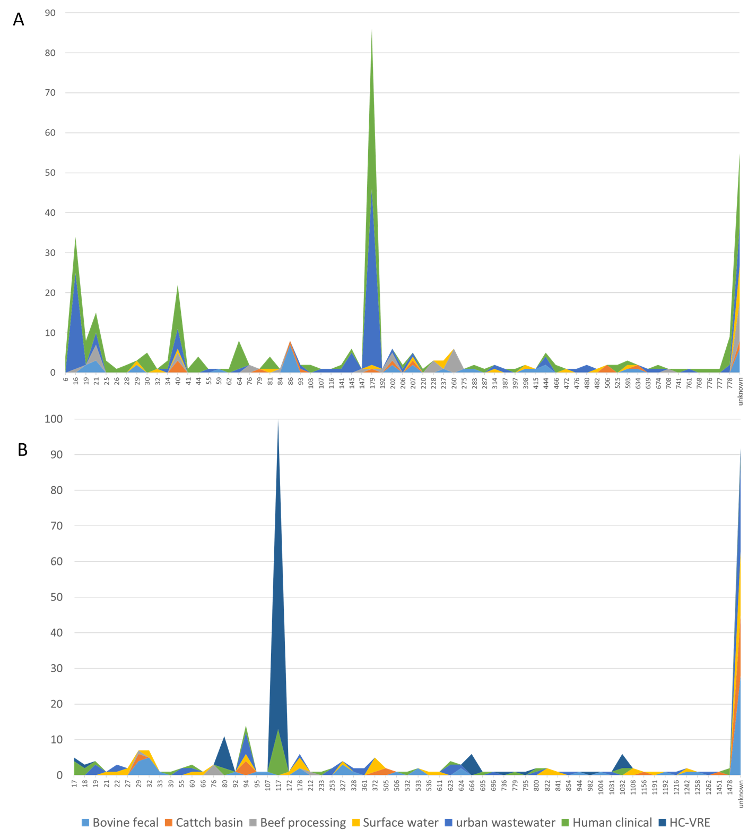
Figure S1: MLST profiles of E. faecalis (A) and E. faecalis (B) across the continuum

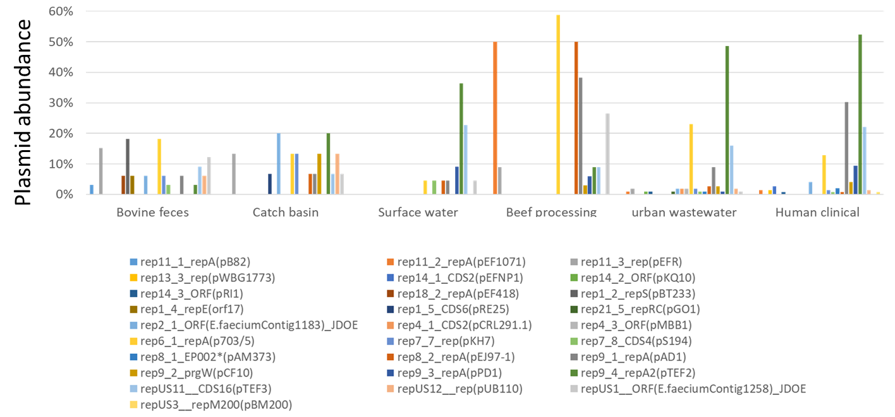
Figure S2: Abundance of various plasmids in E. faecalis across the continuum

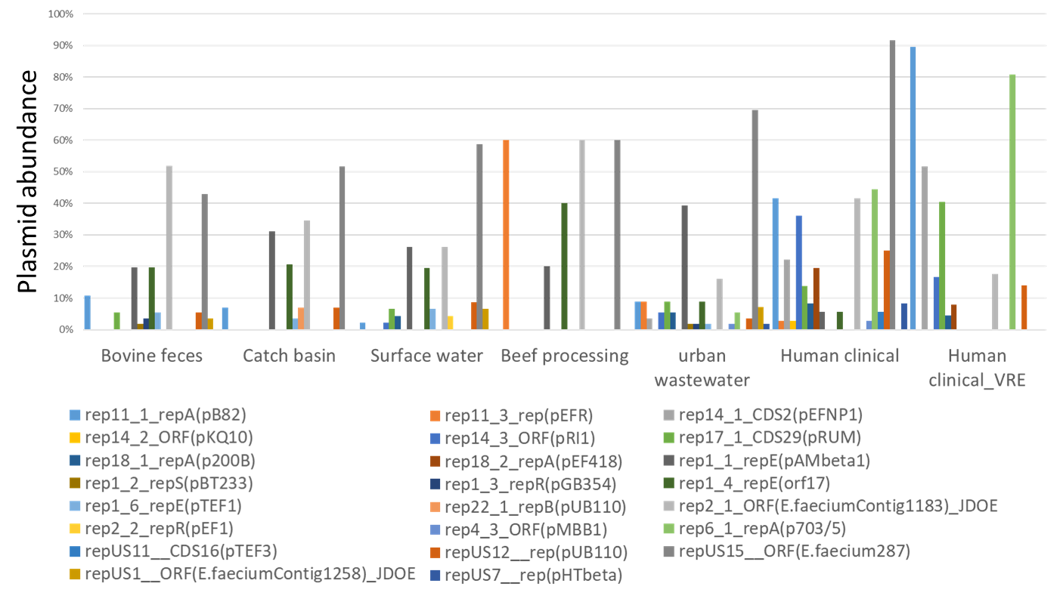
Figure S3: Abundance of various plasmids in E. faecium across the continuum

