Systematic alteration of ATAC-seq for profiling open chromatin in cryopreserved nuclei preparations from livestock tissues

Halstead MM, Kern C, Saelao P, Chanthavixay G, Wang Y, Delany ME, Zhou H, Ross PJ
Department of Animal Science, University of California, Davis, Davis, CA

Supplementary information

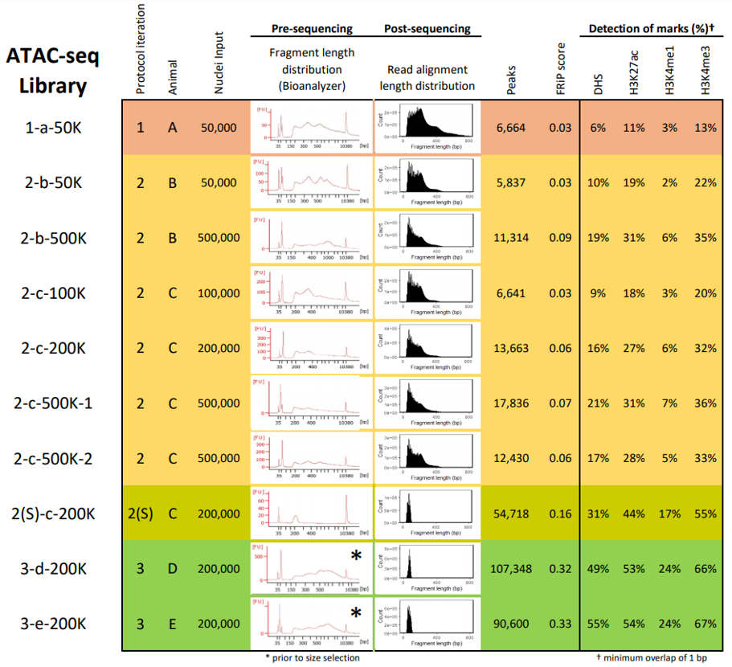
Supplementary Figure 1. Summary of libraries for each ATAC-seq protocol iteration, produced from cryopreserved chicken lung nuclei. Row colors indicate different iterations of the ATAC-seq protocol. Library names indicate “Protocol iteration–Animal–Nuclei input(–Replicate)”. Progressive changes to the protocol improved signal (Fraction of Reads in Peaks (FRiP) score) and improved overlap with DNase-I Hypersensitive Sites (DHS) and active histone modifications (minimum 1 bp overlap).
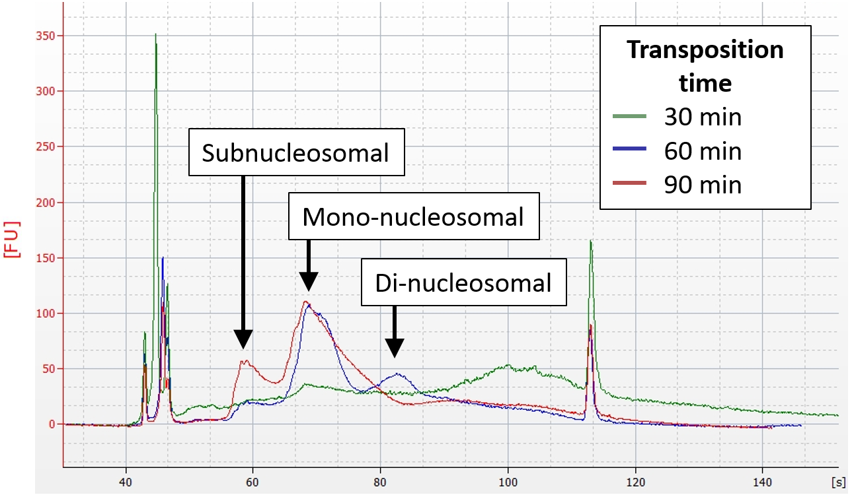
Supplementary Figure 2. Varying transposition time affects library fragment length distribution. Bioanalyzer trace shows that the fragment length distribution of ATAC-seq libraries is shifted towards subnucleosomal length fragments when transposition time is increased from 30 to 90 minutes.

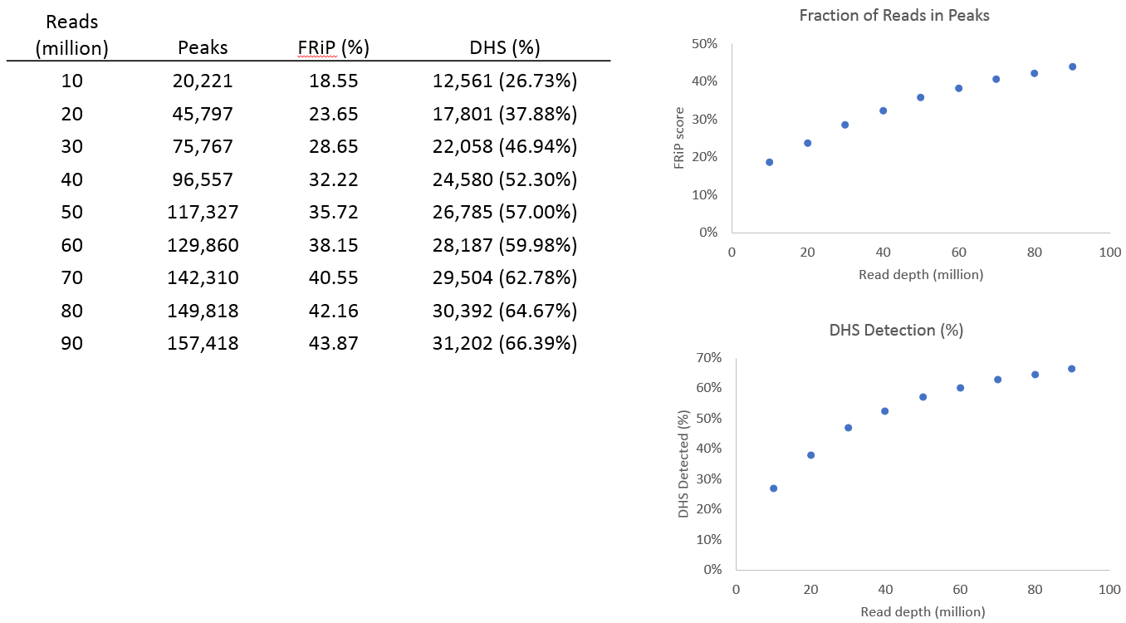Supplementary Figure 3. The combined set of 3-d-200k and 3-e-200k (uniquely-mapped non-mitochondrial monoclonal) was subsampled and used for peak calling to determine optimal sequencing depth for future experiments. Number of peaks called, fraction of reads in peaks (FRiP), and detection of DHS (min 1 bp overlap) started to plateau after 50 million reads.

Supplementary Datasets
ATAC-seq peak interval files:
- ATACSeq_Pig_Lung_Combined_Peaks.bed
- ATACSeq_Pig_Muscle_Combined_Peaks.bed
- ATACSeq_Pig_Spleen_Combined_Peaks.bed
- ATACSeq_Chicken_Lung_Combined_Peaks.bed

DNase-seq and ChIP-seq peak interval files:
- DNaseSeq_Chicken_Lung_Peaks.bed
- H3K4me1_Chicken_Lung_Peaks.bed
- H3K4me3_Chicken_Lung_Peaks.bed
- H3K27ac_Chicken_Lung_Peaks.bed

List of genes with promoters marked by an ATAC-seq peak in pig tissues

