Mdm2 enhances ligase activity of parkin and facilitates mitophagy
Seunghyi Kook, Xuanzhi Zhan, Kimberly Thibeault, Mohamed R. Ahmed, Vsevolod V. Gurevich, and Eugenia V. Gurevich
Department of Pharmacology, Vanderbilt University, Nashville, TN 37232

Uncropped Western blot images

FIGURE 1

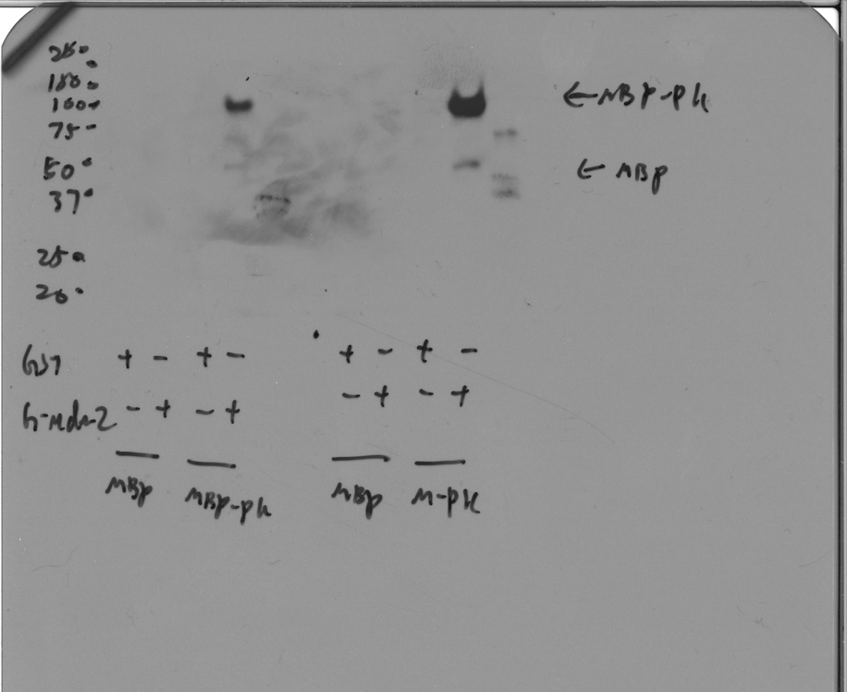

Fig 1A: GST pulldown; anti-MBP blot; two different loads.

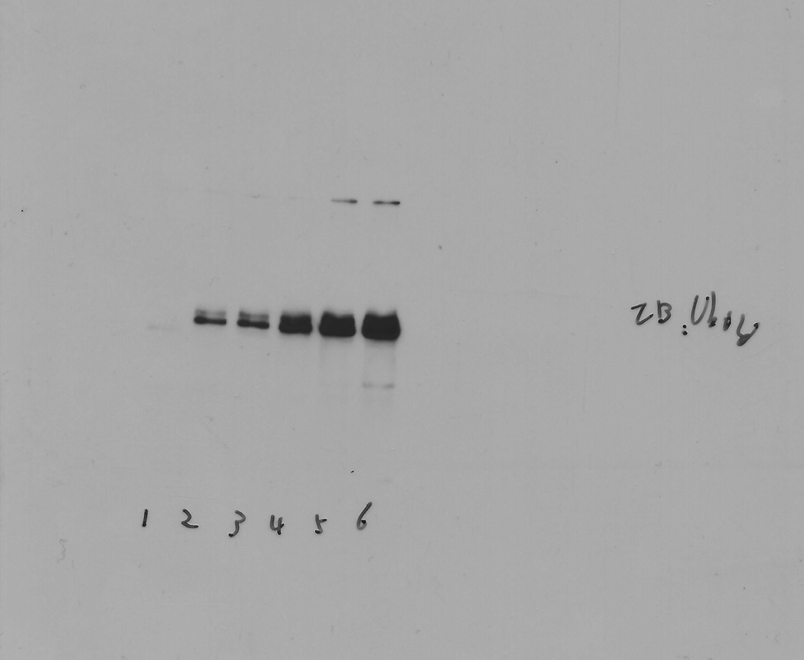

Fig 1B: Ubiquitin blot

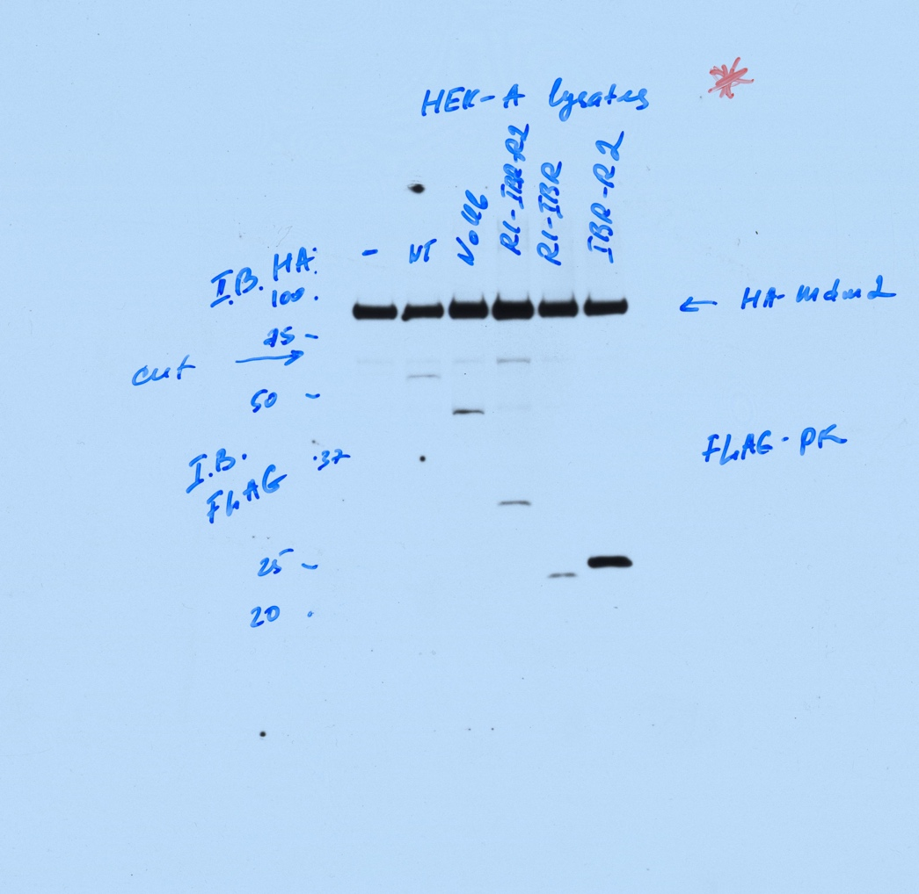
Fig 1E left panel: the blot was cut horizontally and the upper portion probed with anti-AH antibody (for HA-Mdm2) and the lower - with anti-FLAG (for FLAG-Parkin fragments).

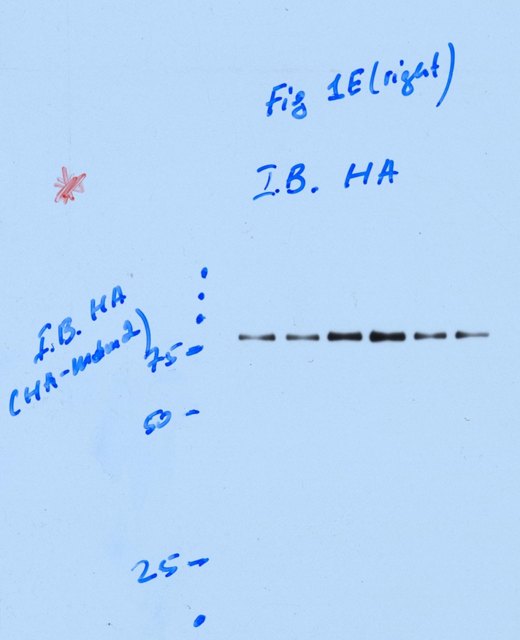
Fig 1E right panel: IB HA (H-Mdm2).

FIGURE 2

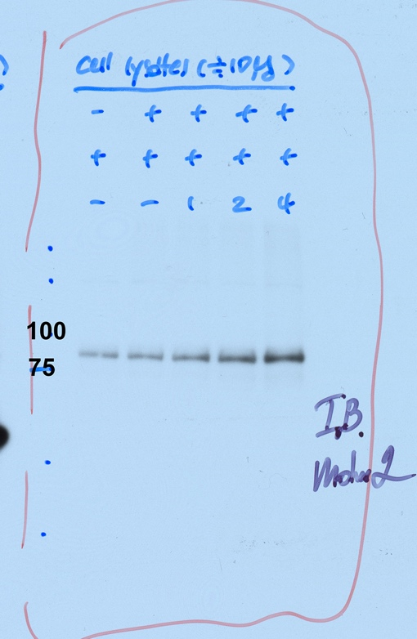
Fig 2A left panel: HEK cell lysates Mdm2

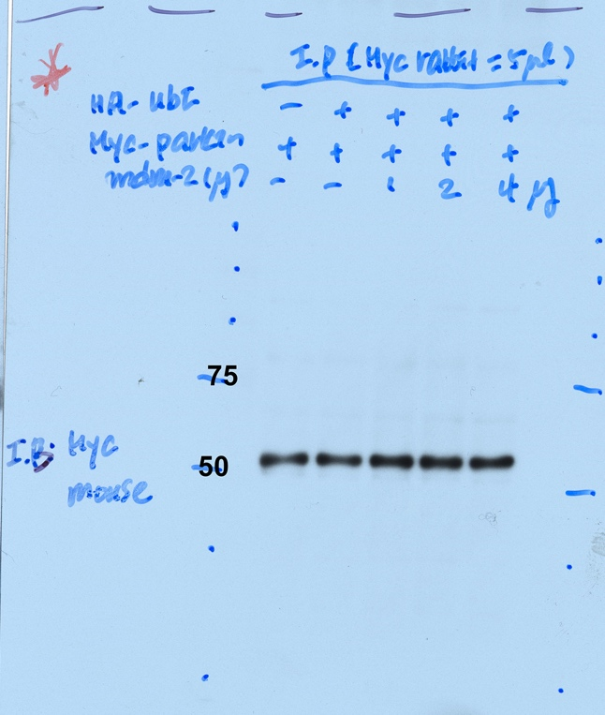
Fig 2A right panel: IP myc IB myc (myc-parkin)

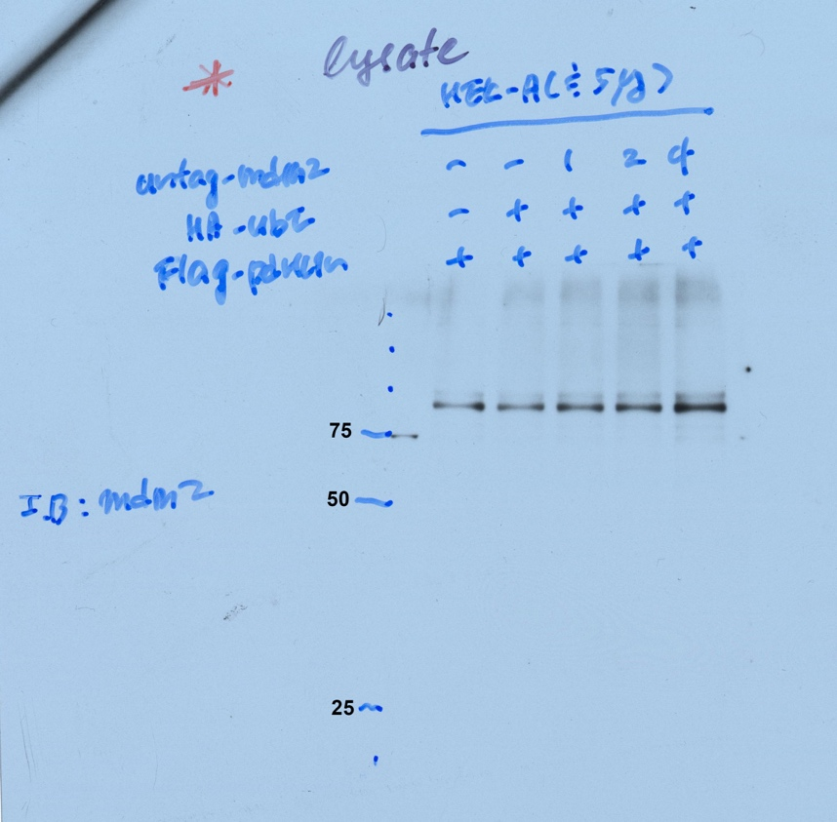
Fig 2B left panel: lysates Mdm2

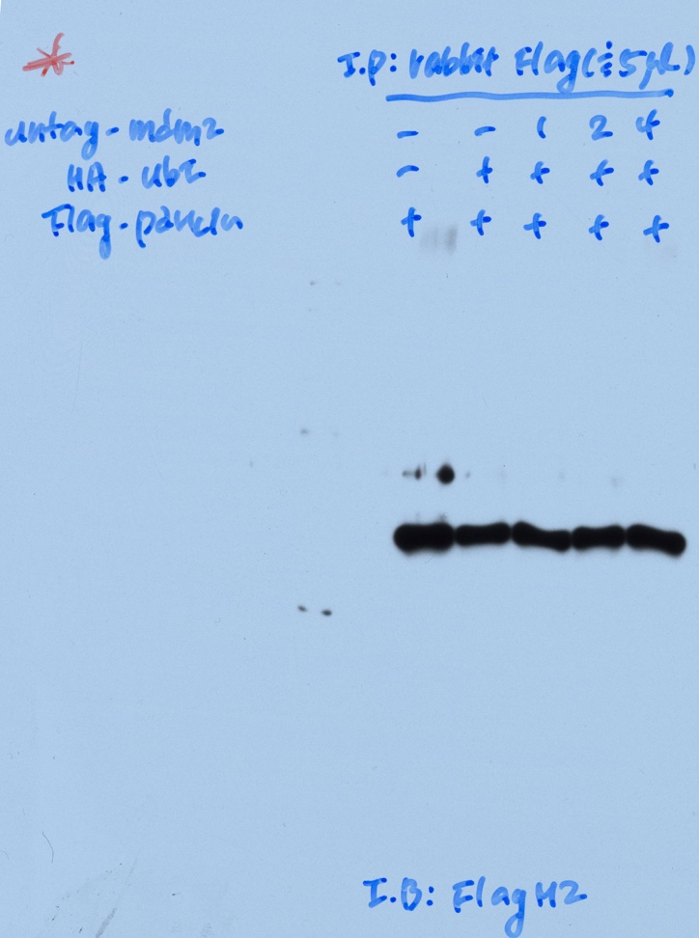
Fig 2B right panel: IP FLAG IB FLAG

FIGURE 3

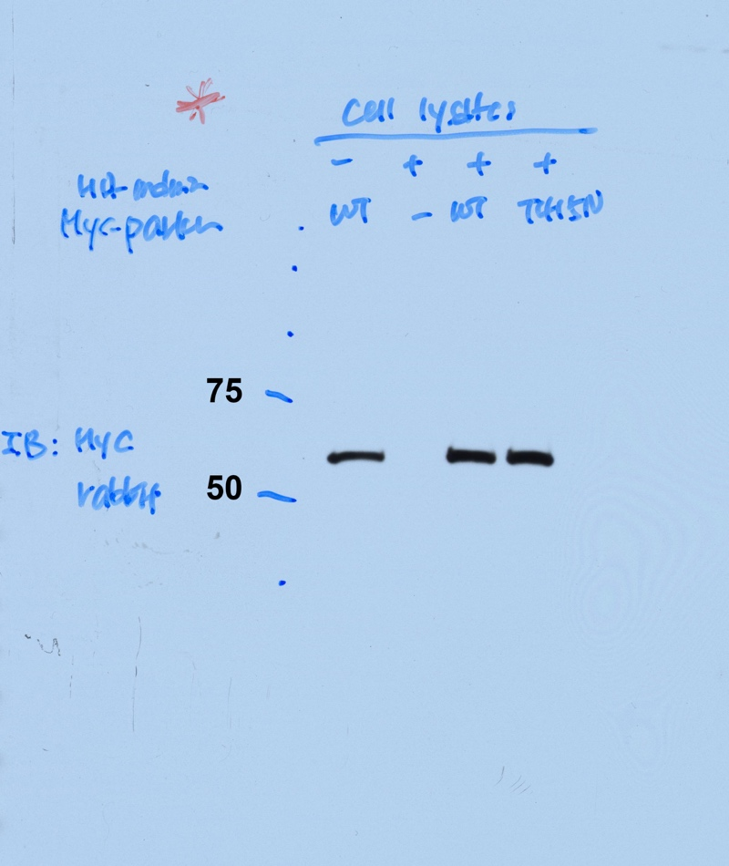
Fig 3A right panel: IB myc (myc-parkin) cell lysates

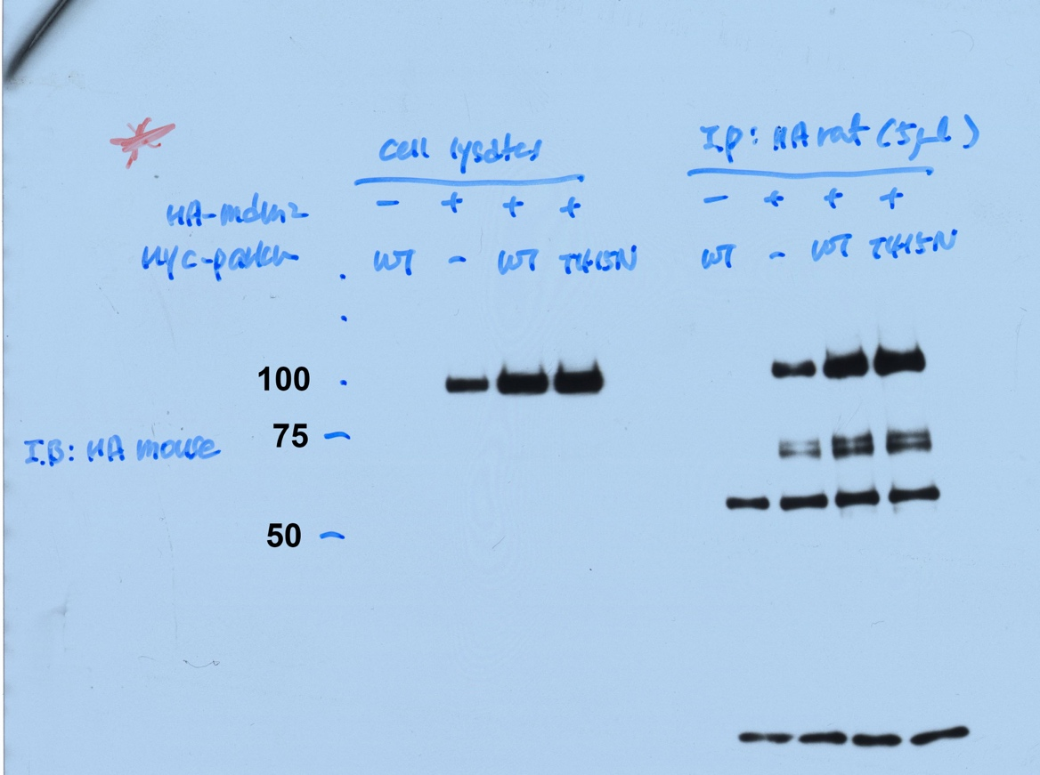
Fig 3A: IB HA cell lysates (right panel in Fig 3A) and IP HA (left panel in Fig 3A)
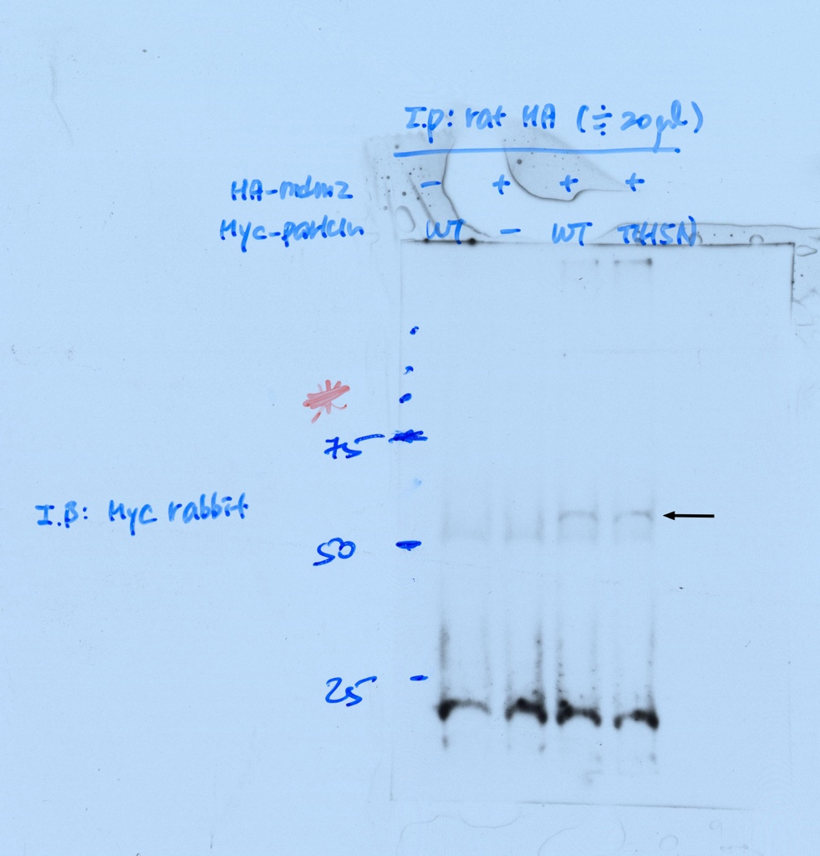
Fig 3A left panel: IP HA IB myc
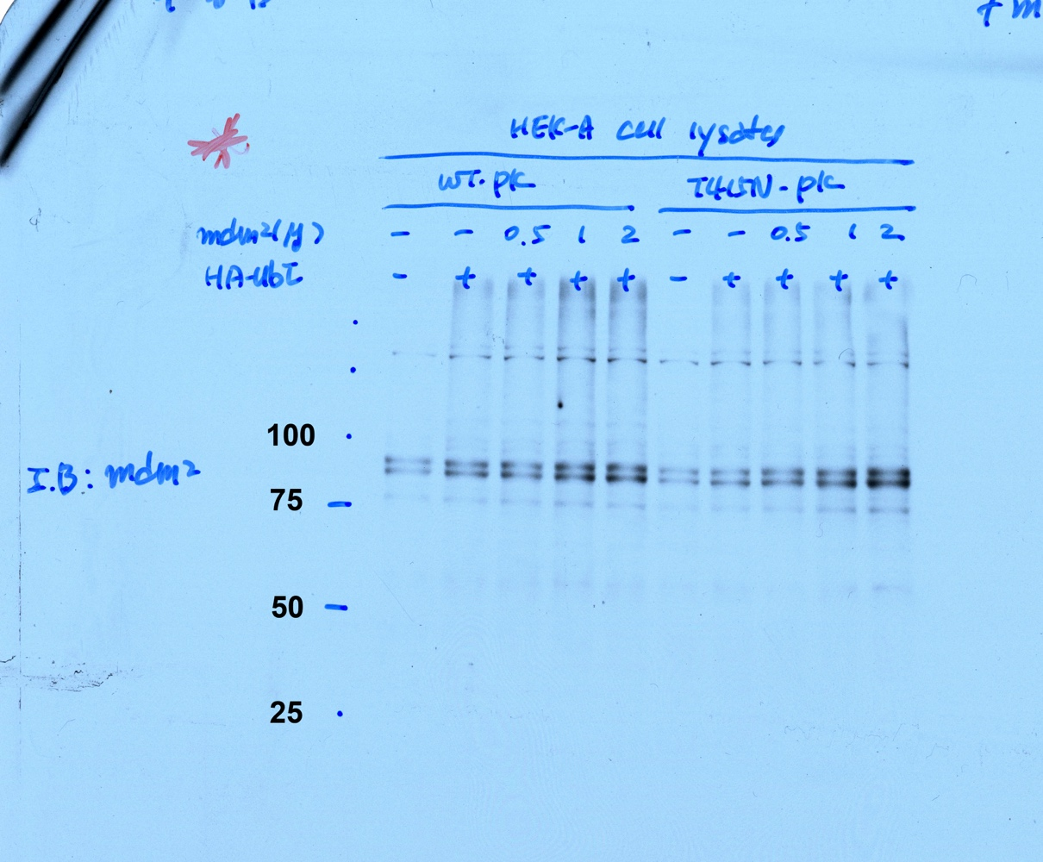
Fig 3B upper panel: Mdm2 cell lysates

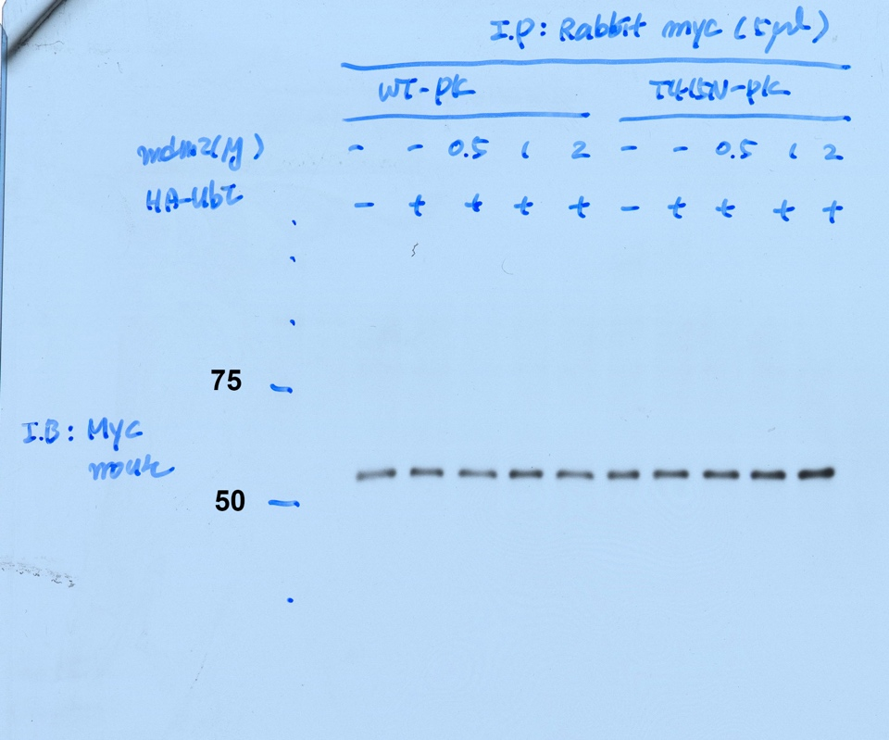
Fig 3B lower panel: IP myc IB myc (myc-parkin)

FIGURE 4

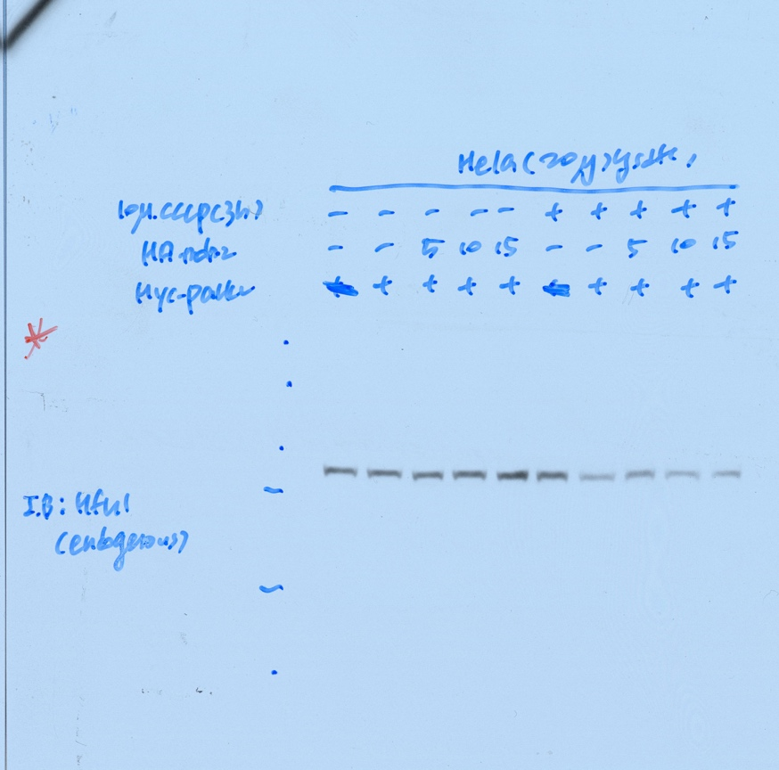
Fig 4A: IB Mfs-1 short exposure

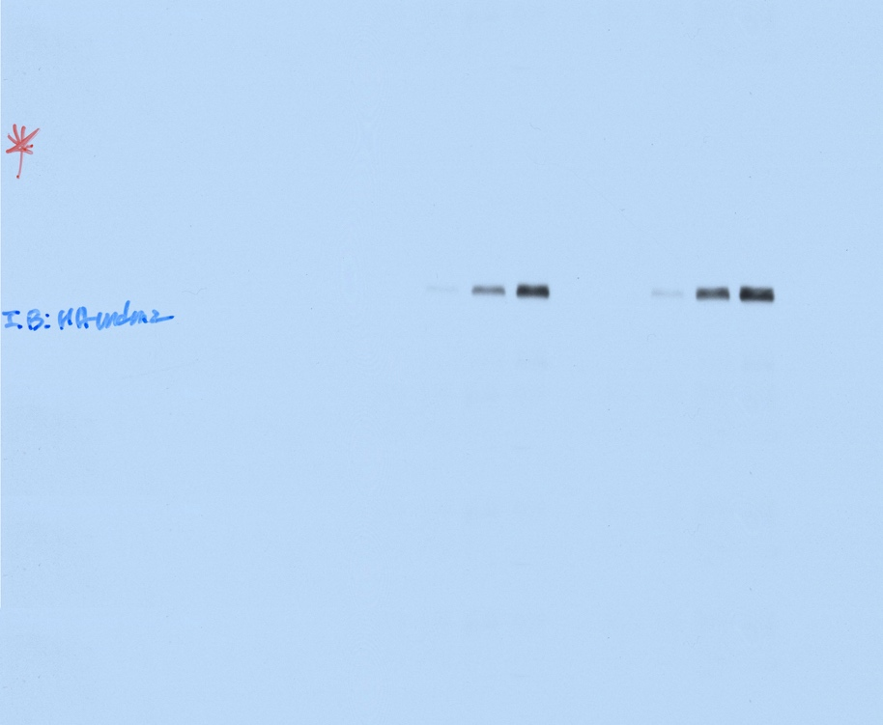
Fig 4A: IB HA - HA-Mdm2

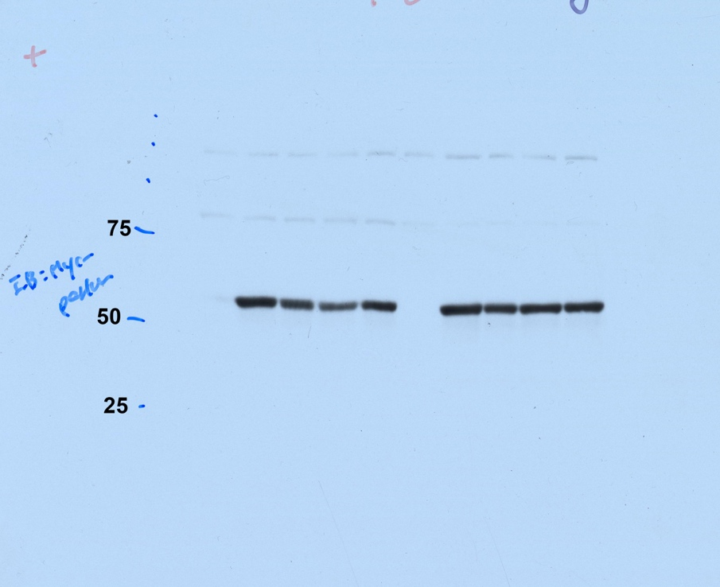
Fig 4A: IB myc - myc-parkin

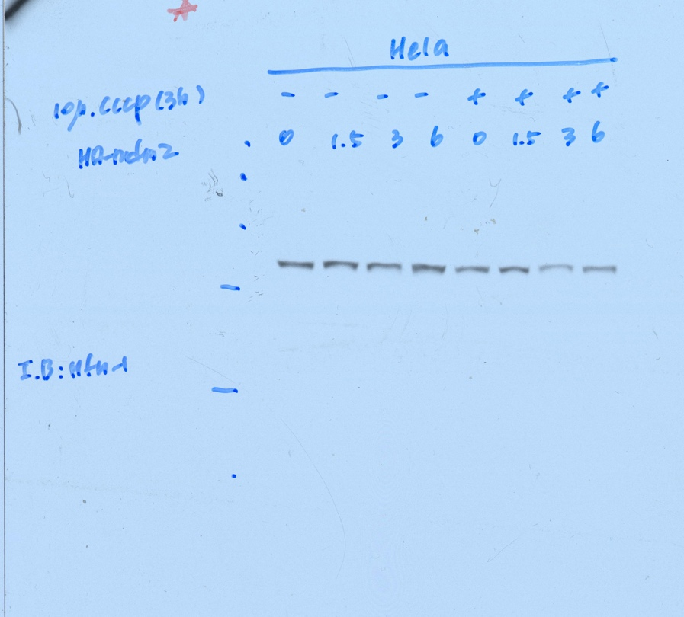
Fig 4B: IB Mfs-1 short exposure

Fig 4D upper panel: IB myc (myc-Mfs-1)
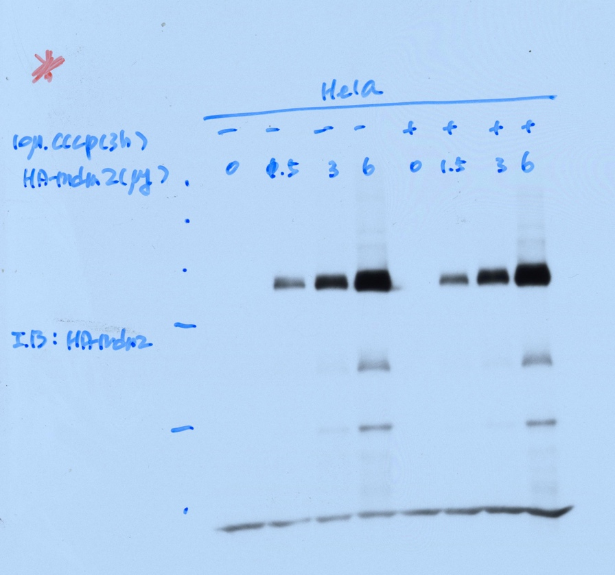
Fig 4B: IB HA - HA-Mdm2

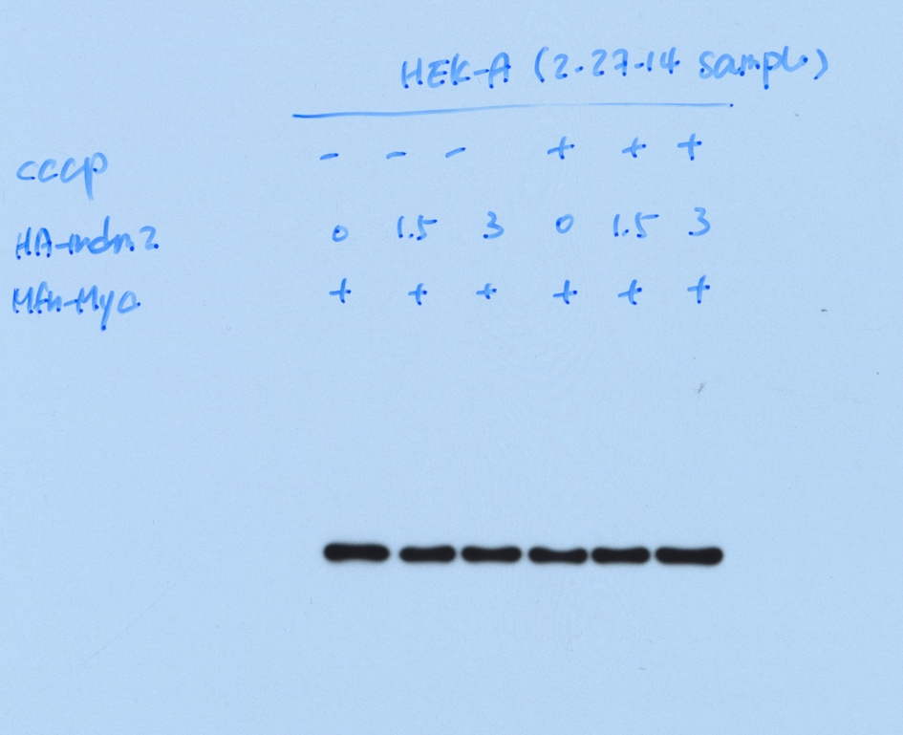
Fig 4B: GABDH

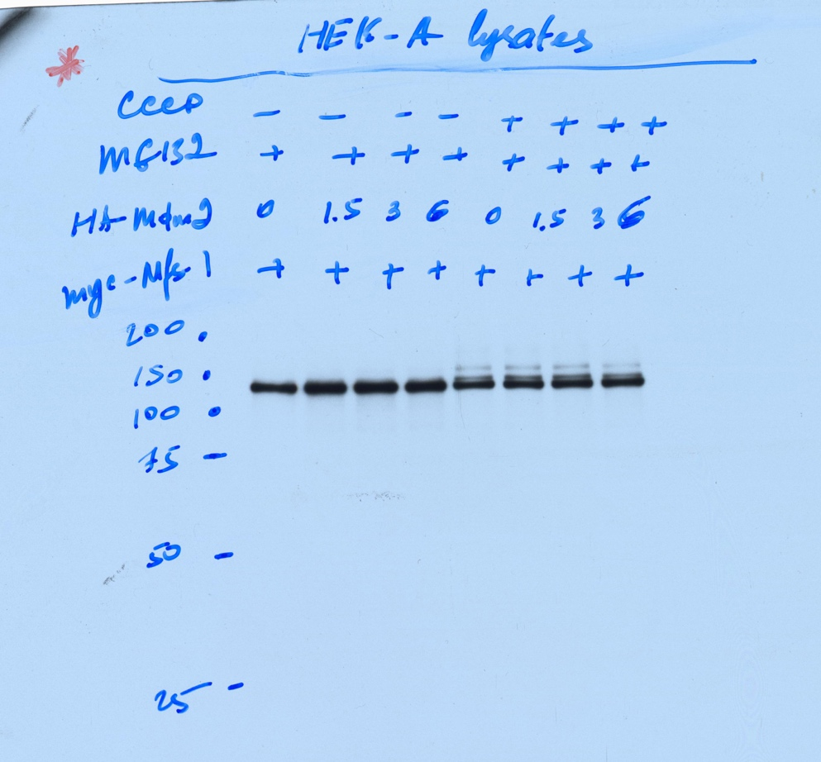
Fig 4D upper panel: IB myc (myc-Mfs-1)

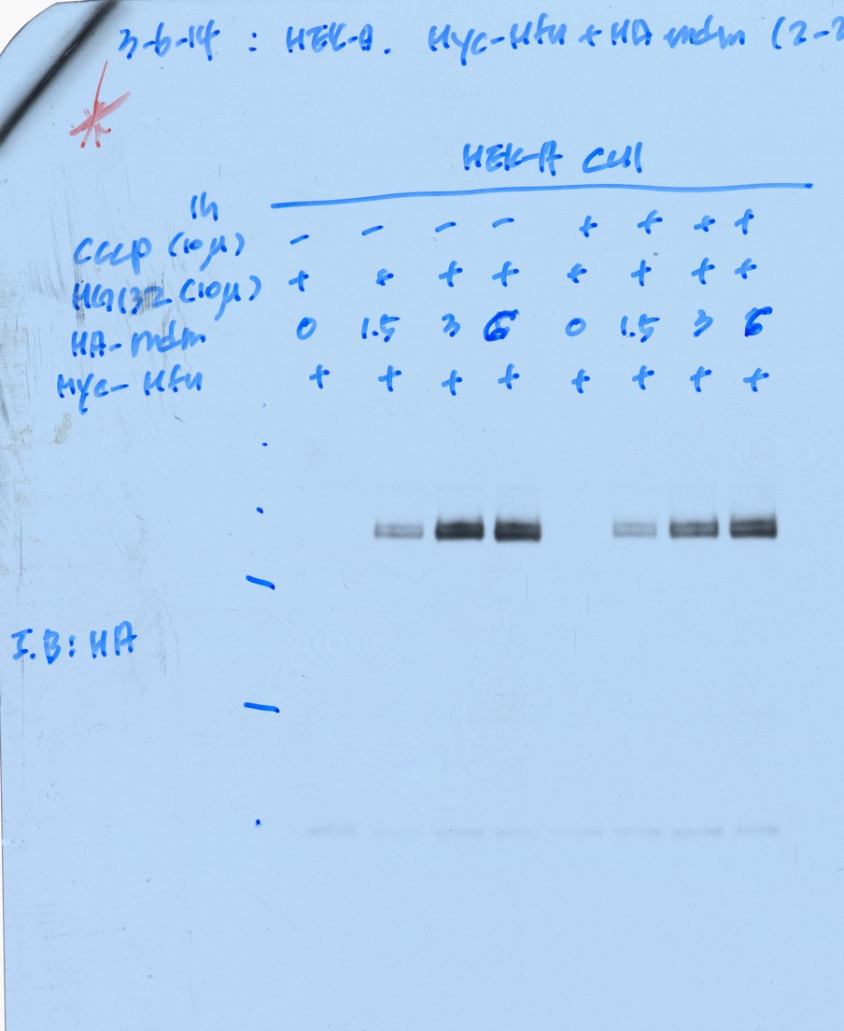
Fig 4D upper panel: IB HA (HA-Mdm2)

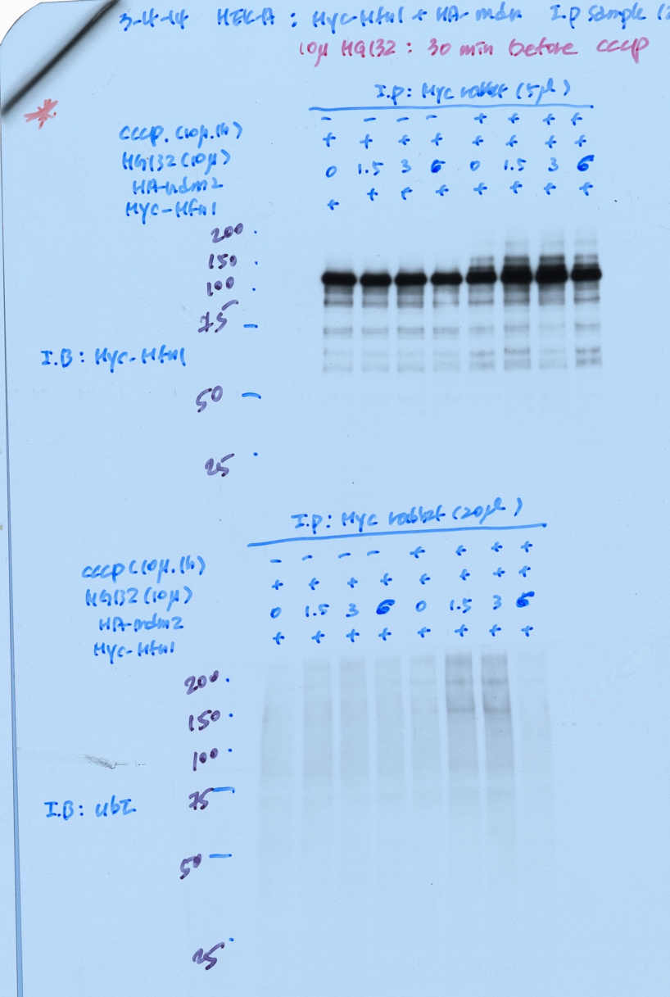
Fig 4D lower panel: IB myc and IB Ubiquitin

FIGURE 6

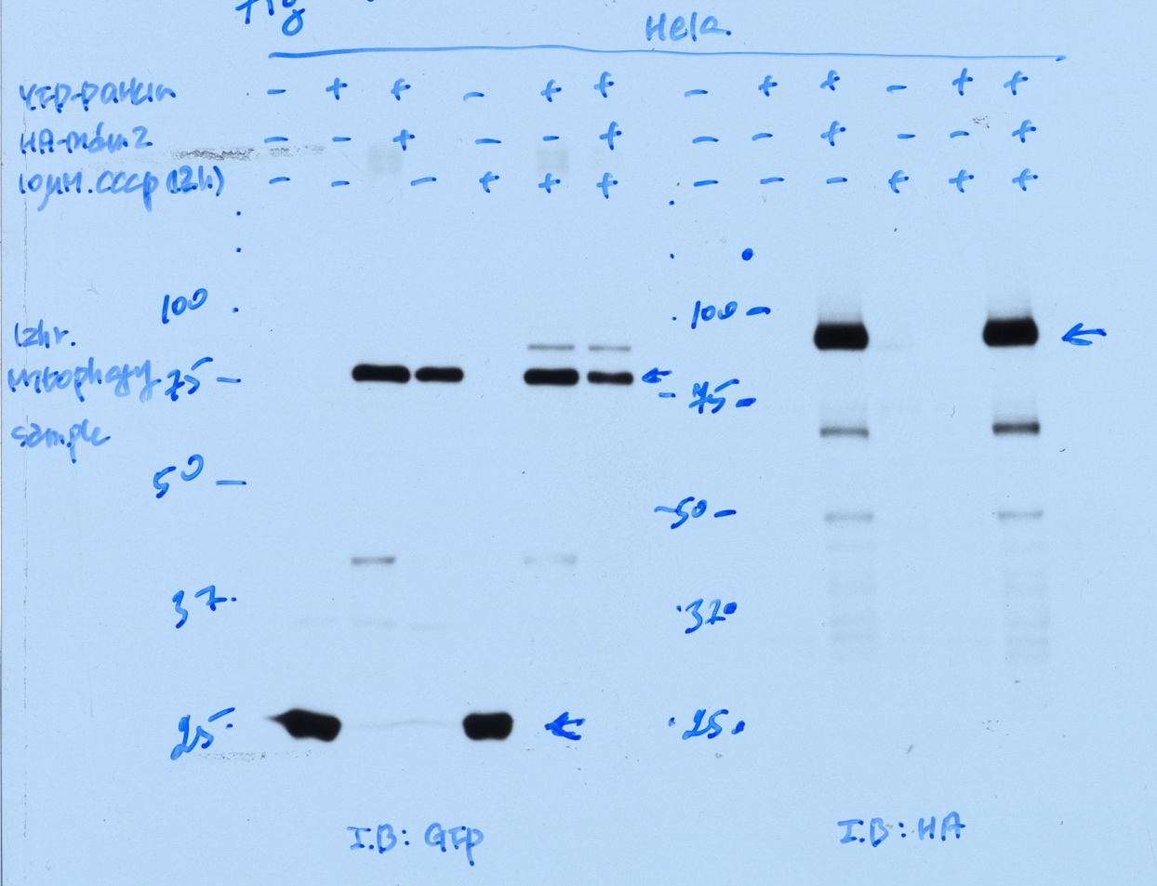
Fig 6B: Left panel - IB GFP (upper band - YFP-parkin; lower band - GFP). Right panel - IB HA (HA-Mdm2).

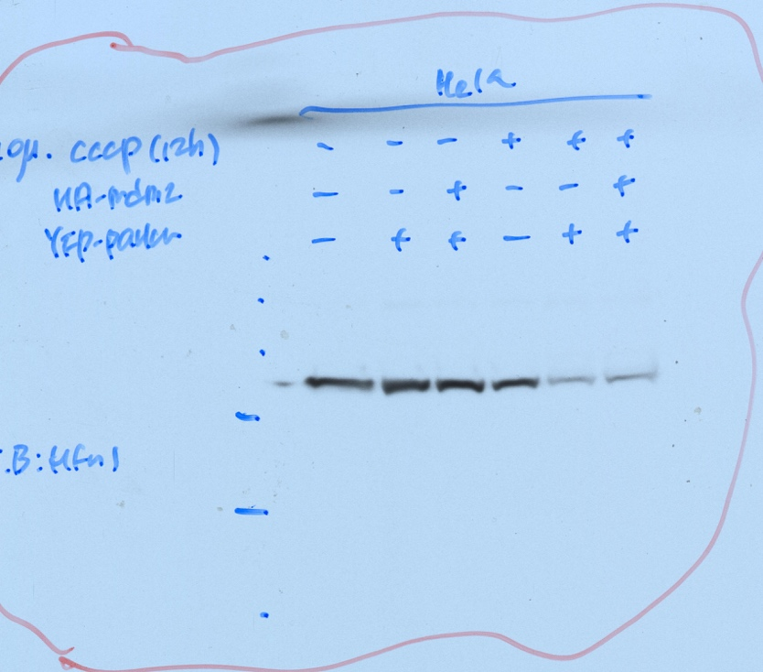

Fig 6B: IB Mfs-1

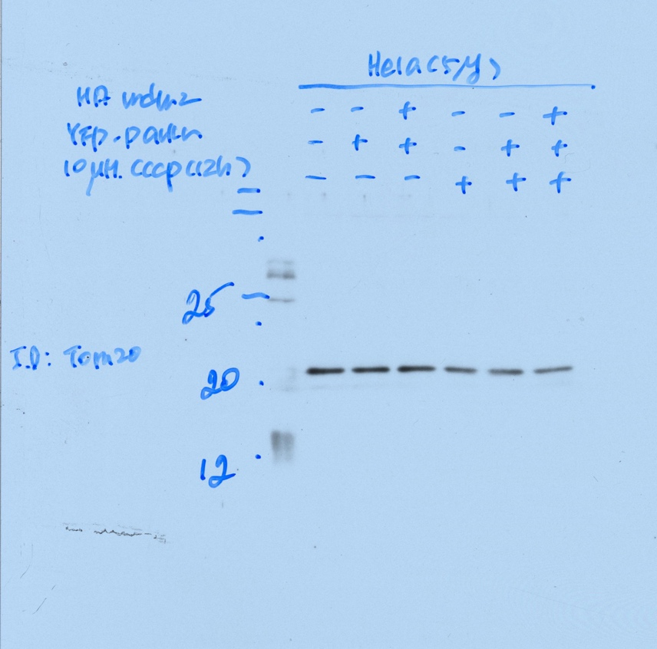
Fig 6B: IB Tom20.

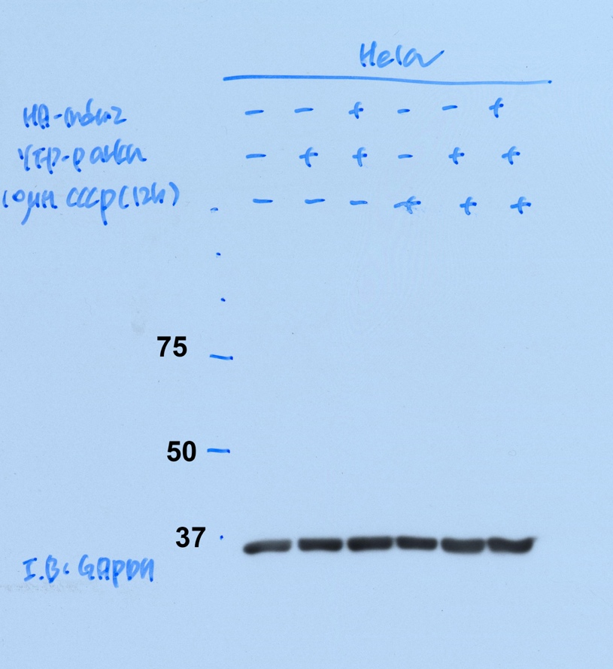
Fig 6B: IB GAPDH.

FIGURE 7

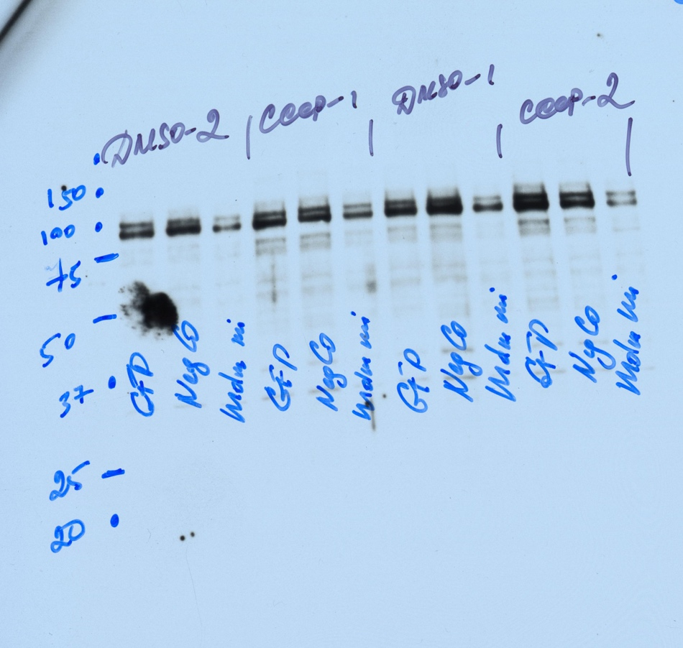
Fig 7B: Mdm2

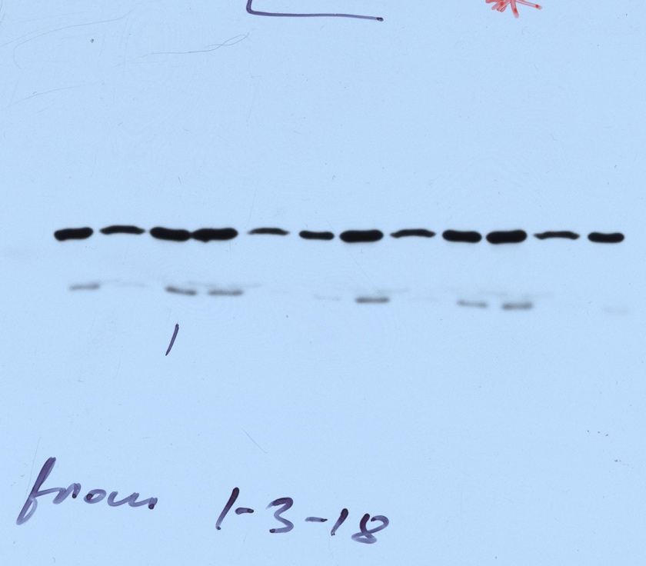
Fig 7B: GFP

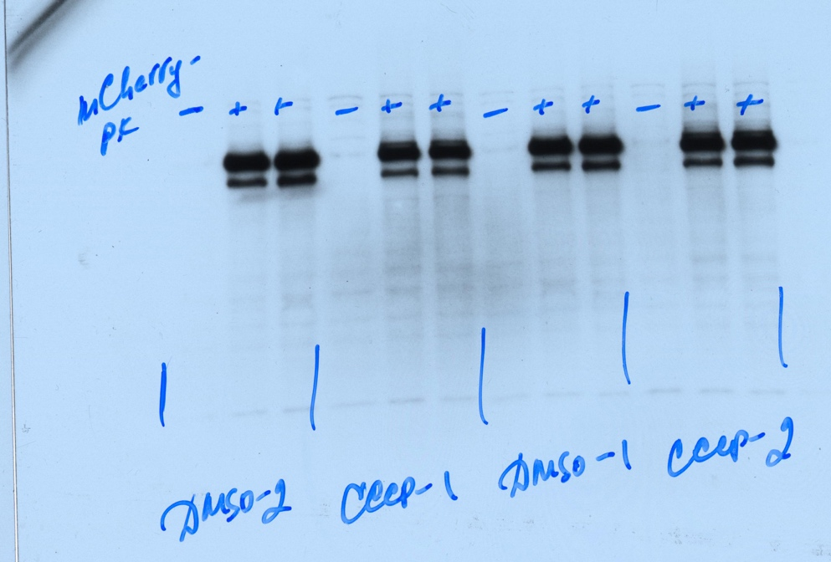
Fig 7B: Parkin

