Supplemental information

Time course of bilateral microglial activation in a mouse model of laser-induced glaucoma
Ana I. Ramírez^{1,2,#}, Rosa de Hoz^{1,2,#}, José A. Fernandez-Albarral¹, Elena Salobrar-Garcia^{1,3}, Blanca Rojas^{1,3}, Francisco J. Valiente-Soriano⁴, Marcelino Avilés-Trigueros⁴, María P. Villegas-Pérez⁴, Manuel Vidal-Sanz⁴, Alberto Triviño^{1,3}, José M. Ramírez^{1,3,}*, Juan J. Salazar^{1,2,}*

¹Instituto de Investigaciones Oftalmológicas Ramón Castroviejo. Universidad Complutense de Madrid. Spain.
²Facultad de Óptica y Optometría. Departamento de Inmunología, Oftalmología y ORL. Universidad Complutense de Madrid. Spain.
³Facultad de Medicina. Departamento de Inmunología, Oftalmología y ORL. Universidad Complutense de Madrid. Spain
⁴Departamento de Oftalmología, Facultad de Medicina, Universidad de Murcia and Instituto Murciano de Investigación Biosanitaria Virgen de la Arrixaca. Murcia, Spain
#These authors contributed equally to this work

*Corresponding authors:
José M. Ramírez (ramirezs@med.ucm.es), and Juan J. Salazar (jjsalazar@med.ucm.es)
Instituto de Investigaciones Oftalmológicas Ramón Castroviejo.
Facultad de Medicina, Pab 6, 4ª planta. Ciudad Universitaria (UCM). 28040. Madrid. Spain.

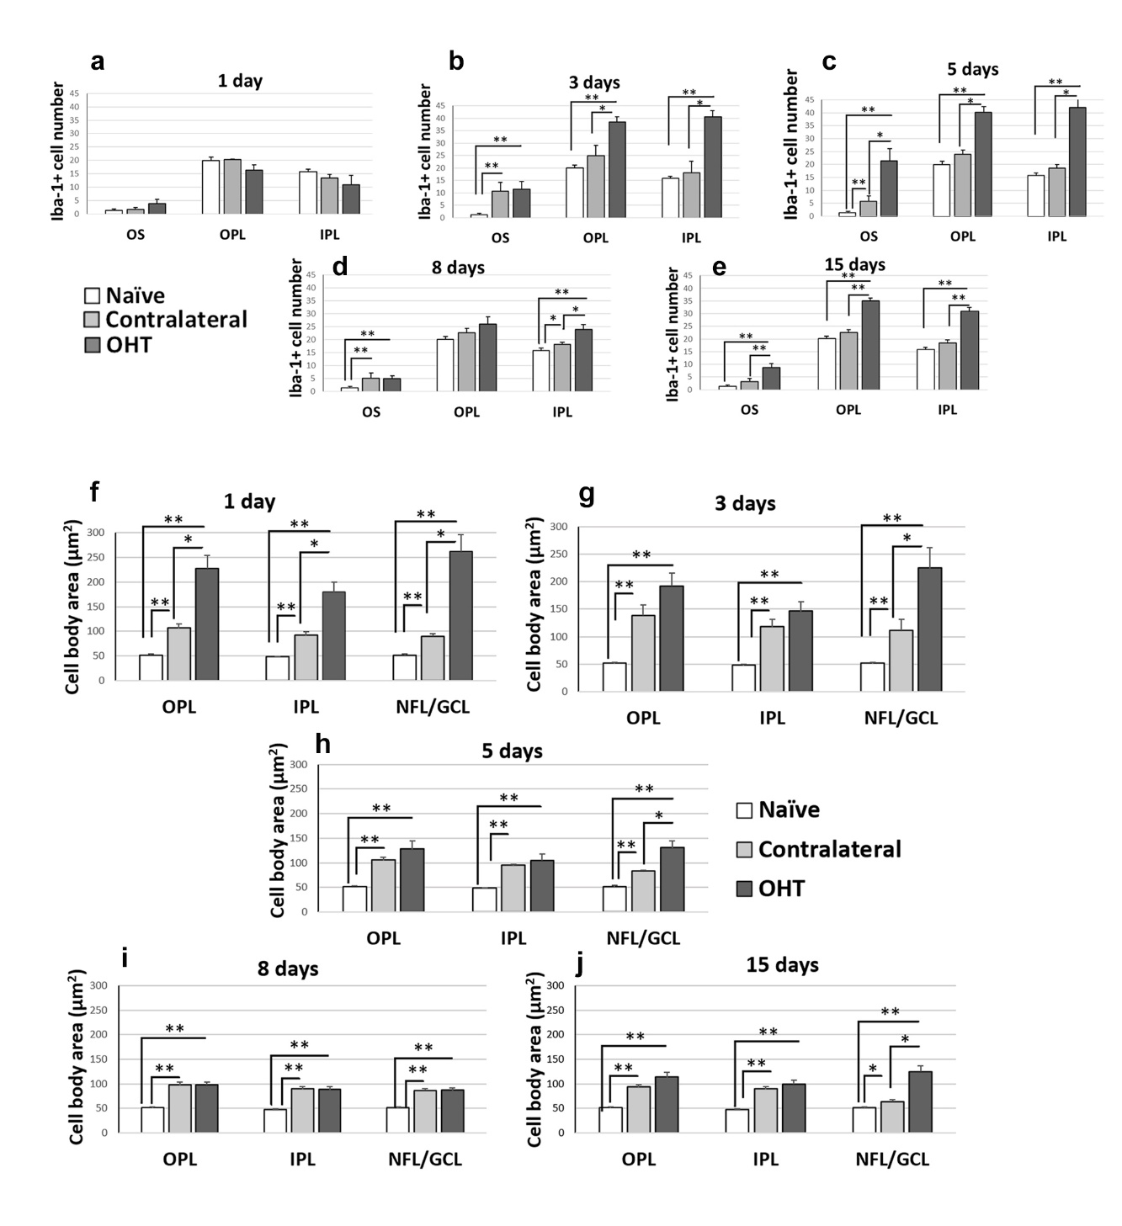
Supplementary Figure S1. Iba-1+ cells in the photoreceptor outer segment layer (OS), outer plexiform layer (OPL), and the inner plexiform layer (IPL) as well as the cell body area of Iba-1 + cells in plexiform layers and nerve fiber-ganglion cell layer (NFL-GCL) at different times after laser-induced ocular hypertension (OHT).
a-e: Quantitative analysis of the Iba-1+ cell number in OS, OPL and IPL. Histograms show the mean (±SD) number of Iba-1+ cells per area of 0.1502 mm² in naïve, contralateral and OHT eyes at 1 d (a), 3 d (b), 5 d (c), 8 d (d) and 15 d (e). f-j: Quantitative analysis of the cell body area of Iba-1+ cells in OPL, IPL and NFL-GCL. Histograms show a mean (±SD) cell body area of Iba-1+ cells in naïve, contralateral and OHT eyes at 1 d (f), 3 d (g), 5 d (h), 8 d (i) and 15 d (j). *p < 0.05, **p < 0.01
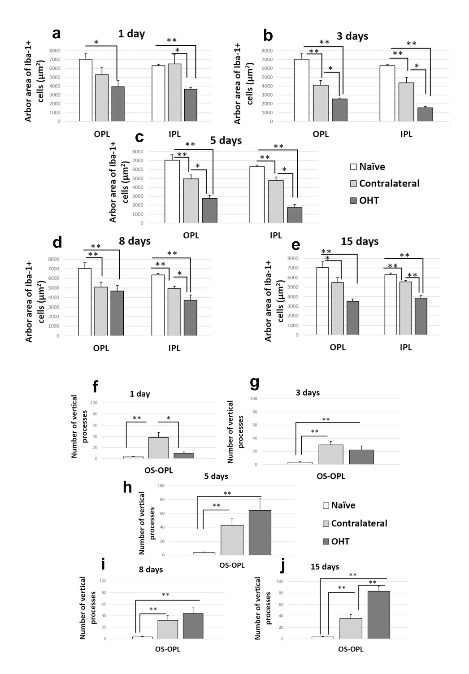
Suplementary Figure S2. Arbor area (AA) of Iba-1 + cells in the outer plexiform layer (OPL) and inner plexiform layer (IPL) as well as Iba-1+ vertical processes (VP) between outer plexiform layer (OPL) and the photoreceptor outer segment layer (OS) at different times after laser-induced ocular hypertension (OHT).
a-e: Quantitative analysis of the AA in OPL and IPL. Histograms show a mean AA (±SD) in naïve, contralateral and OHT eyes at 1 d (a), 3 d (b), 5 d (c), 8 d (d) and 15 d (e).
f-j: Quantitative analysis of the number of VP between OPL and OS. Histograms show mean number of VP (±SD) in naïve, contralateral and OHT eyes at 1 d (f), 3 d (g), 5 d (h), 8 d (i) and 15 d (j). *p < 0.05, **p < 0.01

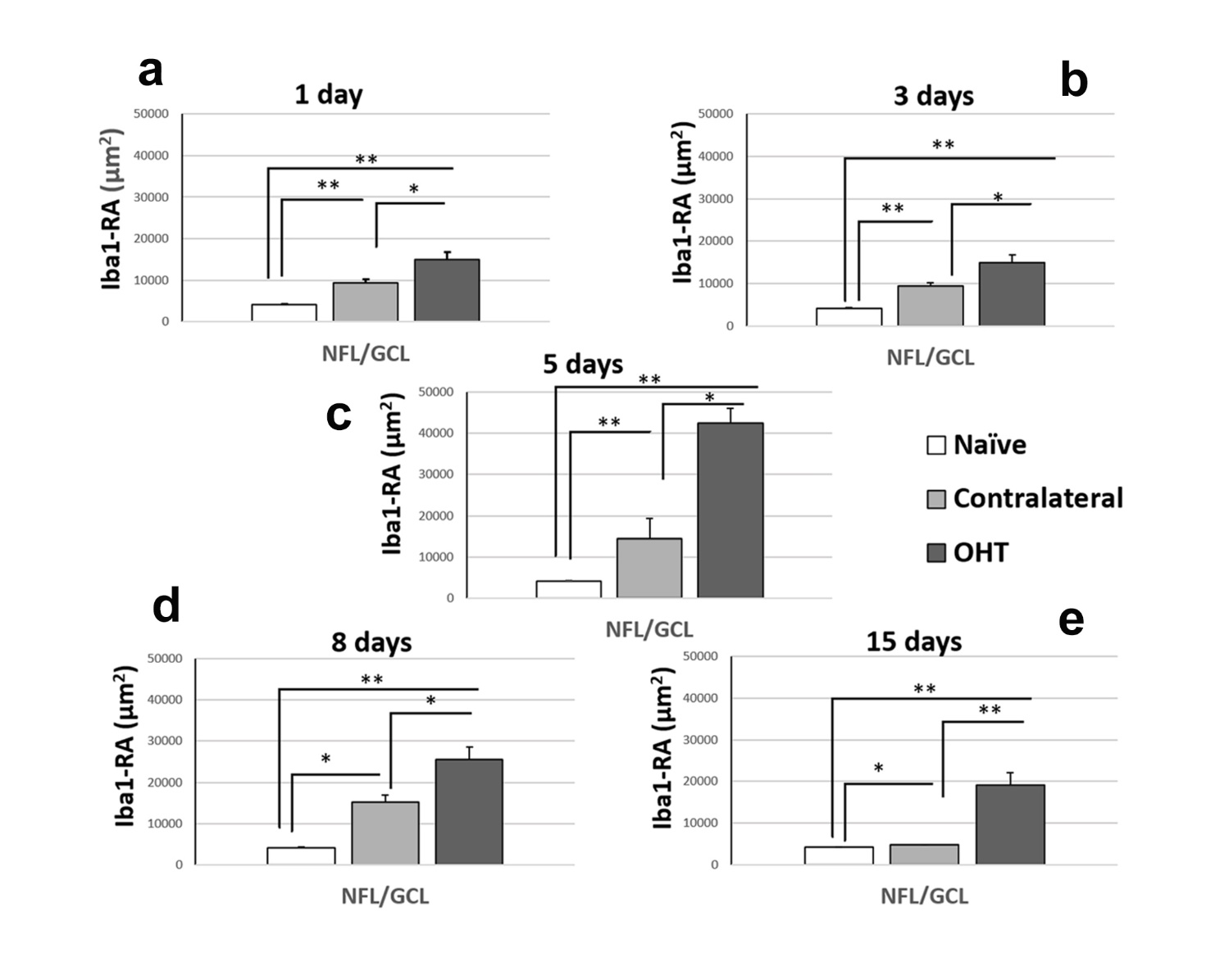

Suplementary Figure S3. Retinal area occupied by Iba-1+ cells (Iba1-RA) in the nerve fiber-ganglion cell layer (NFL-GCL)
Quantitative analysis of the Iba1-RA in NFL-GCL. Histograms show a mean Iba1-RA (±SD) for naïve, contralateral and OHT eyes at 1 d (a), 3 d (b), 5 d (c), 8 d (d) and 15 d (e). *p < 0.05, **p < 0.01.
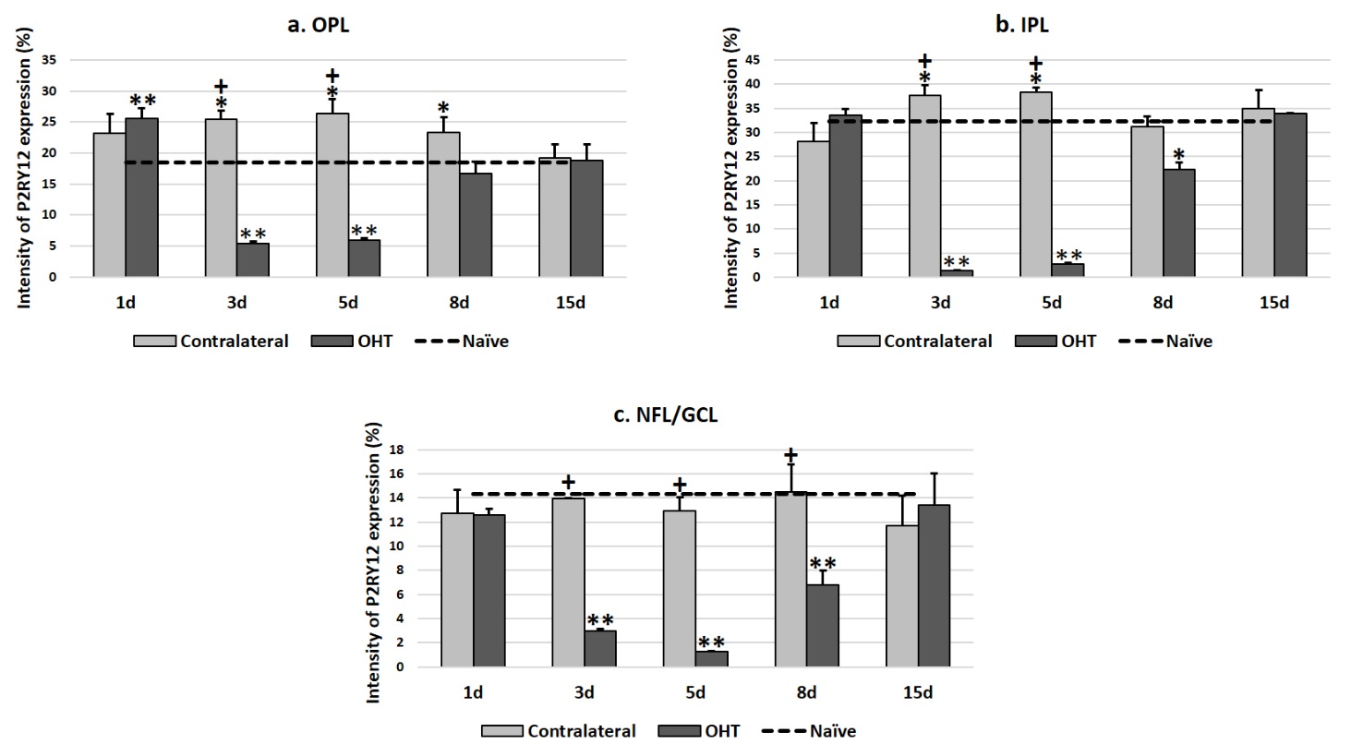

Suplementary Figure S4. Intensity of P2RY12 expression in Iba-1+ cells in the outer plexiform layer (OPL), inner plexiform layer (IPL) and in the nerve fiber-ganglion cell layer (NFL-GCL)
Quantification of the P2RY12 expression intensity over time in OPL (a), IPL (b) and NFL-GCL (c). Histograms show a mean P2RY12 expression intensity (±SD), expressed as a percentage, for naïve, contralateral and OHT eyes. *p < 0.05, **p < 0.01 vs Naïve; ⁺p < 0.05 vs OHT.

