Genome-wide identification and expression analysis of the CBF/DREB1 gene family in lettuce

Sunchung Park¹, Ainong Shi², and Beiquan Mou^{1,}*

Supplementary information
Supplementary Figure S1-6
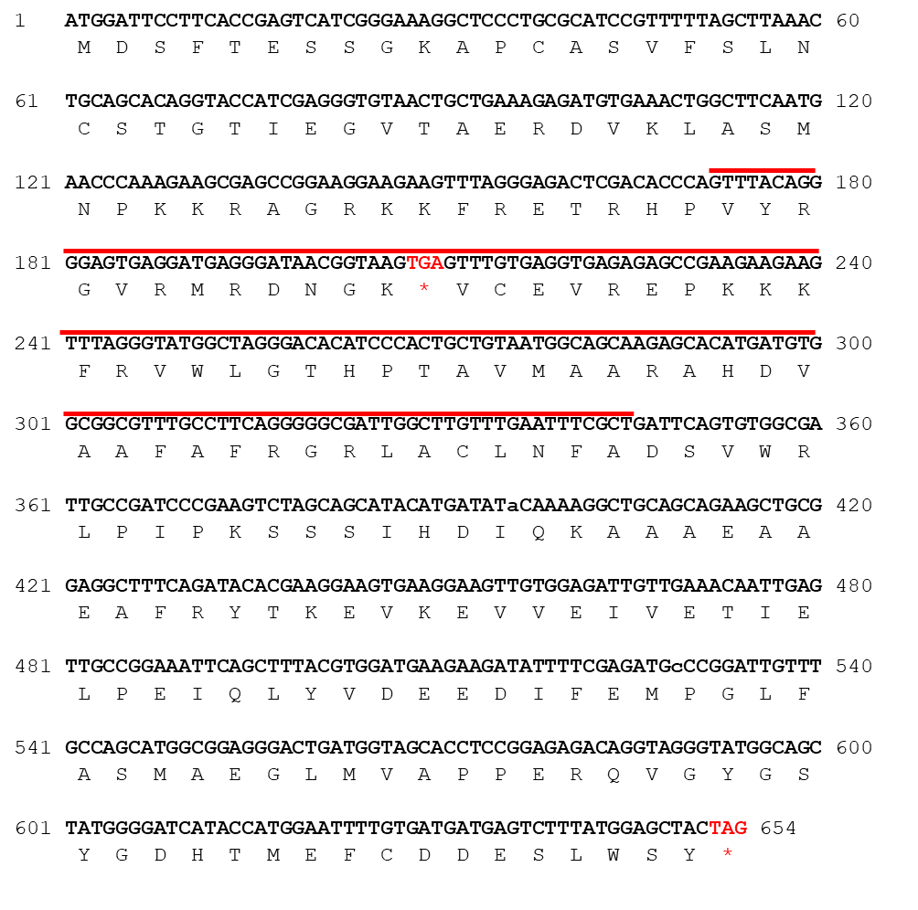
Figure S1. Nucleotide and amino acid sequence of LsCBF7 (Ls9g54581). Stop codons are marked in red. Red lines represent the AP2 DNA-binding domain.

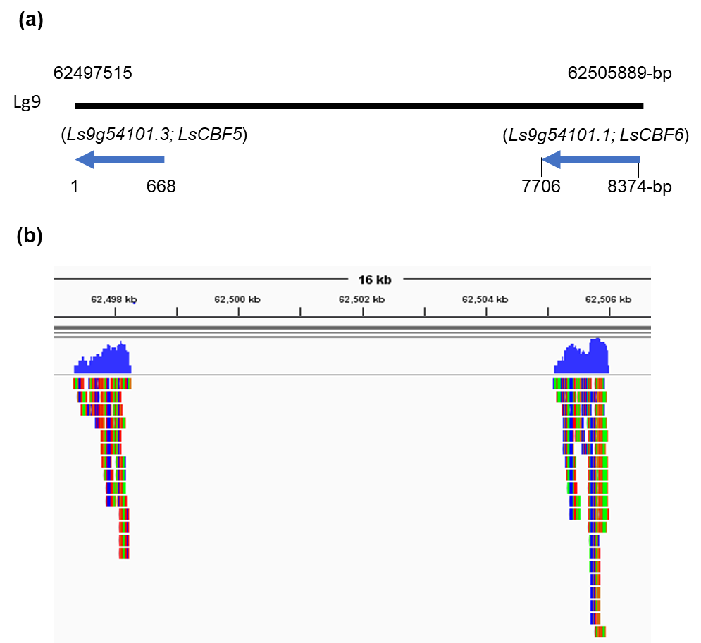
Figure S2. Schematic representation of the genomic location of Ls9g54101 splicing variants. (a) The genomic region from 62497515 to 62505889-bp in the linkage group 9 is shown. The arrows represent coding region and transcriptional direction of the two genes. Numbers at the top indicate genome coordinates; numbers at bottom, relative positions to 5’ end in bp. (b) RNA-seq reads from plants that were mapped to the 8-kb region encompassing the splicing variant genes. The mapped reads were visualized using Integrative Genomics Browser (http://software.broadinstitute.org/software/igv/home)¹.

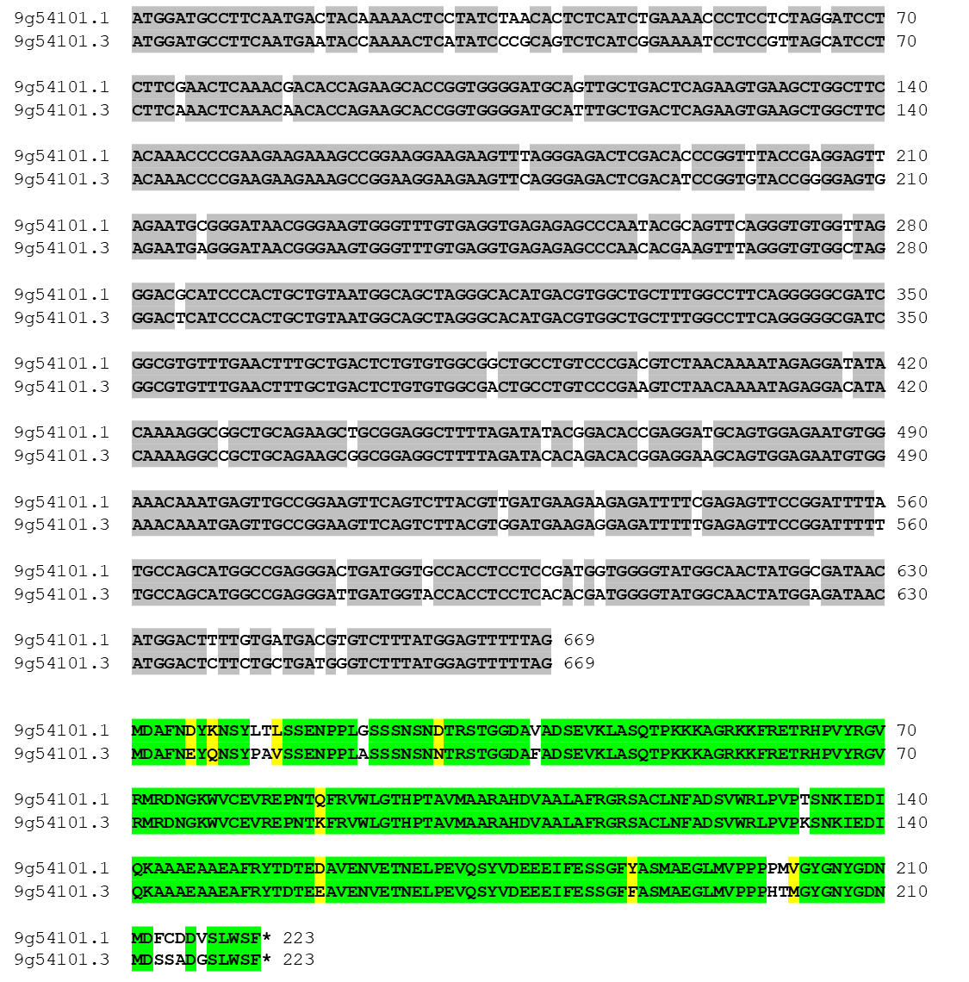

Figure S3. Nucleotide and amino acid sequence alignment of Ls9g54101.1 (LsCBF6) and Ls9g54101.3 (LsCBF5). Identical nucleotides are in grey and identical amino acids are in green, and similar amino acids are in yellow.

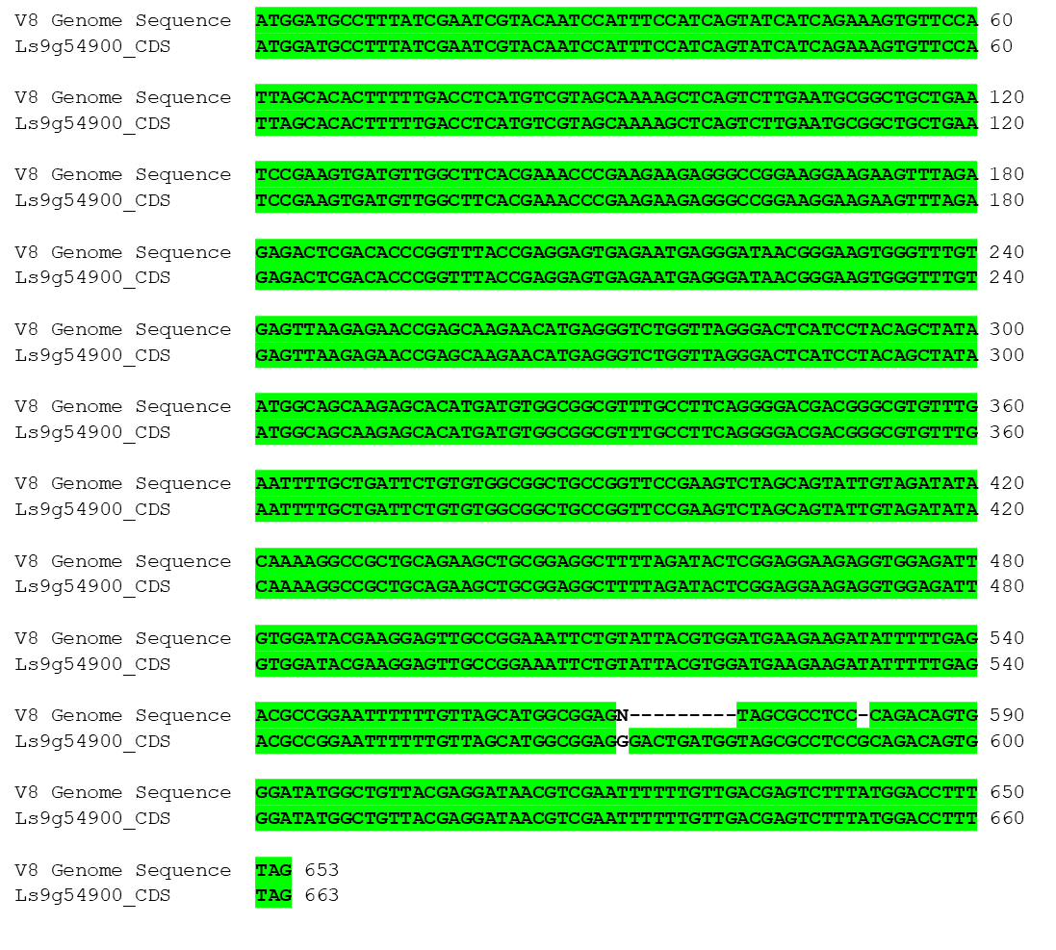
Figure S4. Nucleotide sequences of LsCBF8 (Ls9g54900) coding region in cv. Salinas. The incomplete genomic sequence of LsCBF8 coding region from v8 genome was corrected by Sanger sequencing.

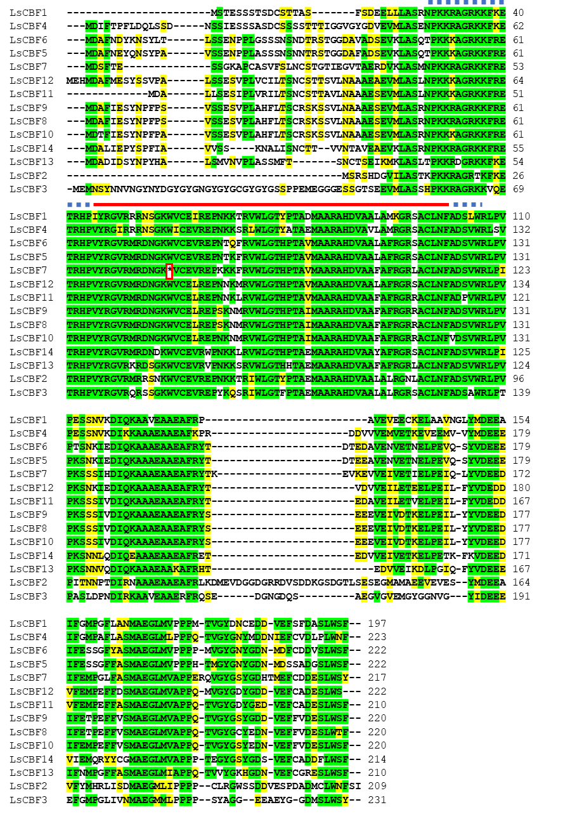
Figure S5. Alignment of lettuce CBF/DREB1 proteins. The amino acid sequences are shown for the 14 members of the lettuce CBF/DREB1 family. The AP2 DNA-binding domain is indicated by a red line and the signature sequences PKK/RPAGRxKFxETRHP and DSAWR are indicated by dashed blue lines. The red box indicates a premature stop codon in LsCBF7. Identical amino acids are in green, and similar ones are in yellow.

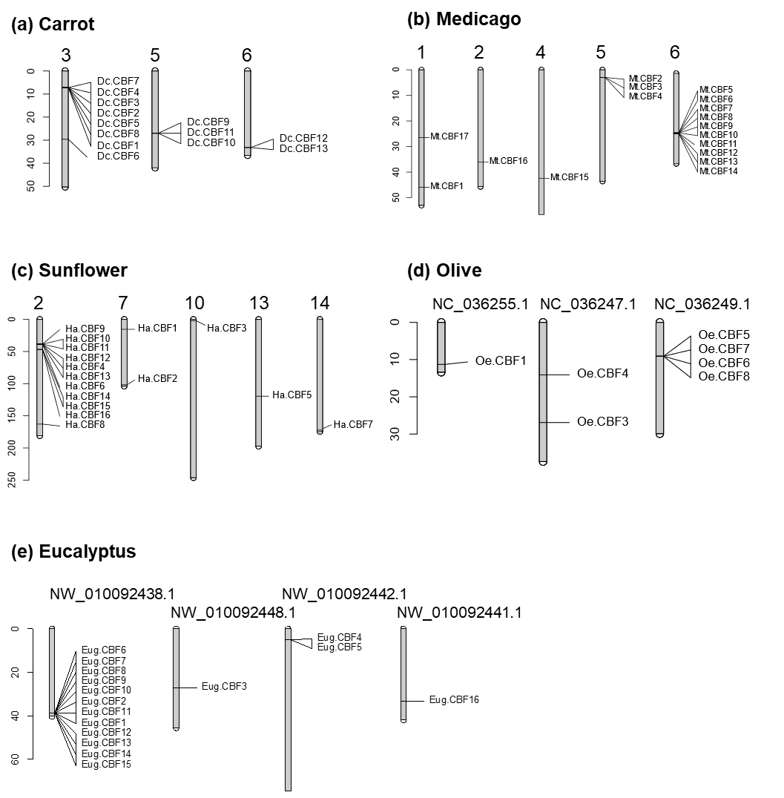
Figure S6. Chromosomal location of the CBF/DREB1 family of carrot (a, Daucus carota), Medicago (b, Medicago truncatula), sunflower (c, Helianthus annuus), olive (d, Olea europaea), and Eucalyptus (e, Eucalyptus grandis). The CBF/DREB1 genes in the phylogenetic tree in Fig. 2 are mapped to chromosomes or linkage groups using the R/LinkageMapView package in R software⁶⁸. The scales on the left side represent mega-base pairs.

References
1. Robinson, J. T., Thorvaldsdóttir, H., Wenger, A. M., Zehir, A. & Mesirov, J. P. Variant review with the integrative genomics viewer. Cancer Res. 77, e31–e34 (2017).

